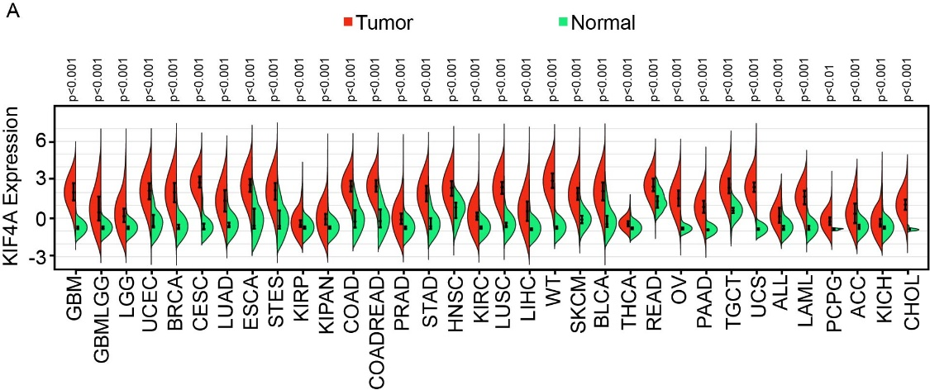
Supplementary Figure 1 The high-expression of KIF4A was detected in pan-cancer analysis from TCGA database. Abbreviations: GBM-Glioblastoma multiforme, GBMLGG-Glioma,LGG: Brain Lower Grade Glioma, UCEC-Uterine Corpus Endometrial Carcinoma, BRCA-Breast invasive carcinoma, CESC-Cervical squamous cell carcinoma and endocervical, adenocarcinoma, LUAD-Lung adenocarcinoma, ESCA-Esophageal carcinoma, STES-Stomach and Esophageal carcinoma, KIRP-Kidney renal papillary cell carcinoma, KIPAN-Pan-kidney cohort (KICH+KIRC+KIRP), COAD-Colon adenocarcinoma COADREAD-Colon adenocarcinoma/Rectum adenocarcinoma Esophageal carcinoma, PRAD-Prostate adenocarcinoma, STAD-Stomach adenocarcinoma HNSC-Head and Neck squamous cell carcinoma, KIRC-Kidney renal clear cell carcinoma, LUSC-Lung squamous cell carcinoma, LIHC-Liver hepatocellular carcinoma, WT-High-Risk Wilms Tumor, SKCM-Skin Cutaneous Melanoma BLCA-Bladder Urothelial Carcinoma, THCA-Thyroid carcinoma READ-Rectum adenocarcinoma, OV-Ovarian serous cystadenocarcinoma PAAD-Pancreatic adenocarcinoma, TGCT-Testicular Germ Cell Tumors UCS-Uterine Carcinosarcoma, ALL-Acute Lymphoblastic Leukemia LAML-Acute Myeloid Leukemia, PCPG-Pheochromocytoma and Paraganglioma ACC-Adrenocortical carcinoma, KICH-Kidney Chromophobe, CHOL-Cholangiocarcinoma

