Supplemental information

Integration of AIEgens into Covalent Organic Frameworks for Pyroptosis and Ferroptosis Primed Cancer Immunotherapy

Liang Zhang^{1,2,4,5}, An Song^{1,5}, Qi-Chao Yang¹, Shu-Jin Li¹, Shuo Wang¹, Shu-Cheng Wan¹, Jianwei Sun², Ryan T. K. Kwok², Jacky W. Y. Lam^{2,*}, Hexiang Deng^{4,*}, Ben Zhong Tang^{2,3,*}, Zhi-Jun Sun^{1,*}
¹1The State Key Laboratory Breeding Base of Basic Science of Stomatology (Hubei-MOST) & Key Laboratory of Oral Biomedicine Ministry of Education, School and Hospital of Stomatology, Wuhan University, Wuhan 430079, China.
² Department of Chemistry, and The Hong Kong Branch of Chinese National Engineering Research Center for Tissue Restoration and Reconstruction, The Hong Kong University of Science and Technology, Clear Water Bay, Kowloon, Hong Kong, 999077, China.
³ Shenzhen Institute of Aggregate Science and Technology, School of Science and Engineering, The Chinese University of Hong Kong, Shenzhen, Guangdong 518172, China.
⁴ Key Laboratory of Biomedical Polymers-Ministry of Education, College of Chemistry and Molecular Sciences, Wuhan University, Luojiashan, Wuhan 430072, China.
⁵These authors contributed equally: Liang Zhang, An Song.
*Email: chjacky@ust.hk; hdeng@whu.edu.cn; tangbenz@cuhk.edu.cn; sunzj@whu.edu.cn

Experimental Section
Chemicals: The organic solvent was procured from Adamas-beta®, while 2,7-dichloro-dihydrofluorescein diacetate (DCFH-DA) and N¹,N^{1'}-(1,4-phenylene)bis(N¹-(4-aminophenyl)-benzene-1,4-diamine) (M-TPA) were obtained from Jilin Chinese Academy of Sciences-Yanshen Technology Co., Ltd. Puromycin, fetal bovine serum (FBS), penicillin/streptomycin (PS), and RPMI-1640 medium were sourced from Thermo Fisher (MA, USA). The CCK8 was acquired from Dojindo Laboratories (Japan), while the anti-mouse PD-1 mAb (CD279) was procured from BioXcell (NH, USA).
Instruments: Fluorescence spectra were obtained using Cary Eclipse Fluorescence Spectrophotometer (Agilent Technologies). UV-vis absorption spectra were obtained using Cary 300 UV-vis Spectrophotometer (Agilent Technologies). Size distribution and zeta potential were detected by using Zetasizer Nano-ZS90 (Malvern). XPS was recorded by Thermal Fisher ESCALAB 250Xi. ICP measurements were performed on a THERMO Intrepid XSP Radial ICP-AES instrument.
Synthesis of COF@PEG sample: These COF samples were well dispersed into PBS solution using F-127 as PEG gens. Typically, 100 mg of COF samples and 200 mg F-127 were dispersed in 100 ml PBS and then sonicated via an 1800 W ultrasonic cell shredder (JY99-IIDN, from Ningbo Scientz Biotechnology Co., Ltd, www.scientz.com) for 24 h. The resulting mixture was centrifuged at 1500 rpm for 30 min to discard un-isolated nanoparticles and then centrifuged at 10000 rpm for 20 min to obtain the isolated COF@PEG samples.
FT-IR spectra for ligands and COFs: All IR spectra were recorded on a Thermo Nicolet iS10 IR spectroscopy made by Thermo fisher, and samples were tableted and utilized KBr background. The wavelength range is 3800 to 500 cm⁻¹. The successful formation of imine linkage was evidenced by the emergence of a 1620 to 1622 cm⁻¹ peak in the Fourier transform infrared (FT-IR) spectrum, representing the telescopic vibration of the imine bond (ν_{C=N}).
X-ray Photoelectron Spectrometer (XPS) measurement of the molecular chromophores and their corresponding COFs: X-ray Photoelectron Spectrometer (XPS) was carried out on a Thermo Fisher ESCALAB 250Xi spectrometer, with the ion source of Al Kα, and samples were prepared in tablet for the test. The XPS spectra reflected the change in the chemical environment of nitrogen before and after the conversion to COFs. New N 1s peaks were observed at 398.9 eV, indicating the successful formation of imine bonds.
UV-Vis diffuse reflectance spectra for ligands and COFs: UV-vis DRS of COFs were performed on a PerkinElmer Lambda 750 S spectroscopy using BaSO₄ as background. Band gap calculations were based on the Kubleka-Munk theory. The optical absorption coefficient (α) was calculated from reflectance data according to the Kubelka-Munk equation that F(R) = α = (1-R)²/2R, in which R is the percentage of reflected light. The incident photon energy (hν) and the optical band gap energy (Eg) are related to the transformed Kubelka-Munk function, [F(R)hν]² = A(hν-Eg), where Eg is the band gap energy, A is the constant depending on transition probability, and intercept of [F(R)hν]² vs hν is Eg. In comparison to the corresponding molecular building blocks, these COFs exhibited smaller band gaps.
N₂ adsorptions analysis of these COFs: N₂ adsorptions isotherms were measured on a Quantachrome Autosorb-IQ2 automatic volumetric instrument in a liquid nitrogen bath (77 K). Ultra-high purity grade N₂ was used for the adsorption experiments. The BET surface area analysis was performed by plotting x/v(1 - x) vs x, where x = P/P₀ (P₀ = 1 bar) and v is the volume of nitrogen adsorbed per gram of COF at standard temperature and pressure (STP), where satisfactory correlation coefficients and positive C constant were observed. The slope ([c - 1]/v_{m}c) and y-intercept (1/v_{m}c) of the linear region between the dashed lines give the monolayer capacity, v_{m}, that is then used to calculate the surface area from A = v_{m}σ₀N_{AV}, where σ₀ is the cross-section area of the adsorbate at liquid density (16.2 Å² for nitrogen) and N_{AV} is Avogadro’s number. The surface areas of these COFs range from 780 to 870 m² g⁻¹.
Determine the crystal structure of these COFs: Powder X-ray diffraction (PXRD) characterization was performed on a Smart lab diffractometer (Rigaku) with filtered Cu Kα radiation. Molecular models of COF-818 and COF-919 were generated with the Materials Studio (ver. 8.0) suite of programs. Pawley refinement was performed using Reflex, a software package for crystal determination from the PXRD pattern. Unit cell dimension was set to the theoretical parameters. The Pawley refinement was performed to optimize the lattice parameters iteratively until the Rwp and Rp value converges and the overlay of the observed with refined profiles shows good agreement. The lattice models were then fully optimized using MS Forcite molecular dynamics module method for each COF model. We performed Pawley refinement using the Reflex Plus module of the Material Studio, which showcases good agreement with the experimental PXRD patterns, with (Rwp, Rp) values of (1.11%, 0.85%) for COF-818, (Rwp, Rp) values of (0.58%, 0.47%) for COF-919 with Pawley refined cell parameters of a = 28.03 Å, b = 22.59 Å, c = 3.72 Å and α = β = γ = 90°, for COF-818, a = 27.39 Å, b = 21.73 Å, c = 3.91 Å, α = β = γ = 90° for COF-919.
DFT calculations: The specific process conformational search is to use ORCA5.0.3 package¹, and the first excited state geometry optimization was conducted under the wB97X-D3/def2SVP level²⁻³.
Cellular iron assay: The intracellular ferrous iron (Fe²⁺) level was determined using an iron assay kit, as per the manufacturer's instructions. Briefly, cells were seeded onto a plate with 5 × 106 cells per plate, collected, and washed in ice-cold phosphate buffer solution. Next, 100-200 μl of lysate was added, and the mixture was centrifuged at 4 °C. The supernatant was then treated with an iron reducer and incubated at 60℃ for 60 min. Subsequently, 30 μl of the iron probe was added, and the solution was mixed thoroughly using a horizontal shaker and incubated at 25 °C for 30 min. Finally, the 550 nm absorbance peak was measured using a microplate reader.
Mitochondrial morphology assays: After washing with PBS three times, 4T1 cells were fixed in 4% paraformaldehyde solution for 1 hour, and the mitochondrial morphology was analyzed by TEM. The cells were fixed in 0.1 M sodium cacodylate buffer solution (pH 7.4) with 2.5% glutaraldehyde, followed by postfixation in 2% aqueous osmium tetroxide and dehydration in an ethanol/propylene oxide mixture. The cells were then embedded in Epon solution for 24 h at 60 °C (Merck, Darmstadt, Germany). Prior to TEM analysis, the cells were cut into ultra-thin sections, stained with 0.5% uranyl acetate for 30 min, and then further stained with 3% lead citrate for 7 min.
References
1 Neese, F. et al. Electronic structure and spectroscopy of novel copper chromophores in biology. Konstanz: University of Konstanz; 1997.
2 Chai, J.-D. & Head-Gordon, M. et al. Systematic optimization of long-range corrected hybrid density functionals. J. Chem. Phys. 128, 084106-084130 (2008).
3 Grimme S. et al. A consistent and accurate ab initio parametrization of density functional dispersion correction (DFT-D) for the 94 elements H-Pu. J. Chem. Phys. 132, 154104-154123 (2010).

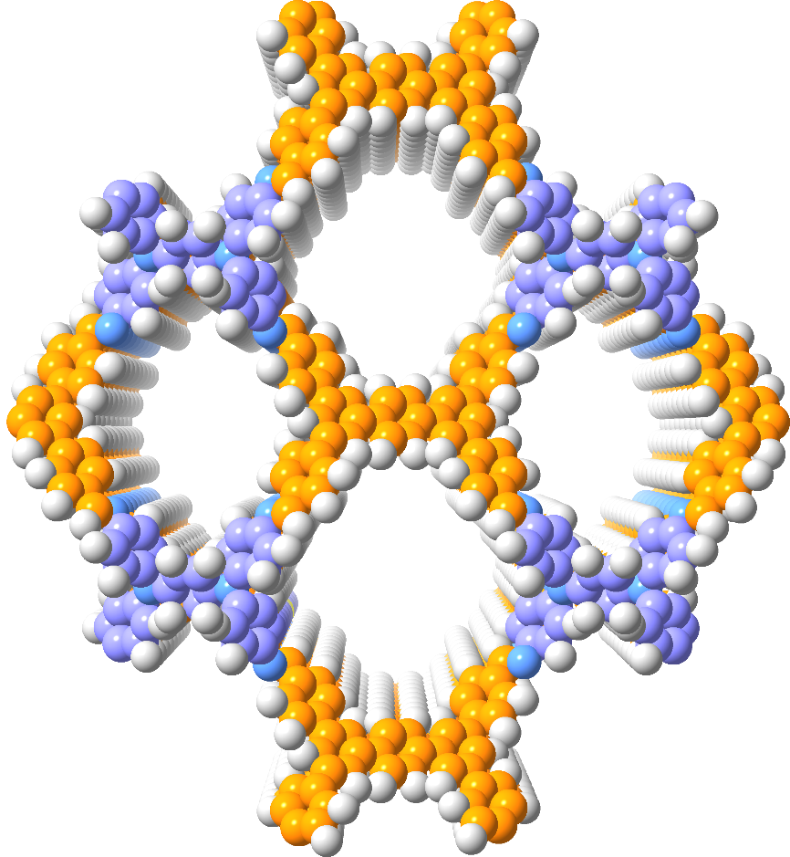
Fig. S1. Space-filling models of COF-818 from the top view.

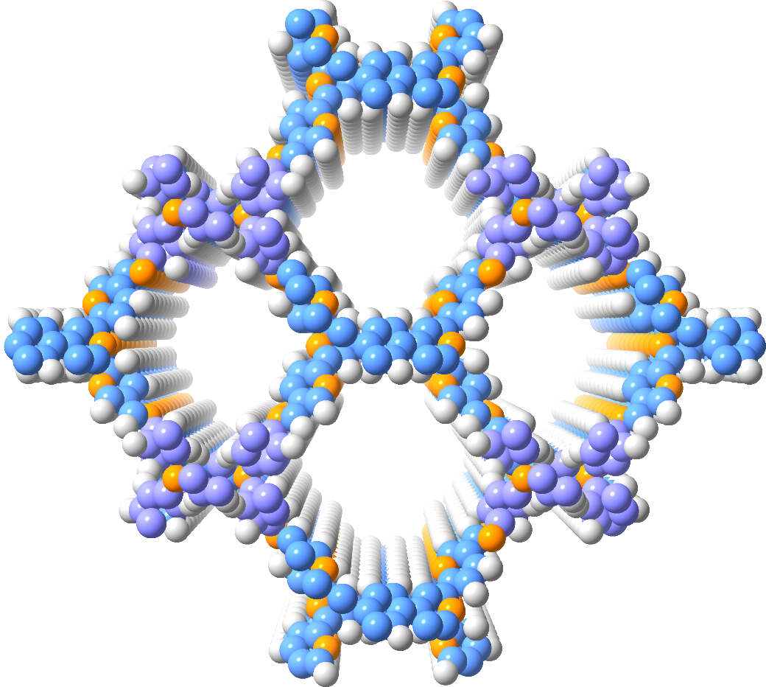
Fig. S2. Space-filling models of COF-919 from the top view.
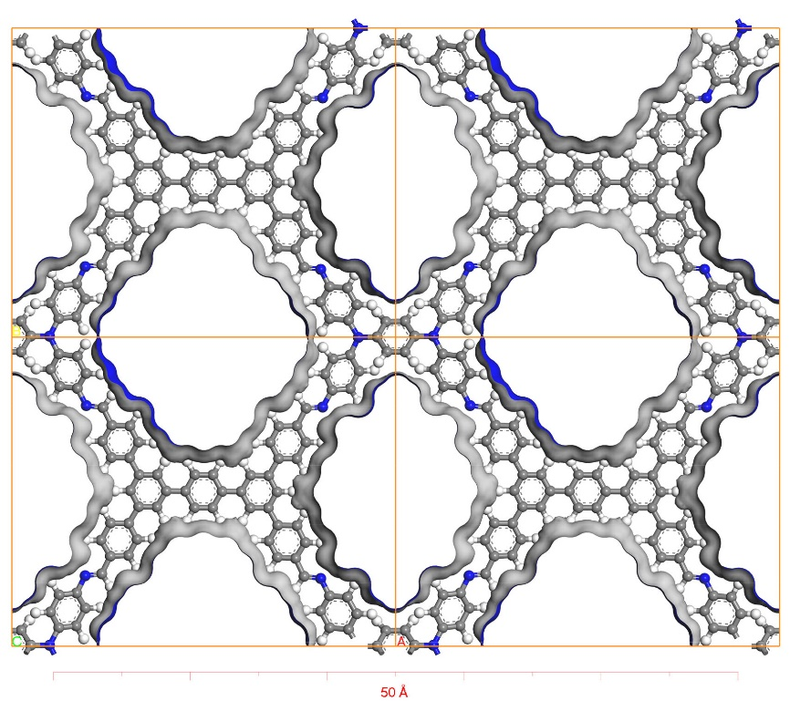
Fig. S3. Connolly surface of COF-818, carbon, hydrogen and nitrogen atoms are represented as grey, white, and blue spheres, respectively.

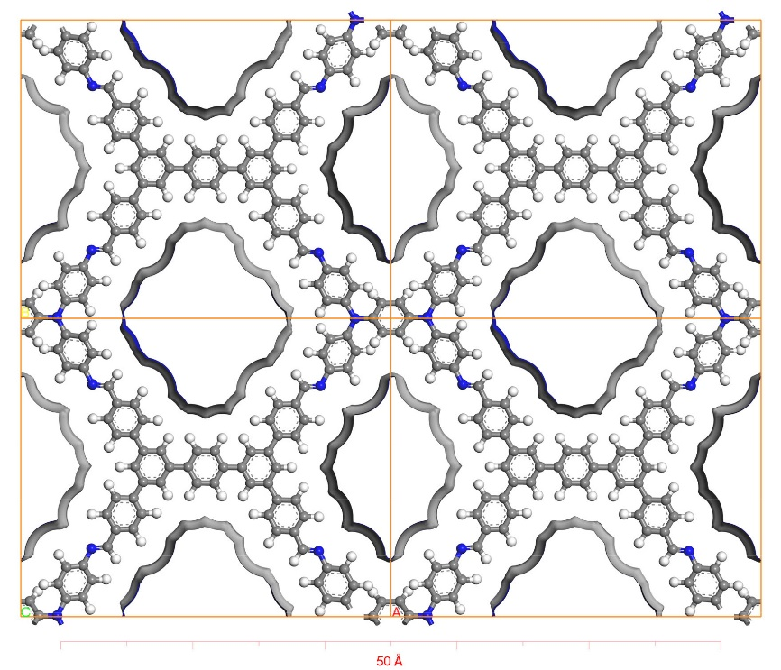
Fig. S4. Solvent surface of COF-818, carbon, hydrogen and nitrogen atoms are represented as grey, white, and blue spheres, respectively.
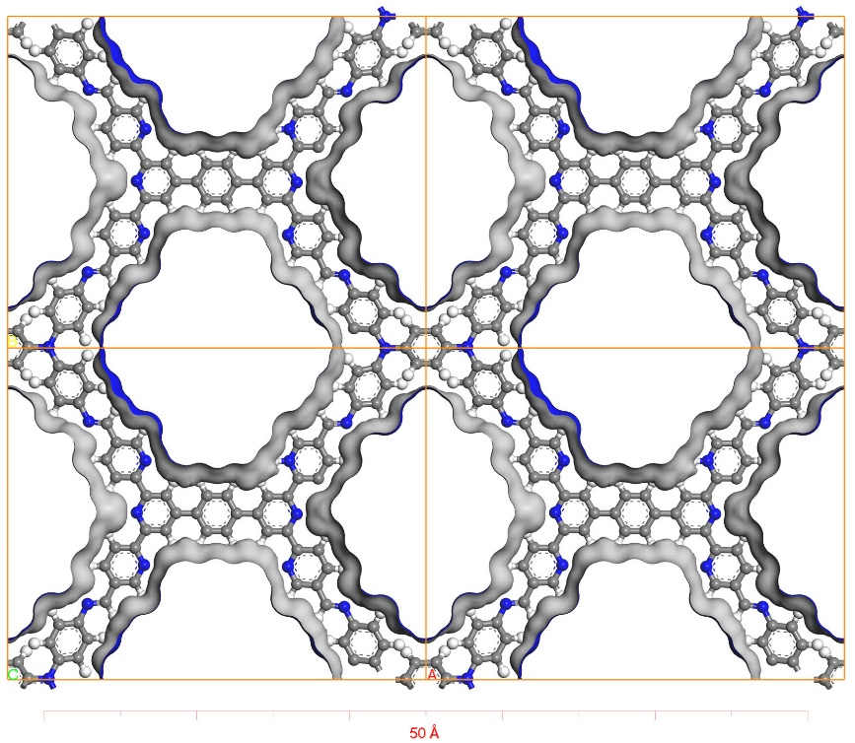
Fig. S5. Connolly surface of COF-919, carbon, hydrogen and nitrogen atoms are represented as grey, white, and blue spheres, respectively.
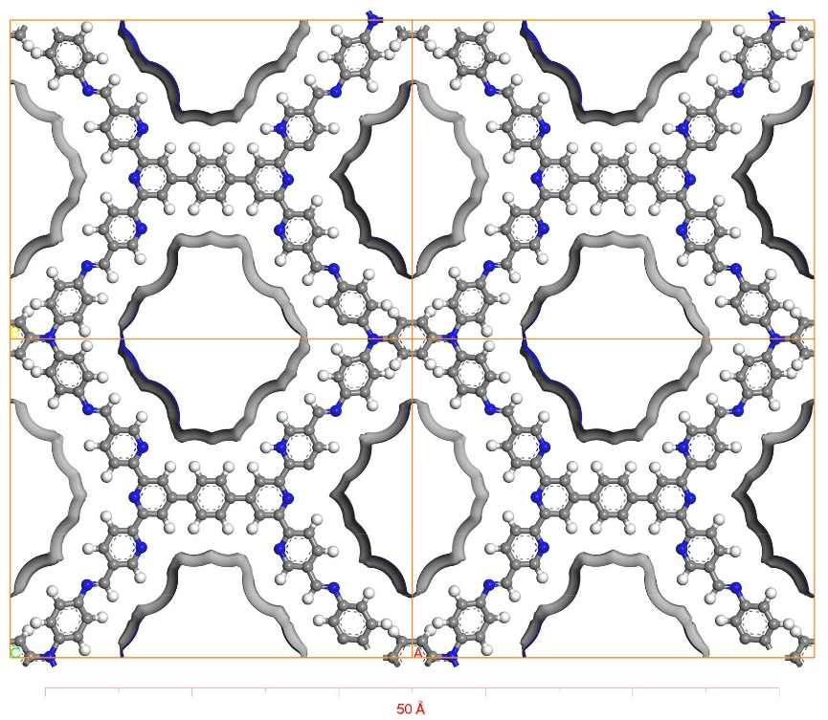
Fig. S6. Solvent surface of COF-919, carbon, hydrogen and nitrogen atoms are represented as grey, white, and blue spheres, respectively.

Table S1. Crystallographic Information of Modeled COFs.
 | COF-818 | COF-919
Space group | Cmmm | Cmmm
a (Å) | 28.03 | 27.39
b (Å) | 22.59 | 21.73
c (Å) | 3.72 | 3.91
R_{p} (%) | 1.11 | 0.58
R_{wp}(%) | 0.85 | 0.47
α (˚)  β(˚)  γ(˚) | 90  90  90 | 90  90  90

Table S2. Atomic parameters of COF-818
Atomic parameters of COF-818
Atom | x (Å) | y (Å) | z (Å) | Atom | x (Å) | y (Å) | z (Å)
C1 | 0.32594 | 0.34581 | -0.04425 | C32 | 0.47669 | 0.55476 | 0.02905
C2 | 0.30363 | 0.29411 | -0.06502 | C33 | 0.67003 | 0.34052 | -0.07718
C3 | 0.7659 | 0.65991 | -0.00925 | C34 | 0.69191 | 0.28797 | -0.08823
C4 | 0.30425 | 0.39753 | -0.0125 | C35 | 0.23611 | 0.66352 | 0.10739
C5 | 0.25664 | 0.29161 | -0.0541 | C36 | 0.69276 | 0.39166 | -0.0508
N6 | 0.80966 | 0.77384 | -0.02624 | C37 | 0.73909 | 0.28431 | -0.07152
C7 | 0.02409 | 0.95247 | 0.23996 | N38 | 0.19385 | 0.77867 | 0.10378
C8 | 0.90446 | 0.89009 | -0.10583 | C39 | 0.97703 | 0.95271 | 0.22266
C9 | 0.88125 | 0.83352 | -0.10004 | C40 | 0.10133 | 0.89555 | -0.03713
C10 | 0.19134 | 0.12332 | -0.12048 | C41 | 0.12494 | 0.84087 | -0.01118
C11 | 0.88098 | 0.94214 | -0.03975 | C42 | 0.80467 | 0.11398 | -0.12374
C12 | 0.83421 | 0.82837 | -0.02832 | C43 | 0.12247 | 0.94566 | 0.05546
C13 | 0.76643 | 0.76982 | 0.01273 | C44 | 0.17061 | 0.83436 | 0.1044
C14 | 0.66797 | 0.44742 | -0.03214 | C45 | 0.23732 | 0.77212 | 0.15368
C15 | 0.62081 | 0.44737 | -0.02267 | C46 | 0.33038 | 0.45176 | 0.01471
C16 | 0.52285 | 0.44784 | 0.0058 | C47 | 0.37757 | 0.45054 | 0.01009
C17 | 0.67314 | 0.65925 | 0.02844 | C48 | 0.47577 | 0.4483 | 0.01524
C18 | 0.69572 | 0.71146 | 0.03246 | C49 | 0.32932 | 0.66027 | 0.13999
C19 | 0.23236 | 0.34311 | -0.0236 | C50 | 0.30739 | 0.71228 | 0.16082
C20 | 0.69499 | 0.60708 | 0.00595 | C51 | 0.76435 | 0.33554 | -0.04586
C21 | 0.74266 | 0.71294 | 0.01267 | C52 | 0.30655 | 0.60959 | 0.10268
N22 | 0.19095 | 0.2281 | -0.03032 | C53 | 0.26026 | 0.71503 | 0.1435
C23 | 0.9745 | 0.04987 | -0.23757 | N54 | 0.80463 | 0.21921 | -0.03568
C24 | 0.10073 | 0.11085 | 0.07441 | C55 | 0.0242 | 0.05139 | -0.22782
C25 | 0.12327 | 0.16579 | 0.05734 | C56 | 0.89824 | 0.10517 | 0.05556
C26 | 0.81611 | 0.88067 | 0.02845 | C57 | 0.87405 | 0.15862 | 0.04873
C27 | 0.12219 | 0.0601 | -0.00522 | C58 | 0.19317 | 0.8828 | 0.20501
C28 | 0.1685 | 0.17227 | -0.03637 | C59 | 0.87707 | 0.05438 | -0.02823
C29 | 0.23412 | 0.23453 | -0.06755 | C60 | 0.82766 | 0.16346 | -0.03906
C30 | 0.33153 | 0.55461 | 0.07254 | C61 | 0.76114 | 0.22632 | -0.07806
C31 | 0.37873 | 0.55465 | 0.06648 | C62 | 0.66909 | 0.55174 | -0.00251

Table S2. Atomic parameters of COF-818
Atomic parameters of COF-818
Atom | x (Å) | y (Å) | z (Å) | Atom | x (Å) | y (Å) | z (Å)
C63 | 0.62192 | 0.55281 | 0.00645 | H98 | 0.398 | 0.59825 | 0.08733
C64 | 0.52378 | 0.5543 | 0.01943 | H99 | 0.45821 | 0.59904 | 0.03875
C65 | 0.0492 | 0.00345 | 0.00701 | H100 | 0.67192 | 0.24497 | -0.11178
C66 | 0.5973 | 0.50035 | -0.00317 | H101 | 0.19767 | 0.66501 | 0.09413
C67 | 0.54738 | 0.50084 | 0.00758 | H102 | 0.95677 | 0.91824 | 0.37899
C68 | 0.9518 | 7.3E-4 | -0.01352 | H103 | 0.06487 | 0.89627 | -0.13581
C69 | 0.40223 | 0.5023 | 0.03543 | H104 | 0.10729 | 0.79769 | -0.08596
C70 | 0.45216 | 0.50177 | 0.02691 | H105 | 0.76724 | 0.11673 | -0.19358
C71 | 0.30876 | 0.50348 | 1.04574 | H106 | 0.25943 | 0.81247 | 0.2088
C72 | 0.25922 | 0.61054 | 1.08778 | H107 | 0.39612 | 0.40647 | -0.01482
C73 | 0.25714 | 0.39856 | 0.99729 | H108 | 0.45627 | 0.40475 | 0.01345
C74 | 0.69077 | 0.49929 | 0.97867 | H109 | 0.32722 | 0.75525 | 0.19324
C75 | 0.74212 | 0.60678 | 0.98764 | H110 | 0.80275 | 0.3329 | -0.03293
C76 | 0.74261 | 0.38988 | 0.96394 | H111 | 0.04452 | 0.08586 | -0.38362
C77 | 0.82788 | 0.06009 | 0.87695 | H112 | 0.93553 | 0.10512 | 0.13177
C78 | 0.16723 | 0.06615 | 0.89045 | H113 | 0.89177 | 0.20205 | 0.11689
C79 | 0.17047 | 0.93753 | 1.18913 | H114 | 0.22967 | 0.87904 | 0.30004
C80 | 0.83668 | 0.92967 | 1.02444 | H115 | 0.74023 | 0.18452 | -0.12174
N81 | 0.90284 | 0.99922 | -0.02694 | H116 | 0.60329 | 0.59695 | 0.02178
N82 | 1.09818 | 1.00316 | 0.01892 | H117 | 0.54328 | 0.59785 | 0.02122
H83 | 0.32316 | 0.25081 | -0.09234 | H118 | 0.23986 | 0.56713 | 1.05926
H84 | 0.80434 | 0.65991 | -0.02465 | H119 | 0.23852 | 0.4426 | 1.02145
H85 | 0.04483 | 0.91944 | 0.40362 | H120 | 0.76268 | 0.43287 | 0.98312
H86 | 0.94221 | 0.89194 | -0.16493 | H121 | 0.18546 | 0.02362 | 0.81076
H87 | 0.90076 | 0.79089 | -0.15431 | H122 | 0.19072 | 0.97746 | 1.28585
H88 | 0.22851 | 0.12633 | -0.19823 | H123 | 0.81199 | 0.96706 | 1.08668
H89 | 0.74527 | 0.8116 | 0.049 | H124 | 0.36441 | 0.34639 | -0.05355
H90 | 0.60156 | 0.40365 | -0.03099 | H125 | 0.36776 | 0.65912 | 0.15416
H91 | 0.54134 | 0.40356 | -0.00346 | H126 | 0.27027 | 0.50362 | 1.0492
H92 | 0.67629 | 0.75494 | 0.05225 | H127 | 0.76107 | 0.5629 | 0.97014
H93 | 0.1939 | 0.34155 | -0.01533 | H128 | 0.82335 | 0.03973 | 0.59727
H94 | 0.95294 | 0.08239 | -0.39828 | H129 | 0.81138 | 0.02858 | 1.07836
H95 | 0.06367 | 0.10901 | 0.15689 | H130 | 0.6347 | 0.65881 | 0.04431
H96 | 0.10432 | 0.20844 | 0.12259 | H131 | 0.63159 | 0.34182 | -0.09036
H97 | 0.25462 | 0.19242 | -0.11286 | H132 | 0.72925 | 0.49936 | 0.97191

Table S3. Atomic parameters of COF-919
Atomic parameters of COF-919
Atom | x (Å) | y (Å) | z (Å) | Atom | x (Å) | y (Å) | z (Å)
N1 | 0.32594 | 0.34581 | -0.04425 | C37 | 0.73909 | 0.28431 | -0.07152
C2 | 0.30363 | 0.29411 | -0.06502 | N38 | 0.19385 | 0.77867 | 0.10378
C3 | 0.7659 | 0.65991 | -0.00925 | C39 | 0.97703 | 0.95271 | 0.22266
C4 | 0.30425 | 0.39753 | -0.0125 | C40 | 0.10133 | 0.89555 | -0.03713
C5 | 0.25664 | 0.29161 | -0.0541 | C41 | 0.12494 | 0.84087 | -0.01118
N6 | 0.80966 | 0.77384 | -0.02624 | C42 | 0.80467 | 0.11398 | -0.12374
C7 | 0.02409 | 0.95247 | 0.23996 | C43 | 0.12247 | 0.94566 | 0.05546
C8 | 0.90446 | 0.89009 | -0.10583 | C44 | 0.17061 | 0.83436 | 0.1044
C9 | 0.88125 | 0.83352 | -0.10004 | C45 | 0.23732 | 0.77212 | 0.15368
C10 | 0.19134 | 0.12332 | -0.12048 | C46 | 0.33038 | 0.45176 | 0.01471
C11 | 0.88098 | 0.94214 | -0.03975 | C47 | 0.37757 | 0.45054 | 0.01009
C12 | 0.83421 | 0.82837 | -0.02832 | C48 | 0.47577 | 0.4483 | 0.01524
C13 | 0.76643 | 0.76982 | 0.01273 | N49 | 0.32932 | 0.66027 | 0.13999
C14 | 0.66797 | 0.44742 | -0.03214 | C50 | 0.30739 | 0.71228 | 0.16082
C15 | 0.62081 | 0.44737 | -0.02267 | C51 | 0.76435 | 0.33554 | -0.04586
C16 | 0.52285 | 0.44784 | 0.0058 | C52 | 0.30655 | 0.60959 | 0.10268
N17 | 0.67314 | 0.65925 | 0.02844 | C53 | 0.26026 | 0.71503 | 0.1435
C18 | 0.69572 | 0.71146 | 0.03246 | N54 | 0.80463 | 0.21921 | -0.03568
C19 | 0.23236 | 0.34311 | -0.0236 | C55 | 0.0242 | 0.05139 | -0.22782
C20 | 0.69499 | 0.60708 | 0.00595 | C56 | 0.89824 | 0.10517 | 0.05556
C21 | 0.74266 | 0.71294 | 0.01267 | C57 | 0.87405 | 0.15862 | 0.04873
N22 | 0.19095 | 0.2281 | -0.03032 | C58 | 0.19317 | 0.8828 | 0.20501
C23 | 0.9745 | 0.04987 | -0.23757 | C59 | 0.87707 | 0.05438 | -0.02823
C24 | 0.10073 | 0.11085 | 0.07441 | C60 | 0.82766 | 0.16346 | -0.03906
C25 | 0.12327 | 0.16579 | 0.05734 | C61 | 0.76114 | 0.22632 | -0.07806
C26 | 0.81611 | 0.88067 | 0.02845 | C62 | 0.66909 | 0.55174 | -0.00251
C27 | 0.12219 | 0.0601 | -0.00522 | C63 | 0.62192 | 0.55281 | 0.00645
C28 | 0.1685 | 0.17227 | -0.03637 | C64 | 0.52378 | 0.5543 | 0.01943
C29 | 0.23412 | 0.23453 | -0.06755 | C65 | 0.0492 | 0.00345 | 0.00701
C30 | 0.33153 | 0.55461 | 0.07254 | C66 | 0.5973 | 0.50035 | -0.00317
C31 | 0.37873 | 0.55465 | 0.06648 | C67 | 0.54738 | 0.50084 | 0.00758
C32 | 0.47669 | 0.55476 | 0.02905 | C68 | 0.9518 | 7.3E-4 | -0.01352
N33 | 0.67003 | 0.34052 | -0.07718 | C69 | 0.40223 | 0.5023 | 0.03543
C34 | 0.69191 | 0.28797 | -0.08823 | C70 | 0.45216 | 0.50177 | 0.02691
C35 | 0.23611 | 0.66352 | 0.10739 | N71 | 0.30876 | 0.50348 | 1.04574
C36 | 0.69276 | 0.39166 | -0.0508 | C72 | 0.25922 | 0.61054 | 1.08778
Table S3. Atomic parameters of COF-919
Atomic parameters of COF-919
Atom | x (Å) | y (Å) | z (Å) | Atom | x (Å) | y (Å) | z (Å)
C73 | 0.25714 | 0.39856 | 0.99729 | H100 | 0.398 | 0.59825 | 0.08733
N74 | 0.69077 | 0.49929 | 0.97867 | H101 | 0.45821 | 0.59904 | 0.03875
C75 | 0.74212 | 0.60678 | 0.98764 | H102 | 0.67192 | 0.24497 | -0.11178
C76 | 0.74261 | 0.38988 | 0.96394 | H103 | 0.19767 | 0.66501 | 0.09413
C77 | 0.82788 | 0.06009 | 0.87695 | H104 | 0.95677 | 0.91824 | 0.37899
C78 | 0.16723 | 0.06615 | 0.89045 | H105 | 0.06487 | 0.89627 | -0.13581
C79 | 0.17047 | 0.93753 | 1.18913 | H106 | 0.10729 | 0.79769 | -0.08596
C80 | 0.83668 | 0.92967 | 1.02444 | H107 | 0.76724 | 0.11673 | -0.19358
N81 | 0.90284 | 0.99922 | -0.02694 | H108 | 0.25943 | 0.81247 | 0.2088
N82 | 1.09818 | 1.00316 | 0.01892 | H109 | 0.39612 | 0.40647 | -0.01482
H83 | 0.32316 | 0.25081 | -0.09234 | H110 | 0.45627 | 0.40475 | 0.01345
H84 | 0.80434 | 0.65991 | -0.02465 | H111 | 0.32722 | 0.75525 | 0.19324
H85 | 0.04483 | 0.91944 | 0.40362 | H112 | 0.80275 | 0.3329 | -0.03293
H86 | 0.94221 | 0.89194 | -0.16493 | H113 | 0.04452 | 0.08586 | -0.38362
H87 | 0.90076 | 0.79089 | -0.15431 | H114 | 0.93553 | 0.10512 | 0.13177
H88 | 0.22851 | 0.12633 | -0.19823 | H115 | 0.89177 | 0.20205 | 0.11689
H89 | 0.74527 | 0.8116 | 0.049 | H116 | 0.22967 | 0.87904 | 0.30004
H90 | 0.60156 | 0.40365 | -0.03099 | H117 | 0.74023 | 0.18452 | -0.12174
H91 | 0.54134 | 0.40356 | -0.00346 | H118 | 0.60329 | 0.59695 | 0.02178
H92 | 0.63571 | 0.65882 | 0.0439 | H119 | 0.54328 | 0.59785 | 0.02122
H93 | 0.67629 | 0.75494 | 0.05225 | H120 | 0.23986 | 0.56713 | 1.05926
H94 | 0.1939 | 0.34155 | -0.01533 | H121 | 0.23852 | 0.4426 | 1.02145
H95 | 0.95294 | 0.08239 | -0.39828 | H122 | 0.76268 | 0.43287 | 0.98312
H96 | 0.06367 | 0.10901 | 0.15689 | H123 | 0.18546 | 0.02362 | 0.81076
H97 | 0.10432 | 0.20844 | 0.12259 | H124 | 0.19072 | 0.97746 | 1.28585
H98 | 0.77847 | 0.88459 | 0.08802 | H125 | 0.81199 | 0.96706 | 1.08668
H99 | 0.25462 | 0.19242 | -0.11286

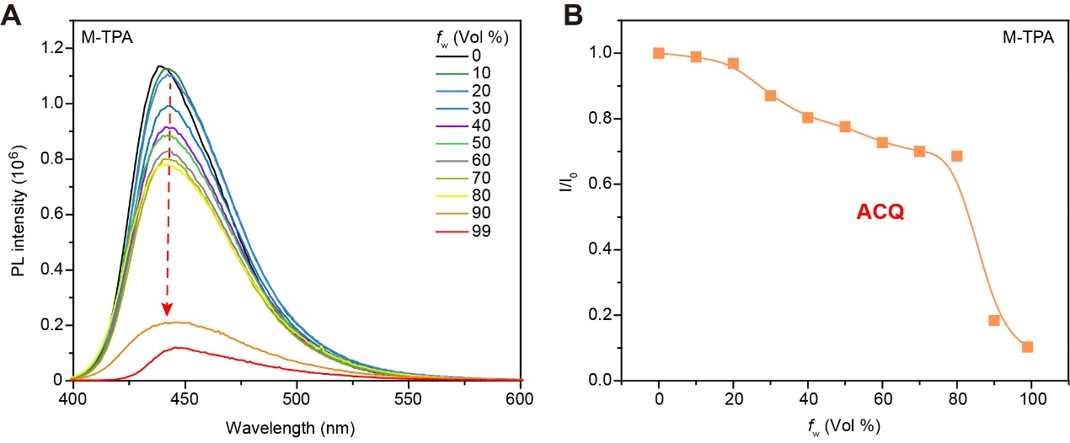
Fig. S7. Aggregation-caused quenching (ACQ) effects of M-TPA, (A) photo luminescence spectrum with different water fractions. (B) ACQ curve of M-TPA.

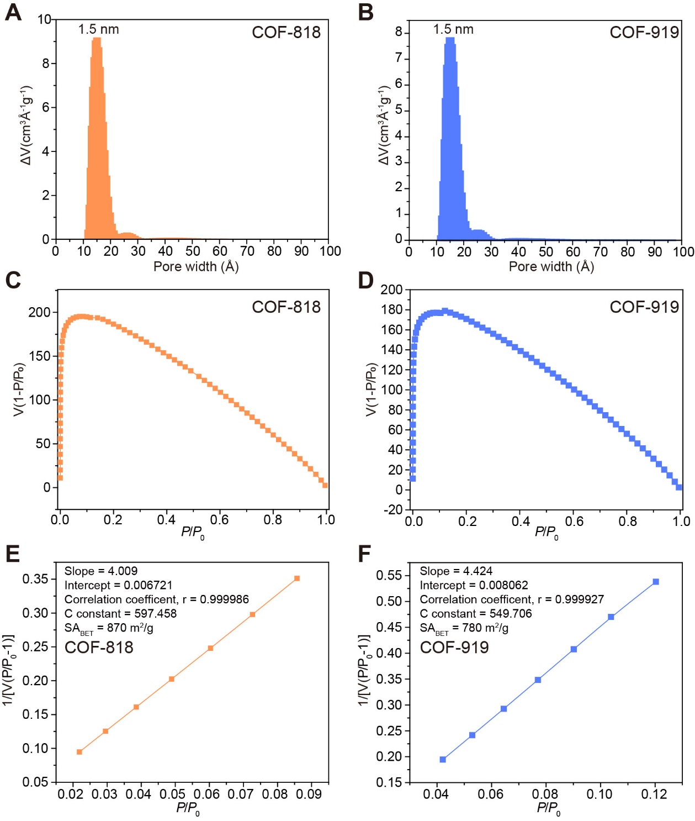
Fig. S8. BET surface area was calculated for COF-818 and COF-919, based on nitrogen adsorption isotherm at 77 K. (A) and (B) pore size distribution of COF-818 and COF-919, (C) to (F) plot shows good fitting to the BET model.

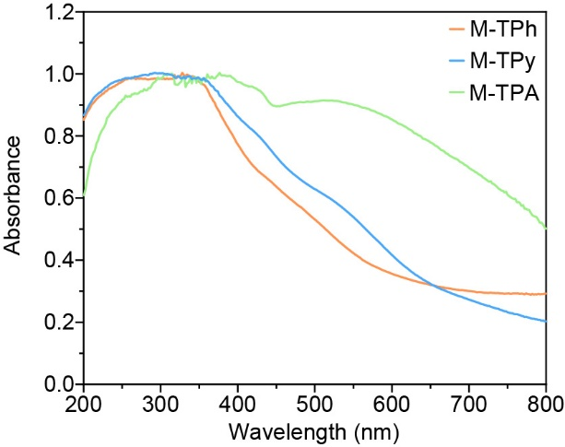
Fig. S9. Light absorbance property of monomers.

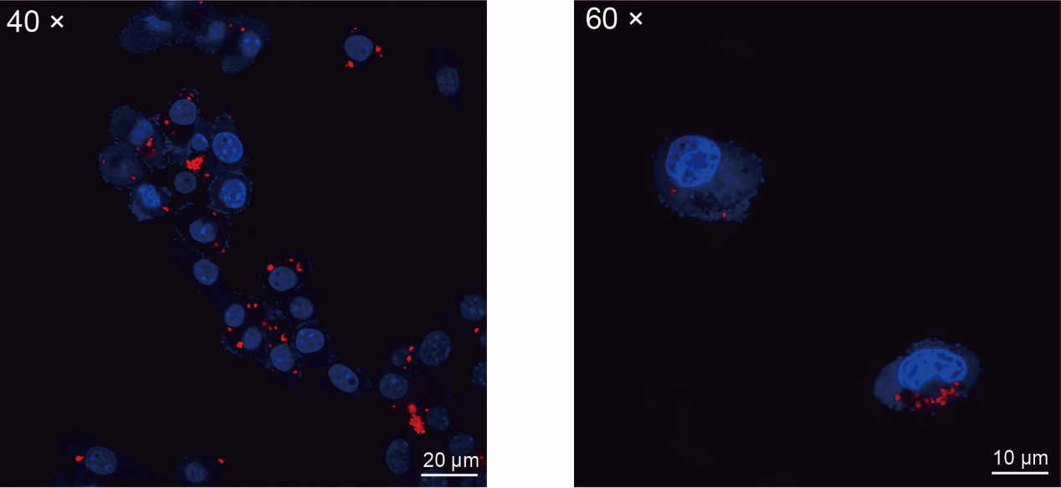
Fig. S10. Intracellular uptake of COF-919 in 4T1 cells, detected by confocal microscopy.

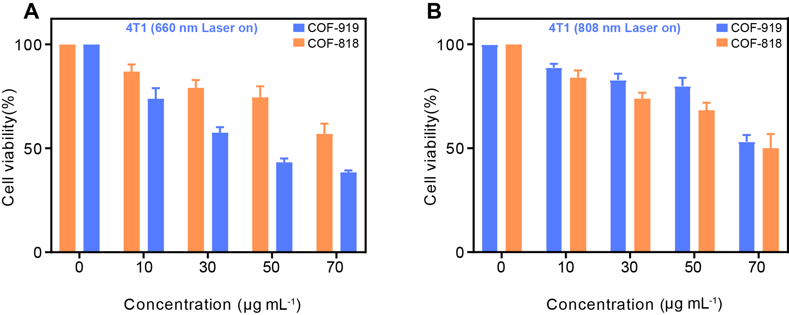
Fig. S11. Cytotoxicity of COF-818 and COF-919 at different concentrations under 660 nm or 808 nm laser irradiation.

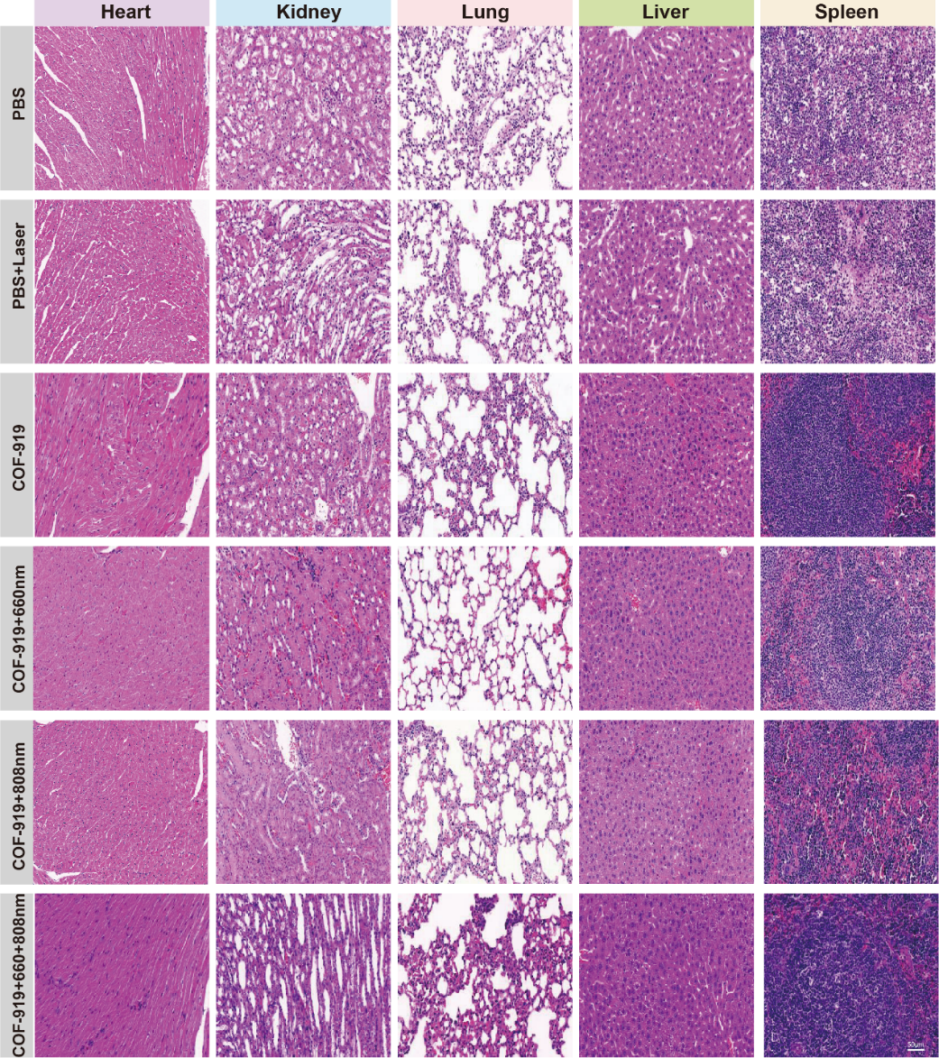
Fig. S12. Representative H&E staining of major organs of differently treated mice,
including hearts, livers, spleens, lungs, and kidneys, scale bar = 50 μm.

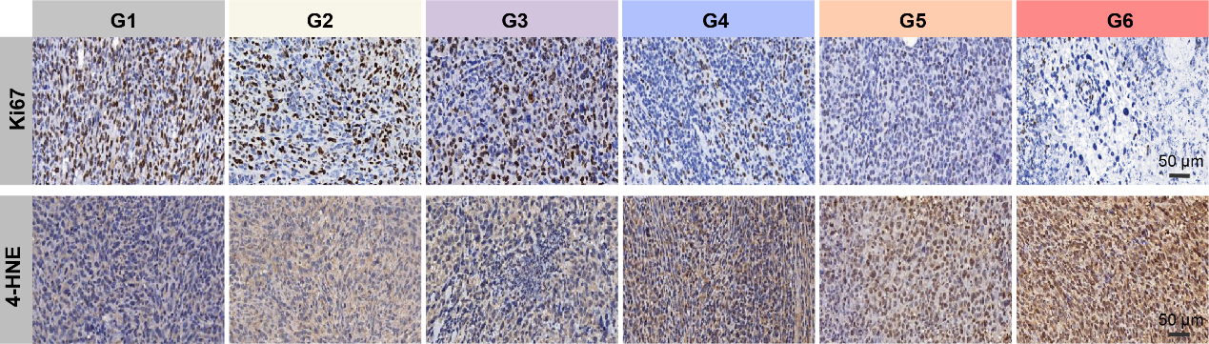

Fig. S13. Representative 4-HNE and Ki67 images of tumor tissues under different treatments, scale bar = 50 μm.

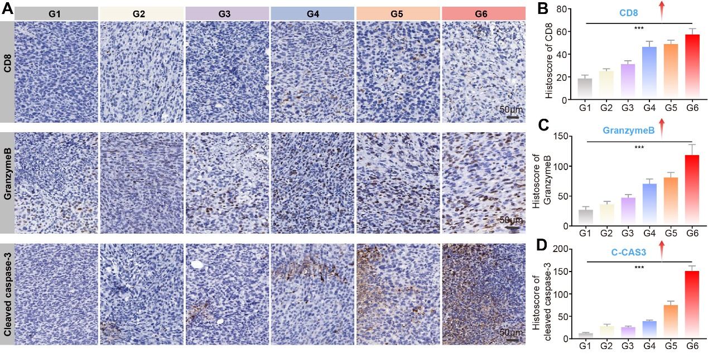
Fig. S14. Quantification and representative immunohistochemical images of CD8, Granzyme B, and cleaved caspase-3 under different treatments, scale bar = 50 μm.

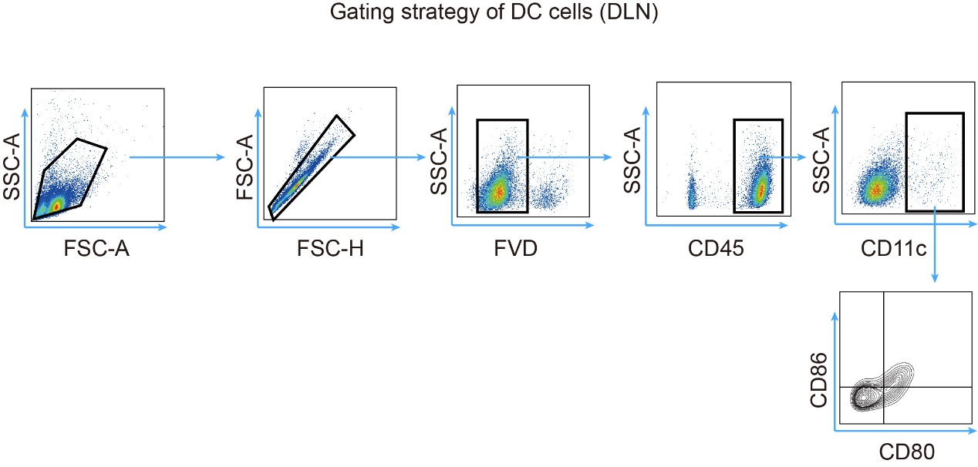
Fig. S15. Gating strategy of DC cells in draining lymph nodes (DLN).

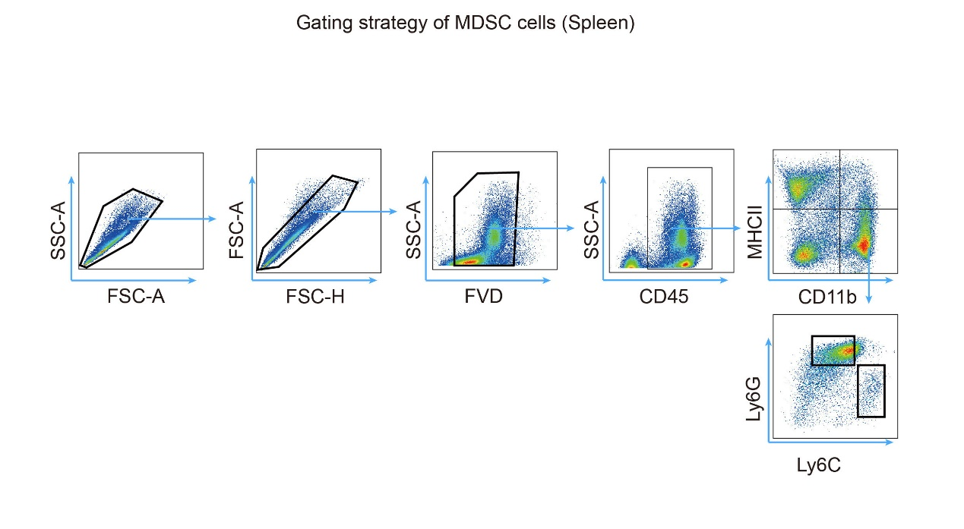
Fig. S16. Gating strategy of myeloid-derived suppressor cells (MDSCs) in spleen.

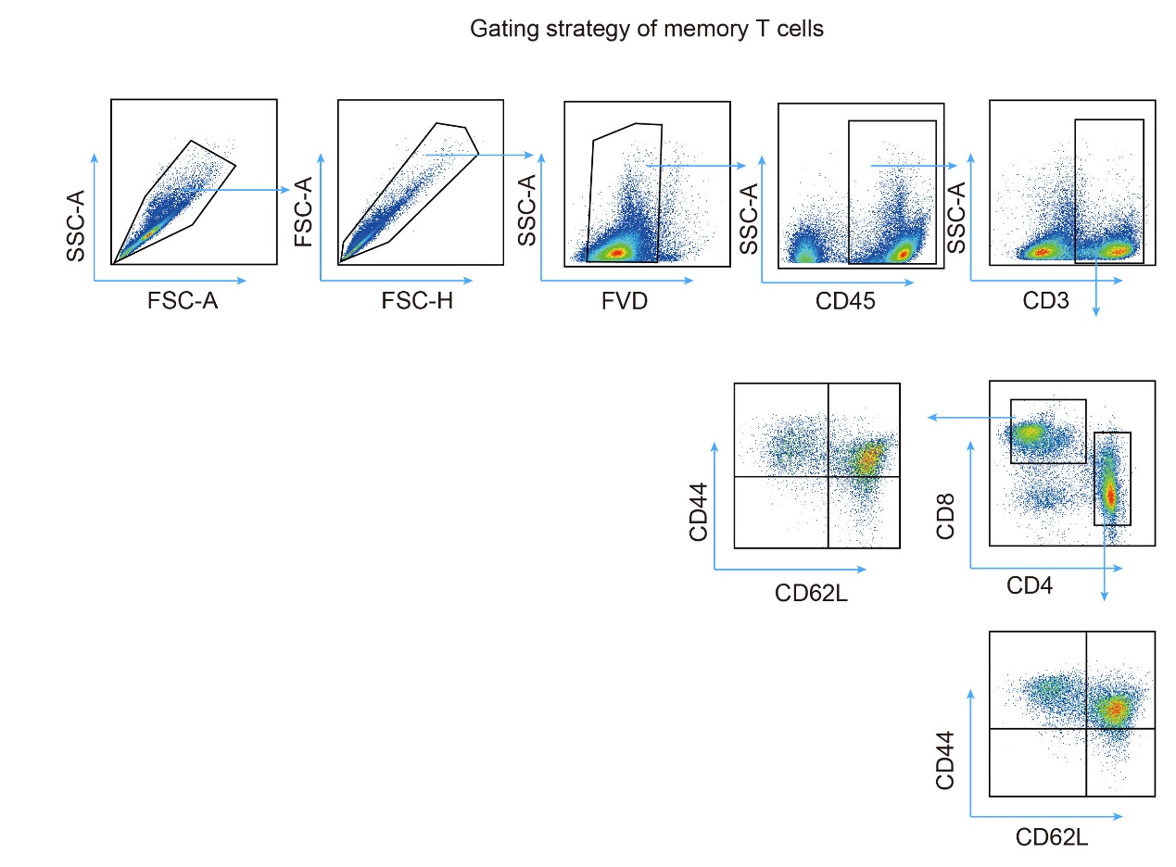
Fig. S17. Gating strategy of memory T cells.

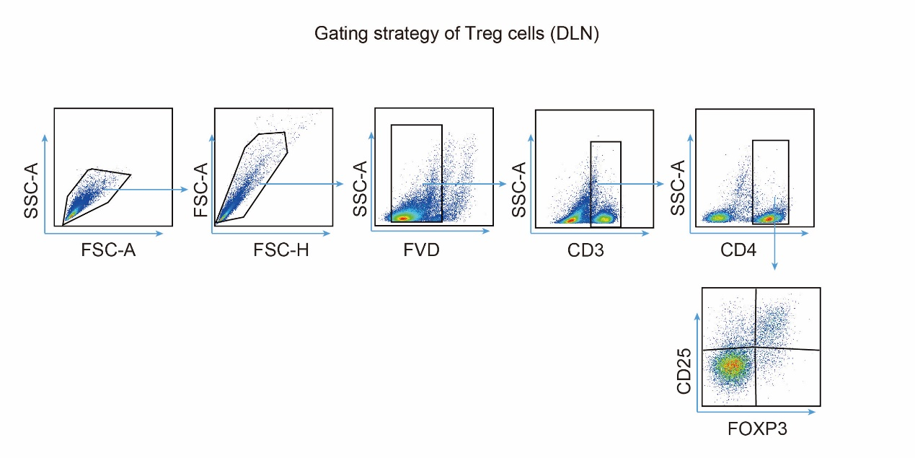
Fig. S18. Gating strategy of Treg cells in draining lymph nodes (DLN).

