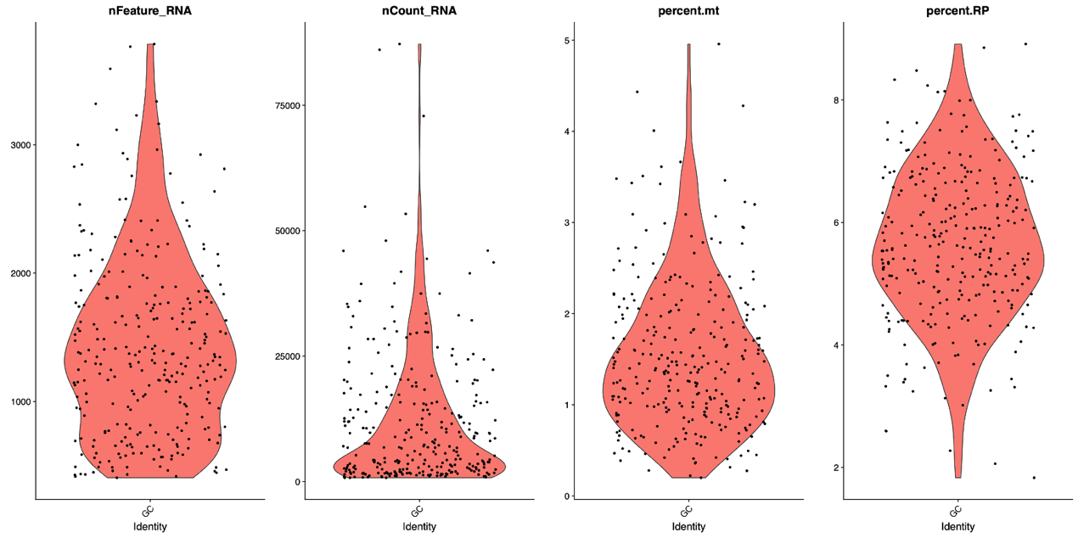
Supplementary Figure1 Single cell RNA sequencing analyses of GCs
Violin plots showing the number of genes, the number of UMI, the percentage of mitochondrial gene filter and the percentage of ribosomal protein filter by samples.

Supplementary Figure2 Comparison of CD24 mRNA expression in pregnant persons and non-pregnancy group
CD24 mRNA expression was highly expressed in granulosa cells in the pregnant group (*p< 0.05).

