Supplementary data

Multicore-shell MnO₂@Ppy@N-doped porous carbon nanofiber ternary composites as electrode materials for high-performance supercapacitors
Yi Wang^{1#}, Jie Wang#,Dong Wei, Lan Xu¹*
¹National Engineering Laboratory for Modern Silk, College of Textile and Engineering, Soochow University, 199 Ren-ai Road, Suzhou 215123, China

Table S1 Factors, actual values and levels for Box-Behnken design
Factors | Actual values of coded levels
Factors | Symbol | -1 | 0 | 1
Temperature（℃） | A | 120 | 160 | 200
Molar ratio | B | 1:3 (0.33) | 5:3 (1.67) | 9:3 (3.00)
Time（h） | C | 2 | 6 | 10

Table S2 Box-Behnken design and response
 | Design variables (Actual values) |  |  | Response (Actual values)
RUN | A: Temperature (℃) | B: Molar ratio | C: Time (h) | Specific capacitance (F/g)
1 | 120.00 | 3.00 | 6.00 | 578.12
2 | 120.00 | 1.67 | 10.00 | 569.02
3 | 160.00 | 1.67 | 6.00 | 587.45
4 | 200.00 | 3.00 | 6.00 | 546.79
5 | 200.00 | 1.67 | 10.00 | 527.86
6 | 200.00 | 0.33 | 6.00 | 511.34
7 | 160.00 | 1.67 | 6.00 | 588.08
8 | 160.00 | 1.67 | 6.00 | 583.53
9 | 160.00 | 1.67 | 6.00 | 589.11
10 | 200.00 | 1.67 | 2.00 | 551.44
11 | 120.00 | 0.33 | 6.00 | 559.37
12 | 120.00 | 1.67 | 2.00 | 573.13
13 | 160.00 | 3.00 | 10.00 | 554.58
14 | 160.00 | 0.33 | 10.00 | 523.24
15 | 160.00 | 0.33 | 2.00 | 531.33
16 | 160.00 | 9.00 | 2.00 | 571.43
17 | 160.00 | 5.00 | 6.00 | 583.53

Table S3 Analysis of variance of the SC regression model
Source (Term) | Sum of squares (SS) | Degree of freedom (DF) | Mean of squares (MS) | F-value | P-value
Model | 9983.28 | 9 | 1109.25 | 82.82 | <0.0001 | Significant
A | 2422.43 | 1 | 2422.43 | 180.86 | <0.0001 | Significant
B | 1880.07 | 1 | 1880.07 | 140.36 | <0.0001 | Significant
C | 346.24 | 1 | 346.24 | 25.85 | 0.0014 | Significant
AB | 97.02 | 1 | 97.02 | 7.24 | 0.0310 | Significant
AC | 94.77 | 1 | 94.77 | 7.08 | 0.0325 | Significant
BC | 19.18 | 1 | 19.18 | 1.43 | 0.2703 | not Significant
AA | 852.21 | 1 | 852.21 | 63.63 | <0.0001 | Significant
BB | 2515.88 | 1 | 2515.88 | 187.83 | <0.0001 | Significant
CC | 1250.97 | 1 | 1250.97 | 93.40 | <0.0001 | Significant
Residua | 93.76 | 7 | 13.39 | - | - | -
Lack of Fit | 74.97 | 3 | 24.99 | 5.32 | 0.0701 | not Significan
Pure Error | 18.79 | 4 | 4.70 | - | - | -
Total | 10077.04 | 16 | - | - | - | -
R²=0.9907 Adj-R² =0.9787

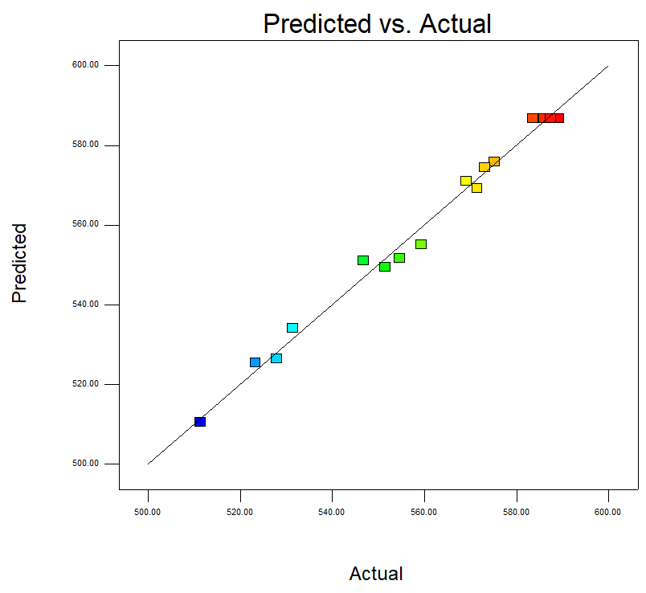
Fig. S1. Predicted and actual SC of MnO₂@Ppy@NPCNFs synthesized by hydrothermal synthesis

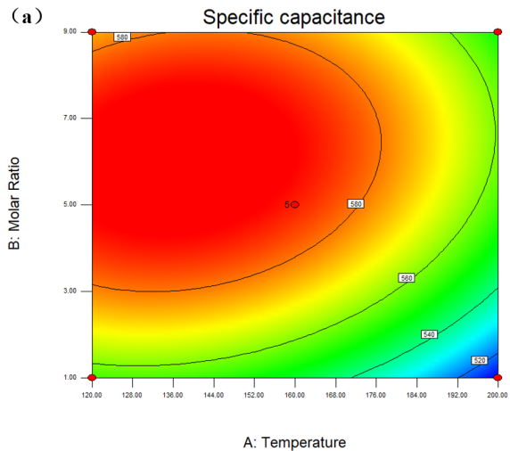 | 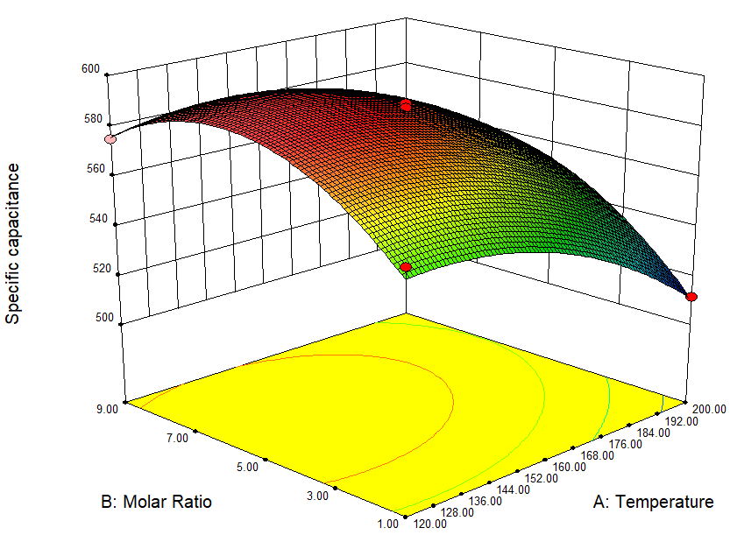
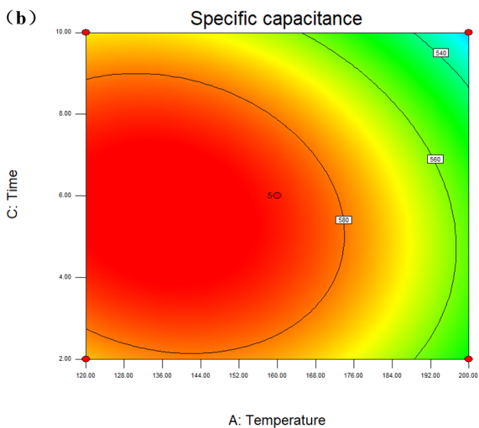 | 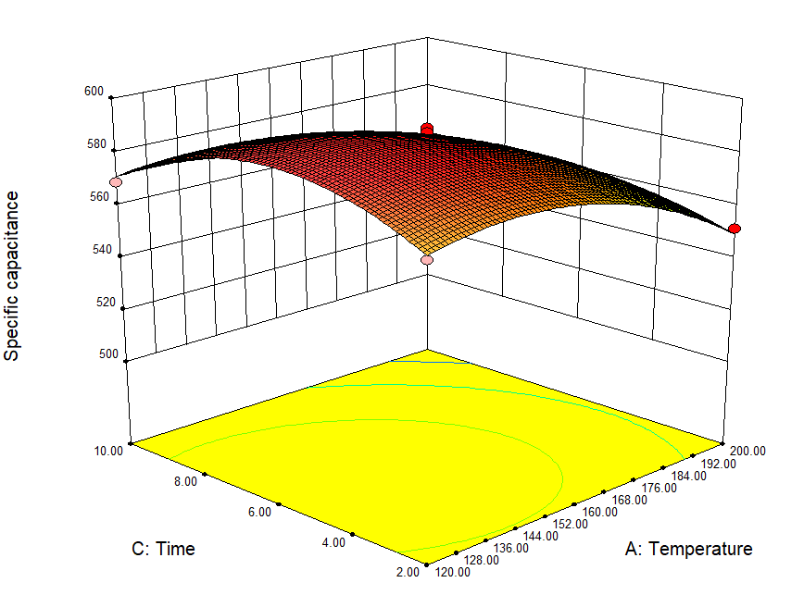
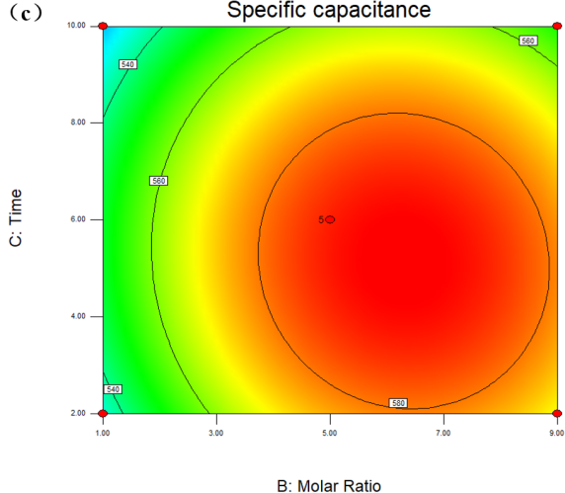 | 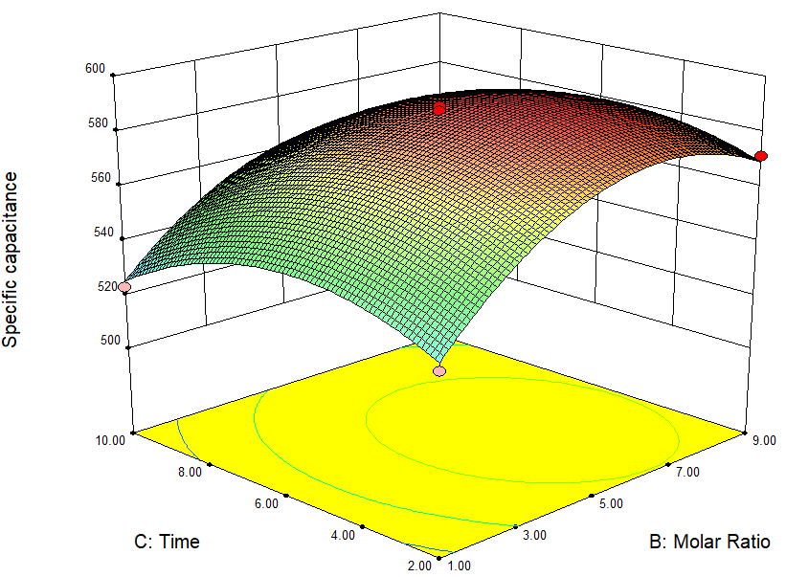
Fig. S2. Contour and three-dimensional response surface plots of the SC of MnO₂@Ppy@NPCNFs as a function of reaction temperature and molar ratio (a), reaction temperature and time (b) and reaction time and molar ratio (c), respectively .

Table S4 Electrochemical performances of the reported MnO₂-loaded carbon materials.
Precursor material | Electrolyte | Specific capacitance(F/ g) | Capacitance retention | Ref.
g-MnO₂/NCNFs | 1 M Na₂SO₄ | 125 ( 0.5 A/g ) | 92.1% (1,000) | [1]
C/Mn(10)/C | 6 M KOH | 220 (1 A/cm² ) | 94%(10,000) | [2]
Core−shell Mn₂O₃@MnO₂-0.3 | 1 M Na₂SO₄ | 225 (5 A/g） | 86.5%(5,000) | [3]
N-G/MnO₂ | 1 M Na₂SO₄ | 411.5 (0.5 A/g) | 88.3% (4,000) | [4]
NiCoO_{x}/C/MnO₂ | 2 M KOH | 431.7 (0.5 A/g) | 68.1%( 8800) | [5]
Mn@ZnO/CNF | 6 M KOH | 501 (1 A/g) | 92% (10,000 ) | [6]
MnO₂@C-110 | 6 M KOH | 665.3 (1 A/g) | 87.2%( 5,000) | [7]
β-NiCo(OH)₂/γ-MnO₂ | 3 M KOH | 879.7 (3 A/g) | 94.3%(5,000) | [8]
MnO₂/ Ni(OH)₂ /NCNFs | 1 M KOH | 1133.3 (1 A/g) | 76.6%(6,000) | [9]
Ppy@NPCNFs-0 | 6 M KOH | 342.13 (1 A/g) | 95.4% (1,000 ) | Our previous work [10]
MnO₂@Ppy@NPCNFs | 6 M KOH | 595.77 (1 A/g) | 96.2% (1,000 ) | This work

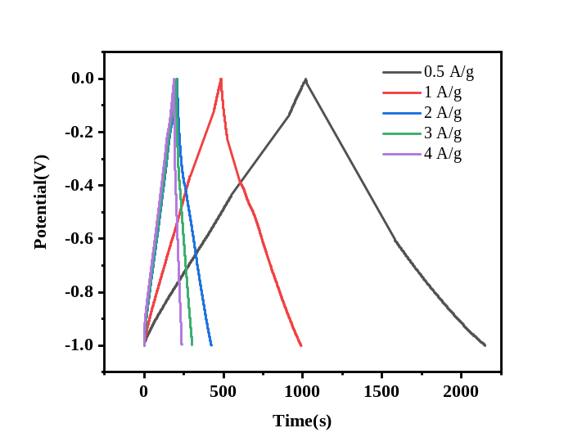
Fig. S3. GCD curves at different current densities of MnO₂@Ppy@NPCNFs.

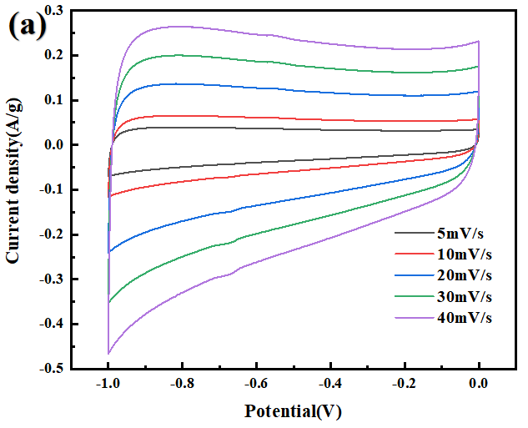 | 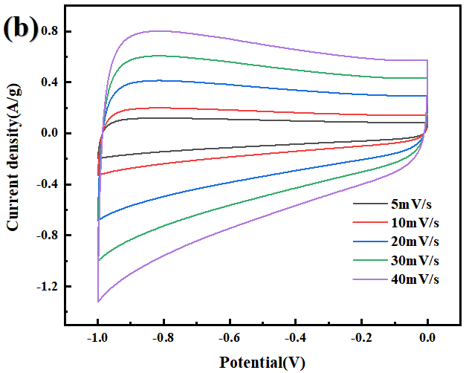
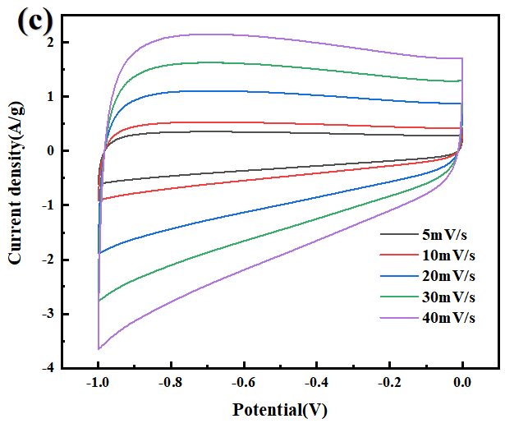 | 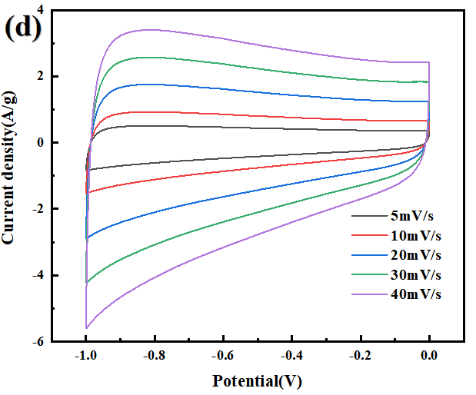
Fig. S4. CV curves at different scan rates of PCNFs (a), NPCNFs (b), Ppy@NPNCFs (c), MnO₂@Ppy@NPCNFs (d).

Table S5 Comparison of MnO₂@Ppy@NPCNFs-0 and reported supercapacitor devices.
Positive// negative electrode | Electrolyte | Capacitance 3E system(F/g) | E_{m} (Wh /kg) | P_{m} (W /kg) | Capacitance retention | Ref.
Mn₂O₃@MnO_{2-0.3//}  AC | 1 M Na₂SO₄ | 225 ( 5 A/g) | 27 | 90 | 84% (5,000 ) | [3]
OZM Nanotubes// OZM Nanotubes | 3 M KOH | 101.9 (20 mV/s) | 3.40 | 350 | 91.2% (5500) | [11]
MnCo₂O₄ NPs// MnCo₂O₄ NPs | 1 M NaNO₃ | 270 (10 mV/s) | 14.85 | 495 | 92.4% (1,000) | [12]
MnO₂-aCNFs//MnO₂-aCNFs | 1 M Na₂SO₄ | 324.55 (0.5 A/g ) | 16.7 | 400 | 97% (10,000 ) | [13]
NCCM-PiT//CNFs | 2 M KOH | 431.7 (0.5 A/g) | 46.4 | 400 | 68.1% (8,000) | [5]
MnCo₂O₄ Nanosheets  //MnCo₂O₄ Nanosheets | 2 M KOH | 250 (0.25 A/g) | 10.04 | 5200 | 95%  (1,000) | [14]
β-NiCo(OH)₂/γ-MnO₂//AC | 3 M KOH | 879.7 (3 A/g) | 24.43 | 5312 | 94.2% (5,000) | [8]
Asymmetric Mn₃O₄/rGO // AC | 1 M Na₂SO₄ | 66.18 (0.5 A/g) | 36.76 | 10,000 | 93%  (5,000) | [15]
Ni–Mn oxides NPs/CNT@CNF//Ni–Mn oxides NPs/CNT@CNF | 1 M KOH | 187 (0.37 A/g) | 16.6 | 12,000 | 96.4%  (10,000 ) | [16]
r α-MnO₂/β-MnO₂ network//RGO | 1 M Na₂SO₄ | 278.2 (0.25 A/g) | 1.81 | 64,000 | 95% (5,000) | [17]
Ppy@NPCNFs-0//Ppy@NPCNFs-0 | 6 M KOH | 342.13 (1A/g) | 3.10 | 50 | -- | Our previous work [10]
MnO₂@Ppy@NPCNFs//  MnO₂@Ppy@NPCNFs | 6 M KOH | 595.77 (1 A/g) | 9.36 | 1,000 | 93.75% (1,000 ) | This work

- Shi K, Giapis KP. Scalable fabrication of supercapacitors by nozzle-free electrospinning. ACS Appl Energ Mater 2018; 1(2): 296-300.
- Kim ES, Lee H-J, Kim B-H. Sandwich-structured carbon nanofiber/MnO₂/carbon nanofiber composites for high-performance supercapacitor. Electrochim Acta 2022; 406:139883.
- Wei L, Yuan L, Man Y, Xin J, Yanxia Z, Yan X. Construction of Hierarchical Mn₂O₃@MnO₂ core–Shell nanofibers for enhanced performance supercapacitor electrodes. ACS Appl Energ Mater 2020; 3(9):
- 8190-7.Le QJ, Huang M, Wang T, et al. Biotemplate derived three dimensional nitrogen doped graphene@MnO₂ as bifunctional material for supercapacitor and oxygen reduction reaction catalyst. J Colloid Interface Sci 2019; 544: 155-63.
- Nie G, Luan Y, Kou Z, et al. Fiber-in-tube and particle-in-tube hierarchical nanostructures enable high energy density of MnO₂-based asymmetric supercapacitors. J Colloid Interface Sci 2021; 582(Pt B): 543-51.
- Samuel E, Joshi B, Kim M-W, Kim Y-I, Swihart MT, Yoon SS. Hierarchical zeolitic imidazolate framework-derived manganese-doped zinc oxide decorated carbon nanofiber electrodes for high performance flexible supercapacitors. Chem Eng J 2019; 371: 657-65.
- Xie Y, Yang C, Chen P, Yuan D, Guo K. MnO₂-decorated hierarchical porous carbon composites for high-performance asymmetric supercapacitors. J Power Sources 2019; 425: 1-9.
- Gowrisankar A, Selvaraju T. Anchoring gamma-MnO₂ within beta-NiCo(OH)₂ as an interfacial electrode material for boosting power density in an asymmetric supercapacitor device and for oxygen evolution catalysis. Langmuir 2021; 37(19): 5964-78.
- Nie G, Zhang Z, Liu Y, et al. One-Pot Rational deposition of coaxial double-layer MnO₂/Ni(OH)₂ nanosheets on carbon nanofibers for high-performance supercapacitors. Adv Fiber Mater 2022.
- Gao L, Wang Y, Liu Y , Xu L. Core-shell Ppy@N-doped porous carbon nanofiber-based electrodes for high-property supercapacitors. Colloids Surf Physicochem Eng Aspects; 2023; 366: 131056.
- Yang C-H, Chen Y-C, Wu C-F, Chung R-J, Yougbaré S, Lin L-Y. Novel synthesis of ZIF67-derived MnCo₂O₄ nanotubes using electrospinning and hydrothermal techniques for supercapacitor. J Solid State Chem 2022; 313: 123351.
- Shanmugavadivel M, Dhayabaran VV, Subramanian M. Fabrication of high energy and high power density supercapacitor based on MnCo₂O₄ nanomaterial. J Phys and Chem Solids 2019; 133: 15-20.
- Shanmugavadivel M, Dhayabaran VV, Subramanian M. MnO₂-based carbon nanofiber cable for supercapacitor applications. J Energy Storage 2021; 33: 102130.
- Sahoo S, Naik KK, Rout CS. Electrodeposition of spinel MnCo(2)O(4) nanosheets for supercapacitor applications. Nanotechnology 2015; 26(45): 455401.
- Huang Z, Li S, Li Z, et al. Mn₃O₄ nanoflakes/rGO composites with moderate pore size and (O=)C-O-Mn bond for enhanced supercapacitor performance. J Alloy Compd 2020; 830: 154637.
- Fernando N, Chinnappan A, Aziz A, Abdelkader A, Ramakrishna S, Welland ME. Flexible free-standing Ni-Mn oxide antenna decorated CNT/nanofiber membrane for high-volumetric capacitance supercapacitors. Nanoscale 2021; 13(45): 19038-48.
- Shijin Z, Wang T, Liu X, et al. Low-Charge-Carrier-Scattering three-dimensional α-MnO₂/β-MnO₂ networks for ultra-high-Rate asymmetrical supercapacitors. ACS Appl Energ Mater 2018; 2(2): 1051-9.

# These authors contributed equally to the work. * Corresponding author. lanxu@suda.edu.cn (L. Xu)

