SUPPLEMENTARY MATERIAL
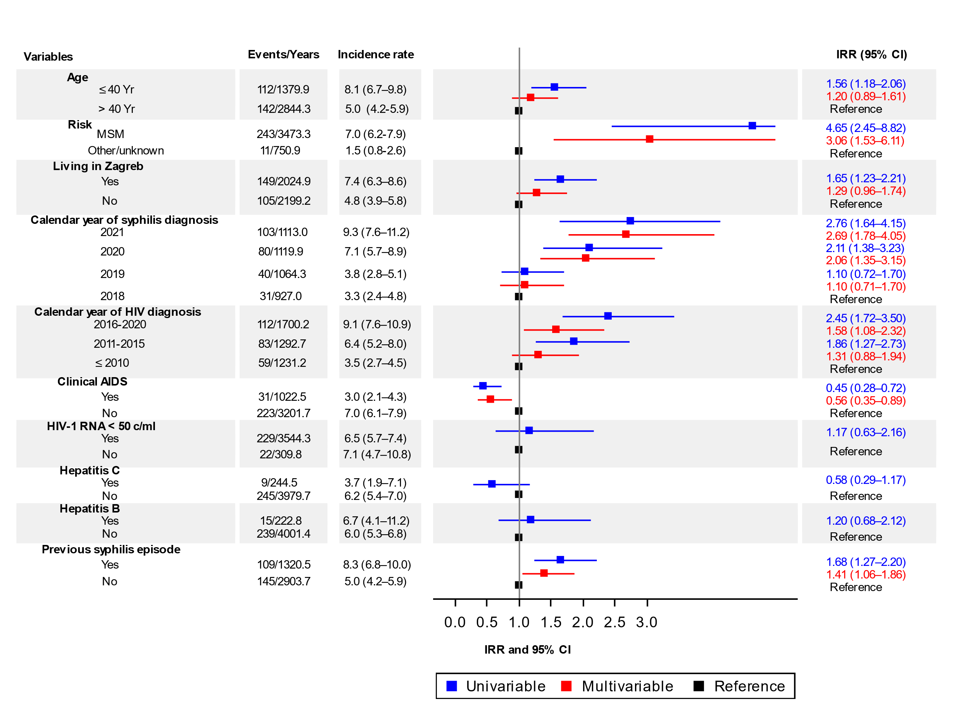

Supplementary Figure 1: Rates of incident syphilis per 100 PYFU with 95% confidence interval in men living with HIV by sociodemographic and clinical characteristics and crude (univariable) and multivariable IRR for syphilis events, Croatia, 2018 to 2021. Years are person-years of follow-up. The overall incidence rate per 100 PYFU was 6.0 (95% CI, 5.3–6.8).
MSM, men who have sex with men; IRR, incidence rate ratio; CI, confidence intervals PYFU, person-years of follow-up; Clinical AIDS, HIV-1 RNA, hepatitis C and previous syphilis diagnosis were time-updated variables. IRR are based on a generalized estimating equations model with an exchangeable correlation structure. The upper 95% CI for risk is truncated.
The 95% confidence intervals for the rate per 100 person-years of follow-up was calculated using the Rothman/Greenland estimation.

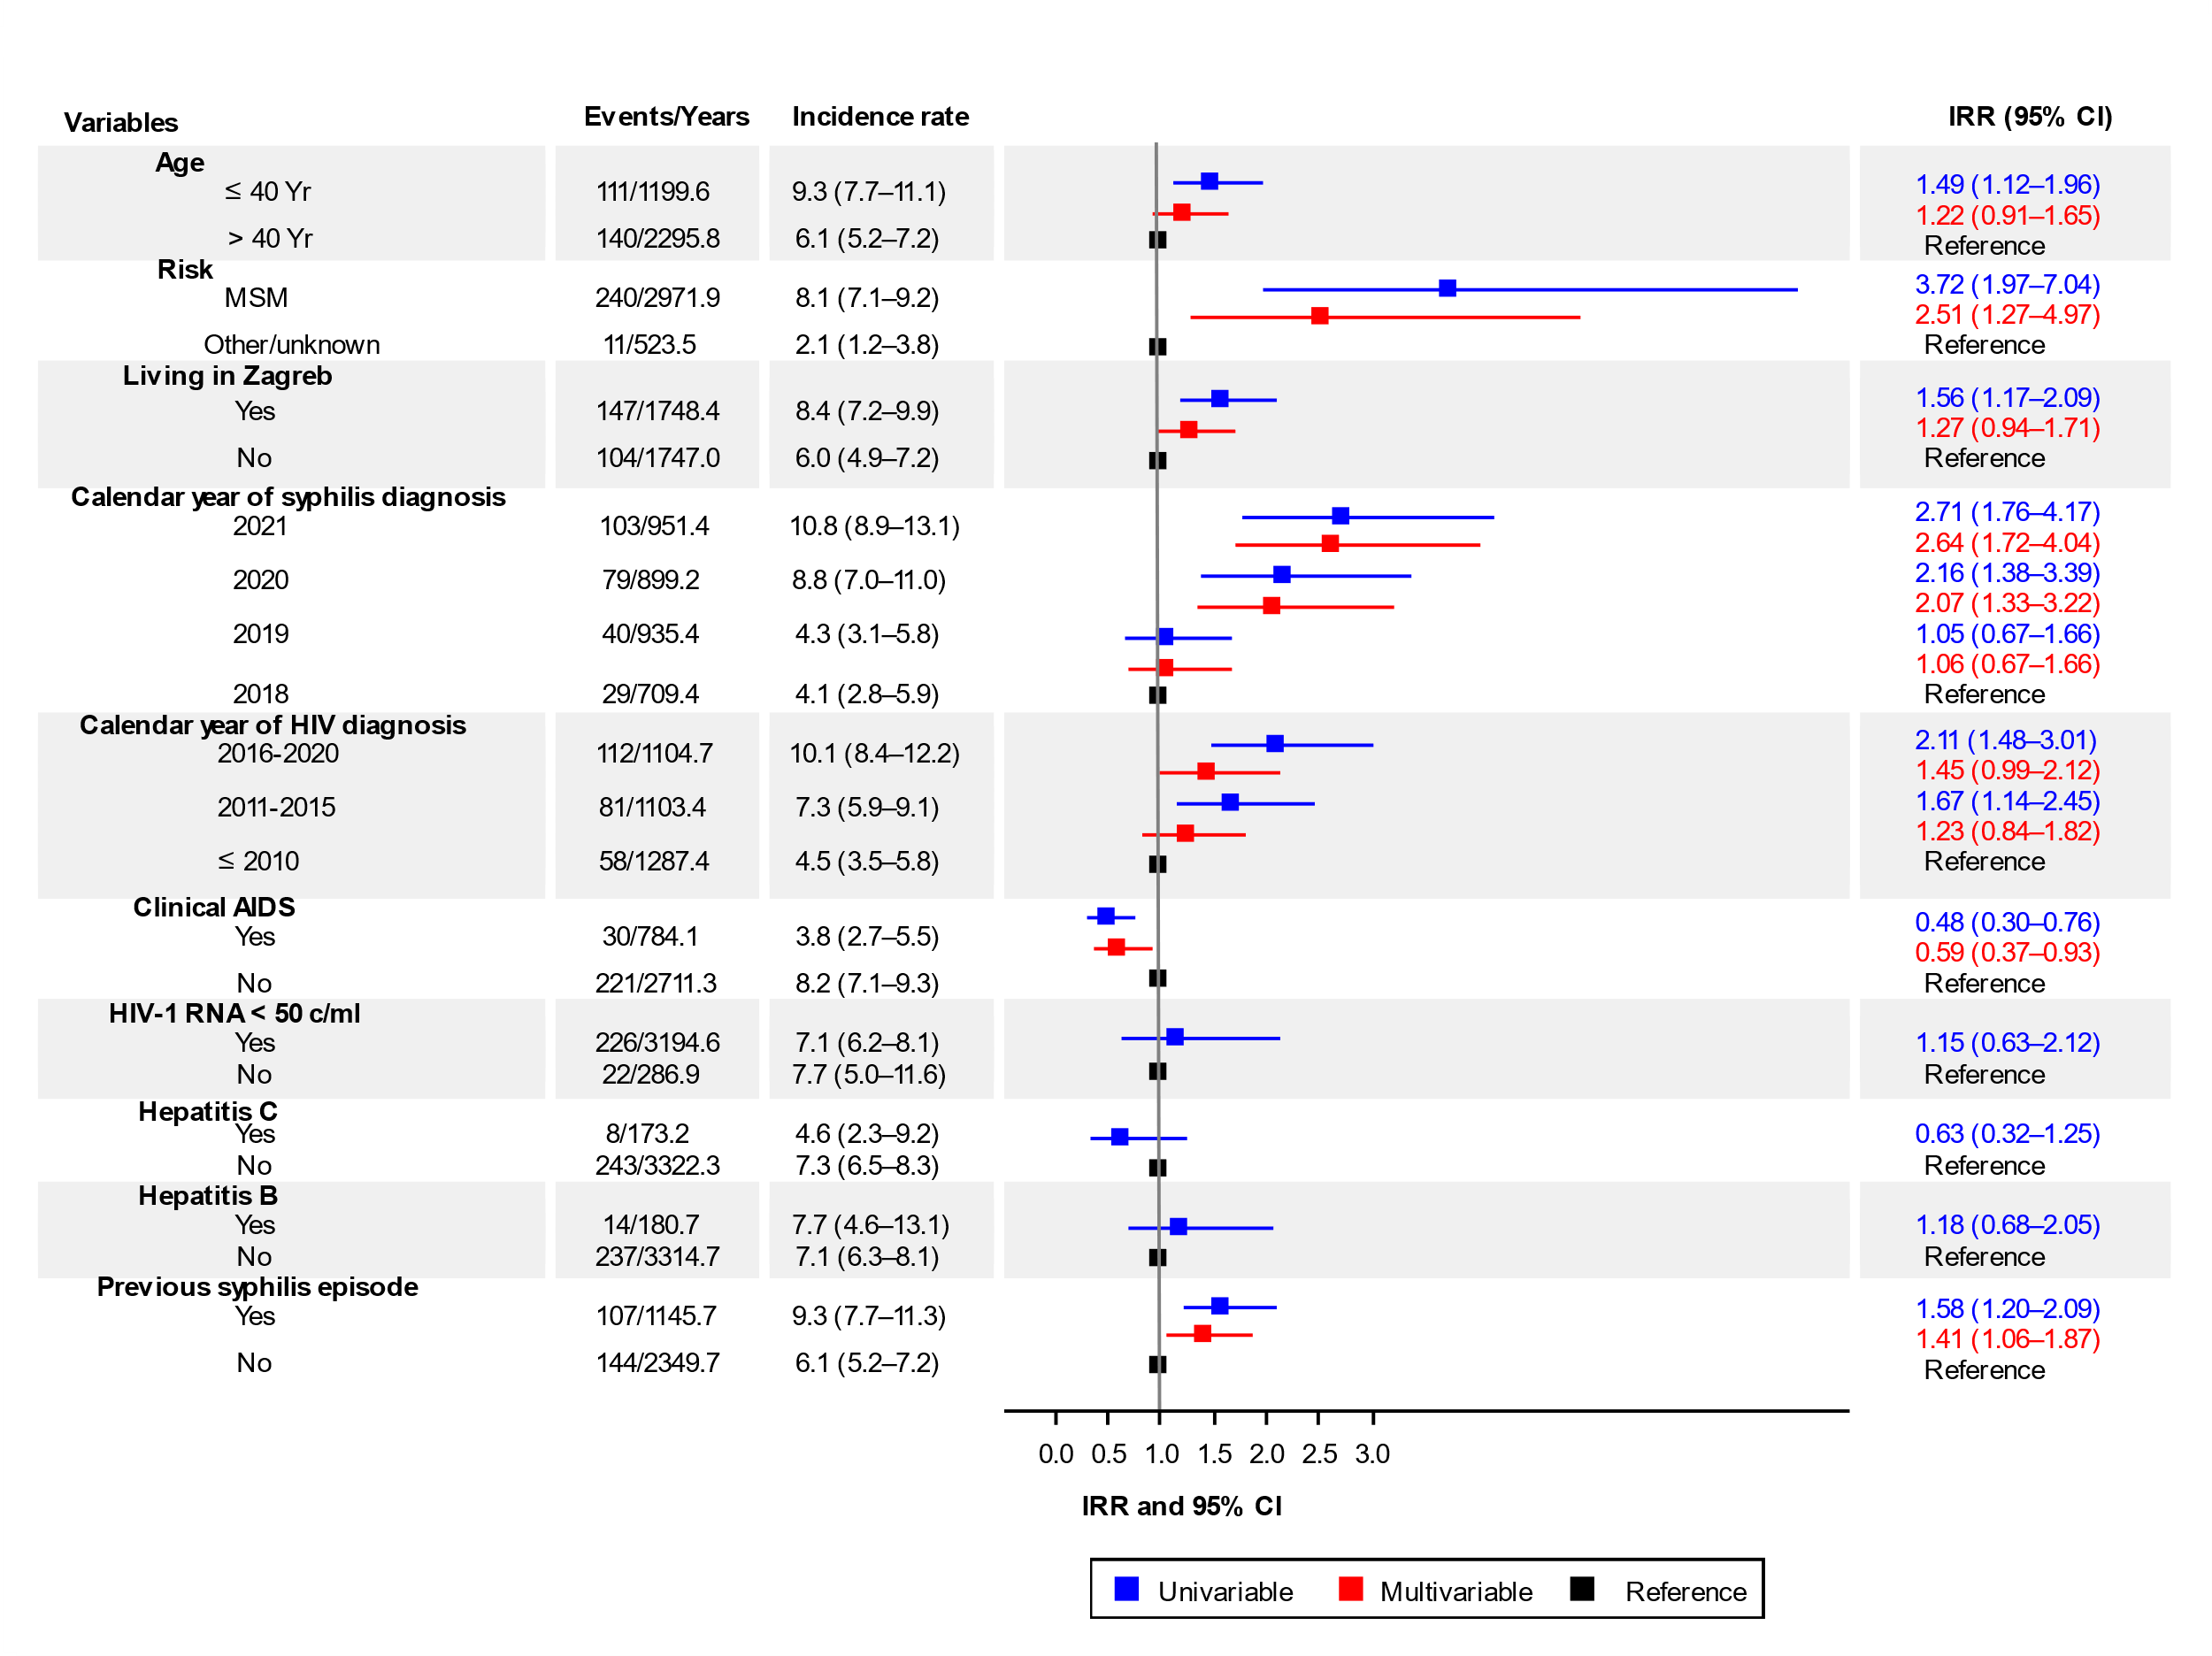
Supplementary Figure 2:
Rates of incident syphilis per 100 PYFU with 95% confidence interval in men living with HIV who had at least one syphilis test done annually by sociodemographic and clinical characteristics and crude (univariable) and multivariable IRR for syphilis events, Croatia, 2018 to 2021. Years are person-years of follow-up. The overall incidence rate per 100 PYFU was 7.2 (95% CI, 6.3–8.1).
MSM, men who have sex with men; IRR, incidence rate ratio; CI, confidence intervals; PYFU, person-years of follow-up; Clinical AIDS, HIV-1 RNA, hepatitis C and previous syphilis diagnosis were time-updated variables. IRR are based on a generalized estimating equations model with an exchangeable correlation structure. The 95% confidence intervals for the rate per 100 person-years of follow-up was calculated using the Rothman/Greenland estimation.

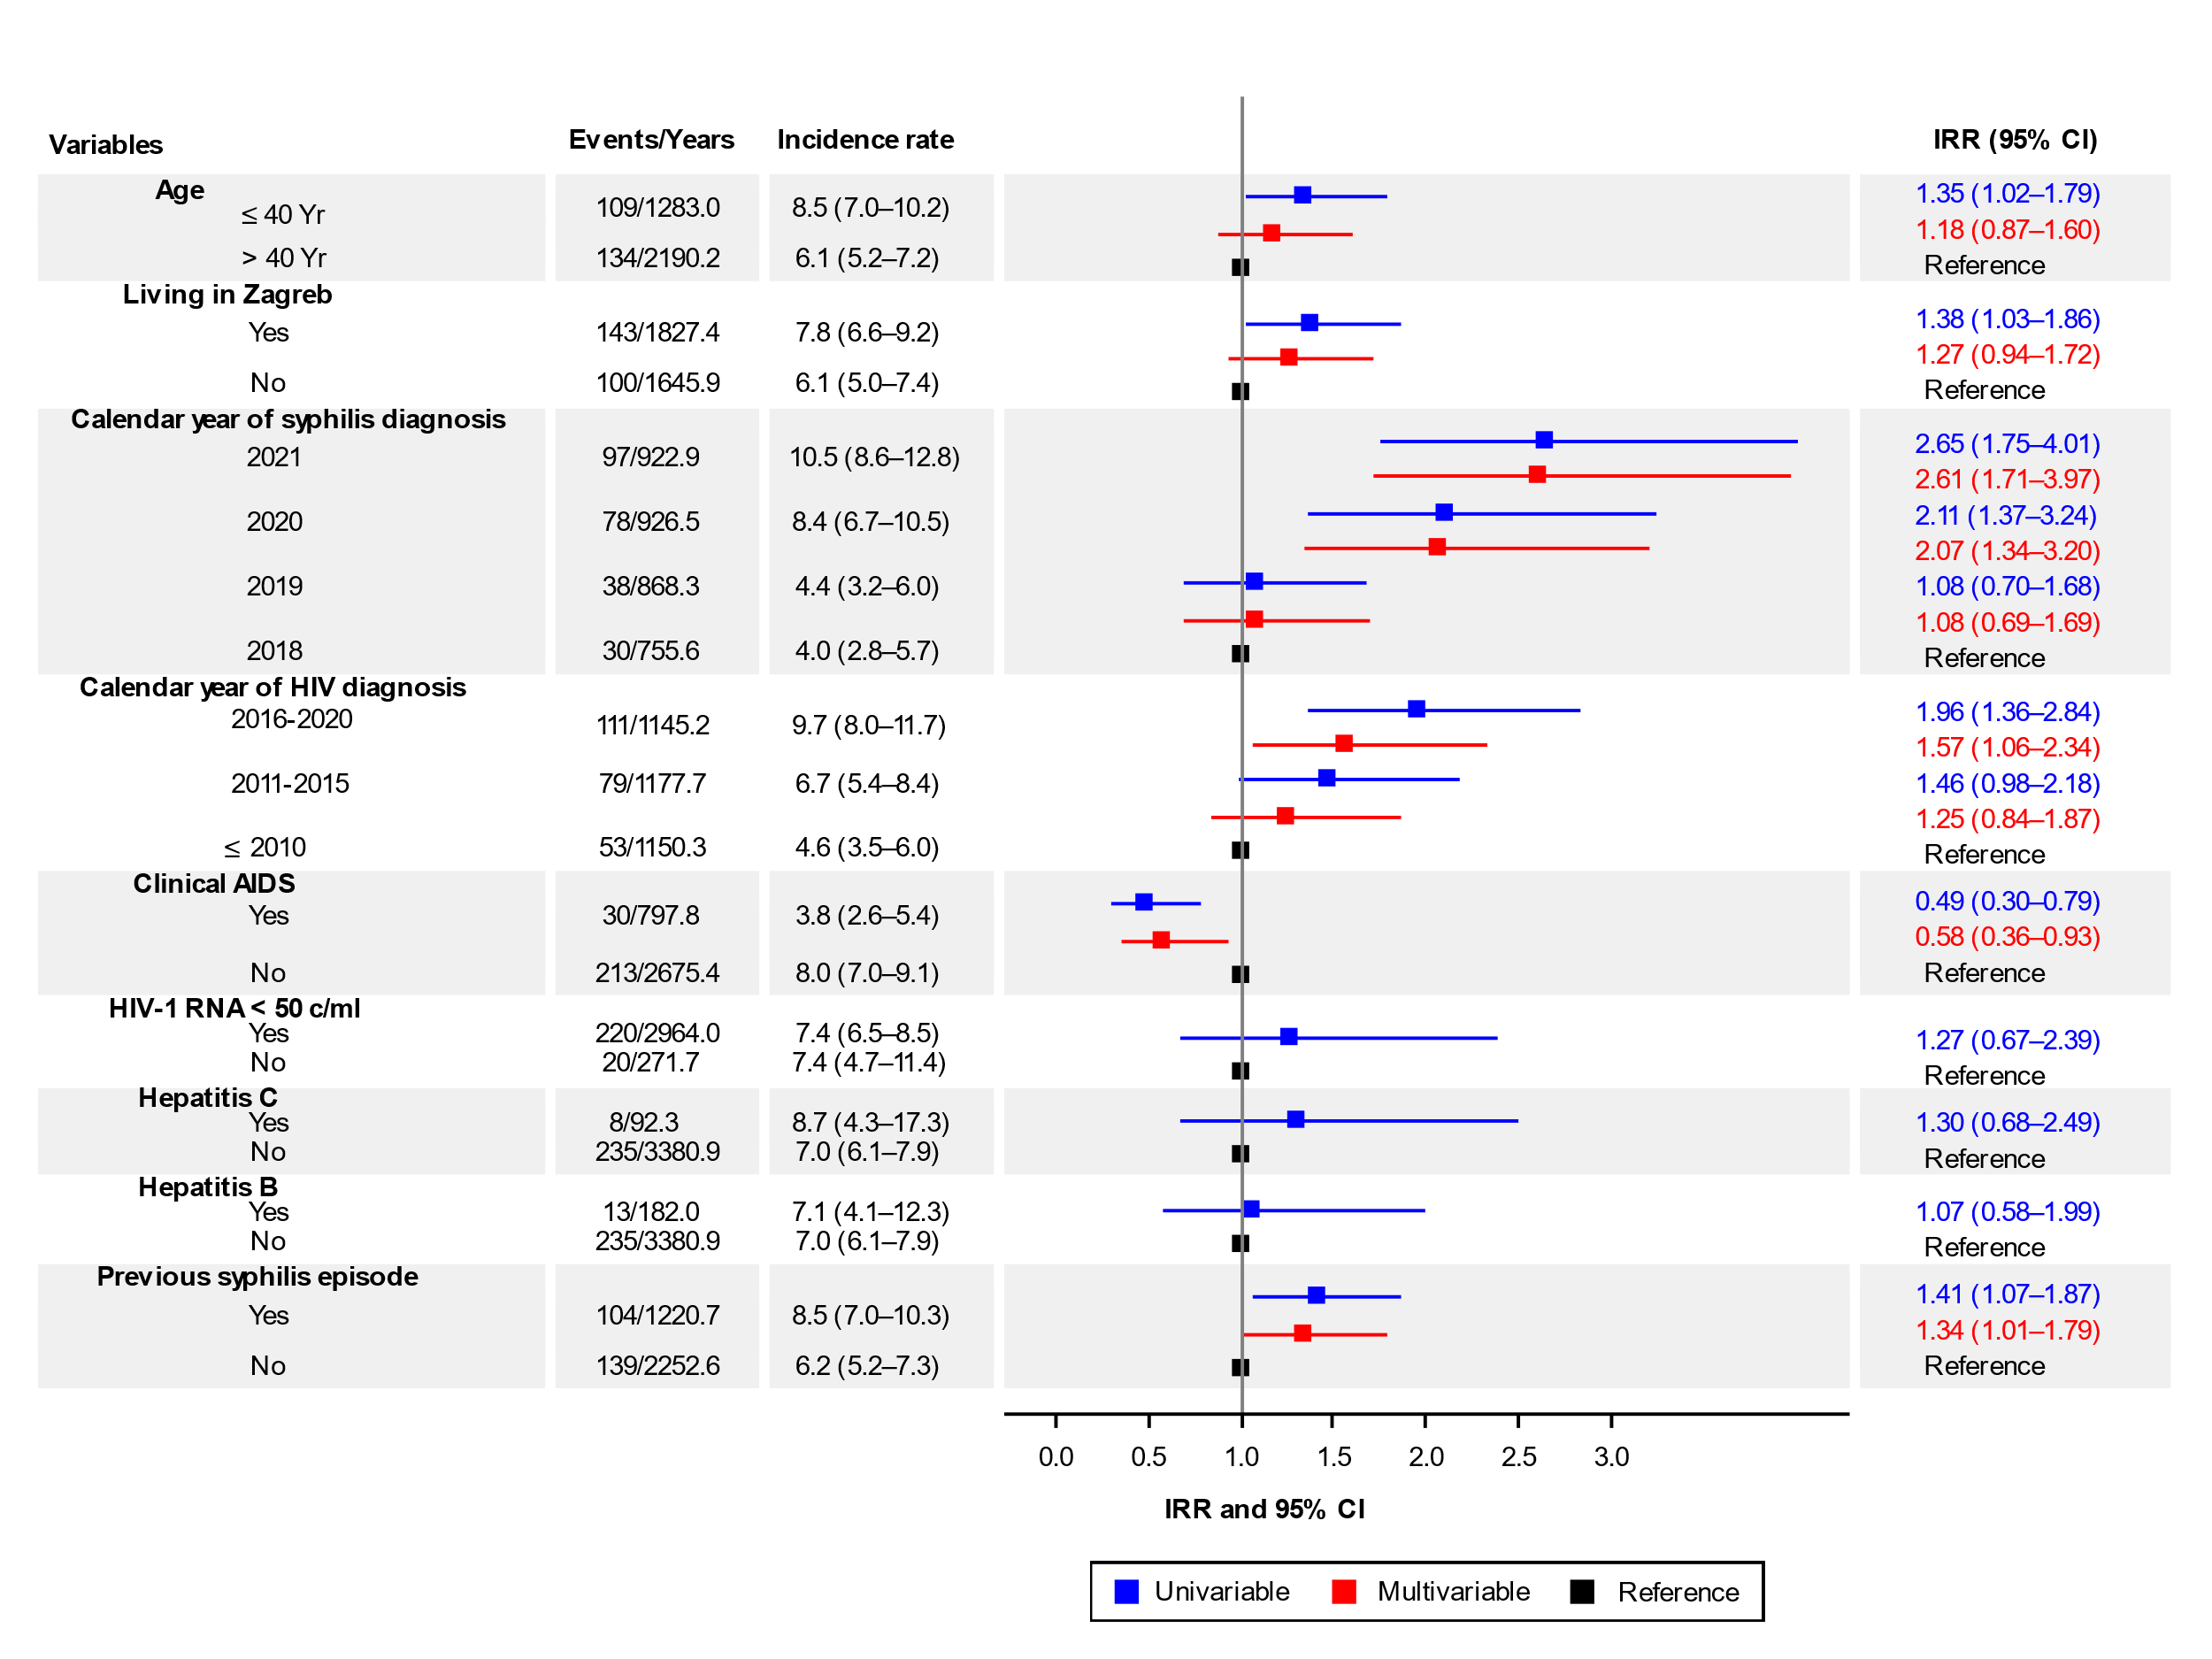
Supplementary Figure 3:
Rates of incident syphilis per 100 PYFU with 95% confidence interval in MSM living with HIV by sociodemographic and clinical characteristics and crude (univariable) and multivariable IRR for syphilis events, Croatia, 2018 to 2021. Years are person-years of follow-up. The overall incidence rate per 100 PYFU was 7.0 (95% CI, 6.2–8.0).
MSM, men who have sex with men; IRR, incidence rate ratio; CI, confidence intervals; PYFU, person-years of follow-up; Clinical AIDS, HIV-1 RNA, hepatitis C and previous syphilis diagnosis were time-updated variables. IRR are based on a generalized estimating equations model with an exchangeable correlation structure. The 95% confidence intervals for the rate per 100 person-years of follow-up was calculated using the Rothman/Greenland estimation.

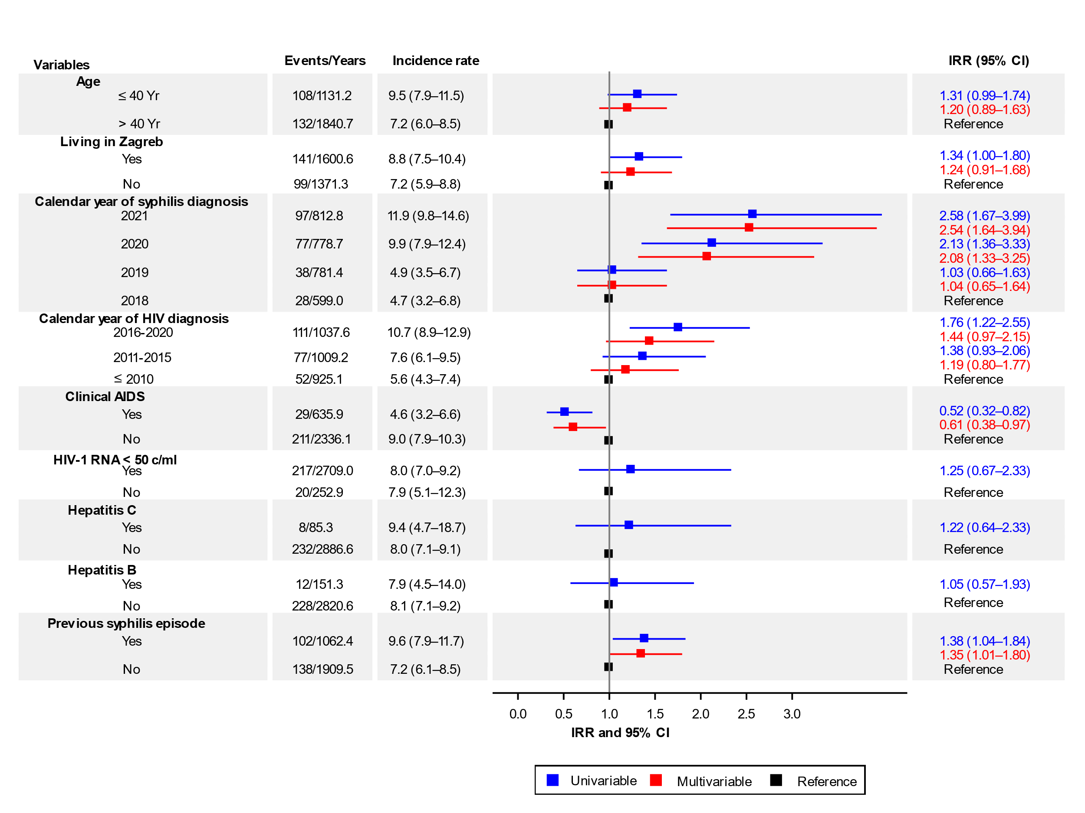
Supplementary Figure 4: Rates of incident syphilis per 100 PYFU with 95% confidence intervals in MSM living with HIV who had at least one syphilis test done annually by sociodemographic and clinical characteristics and crude (univariable) and multivariable IRR of syphilis events, Croatia, 2018 to 2021. Years are person-years of follow-up. The overall incidence rate rate per 100 PYFU was 8.1 (95% CI, 7.1–9.2).
MSM, men who have sex with men; IRR, incidence rate ratio; CI, confidence intervals; PYFU, person-years of follow-up; Clinical AIDS, HIV-1 RNA, hepatitis C and previous syphilis diagnosis were time-updated variables. IRR are based on a generalized estimating equations model with an exchangeable correlation structure. The 95% confidence intervals for the rate per 100 person-years of follow-up was calculated using the Rothman/Greenland estimation.

