Supplemental Materials

SI.I. Model derivation – Geometrical Argument
This section describes in detail the mathematical steps involved in the model derivation through a geometrical argument. As mentioned previously, we are interested in describing the capillary breakup behavior in a regime that is not contemplated by the models described above, namely of viscous fluids in a non-isothermal regime, where the fluid thread is fed through a hot zone, usually a flame or laser, which induces a propagating temperature gradient. Once the fiber is inside the hot zone of the flame, the Si core liquefies, and the silica cladding softens. While the core plus cladding system continues to move through the hot zone in the axial direction x, surface tension minimization drives the pinching-off of the core into droplets at an approximately constant pinching location $x_{bu}$ for each feed speed (Figure 2), as is observed experimentally. At this location, the core thread reshapes into a droplet and pinches off while a critical amount of material is fed into the droplet. This results in uniformly spaced spheres with a wavelength $λ$.

In order to understand the process shown above, we consider that the amount of core material that is fed into the droplet before it breaks off the core at the time $τ$ = $t_{pinch}$ (pinch time, defined in the main text) is equivalent to that stored in a section of a core of length $λ$ being fed for a time $t_{g}$ (growth time). This relationship is mathematically expressed as:
 | $$τ= \frac{λ}{v_{f}}$$ | (1)
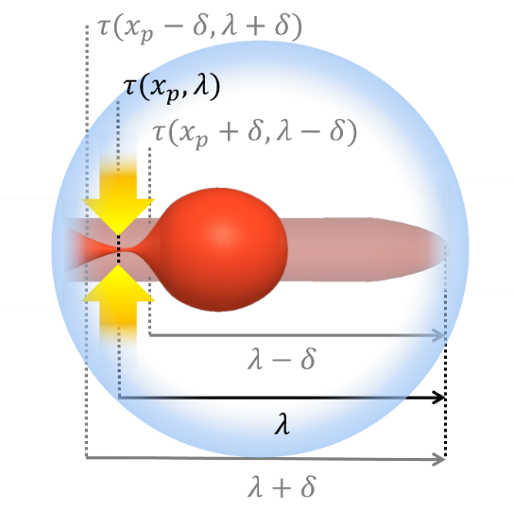
, where $τ$ may be a function of interface energy, viscosity and $λ$, such that $τ=τ(x, λ)$. Moreover, we state that the derivative of the neck thickness around the br eakup point $x_{bu}$ is smooth and equal to 0 at $x_{bu}$.
Supplemental Figure S1: Illustration of pinch-off process of the core thread at position $x_{bu}.$

In Figure S1, we show an illustration of the pinch-off process: Once the length $λ$ is fed through the pinching front at $x_{bu}$, a breakup occurs, and at this time, the neck thickness is zero. We can also define the pinching speed $v_{p}$ as the ratio between $a^{'}$ and the pinch-off time $τ$ where $a^{'}$ is the difference between the thread radius, a, and the neck half-thickness $d_{1/2}$ at the front location.

Let us now consider what happens at a position $x_{bu }+δ$, where $δ$ is an infinitesimally small quantity: at the same moment as the pinching is occurring at $x_{bu}$, it hasn't yet occurred at $x_{bu }+δ$. Moreover, the material has begun to be fed through $x_{bu }+δ$ later than at $x_{bu}$ by a factor of $τ^{'}= δ/{v_{f}}$ . In this way, we can define an "excessive pinching time" $τ^{+}$as the pinching time $τ$ at $x_{bu }+δ$ minus $τ^{'}$:

 | $$τ^{+}=τ\left(λ-δ, x_{bu}+δ\right)- \frac{λ-δ}{v_{f}}$$ | (2)
Similarly, for the pinching front $x_{bu }-δ$, we have:

 | $$τ^{-}=τ\left(λ+δ, x_{bu}-δ\right)- \frac{λ+δ}{v_{f}}$$ | (3)
By multiplying the pinch-off time by $a^{'}$, we can obtain the half-thickness $d_{1/2}^{±}$ of the neck at the locations $x_{bu }±δ$, at the moment of pinch-off, which are expressed in Equations (2) and (3), and illustrated in Figure S2:
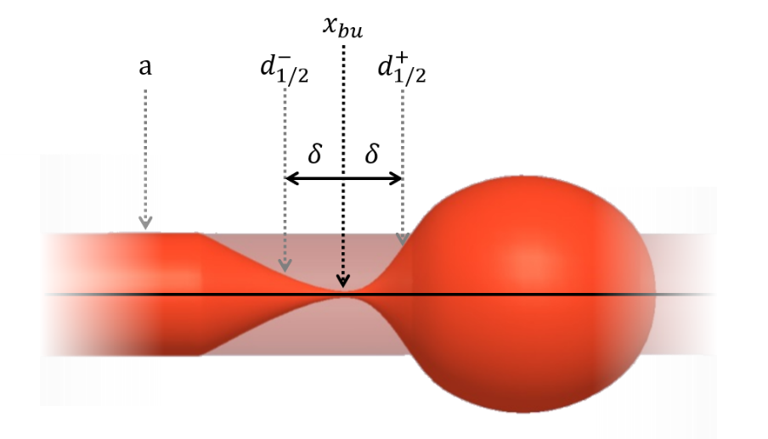
Supplemental Figure S2: Schematic representation of the fiber core during pinch-off.
 | $$d_{1/2}^{+}=a\left(1 - \frac{λ+δ}{v_{f}} \frac{1}{τ(λ+δ, x_{bu}-δ)}\right)$$ | (4)

 | $$d_{1/2}^{-}=a\left(1 - \frac{λ-δ}{v_{f}} \frac{1}{τ(λ-δ, x_{bu}+δ)}\right)$$ | (5)

As stated before, we propose that the derivative of the neck thickness at $x_{bu}$ is smooth and equal to 0:

 | $$\frac{∂}{∂δ}{\left[a\left(1 - \frac{λ-δ}{v_{f}} \frac{1}{τ\left(λ-δ, x_{bu}+δ\right)}\right)\right]}_{δ=0}=0$$ | (6)
 | $${\left[τ\left(λ-δ, x_{bu}+δ\right)+(λ-δ)\frac{dτ}{dδ}\right]}_{δ=0 }=0$$ | (7)

Since $τ=τ\left(x, λ\right)$ , we write the partial derivative on $τ$as
 | $$\frac{dτ}{dδ}= \frac{∂τ}{∂x}\frac{∂x}{∂δ}+ \frac{∂τ}{∂λ}\frac{∂λ}{∂δ}= \left(\frac{∂}{∂x}+\frac{∂}{∂λ}\right)τ$$ | (8)

So we can rewrite Equation (7) as:
 | $$τ\left(λ, x_{bu}\right)+λ\left(\frac{∂}{∂x}+\frac{∂}{∂λ}\right)τ=0$$ | (9)

Substituting $τ$ from (4), and dividing (12) by $λ$, we obtain:

 | $$\frac{1}{v_{f}}+ \left(\frac{∂}{∂x}+\frac{∂}{∂λ}\right)τ\left(λ,x_{bu}\right)=0$$ | (10)

Thus, from equations (1) and (10), we obtain the following set of two equations in two variables from which we can obtain our solution:
 | $$\left\{\begin{aligned} {\left.\left(\frac{λ}{v_{f}}-τ\left(λ, x\right)\right)\right|}_{x_{bu}}=0 \\ {\left.\left(\frac{∂}{∂x}- \frac{∂}{∂λ}\right)\left(\frac{λ}{v_{f}}-τ\left(λ, x\right)\right)\right|}_{x_{bu}}=0\end{aligned}\right.$$ | (11)

Solving this system, however, requires information about the breakup time $τ$. Considering that $η_{clad}≫η_{core}$, we have
 | $$τ∼\frac{βa η_{clad}}{γ}$$ | (12)

Where $β$ is a system-dependant function of viscosity contrast between the core and the cladding materials. In some specific cases, for large viscosity contrast, $β$ converges asymptotically to a constant derived by solving the Marginal Stability Criterion for propagating Plateau-Rayleigh instability case, as is done in Powers et al. (1998)¹, and to a different constant assuming the classical Tomotika's growth rate.

Feeding Eq. (12) into (11), and considering that, for silica, $μ_{clad}=μ_{clad}\left(T\left(x\right)\right)=Ae^{B/T(x)}$, where $A=5.7×{10}^{-8} Pa ⋅s^{-1}$ and $B=61812 K$ are material properties², we rewrite (11) as:

 | $$\left\{\begin{aligned}{\left.\left(\frac{λ}{v_{f}}-\frac{βaAe^{B/T\left(x\right)}}{γ} \right)\right|}_{x_{bu}}=0 \\ {\left.\left(\frac{∂}{∂x}- \frac{∂}{∂λ}\right)\left(\frac{λ}{v_{f}}-\frac{βaAe^{B/T\left(x\right)}}{γ} \right)\right|}_{x_{bu}}=0\end{aligned}\right.$$ | (13)

SI.II. Lagrangian derivation

Starting with
 | $$\frac{d}{dt}\left(\frac{∂L}{∂\dot{q}}\right)- \frac{∂L}{∂q}=0$$ | (14)
It holds that
 | $$\frac{d}{dt}\left(\frac{∂CF^{v_{f}}\left(λ,x\right)}{∂\dot{q}}\right)- \frac{∂CF^{v_{f}}\left(λ,x\right)}{∂q}=0$$ | (15)
with $\dot{q}=v_{f}$ and $q=λ$. We can expand (15) as
 | $$\frac{d}{dt}\left(C\frac{∂F^{v_{f}}\left(λ,x\right)}{∂v_{f}}+ F^{v_{f}}\frac{∂C}{∂v_{f}}\right)- \left(C\frac{∂F^{v_{f}}\left(λ,x\right)}{∂λ}+F^{v_{f}}\frac{∂C}{∂λ}\right)=0$$ | (16)
As both $\frac{dC}{dt}=0$ and $\frac{dF^{v_{f}}}{dt}=0$, (16) becomes
 | $$\left[C\frac{d}{dt}\left(\frac{∂F^{v_{f}}\left(λ,x\right)}{∂v_{f}}\right)+F\frac{d}{dt}\left(\frac{∂C}{∂v_{f}}\right)\right]-\left[\left(C\frac{∂F^{v_{f}}\left(λ,x\right)}{∂λ}\right)+\left(F^{v_{f}}\frac{∂C}{∂λ}\right) \right]=0$$ | (17)
We can easily see that since $\frac{∂C}{∂v_{f}}=2πa γ$, it follows that $\frac{d}{dt}\left(\frac{∂C}{∂v_{f}}\right)=0$. Also, $\frac{∂C}{∂λ}=0$, and thus we have:
 | $$C\frac{d}{dt}\left(\frac{∂F^{v_{f}}\left(λ,x\right)}{∂v_{f}}\right)-C\frac{∂F^{v_{f}}\left(λ,x\right)}{∂λ}=0$$ | (18)
We can verify that (18) is true by performing the derivatives on $F^{v_{f}}\left(λ,x\right)$:
 | $$\frac{d}{dt}\left(\frac{∂F^{v_{f}}\left(λ,x\right)}{∂v_{f}}\right)= \frac{d}{dt}\left[\frac{∂}{∂v_{f}}\left(\frac{λ}{v_{f}}- \frac{βa η_{clad}}{γ}\right)\right]$$ | (19)

 | $$\frac{d}{dt}\left(\frac{∂F^{v_{f}}\left(λ,x\right)}{∂v_{f}}\right)= \frac{d}{dt}\left(-\frac{λ}{v_{f}^{2}}\right)= -\frac{1}{v_{f}^{2}}\frac{dx}{dt}\frac{dλ}{dx}= \frac{1}{v_{f}}$$ | (20)

And
 | $$\frac{∂F^{v_{f}}\left(λ,x\right)}{∂λ}= \frac{∂}{∂λ}\left(\frac{λ}{v_{f}}- \frac{βa η_{clad}}{γ}\right)= \frac{1}{v_{f}}$$ | (21)
Therefore,
 | $$\frac{d}{dt}\left(\frac{∂F^{v_{f}}\left(λ,x\right)}{∂v_{f}}\right)= \frac{∂F^{v_{f}}\left(λ,x\right)}{∂λ}$$ | (22)

SI.III. Silicon-Silica Surface Tension
The value of the surface tension $γ_{Si-SiO_{2}}$ between liquid silicon and silica was obtained as follows:
In Fujii et al. (2006)³ , the surface tension $γ_{Si}$ of molten silicon is measured by the microgravity oscillating drop method and the following relation between $γ_{Si}$ (in mN/m) and the temperature T, is presented:
 | $$γ_{Si}=733-0.062(T-1687)$$ | (23)
for a temperature range of 733 K to 1890K, in agreement with Lucas et al. (1984)⁴.
From Parikh (1985)⁵, we get that the surface tension of silica is $γ_{SiO_{2}}=280 mJ/m^{2}$. In Li et al. (1992)⁶, the wettability of silica by molten silicon is investigated through the sessile drop method, and the contact angle $θ$ of silicon on silica was determined to be 92° at 1703 K. The work of adhesion W is then given by:
 | $$W=σ_{SL}\left(1-cosθ\right)=708 mJ/m^{2}$$ | (24)
With $σ_{SL}=γ_{Si}+γ_{SiO2}-γ_{Si-SiO_{2}}$.
Thus, we can calculate $γ_{Si-SiO_{2}}$ as
 | $$γ_{Si-SiO_{2}}=γ_{Si}+γ_{SiO_{2}}-W=0.298 J/m^{2}∼0.3 J/m^{2}$$ | (25)

, which is consistent with the values found in the literature^{7,8}.

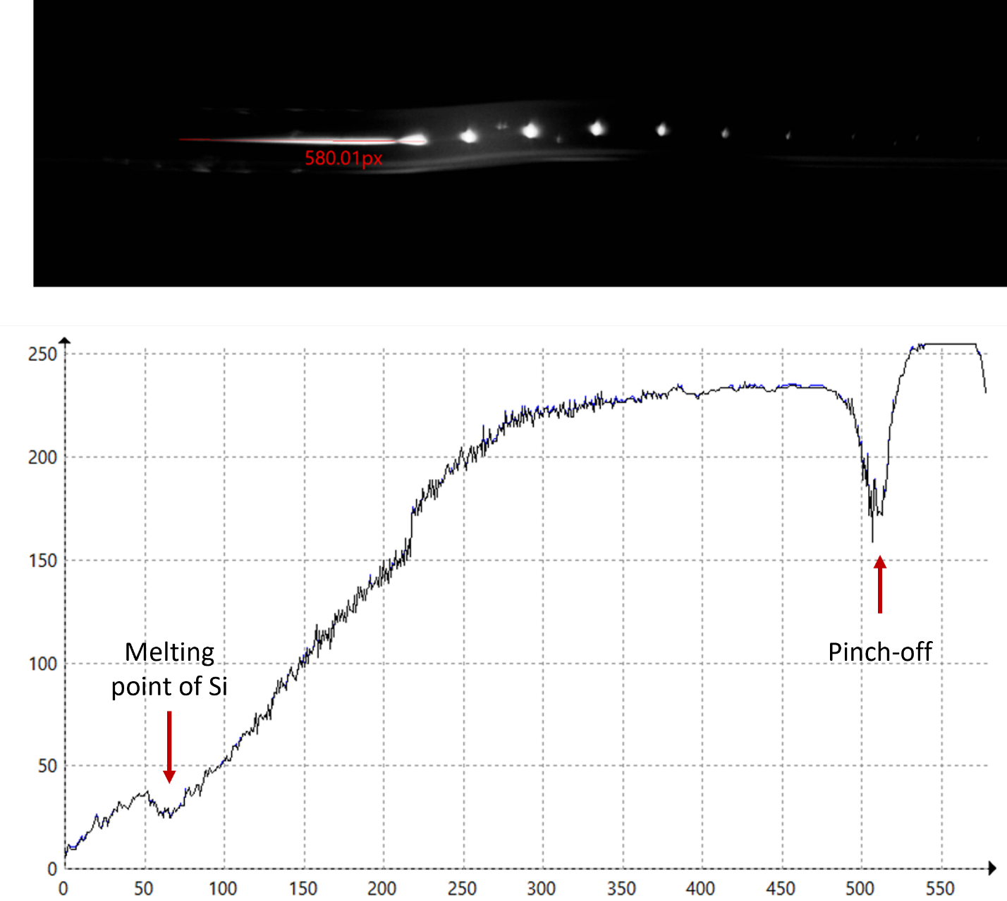
SI.IV. Capturing the breakup:
Figure S3: Snapshot of a breakup experiment illustrating how the breakup location is measured with respect to the melting position of silicon, which can be determined as a dip in the intensity profile (y-scale on the bottom graph is intensity in arbitrary units, x-scale is the number of pixel starting from right along the red line 580 pixels long on the image, along which the intensity profile was collected).
To capture the dip in emissivity associated with the Si melting point, the dynamic range is compromised: it can be noted that the signal saturates around pixel 550, thus emissivity corresponding for T_{max} is not captured. At the same time, in our experience, if the sensitivity of the camera is reduced, such that there is no saturation of the signal in the frame, the dip in the emissivity corresponding to the melting of silicon blends into the noise and can’t be captured reliably. Hence the challenge of reconstructing the temperature profile from the emissivity signal, mentioned in the main text.

SI.V. Model fitting to Experimental data
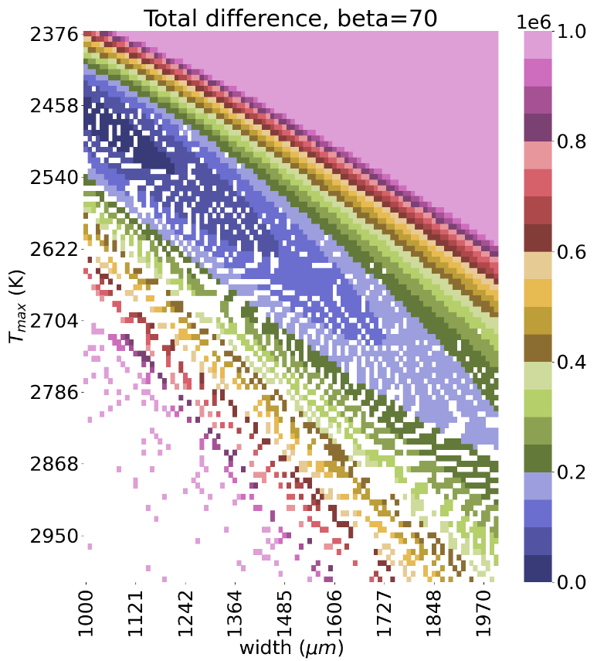
Supplemental Figure S4: Map of the sum of the ssd for $λ_{bu}$ and +$x_{bu}$ with respect to the experimental values, by sweeping the temperature parameters $T_{max}$ and $w$.
In order to determine the best temperature profile parameters to fit the model to the experimental results, a simple algorithm was developed: for any given combination of temperature profile parameters, the sum of the square difference (ssd) between the model prediction and the experimental results can be easily calculated. By sweeping the parameters $T_{max}$ and $w$, a map is generated, which allows the identification of the parameters that yield the best model fit to the data. This was performed for each value of $β$ evaluated.

SI.VI. COMSOL evaluation of the numerical constant $β$:

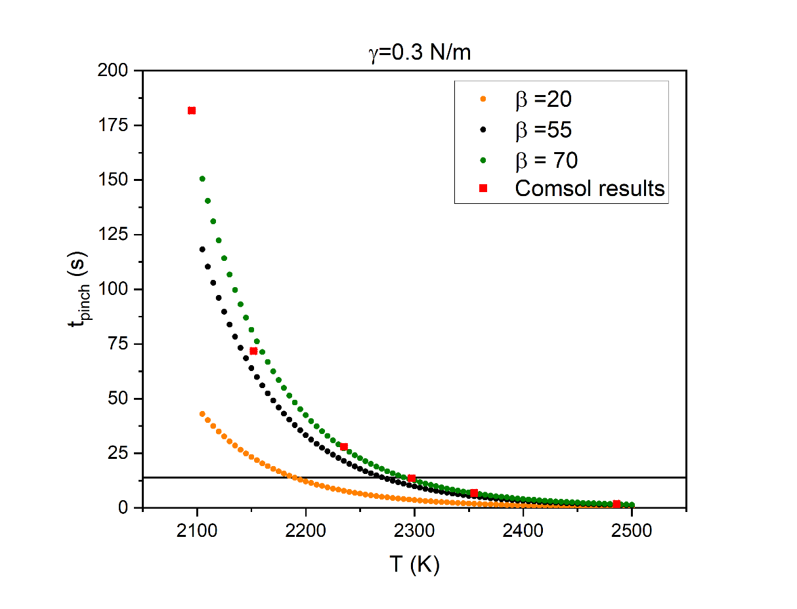
Through similar COMSOL⁹ simulations, as performed in previous work by Faccini de Lima et al. (2019)¹⁰, we evaluated $β$ by comparing the pinch-off time of the first sphere off the initially continuous room-temperature core when exposed at time=0 to a static localized heat source set to generate various temperatures T (Figure S5). We considered a 4 μm-thick silicon core surrounded by a silica cladding, exposed to a temperature profile described in Ref.¹⁰. The surface tension between silica and silicon was set to $γ=0.3$ N/m. The results, shown in Figure S5, indicate good agreement between the COMSOL simulation results and our model predictions for $β=60±10$, with respect to the time needed for the first pinch-off in a stand-still initially continuous fiber core to occur while at time zero exposed to the hydrogen-oxygen flame.
Figure S5: Pinch-off time $t_{pinch}$ as function of temperature T for a 4 $μm$-thick silicon core surrounded by silica, under surface tension of 0.3 N/m. The results obtained from COMSOL simulations are compared to the AVG Instability model predictions under assumption of different $β$ values, sowing best agreement for $β=60±10$.

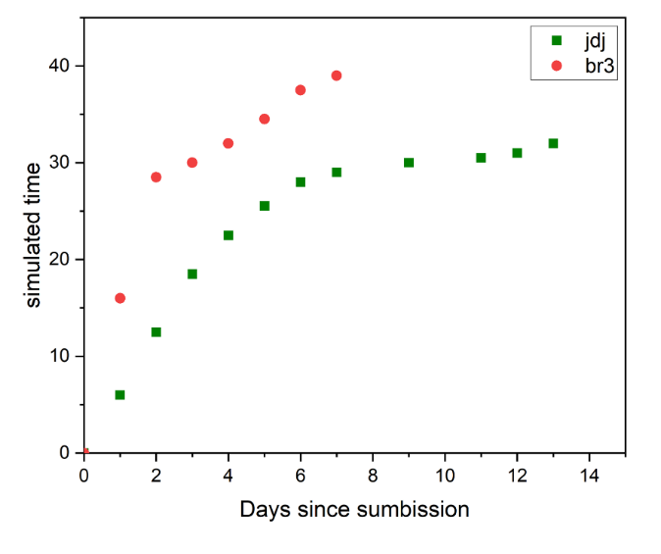
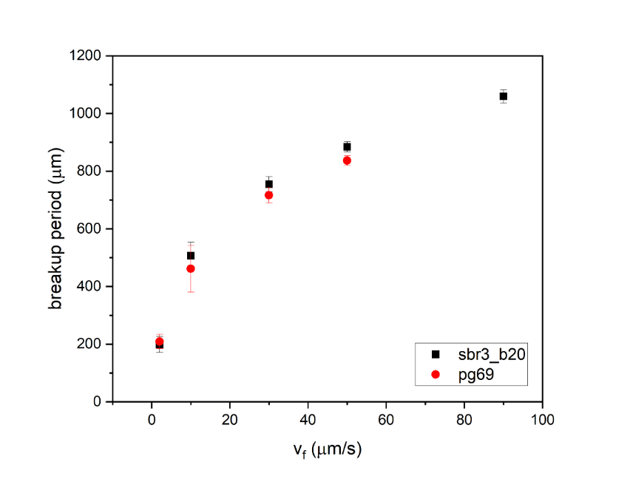
SI.VII. Capillary breakup simulation dependence on the computational resource:
Figure S7: Simulaiton time propagation differences of ab-initio simulation code on Indiana University’s BR3 supercomputer (sbr3_b20) and comparison with a simulation times obtained, for the same simulation paramerters, at MIT’s jdj cluster (pg69).
Figure S6: Verification of the installation of the ab-initio simulation code on Indiana University’s BR3 supercomputer (sbr3_b20) and comparison with a simulation result obtained, for the same simulation paramerters, at MIT’s jdj cluster (pg69).

At jdj the simulations were set to run on two cores of a single CPU. At BR3 the simulations were set to run on 32 CPU’s, two cores on each. The short-term acceleration is depicted in Figure S7. The long-term acceleration is such that for the breakup process to reach the steady state (~3 breakup periods are simulated), it would take 4-6 months on jdj, compared to 2-3 weeks on BR3 – an order of magnitude faster, although not fast enough to enable optimization calculations, only in combination with AVG-IM model, as is described in Figure 4 in the main text.

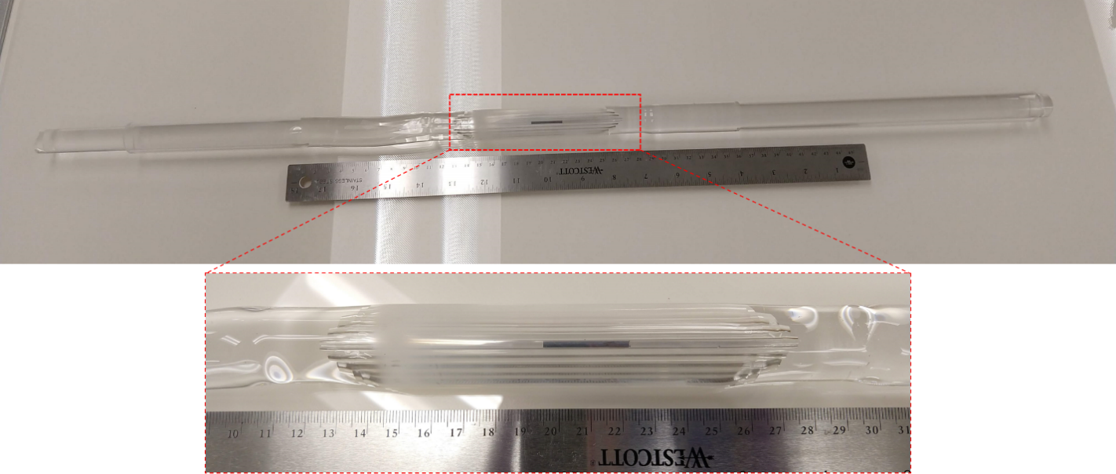
SI.VIII. Fiber preform fabrication and draw results:

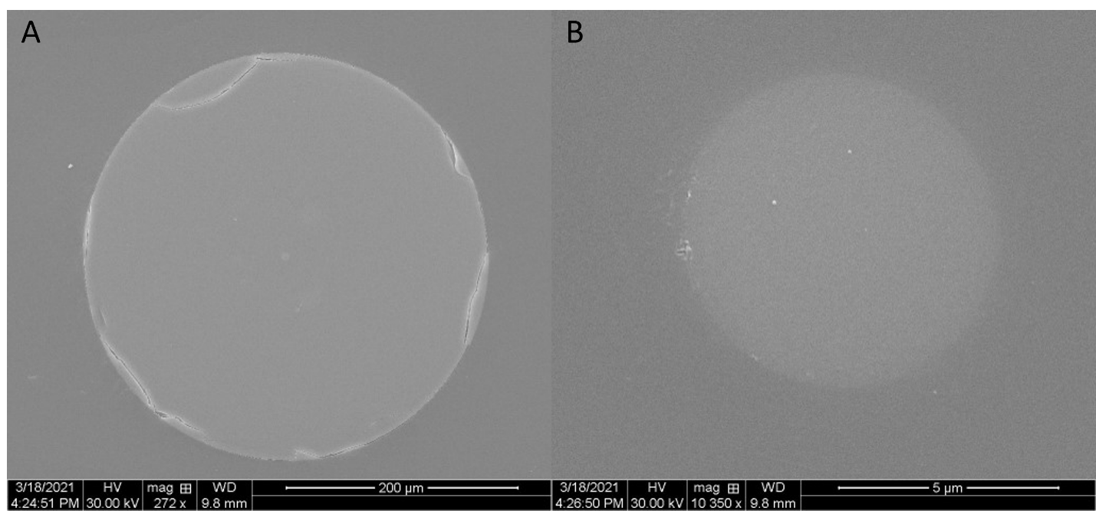
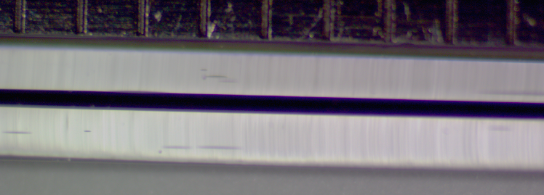
Figure S8: Assembled preform for the fabrication of a silicon-core silica fiber. A silicon rod is inserted in concentric silica tubes and sealed under vacuum with a glass lathe (top). The resulting first-draw cane is demonstrated next to a ruler with 1 mm thicks (bottom). This cane was stacked into a new preform, as is described in the Methods section and redrawn into a fiber on Figure S9.
Figure S9: A: SEM image of the silicon core fiber cross-section. B: details of the silicon core.

Bibliography

1. Powers, T. R., Zhang, D., Goldstein, R. E. & Stone, H. A. Propagation of a topological transition: TheRayleigh instability. Physics of Fluids 10, 1052 (1998).
2. Zhang, J. et al. Laser-Induced In-Fiber Fluid Dynamical Instabilities for Precise and Scalable Fabrication of Spherical Particles. Adv Funct Mater 27, 1703245 (2017).
3. Fujii, H., Matsumoto, T., Izutani, S., Kiguchi, S. & Nogi, K. Surface tension of molten silicon measured by microgravity oscillating drop method and improved sessile drop method. Acta Materialia 54, 1221–1225 (2006).
4. Lucas, L. D. Techniques de l’Ingénieur. (1984).
5. PARIKH, N. M. Effect of Atmosphere on Surface Tension of Glass. Journal of the American Ceramic Society 41, (1958).
6. Li, J. G. & Hausner, H. Wetting and adhesion in liquid silicon/ceramic systems. Materials Letters 14, (1992).
7. Danielson, D. T., Sparacin, D. K., Michel, J. & Kimerling, L. C. Surface-energy-driven dewetting theory of silicon-on-insulator agglomeration ARTICLES YOU MAY BE INTERESTED IN. J. Appl. Phys 100, 83507 (2006).
8. Eaglesham, D. J., White, A. E., Feldman, L. C., Moriya, N. & Jacobson, D. C. Equilibrium shape of Si. Physical Review Letters 70, (1993).
9. COMSOL AB. COMSOL Multiphysics. www.comsol.com.
10. Faccini de Lima, C. et al. Towards Digital Manufacturing of Smart Multimaterial Fibers. Nanoscale Res Lett 14, 209 (2019).

