Appendix
Pulse Study Flow Chart
22 volunteers (NHS staff)

Eligibility Criteria
Patient information leaflet and consent form signed

Lying flat in hospital bed in training room of ICU

Baseline HR and BP

Thigh tourniquet on but not inflated

Pulse oximeters on 2nd and 3rd toe of both feet
Screenshot of waveform at 15, 30, 60 and 90 seconds

Leave for 90 seconds to allow the waveform to equilibrate

Screenshot of waveform 15 seconds (timepoint 0, Baseline) before thigh tourniquet inflation

Tourniquet then put up at 300mmHg for 90 seconds
Screenshot at 30, 60, 90 seconds (T 30, T 60 (timepoint 1, inflation), T 90 timepoint 2, just prior to deflation)) after the tourniquet has been inflated.

Let tourniquet down
Screenshot 60 seconds after the tourniquet has gone down. Timepoint 3, after deflation
At the end download data (Pulse Rate, Saturations, and Perfusion Index) for the whole time period from the central workstation in ICU – including print off of the pulse oximeter trace, upload/email screenshots to trust email account
Then do the same for the upper limb – pressure set to 250mmHg

Table 3: Linear mixed models’ results for arms’ data
 | Control | Experimental | Difference‡ (95% CI),  p-value
Phillips data ˤ
Baseline | 4.07 (2.69-5.46)† | 4.54 (3.16-5.93)† | 0.47 (-0.60 to 1.54), 0.383
Deflation | 4.54 (3.16-5.92)† | 5.59 (4.20-6.97)† | 1.05 (-0.02 to 2.12), 0.055
Difference§ (95% CI),  p-value | 0.47 (-0.60 to 1.54),  0.386 | 1.04 (-0.03 to 2.11),  0.056
Masimo data ˤ
Baseline | 4.67 (3.48-5.87)† | 5.12 (3.93-6.32)† | 0.45 (-0.41 to 1.30), 0.299
Deflation | 4.78 (3.58-5.97)† | 5.81 (4.62-7.01)† | 1.04 (0.18 to 1.89), 0.018
Difference§ (95% CI),  p-value | 0.10 (-0.76 to 0.96),  0.815 | 0.69 (-0.17 to 1.55),  0.112
CI = Confidence interval; ˤ Separate models; † Mean (95% CI); ‡ Experimental - Control; § Deflation - Baseline
Table 4: Linear mixed models’ results for legs’ data
 | Control | Experimental | Difference‡ (95% CI),  p-value
Phillips data ˤ
Baseline | 2.29 (1.44-3.14)† | 1.60 (0.74-2.45)† | -0.70 (-1.36 to -0.03), 0.042
Deflation | 2.78 (1.93-3.63)† | 2.29 (1.44-3.14)† | -0.49 (-1.15 to 0.18), 0.152
Difference§ (95% CI),  p-value | 0.49 (-0.18 to 1.16),  0.148 | 0.70 (0.03 to 1.37),  0.041
Masimo data ˤ
Baseline | 1.53 (0.82-2.25)† | 1.68 (0.97-2.40)† | 0.15 (-0.47 to 0.78), 0.624
Deflation | 2.04 (1.32-2.75)† | 3.04 (2.33-3.76)† | 1.01 (0.38 to 1.63), 0.002
Difference§ (95% CI),  p-value | 0.51 (-0.12 to 1.13),  0.110 | 1.36 (0.74 to 1.98),  <0.001

CI = Confidence interval; ˤ Separate models; † Mean (95% CI); ‡ Experimental - Control; § Deflation - Baseline

Table 5: Comparing Phillips and Masimo arms’ data when there is no inflation
Time point | Group | Mean difference† (95% CI), p-value | Pearson’s correlation  (95% CI) | ICC
Baseline | Experimental  Control | -0.58 (-1.57, 0.41), 0.237  -0.60 (-1.53, 0.32), 0.189 | 0.74 (0.42, 0.90)  0.72 (0.50, 0.87) | 0.72  0.71
Inflation (Pulse trace lost) | Control | -0.41 (-1.38, 0.55), 0.380 | 0.76 (0.54, 0.91) | 0.76
Inflation (minimum value) | Control | -0.21 (-0.97, 0.56), 0.584 | 0.81 (0.63, 0.93) | 0.82
Deflation | Experimental  Control | -0.23 (-1.41, 0.96), 0.695  -0.24 (-1.59, 1.12), 0.722 | 0.61 (0.33, 0.79)  0.53 (0.32, 0.82) | 0.61  0.54

†Phillips – Masimo; CI = Confidence interval; ICC = Intraclass correlation coefficient

Table 6: Comparing Phillips and Massimo arms’ data during inflation
 | Spearman’s correlation  (95% CI) | Kendall’s Tau ($τ$)  (95% CI) | p-value  †
During inflation (Pulse trace lost) | 0.16 (-0.24, 0.49) | 0.08 (-0.17, 0.31) | 0.017
During inflation (Minimum value) | 0.63 (0.28, 0.84) | 0.53 (0.24, 0.75) | 0.346

† Wilcoxon signed-rank test; CI = Confidence interval

Table 7: Comparing Phillips and Massimo legs’ data when there is no inflation
Time point | Group | Mean difference† (95% CI), p-value | Pearson correlation  (95% CI) | ICC
Baseline | Experimental  Control | -0.09 (-0.77, 0.60), 0.788  0.76 (0.12, 1.40), 0.023 | 0.21 (-0.40, 0.75)  0.79 (0.20, 0.94) | 0.23  0.63
Inflation (Pulse trace lost) | Control | 0.59 (0.01, 1.16), 0.047 | 0.82 (0.66, 0.93) | 0.78
Inflation (minimum value) | Control | 0.41 (-0.25, 1.07), 0.208 | 0.81 (0.59, 0.90) | 0.76
Deflation | Experimental  Control | -0.75 (-1.81, 0.31), 0.157  0.74 (0.04, 1.45), 0.039 | 0.23 (-0.57, 0.70)  0.77 (0.45, 0.91) | 0.20  0.69

†Phillips – Masimo; CI = Confidence interval; ICC = Intraclass correlation coefficient

Table 8: Comparing Phillips and Massimo legs’ data during inflation
 | Spearman’s correlation  (95% CI) | Kendall’s Tau ($τ$)  (95% CI) | p-value  †
During inflation (Pulse trace lost) | 0.07 (-0.37, 0.53) | 0.05 (-0.39, 0.49) | 0.527
During inflation (Minimum value) | 0.18 (-0.22, 0.74) | 0.24 (-0.19, 0.62) | 0.243

† Wilcoxon signed-rank test; CI = Confidence interval

Figure 8: Scatter plots for control sides Phillips and Masimo legs’ perfusion index values at different time points. The dashed line is the line of equal Phillips and Masimo value.

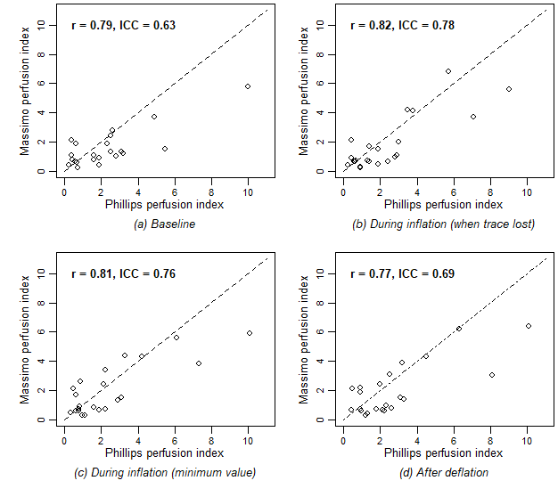

Figure 9: Scatter plots for experimental sides Phillips and Masimo legs’ perfusion index values at different time points. Dashed lines are lines of equal Phillips and Massimo value.
