Supplemental Results

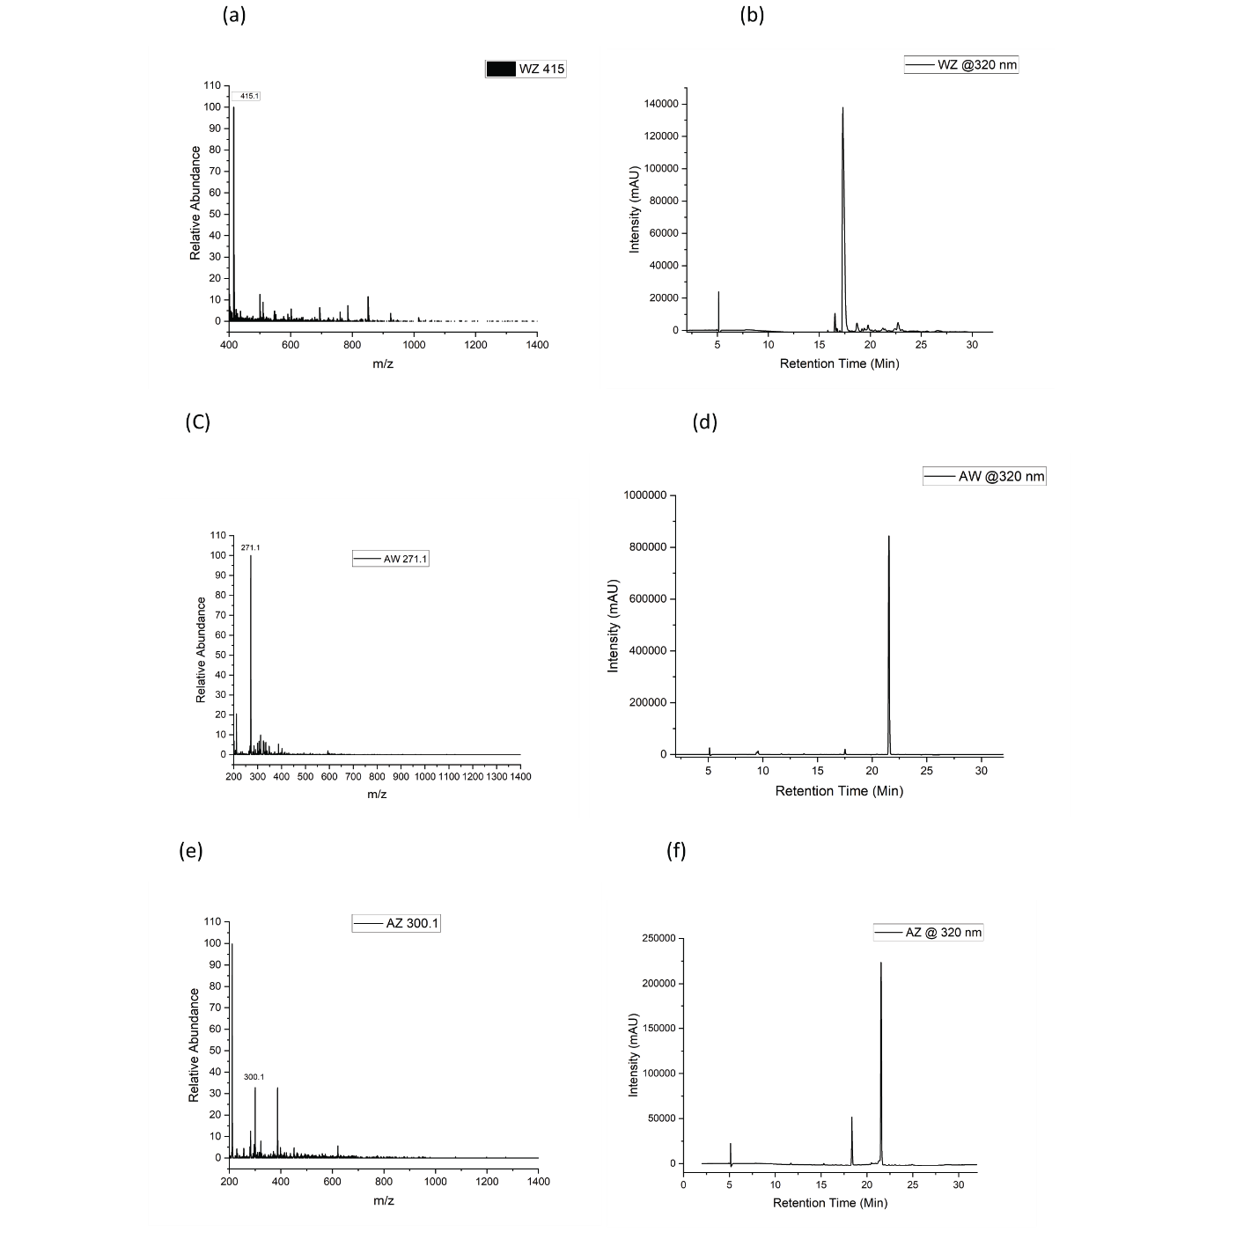
Figure S1: The profiles of the purified peptide spectra using the HPLC and the mass spec profile is shown in (a) and (b) for WZ, (c) and (d) for AW, and (e) and (f) for AZ.

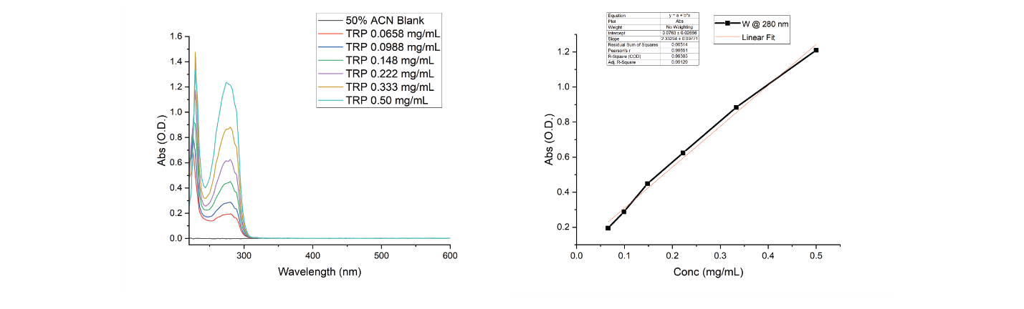

Figure S2: The absorbance of various concentrations versus the scanned wavelength is shown in (a). the linear curve of absorbance versus the concentrations is shown in figure (b).

