Supplementary Information

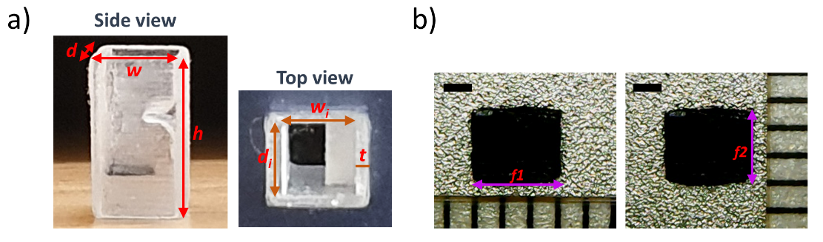
Supplementary Figure 1: Dimensions of dynamic meta-brick and flap. a) Photographs of fabricated dynamic meta-brick, printed from model designed with dimensions d = 4.730 mm, d_{i} = 3.730 mm, w = 4.898 mm, w_{i} = 3.898 mm, h = 8.661 mm = λ, t = 0.5 mm. b) Photographs of fabricated magnetic flap with approximate dimensions
f₁ = 3.2 mm, and f₂ = 2.6 mm. Scale bars, 1 mm. Subscript i refers to the internal dimension.

Supplementary Figure 2: Plot showing fabrication consistency of flap thickness. Plot of flap thickness (µm), 444 ± 5 $μ$m, against 24 flap samples. The flap thicknesses were determined using image processing software ImageJ.
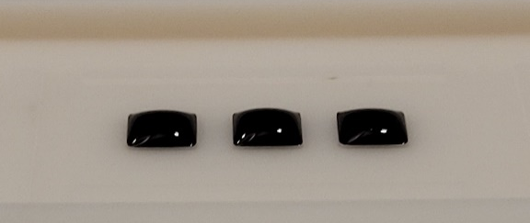
Supplementary Figure 3: Dispensed magnetic mixture for three flaps without glass plates. Photograph shows curvature of dispensed mixture due to surface tension.
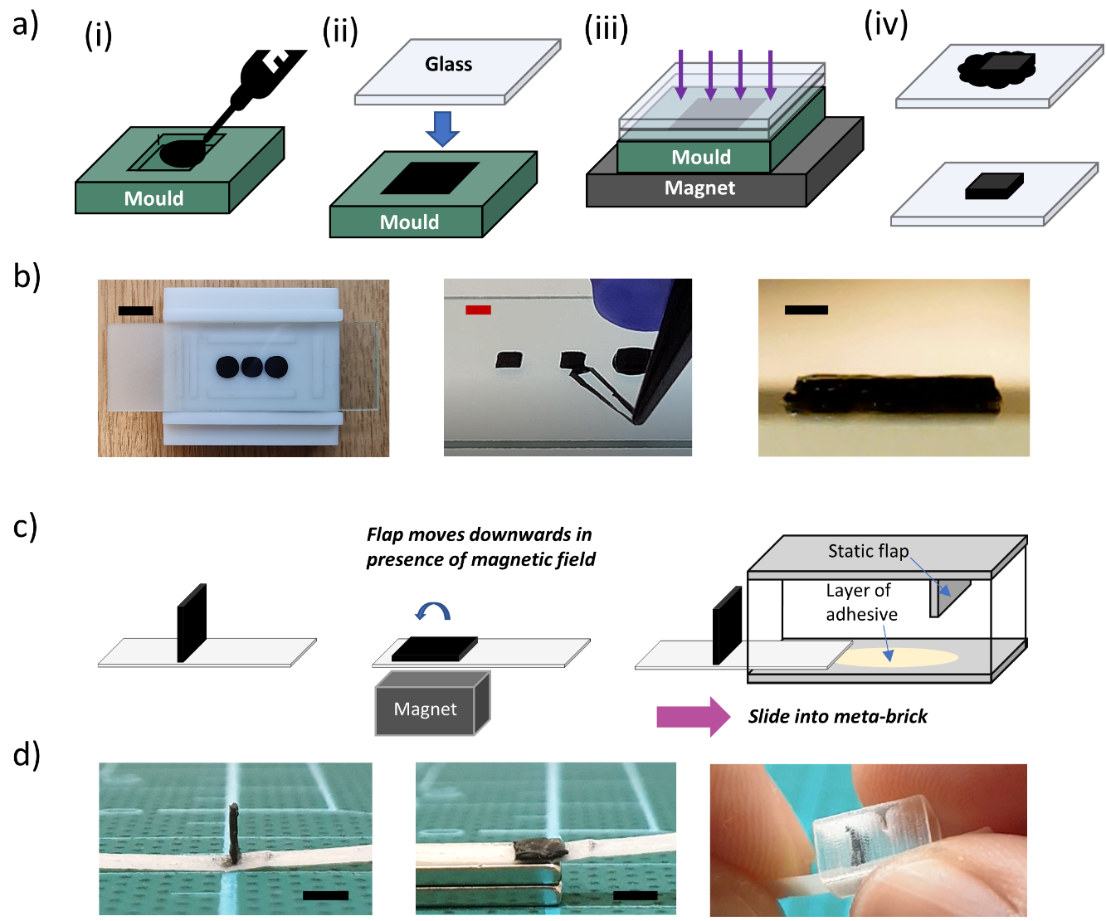
Supplementary Figure 4: Moulding process for fabricating the flap, and assembly process of flap and meta-brick. a) (i) Dispensing mixture, (ii) Settling mixture into the mould and placing a glass plate on top of mould (blue arrow), (iii) Placing a second glass plate on top of mould and placing mould on magnet, (iv) Peeling cured flap (top) and cutting away residue (bottom). b) On the left is a photograph of a mould for three flaps undergoing the curing process with two stacked glass slides at the surface. Scale bar, 1 cm. In the middle, excess silicone is removed from a cured flap. Scale bar, 3 mm. On the right, an image of a fabricated flap which has a thickness of 0.44 ± 0.005 mm. Scale bar, 500 μm. c) Schematics of assembly method. The flap is attached to the PET substrate (thickness, 100 µm) and inserted into the meta-brick. Fabrication process flow showing moulding steps for a magnetic flap. d) Corresponding photographs to c), from left to right. Scale bars, 2 mm.
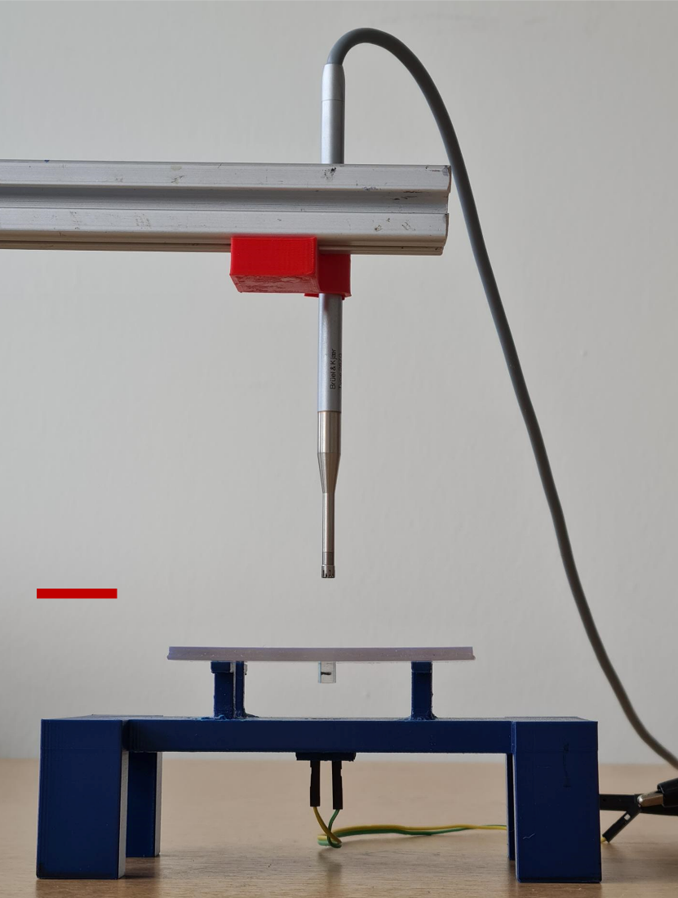
Supplementary Figure 5: Photograph of measurement setup for the individual meta-brick. The meta-brick is held within a 3 mm thick frame. The frame sits on a blue support structure which holds the 40 kHz transducer sound source. The microphone is suspended by a scanning arm from above, positioned approximately two wavelengths away from the output of the meta-brick. Scale bar, 2 cm.
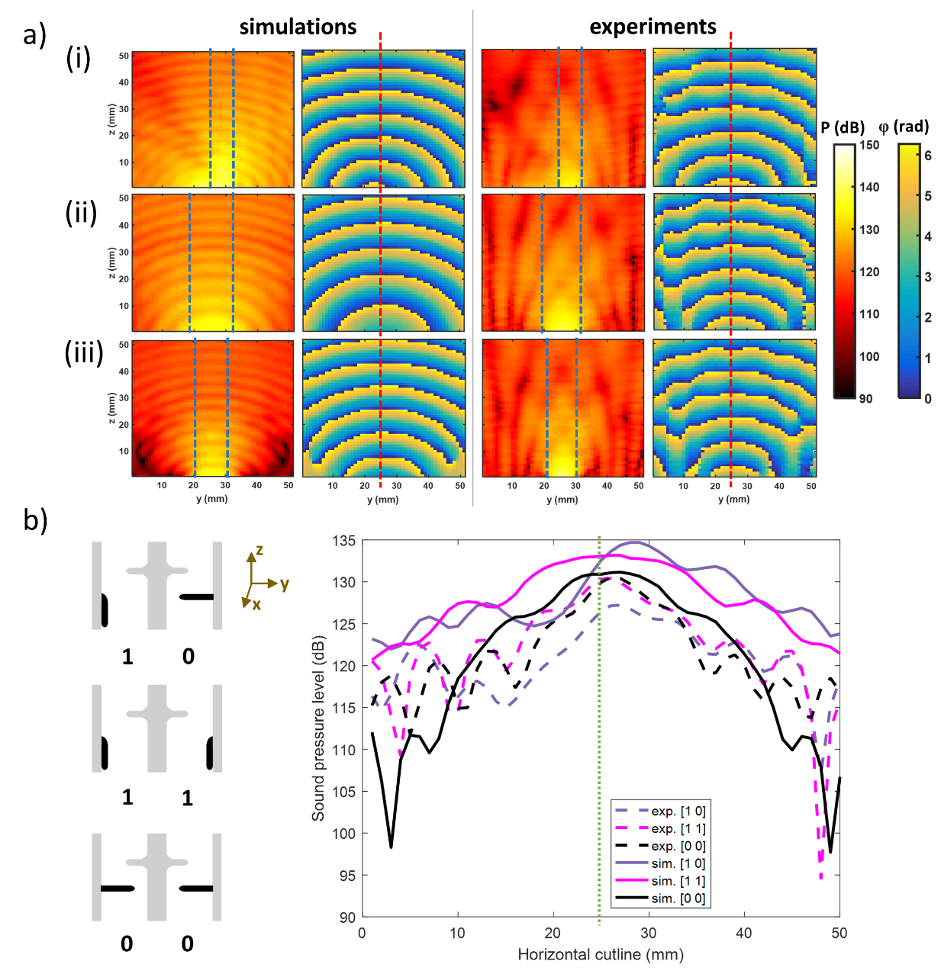
Supplementary Figure 6: Results showing selective actuation (states A1 or A0) for an array of two meta-bricks. a) YZ plots for both simulated and experimental acoustic pressure (dB) and phase (rad) with color bars on the right. Vertical red dashed line is for visualisation of the center of the plot, and vertical blue dashed lines is for visualisation of the main beam. (i) Plots for state [1 0], with actuated meta-brick on the left. (ii) Plots for state [1 1], with both meta-bricks actuated. (iii) Plots for state [0 0], with both meta-bricks unactuated. b) Amplitude line plot comparing simulated and experimental results for the different states with corresponding schematics on the left. Sound pressure level (dB) is plotted against a horizontal cutline 50 mm across, positioned at a vertical distance of 17 mm (approximately two wavelengths) at the output above the meta-bricks. Dashed lines represent experimental results, and solid lines represent simulated results. The vertical green dotted line at the center of the plot (25 mm on cutline) is for visualisation. Results for state [0 1] are shown in mauve, state [1 1] in magenta, and state [0 0] in black. States [1 1] and [0 0] give a similar sound pressure level at the output compared to state [1 0], but the case where both flaps are unactuated [0 0] gives a narrower output beam (Supplementary Fig. 6b). The YZ phase map shows large phase shifts towards the edges for the A0 meta-bricks.

Supplementary Method 1. Information on 2D COMSOL Multiphysics® parameter sweep simulations for the dynamic meta-brick geometry
The main criteria for a successful dynamic meta-brick design were high transmission, and a relative difference in amplitude and phase between the two states (A0 and A1).
Based on the parameters below, the first sweep determined the set of values which would provide the lowest amplitude while both flaps were in a straight position.
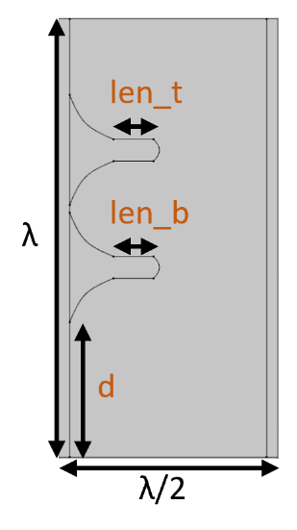
Supplementary Figure 7: Geometric parameters for first sweep. Parameters len_t and len_b represent the straight lengths of the top flap and bottom flap respectively, excluding any curved edges and fillets. d is the distance from the entrance of the brick to the base of the bottom flap.
Parameter name | Parameter values (mm)
len_t | 0.791, 1.466, 2.140, 2.815
len_b | 0.791, 1.466, 2.140, 2.815
d | 2.667, 3.169, 3.671, 4.173
Supplementary Table 1: Parameter values. Each parameter has 4 points. The initial values for the brick are in red, which correspond to the original geometry.

Based on meta-brick 8 as reported by Memoli et. al.¹, the parameters and starting dimensions for two flaps are shown in Supplementary Fig. 7 and Supplementary Table 1. A standard constant acoustic pressure input of 1 Pa was applied to the 2D model. Each parameter was swept over 4 points, starting from existing dimensional values as the minimum, giving 64 combinations in total. With every incremental point, either the flaps got longer with a step size of 0.675 mm, or they shifted upwards with a step size of 0.502 mm. Due to size restrictions, chosen ranges could not exceed the specified upper limit. Smaller step sizes, e.g. < 10⁻² mm, were unnecessary because such a minor increment had little impact on the 40 kHz wave. Moreover, fabrication with that precision and resolution is difficult using conventional methods. We found the set of values which had the lowest transmission (while also being feasible to fabricate) to be (len_b, len_t, d) = (2.1403, 0.791, 3.169) mm. The bottom flap was the longest and had the greatest influence on transmission. Hence, the bottom flap was made to be dynamic, and the top flap remained static. Only one flap was made dynamic to reduce the number of moving components in the meta-brick.
Several smaller sweeps were then implemented to determine whether acoustic performance improved by placing the top and bottom flap on opposing walls (Figure 7). The sweeps were conducted for both actuated and unactuated states. From this point onwards, the 2D model used the piston model formula². The sweeps varied d alone, by taking d = 3 mm as a mid-point reference. Changing the value of d physically meant that the flaps were shifted vertically along the side walls. The vertical distance between the flaps were fixed, and they shifted together as a single entity. We compared two main data sets: range (first point, step size, last point) (3, 0.1, 4) mm and (1, 0.5, 3) mm. d = 1.5 mm and d = 1 mm showed the lowest transmission for state A0 and the highest transmission for state A1, but these dimensions were not appropriate for experimental realisation as they were < 2 mm and the bottom flap had a length of ~ 2 mm. By taking the minimum possible limit at d = 2 mm, a comparison was made between the position of the top flap, i.e., on the left with the bottom flap, or opposite on the right side, based on the absolute pressure and phase relative to the case with the transducer alone.
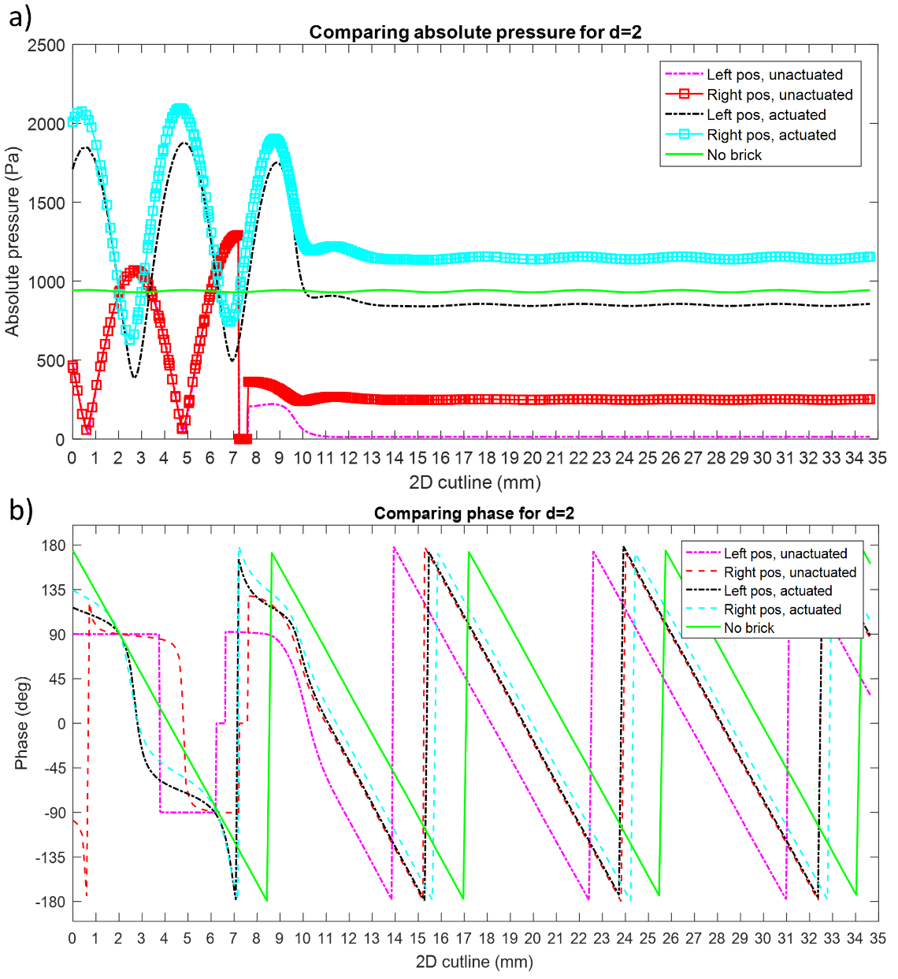
Supplementary Figure 8: Absolute pressure and phase plots for both flap configurations at d = 2 mm. The extended 35 mm cutline runs through the middle of the brick, starting λ/2 below the entrance of the brick, and 2.5λ from the exit of the brick. a) Absolute pressure plot (Pa). The dash-dot lines represent the actuated and unactuated states for the configuration with the top flap on the left. The lines with square markers represent the actuated and unactuated states for the configuration with the top flap on the right. The light green solid line represents the amplitude without any brick. b) Phase plot (deg). The dash-dot lines represent the actuated and unactuated states for the configuration with the top flap on the left. The dashed lines represent the actuated and unactuated states for the configuration with the top flap on the right. The light green solid line represents the phase without any brick.

We extended the output region in the model and the corresponding cutline to 2.5λ away from the exit of the brick to avoid the immediate near-field region when evaluating the amplitude and phase. 2λ from the exit of the brick corresponded to 30.31 mm on the cutline (x-axis). According to Supplementary Fig. 8a above, the configuration with the top flap on the right had the highest transmission. According to Supplementary Fig. 8b at 30.31 mm, the ‘Right pos, actuated’ light blue curve had the lowest phase change in comparison with the green curve (no brick). This result was desirable for state A1 because it ideally mimics the situation where the internal channel has minimal obstruction. Hence, the top flap was moved to the opposite wall.
In this new configuration, the following sweeps were performed with a stronger focus on replicating the experimental meta-brick. The fillets were removed for the bottom flap as a thicker base for the dynamic flap hindered its movement during actuation, requiring more force. The tip of the flap remained at approximately 0.2 mm. A finer sweep was performed to further optimise the value of d and the length of the bottom flap (= length of flap tip + len_b). By taking a difference of 0.2 mm between d and len_b, we swept 9 combinations (Supplementary Table 2).
Combination | 1 | 2 | 3 | 4 | 5 | 6 | 7 | 8 | 9
len_b | 2.0 | 2.1 | 2.2 | 2.3 | 2.4 | 2.5 | 2.6 | 2.7 | 2.8
d | 2.2 | 2.3 | 2.4 | 2.5 | 2.6 | 2.7 | 2.8 | 2.9 | 3.0
Supplementary Table 2: Combinations of values for parameters len_b and d. Table shows 9 combinations.

Combination 5 showed the best result with the lowest absolute pressure for the unactuated state, and high absolute pressure above 1200 Pa. Thereafter, the final sweep varied the straight length of the top flap (without flap tip and fillets) using the parameter m, instead of len_t, as the flap was now positioned on the opposite wall.
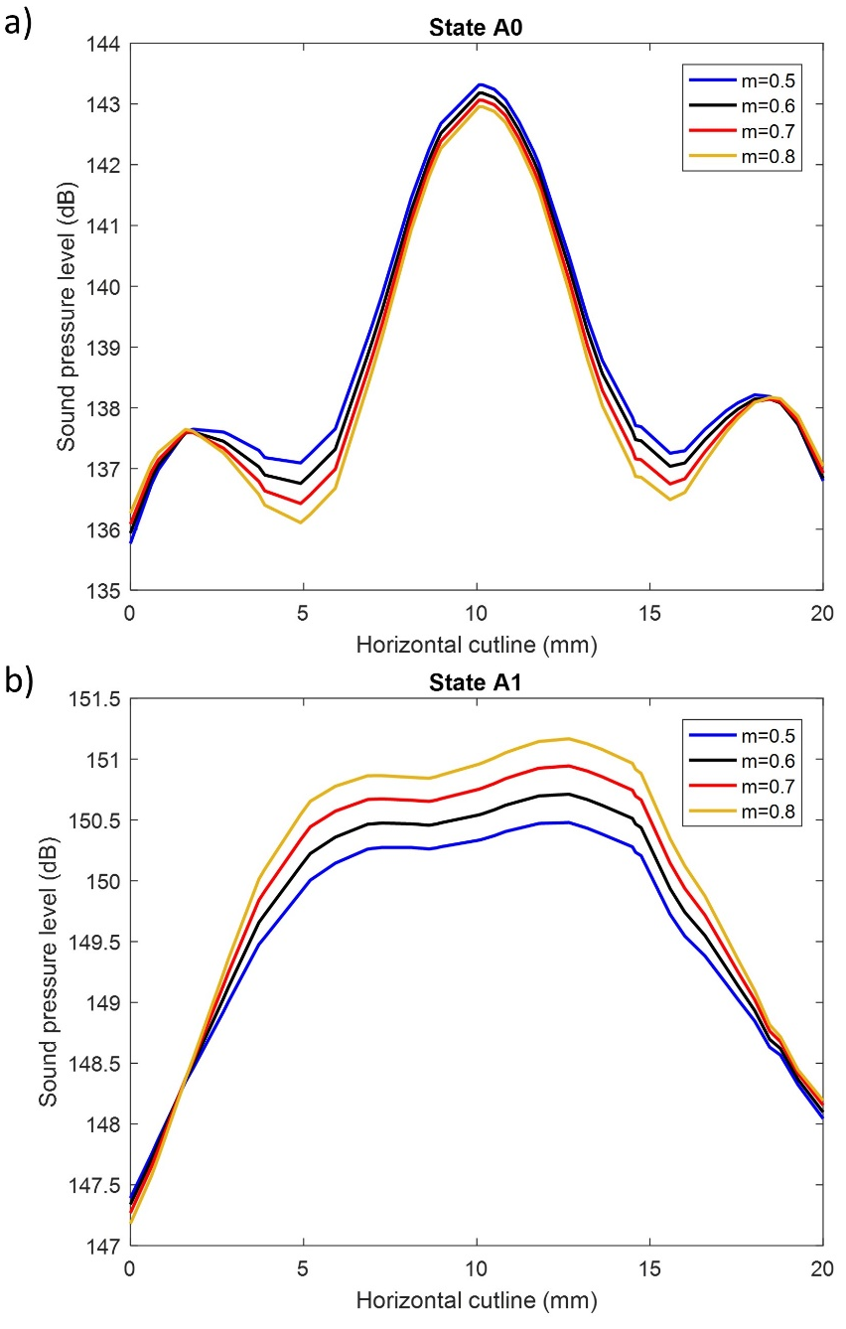
Supplementary Figure 9: Results for parameter sweep of parameter m. Sound pressure level (dB) plots for a) A0, and b) A1.

Parameter m was swept over four values from 0.5 mm to 0.8 mm with an increment of 0.1 mm. The value for m was chosen to be 0.8 mm, as it exhibited the lowest transmission in the unactuated state (Supplementary Fig. 9a) and the highest transmission in the actuated state (Supplementary Fig. 9b). It was found that the phase change relative to the transducer output was similar for all four cases.

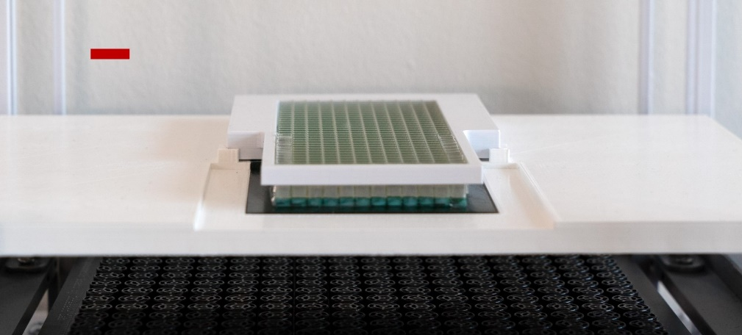
Supplementary Figure 10: Photograph of metasurface within support structures. The metasurface sits within a large white frame above the transducer board. The frame ensures that the sound is transmitted to the metasurface and not at the sides. A smaller white frame at the top of the large white frame holds the metasurface in place. Scale bar, 1 cm.

Supplementary Method 2. Transducer piston model
First, we must define the pressure produced by the PAT board and incident on the underside of the AMM. The complex pressure $ψ_{t}$ of a transducer $t$ is modelled as a point source with initial amplitude $a_{t}$ and phase $φ_{t}$.
$$ψ_{t}=a_{t}⋅e^{iφ_{t}}$$
( 1 )
Using the transducer piston model³, we can formulate a complex directivity function to describe the evolution of the complex sound pressure as the wave travels from transducer $t$ to a point $p$ in 3D space.

$$ξ_{t, p}= \frac{2∙J_{1}(k∙r∙\sin{θ})}{k∙r∙\sin{θ}}∙\frac{P_{ref}}{d(t, p)}∙e^{i∙k∙d(t, p)}$$
( 2 )
Where $P_{ref}$ is the reference pressure of the transducer driven at maximum amplitude and measured at a distance of 1 metre; $r$ is the radius of the transducer; $k$ is the wavenumber; $d(t, p)$is the distance between the transducer$t$ and point $p$; and $θ$ is the angle between the vector $\vec{tp}$, and the transducer normal. Finally, $J_{1}$ denotes a Bessel function of the first kind.
The complex acoustic pressure contribution of a given transducer $t_{i }$at a given point $p_{j }$ is determined via the product of that transducers initial complex pressure $ψ_{t_{i}}$ and the directivity function $ξ_{t_{i},{ p_{j}}_{ }}$calculated for that pairing of points.

$$ψ_{{ p}_{j }}=ψ_{t_{i}}∙ξ_{t_{i},{ p_{j}}_{ }}=a_{t}⋅e^{iφ_{t}}∙ξ_{t,{ p}_{i,j }}$$
( 3 )
The incident complex pressure ($ψ_{in}$) contribution of each transducer $t∈\left\{0, …, m\right\}$ at all points $p∈\left\{0, …, n\right\}$ on the underside of the AMM can be found through a matrix calculation.
$${ ψ}_{in}=\left[\begin{matrix}ψ_{{in}_{0}} \\ ⋮ \\ ψ_{{in}_{n}}\end{matrix}\right]=\left[\begin{matrix}ψ_{t_{0}} \\ ⋮ \\ ψ_{t_{m}}\end{matrix}\right]∙\left[\begin{matrix}ξ_{t_{0},{ p}_{0 }} & ⋯ & ξ_{t_{0},{ p}_{n }} \\ ⋮ & ⋱ & ⋮ \\ ξ_{t_{m},{ p}_{0 }} & ⋯ & ξ_{t_{m},{ p}_{n }}\end{matrix}\right]$$
( 4 )
Supplementary Method 3. Metasurface phase delays
We can use a simple Pythagorean matrix calculation to find the phase delays $φ_{del}$ applied by the AMM to create a focal point at some point in the trapping plane. We find the distance $h∈\left\{0, …, n\right\}$ between each element on the AMM plane and the focal point in the far field.
$$h_{i}=\sqrt{{\left({p_{i}}_{x}+q_{x}\right)}^{2}+{\left({p_{i}}_{y}+q_{y}\right)}^{2}+{\left({p_{i}}_{z}+q_{z}\right)}^{2}}$$
( 5 )
We multiply this distance matrix by the wavenumber $k$ to get the total change in phase undergone by a wave as it travels this distance. Subtracting this from the phase we want all waves arriving at the focus to meet with ($φ_{foc}$), allows us to have all waves transmitted by the AMM to maximally constructively interfere at this location and create a point of high pressure.
$$φ_{del}=φ_{foc}-k \left[\begin{matrix}h_{0} & ⋯ & h_{n}\end{matrix}\right]$$
( 6 )
Supplementary Method 4. Angular Spectrum Method
To model the propagation of the wave after it has passed through the AMM and been modulated, we use the angular spectrum method (ASM)⁴. Using the transducer piston model, we can calculate the complex pressure field generated by the transducers and incident on the AMM plane at $z_{AMM}$. ASM allows us to propagate this pressure field to the trapping plane $z_{trap}$, an arbitrary distance away and at a level of accuracy equal to the Helmholtz equation⁵. The complex pressure ${ ψ}_{z_{trap}}$ at the trapping plane is given by:
$${ ψ}_{z_{trap}}=IFT⁡\left[FT⁡\left[{ ψ}_{mod}\right]e^{i\sqrt{k^{2}-k_{x}^{2}-k_{y}^{2}}\left(z_{trap}-z_{AMM}\right)}\right]$$
( 7 )
Where, FT and IFT denote “Fourier transform” and “inverse Fourier transform,” respectively, $k_{x}$ and $k_{y}$ are the conjugate variables of the wavenumber $k$ in the $x$ and $y$ directions. The modulated surface pressure${ ψ}_{mod}$ is the combination of the amplitude and phase components of the incident complex pressure $ψ_{in}=a_{in}⋅e^{iφ_{in}}$ and the phase delays $φ_{del}$ introduced by the AMM.
$${ ψ}_{mod}= a_{in}⋅e^{i{(φ}_{in}+φ_{del})}$$
( 8 )

Supplementary References
- Memoli, G. et al. Metamaterial bricks and quantization of meta-surfaces. Nat. Commun. 8, 14608 (2017).
- Prat‐Camps, J., Christopoulos, G., Hardwick, J. & Subramanian, S. A Manually Reconfigurable Reflective Spatial Sound Modulator for Ultrasonic Waves in Air. Adv. Mater. Technol. 5, 2000041 (2020).
- O’Neil, H. T. Theory of Focusing Radiators. J. Acoust. Soc. Am. 21, 516 (2005).
- Williams, E. G. Fourier Acoustics: Sound Radiation and Nearfield Acoustical Holography (Academic Press, Cambridge, 1999).
- Goodman, J. W. Introduction to Fourier Optics (W. H. Freeman, New York, 2017).

