Supporting Information

The Nanomaterial-induced Bystander Effects Reprogrammed Macrophage Immune Function
Peng Yuan#, Zhan Ban#, Xiangang Hu, Qixing Zhou*
Key Laboratory of Pollution Processes and Environmental Criteria (Ministry of Education)/Tianjin Key Laboratory of Environmental Remediation and Pollution Control, College of Environmental Science and Engineering, Nankai University, Tianjin 300350, China.

#Peng Yuan and Zhan Ban contributed to the work equally.
*Corresponding author: Qixing Zhou, qxzhou523@163.com

Fax: 0086-022-23507800
Tel.: 0086-022-23507800

Number of pages: 5
Number of figures: 5
Number of tables: 2

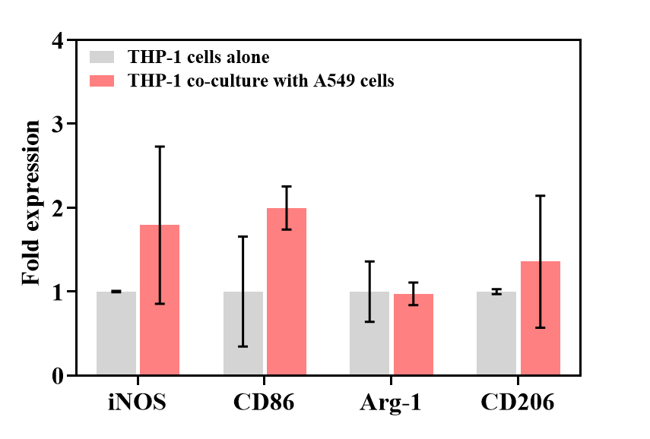Figure S1. The expression levels of M1-specific indicators (iNOS and CD86) and M2-specific indicators (Arg-1 and CD206) by qPCR.

Figure S2. PCA score plot (a) and PLS-DA score plot (b) of metabolites in THP-1 cells co-cultured with WS₂ nanosheets pretreated A549 cells.

Figure S3. Heat map of the identified metabolites. Heat map representation of the metabolites in the THP-1 cells that were bystander exposed to the 100 μg/mL WS₂ nanosheets. The up-regulated and down-regulated metabolites were shown in red and green, respectively.

Figure S4. Volcano plots of metabolomics data. The red triangle represented metabolic features with fold change > 2 and p < 0.05, and the green triangle represented metabolic features with fold change < 0.5 and p <0.05.
Figure S5. Analysis of metabolic pathways of THP-1 cells co-cultured with WS₂ nanosheets pretreated A549 cells. Every circle represents a metabolic pathway, with redder color indicating higher impact and yellower color indicating lower impact. The pathways with impact value > 0.1 and p < 0.05 were determined to have significant changes. The size of the circles indicates the relative impact value. Numbers 1–9 represent the following pathways: 1. pyruvate metabolism; 2. arginine and proline metabolism; 3. glyoxylate and dicarboxylate metabolism; 4. glycerolipid metabolism; 5. taurine and hypotaurine metabolism; 6.alanine, aspartate and glutamate metabolism; 7. glycolysis or gluconeogenesis; 8. butanoate metabolism; 9. cysteine and methionine metabolism.
Table S1. Sequences of qPCR primers in the study
Gene | Forward (5′-3′) | Reverse (5′-3′)
GAPDH | AAGGTGAAGGTCGGAGTCAAC | GGGGTCATTGATGGCAACAATA
iNOS | TTCAGTATCACAACCTCAGCAAG | TGGACCTGCAAGTTAAAATCCC
Arg-1 | TGGACAGACTAGGAATTGGCA | CCAGTCCGTCAACATCAAAACT
CD86 | GCGGCCTCGCAACTCTTATA | TCTCTTTTCTTGGTCTGTTCACTCTC
CD206 | AAGGCGGTGACCTCACAAG | AAAGTCCAATTCCTCGATGGTG
TNF-α | CCTCTCTCTAATCAGCCCTCTG | GAGGACCTGGGAGTAGATGAG
IL-10 | ACATCAAGGCGCATGTGAAC | GCCACCCTGATGTCTCAGTT

Table S2. Hydrodynamic size and zeta-potential of WS₂ nanosheet in different media
 | Media | Value | pH
Hydrodynamic size (nm) | Deionized water | 1523 ± 255 | 6.68
Hydrodynamic size (nm) | PBS | 1991 ± 782 | 7.95
Hydrodynamic size (nm) | RPMI 1640 (10% FBS) | 825 ± 330 | 7.92
Zeta-potential (mV) | Deionized water | -33.2 ± 5.4 | 6.68
Zeta-potential (mV) | PBS | -12.4 ± 1.7 | 7.95
Zeta-potential (mV) | RPMI 1640 (10% FBS) | -8.5 ± 0.9 | 7.92

