Supplementary figure 1
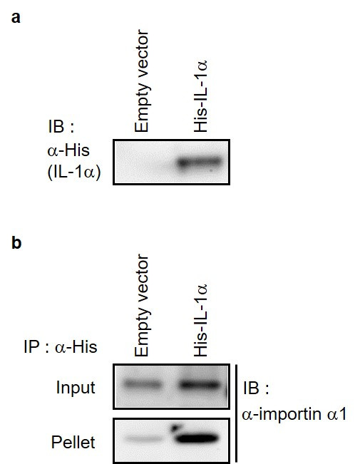
Supplementary Figure S1. Analysis of the interaction between importin α1 and IL-1α by coimmunoprecipitation. (a) Expression of His-tag-fused IL-1α gene in HeLa cells was confirmed by Western blotting using anti-His antibody. (b) Coimmunoprecipitation of HeLa cells shown in (a) was performed using anti-His antibody. The obtained fractions (input; lysate of HeLa cells before immunoprecipitation, and pellet; pellet fraction) were subjected to Western blotting to detect importin α1. The signal intensity of importin α1 in the input sample in IL-1α-expressing HeLa cells was roughly same as that in empty vector expressing cells, but in the pellet fraction, the signal intensity of importin α1 was significantly stronger in IL-1α-expressing HeLa cells than that in empty vector expressing cells; importin α1, which interacts with IL-1α, is enriched in the pellet fraction.

Supplementary figure 2
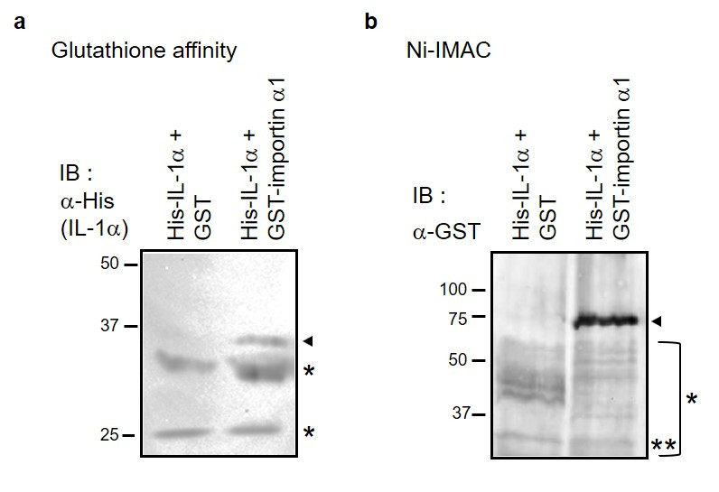
Supplementary Figure S2. Analysis of the interaction between importin α1 and IL-1α by GST pulldown assay. GST-importin α1 and His-IL-1α coexpressing HeLa cells were used for the analysis. (a) GST-fusion protein complexes were purified using glutathione affinity matrix and IL-1α was detected using an anti-His antibody in the collected complexes. Since the signal intensities of the non-specific bands were nearly equivalent between the two lanes of “His-IL-1α+GST” and “His-IL-1α+GST-importin α1”, it was assumed that nearly equal amounts of protein were blotted. (b) His-tag fusion protein complexes were collected using Ni-IMAC, and importin α1 was identified in the complexes collected using an anti-GST antibody. Since the signal intensities of non-specific bands located at the same molecular weight in the “His-IL-1α+GST” and “His-IL-1α+GST-importin α1” lanes (indicated by double asterisks) were nearly equivalent, these lanes contained approximately equal amounts of protein. Arrowheads indicate bands corresponding to the expected molecular weight of each protein. Asterisks indicate non-specific bands.

Supplementary figure 3
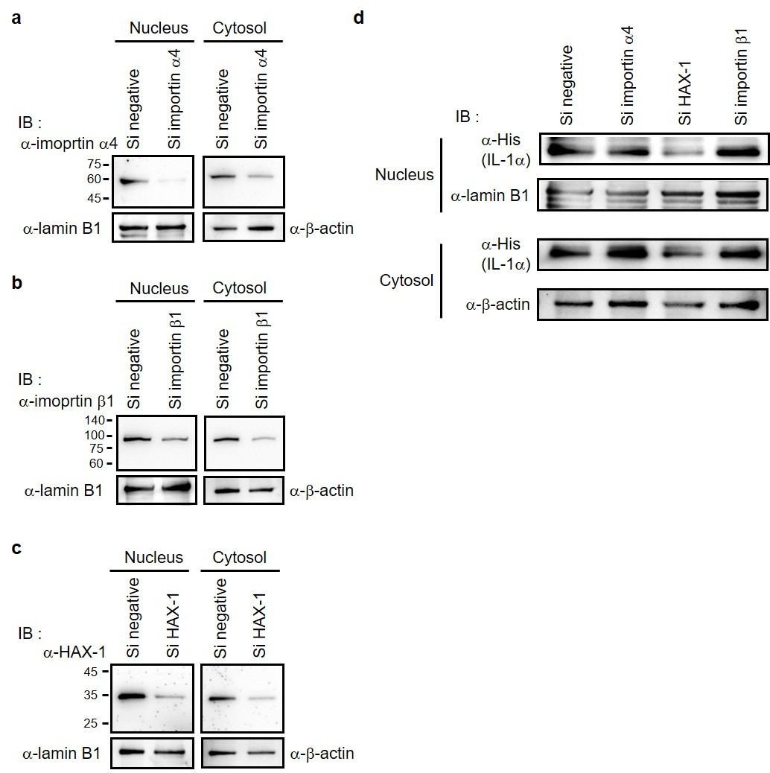
Supplementary Figure S3. Analysis of the effects of importin α4, importin β1, and HAX-1 on the nuclear translocation of IL-1α. (a), (b), (c) The cell lysates of HeLa cells transfected with siRNA targeting each of importin α4, importin β1, and HAX-1 and transfected with His-tag-fused IL-1α after 24 h were subjected to Western blotting with anti-importin α4, anti-importin β1 anti-HAX-1, anti-lamin B1, and anti-GAPDH antibodies. (d) HeLa cells used in (a), (b), and (c) were fractionated into nuclear and cytoplasmic fractions, and Western blotting was performed using each fraction with anti-IL-1α, anti-lamin B1, and anti-β-actin antibodies.

Supplementary table 1

