Supplementary Information:
Thermodynamics of multi-sublattice battery active materials: from an extended regular solution theory to a phase-field model of LiMn_{y}Fe_{1-y}PO₄
Pierfrancesco Ombrini¹, Martin Z. Bazant², Marnix Wagemaker¹, Alexandros Vasileiadis^{1*}
1. Storage of Electrochemical Energy, Department of Radiation Science and Technology, Faculty of Applied Sciences, Delft University of Technology, Mekelweg 15, 2929JB, Delft, The Netherlands
* Corresponding author: a.vasileiadis@tudelft.nl
Contents
- Supplementary Methods
  - Single particle phase field model
  - Conversion from concentration to volume expansion
  - Table of parameters
- Supplementary Results
  - Examples of Three-dimensional Energy Paths
  - Effect of temperature on the order of phase transition in LiMn_{y}Fe_{1-y}PO₄
  - Equilibrium voltage profile
  - Evolution of the concentration distribution
  - Simulated operando XRD of a 1C cycle
- Supplementary References

1. Supplementary Methods
1.1. Single particle phase field model
To accurately apply the extended regular solution model, a complete phase field model is needed. It is necessary to return to the Cahn-Hilliard formalism and derive the free energy functional, including the effects of nonuniform compositions. In this approach, the free energy of a nonuniform system depends not only on the concentration but also on the higher-order gradient terms $∇{\tilde{c}}_{i}, ∇^{2}{\tilde{c}}_{i}$. It was chosen to neglect the effects of the mutual interaction of ${\tilde{c}}_{i}$ and ${\tilde{c}}_{j}$ on the gradient terms and, therefore, to directly add to the homogenous free energy the term $\frac{1}{2}κ_{i}{\left|∇{\tilde{c}}_{i}\right|}^{2}$ to account for gradient penalties. The concentrations are defined such that $\tilde{c}=\sum_{i=1}^{n}{y_{i}{\tilde{c}}_{i}}$, $\overline{c}$ is the overall mean concentration of the particle and $c_{max}= \sum_{i=1}^{n}{y_{i}{\tilde{c}}_{i_{max}}}$.
To calculate how $κ_{i}$ depends on the composition is necessary to recall the formulation found by Zelič and al.¹
$$κ_{i}=\frac{Nzd^{2}}{m}Ω_{ii} (E1)$$
In which $d$represent the distance between crystal planes and $m$is a geometrically deduced parameter. Following that theory, in a case in which the structure is not heavily modified by the metal substitution, the effective boundary energy can be calculated by multiplying the original $κ_{i}$ by $y_{i}^{2}$.
Another effect that must be considered in the case of a nonuniform system is the coherency strain energy, which was proven to be fundamental to explaining the anisotropy of the phase separation in LFP².
Given the limited energy scale of the coherency strain, it was not considered necessary to reformulate the original theory developed for two-phase materials in the presence of multiple stable phases. Thus the formulation^{2,3}:
$$B\left(n\right)=C_{ijkl}ϵ_{ij}^{0}ϵ_{kj}^{0}-n_{i}σ_{ij}^{0}Ω_{jl}(n)σ_{lm}^{0}n_{m},$$
$${\left[Ω^{-1 }\right]}_{ij}=C_{iklj}n_{k}n_{l}, (E2)$$
$$σ_{ij}^{0}=C_{ijkl}ϵ_{kl}^{0},$$
In which $B(n)$ is the coherency strain pressure along the direction $n$, $C_{ijkl}$ is the stiffness tensor and $ϵ_{ij}^{0}$ is the strain matrix.
Finally, for dimensionality reduction, the Cahn approach was implemented^{2–4}: $B_{0}$ is selected as the minima amongst the different directions and a term $\frac{1}{2}\frac{B_{0}}{c_{max}}{\left(\tilde{c}-\overline{c}\right)}^{2}$ is added to the free energy functional.
The total $B_{0}$ is instead computed as $B_{0}=\sum_{i=1}^{n}{y_{i}B_{i}(n_{0})}$, since the correct value for a compound material would require a consistent number of first-principles calculations without a valuable gain in accuracy.
The complete specific Gibbs free energy will be given by
$$g= c_{max}\left\{\frac{F}{N}+ \sum_{i=1}^{n}{ \frac{1}{2}y_{i}^{2}κ_{i}{\left|∇{\tilde{c}}_{i}\right|}^{2}} + \frac{1}{2}\frac{B_{0}}{c_{max}}{\left(\tilde{c}-\overline{c}\right)}^{2}\right\} (E3)$$
For the phase-field approach, it is now sufficient to calculate the chemical potentials $μ_{i}$ in the sublattice $i ≠j$as a functional derivative of $G=\int_{V}{g dV}$ so that
$$μ_{i}=k_{B}Tln\left(\frac{{\tilde{c}}_{i}}{1-{\tilde{c}}_{i}}\right)+\sum_{j=1}^{n}{y_{j}Ω_{ij}(1-2{\tilde{c}}_{j})}+{\frac{B_{0}}{c_{max}}\left(\tilde{c}-\overline{c}\right)-{y_{i}κ}_{i}∇^{2}{\tilde{c}}_{i}+μ}_{i}^{Θ} (E4)$$
Since the crystal structure of LFMP is equivalent to the one of LFP (Pnma) it is possible to use the same approach used by Cogswell and al.⁵ to simulate an LFP particle so that the platelet-shaped particles can be simulated along the [101] dimension. The concentration along the depth of the platelet is considered uniform, all the points of the array are in contact with the electrolyte, and they react with it depending on their chemical potential. Therefore, the system is considered open and can be included in the Allen-Chan formalism.
Due to the known transport limitation of LFMP⁶, the depth-averaged approximation prevents the model from reliably accounting for fast (de)lithiation making it suitable only to explore close to equilibrium conditions, approximately up to 1C for thin platelet particles.
The reaction dependence on the overpotential was modeled through the modified version of the Butler-Volmer equation⁷, in which the current exchange density depends on the activity of the Li in both the electrolyte and solid phases.
$$i\left(c_{i},x\right)=y_{i}\frac{k_{0}a_{O}^{1-α}a_{i}^{α}}{γ_{i}^{‡}}\left(e^{-\frac{αeη_{i}}{k_{B}T}}-e^{\frac{\left(1-α\right)eη_{i}}{k_{B}T}}\right) (E5)$$
Where $α$ is the reactor symmetry factor, $k_{0}$ is the reaction rate constant per unit area, $e$ is the elementary charge, $a_{O}$ is the activity of the oxidized state, which also includes the activity of the electron participating in the reaction, $a_{i}$ is the activity of the ion in the sublattice $i$, $η_{i}$ is the charge transfer overpotential for the sublattice $i$($eη_{i}=μ_{i}-μ_{O})$ and $γ_{i}^{‡}= = \frac{1}{\left(1-{\tilde{c}}_{i}\right)}$ is the activity coefficient of the transition state of the sublattice $i$.
Other than the redox potential and the mixing energy, to implement a phase field model is necessary to quantify the gradient energy term $κ_{i}$ and the coherency strain $B_{0}$. Following the approach described above for the gradient penalty energy, starting from the know $κ_{LFP}= 9.919 {∙10}^{-10} J/m$ ⁵, and considering the same characteristic length $λ$ for LMP, it is possible to quantify $κ_{LMP}=17.06 ∙{10}^{-10} J/m$. To calculate the coherency strain, the values of the stiffness tensors are taken form the work of Lethole and al.⁸, and applying equation E2, the following values are obtained $B_{0_{LFP}}=0.2291 GPa$, $B_{0_{LMP}}=0.2038 GPa$.
The developed theory can simulate an electrochemical reaction between a phase separating multi-sublattice particle and an electrolyte. However, for computational reasons, the chemical potential implemented in the open-source code MPET was slightly modified so that the one implemented for a 2 sublattice material becomes
$$μ_{i}={2k}_{B}Tln\left(\frac{{\tilde{c}}_{i}}{1-{\tilde{c}}_{i}}\right)+y_{i}Ω_{ii}^{*}\left(1-2{\tilde{c}}_{i}\right)+y_{j}Ω_{ij}\left(1-2{\tilde{c}}_{j}\right)+{\frac{B_{0}}{c_{max}}\left(\tilde{c}-\overline{c}\right)-{y_{i}κ}_{i}^{*}∇^{2}{\tilde{c}}_{i}+μ}_{i}^{Θ} (E6)$$
The computational necessity, due to the numerical handling of the logarithmic term, to modify the entropic contribution by multiplying it by 2 was compensated by applying a different $Ω_{ii}$, named $Ω_{ii}^{*}$, that was calculated again, assuring that the voltage hysteresis gap between charge and discharge of the mono-sublattice corresponding material (LFP and LMP) assumed the same value as the one calculated using a coefficient 1 on the entropy. To maintain the same characteristic length of the phase boundary, also $κ_{i}^{*}$ was also modified proportionally. The electrolyte parameters are taken from Bernardi and Go 2011⁹

1.2. Conversion from concentration to volume expansion
To compare the evolution of the simulated distribution of the concentration during the charge and discharge process in LFMP with the available refined operando XRD experimental data, we collected the normalized concentration of every finite difference of every particle at every time step in a histogram, creating a probability distribution of the normalized concentration. This distribution is then converted to a volume expansion distribution, as described in this section. Finally, a gaussian broadening is applied to the distribution for visual intent. The obtained result before the conversion to volume is represented in the results section of this document.
To convert from concentration to volume, we define a non-linear relationship between the total normalized concentration in the active particle $\tilde{c}$ and the normalized volume expansion.
A distinction was made between the solid solution state and the single crystalline phase state: if the particle concentration is in a range in which a solid solution transition is expected, we assume that the volume grows linearly with the concentration, if instead, the particle concentration is in a well-defined phase, so before or after the spinodal compositions, we assume that the volume, or at least the refined volume value from X-ray scattering, does not change with the concentration.
In the case of LFMP, during the lithiation of the Mn sublattice where ${\tilde{c}}_{1}$ will go from 0 to 1, the particles can either be found in a solid solution state if $y$is lower than the critical value described in the main text, or they can separate in a bimodal composition. In the latter case, one part of the population can be in a single crystalline phase called $α$, which will then give a constant volume, and the remaining is in a solid solution phase. A similar approach can be applied to the Fe plateau, in which ${\tilde{c}}_{2}$ will go from 0 to 1, where all the particles will start from a solid solution state and, during lithiation, some of them may nucleate into the $β$ crystalline phase.
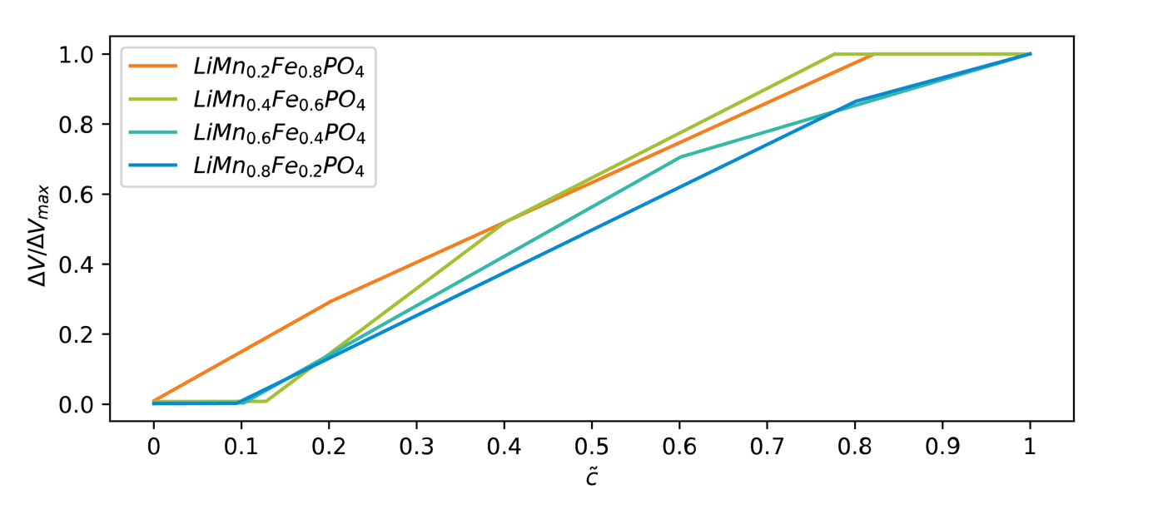
Fig. S4 Relationship used to convert the concentration to the volume.
Following this reasoning and considering that the volume expansion during the solid solution transition will depend on the filling Mn or the Fe sublattice, we can create a rectified linear unit function for the evolution of the volume.
Explicitly, we start by finding the spinodal compositions ${{\tilde{c}}_{i}}_{minus},{{\tilde{c}}_{i}}_{plus}$
$$\frac{∂μ_{i}}{∂{\tilde{c}}_{i}}{\left.​\right|}_{{{\tilde{c}}_{i}}_{minus},{{\tilde{c}}_{i}}_{plus}}= 0 (E7)$$
The volume of each sublattice, $V_{Mn}$ and $V_{Fe}$ , will then be given by
$$\left\{\begin{aligned}{ΔV}_{Mn}\left({\tilde{c}}_{1}\right)=0 if {\tilde{c}}_{1}< {\tilde{c}}_{1_{minus}} \\ {ΔV}_{Mn}\left({\tilde{c}}_{1}\right)=ΔV_{LMP}\frac{{\tilde{c}}_{1}-{\tilde{c}}_{1_{minus}}}{1-{\tilde{c}}_{1_{minus}}} if {\tilde{c}}_{1}> {\tilde{c}}_{1_{minus}}\end{aligned}(E8)\right.$$
$$\left\{\begin{aligned}{ΔV}_{Fe}\left({\tilde{c}}_{2}\right)= ΔV_{LFP}\frac{{\tilde{c}}_{2}}{{\tilde{c}}_{2_{plus}}} if {\tilde{c}}_{2}< {\tilde{c}}_{2_{plus}} \\ {ΔV}_{Fe}\left({\tilde{c}}_{2}\right)= ΔV_{LFP} if {\tilde{c}}_{2}> {\tilde{c}}_{2_{plus}}\end{aligned}\right.(E9)$$

Where $ΔV_{LFP}$ and $ΔV_{LMP}$ are the maximum volume expansions of respectively LFP and LMP.
The total normalized volume expansion will then be
$$\frac{ΔV\left(\tilde{c}\right)}{ΔV_{max}}=\frac{{{y ΔV}_{Mn}\left({\tilde{c}}_{1}\right)+ \left(1-y\right)ΔV}_{Fe}\left({\tilde{c}}_{2}\right)}{{{y ΔV}_{Mn}\left({\tilde{c}}_{1}=1\right)+ \left(1-y\right)ΔV}_{Fe}\left({\tilde{c}}_{2}=1\right)} (E10)$$
Where $y$is the fraction of Mn and $\tilde{c}=y {\tilde{c}}_{1}+\left(1-y \right){\tilde{c}}_{2}$.
The result of the above calculation will lead to the conversion between volumes plotted in figure S4.
We want to highlight that this conversion is primarily qualitative, and it was done to explore the correspondence in the phase transition behavior between the simulations and the experiments. A proper conversion will require a complete study of its own.

Table T1 Parameters used for the multiphase porous electrode theory simulations.
LFMP parameters
Enthalpy of mixing ($Ω_{Mn}^{*}$) | 4.705*10⁻²⁰ J/Li
Gradient penalty ($κ_{Mn}$) | 17.06*10⁻¹⁰ J/m
Coherency strain (${B_{0}}_{Mn}$) | 0.2291 GPa | Ref.⁸
Enthalpy of mixing ($Ω_{Fe}^{*}$) | 2.931*10⁻²⁰ J/Li | Ref.⁵
Gradient penalty ($κ_{Fe}$) | 9.91*10⁻¹⁰ J/m | Ref.⁵
Coherency strain (${B_{0}}_{Fe}$) | 0.2891 GPa | Ref.⁸
Charge transfer coefficient ($α)$ | 0.5
$$k_{0}$$ | 0.5 $A/m^{2}$
Morphology
Particle average length | 100 nm
Particle standard deviation | 50 nm
Cathode thickness (L) | 30 μm, 80 μm
Electrode porosity | 60 %, 30 %
Active material volume loading | 70 %
Number of particles | 400
Bruggeman coefficient | 0.5

2. Supplementary Results
2.1. Examples of Three-dimensional Energy Path
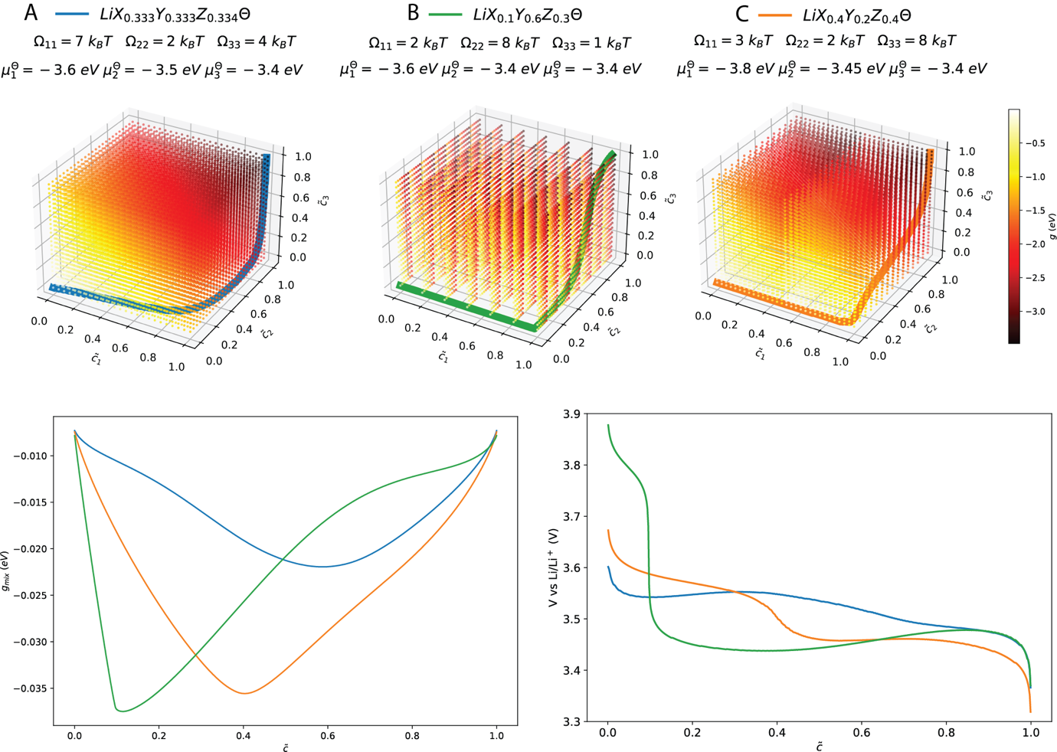
Fig. S1 Examples of not-trivial energy paths in three-dimensional energy space of materials A (blue lines), B (green lines), and C (orange lines), the dots represent the free energy at that composition (top). Corresponding minimum mixing free energy path (bottom left) and expected voltage curves for the homogenous system (bottom right).
Taking equation 4 of the main text and applying it to a 3-sublattice material, we can observe how modifying $Ω_{ii}$, $μ_{i}^{Θ}$ and $y_{i}$ it is possible to build non-trivial chemical potentials so that an originally phase-separating material can now behave as a solid solution or vice versa.
For example, material A (in figure S1), having similar $μ_{i}^{Θ}$But quite different $Ω_{ii}$, show a shallow phase separation between $\tilde{c}≈0.1$ and $\tilde{c}≈0.6$ even if $Ω_{11}$ is much bigger than the $2 k_{B}T$ threshold value. Conversely, material B will have ${\tilde{c}}_{2}$ and ${\tilde{c}}_{3}$ reacting simultaneously following a phase separation. Finally, material C is almost following a solid solution path even if most of its components have $Ω_{ii}>2 k_{B}T$.

2.2. Effect of temperature on the order of phase transition in LiMn_{y}Fe_{1-y}PO₄
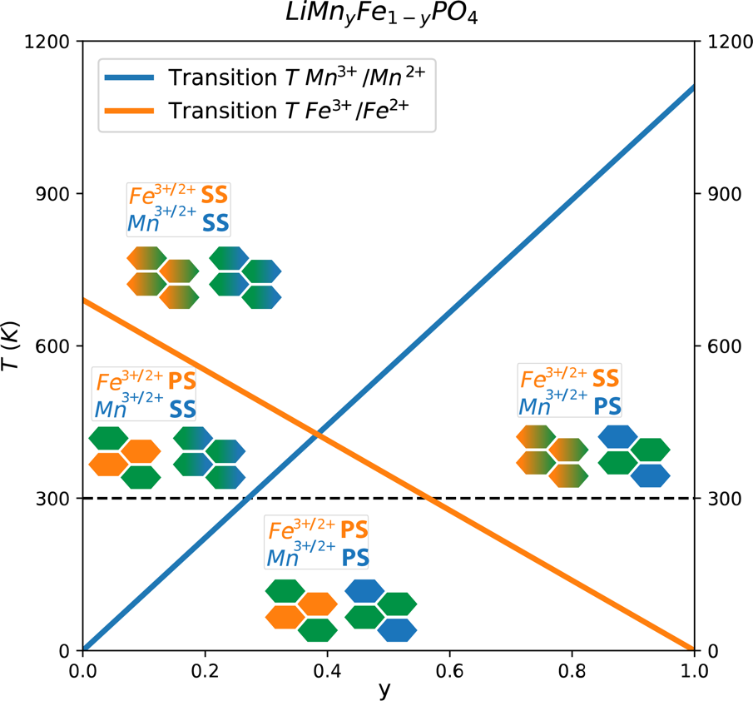
Figure S2. Concentration-dependent solid solution temperature of LiMn_{y}Fe_{1-y}PO₄. The orange and blue lines show how the temperature in which we observe a solid solution transition of the Fe and the Mn plateaus, respectively, depending on the Mn concentration $y$. A schematic representation of the phase transition is added in the four zones arising from these calculations.
Assuming that the calculation for the solid solution composition $y_{i_{ss}}(T)<2k_{B}T/Ω_{i}$ could be done for a wide range of temperatures, the order of phase transition for the two plateaus of LiMn_{y}Fe_{1-y}PO₄ can be calculated. In figure S2 is possible to observe how the system behaves similarly to a eutectic system, in which at a specific concentration ($y=0.38),$ the temperature required to obtain a solid solution regime in both the plateaus drop considerably. We can find four different zones where the different plateaus have different behaviors.

2.3. Equilibrium voltage profile
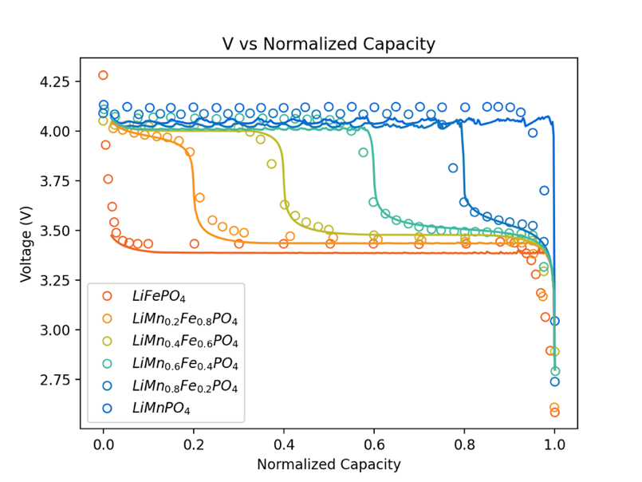
Figure S3. Simulated voltage curves upon a C/100 discharge of LiMn_{y}Fe_{1-y}PO₄ at various compositions
As shown in figure S3, the model can replicate the experimental voltage curves of LiMn_{y}Fe_{1-y}PO₄ with high accuracy, confirming what was stated during the comparison between the analytical calculations and the cyclic voltammetry.
The simulations in equilibrium conditions show how the redox shift of the plateau is matched without imposing it for every composition and how the same equation can smoothly replicate the potential at various stoichiometries just by changing the single parameter $y$. The voltage curves corresponding to the solid solution behavior are closely reproduced; the ones showing a phase separation instead are slightly different since the simulations focused on the constant current discharge process (for computational efficiency) while the experiments were probably done using different protocols.

2.4. Evolution of the concentration distribution
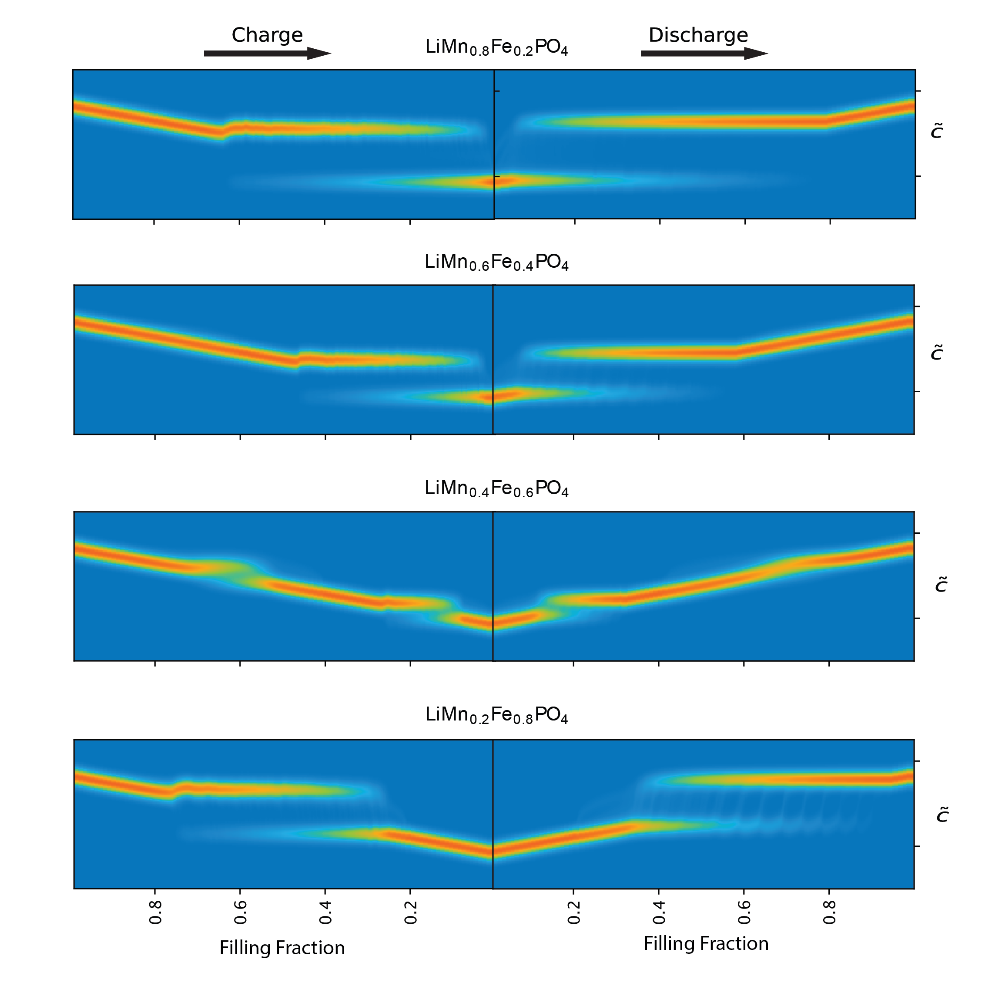
Fig S5. Evolution of the concentration of the C/10 simulations of the main text during charging and discharging.
To further clarify the results in the main text, in figure S5 we reported the original evolution of the concentration distribution during charging and discharging at C/10 for the selected compositions of LFMP. The results are similar to figure 5 of the main text, and it clearly shows phase separation and solid solution behavior in the filling fractions, confirming that the close match with the experiments is not a result of the artificial conversion from concentration to volume.
The main difference is in the single-phase regions, where the concentration evolves linearly with time, and the intensity shifts linearly. There are several supplementary video files depicting this behavior in detail.

2.5. Simulated operando XRD of a 1C cycle
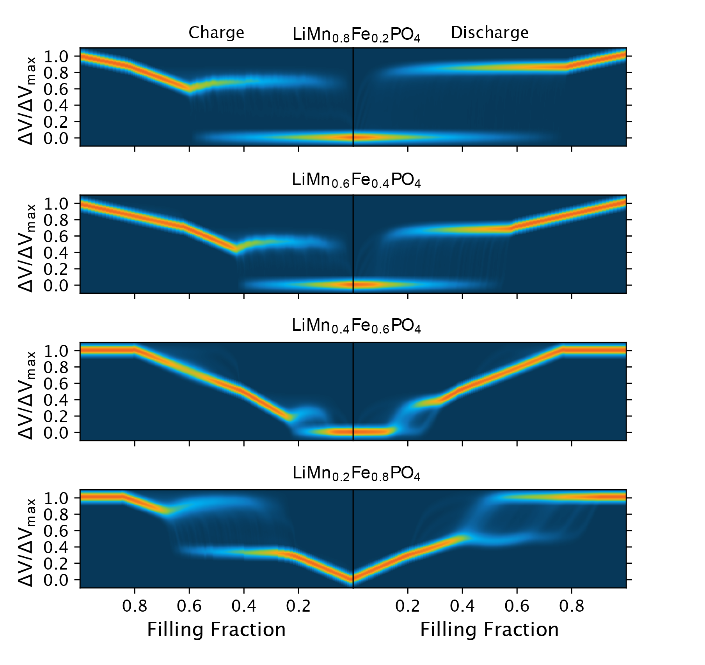
Fig. S6: Simulated operando XRD of the particle ensemble studied in the main text for a 1C discharge at different compositions.
To understand more in-depth the collective behavior, the 1C cycle behavior was simulated using the same particle set shown in the main text and described in table T1. The results of the simulated operando XRD in figure S6 show how at higher discharge rates, the phase separation is more strongly suppressed even during charge for LiMn_{0.4}Fe_{0.6}PO₄. This can be explained considering the theory on the auto-inhibitory behavior of a collective particle ensemble¹⁰. The exchange current density dependence on concentration is, in fact, for both plateaus similar to the one of LFP so that, thanks to the intrinsic low enthalpic term, the phase separation is already suppressed at relatively low rates for the case of $y=0.4$. In the other compositions, the phase separation is still present due to the stronger effective mixing enthalpy of the corresponding plateaus.

3. Supplementary References
(1) Zelič, K.; Katrašnik, T. Thermodynamically Consistent Derivation of Chemical Potential of a Battery Solid Particle from the Regular Solution Theory Applied to LiFePO4. Sci. Rep. 2019, 9 (1), 2123. https://doi.org/10.1038/s41598-019-38635-2.
(2) Cogswell, D. A.; Bazant, M. Z. Coherency Strain and the Kinetics of Phase Separation in LiFePO ₄ Nanoparticles. ACS Nano 2012, 6 (3), 2215–2225. https://doi.org/10.1021/nn204177u.
(3) Hörmann, N. G.; Groß, A. Phase Field Parameters for Battery Compounds from First-Principles Calculations. Phys. Rev. Mater. 2019, 3 (5), 055401. https://doi.org/10.1103/PhysRevMaterials.3.055401.
(4) Cahn, J. W. On Spinodal Decomposition in Cubic Crystals. Acta Metall. 1962, 10 (3), 179–183. https://doi.org/10.1016/0001-6160(62)90114-1.
(5) Bai, P.; Cogswell, D. A.; Bazant, M. Z. Suppression of Phase Separation in LiFePO ₄ Nanoparticles During Battery Discharge. Nano Lett. 2011, 11 (11), 4890–4896. https://doi.org/10.1021/nl202764f.
(6) Yang, L.; Deng, W.; Xu, W.; Tian, Y.; Wang, A.; Wang, B.; Zou, G.; Hou, H.; Deng, W.; Ji, X. Olivine LiMn _{x} Fe _{1−x} PO ₄ Cathode Materials for Lithium Ion Batteries: Restricted Factors of Rate Performances. J. Mater. Chem. A 2021, 9 (25), 14214–14232. https://doi.org/10.1039/D1TA01526E.
(7) Bai, P.; Bazant, M. Z. Charge Transfer Kinetics at the Solid–Solid Interface in Porous Electrodes. Nat. Commun. 2014, 5 (1), 3585. https://doi.org/10.1038/ncomms4585.
(8) Lethole, N. L.; Ngoepe, P. E.; Chauke, H. R. First-Principles Study: Effect of Lithium and Sodium Intercalation in Transition Metal Phosphates, MPO4 (M: Mn, Fe, Co). Comput. Condens. Matter 2020, 22, e00437. https://doi.org/10.1016/j.cocom.2019.e00437.
(9) Bernardi, D. M.; Go, J.-Y. Analysis of Pulse and Relaxation Behavior in Lithium-Ion Batteries. J. Power Sources 2011, 196 (1), 412–427. https://doi.org/10.1016/j.jpowsour.2010.06.107.
(10) Li, Y.; El Gabaly, F.; Ferguson, T. R.; Smith, R. B.; Bartelt, N. C.; Sugar, J. D.; Fenton, K. R.; Cogswell, D. A.; Kilcoyne, A. L. D.; Tyliszczak, T.; Bazant, M. Z.; Chueh, W. C. Current-Induced Transition from Particle-by-Particle to Concurrent Intercalation in Phase-Separating Battery Electrodes. Nat. Mater. 2014, 13 (12), 1149–1156. https://doi.org/10.1038/nmat4084.

