Figure S1

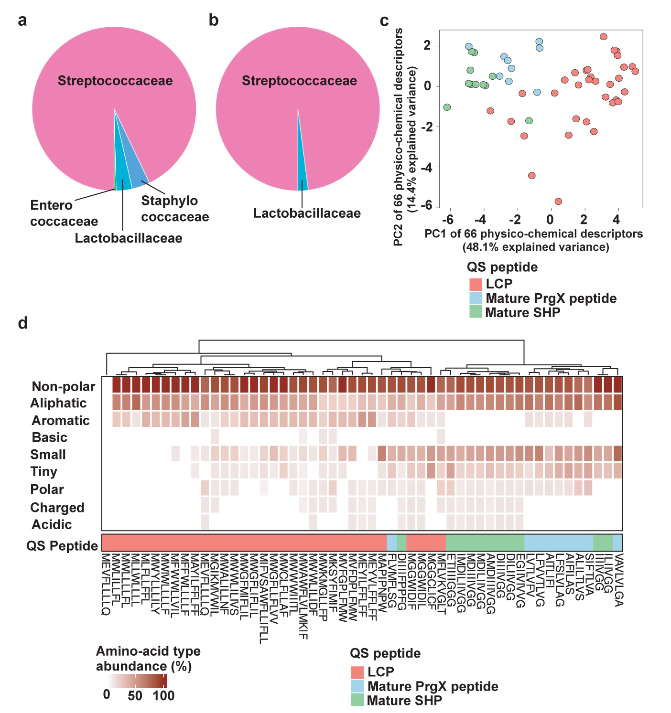

Figure S1. The distribution of Rgg1-SHP (a) and Rgg2-SHP (b) systems in different bacterial taxa. c) Physico-chemical signatures of LCPs (red) and of PptAB-exported streptococcal SHPs (green) and enterococcal PrgX-like (blue) mature quorum sensing peptides. The panel displays the coordinates of each peptide sequence in the two first principal components of the space of 66 physiochemical amino-acid descriptors (the 10 Blosum indices, 3 Cruciani properties, 6 FASGAI vectors, 10 Kidera factors, 3 MS-WHIM scores, 8 protFP descriptors, 8 ST-scales, 5 T-scales, 8 VHSE-scales and 5 Z-scales implemented in the ‘Peptides’ R package). d) Clustered heatmap representing the enrichment of each amino-acid type within LCPs (red), SHPs (green) and PrgX (blue): non-polar (A,C,F,G,I,L,M,P,V,W,Y), aromatic (F,H,W,Y), aliphatic (A,I,L,V), small (A,B,C,D,G,N,P,S,T,V), tiny (A,C,G,S,T), polar (D,E,H,K,N,Q,R,S,T,Z), charged (B,D,E,H,K,R,Z), acidic (B,D,E,Z) and basic (H,K,R).

Figure S2
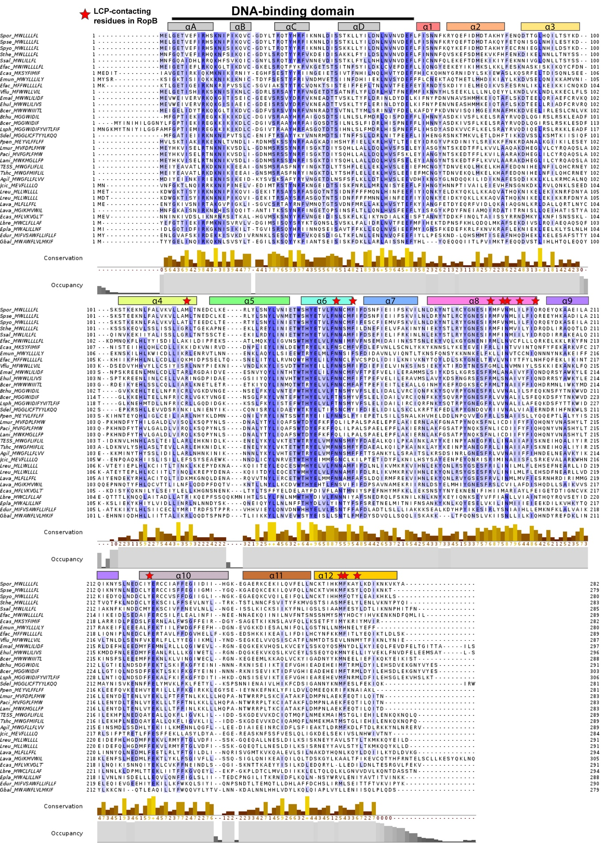
Figure S2. Differential conservation of amino acids across regions of LCP clan receptors. Structure-guided multiple sequence alignment of receptors paired with LCPs. Each row depicts a receptor sequence, labeled according to their species origin and their cognate LCP. The structural domains and the LCP-contacting residues of RopB from S. pyogenes are mapped onto corresponding sites of the alignment. The conservation level of each site is displayed in the bottom of the alignment, and the most conserved amino acids at each site are highlighted in different shades of blue.

Figure S3
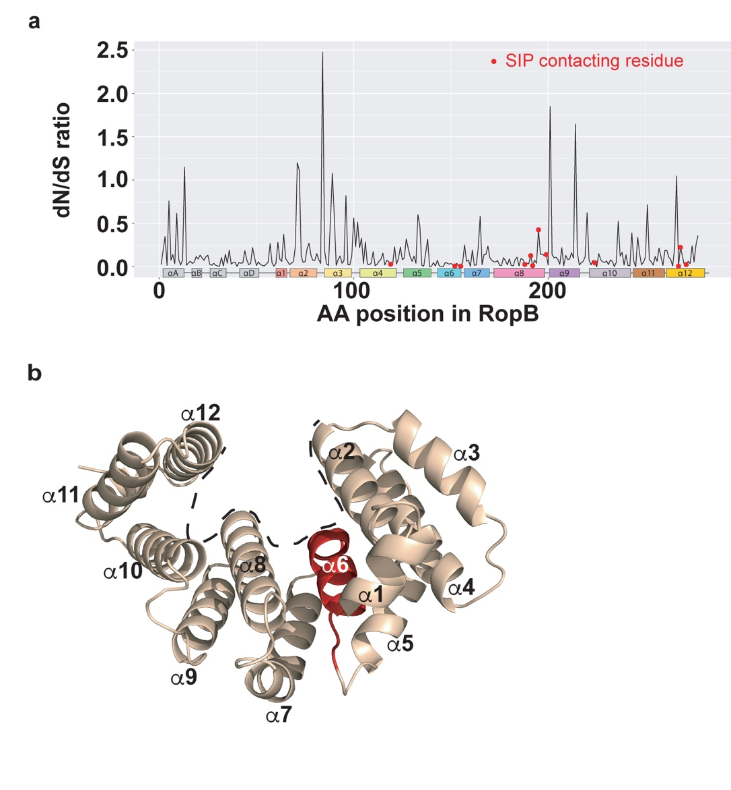

Figure S3. Differential selective pressure across regions of RopB clan receptors. a, Site-wise dN/dS of each amino acid in the alignment in fig. S2 (the closer to 0, the higher the inferred purifying selection acting against amino acid substitution). Sites corresponding to LCP-contacting residues in RopB are highlighted in red. b, Structure of the LCP-binding pocket of RopB (PDB code: 6DQL). The boundary of the LCP-binding pocket is marked as dashed lines. The secondary structure (helices α1-12) of RopB-CTD is labeled and the highly conserved helix α6 is highlighted in red.

Figure S4
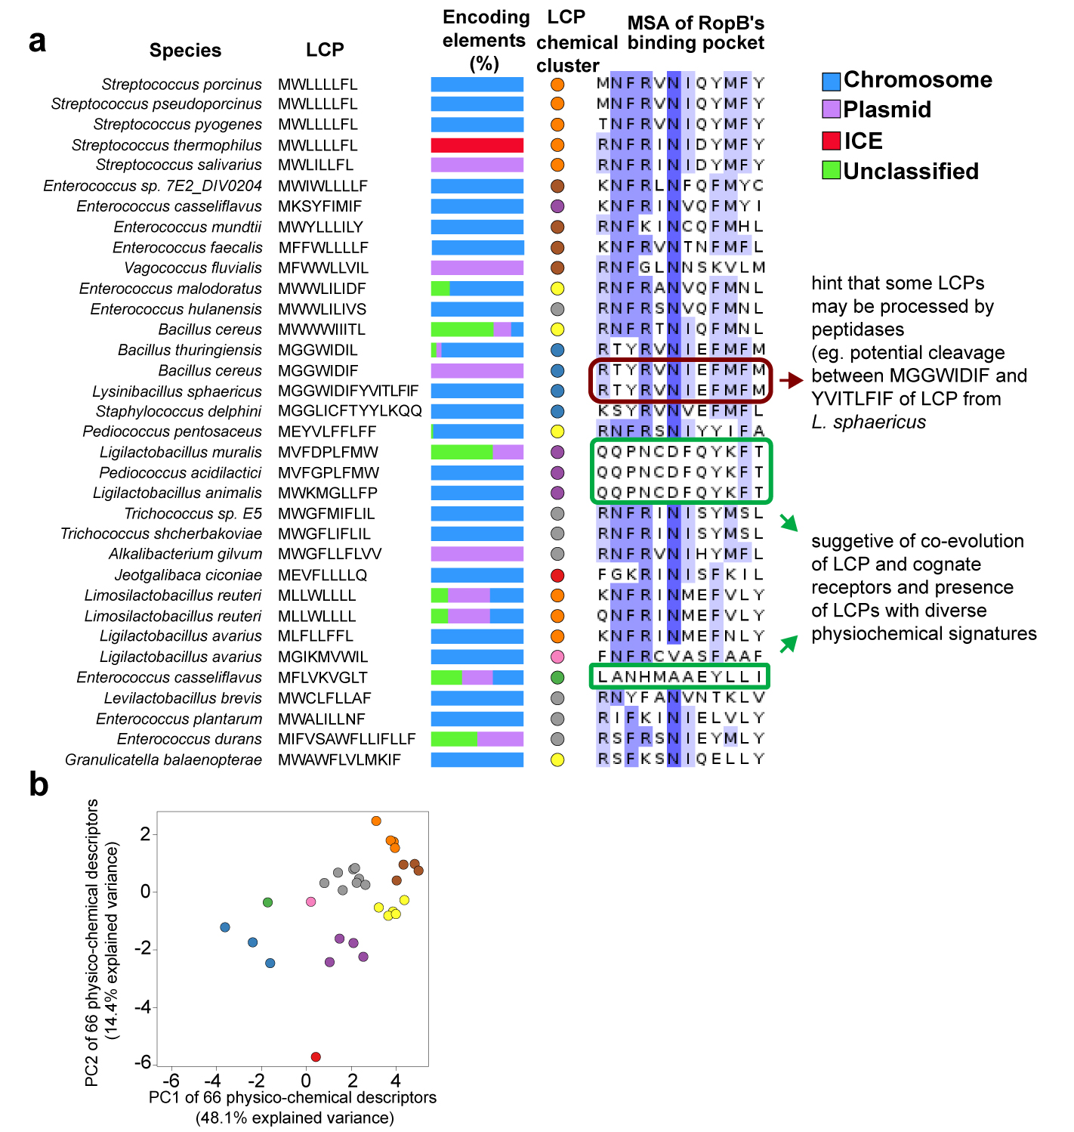

Figure S4. Co-evolution receptor-LCP pairs. a, Mapping LCP-contacting residues and LCP sequences. Each line corresponds to a candidate receptor-LCP pair of a given species. The corresponding physiochemical cluster of the LCP is highlighted in color (as in panel b), and the LCP-contacting residues are displayed at the right. The LCP-contacting amino-acids are colored according to their conservation level in the multiple sequence alignment. The green boxes indicate outlier LCP-binding residues, whose cognate LCPs also deviate from the canonical LCP signature in the PCA of peptide chemical descriptors. The red box highlights identical LCP-contacting residues associated with distinct LCPs, which nonetheless harbor an identical region. b, PCA of LCP chemical signatures.

Figure S5

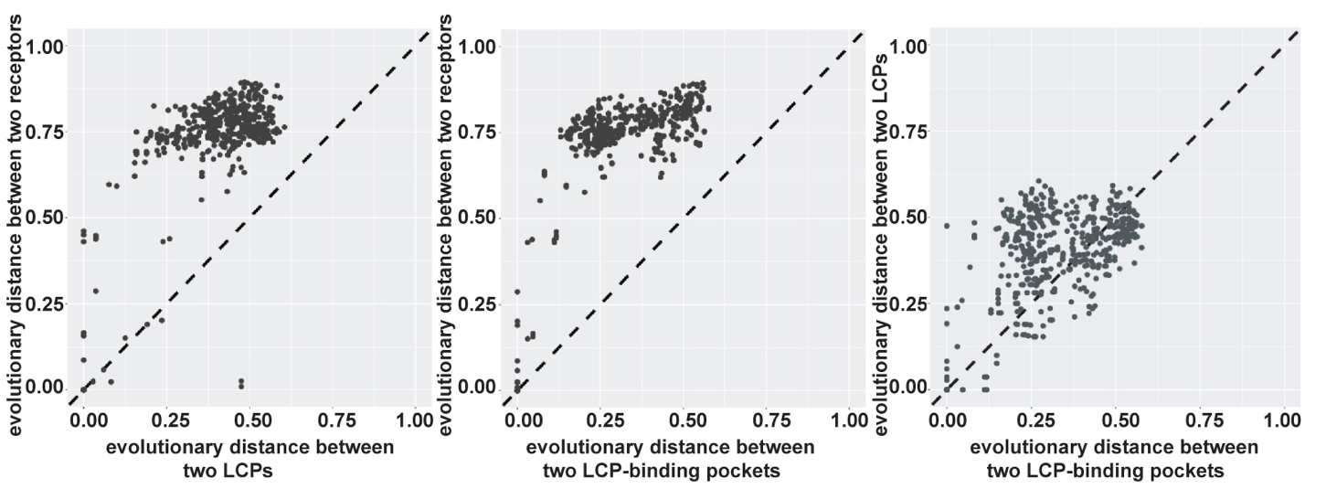

Figure S5. Comparisons of pairwise evolutionary distances between entire receptors, LCP contacting residues, and predicted LCPs.

Figure S6
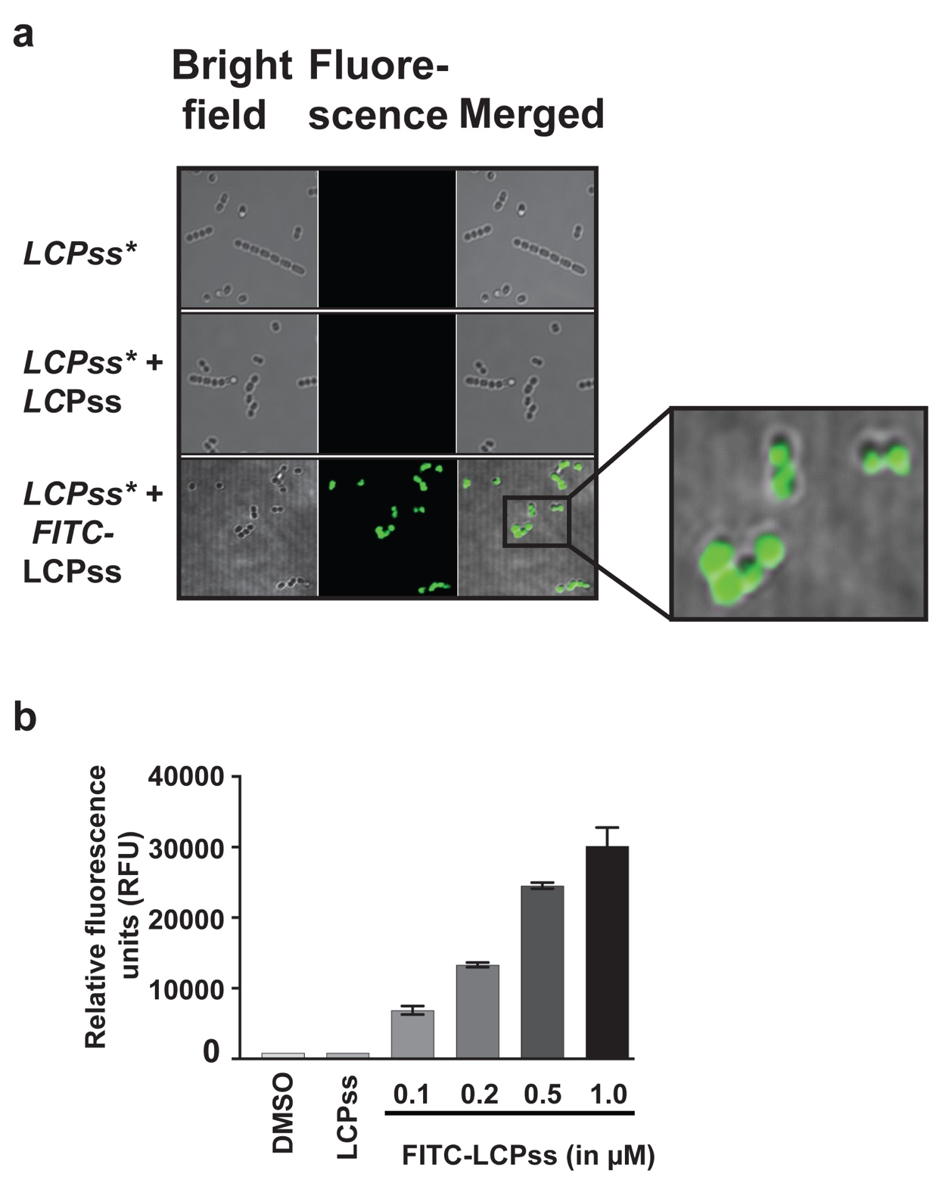

Figure S6. a, Confocal microscopy images of the LCP_{ss}* mutant strain either unsupplemented or supplemented with the indicated synthetic peptide. For each sample, bright-field, fluorescence-field, and merged images are shown. Magnified view of the FITC–LCP_{ss}–supplemented growth. b, The LCP_{ss}* mutant strain was grown to the late exponential phase (A₆₀₀ ∼ 2.0) and supplemented with either the indicated synthetic peptide or the carrier for the synthetic peptides (DMSO). Unmodified LCP_{ss} was added at a final concentration of 1 μM, whereas varying concentrations FITC-LCP_{ss} were used. After 30 min of incubation at 37 °C, cells were washed three times with sterile PBS, suspended in PBS, and lysed. Fluorescence measurements were obtained with clarified cell lysates using excitation and emission wavelengths of 480 nm and 520 nm, respectively. The unsupplemented LCP_{ss}* mutant strain was used as a reference, and changes in relative fluorescence units (RFU) relative to the reference are shown.

Figure S7

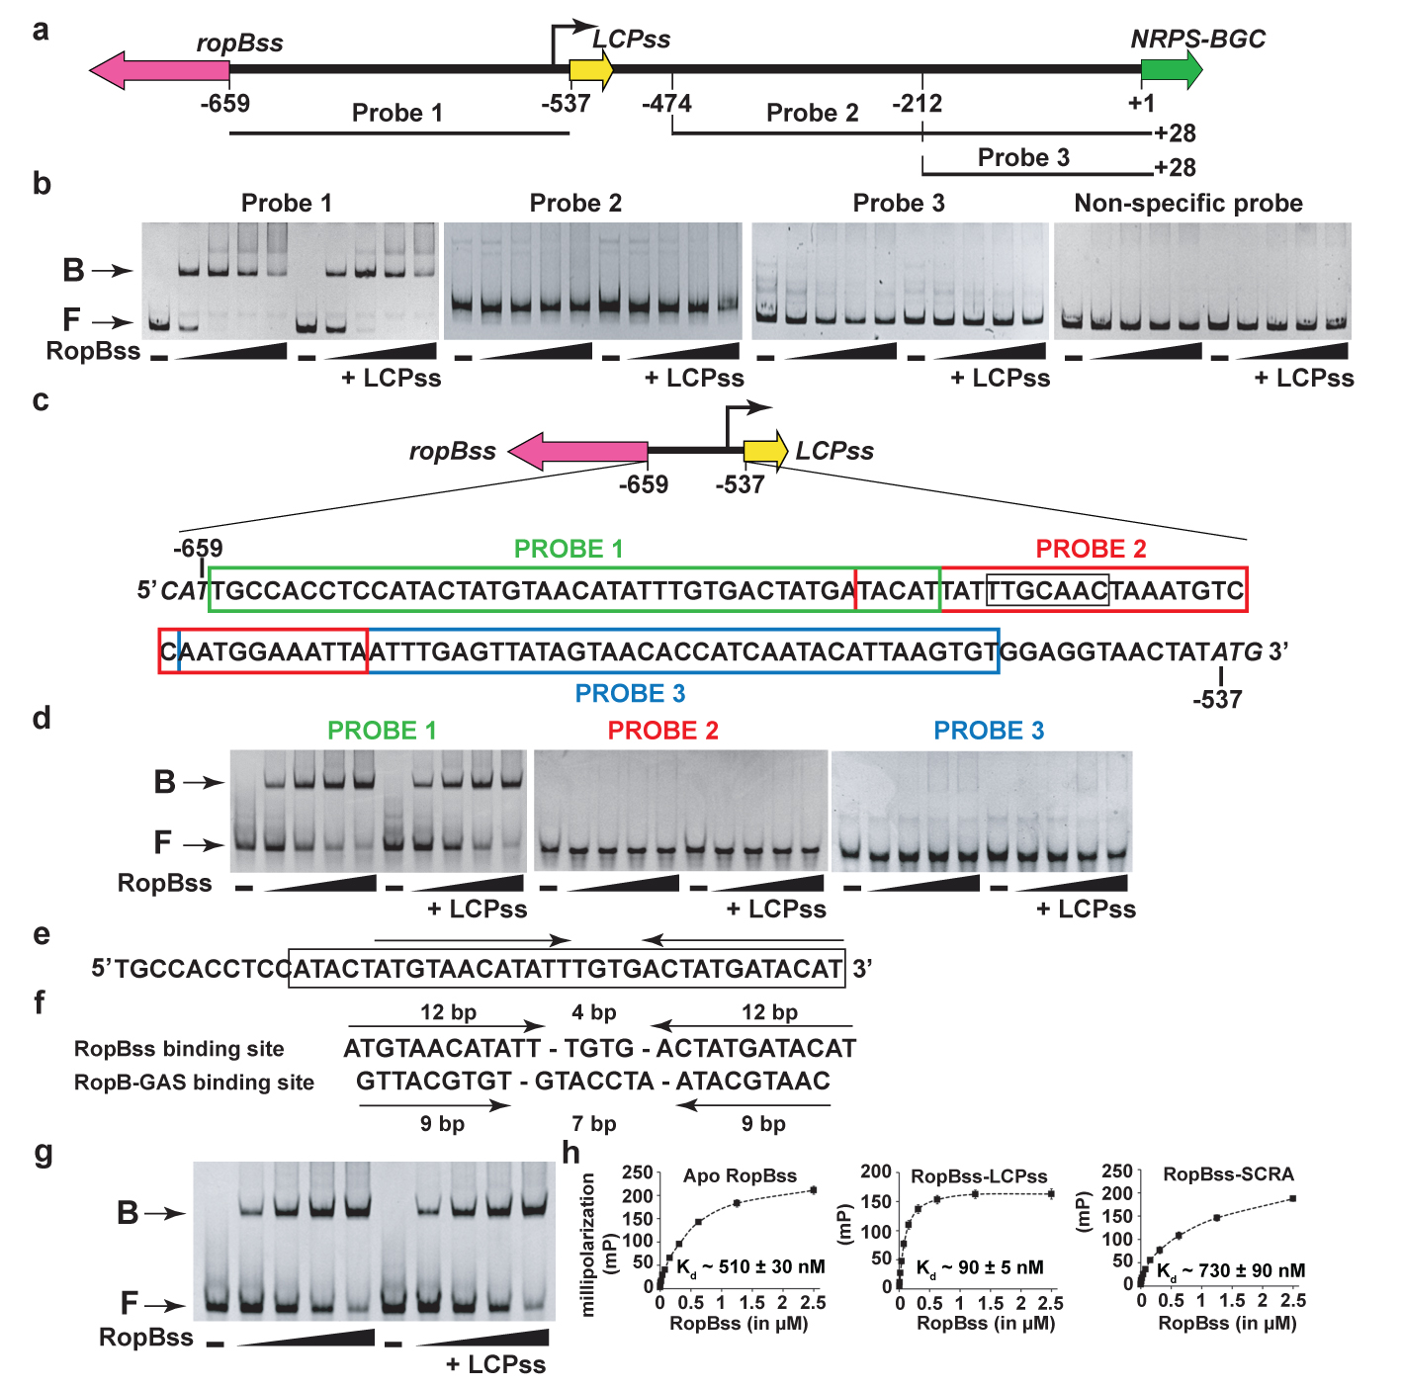

Figure S7. Analysis of RopB_{ss} binding sites within the ropB_{ss}-NRPS-BGC intergenic region. a, the ropB_{ss}, LCP_{ss}, and NRPS-BGC genes are marked by block arrows. The bent arrow above the line indicates the putative transcription start site of LCP_{ss} (PLCP_{ss)}. Numbers indicate the nucleotide positions relative to the first nucleotide of NRPS-BGC start codon. Promoter fragments (probes 1-3) tested for RopB_{ss} binding in the electrophoretic mobility shift assay (EMSA) are shown as bars and the numbers at either side of each probe indicate the positions of 5’ and 3’ ends of the fragment relative to the first nucleotide of NRPS-BGC start codon. b, increasing concentrations of purified apo-RopB_{ss} and LCP_{ss}-bound RopB_{ss} (50, 100, 150, and 200 nM of RopB_{ss}) were incubated with the indicated probe and reaction mixtures were resolved on a 10% native-PAGE. Synthetic LCP_{ss} was added in the reaction mixture at a final concentration of 1 µM to generate LCP_{ss}-bound RopB_{ss}. The positions of free (F) and RopB_{ss}-bound (B) probes are marked. c, analysis of RopB_{ss} binding sites within the ropB_{ss}-LCP_{ss} intergenic region. The nucleotide sequence within the ropB_{ss}-LCP_{ss} intergenic region is shown and the promoter fragments (probes 1-3) tested for RopB_{ss} binding in the EMSA are boxed and shaded in different colors. d, increasing concentrations of purified apo-RopB_{ss} and LCP_{ss}-bound RopB_{ss} (50, 100, 150, and 200 nM of RopB_{ss}) were incubated with the indicated probe and reaction mixtures were resolved on a 10% native-PAGE. e, the nucleotide sequence of RopB_{ss} binding site in PLCP_{ss} and the nucleotide sequence used in the FP studies is boxed. The inverted repeats within the RopB_{ss} binding site are marked by arrows above. f, comparison of RopB_{ss} and RopB-GAS binding sites. The 12-4-12 bp motif in RopB_{ss} binding site and 9-7-9 bp motif in RopB-GAS binding site are labeled. g, increasing concentrations of purified apo-RopB_{ss} and LCP_{ss}-bound RopB_{ss} (50, 100, 150, and 200 nM of RopB_{ss}) were incubated oligoduplex containing the identified RopB-binding site and reaction mixtures were resolved on a 10% native-PAGE. h, Analyses of the binding between the FITC-labeled oligoduplex containing the putative RopB_{ss}-binding site and apo-RopB_{ss}, LCP_{ss}-bound, or SCRA-bound RopB_{ss}, as assessed by FP assay.

Figure S8
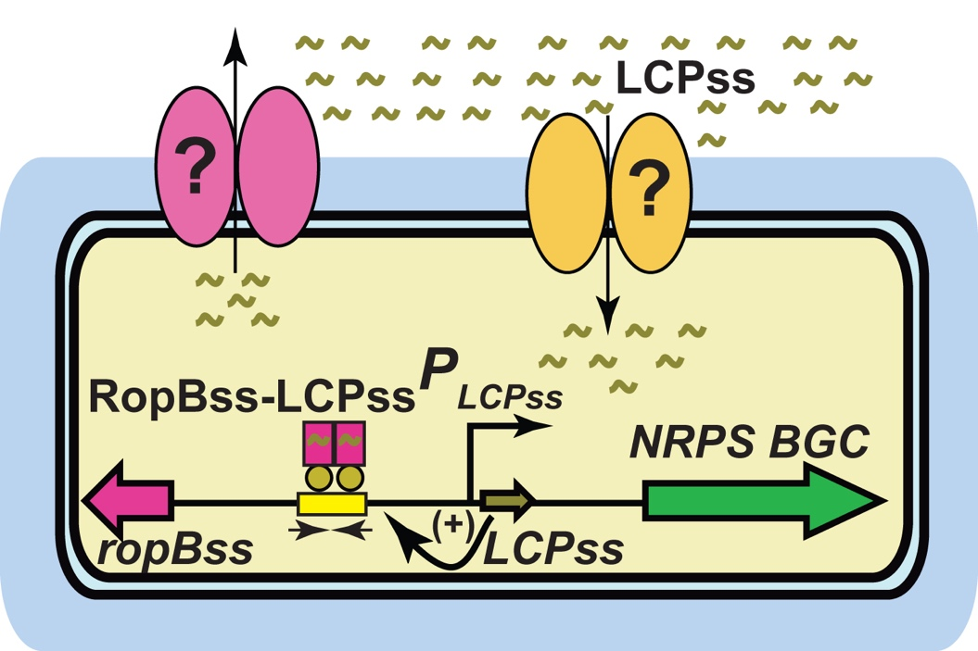
Figure S8. Proposed model for LCP_{ss} signaling. LCP_{ss} is produced, exported, and reinternalized into the cytosol. The recognition of LCP_{ss} by RopB_{ss} promotes high affinity interactions between RopB_{ss} and binding site in LCP_{ss} promoter, which leads to the upregulation of LCP_{ss} and NRPS-BGC.

