Supporting Information
for
Biodegradable trimethyl chitosan nanofiber mats as bioabsorbable dressings for wound closure and healing

Alexandru Anisiei¹, Bianca-Iustina Andreica¹, Liliana Mititelu-Tartau², Corneliu G. Coman², Rostyslav Bilyy³, Galyna Bila³, Irina Rosca¹, Andreea-Isabela Sandu¹, Evžen Amler⁴, Luminita Marin¹*

¹“Petru Poni” Institute of Macromolecular Chemistry of Romanian Academy, Iasi, Romania
²“Grigore T. Popa” University of Medicine and Pharmacy, Iasi, Romania
³Lectinotest R&D, Mechamichna Str 2, 79022, Ukraine
⁴Research and Development Department Inocure, Prague, Czech Republic
*lmarin@icmpp.ro

Content
Synthesis of N, N, N-trimethyl chitosan
Figure S1. ¹H-NMR spectrum of TMC and determination of the quaternization degree-TMC
Figure S2. FTIR spectrum of TMC
Figure S3. ¹H-NMR spectrum of residual PEO
Figure S4. FTIR spectra of NCT and NC fibers
Figure S5. ¹H-NMR spectra of NCT and NC fibers and TMC
Figure S6. POM images of the NCT fibers and TMC
Figure S7. Histograms of the fibers’ alignment assigned by Image J
Figure S8. Diameter distribution histograms of the fibers determined from SEM images
Figure S9. The kinetics of water vapor sorption uptake
Figure S10. Optical microscopy images of liver structure in rats treated with the studied fibers
Figure S11. Optical microscopy images of kidney structure in rats treated with the studied fibers Table S1. Fiber mats morphological parameters
Table S2. Parameters of the dynamic water sorption
Table S3. RBC, Hb, and Ht values in rats treated with the studied fibers
Table S4. Percentage values of components of leukocyte formula of rats treated with the studied fibers
Table S5. Serum levels of GPT, GOT, and LDH of rats treated with the studied fibers
Table S6. Effects of TMC-NCT nanofiber administration on blood urea and creatinine values in rats treated with the studied fibers
Table S7. Values of the serum complement activity and peripheral blood PMN phagocytosis capacity (NBT %) of rats treated with the studied fibers

Synthesis of N, N, N-trimethyl chitosan (TMC) was done in two steps, as follows. (i) 1 g of chitosan, 3 mL formic acid, 4 mL 37% formaldehyde, and 18 mL H₂O were added into a 100 mL round-bottom flask were, and kept under reflux, at 70 ℃ with continuous stirring for 5 days, when it turned into a homogeneous, viscous liquid of dark-yellow colour. The pH of the media was then adjusted to 12 with 1M NaOH, and the formed gel was separated by filtration under reduced pressure and washed with distilled water. The gel was then dissolved in acidic water (HCl, pH 4), filtered, and lyophilized. (ii) 250 mg of the previously obtained product (N,N-Dimethylchitosan) was dissolved in 40 mL distilled water, and then the pH was adjusted to 11 with 1M NaOH. The obtained gel was washed by filtration with distilled water and three times with acetone. Further, the gel was poured into a 100 mL round-bottom flask and 50 mL N-methyl-2-pyrrolidone was added, along with 2 mL iodomethane. The reaction mixture was kept under magnetic stirring, at 40 ℃, for 3 days, and then it was precipitated in a mixture of diethyl ether/ethanol (1/1, v/v). The solid was separated by filtration, washed with diethyl ether, and dried under vacuum overnight. For the exchange of I⁻ with Cl⁻, the obtained product was dissolved in 40 mL 10% NaCl and kept under stirring for 24 hours. The final product was obtained by precipitation in diethyl ether/ethanol (1/1, v/v), filtration, washing with diethyl ether, and drying under vacuum overnight.

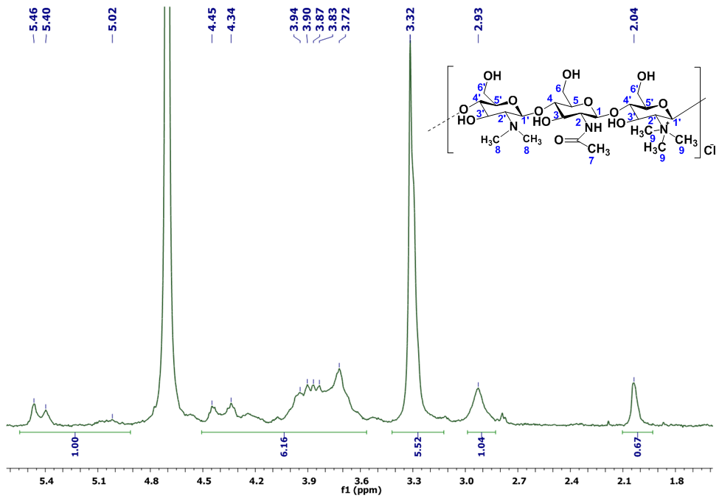
Figure S1. ¹H-NMR spectrum of TMC (400 MHz, D₂O, ppm): δ = 2.04 (H7), 2.8 (H2), 2.93 (H8), 3.32 (H9), 3.72-4.1 (H3-H6), 4.1-4.5 (H2′-H6′), 5.02-5.46 (H1′).

Determination of the quaternization degree-TMC (DQ)
The degree of quaternization (DQ%) and of dimethylation (DDM%) of TMC were determined from the following equations:
DQ (%) = [(CH₃)₃/(H₁) x 1/9] x100
DDM (%) = [(CH₃)₂/(H₁) x 1/6] x100
Where (CH₃)₃ represents the integral corresponding to the hydrogens of trimethyl groups at 3.32 ppm, (CH₃)₂ represents the integral corresponding to the hydrogens of dimethyl groups at 2.93 ppm and (H1) represents the integral of the H1, between 5.4-5.46 ppm. Applying these equations, the values of DQ and DDM were found: DQ = 61.33% and DDM = 17.33%

Figure S2. FTIR spectrum of TMC (ATR, cm⁻¹): 3733-2997 (υ_{OH,} υ_{NH}), 2932, 2887 (υ_{C-H}), 1657 (υ_{C=}o amide), 1562 (υ_{N-H}), 1480 (δ_{N}⁺_{(CH3)3}), 1151 (υ_{C-O-C}).

Figure S3. ¹H-NMR spectrum recorded on the residuum extracted from the ethanol used to remove PEO from the ternary fibers. The spectrum was recorded in D₂O/AcOH to simulate the same conditions as for the nanofibers, and it shows the bands characteristic for PEO and the absence of the bands characteristic for chitosan and TMC, proving that only PEO was removed by washing with ethanol.
TMC: 3736-2994 (υ_{OH}, υ_{NH}), 2928, 2883 (υ_{C-H}), 1659 (υ_{C=O} amide), 1563 (υ_{N-H}), 1481 (δ_{CH3}), 1156 (υ_{C-O-C}), 1100, 1038 (υ_{C-O amide}).

NCT3: 3668-2995 (υ_{OH,} υ_{NH}), 2919, 2875 (υ_{C-H}), 1650 (υ_{C=O} amide), 1594 (υ_{N-H}), 1461 (δ_{CH3}), 1152 (υ_{C-OC}), 1094, 1028 (υ_{C-O}).

NCT7: 3667-2996 (υ_{OH,} υ_{NH}), 2922, 2871 (υ_{C-H}), 1630 (υ_{C=}o _{amide}), 1590 (υ_{N-H}), 1461(δ_{CH3}), 1152 (υ_{C-OC}), 1091, 1034 (υ_{C-O amide}).
NCT19: 3668-2995 (υ_{OH,} υ_{NH}), 2922, 2873 (υ_{C-H}), 1649 (υ_{C=O amide}), 1596 (υ_{N-H}), 1461(δ_{CH3}), 1152 (υ_{C-O-C}), 1090, 1034 (υ_{C-O amide}).

NC: 3675-3229 (υOH, υNH), 2924, 2858 (υC-H), 1669 (υC=O amide), 1600 (υN-H), 1158 (υC-O-C), 1080, 1032 (υC-O amide)
Figure S4. FTIR spectra of NCT and NC fibers

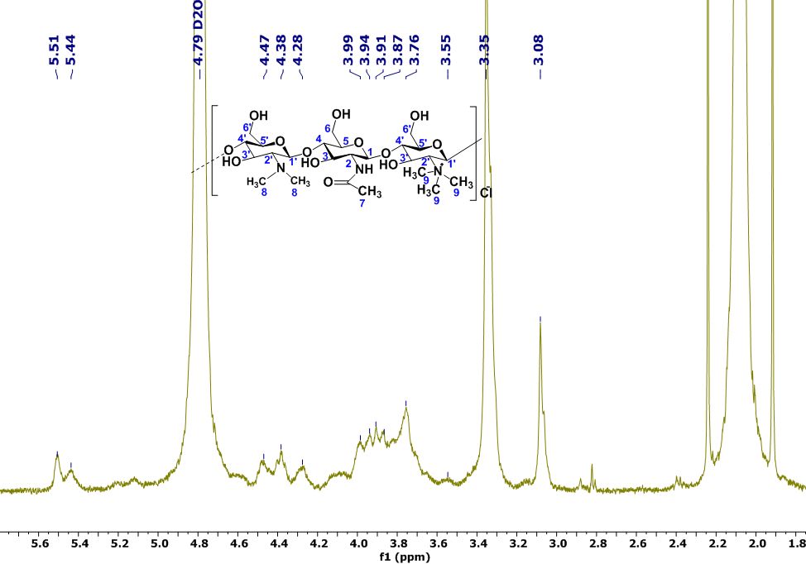
TMC: δ = 3.03 (H8), 3.08 (H2), 3.35 (H9), 3.76-4.2 (H3-H6), 4.2-4.7 (H2′-H6′), 5.44-5.51 (H1′)
NCT3: δ = 3.03 (H8), 3.14 (H2), 3.31 (H9), 3.58 – 4.01 (H3-H6), 4.2-4.5 (H2′ -H6′)

NCT7: δ = 3.03 (H8), 3.15 (H2), 3.32 (H9), 3.58 – 4.01 (H3-H6), 4.2-4.5 (H2′ -H6′)

NCT19: δ = 3.03 (H8), 3.14 (H2), 3.31 (H9), 3.57 – 4.02 (H3-H6), 4.2-4.5 (H2′ -H6′)
NC: δ = 1.93, 2.05 (H7), 3.11 (H2), 3.71 – 3.87 (H3-H6)
Figure S5. ¹H-NMR spectra of the studied NCT and NC fibers and TMC, recorded in D₂O/AcOH

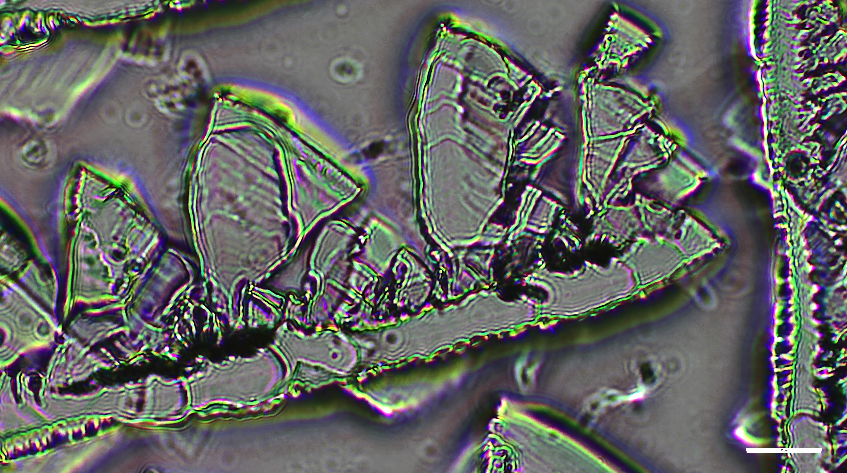
- TMC
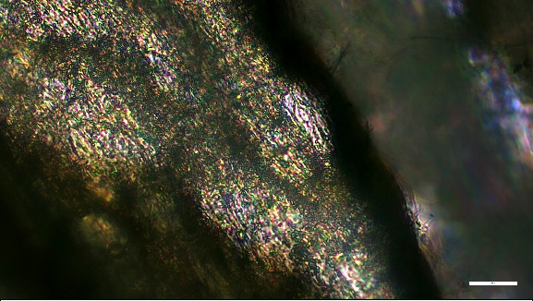  - NC | 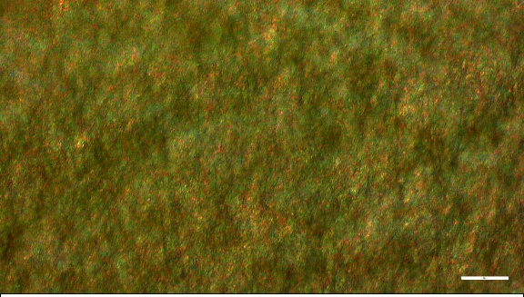  - NCT19
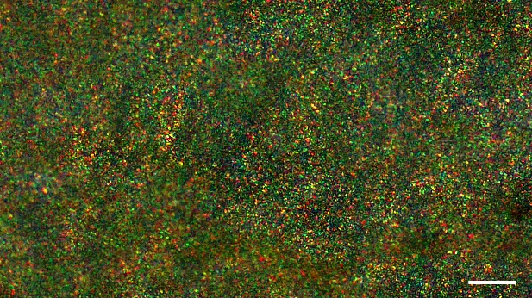  - NCT7 | 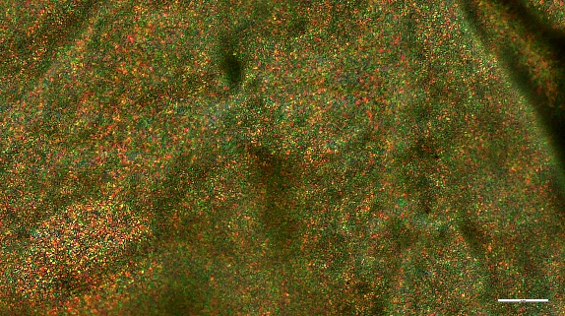  - NCT3
Figure S6. POM images of the NCT fibers and TMC (scale bar: 20 μm)

- NC | - NCT19
- NCT7 | - NCT 3

Figure S7. Histograms of the fibers’ alignment assigned by Image J

- NC | - NCT19
- NCT7 | - NCT3
Figure S8. Diameter distribution histograms of the fibers determined from SEM images

- NC

- NCT19

- NCT7

- NCT3
Figure S9. The kinetics of water vapor sorption uptake (blue colour was used for the steps of increasing the humidity; red colour was used for the mass increase of the sample in response to the increase of humidity

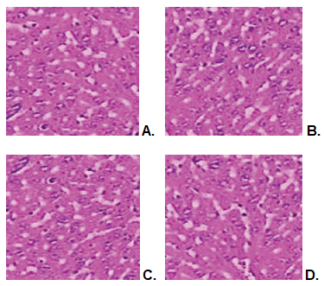.
Figure S10. Optical microscopy images of liver structure in rats from the control (A); NCT3 (B); NCT7 (C); and NCT19 (D) groups. H&E x 50 stains.

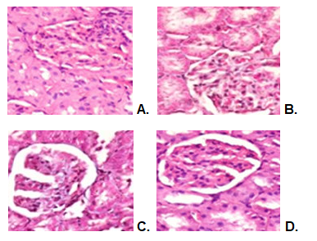
Figure S11. Optical microscopy images of kidney structure in rats from the control (A); NCT3 (B); NCT7 (C); and NCT19 (D) groups. H&E x 200 stain

Table S1. Fiber mats morphological parameters
 | NC | NCT3 | NCT7 | NCT19
Diameter Mean (µm) | 0.171944 | 0.153577 | 0.158247 | 0.193082
Diameter SD (µm) | 0.033644 | 0.031823 | 0.064791 | 0.033896
Mean Inter-fiber Pore Area (µm²) | 51.69674 | 12.10142 | 7.282158 | 28.53398
Inter-fiber pore Area SD (µm²) | 61.69834 | 13.63104 | 9.193949 | 40.95672
Min. Pore Area (µm²) | 0.207469 | 0.099585 | 0.099585 | 0.099585
Max. Pore Area (µm²) | 257.2614 | 93.84232 | 70.87137 | 246.083
Percent Porosity (%) | 52.05 | 28.88 | 21.96 | 38.74

Table S2. Parameters of the dynamic water sorption (A = BET surface area; W= maximum water uptake)
SAMPLE | A, m² (BET) | Max water uptake (%) | Average pore size (nm)
NC | 301.6 | 28.5 | 1.89
NCT19 | 284.1 | 41.9 | 2.95
NCT7 | 287.1 | 45.4 | 3.16
NCT3 | 247.6 | 40.3 | 3.26

Table S3. RBC, Hb, and Ht values expressed as the arithmetic mean ± S.D. of the average for 5 rats per lot
 | Moment of determination | RBC (mil/μl) | SD | Hb (g/ml) | SD | Ht (%) | SD
Control | 24 hours | 8.49 | 2.31 | 12.16 | 4.33 | 45.07 | 11.11
Control | 7 days | 8.67 | 2.53 | 11.63 | 3.88 | 45.45 | 10.93
NCT3 | 24 hours | 8.54 | 2.38 | 11.49 | 3.47 | 44.83 | 10.35
NCT3 | 7 days | 8.51 | 2.26 | 11.58 | 3.93 | 45.14 | 10.67
NCT7 | 24 hours | 8.43 | 2.67 | 11.84 | 3.41 | 44.48 | 10.53
NCT7 | 7 days | 8.48 | 2.16 | 12.22 | 4.16 | 44.56 | 11.22
NCT19 | 24 hours | 8.62 | 3.26 | 12.14 | 4.31 | 45.27 | 10.31
NCT19 | 7 days | 8.56 | 2.33 | 11.56 | 3.67 | 44.53 | 10.55

Table S4. Percentage values of components of leukocyte formula expressed arithmetic mean ± S.D. of the average for 5 rats per lot
 | Moment of determination | Leukocyte formula (%)
 | Moment of determination | PMN | SD | Ly | SD | E | SD | M | SD | B | SD
Blank | 24 hours | 27.1 | 8.16 | 69 | 13.17 | 0.3 | 0.01 | 3.4 | 0.1 | 0.2 | 0.01
Blank | 7 days | 27.3 | 8.41 | 68.7 | 13.33 | 0.3 | 0.03 | 3.5 | 0.1 | 0.2 | 0.03
NCT3 | 24 hours | 26.8 | 7.29 | 69.3 | 12.67 | 0.4 | 0.03 | 3.3 | 0.05 | 0.2 | 0.01
NCT3 | 7 days | 27.2 | 7.55 | 68.8 | 13.25 | 0.3 | 0.03 | 3.5 | 0.05 | 0.2 | 0.01
NCT7 | 24 hours | 27.4 | 7.67 | 68.6 | 12.83 | 0.3 | 0.01 | 3.5 | 0.1 | 0.2 | 0.01
NCT7 | 7 days | 27.6 | 8.43 | 68.5 | 12.55 | 0.3 | 0.01 | 3.4 | 0.05 | 0.2 | 0.03
NCT19 | 24 hours | 26.9 | 7.33 | 68.9 | 13.41 | 0.4 | 0.03 | 3.6 | 0.1 | 0.2 | 0.01
NCT19 | 7 days | 27.5 | 8.17 | 68.6 | 12.88 | 0.3 | 0.05 | 3.4 | 0.1 | 0.2 | 0.01

Table S5. Serum levels of GPT, GOT, and LDH expressed as the arithmetic mean ± S.D. of the average for 5 rats per lot.
 | Moment of determination | GPT (U/l) | SD | GOT (U/l) | SD | LDH (U/l) | SD
Blank | 24 hours | 47.65 | 11.88 | 124.12 | 27.93 | 1279.25 | 135.51
Blank | 7 days | 47.34 | 13.26 | 125.64 | 28.51 | 1283.54 | 131.16
NCT3 | 24 hours | 46.76 | 12.79 | 122.38 | 29.25 | 1280.39 | 134.39
NCT3 | 7 days | 47.55 | 11.33 | 124.82 | 28.67 | 1285.46 | 136.88
NCT7 | 24 hours | 46.39 | 12.67 | 123.46 | 28.79 | 1294.32 | 135.43
NCT7 | 7 days | 46.64 | 14.55 | 121.65 | 30.16 | 1289.27 | 132.27
NCT19 | 24 hours | 47.48 | 13.39 | 125.76 | 29.75 | 1298.16 | 137.55
NCT19 | 7 days | 48.16 | 15.22 | 123.53 | 29.33 | 1287.43 | 135.67

Table S6. Effects of TMC-NCT nanofiber administration on blood urea and creatinine values. Values are represented as the arithmetic mean ± S.D. of the average for 5 animals per lot.
 | Moment of determination | Urea (mg/dl) | SD | Creatinine (mg/dl) | SD
Blank | 24 hours | 42.67 | 14.26 | 0.16 | 0.03
Blank | 7 days | 43.56 | 15.79 | 0.15 | 0.03
NCT3 | 24 hours | 43.48 | 14.33 | 0.15 | 0.03
NCT3 | 7 days | 42.33 | 13.45 | 0.16 | 0.01
NCT7 | 24 hours | 42.27 | 13.83 | 0.15 | 0.03
NCT7 | 7 days | 44.72 | 15.22 | 0.16 | 0.05
NCT19 | 24 hours | 43.38 | 14.67 | 0.17 | 0.03
NCT19 | 7 days | 43.46 | 15.16 | 0.15 | 0.01

Table S7. Values of the serum complement activity and peripheral blood PMN phagocytosis capacity (NBT %), expressed as the arithmetic mean ± S.D. of the average for 5 animals per lot
 | Moment of determination | Complement (UCH50) | SD | NBT (%) | SD
Blank | 24 hours | 54.45 | 14.43 | 14.21 | 5.26
Blank | 7 days | 53.76 | 14.88 | 14.42 | 4.43
NCT3 | 24 hours | 53.39 | 15.26 | 14.78 | 4.51
NCT3 | 7 days | 55.12 | 14.51 | 14.64 | 3.38
NCT7 | 24 hours | 54.34 | 15.43 | 14.53 | 4.67
NCT7 | 7 days | 53.61 | 16.51 | 14.19 | 3.88
NCT19 | 24 hours | 54.46 | 15.38 | 14.12 | 5.26
NCT19 | 7 days | 55.73 | 15.67 | 14.75 | 4.38

Table S8. Wound closure (%)
day | G | G-SFT | NCT7
22 | -19±15 | -22.5±9 | -49.57±0

