Supporting Information on
Unveiling the origin of n-type doping of natural MoS₂: Carbon

Youngsin Park,^{1,†} Nannan Li,^{2,†} Daesung Jung,^{3,†} Laishram Tomba Singh,^{4,†} Jaeyoon Baik,⁴ Eunsook Lee,⁴ Dongseok Oh,⁴ Young Dok Kim,² Jin Yong Lee,² Jeongseok Woo,⁵ Seungmin Park,⁵ Hanchul Kim,⁶ Geunseop Lee,^{5,} Geunsik Lee,^{1,} and Chan-Cuk Hwang^{4,}

¹Department of Chemistry, College of Natural Science, Ulsan National Institute of Science and Technology, Ulsan 44919, Korea
²Department of Chemistry, Sungkyunkwan University, Suwon 16419, Korea
³Convergence Research Center for Energy and Environmental Science, Sungkyunkwan University, Suwon 16419, Korea
⁴Pohang Accelerator Laboratory, Pohang University of Science and Technology, Pohang 37673, Korea
⁵Department of Physics, Inha University, Incheon 22212, Korea
⁶Department of Applied Physics, Sookmyung Women’s University, Seoul 04310, Korea

†These authors contributed equally to this work.
*glee@inha.ac.kr
‡gslee@unist.ac.kr
§cchwang@postech.ac.kr

- Selection of proper photon energy to determine valence band maximum
MoS₂ is one of the representative two-dimensional layered materials, but it has a sizable dispersion in the direction perpendicular to the layers due to interlayer coupling. We varied the photon energy (hv) and monitored the changes in in-plane band structures to determine the accurate valence band maximum (VBM) of MoS₂ samples. Figure S1 shows the band structures of a MoS₂ sample along the Γ-K symmetry direction of the Brillouin zone (BZ) measured with several photon energies immediately after exfoliation under ultra-high vacuum (UHV). A chevron-shaped dispersion was observed at hv = 38 eV, which is close to the hv of He Ⅱ (40.8 eV), where most previous measurements were made¹⁻³. As hv was increased, the apex became barely visible with stronger “wings” at hv = 48 eV, but it started to appear again at hv = 50 eV. At hv = 56 eV, the most obvious chevron appears with similar intensity in the apex and both wings. Two bands with different orbital characters (and thus different photoelectric cross sections) may contribute to the experimental band. According to previous reports^{4,5}, and our theoretical calculations, the bands are derived from S 3p_{z} and Mo 4d_{z}². The energy positions of the apex were approximately -0.6, -0.8, and -0.3 eV at hv = 38, 48, and 56 eV, respectively. This suggests a dispersion in the direction perpendicular to the layers. The energy position of the valence band was determined to be highest when measured using hv = 56 eV. Therefore, hv = 56 eV was chosen as the optimal photon energy to determine the VBM energy position and work function. Figure S2 shows constant energy maps obtained at three different binding energies of -0.2, -0.8, and -1.6 eV using hv = 56 eV.
Fig. S1. Electronic band structures of a MoS₂ sample exfoliated in UHV along the Γ-K symmetry direction of BZ. The angle-resolved photoemission spectroscopy data were obtained by using different photon energies.

- Constant energy maps
Fig. S2. (a) Experimental constant energy maps of a MoS₂ three different binding energies of -0.2, -0.8, and -1.6 eV using hv = 56 eV. (b) and (c) Electronic band structures along the Γ-K (b) and Γ-M (c) symmetry directions of BZ.

- High-resolution core-level photoemission spectroscopy (PES) spectra
High-resolution core-level PES was used to explain the differences in VBM position and WF values between different MoS₂ samples. No other peaks except for Mo- and S-related peaks were visible, and little difference in the spectra was observed for different samples with photon energies higher than 600 eV. Using a reduced photon energy of 360 eV, where the photoionization cross-section of the carbon K-edge was enhanced by two orders of magnitude, a small amount of carbon could be detected as C 1s peaks in the PES spectra [insets of Fig. 1(a)-(d) and Fig. S3]. The C 1s peak was detected for most as-exfoliated samples (samples A₁ and A₂), whereas it was almost not observed in some samples (sample B). Whenever the C 1s peak was absent, the VBM almost reached the Fermi level. Otherwise, the VBM was located away from the Fermi level with different binding energies depending on the amounts of carbon. When the carbon-free sample was kept in the UHV chamber for a long time, the C 1s peak began to appear and grew slowly over time [insets of Figs. 1(c) and 1(d), and Fig. S3(b)].

Fig. S3. (a) Wide PES spectra of the sample-B in Fig. 1 obtained with a photon energy of 360 eV immediately after exfoliation (black line), and keeping under UHV without any treatment for 24 hours (green line), and 48 hours (pink line). The red- and blue lines depict the PES spectra of sample-A₁ and A₂ in Fig. 1(a) with noticeable amounts of carbon immediately after exfoliation under UHV. The broad peak near 220 eV is the S LMM Auger line. Other small peaks at 141, 102, 64, 37.1, and 13.9 eV were assigned to Mo MVV Auger, C KVV Auger, Mo 4s, Mo 4p, and S 3s, respectively. (b) Zoomed-in PES spectra for the C 1s peak shown in (a). The shift represented by an arrow is in good agreement with the VBM downshift in Figs. 1b-1d of the manuscript.

- Scanning tunneling microscopy (STM) observations of atomic-scale defects and nanometer-scale defects
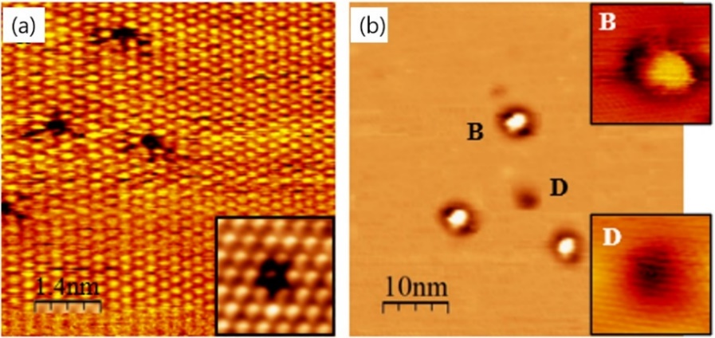
Fig. S4. STM images showing defects present on the MoS₂ surface. (a) an atomic-scale defects that are considered sulfur vacancies (inset: zoomed-in image). (b) nanometer-scale defects appearing as bright protrusions (B) and a dark depression (D) (insets: zoomed-in images of B and D defects). Atomic protrusions from S atoms are well resolved in (a) but not in (b). Note the difference in the size of the defects (see scale bar). Both images were obtained under the tunneling conditions of V_{s} = -1.0 V and I_{t} = 0.3 nA.

- Interstial C defects: stability and band structures
A $4×3\sqrt{3}$ supercell of bulk ${MoS}_{2}$ was used to investigate the energetic stability of the interstitial C defects as well as the activation energy for a C atom hopping from one to neighbor stable site. The density functional theory calculations were performed using the VASP package with the Perdew–Burke–Ernzerhof exchange-correlation functional, kinetic energy cutoff of 400 eV, and the Γ-centered Monkhorst-Pack-type 2×2 k-point grid. The optB88-vdW was used to describe the dispersion interaction. The atomic geometries were optimized until the atomic forces became less than $0.01 eV/Å$. For the band structures, a $4×4$ supercell of bilayer MoS₂ was used as in Figure 4 with spin polarization included for Cꞌ_{int} exhibiting half-filled gap states.
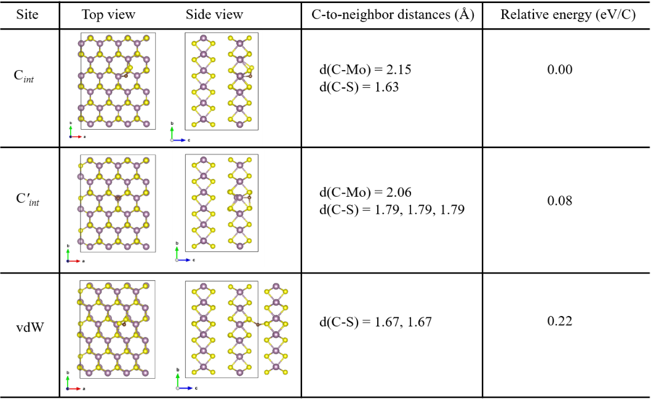
Fig. S5. Atomic structures and relative total energies for three types of stable interstitial C defects, chemisorbed on MoS₂ layers (top two rows) and within vdW gap (bottom one row).

- Gas adsorption
According to our residual gas analyzer (RGA) data, there are gases such as H₂, H₂O, CO, CO₂ in the UHV chamber. O 1s was not observed for most of the samples, even at the photon energy where the photoionization cross-section is maximized. Besides, if oxygen is adsorbed, the bands are likely to shift towards lower BE because of its higher electronegativity than Mo and S, as previously reported⁶. H₂ also induces a p-type doping^{7,8}. That’s why we excluded H₂ and H₂O as candidates in our gas exposure experiments.
Carbon monoxide (CO) is the most abundant C-containing species in a UHV chamber, as monitored by an RGA. In addition, we suppose that hydrocarbon (C_{x}H_{y}) gases may also exist in the background. By intentionally exposing the surface to finely controlled C-containing molecules, CO and C₂H₂, we tested the relevance of C-containing molecules adsorption as an extrinsic origin of the increased amounts of C near the surface. While C₂H₂ resulted in no changes in the band structure, exposure to CO gas induced a slight change (Figure S6). The VBM moved toward higher binding energy by ~0.3 eV after CO exposure up to 10⁴ Langmuir (L). With a CO partial pressure of ~10⁻¹¹ Torr under UHV (total pressure of ~1.3 ×10⁻¹⁰ Torr), it would take 10⁹ seconds (over 10⁴ days) for the same exposure. In contrast, significant band shifts were already seen with increasing C content, even when the initially carbon-free MoS₂ sample was kept under UHV for days or weeks. Therefore, the adsorption of C-containing residual gases alone cannot explain these large changes in VBM.
Fig. S6. (a) Wide PES spectra of a pristine MoS₂ obtained with a photon energy of 360 eV immediately after exfoliation (black line), and after CO exposures to 100 L (red line) and 10000 L (blue line). (b) Zoomed-in PES spectra for the C 1s peak shown in (a). (c) Electronic band structures from a pristine MoS₂ and after CO exposures.

- Energetic preference of surface sites for C-related defects
A seven-${MoS}_{2}$-layer slab with a 3×3 in-plane supercell and an intervening $15 Å$-thick vacuum region was used to investigate the energetic stability of the substitutional and the interstitial C defects as a function of depth from the surface. The density functional theory calculations were performed using the VASP package with the projected-augmented-wave potentials, the Perdew–Burke–Ernzerhof exchange-correlation functional, kinetic energy cutoff of 450 eV, and the Γ-centered Monkhorst-Pack-type 2×2 k-point grid. The atomic geometries were optimized until the atomic forces became less than $0.002 eV/Å$.
Fig. S7. Layer-dependent energetic stability of substitutional and interstitial C defects. (a) Top and side view of a seven-layer slab with in-plane 3x3 periodicity. In the side view, the layer indices from the top layer are denoted for the top-most three layers. (b) and (c) The total energy of substitutional C defects (b) and of interstitial C defects (c) with respect to the depth from the top surface. Both the substitutional and the interstitial C defects prefer the top surface sites: ~0.01 eV and ~0.09 eV for substitutional and interstitial C, respectively. The stabilization of interstitial C is due mainly to the formation of a new Mo-C bond (inset of c).

- Potential energy barriers for horizontal and perpendicular hoppings of C_{int}
We speculate the path of outward C diffusion to be consisting of (i) horizontal hoppings from one C_{int} site to neighboring C_{int} sites via C'_{int}, (ii) vertical hoppings across vdW gaps, and (iii) penetrations through atomic (MoS₂) layers. Using the same structure models and calculation parameters as in Figure S5, the transition state energy between two neighboring interstitial sites was found according to the nudged elastic band method with the climbing image. As shown in Figure S8, the barriers are $E_{a}^{∥}=0.36$eV and $E_{a}^{⊥}=0.56$ eV along in-plane direction and across the vdW gap, respectively. The barriers are relatively lower than those for a typical three-dimensional covalently bonded lattice. They are ascribed to flexible Mo-S bond angle and distance owing to vdW interlayer regions. Regarding the third process (iii), while C impurities hardly go through MoS₂ layers, they will be able to pass each MoS₂ layer through sufficiently large voids. Since chemically active sites around voids are likely to be passivated, associated penetration is expected to be relatively easy. Thus, we take $E_{a}^{⊥}=0.56$ as a major factor limiting the outward diffusion.
We consider the random walk model to estimate the diffusion constant, D = Aa²/τ, where a is the distances between neighbor C interstitial sites, $τ^{-1}=νe^{-E_{a}/RT}$ the hopping rate with the attempt frequency $ν \sim {10}^{12}/sec$, and A is a constant of order unity depending on the lattice type. Once the value of D is found, the associated diffusion length can be estimated by $l \sim \sqrt{D×time}$. By using ${E_{a}=E}_{a}^{⊥}=0.56$ eV, we obtain $D^{⊥} \sim {10}^{-6} {μm}^{2}/sec$ at room temperature. Then outward diffusion length scale is estimated to be sub-micrometer, which matches reasonably well with the experimental observations.
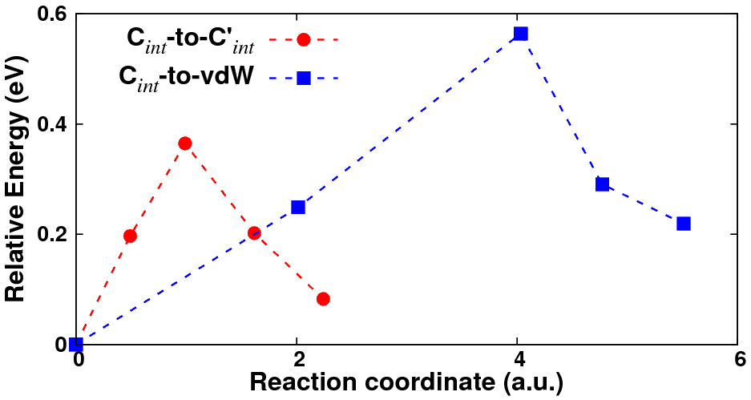
Fig. S8. Calculated potential energy curves along the minimum energy path from the most stable chemisorbed interstitial site (C_{int}) to the meta-stable one (C'_{int}) (red circles) or to the stable site within vdW gap (vdW) (blue squares). Relevant configurations are listed in Figure S5.

REFERENCES
- Mahatha, S. K. & Menon, K. S. R. Quantum Well States in Ag Thin Films on MoS₂ (0001) Surfaces. J. Phys. Cond. Matter 25, 115501 (2013).
2. Mahatha, S. K., Patel, K. D. & Menon, K. S. R. Electronic Structure Investigation of MoS₂ and MoSe₂ using Angle-resolved Photoemission Spectroscopy and ab initio Band Structure Studies. J. Phys. Cond. Matt. 24, 475504 (2012).
3. Mahatha, S. K. & Menon, K. S. R. Inhomogeneous Band Bending on MoS₂ (0001) Arising from Surface Steps and Dislocations. J. Phys. Cond. Matt. 24, 305502 (2012).
4. Han, S. W. et al. Band-gap Transition Induced by Interlayer van der Waals Interaction in MoS₂. Phys. Rev. B 84, 045409 (2011).
5. Han, S. W. et al. Band-gap Expansion in the Surface-localized Electronic Structure of MoS₂(0002). Phys. Rev. B 86, 115105 (2012).
6. Lee, S. Y. et al. Large Work Function Modulation of Monolayer MoS₂ by Ambient Gases. ACS Nano 10, 6100-6107 (2016).
7. Pierucci, D. et al. Tunable Doping in Hydrogenated Single Layered Molybdenum Disulfide. ACS Nano 11, 1755-1761 (2017).
8. Cho, S. et al. Electronic-dimensionality Reduction of Bulk MoS₂ by Hydrogen Treatment. Phys. Chem. Chem. Phys. 20, 23007-23012 (2018).

