Additional file 1
Supplementary figure
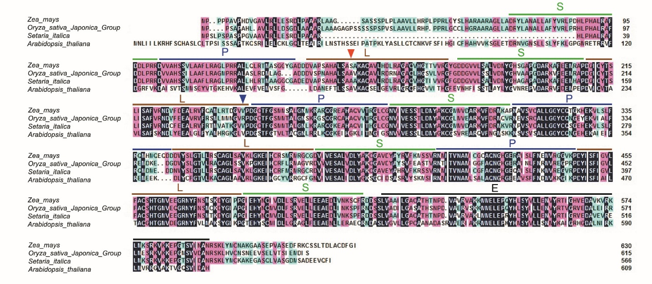
Fig. S1. Amino acid alignment of maize DEK55 with homologous PPR proteins of other plant species.
PPR elements P, L and S are indicated by a green, blue and red bar, respectively. The mutant sites in dek55-1 and dek55-2 are indicated by red and blue arrow heads, respectively. E domain is indicated by black bar. Arabidopsis thaliana, sequence ID NP_171853.1; Oryza sativa Japonica Group, sequence ID XP_015643919.1; Setaria italica, sequence ID XP_022681874.1. All data obtained from the NCBI (https://www.ncbi.nlm.nih.gov/)
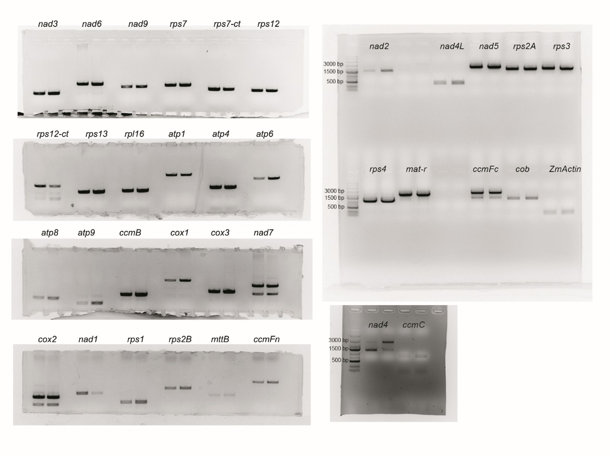
Fig. S2. Original gel images corresponding to Fig. 5a.
The RT-PCR products were detected by 1.0% agarose gel electrophoresis. The genes name were marked.
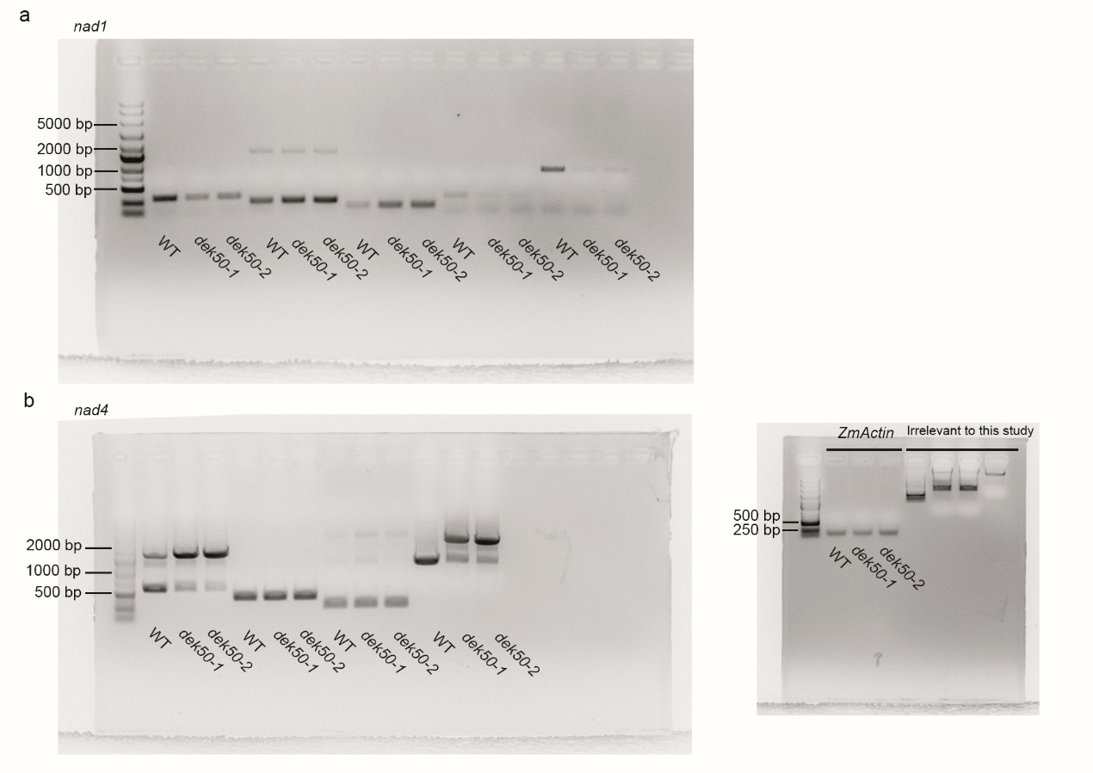
Fig. S3. Original gel images corresponding Fig. 5c-d.
(a) Original gel images of RT-PCR analysis of intron-splicing efficiency of nad1 in WT, dek55-1 and dek55-2 mutant kernels.
(b) Original gel images of RT-PCR analysis of intron-splicing efficiency of nad4 in WT, dek55-1 and dek55-2 mutant kernels. ZmActin gene (GRMZM2G126010) was used as an internal control and original gel image was also shown. Results irrelevant to this study were marked with “Irrelevant to this study”.
Fig. S4. Original gel images corresponding to Fig. 6a-b.
(a) Original gel images of BN-PAGE analysis of mitochondrial complexes.
(b) Original gel images of in-gel NADH dehydrogenase activity analysis of complex I.
Results irrelevant to this study were marked with “Irrelevant to this study”.
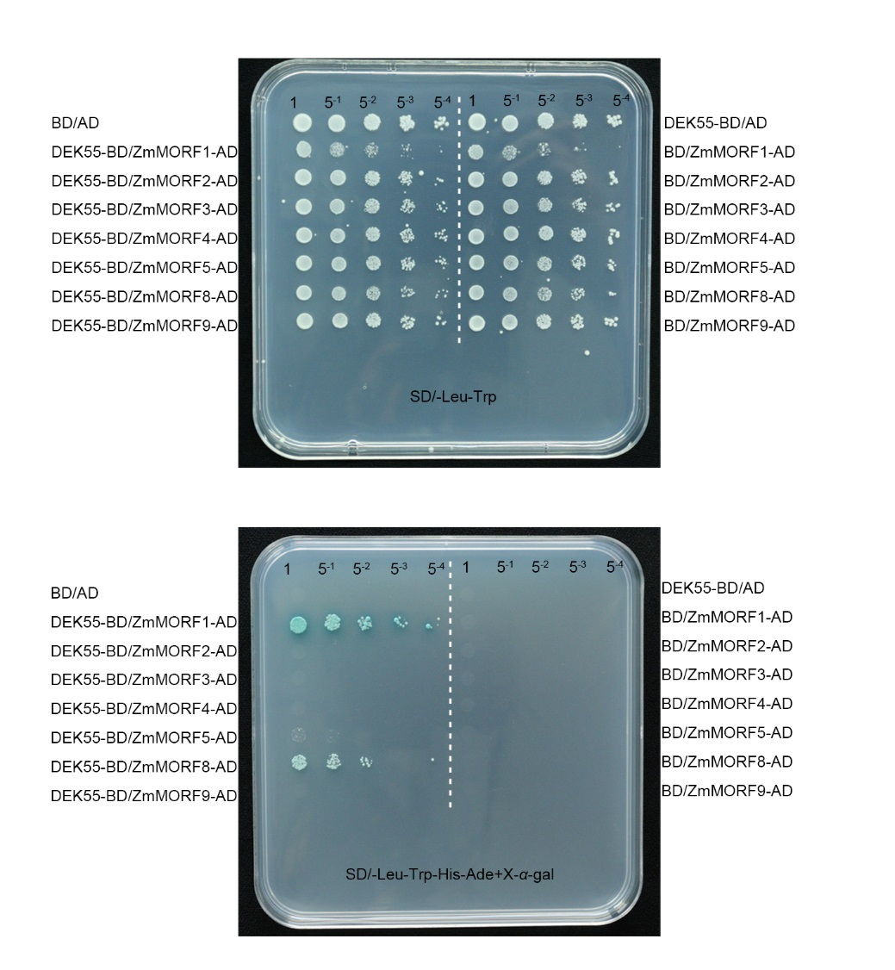
Fig. S5. Original gel images corresponding to Fig. 7b.

Supplementary Table
Table S1. Genetic analysis of the mutant kernels in the segregating ear.
Self-pollinated parents | Number of mutants | Number of WT | Actual ratio | Expected ratio | P
dek55-1/+ | 411 | 1239 | 1:3.01 | 1:3 | 0.93
F₁ (C733×dek55-1/+) | 916 | 2821 | 1:3.07 | 1:3 | 0.49
F₁ (S162×dek55-1/+) | 457 | 1364 | 1:2.98 | 1:3 | 0.92

Table S2. Primers used in this study.

umc1705-F | ATCTCACGTACGGTAATGCAGACA | For fine mapping
umc1705-R | CATGACCTGATAAACCCTCCTCTC | For fine mapping
umc2302-F | GCATATGCGAGATCATATCGTTGA | For fine mapping
umc2302-R | CTATACAGCCCTCAGCTCTGCTGT | For fine mapping
M2-F | GTGCTATGCATGAGGGTAGAGT | For fine mapping
M2-R | TGTATTGGGCGATACCGAGC | For fine mapping
M3-F | ATCTGTAGTGCTTCCGTGCTCT | For fine mapping
M3-R | GGCTCATTTGTAAGGTTGTGC | For fine mapping
M4-F | GTTGAGATAACTATGCAAATCGTG | For fine mapping
M4-R | CTTCCAACGTGCGTCTCTAC | For fine mapping
M5-F | CGTCGTCGAGGTGATTAGGG | For fine mapping
M5-R | GAACCCTCCTCCCGACTACT | For fine mapping
M6-F | GGTTTCCAGAGCTAGGTGGG | For fine mapping
M6-R | CGTCGTTTCCGTCGTCAATC | For fine mapping
F148-F | GTTCGGTCGAGTTGGGATGA | For fine mapping
F148-R | CAGACCAACCCTTCAGTCCC | For fine mapping
DEK55-Full-F | GCCAGGTAGAATAGATGGAACC | Clone DEK55 full length
DEK55-Full-R | CAAGAGCTGCTAAAATTTGTCAGTAC | Clone DEK55 full length
ZmActin-F | ATGGTCAAGGCCGGTTTCG | qRT-PCR and RT-PCR primer of ZmActin
ZmActin-R | TCAGGATGCCTCTCTTGGCC | qRT-PCR and RT-PCR primer of ZmActin
DEK55-qRT-F | CGATGACTGGTATAGCTTAGGG | qRT-PCR analysis of DEK55 gene expression
DEK55-qRT-R | CGCATCCTCTCATCCTCATAG | qRT-PCR analysis of DEK55 gene expression
nad1-1F | GCAACGTAGAAAGGGTCCTG | Test nad1 introns splicing efficiency
nad1-2R | TGAGCTGCAGATCGTAATGC | Test nad1 introns splicing efficiency
nad1-2F | TCGAAATATGCCTTTCTAGGAG | Test nad1 introns splicing efficiency
nad1-3R | ATTCAGCTTCCGCTTCTGG | Test nad1 introns splicing efficiency
nad1-3F | GTCATGGCGCAAAAGCAGATATGG | Test nad1 introns splicing efficiency
nad1-4R | AGAGCAGACCCCATTGAAGA | Test nad1 introns splicing efficiency
nad1-4F | TCTTCAATGGGGTCTGCTCT | Test nad1 introns splicing efficiency
nad1-5R | AGGGAGCCATCGAAAGGTGA | Test nad1 introns splicing efficiency
nad4-1F | TTGATTGGTCTGTGCGTTTC | Test nad4 introns splicing efficiency
nad4-2R | GGCTTCGGGTAACCAAATA | Test nad4 introns splicing efficiency
nad4-2F | TGCCGTCAAAGTGCCTAT | Test nad4 introns splicing efficiency
nad4-3R | GGTGCTCACTAAACCTCCATA | Test nad4 introns splicing efficiency
nad4-3F | CACTTTAGCCAATATGAGTTTACC | Test nad4 introns splicing efficiency
nad4-4R | ATGCAGTCCGGGAACACT | Test nad4 introns splicing efficiency
AOX1-qRT-F | AAGGTGCTGCTCGACAAGAT | qRT-PCR analysis of AOX1 gene expression
AOX1-qRT-R | GTAGGCGTTGAAGAAGACGC | qRT-PCR analysis of AOX1 gene expression
AOX2-qRT-F | GACATCTTCTTCCAGAGGCG | qRT-PCR analysis of AOX2 gene expression
AOX2-qRT-R | TGACTACGTCCTTGAGCGTG | qRT-PCR analysis of AOX2 gene expression
AOX3-qRT-F | CCAAGCTCGTGAAGGAAGAC | qRT-PCR analysis of AOX3 gene expression
AOX3-qRT-R | GTAGGCGTTGAAGAAGACGC | qRT-PCR analysis of AOX3 gene expression
DEK55-SC-F | CCGCGAATTCATGCCGCCGCCCCCAGCCG | Construct full length DEK55-EGFP vector
DEK55-SC-R | CCGCGGTACCGATACCAAAATCACAAGC | Construct full length DEK55-EGFP vector
nad4-F1 | TTGATTGGTCTGTGCGTTTC | RT-PCR
nad4-R1 | ATGCAGTCCGGGAACACT | RT-PCR
nad4-F | CAGTCACCCGGAGAAGATTT | Gene sequencing in RNA editing efficiency analysis
nad4-R | TAATTTGGCGCCTGATTGAC | Gene sequencing in RNA editing efficiency analysis
nad2-F | GACGGAGGAGAGGAAATGAA | RT-PCR, Gene sequencing in RNA editing efficiency analysis
nad2-R | GCAGTCCACCCTTTCTTTGA | RT-PCR, Gene sequencing in RNA editing efficiency analysis
nad3-F | CTTTCCTATGTCCTTCCCCC | RT-PCR, Gene sequencing in RNA editing efficiency analysis
nad3-R | GAGGAGAGCGAGAGAACGAA | RT-PCR, Gene sequencing in RNA editing efficiency analysis
nad4L-F | CTGACATTCCATGTTTCCGA | RT-PCR, Gene sequencing in RNA editing efficiency analysis
nad4L-R | GAAGAGAACGAAAGGAGAACAGA | RT-PCR, Gene sequencing in RNA editing efficiency analysis
nad5-F | CGCTCGAACATTGTCTGATT | RT-PCR, Gene sequencing in RNA editing efficiency analysis
nad5-R | GTCCTGGCAAGCTCCTACAG | RT-PCR, Gene sequencing in RNA editing efficiency analysis
nad6-F | TGGAAAAACCAAACCCACAT | RT-PCR, Gene sequencing in RNA editing efficiency analysis
nad6-R | CAAGTTCCCTTGGCGTAGTC | RT-PCR, Gene sequencing in RNA editing efficiency analysis
nad7-F | GTTTTGGCTCGCAATAAAGC | RT-PCR, Gene sequencing in RNA editing efficiency analysis
nad7-R | CAGGTGGGACAAGCTCTAGG | RT-PCR, Gene sequencing in RNA editing efficiency analysis
nad9-F | AGCAAGAAGCGGAACAAAAA | RT-PCR, Gene sequencing in RNA editing efficiency analysis
nad9-R | TATTGATTTGTCCCCTCCCC | RT-PCR, Gene sequencing in RNA editing efficiency analysis
cob-F | ATCAAGGCAAGGGGGTAAAT | RT-PCR, Gene sequencing in RNA editing efficiency analysis
cob-R | GGTGTGATCAGTCTCATCCG | RT-PCR, Gene sequencing in RNA editing efficiency analysis
cox1-F | GGCCCCTCTCTGATAAGGTT | RT-PCR, Gene sequencing in RNA editing efficiency analysis
cox1-R | GTTAAGGCAAAGCCCAAACA | RT-PCR, Gene sequencing in RNA editing efficiency analysis
cox2-F | GTCCTACTTCTGGTGCTGCC | RT-PCR, Gene sequencing in RNA editing efficiency analysis
cox2-R | GAGAATTGCATTTCCGCTTC | RT-PCR, Gene sequencing in RNA editing efficiency analysis
cox3-F | TCAATCCACTTATTCGTTCCC | RT-PCR, Gene sequencing in RNA editing efficiency analysis
cox3-R | GTTTACATACAACCGGGGCA | RT-PCR, Gene sequencing in RNA editing efficiency analysis
atp1-F | CGTTGCTGGTGAAGAAGCAT | RT-PCR, Gene sequencing in RNA editing efficiency analysis
atp1-R | AAAAGCGGATTTATCCATCG | RT-PCR, Gene sequencing in RNA editing efficiency analysis
atp4-F | AGCCACGTGCTCTAATCCTC | RT-PCR, Gene sequencing in RNA editing efficiency analysis
atp4-R | TCCCTTTCTCTTGGAGCAGA | RT-PCR, Gene sequencing in RNA editing efficiency analysis
atp6-F | CCAAGTCTCTTTTGGGAGCA | RT-PCR, Gene sequencing in RNA editing efficiency analysis
atp6-R | GGCTCCTCGTTTTTATGCAA | RT-PCR, Gene sequencing in RNA editing efficiency analysis
atp8-F | GGCAAGGATCCTCAGTCCTA | RT-PCR, Gene sequencing in RNA editing efficiency analysis
atp8-R | GAGGGTTGGTTTGATTGGAA | RT-PCR, Gene sequencing in RNA editing efficiency analysis
atp9-F | AGGGGCCTCGTCATCTCTAT | RT-PCR, Gene sequencing in RNA editing efficiency analysis
atp9-R | TAGTTGCGAAGGAAAAGCGT | RT-PCR, Gene sequencing in RNA editing efficiency analysis
ccmB-F | AGCCGTCGAAGTGAATGAAT | RT-PCR, Gene sequencing in RNA editing efficiency analysis
ccmB-R | AACGGCTTTTCCATGACTTG | RT-PCR, Gene sequencing in RNA editing efficiency analysis
ccmC-F | ACTTGCAAGGCAAGGAAAAA | RT-PCR, Gene sequencing in RNA editing efficiency analysis
ccmC-R | CCATGGATGCTTTAGCGAGT | RT-PCR, Gene sequencing in RNA editing efficiency analysis
ccmFc-F | GAGAAGCTCAAATCGAACGG | RT-PCR, Gene sequencing in RNA editing efficiency analysis
ccmFc-R | CGCAGCCACTATTTTGACTC | RT-PCR, Gene sequencing in RNA editing efficiency analysis
ccmFn-F | TGAAGATTGTAAGGCGTTTCC | RT-PCR, Gene sequencing in RNA editing efficiency analysis
ccmFn-R | GGATCATCCTGTGGTTACCG | RT-PCR, Gene sequencing in RNA editing efficiency analysis
rps1-F | AAGGTGGGCTTCGGATTATT | RT-PCR, Gene sequencing in RNA editing efficiency analysis
rps1-R | TCTTCAGTTTTACGCTTACGCT | RT-PCR, Gene sequencing in RNA editing efficiency analysis
rps2A-F | CAGGAAAGATATTTGCCCCA | RT-PCR, Gene sequencing in RNA editing efficiency analysis
rps2A-R | CCTGTATCTCCGGAAACGAA | RT-PCR, Gene sequencing in RNA editing efficiency analysis
rps2B-F | TCCATGGACCCACGTAAAAT | RT-PCR, Gene sequencing in RNA editing efficiency analysis
rps2B-R | GGCCCCTCTCTGATAAGGAA | RT-PCR, Gene sequencing in RNA editing efficiency analysis
rps3-F | GCAGAAAGGGGCAAAAGTAA | RT-PCR, Gene sequencing in RNA editing efficiency analysis
rps3-R | TCGCGACCCCTACTACATCT | RT-PCR, Gene sequencing in RNA editing efficiency analysis
rps4-F | AGAGTTGGGTTCGATTCCCT | RT-PCR, Gene sequencing in RNA editing efficiency analysis
rps4-R | AGCGACTAGGCCGATCTTTT | RT-PCR, Gene sequencing in RNA editing efficiency analysis
rps7-F | TTCGTTGGAAAAACCTACGC | RT-PCR, Gene sequencing in RNA editing efficiency analysis
rps7-R | ATGAGGAAGGCCGATTTTCT | RT-PCR, Gene sequencing in RNA editing efficiency analysis
rps7-ct-F | TTGAACCTCTTTCACGCTCA | RT-PCR, Gene sequencing in RNA editing efficiency analysis
rps7-ct-R | TTCCGATCGAGATGTATGGA | RT-PCR, Gene sequencing in RNA editing efficiency analysis
rps12-F | CTAGCTGCTTCCATATCGCC | RT-PCR, Gene sequencing in RNA editing efficiency analysis
rps12-R | CGGATCGGGAGTAACCACTA | RT-PCR, Gene sequencing in RNA editing efficiency analysis
rps12-ct-F | TGTACGGTTCTGTAGAGGGACA | RT-PCR, Gene sequencing in RNA editing efficiency analysis
rps12-ct-R | TCCGTTTTCTTTTTATAAGGGC | RT-PCR, Gene sequencing in RNA editing efficiency analysis
rps13-F | TCATGATGATTAAGGGAAGAGTGA | RT-PCR, Gene sequencing in RNA editing efficiency analysis
rps13-R | TTGAATTGAACAGTGTGATTGAT | RT-PCR, Gene sequencing in RNA editing efficiency analysis
rpl16-F | GGTTTTTCCCCACTAACCAA | RT-PCR, Gene sequencing in RNA editing efficiency analysis
rpl16-R | GGGTGCGGAAATAGCTAGAA | RT-PCR, Gene sequencing in RNA editing efficiency analysis
mat-r-F | AACGCCTGTTCGCTAAAATC | RT-PCR, Gene sequencing in RNA editing efficiency analysis
mat-r-R | AGGCTTTGCTCCCCTTTTT | RT-PCR, Gene sequencing in RNA editing efficiency analysis
mttB-F | TTGGTTTAGAATTGCTCGGG | RT-PCR, Gene sequencing in RNA editing efficiency analysis
mttB-R | AGGGGGAACCCTACCGAC | RT-PCR, Gene sequencing in RNA editing efficiency analysis
AD-Zmd049043F | CGGAATTCATGGCCCTCGCACTGCGCC | Yeast two-hybrid assay
AD-Zmd049043R | CGGGATCCTCATACCTGCCAGTTTCCTTG | Yeast two-hybrid assay
AD-Zmd045528F | CGGAATTCATGGCCGCCGCCGCC | Yeast two-hybrid assay
AD-Zmd045528R | CGGGATCCTCATCGCTGGTTCTCCCTC | Yeast two-hybrid assay
AD-Zmd026307F | CGGAATTCATGGCAGCCGCATCAGCG | Yeast two-hybrid assay
AD-Zmd026307R | CGGGATCCTCAGTGCTGCTCCTGATTC | Yeast two-hybrid assay
AD-Zmd038760F | CGCATATGATGTATGCTTTTAGTACGAC | Yeast two-hybrid assay
AD-Zmd038760R | CGGAATTCCTAGTCGCAGCTCCCAGTG | Yeast two-hybrid assay
AD-Zmd026243F | CGGAATTCATGGCCACCGTAGCGCGC | Yeast two-hybrid assay
AD-Zmd026243R | CGGGATCCTCATCTCTGGTAAGATTGG | Yeast two-hybrid assay
AD-Zmd048291F | CGGAATTCATGGCGTCGGCGTCGCGTG | Yeast two-hybrid assay
AD-Zmd048291R | CGGGATCCTCACTGGAAGTTGGAGTTGCC | Yeast two-hybrid assay
AD-Zmd024674F | CGGAATTCATGGCCGCCTCCCTCCCGAC | Yeast two-hybrid assay
AD-Zmd024674R | CGGGATCCTCACGAAGACGCGGACTCG | Yeast two-hybrid assay
DEK55-BD-F | CGGAATTCGACCGCTACCTTGCTAACGCG | Yeast two-hybrid assay
DEK55-BD-R | CGGGATCCTCAGATACCAAAATCACAAGC | Yeast two-hybrid assay

