Additional file 1
Supplementary figure
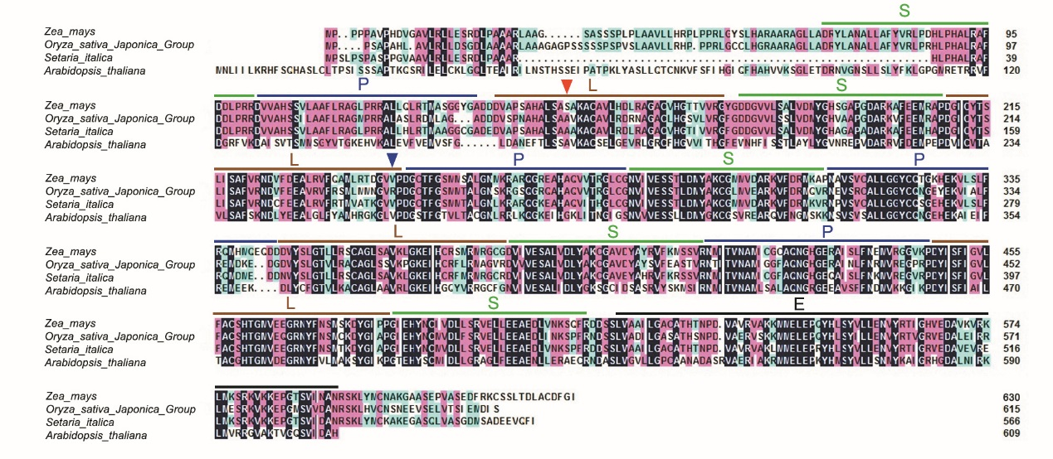
Figure S1. Amino acid alignment of maize DEK55 with homologous PPR proteins of other plant species
PPR elements P, L and S are indicated by a green, blue and red bar, respectively. The mutant sites in dek55-1 and dek55-2 are indicated by red and blue arrow heads, respectively. E domain is indicated by black bar. Arabidopsis thaliana, sequence ID NP_171853.1; Oryza sativa Japonica Group, sequence ID XP_015643919.1; Setaria italica, sequence ID XP_022681874.1. All data obtained from the NCBI (https://www.ncbi.nlm.nih.gov/)
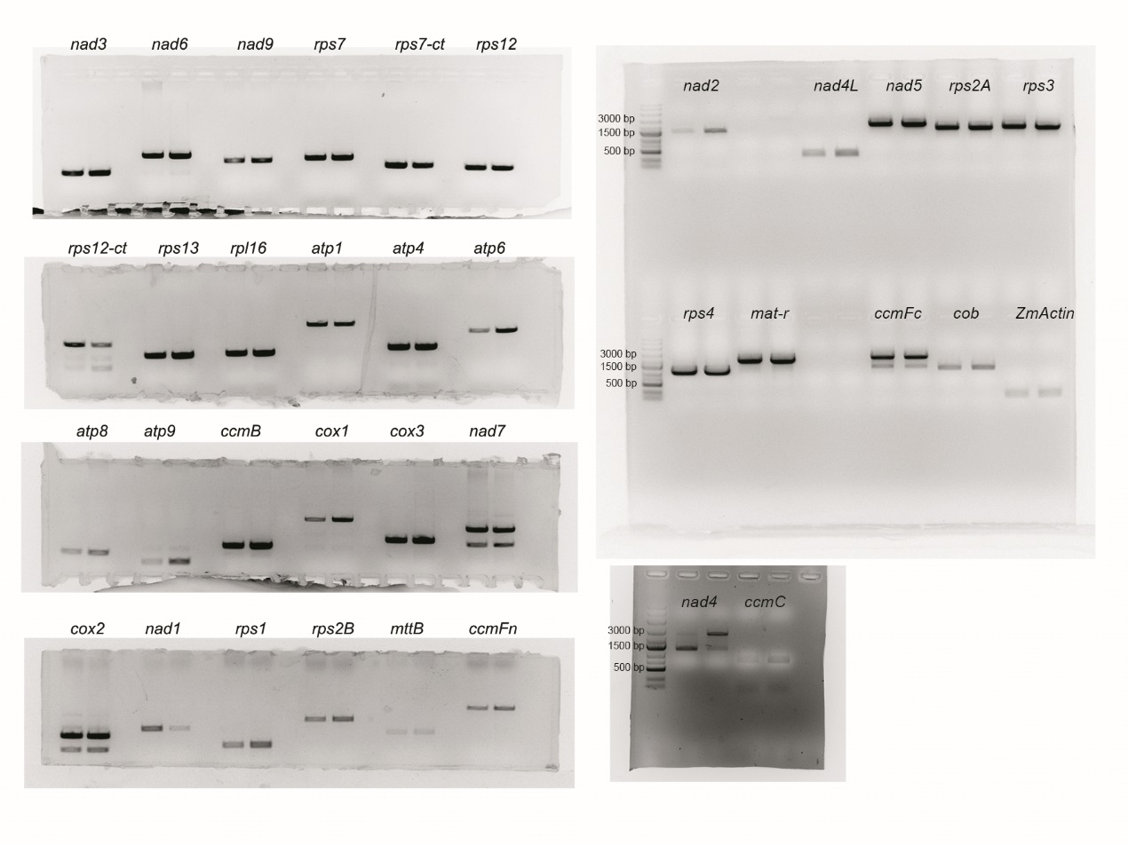
Figure S2. Original gel images of expression level analysis of 35 mitochondrial coding genes in WT and dek55-1 by RT-PCR.
The RT-PCR products were detected by 1.0% agarose gel electrophoresis. The genes name were marked.
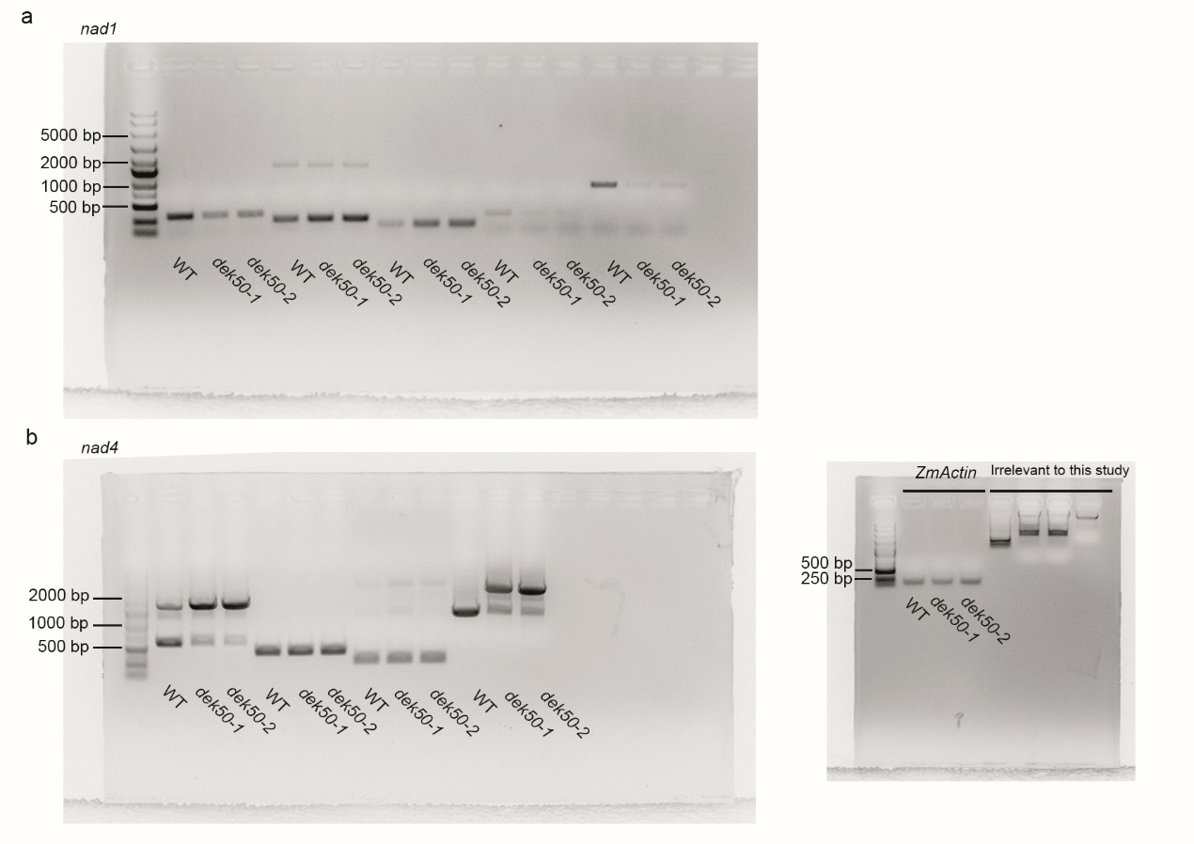
Figure S3. Original gel images of RT-PCR analysis of intron-splicing efficiency of nad1 and nad4 in WT, dek55-1 and dek55-2 mutant kernels.
(a) Original gel images of RT-PCR analysis of intron-splicing efficiency of nad1 in WT, dek55-1 and dek55-2 mutant kernels.
(b) Original gel images of RT-PCR analysis of intron-splicing efficiency of nad4 in WT, dek55-1 and dek55-2 mutant kernels. ZmActin gene (GRMZM2G126010) was used as an internal control and original gel image was also shown. Results irrelevant to this study were marked with “Irrelevant to this study”.
Figure S4. Original gel images of BN-PAGE analysis of mitochondrial complexes and in-gel NADH dehydrogenase activity analysis of complex I.
(a) Original gel images of BN-PAGE analysis of mitochondrial complexes.
(b) Original gel images of in-gel NADH dehydrogenase activity analysis of complex I.
Results irrelevant to this study were marked with “Irrelevant to this study”.
Supplementary Table
Table S1. Genetic analysis of the mutant kernels in the segregation ear, which are from self-pollinated dek55-1 and F₁ heterozygotes.
Self-pollinated parents | Number of mutants | Number of WT | Actual ratio | Expected ratio | P
dek55-1/+ | 411 | 1239 | 1:3.01 | 1:3 | 0.93
F₁ (C733×dek55-1/+) | 916 | 2821 | 1:3.07 | 1:3 | 0.49
F₁ (S162×dek55-1/+) | 457 | 1364 | 1:2.98 | 1:3 | 0.92

Table S2. The primers used in this study.

umc1705-F | ATCTCACGTACGGTAATGCAGACA | For fine mapping
umc1705-R | CATGACCTGATAAACCCTCCTCTC | For fine mapping
umc2302-F | GCATATGCGAGATCATATCGTTGA | For fine mapping
umc2302-R | CTATACAGCCCTCAGCTCTGCTGT | For fine mapping
M2-F | GTGCTATGCATGAGGGTAGAGT | For fine mapping
M2-R | TGTATTGGGCGATACCGAGC | For fine mapping
M3-F | ATCTGTAGTGCTTCCGTGCTCT | For fine mapping
M3-R | GGCTCATTTGTAAGGTTGTGC | For fine mapping
M4-F | GTTGAGATAACTATGCAAATCGTG | For fine mapping
M4-R | CTTCCAACGTGCGTCTCTAC | For fine mapping
M5-F | CGTCGTCGAGGTGATTAGGG | For fine mapping
M5-R | GAACCCTCCTCCCGACTACT | For fine mapping
M6-F | GGTTTCCAGAGCTAGGTGGG | For fine mapping
M6-R | CGTCGTTTCCGTCGTCAATC | For fine mapping
F148-F | GTTCGGTCGAGTTGGGATGA | For fine mapping
F148-R | CAGACCAACCCTTCAGTCCC | For fine mapping
DEK55-Full-F | GCCAGGTAGAATAGATGGAACC | Clone DEK55 full length
DEK55-Full-R | CAAGAGCTGCTAAAATTTGTCAGTAC | Clone DEK55 full length
ZmActin-F | ATGGTCAAGGCCGGTTTCG | qRT-PCR and RT-PCR primer of ZmActin
ZmActin-R | TCAGGATGCCTCTCTTGGCC | qRT-PCR and RT-PCR primer of ZmActin
DEK55-qRT-F | CGATGACTGGTATAGCTTAGGG | qRT-PCR analysis of DEK55 gene expression
DEK55-qRT-R | CGCATCCTCTCATCCTCATAG | qRT-PCR analysis of DEK55 gene expression
nad1-1F | GCAACGTAGAAAGGGTCCTG | Test nad1 introns splicing efficiency
nad1-2R | TGAGCTGCAGATCGTAATGC | Test nad1 introns splicing efficiency
nad1-2F | TCGAAATATGCCTTTCTAGGAG | Test nad1 introns splicing efficiency
nad1-3R | ATTCAGCTTCCGCTTCTGG | Test nad1 introns splicing efficiency
nad1-3F | GTCATGGCGCAAAAGCAGATATGG | Test nad1 introns splicing efficiency
nad1-4R | AGAGCAGACCCCATTGAAGA | Test nad1 introns splicing efficiency
nad1-4F | TCTTCAATGGGGTCTGCTCT | Test nad1 introns splicing efficiency
nad1-5R | AGGGAGCCATCGAAAGGTGA | Test nad1 introns splicing efficiency
nad4-1F | TTGATTGGTCTGTGCGTTTC | Test nad4 introns splicing efficiency
nad4-2R | GGCTTCGGGTAACCAAATA | Test nad4 introns splicing efficiency
nad4-2F | TGCCGTCAAAGTGCCTAT | Test nad4 introns splicing efficiency
nad4-3R | GGTGCTCACTAAACCTCCATA | Test nad4 introns splicing efficiency
nad4-3F | CACTTTAGCCAATATGAGTTTACC | Test nad4 introns splicing efficiency
nad4-4R | ATGCAGTCCGGGAACACT | Test nad4 introns splicing efficiency
Aox1-qRT-F | AAGGTGCTGCTCGACAAGAT | qRT-PCR analysis of Aox1 gene expression
Aox1-qRT-R | GTAGGCGTTGAAGAAGACGC | qRT-PCR analysis of Aox1 gene expression
Aox2-qRT-F | GACATCTTCTTCCAGAGGCG | qRT-PCR analysis of Aox2 gene expression
Aox2-qRT-R | TGACTACGTCCTTGAGCGTG | qRT-PCR analysis of Aox2 gene expression
Aox3-qRT-F | CCAAGCTCGTGAAGGAAGAC | qRT-PCR analysis of Aox3 gene expression
Aox3-qRT-R | GTAGGCGTTGAAGAAGACGC | qRT-PCR analysis of Aox3 gene expression
DEK55-SC-F | CCGCGAATTCATGCCGCCGCCCCCAGCCG | Construct full length DEK55-EGFP vector
DEK55-SC-R | CCGCGGTACCGATACCAAAATCACAAGC | Construct full length DEK55-EGFP vector

