Supplementary Material

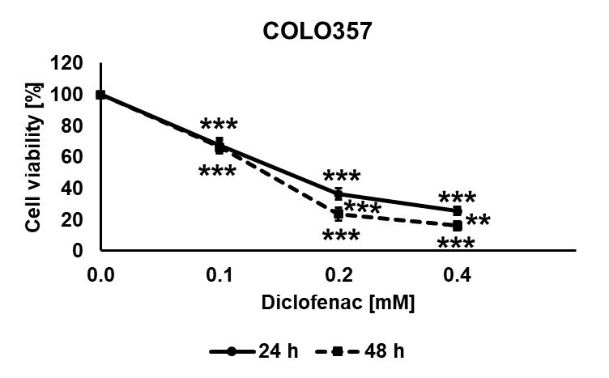
Supplementary Figure 1. Diclofenac inhibits cell viability in COLO357 cancer cells. Toxicity assay COLO357 cancers cells treated with diclofenac (0.0, 0.1, 0.2 and 0.4 mM) for 24 and 48 h. Two way ANOVA was used to evaluate significant differences (**p ≤ 0.01, ***p ≤ 0.001).

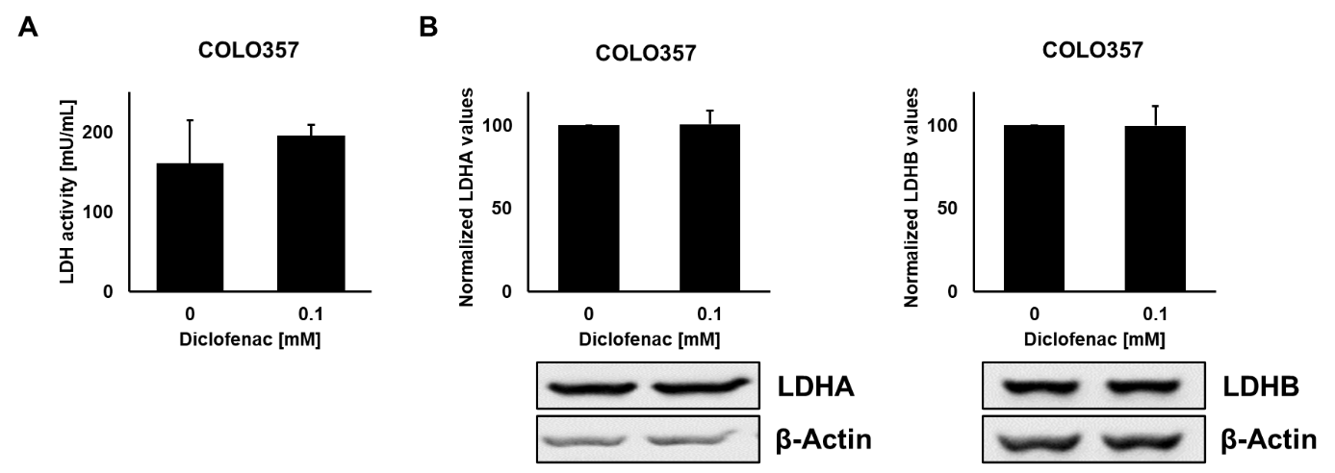
Supplementary Figure 2. LDH activity and expression levels in COLO357 cancer cells after diclofenac treatment. (A) LDH activity assay of COLO357 cancer cells treated with diclofenac (0 and 0.1 mM) for 48 h. (B) Representative immunoblot showing the expression of LDHA and LDHB 48 h after diclofenac (0 and 0.1 mM) treatment. Quantification of the LDHA and LDHB signals of at least 3 independent experiments are shown in the bar charts above.

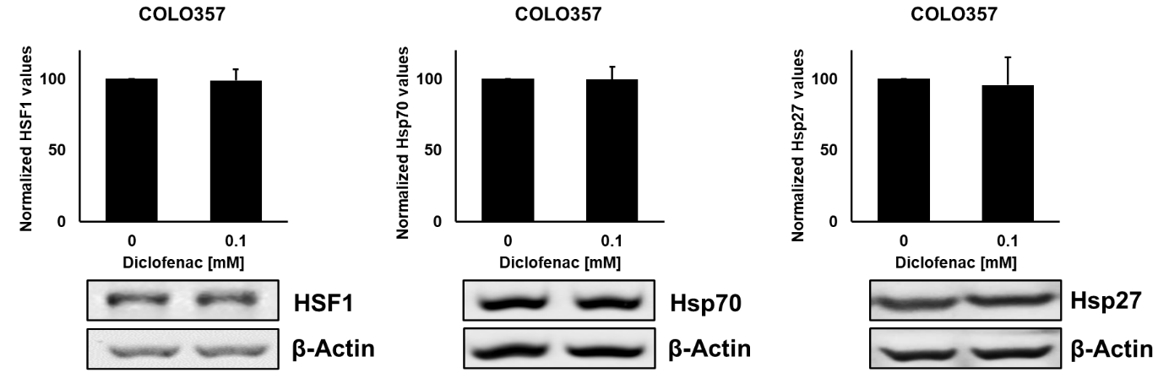
Supplementary Figure 3. Effects of diclofenac on cytosolic stress protein expression. Representative immunoblot showing the expression of Hsp70 and Hsp27 48 h after diclofenac treatment in COLO357 cancer cells. Quantification of the respective proteins signals of at least 3 independent experiments are shown in the bar charts above.

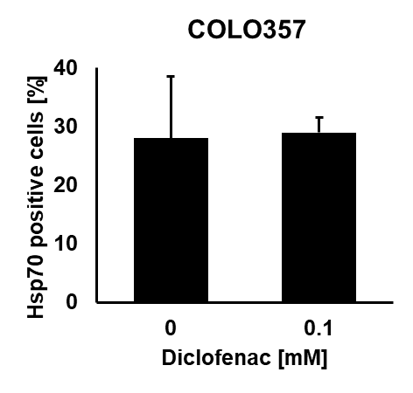
Supplementary Figure 4. Effects of diclofenac on the membrane Hsp70 expression. Plasma membrane bound Hsp70 on untreated and diclofenac treated (0.1 mM for 48 h) COLO357 cancer cells. The proportion of positively stained cells is shown.

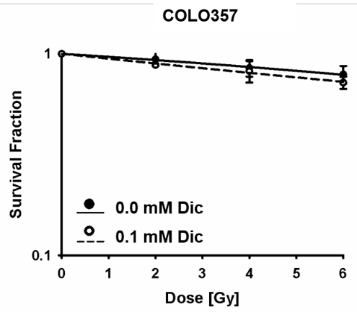
Supplementary Figure 5. Colony forming assay for COLO357 cells. Cancer cells were treated with 0.1 mM diclofenac (Dic) for 48 h, irradiated (0-6 Gy) and then allowed to form colonies in drug-free medium.

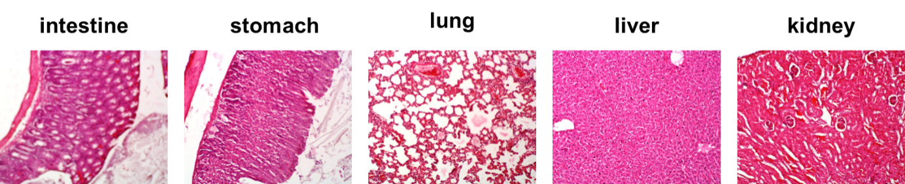
Supplementary Figure 6. Histopathology inspection of major organs of the treated mice with diclofenac, 16 days post-induction of the xenograft LS174T tumor (Hematoxylin and Eosin staining 40 X). The treated mice received three intraperitoneal injections of diclofenac (40 mg/kg) 7, 9, and 11 days after injection of the cells once a day.

Supplementary Table 1. Summary of the radiobiological parameters shown in Figure 5 A-D.
Cell line | D₅₀ (Gy)ª | SER^{b} | α (Gy⁻¹)^{c} | β (Gy⁻¹)^{c}
LS174T
0.0 mM Dic | 2.75 | 1.00 | 0.15 | 0.04
0.1 mM Dic | 1.85 | 1.48 | 0.21 | 0.09
LoVo
0.0 mM Dic | 2.96 | 1.00 | 0.09 | 0.05
0.1 mM Dic | 2.00 | 1.48 | 0.14 | 0.10
A549
0.0 mM Dic | 6.83 | 1.00 | 0.06 | 0.01
0.1 mM Dic | 6.58 | 1.04 | 0.10 | 0.001
MDA-MB-231
0.0 mM Dic | 3.77 | 1.00 | 0.03 | 0.04
0.1 mM Dic | 3.59 | 1.05 | 0.01 | 0.05
ª D₅₀: dose (Gy) required for 50% inactivation of a tumor cell population.
^{b} SER: Sensitizing enhancement ratio = D₅₀ (control)/D₅₀ (drug treatment). A SER greater than 1.20 indicates a radio-sensitization (indicated in bold).
^{c} α and β values were derived from the linear quadratic equation f= exp(−α*x − β*x²).
Dic: Diclofenac

Supplementary Methods
Pathology Evaluation

An intraperitoneal injection of sodium pentobarbital (800 mg/kg body weight) was used to euthanize the animals 16 days after the LS174T cell injection. An examination of the peritoneal membrane and cavity was performed to detect macroscopic lesions. The main organs, including the stomach, kidneys, liver, intestine, and lungs, were removed and then transferred for formalin fixation and paraffin embedding. Following the preparation of the tissue sections, the staining with hematoxylin & eosin was performed. Careful examination and observation of the prepared slides of the tissue sections were conducted.

