Supplementary Data for
Mechanistic study of Huangqi Guizhi Wuwu decoction in the treatment of osteoarthritis using a weighted gene co-expression network and molecular docking techniques
Zhongbo Jiang^{1#} Yuli Cai^{2#} Weiguo Wang^{2#} Wenxue Lv²*
1) Zhongbo Jiang E-mail: 654491227@qq.com
2)Yuli Cai E-mail: 182018314@qq.com
3)Weiguo Wang E-mail: xixi_wwg@hotmail.com
4)Wenxue Lu E-mail:lvwenxue@163.com

* Correspondence: lvwenxue@163.com; (Tel:8613012990997)
# Zhongbo Jiang and Yuli Cai contributed equally to this article and are joint first authors.

Table 1 ：Clinical characteristics of samples in GEO dataset
Dataset | Platform | Control group | OA group | Tissue type
GSE55235 | GPL96 | 10 | 10 | synovial tissue
GSE206848 | GPL570 | 7 | 7 | synovial tissue
GSE55457 | GPL91 | 10 | 10 | synovial tissue

Figure 1：Normalization of datasets

Figure 2 Screening for DEGs in the merged dataset (heatmap showing the top 20 genes)

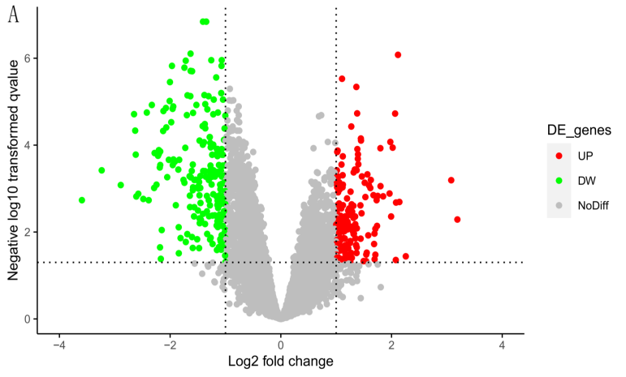

Figure 3 WGCNA of the merged dataset

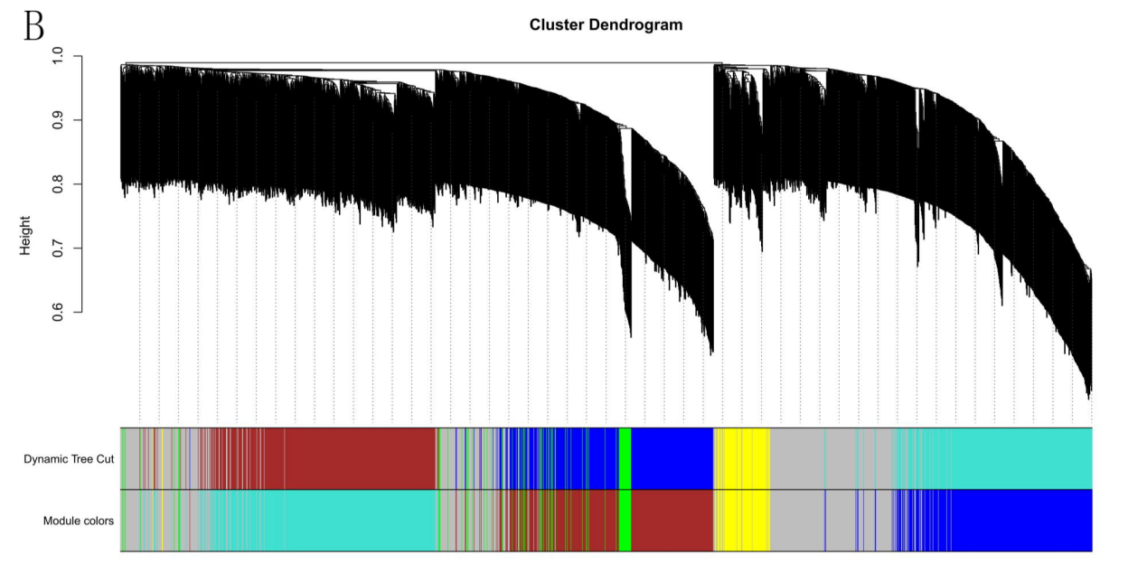
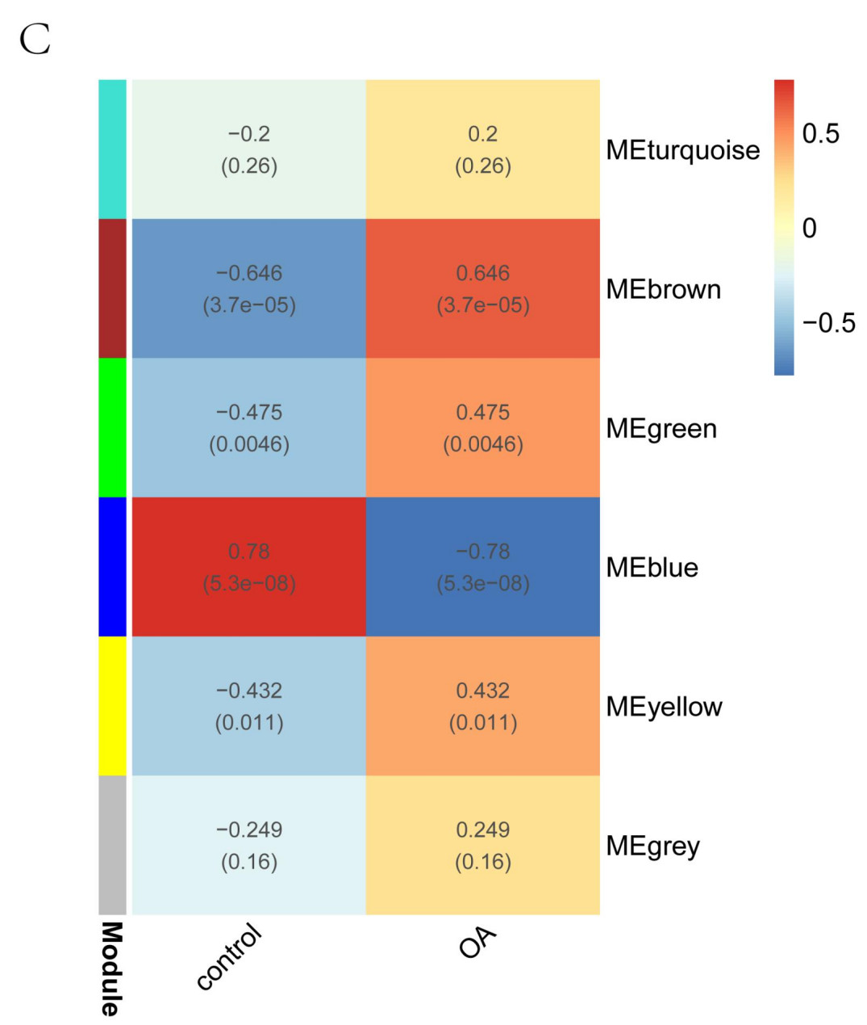
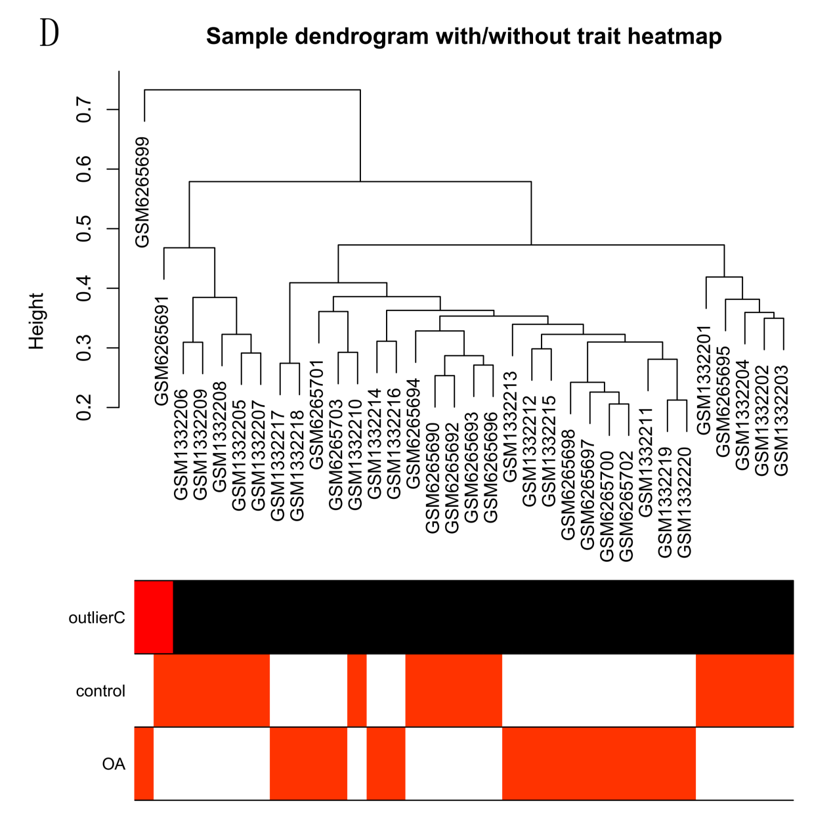

Figure 4 PPI network construction
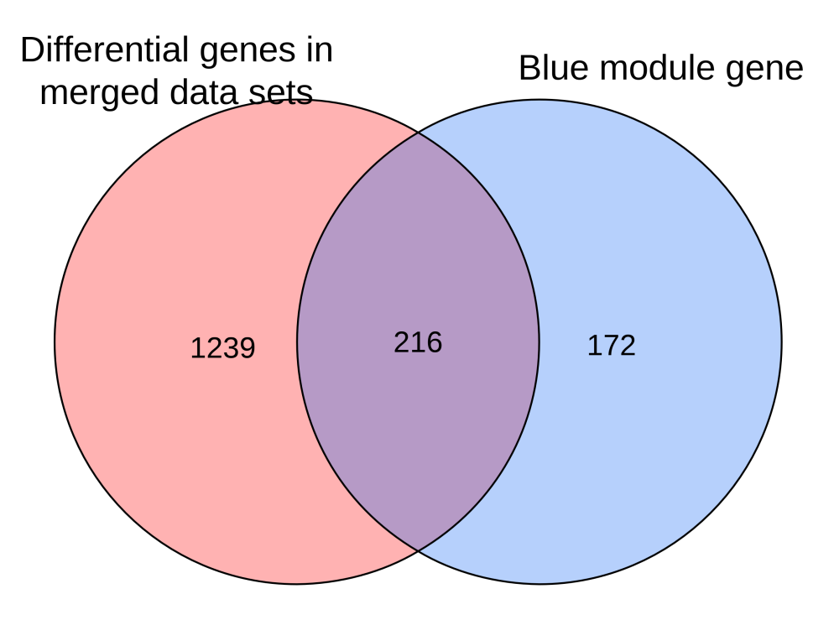
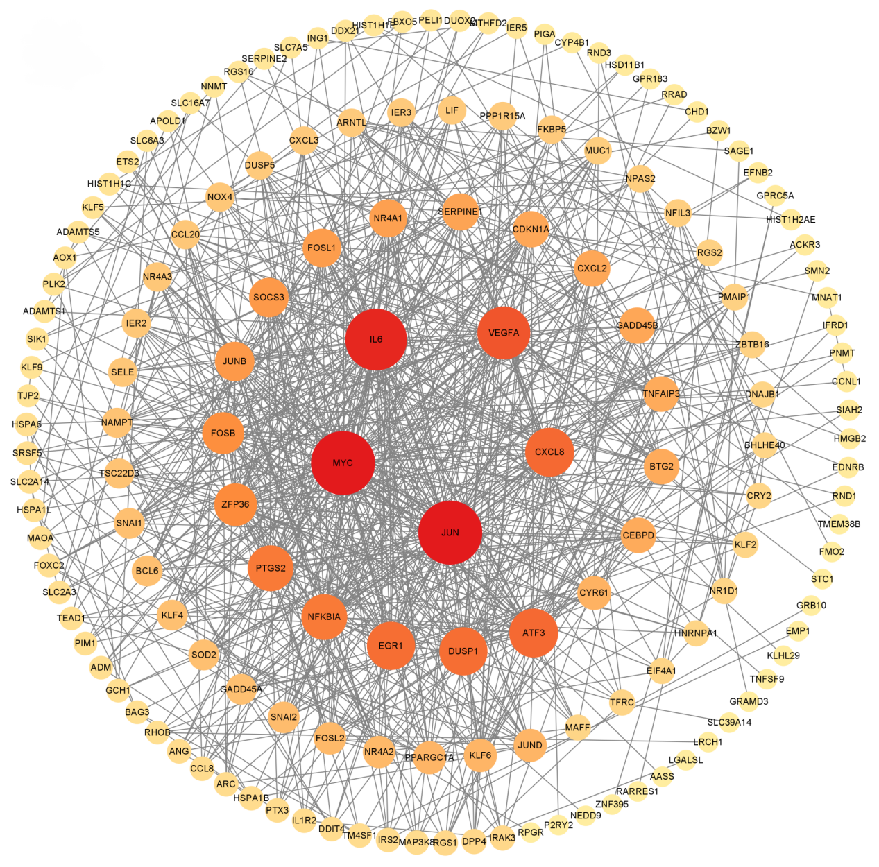
Figure 5 "Drug-Active Ingredient-Related Target" network diagram
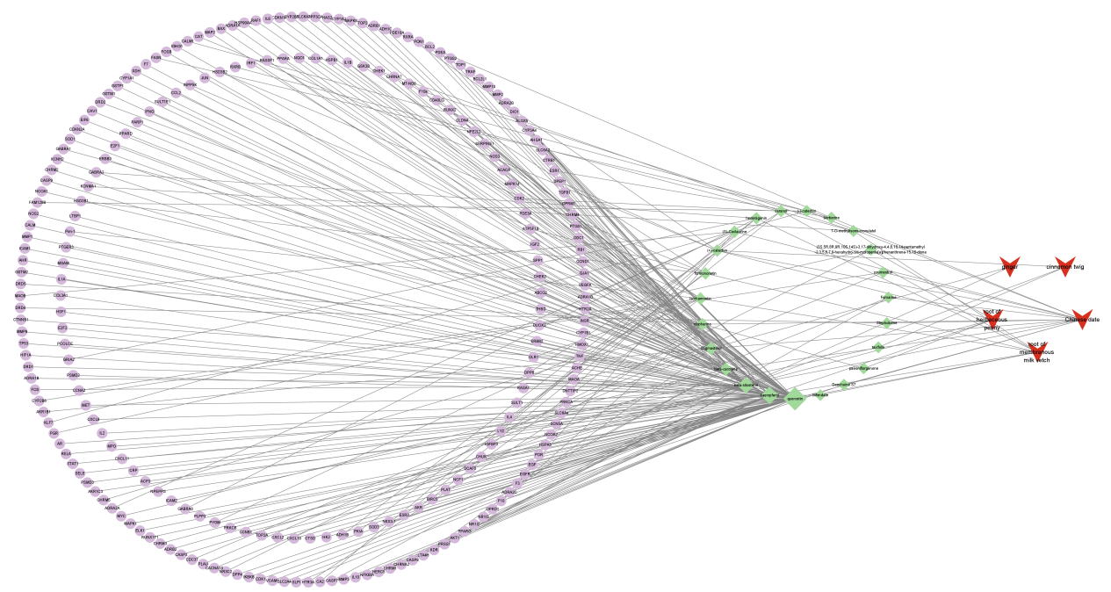

Figure 6 Screening of hub genes of OA affected by HGWWD
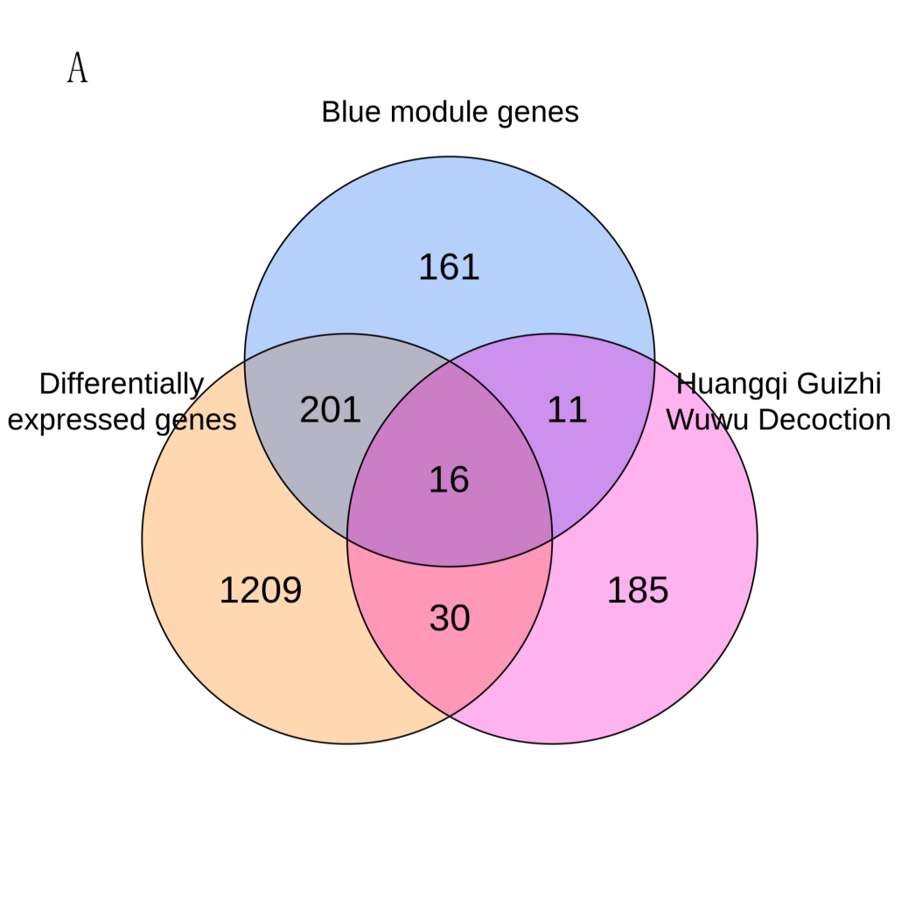
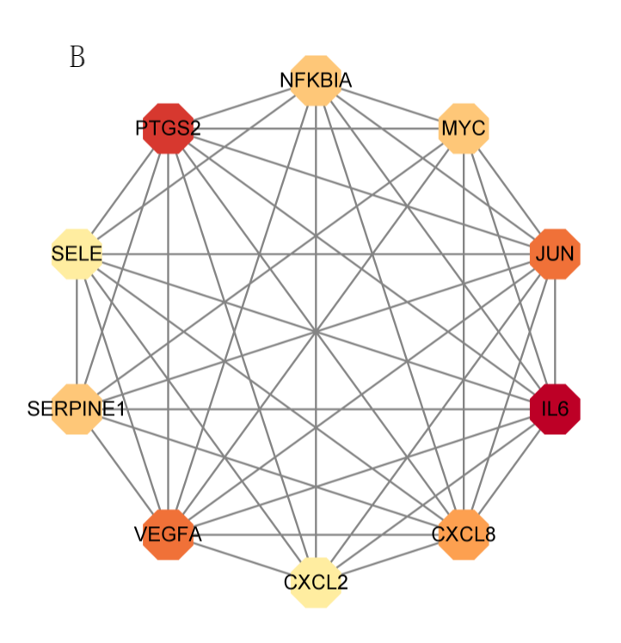
Figure 7 Enrichment analysis of common genes

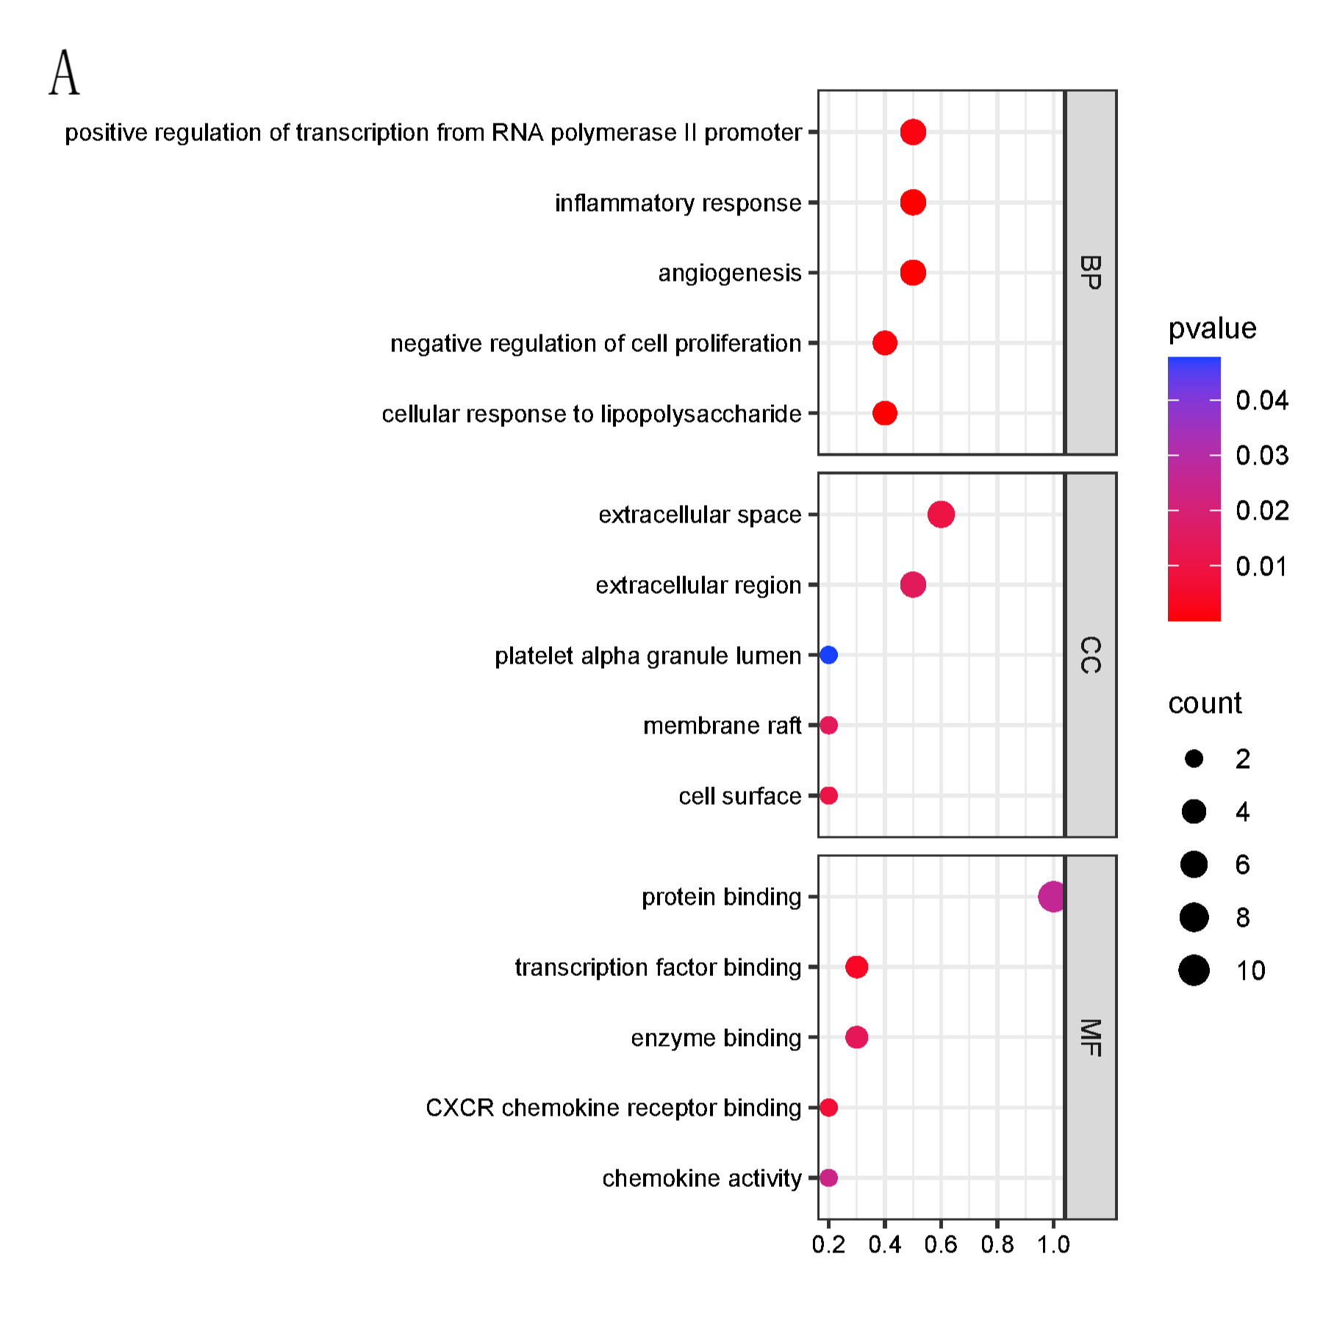
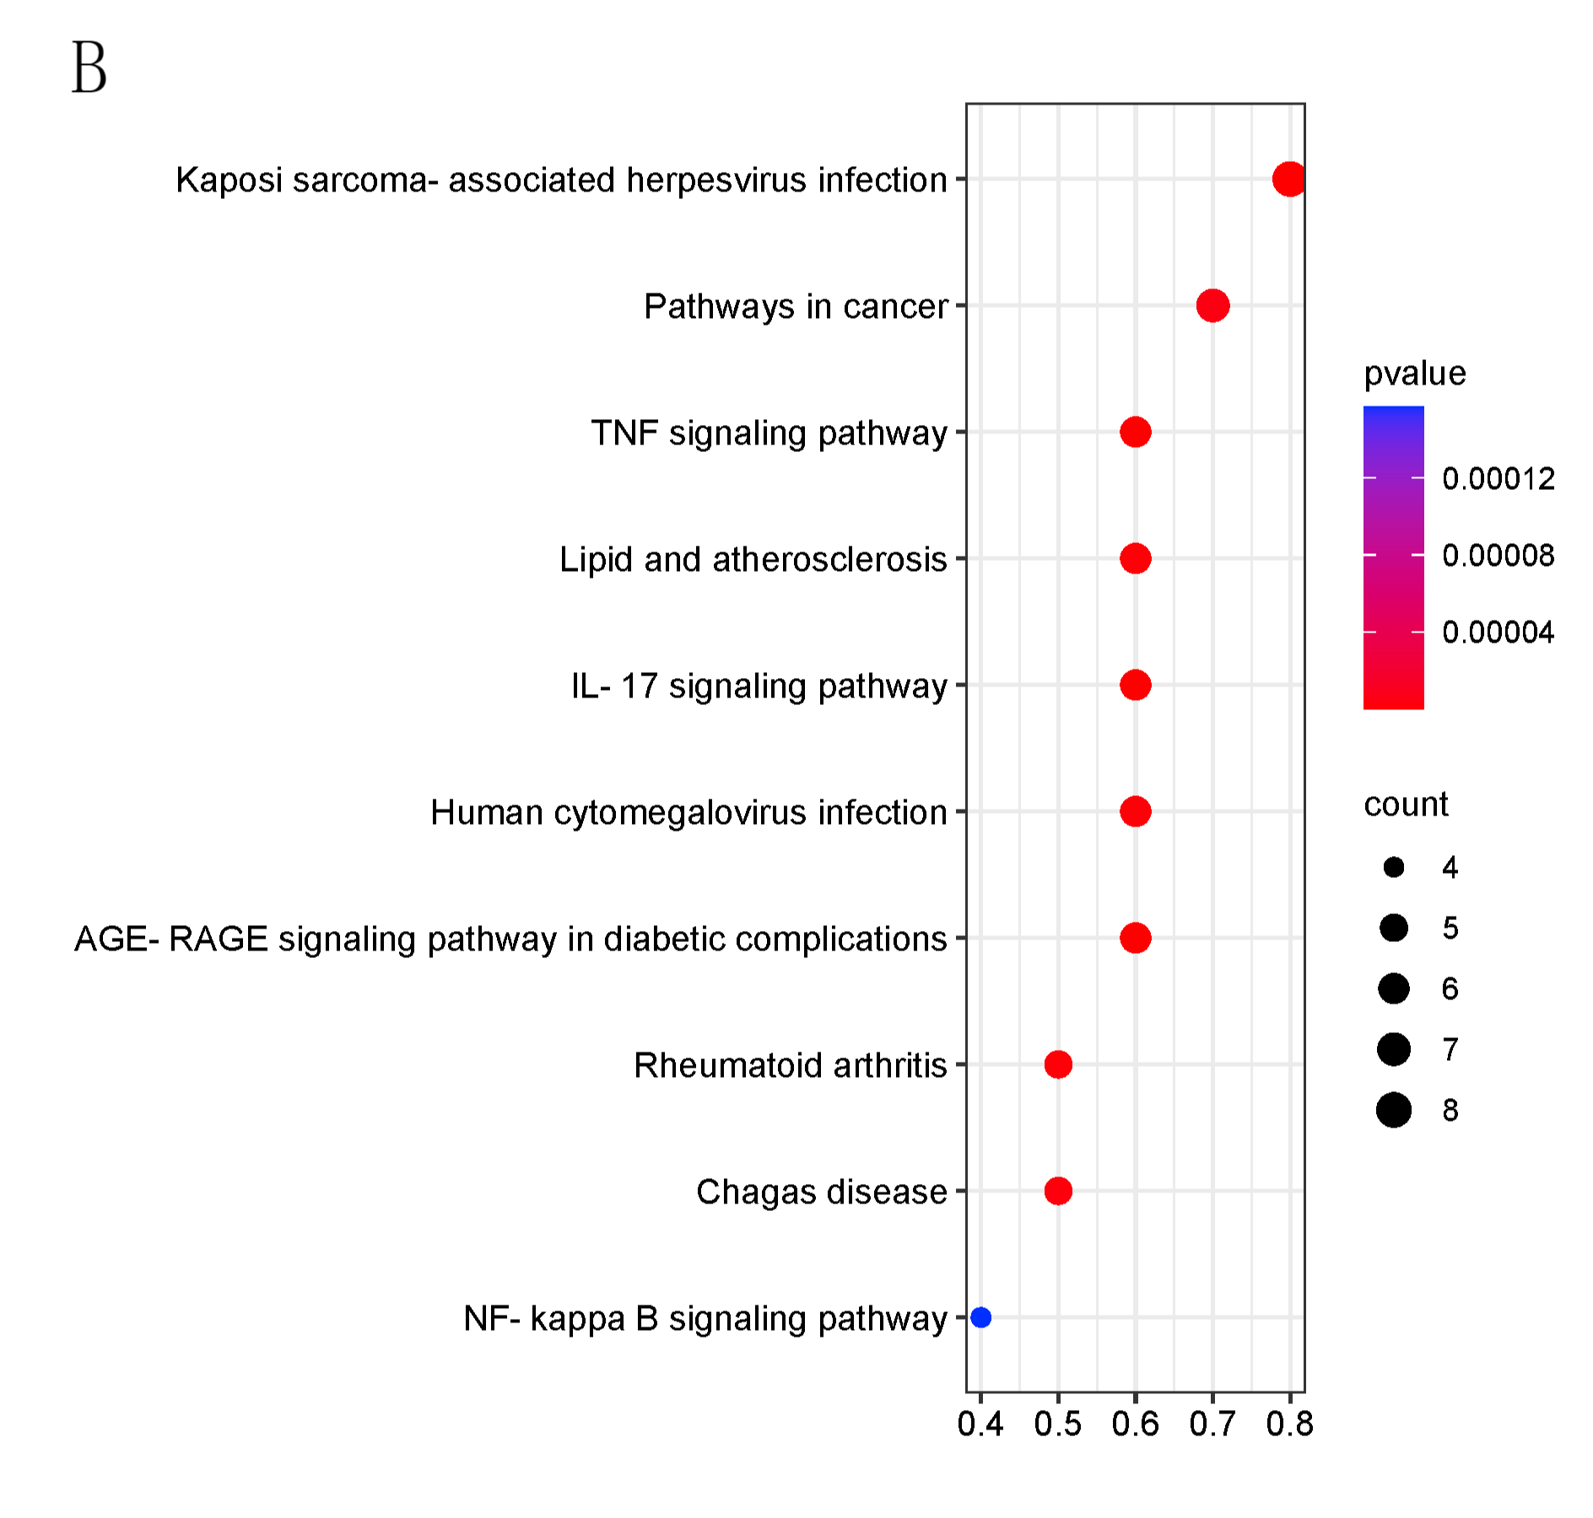
Figure 8 Diagnostic value of hub genes in the GSE55457 dataset for OA

Figure 9 The expression differences in hub genes between the control and OA groups

Figure 10 Diagram of molecular docking

