Supplementary figures:

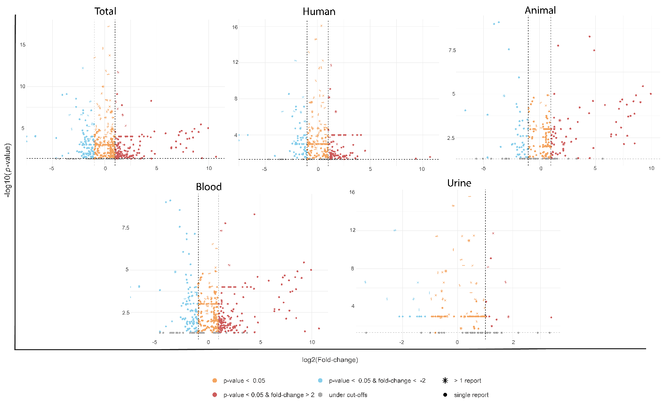

Figure S1: Volcano plots for quantitative results of amanida meta-analysis of total studies, Human and animal subgroups as well as urine and blood subgroups.

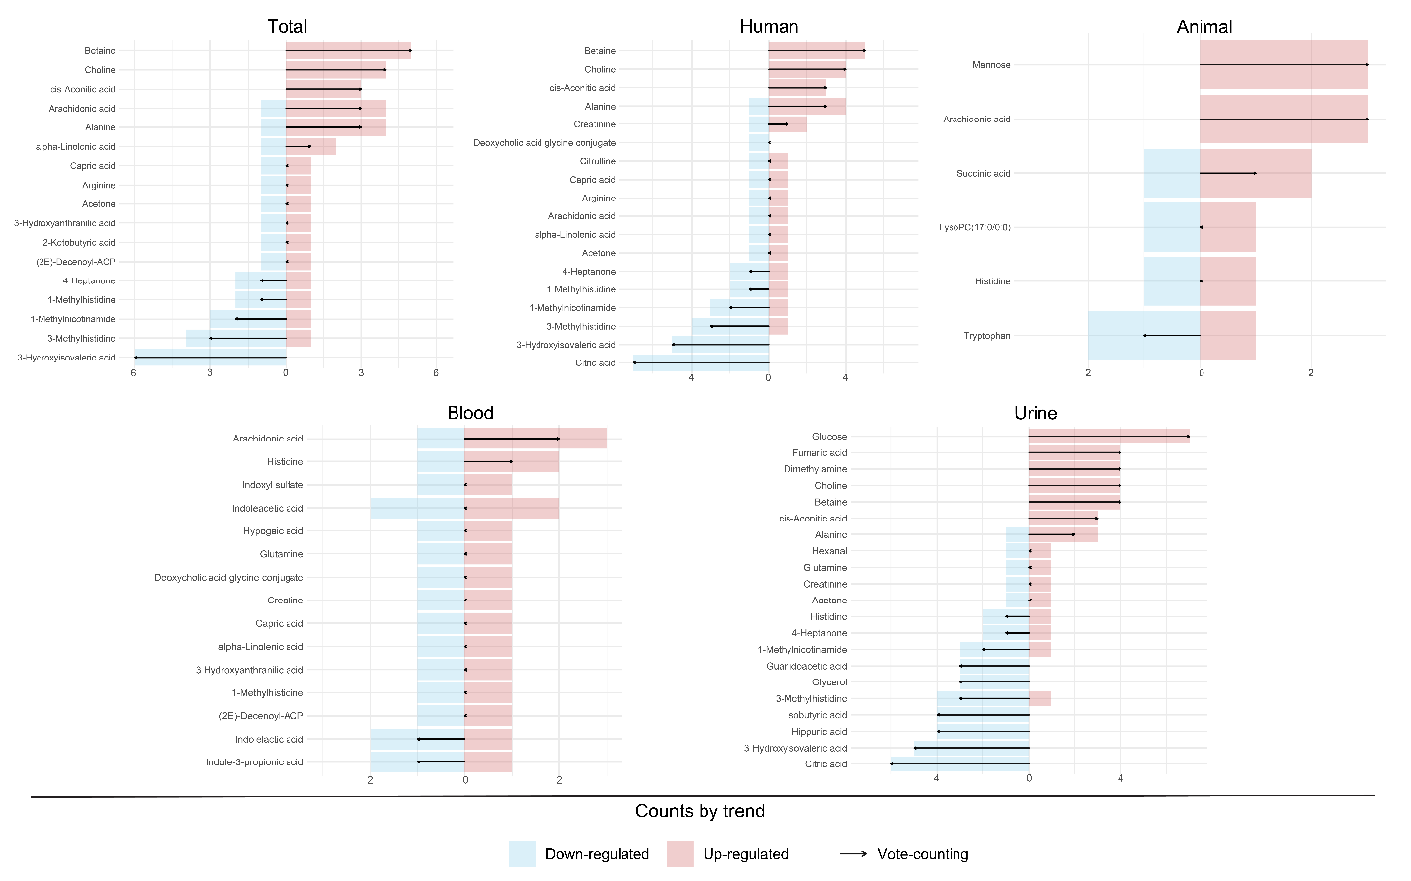

Figure S2: Explore plots of the vote-counting results with the number of times a compound is found upregulated or downregulated. These plots are the results of amanida meta-analysis on total studies, Human and animal subgroups as well as urine and blood subgroups.

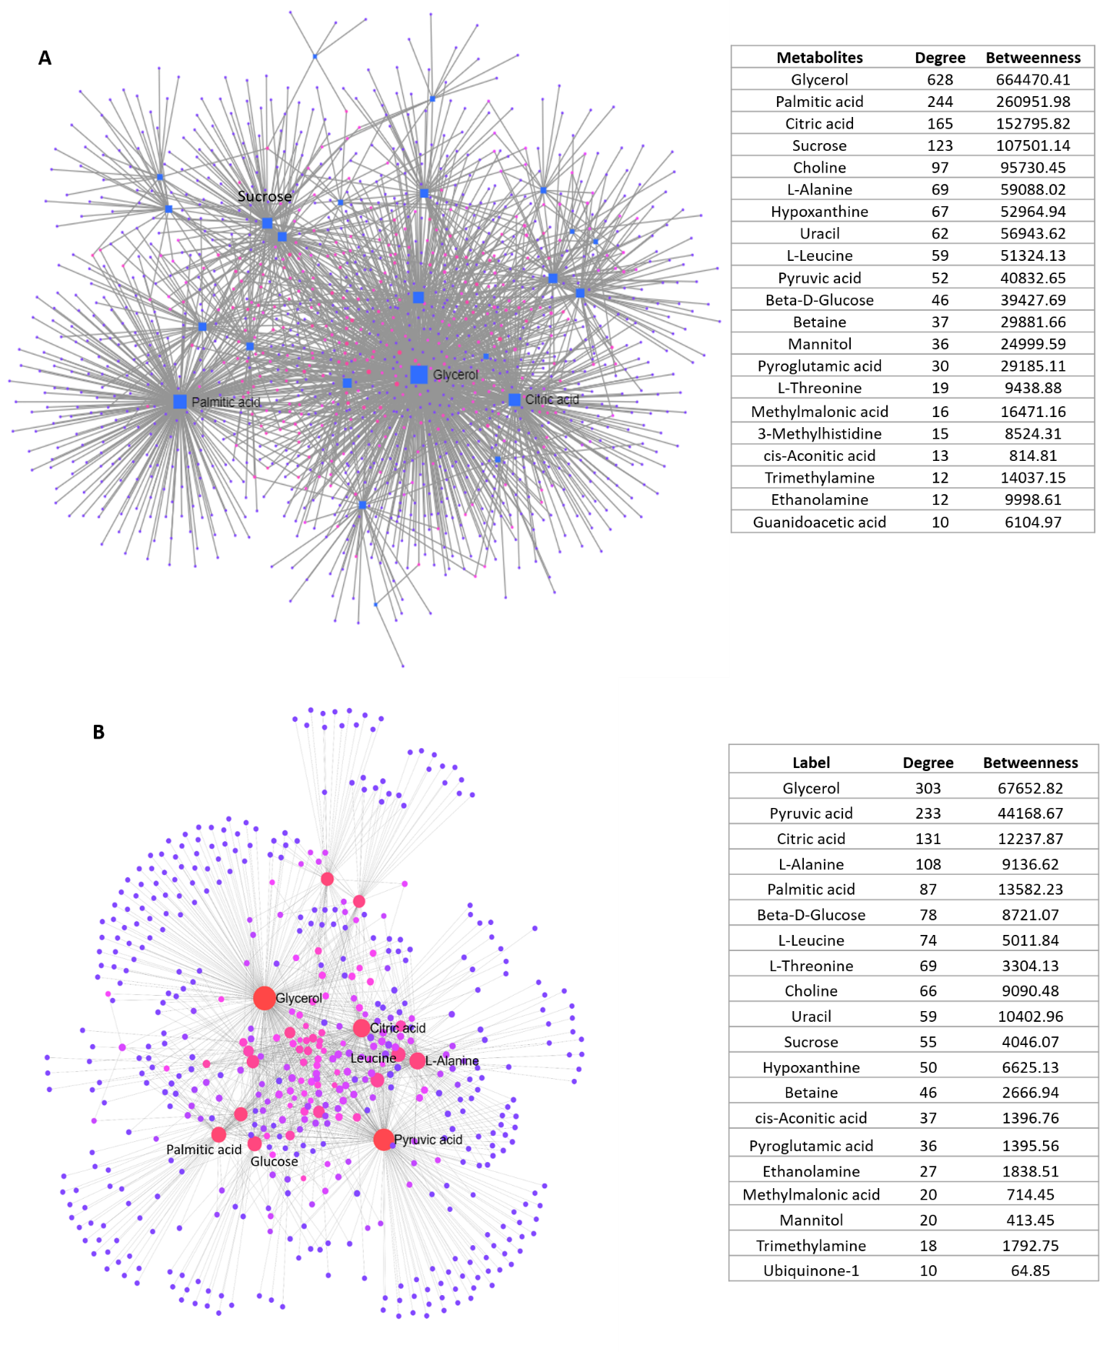

Figure S3: A:Gene-Metabolite interaction network and B:metabolite-metabolite interaction network

