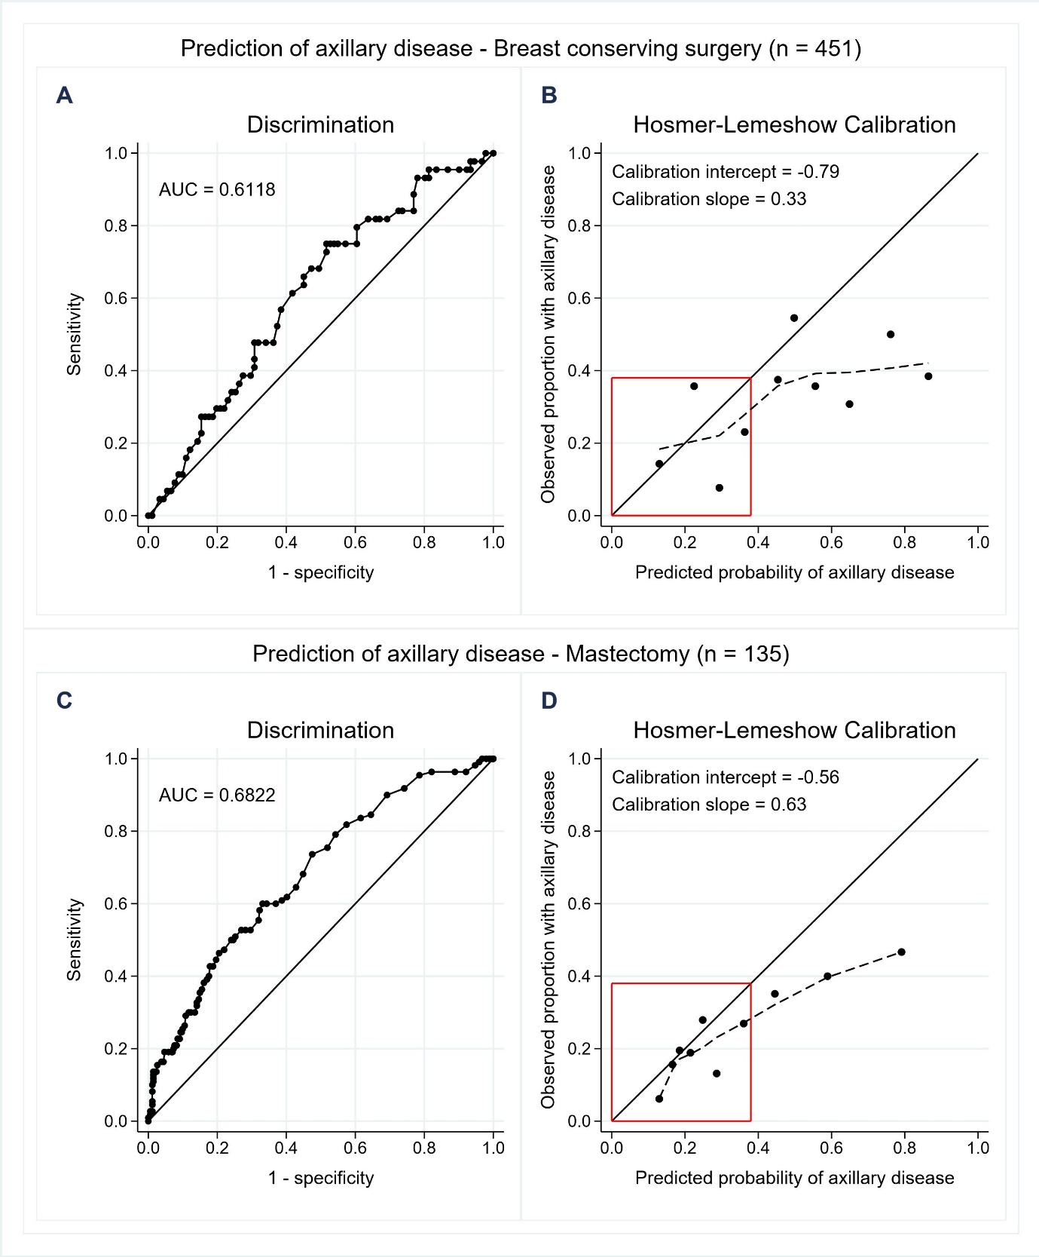
Supplementary Figure 3. Type of breast surgery (breast conserving surgery and mastectomy). A/C) Area under the receiver operating characteristics curve (AUC) visualizing the discriminatory performance of noninvasive lymph node staging (NILS) model for the estimation of axillary disease (N+). B/D) Hosmer-Lemeshow calibration plot of observed proportion N+ versus mean predicted probability of N+ for each decile of the predictions. Locally weighted scatterplot smoothing (LOWESS), the dotted line, was used to capture the calibration performance for low probabilities of N+, i.e. within the red box.

