Supplementary materials
GREEN SYNTHESIS OF ZnO DOPED PIPER CHAUDOCANUM LEAF EXTRACT BY CO-PRECIPITATION METHOD: CHARACTERIZATION, ANTIBACTERIAL AND ANTICANCER ACTIVITY
Truong Thi Thao¹, Khieu Thi Tam^{1*}

¹Faculty of Chemistry, TNU-University of Sciences, Tan Thinh Ward, Thai Nguyen city, Vietnam
*Corresponding author: Khieu Thi Tam (tamkt@tnus.edu.vn)
†Present address: Faculty of Chemistry, TNU-University of Sciences, Tan Thinh Ward, Thai Nguyen city, Vietnam
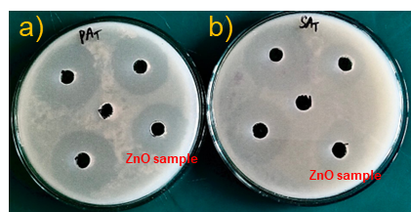
Figure S1. Antibacterial activity of ZnO symbol sample against: (a) P. aeruginosa, (b) S. aureus
Table S1. Antibacterial activity of ZnO NPs samples against: (a) P. aeruginosa, (b) S. aureus
Bacterial strains | Diameters of the zones of inhibition for the tested bacteria (mm)
Bacterial strains | DMSO | ZnO | ZPS25 | ZPS50 | ZPS75
P. aeruginosa | 0 | 21 | 31 | 42 | 37
S. aureus | 0 | 16 | 35 | 39 | 36
Table S2. Cytotoxic activity against KB human cancer cell line of ZPS50
No. | Concentration (μg/mL) | Inhibition (%)
1 | 256 | 81
2 | 64 | 79
3 | 16 | 11
4 | 4 | 0
5 | IC₅₀ | 43.53±2.98
Figure S2. Anticancer activity of various concentrations of ZPS50 against KB

