Supplementary Materials for
The Role of Arsenic in the Operation of Electrical Threshold Switches
Renjie Wu et al.
* Corresponding authors. Email: minzhu@mail.sim.ac.cn

Figure S1 50 individual devices for each composition were measured, whose performances conform to normal distributions. The V_{fire} values for pure GeS range from 4.1 to 4.5 V. The mean value is 4.33 V, and the standard-deviation (SD) value is 0.077. The V_{th} values for pure GeS devices vary from 1.3 V to 2.3 V. The mean value is 1.79 V, and the SD value is 0.178. The V_{h} values vary from 1.1 V to 1.9 V. The mean value is 1.46 V, and the SD value is 0.157. The window between V_{th} and V_{h} might result in errors in the read process in memory applications. With the addition of As, V_{h} stabilizes at about 1.5 V, and the fluctuation of V_{th} values diminished. The V_{fire} values for GeSAs₂₀ range from 4.9 to 5.6 V. The mean value is 5.06 V, and the SD value is 0.128. The V_{th} values vary from 2.4 V to 3.1 V. The mean value is 2.78 V, and the SD value is 0.238. The V_{h} values vary from 1.3 V to 1.7 V. The mean value is 1.49 V, and the SD value is 0.08. The V_{fire} values for GeSAs₂₅ range from 4.6 to 5 V. The mean value is 4.73 V, and the SD value is 0.052. The V_{th} values vary from 2 V to 3 V. The mean value is 2.64 V, and the SD value is 0.228. The V_{h} values vary from 1.3 V to 1.6 V. The mean value is 1.46 V, and the SD value is 0.055. The V_{fire} values for GeSAs₄₃ range from 4 to 4.6 V. The mean value is 4.24 V, and the SD value is 0.075. The V_{th} values vary from 1.8 V to 2.7 V. The mean value is 2.2 V, and the SD value is 0.18. The V_{h} values vary from 1.3 V to 1.7 V. The mean value is 1.46 V, and the SD value is 0.1.

Fig. S2 Horizontal comparation of current and voltage parameters of different components. The variation of I_{on} and I_{off} with As content is displayed on the left, and the fluctuation of V_{fire}, V_{th} and V_{h} of 50 individual devices is on the right. I_{on} was captured at the point of threshold switching. I_{off} refers to the current at 1/2 V_{th} in the subthreshold region. In concert with the growing trend of As, the mean value of I_{off} from 30 devices for each As content starts at 0.16 μA at 1 V, then goes down to 0.11 nA at 1.5 V, which is the turning point, then slowly climbed to 0.13 nA at 1.5 V, and it kept increasing to 0.2 nA at 1.2 V finally. It can be seen from the figure that the addition of As immensely improved the uniformity of I_{off}. The ON state current goes up from 0.59 mA to 1.36 mA and then down to 1.11 mA. The regulation of voltage seems to be similar with that of the on-current. V_{fire} goes up from 4.3 V to 5 V, goes down to 4.7 V next, and ends up at 4.4 V, while V_{th} jumps from 1.79 V to 2.79 V and decreases to 2.64 V and then to 2.23 V. V_{h} basically remained unchanged at 1.5 V.

Fig. S3 Comparison of the on-current density of GeSAs with that of other OTS cells. The on-current density (J_{on}) quadratically increases with a decrease of the device size. GeSAs shows advantages in terms of current density as well as thermal stability.^{1–15}

Figure S4 a. To measure the electrical characteristics, a 1 kΩ and a 100 Ω resistor were connected in series with GeSAs devices. The 1 kΩ resistor was used to limit the current, and the oscilloscope collects the voltage signal across the 100 Ω one. b. Integration of input voltage and output current. The input voltage is a triangular pulse with a rise time of 1 μs. The output voltage signal is captured by the oscilloscope and the result is converted into current, as shown in the figure, from which an obvious switching phenomenon can be observed. c. Enlarged views of the current response of on- and off- states. When the input voltage reaches V_{th}, the current signal suddenly surges. With a further increase of the input voltage, the upward trend slows down. We interpret the steep increase period as the on-speed. Similarly, the sudden drop of current is taken as the off-speed d. Speed statistics of 30 individual devices of all compositions. The on-speed of devices with different compositions range from 7 to 12 ns, and the off speed is in the range 5~15 ns.

Figure S5 Endurance of unannealed GeS and GeSAs₂₀ devices. Square pulses were used in the endurance measurements. The dynamical responses of the switches were measured for a set number of square pulses. Yellow curves correspond to the applied voltage pulses, while the blue curves correspond to the dynamical response measured across the resistor in series with the device. The on-current could be obtained from the dynamical-response curves. Clearly, the GeS and GeSAs₂₀ devices were successfully turned on and off by each pulse. After the set number of square pulses operation, the DC I-V curves of these devices were obtained, from which off-currents were obtained, as summarized in Fig. 1f. The GeS and GeSAs₂₀ devices cells work well up to 10⁸-cycle pulse operations in this case.

Figure S6 Endurance of unannealed GeSAs₂₅ and GeSAs₄₃ devices. GeSAs₂₅ and GeSAs₄₃ devices were successfully turned on and off for 10⁸ cycles, as shown in Fig. 1f.

Figure S7 GeS film samples were annealed at 300 ℃ and 350 ℃ for 30 minutes and 400 ℃ for 10 minutes, respectively. GeSAs samples were processed at 150, 250, 350 and 450 ℃ for 30 minutes, and at 500 ℃ for 10 minutes. The samples were then measured by X-ray diffraction (XRD), whose results are shown in the figure above. Clearly, there is a very small crystallization peak at 30° in the GeS sample annealed at 400 ℃, indicating that the GeS crystallized at that time. However, the XRD results of the annealed GeSAs samples are almost the same as that of the as-deposited samples, which confirms that As incorporation has a positive effect on the thermal stability of a-GeS.

Fig. S8 I-V curves of GeSAs devices with 60-nm electrodes after annealing at 450 ℃ for 30 min. The devices with As involved can all be turned on normally. The on-current of GeSAs₂₀ is 0.6 mA. The on-current of GeSAs₂₅ is 0.45 mA. The on-current of GeSAs₄₃ is 0.33 mA.

Figure S9 a. V_{fire}, V_{th} and V_{h} distributions for 10 nm thick, 450℃ annealed devices containing As. In 20 at. % As cells, V_{fire} is between 6 V and 7.69 V, V_{th} is in the range 2.42~4.41V, and V_{h} is located between 1.52 V and 2.12 V. In 25 at.% As cells, V_{fire} is between 5.73 V and 6.4 V, V_{th} is in the range 1.92~2.97 V, and V_{h} is located between 1.4 V and 1.7 V. In 43 at.% As cells, V_{fire} is between 4.79 V and 5.19 V, V_{th} is in the range 1.79~2.36 V, and V_{h} is located between 1.39 V and 1.57 V. The dispersion of V_{fire}, V_{th} and V_{h} decreases with increasing As content, indicating that the addition of As is beneficial to improve the consistency of device performance. b. After annealing at 450 ℃ for 30 min, GeS loses its switching performance, while the compositions containing As still work. By increasing the As content, the tendency of changes of V_{fire}, V_{th} and V_{h} is consistent with that before annealing, and V_{fire} decreases from 6.5 V to 6.2 V and then to 6 V; V_{th} decreases from 3.3V to 2.5 V and then to 2 V. The device leakage current increases from 3.1×10⁻⁹ A to 1×10⁻⁷ A with increasing As content. The on-current of the devices decreases from 0.7 mA to 0.4 mA, which is also consistent with the trend before annealing.

Figure S10 a. V_{fire}, V_{th} and V_{h} distributions for as-deposited GeS devices with 5, 10 and 20 nm thick OTS layers. In 5 nm-GeS cells, V_{fire} is between 2.74 V and 3.11 V, V_{th} is in the range 1.33~1.97 V, and V_{h} is located between 1.14 V and 1.56 V. In 10 nm-GeS cells, V_{fire} is between 4.14 V and 4.45 V, V_{th} is in the range1.51~2.07 V, and V_{h} is located between 1.14 V and 1.68 V. In 20 nm-GeS cells, V_{fire} is between 6.41 V and 6.66 V, V_{th} is in the range 1.73~3.00 V, and V_{h} is located between 1.18 V and 1.79 V. b. I_{off} of deposited GeS devices with 5, 10 and 20 nm thick OTS layer. Dotted lines correspond to the FF process. Solid lines correspond to I_{off}. c. V_{fire}, V_{th} and V_{h} variations with thickness. When the As content is zero, V_{fire} rises from 2.8 V, and V_{th} rises from 1.75V, which increase nonlinearly with thickness, and V_{h} is independent of thickness. d. I_{on} and I_{off} variations with thickness. I_{on} increases and I_{off} decreases with increasing thickness.

Figure S11 a. V_{fire}, V_{th} and V_{h} distributions for as-deposited GeSAs₂₀ devices with 5, 10 and 20 nm thick OTS layers. In 5-nm cells, V_{fire} fluctuates between 3.98 V and 4.24 V, V_{th} is distributed from 2.03 to 2.6 V, and V_{h} ranges from 1.32 V to 1.61 V. In 10-nm cells, V_{fire} fluctuates between 4.95 V and 5.29 V, V_{th} is distributed from 2.4 to 3.18 V, and V_{h} ranges between 1.33 V and 1.62 V. In 20-nm cells, V_{fire} is between 8.79 V and 8.88 V, V_{th} is in the range 2.65~4.62 V, and V_{h} is located between 1.701 V and 2.11 V. b. V_{fire}, V_{th} and V_{h} distributions for annealed GeSAs₂₀ devices with 5, 10 and 20 nm thick OTS layers. In 5-nm cells, V_{fire} fluctuates between 3.95 V and 4.53 V, V_{th} is distributed between 2.12 and 2.72 V, and V_{h} ranges from 1.48 V to 2.06 V. In 10-nm cells, V_{fire} fluctuates between 6 V and 7.69 V, V_{th} is distributed between 2.42 and 4.37 V, and V_{h} is located between 1.52 V and 2.08 V. In 20-nm cells, V_{fire} is between 7.6 V and 8.4 V, V_{th} is in the range 3.61~5.32 V, and V_{h} is located between 1.64 V and 2.05 V. c. I_{off} of as-deposited GeSAs₂₀ devices with 5, 10 and 20 nm thick OTS layers. Dotted lines correspond to the FF process. Solid lines correspond to I_{off}. d. I_{off} of annealed GeSAs₂₀ devices with 5, 10 and 20 nm thick OTS layers. Dotted lines correspond to the FF process. Solid lines correspond to I_{off}. e. V_{fire}, V_{th} and V_{h} variations, before and after annealing, with thickness. Solid lines correspond to the as-deposited state. V_{fire} increases from 3.3 V to 5 V and then to 8.8 V with a doubling of the thickness. V_{th} increases from 2.2 V for 5 nm, to 2.8 V for 10 nm and ends up at 4.8 V for 20 nm. V_{h} remains almost unchanged. Dotted lines correspond to the annealed state. V_{fire} increases from 4.26 V to 6.53 V and then to 8.11 V with a doubling of the thickness. V_{th} increases from 2.35 V for 5 nm, to 3.29 V for 10 nm and ends up at 4.32 V for 20 nm. V_{h} stays nearly the same. f. I_{on} and I_{off} variations before and after annealing with thickness. Solid lines correspond to the as-deposited state. I_{on} changes from 1.45 mA to 1.28 mA, and then to 2.3 mA. I_{off} decreases from 51.6 nA to 10.8 nA, and then to 0.74 nA. Dotted lines correspond to the annealed state. I_{on} becomes slightly smaller than those of unannealed cells. I_{on} increases from 0.42 mA to 0.71 mA, and then to 1.17 mA. While I_{off} of the annealed state is lower, it decreases from 8.4 nA to 3.1 nA, and to 1.65 nA.
Figure S12 a. V_{fire}, V_{th} and V_{h} distributions for as-deposited GeSAs₂₅ devices with 5, 10 and 20 nm thick OTS layers. In 5-nm cells, V_{fire} fluctuates between 3.35 V and 3.71 V, V_{th} is distributed between 1.88 and 2.66 V, and V_{h} ranges from 1.33 V to 1.59 V. In 10-nm cells, V_{fire} fluctuates between 4.63 V and 4.92 V, V_{th} is distributed in the range 2.33 to 2.94 V, and V_{h} is located between 1.33 V and 1.59 V. In 20-nm cells, V_{fire} is between 7.39 V and 8.64 V, V_{th} is in the range 3.18 to 4.89 V, and V_{h} is located between 1.37 V and 1.79 V. b. V_{fire}, V_{th} and V_{h} distributions of annealed GeSAs₂₀ devices with 5, 10 and 20 nm thick OTS layers. In 5-nm cells, V_{fire} fluctuates between 3.41 V and 3.61 V, V_{th} is distributed between 1.61 and 1.92 V, and V_{h} ranges from 1.32 V to 1.62 V. In 10-nm cells, V_{fire} fluctuates between 5.76 V and 6.4 V, V_{th} is distributed between 1.92 and 2.97 V, and V_{h} is located between 1.4 V and 1.7 V. In 20-nm cells, V_{fire} lies between 6.93 V and 8.47 V, V_{th} is in the range 2.91 to 4.35 V, and V_{h} is located between 1.42 V and 1.84 V. c. I_{off} of as-deposited GeSAs₂₀ devices with 5, 10 and 20 nm thick OTS layers. Dotted lines correspond to the FF process. Solid lines correspond to I_{off}. d. I_{off} of annealed GeSAs₂₀ devices with 5, 10 and 20 nm thick OTS layers. Dotted lines correspond to the FF process. Solid lines correspond to I_{off}. e. V_{fire}, V_{th} and V_{h} variations before and after annealing with thickness. Solid lines correspond to the as-deposited state. V_{fire} increases from 3.45 V to 4.73 V and then to 7.82 V with a doubling of the thickness. V_{th} increases from 2.23 V for 5 nm, to 2.64 V for 10 nm and ends up at 4.16 V for 20 nm. V_{h} remains almost unchanged. Dotted lines correspond to the annealed state. V_{fire} increases from 3.84 V to 6.01 V and then to 7.8 V with a doubling of the thickness. V_{th} increases from 2.16 V for 5 nm, to 2.51 V for 10 nm and ends up at 3.65 V for 20 nm. V_{h} stays nearly the same. f. I_{on} and I_{off} variations before and after annealing with thickness. Solid lines correspond to the as-deposited state. I_{on} increases from 1.45 mA to 1.28 mA, and then to 2.3 mA. I_{off} decreases from 56 nA to 13 nA, and then to 0.6 nA. Dotted lines correspond to the annealed state. I_{on} becomes slightly smaller than those of unannealed cells. I_{on} increases from 0.42 mA to 0.7 mA, and then to 0.93 mA. While I_{off} for the annealed state is lower, it decreases from 31 nA to 48 nA, and then to 6.9 nA.
Figure S13 a. V_{fire}, V_{th} and V_{h} distributions of as-deposited GeSAs₄₃ devices with 5, 10 and 20 nm thick OTS layers. In 5-nm cells, V_{fire} fluctuates between 2.95 V and 3.28 V, V_{th} is distributed between 1.55 and 2.10 V, and V_{h} ranges from 1.19 V to 1.46 V. In 10-nm cells, V_{fire} fluctuates between 4.18 V and 4.27 V, V_{th} is distributed from 1.95 to 2.54 V, and V_{h} is located between 1.35 V and 1.69 V. In 20-nm cells, V_{fire} is between 7 V and 8.84 V, V_{th} is in the range 2.87 to 4.28 V, and V_{h} is located between 1.29 V and 1.7 V. b. V_{fire}, V_{th} and V_{h} distributions of annealed GeSAs₂₀ devices with 5, 10 and 20 nm thick OTS layers. In 5-nm cells, V_{fire} fluctuates between 3.63 V and 4.05 V, V_{th} is distributed in the range 1.52 to 2.14 V, and V_{h} ranges from 1.29 V to 1.83 V. In 10-nm cells, V_{fire} fluctuates between 6 V and 7.69 V, V_{th} is distributed in the range 2.42 to 4.37 V, and V_{h} is located between 1.52 V and 2.08 V. In 20-nm cells, V_{fire} is between 6.38 V and 8.16 V, V_{th} is in the range 2.76 to 4.34 V, and V_{h} is located between 1.4 V and 2 V. c. I_{off} of as-deposited GeSAs₂₀ devices with 5, 10 and 20 nm thick OTS layers. Dotted lines correspond to the FF process. Solid lines correspond to I_{off}. d. I_{off} of annealed GeSAs₂₀ devices with 5, 10 and 20 nm thick OTS layers. Dotted lines correspond to the FF process. Solid lines correspond to I_{off}. e. V_{fire}, V_{th} and V_{h} variations before and after annealing with thickness. Solid lines correspond to the as-deposited state. V_{fire} increases from 3.15 V to 4.25 V and then to 7.96 V with a doubling of the thickness. V_{th} increases from 1.86 V for 5 nm, to 2.23 V for 10 nm and ends up at 4.16 V for 20 nm. V_{h} remains almost unchanged. Dotted lines correspond to the annealed state. V_{fire} increases from 3.78 V to 5.82 V and then to 7.36 V with a doubling of the thickness. V_{th} increases from 1.77 V for 5 nm, to 2.02 V for 10 nm and ends up at 3.41 V for 20 nm. V_{h} stays nearly the same. f. I_{on} and I_{off} variations before and after annealing with thickness. Solid lines correspond to the as-deposited state. I_{on} increases from 0.61 mA to 1.1 mA, and then to 1.84 mA. I_{off} decreases from 67.2 nA to 20.6 nA, and to 4.18 nA. Dotted lines correspond to the annealed state. I_{on} becomes slightly smaller than those of unannealed cells. I_{on} increases from 0.25 mA to 0.41 mA, and then to 0.88 mA. While I_{off} of the annealed state is lower, it decreases from 0.8 nA to 0.1 μA, and to 13.3 nA.

Figure S14 Endurance of GeSAs₂₀ and GeSAs₂₅ devices after annealing at 450 ºC for 30 min. The device endurance of GeSAs₂₀ reaches 10⁷ cycles and GeSAs₂₅ can be operated 10⁹ times normally.

Figure S15 Endurance of GeSAs₄₃ devices after annealing at 450 ºC for 30 min. The device endurance of GeSAs₄₃ reaches 9×10⁹ cycles.

Fig. S16 Comparison of performances of GeSAs with those of other types of OTS cells, after heat treatment, and the radar charts obtained from the table. Compared with NGeCTe, AsTeGeSiN, TeAsGeSiSe, GeSeSbN and CTe , GeSAs devices exhibit larger on-current densities after higher temperature heat treatment, and smaller I_{off} values can also be obtained by adjusting the As content. The endurance of GeSAs₄₃ devices after annealing is superior to AsTeGeSiN, GeSe, GeSeSbN and CTe devices. Clearly, GeSAs devices have improved balanced performance metrics for practical applications from the charts.¹⁻⁶

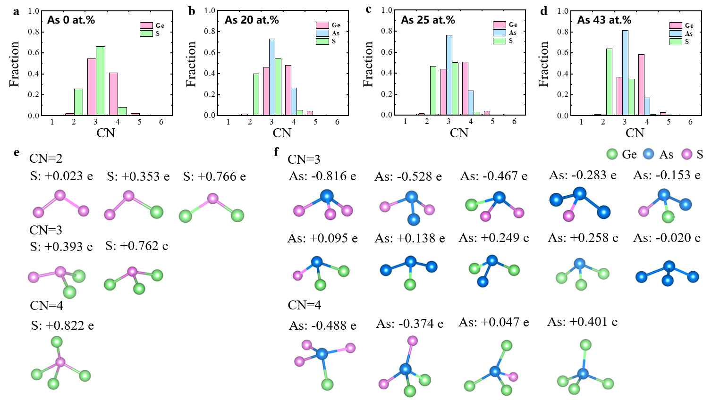
Figure S17 Correlation between the coordination environment and the charge transfer of central S/As atoms. a-d. Coordination numbers (CN) for a-GeS, a-GeAsS₂₀, a-GeAsS₂₅ and a-GeAsS₄₅, respectively. The CNs of Ge/As atoms are concentrated on 3 and 4, and the central S atoms are mainly 2-fold and 3-fold coordinated. e. Various coordination environments of central S atoms with the corresponding values of electron transfer. f. Various coordination environments of central As atoms with the corresponding electron-transfer values.

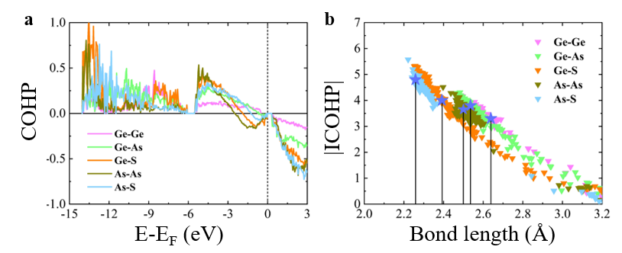
Figure S18 Analysis of bonding properties for the a-GeSAs₄₃ system. a. COHP curves for different bonds in a-GeAsS₄₅. b. The |ICOHP| curves for different bonds with respect to the bond length in a-GeAsS₄₅; the blue stars correspond to the interatomic distances for the first peaks of the PDF, g(r), in Fig 3d, which represents the bond distributions.
The crystal orbital Hamilton populations (COHP) were calculated by the LOBSTER code. Fig. S18a shows the COHP curves for different bonds in the model of a-GeAsS₄₅, in which the COHP values of As-As, As-S and Ge-S interactions are negative below the Fermi level, indicating that those bonds have antibonding-like character. The COHP for As-S is generally larger than for Ge-S, suggesting that As-S bonds are stronger than Ge-S bonds. To describe the strength of chemical bonds more precisely, one can integrate the COHP (i.e. |ICOHP|) below the Fermi level. The bond strengths marked with the blue stars correspond to the interatomic distances of the first peaks of the PDF, g(r), in Fig. 3d. The bond-formation strengths of Ge-Ge, Ge-S, Ge-As, As-As and As-S bonds are calculated to be 3.4 eV, 4 eV, 3.8 eV, 3.65 eV and 4.8 eV, respectively. That is to say, As-S bonds are stronger than Ge-S bonds, thus accounting for the >100 ℃ increase in the crystallization temperature upon As incorporation.

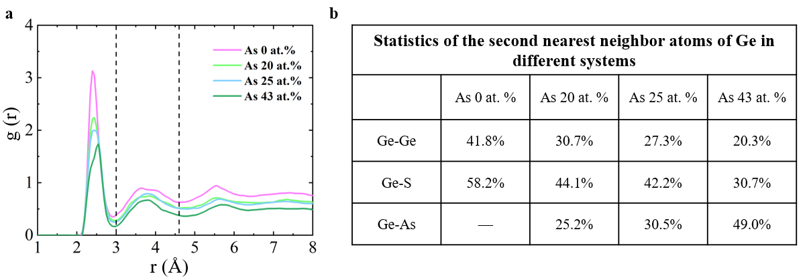
Figure S19 a. The partial PDF, g(r) centred on Ge for a-GeS, a-GeSAs₂₀, a-GeSAs₂₅ and a-GeSAs₄₃ systems. The first peaks and the second peaks represent the separation between nearest-neighbor atoms and between second nearest-neighbor atoms, respectively, from which one can identify that the second nearest-neighbor atomic separation lies between 3.0 and 4.6 Å (dashed lines). The second nearest-neighbor coordination number of Ge atoms can be obtained by integrating g(r) of Ge-Ge, Ge-S and Ge-As correlations between these distances in Fig 3d. b. Statistics of the second nearest-neighbor atoms of Ge in different systems. For the second nearest-neighbor atoms of Ge, the fractions of Ge-Ge and Ge-S bonds decreases and the fraction of Ge-As bonds increases.

Figure S20 The electrical conductivity activation energy can be drawn from the Arrhenius equation: σ = σ₀exp(-E_{a}/k_{B}T). E_{a} is the activation energy for electrical conduction. k_{B} is the Boltzmann constant and T is the absolute temperature. The value increases from 0.79 to 0.93 eV, then drops to 0.8 eV, and ends up at 0.76 eV with increasing As content, which is consistent with the variations of I_{off} and the bandgap.
Figure S21 a. Fluorinert FC43 was used for a previous PDS experiment¹⁶, whereas carbon tetrachloride was used in this work. FTIR results for FC43 and carbon tetrachloride for an optical path length of 10 mm are shown. The PDS in this region is subject to the absorption of the deflection medium. Below 0.33 eV, FC43 does not transmit light. There is a region where the transmittance is low, even at 0.33 eV or more. Carbon tetrachloride, on the other hand, has a transmittance of about 80% in most regions above 0.3 eV. b. As shown by the vertical lines, there is a good agreement between the absorption position of FC43 and the peak position of the PDS spectrum. c. It can be seen that carbon tetrachloride has almost no effect in the high-transmittance region. Absorption around 0.29 eV for carbon tetrachloride affects the spectrum. Therefore, it is concluded that the absorption of the deflection medium is superimposed on the PDS spectrum in the region where the transmittance of the deflection medium is 20% or less. From these results, carbon tetrachloride is suitable for evaluating the trap levels of GeSAs.

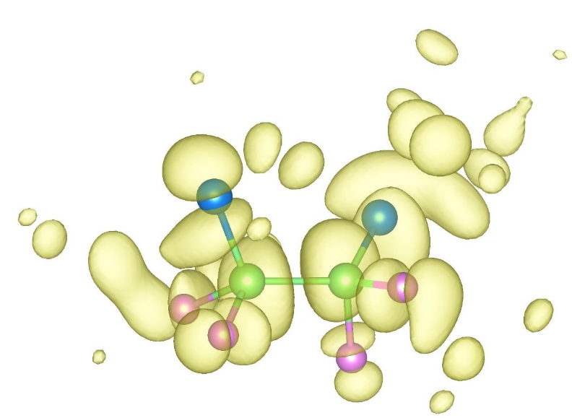
Figure S22 The atomic configuration corresponding to the gap state near the conduction-band edge with a large IPR value in a-GeSAs20, in which the Ge-Ge bonds also exist but they obey the "8-N" rule, unlike the trap states.

References
1. Ambrosi, E. et al. Low variability high endurance and low voltage arsenic-free selectors based on GeCTe. in 2021 IEEE International Electron Devices Meeting (IEDM) 28.5.1-28.5.4 (IEEE, 2021).
2. Kim, S. et al. Performance of threshold switching in chalcogenide glass for 3D stackable selector. in 2013 Symposium on VLSI Technology T240–T241 (IEEE, 2013).
3. Govoreanu, B. et al. Thermally stable integrated Se-based OTS selectors with >20 MA/cm 2 current drive, >3.10 3 half-bias nonlinearity, tunable threshold voltage and excellent endurance. in 2017 Symposium on VLSI Technology vol. 21 T92–T93 (IEEE, 2017).
4. Cheng, H. Y. et al. An ultra high endurance and thermally stable selector based on TeAsGeSiSe chalcogenides compatible with BEOL IC Integration for cross-point PCM. in 2017 IEEE International Electron Devices Meeting (IEDM) vol. 1 2.2.1-2.2.4 (IEEE, 2017).
5. Verdy, A. et al. High Temperature Stability and Performance Analysis of N-doped Ge-Se-Sb Based OTS Selector Devices. in 2018 IEEE International Memory Workshop (IMW) 1–4 (IEEE, 2018).
6. Chekol, S. A. et al. A C–Te-based binary OTS device exhibiting excellent performance and high thermal stability for selector application. Nanotechnology 29, 345202 (2018).
7. Yoo, J., Lee, D., Park, J., Song, J. & Hwang, H. Steep Slope Field-Effect Transistors with B-Te-Based Ovonic Threshold Switch Device. IEEE J. Electron Devices Soc. 6, 821–824 (2018).
8. Avasarala, N. S. et al. Half-threshold bias I_{off} reduction down to nA range of thermally and electrically stable high-performance integrated OTS selector, obtained by Se enrichment and N-doping of thin GeSe layers. in 2018 IEEE Symposium on VLSI Technology vols 2018-June 209–210 (IEEE, 2018).
9. Jia, S., Li, H., Liu, Q., Song, Z. & Zhu, M. Scalability of Sulfur‐Based Ovonic Threshold Selectors for 3D Stackable Memory Applications. Phys. status solidi – Rapid Res. Lett. 15, 2100084 (2021).
10. Li, X., Yuan, Z., Lv, S., Song, S. & Song, Z. Extended endurance performance and reduced threshold voltage by doping Si in GeSe-based ovonic threshold switching selectors. Thin Solid Films 734, 1–9 (2021).
11. Anbarasu, M., Wimmer, M., Bruns, G., Salinga, M. & Wuttig, M. Nanosecond threshold switching of GeTe₆ cells and their potential as selector devices. Appl. Phys. Lett. 100, 143505 (2012).
12. Cheng, H. Y. et al. Ultra-High Endurance and Low I_{OFF} Selector based on AsSeGe Chalcogenides for Wide Memory Window 3D Stackable Crosspoint Memory. in 2018 IEEE International Electron Devices Meeting (IEDM) vols 2018-Decem 37.3.1-37.3.4 (IEEE, 2018).
13. Cyrille, M. C. et al. OTS selector devices: Material engineering for switching performance. in 2018 International Conference on IC Design & Technology (ICICDT) 113–116 (IEEE, 2018).
14. Kim, M. et al. PE-ALD of Ge_{1−x}S_{x} amorphous chalcogenide alloys for OTS applications. J. Mater. Chem. C 9, 6006–6013 (2021).
15. Koo, Y., Lee, S., Park, S., Yang, M. & Hwang, H. Simple Binary Ovonic Threshold Switching Material SiTe and Its Excellent Selector Performance for High-Density Memory Array Application. IEEE Electron Device Lett. 38, 568–571 (2017).
16. Jia, S. et al. Ultrahigh drive current and large selectivity in GeS selector. Nat. Commun. 11, 4636 (2020).

