Contents

Supplementary Materials…………………………………………………………………………2
Supplementary Figures……………………………………………………………………………4

Supplementary Materials

Ethics Committees of 12 hospitals：
PLA General Hospital
Cancer Hospital Chinese Academy of Medical Sciences
The First Bethune Hopsital of Jilin University
Fujian Provincial Hospital
The First Affiliated Hospital of Guangxi Medical University
The Second Affiliated Hospital of Guangxi Medical University
Guangxi Tumour Hospital
Xijing Hospital
Sichuan Cancer Hospital
The First Affiliated Hospital, College of Medicine, Zhejiang University
The Second Affiliated Hospital, College of Medicine, Zhejiang University
The Third Affiliated Hospital of Sun Yat-sen University

Definition:
Charlson comorbidity index (CCI):
Record patient’s comorbidities and calculate CCI according to the following figure:
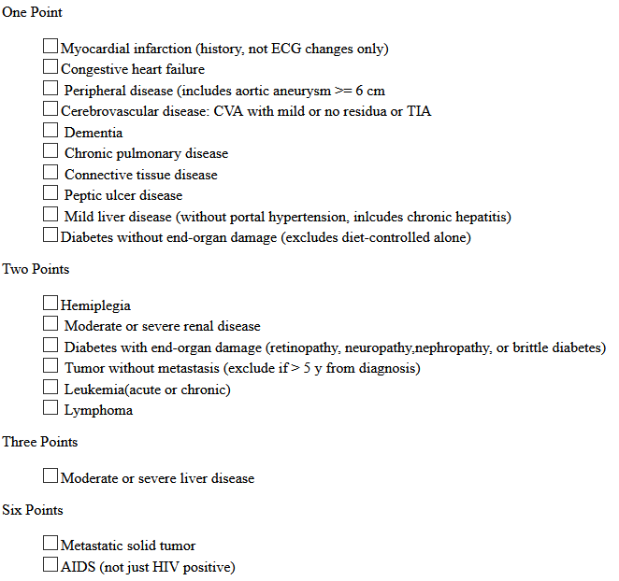
To prevent strong collinearity with Age, we use the non-age-adjusted CCI.

Liver cirrhosis：
In order to ensure the feasibility of the model, the diagnosis of liver cirrhosis was made before treatment by ultrasound, CT, or MRI, not by histological biopsy. Because the model could only use preoperative textual information, histological biopsy results cannot be used as an available factor.

Therapy process
LH protocol:
For LH group, multiple senior physicians analyzed preoperative imaging to determine tumor size, location, and surrounding structure. LH was performed by surgeons with more than 8 years of ablation experience. Surgical method and resection range were determined by surgeon according to tumor location and tumor size, location, and surrounding structure.
Surgery was performed by experienced surgeons with 10-15 years of experience in hepatic resection and more than 5 years of laparoscopic experience. All procedures were performed with the patients in a supine position under general anesthesia. LH was completed through the umbilical port. Pneumoperitoneum at 10e12mmHgwas first established using the Verres needle, and the abdomen was then punctured with trocars under direct vision. The primary and secondary incisions were made according to the location of the tumor. Intraoperative ultrasound was routinely used to evaluate the tumor burden, the liver remnant, and the possibility of a negative resection margin laparoscopically. The type of hepatectomy was defined according to established guidelines

MWA protocol:
For MWA group, multiple senior physicians analyzed preoperative imaging to determine tumor size, location, and surrounding structure, and negotiated ablation strategies. MWA was performed by physicians with more than 10 years of ablation experience. All MWA were performed under ultrasound or CEUS guidance. Contrast-enhanced CT or contrast-enhanced CT MRI was used to evaluate treatment effect within 1-3 days after MWA, and to ensure that an ablative margin of at least 5 mm of healthy liver tissue surrounding the tumor. If there is tumor residue or insufficient ablative margin, supplementary ablation should be performed immediately, and the patient can be included in this study after supplementary ablation.
All patients need to undergo histological biopsy before MWA. Puncture point was selected by ultrasound or contrast-enhanced ultrasound. A 17-gauge guide needle reached the leading edge of the lesion under ultrasound guidance, then the needle core was pulled out. The 18-gauge biopsy needle entered the lesion along guide needle, and 3-5 pieces of tissue were taken out for pathological examination.
A cooled-shaft MW system with a 15-gauge, 18 cm-long cooled-shaft antenna was used in our study. The MWA was performed by doctors with at least 3 years of experience in hepatic MWA. All MWA procedures were performed percutaneously under general anesthesia and real-time ultrasound guidance. The microwave energy application was set at 40–60W for 4–10 min in a session. The region of ablation was monitored by real-time US monitoring. MWA emission was stopped when the hyperechoic zone covered the entire tumor including a safety margin. The ablation therapy included an ablative margin of healthy tissue of at least 5mm surrounding the tumor. For patients with tumors adjacent to the critical organs, an ablation margin of less than 5mm or conformal ablation was achieved with the assistance of a temperature monitor, artificial pleural effusion or ascites.

Supplementary Figures
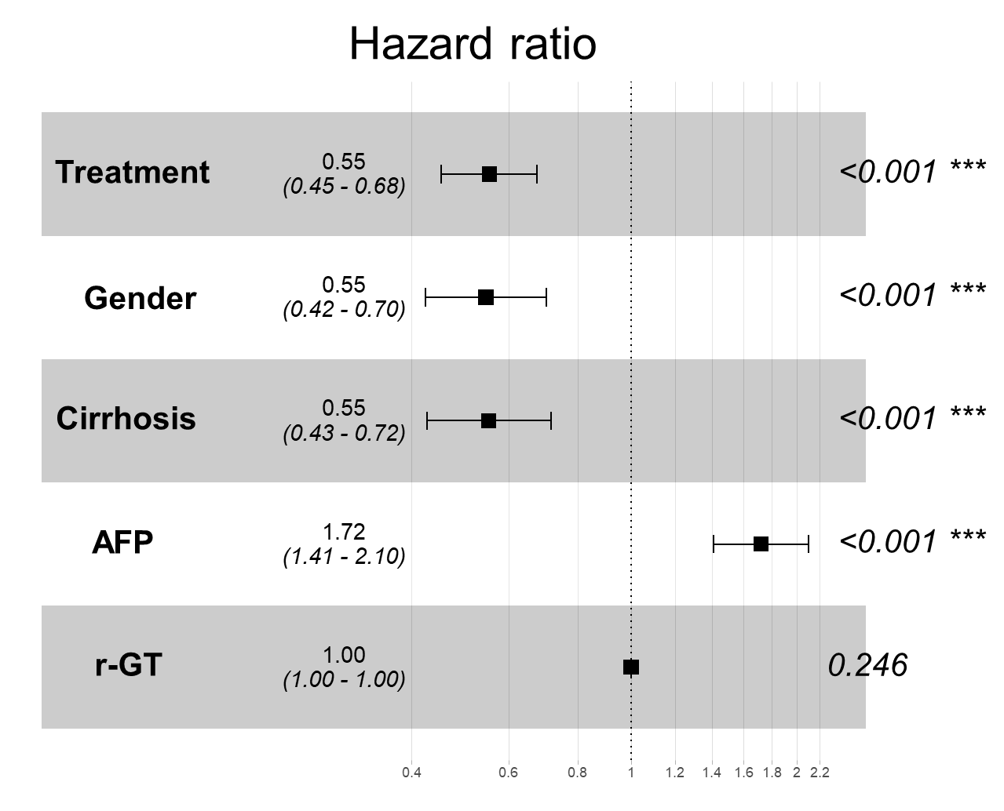
Supplementary Figure 1: The forest plot of cox multivariate analysis

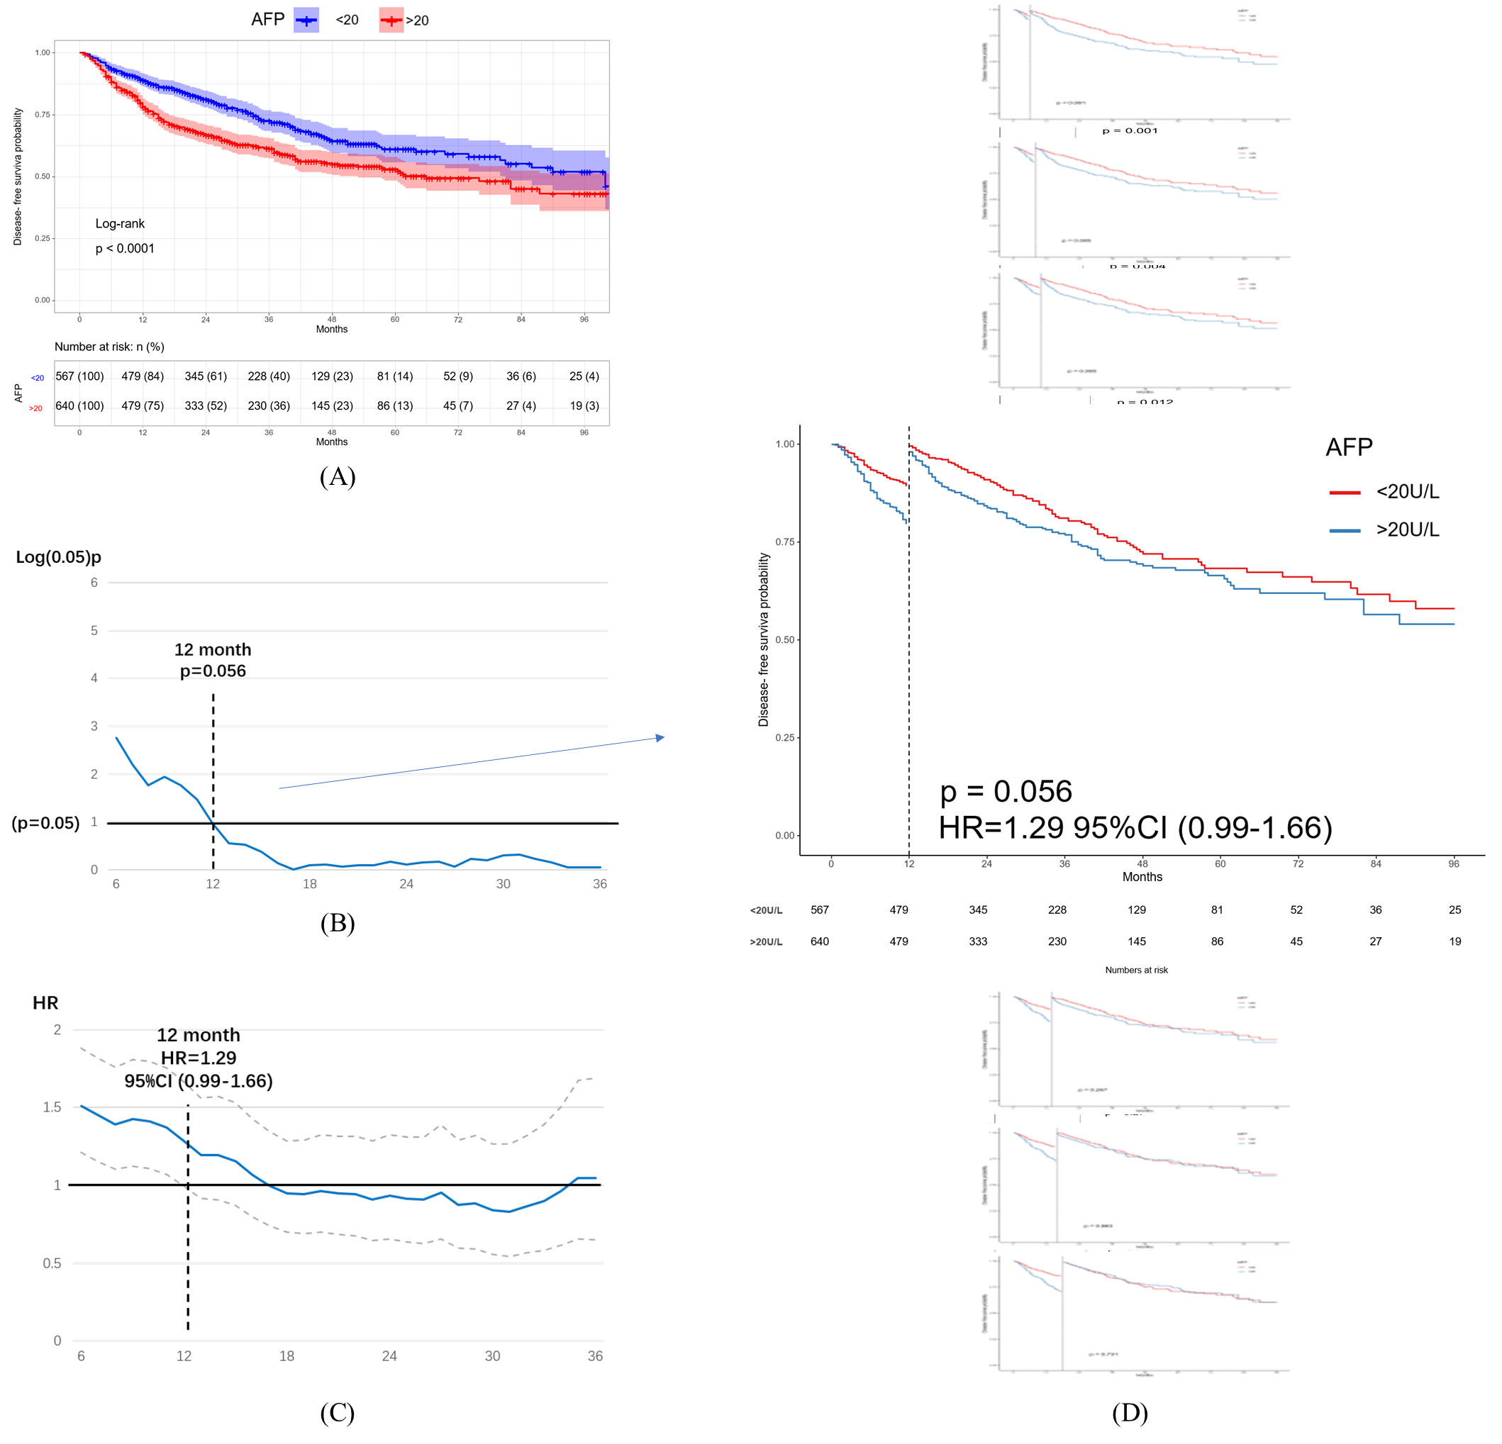
Supplementary Figure 2: (A) Kaplan-Meier curve for DFS between AFP≤20U/L and AFP＞20U/L; (B) The change of p value over time from 6th month to 36th month after treatment; (C) The change of HR over time from 6th month to 36th month after treatment; (D) AFP did not have significant influence on intrahepatic recurrence of HCC since 12th month.

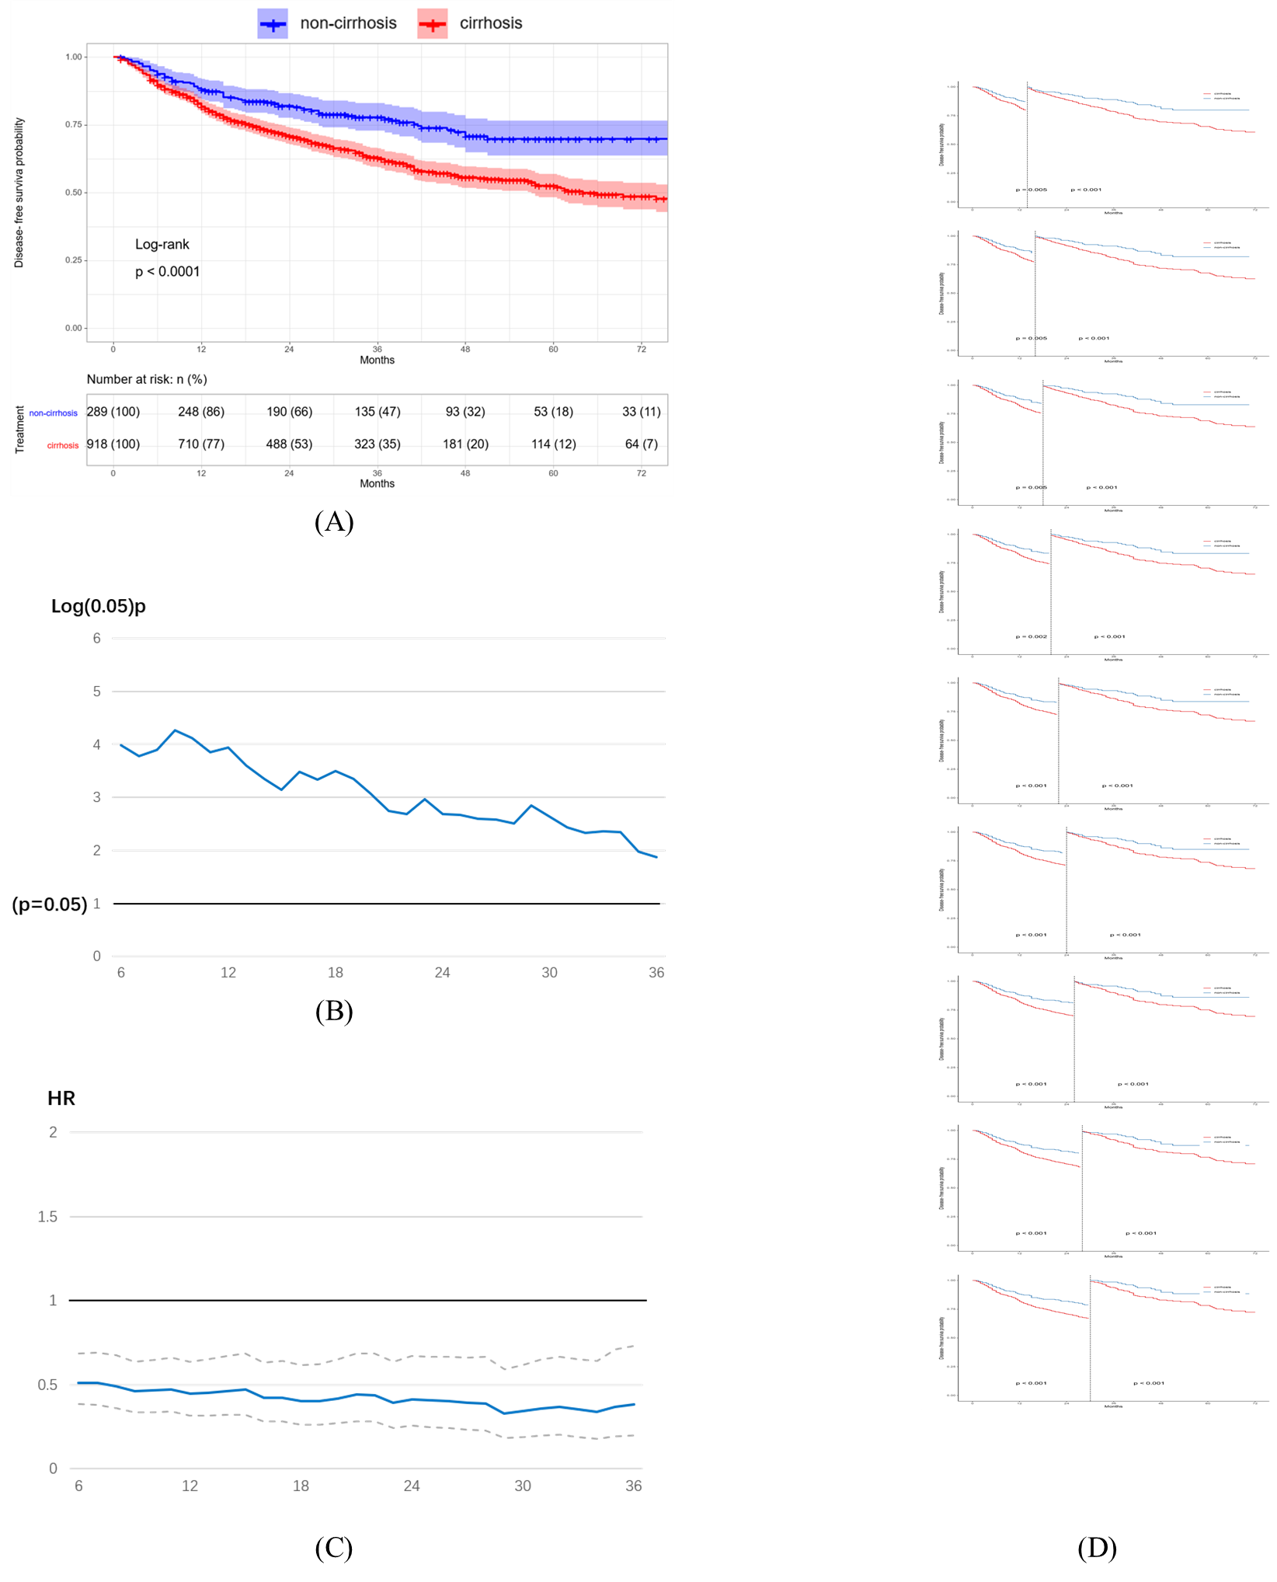
Supplementary Figure 3: (A) Kaplan-Meier curve for DFS between non-cirrhosis and cirrhosis; (B) The change of p value over time from 6th month to 36th month after treatment; (C) The change of HR over time from 6th month to 36th month after treatment; (D) Cirrhosis had a long-term influence on intrahepatic recurrence of HCC.

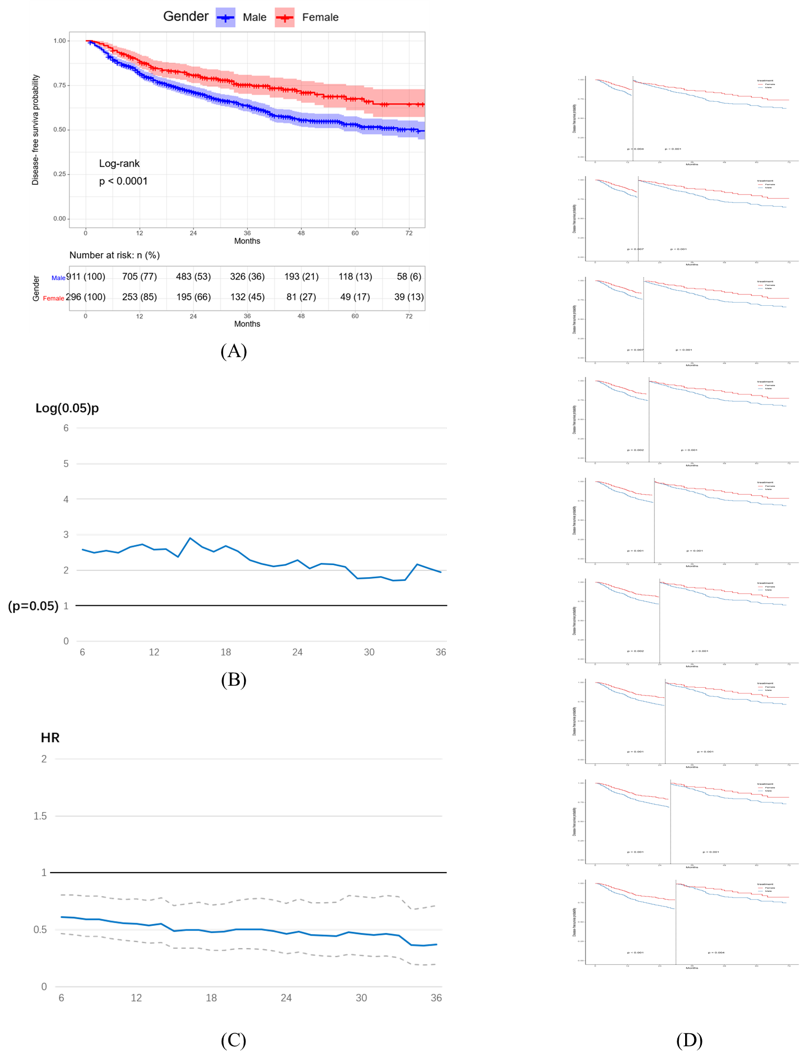
Supplementary Figure 4: (A) Kaplan-Meier curve for DFS between different gender; (B) The change of p value over time from 6th month to 36th month after treatment; (C) The change of HR over time from 6th month to 36th month after treatment; (D) Gender had a long-term influence on intrahepatic recurrence of HCC.

