Supplemental:

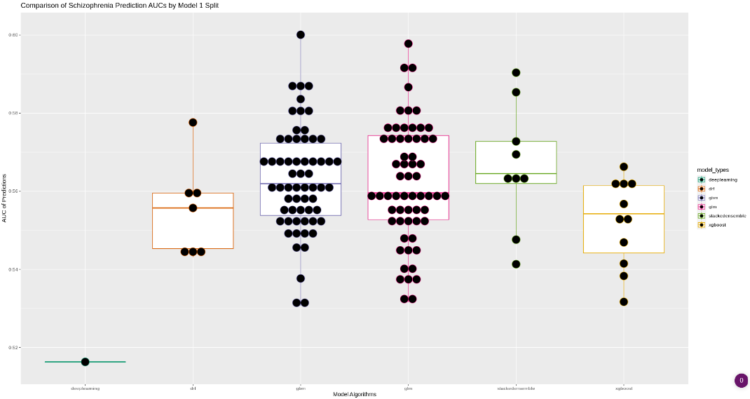
Supplemental A. This plot represents the average performance of 150 models for each split type for a total of 450 models.

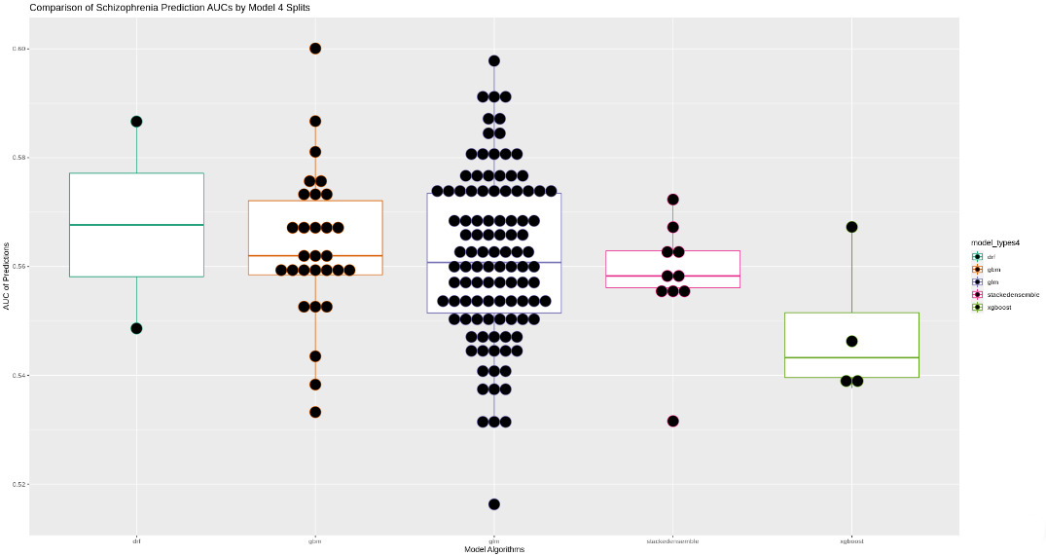
Supplemental B. This plot represents the average performance of 150 models for each split type for a total of 450 models.

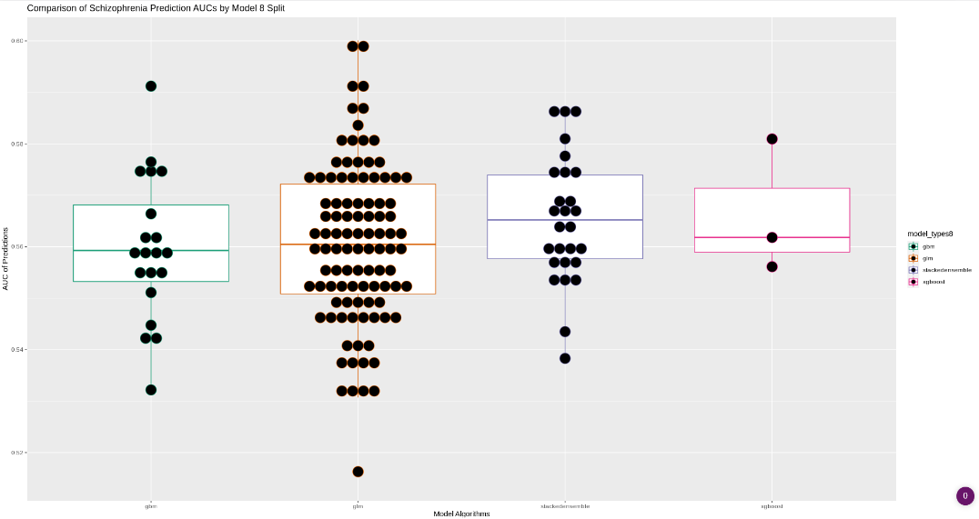
Supplemental C. This plot represents the average performance of 150 models for each split type for a total of 450 models.

