Supporting Information
Flexible Phase Change Materials for Overheating Protection of Electronics
Chang-Ping Feng¹, Xiao Guan⁴, Meng Shi², Fang Wei*³, Hong-Bo Lan¹, Wei Yang*²

¹Shandong Engineering Research Center for Additive Manufacturing, Qingdao University of Technology
Qingdao 266520, Shandong, People’s Republic of China.
²College of Polymer Science and Engineering, Sichuan University, State Key Laboratory of Polymer Materials Engineering, Chengdu, 610065, Sichuan, People’s Republic of China.
³Group of Biomimetic Smart Materials, Qingdao Institute of Bioenergy and Bioprocess Technology, Chinese Academy of Sciences, Qingdao 266101, Shandong, People’s Republic of China.
⁴School of Materials Science and Engineering, Qilu University of Technology, Jinan 250353, Shandong, People’s Republic of China.

Results and discussion

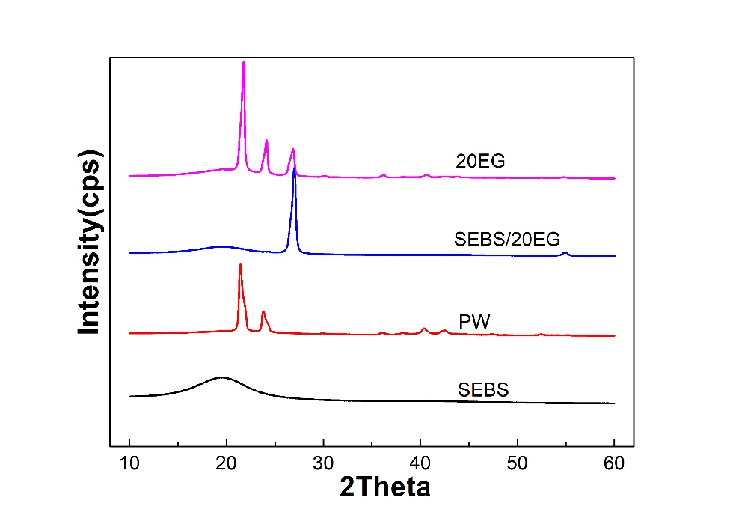
Fig. S1. XRD patterns of the as-fabricated samples
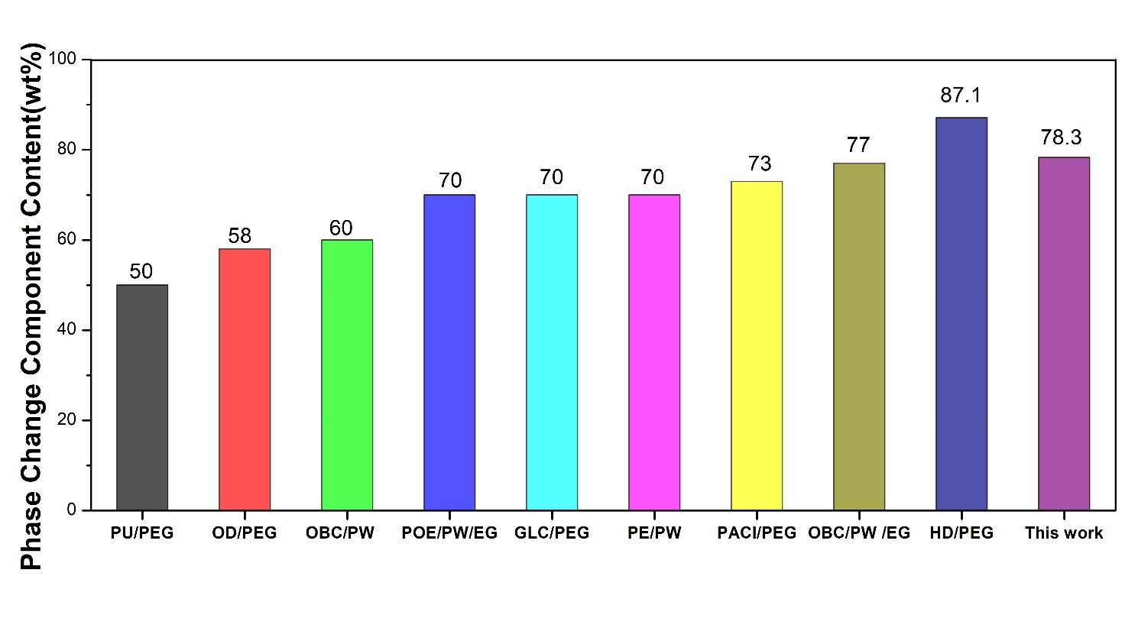
Fig. S2. The summary of phase change component content of reported flexible composite PCMs. (Octadecanol (OD)/PEG[1],OBC/PW[2], PW/polyolefin elastomer (POE)/EG[3], Olefin block copolymer (OBC)/PW /EG[4] , Polyurethane/PEG[5], Glucose(PLC)/PEG[6], Polyethylene(PE)/PW[7], Poly(acrylonitrile-co-itaconate)(PACI)/PEG[8], Hexamethylene diisocyanate(HD)/PEG[9]).

References
[1] B. Oktay, N. Kayaman‐Apohan (2021) Biodegradable Polyurethane Solid‐Solid Phase Change Materials. ChemistrySelect 6: 6280-6285
[2] X.-d. Qi, Y.-w. Shao, H.-y. Wu, J.-h. Yang, Y. Wang (2019) Flexible phase change composite materials with simultaneous light energy storage and light-actuated shape memory capability. Composites Science and Technology 181: 107714
[3] X. Zou, J. Liu (2020) Polyoxyethylene based phase change materials with enhanced mechanical property, thermal conductivity and photo-thermal energy charging capacity. Energy Reports 6: 2948-2955
[4] X. Lin, X. Zhang, J. Ji, L. Liu, Y. Wu, M. Yang, D. Lu, H. Zheng (2021) Development of flexible form-stable phase change material with enhanced electrical resistance for thermal management. Journal of Cleaner Production 311: 127517
[5] W. Kong, Y. Lei, Y. Jiang, J. Lei (2017) Preparation and thermal performance of polyurethane/PEG as novel form-stable phase change materials for thermal energy storage. Journal of Thermal Analysis and Calorimetry 130: 1011-1019
[6] M.M. Umair, Y. Zhang, K. Iqbal, S. Zhang, B. Tang (2019) Novel strategies and supporting materials applied to shape-stabilize organic phase change materials for thermal energy storage–A review. Applied Energy 235: 846-873
[7] F. Chen, M. Wolcott (2015) Polyethylene/paraffin binary composites for phase change material energy storage in building: A morphology, thermal properties, and paraffin leakage study. Solar Energy Materials and Solar Cells 137: 79-85
[8] S. Mu, J. Guo, Y. Yu, Q. An, S. Zhang, D. Wang, S. Chen, X. Huang, S. Li (2016) Synthesis and thermal properties of cross-linked poly(acrylonitrile-co-itaconate)/polyethylene glycol as novel form-stable change material. Energy Conversion and Management 110: 176-183
[9] X. Lu, C. Fang, X. Sheng, L. Zhang, J. Qu (2019) One-Step and Solvent-Free Synthesis of Polyethylene Glycol-Based Polyurethane As Solid–Solid Phase Change Materials for Solar Thermal Energy Storage. Industrial & Engineering Chemistry Research 58: 3024-3032

