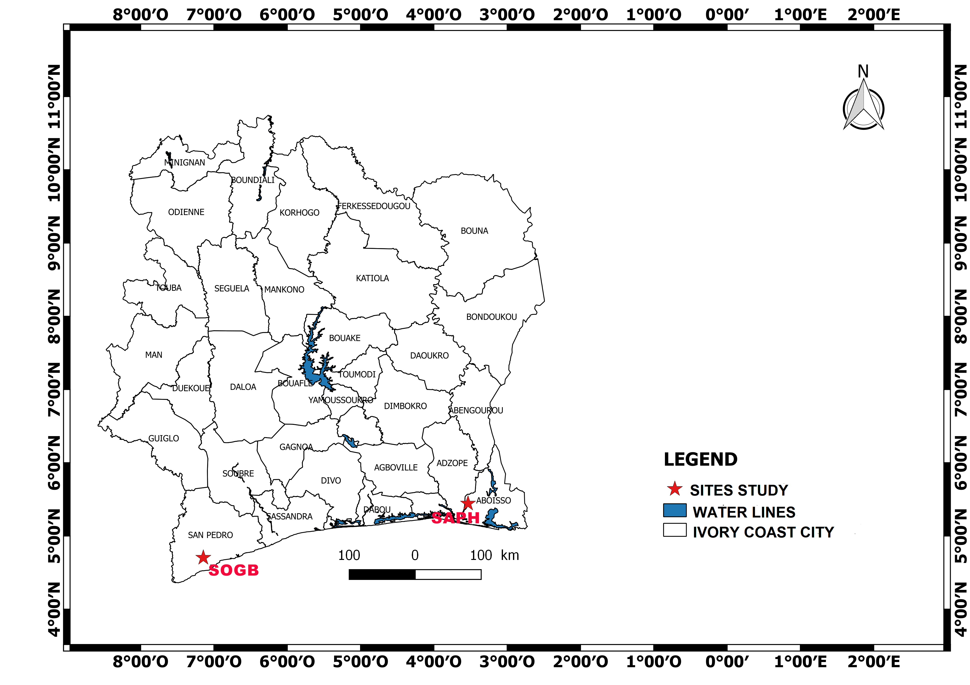
Fig. S1: Map of the geographical location of the two study sites.

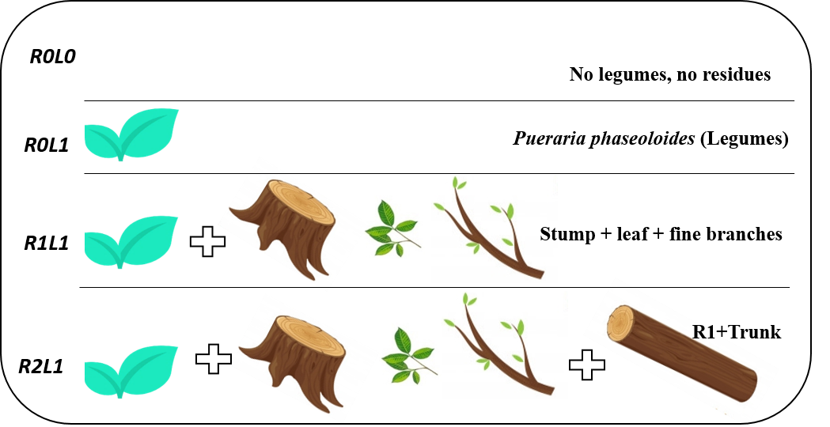
Fig. S2: Practices set up in the experimental design at both sites

Fig. S3: Timeline showing the soil sampling at both sites

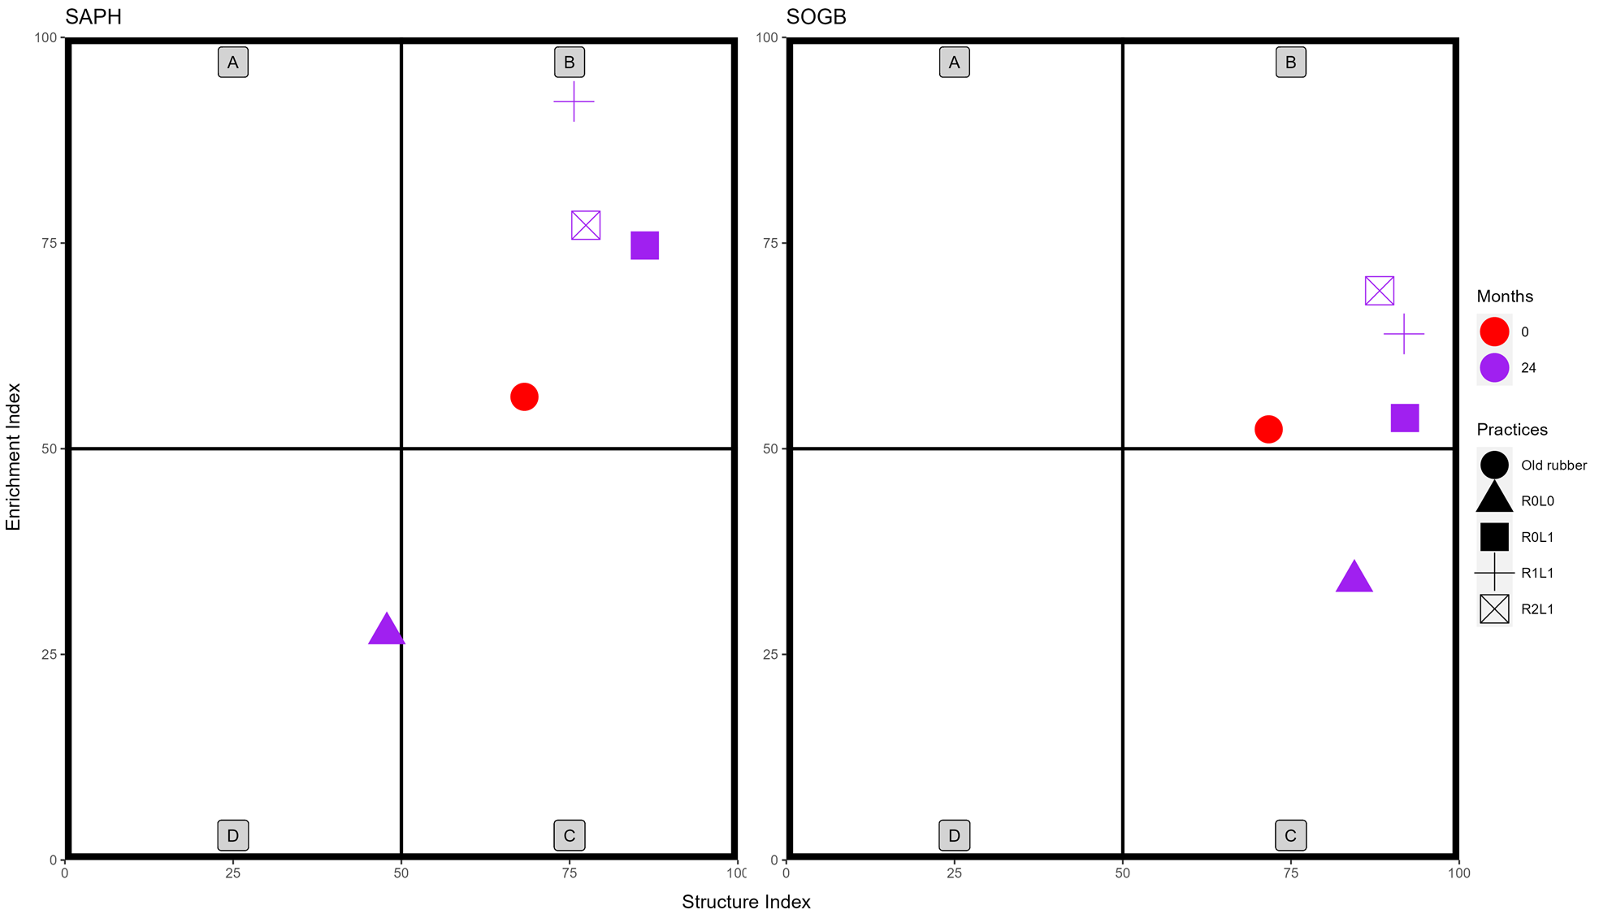
Fig. S4: Influence of practices on nematode soil food web indices according to sites between 0 and 24 months. Quadrats refer to faunal profiles A, B, C, and D (Ferris and Bongers 2009). T0 (Before logging), R0L0 no legumes, no logging residues; R0L1 legume (Pueraria phaseoloides), no logging residues; R1L1: logging residues (stump + leaf + fine branches), legumes; R2L1 R1L1+ trunk.

