Supplementary Information for
“Improving the creation of SiV centers in diamond via sub-$μs$ pulsed annealing treatment.”

Yan-Kai Tzeng^{1,†}, Feng Ke^{2,3,†}, Chunjing Jia^{2,†}, Yayuan Liu⁴, Sulgiye Park^{2,3}, Mungo Frost⁵, Xinxin Cai⁶, Wendy L. Mao^{2,3}, Rodney C. Ewing³, Yi Cui⁴, Thomas P. Devereaux^{2,4}, Yu Lin^{2,*}, Steven Chu^{1,7,*}

¹Department of Physics, Stanford University, Stanford, California 94305, USA
²Stanford Institute for Materials and Energy Science, SLAC National Accelerator Laboratory, Menlo Park, California 94025, USA
³Department of Geological Sciences, Stanford University, Stanford, California 94305, USA
⁴Department of Materials Science and Engineering, Stanford University, Stanford, California 94305, USA
⁵SLAC National Accelerator Laboratory, Menlo Park, California 94025, USA
⁶Department of Physics and Astrophysics, University of Rochester, Rochester, New York 14627, USA
⁷Department of Molecular and Cellular Physiology, Stanford University, Stanford, California 94305, USA

*Corresponding author. Email: lyforest@stanford.edu (Y.L.); schu@stanford.edu (S.C.).

Figure S1 | The optical system of laser-heated DAC is included laser heating, laser annealing, and thermometry.

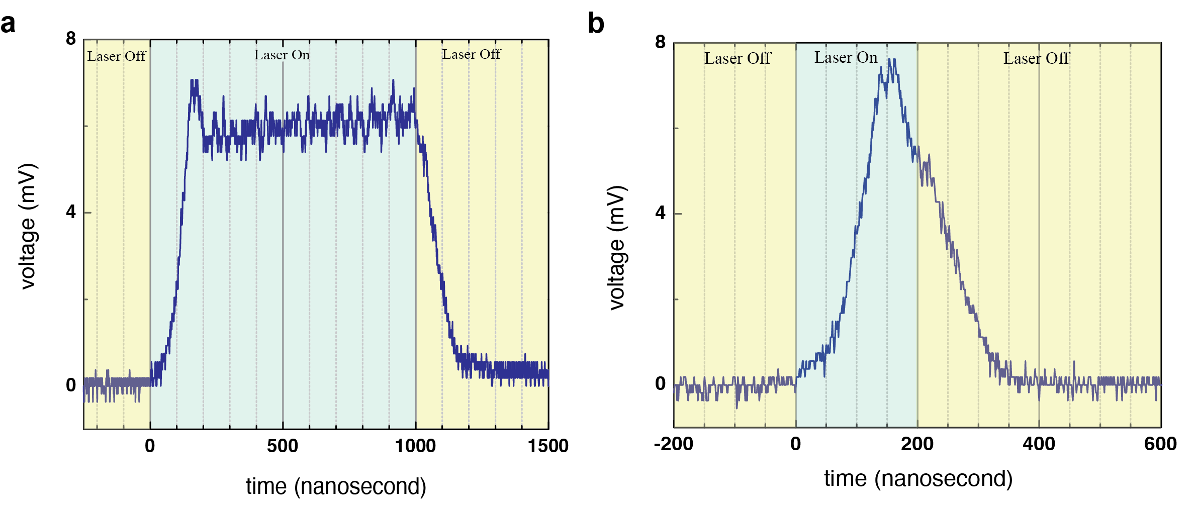

Figure S2 | The rise/fall time of AOM was measured to be ~150 ns. a, The annealing laser was turn on for 1$μs$. b, The annealing laser was turned on for 200 ns.

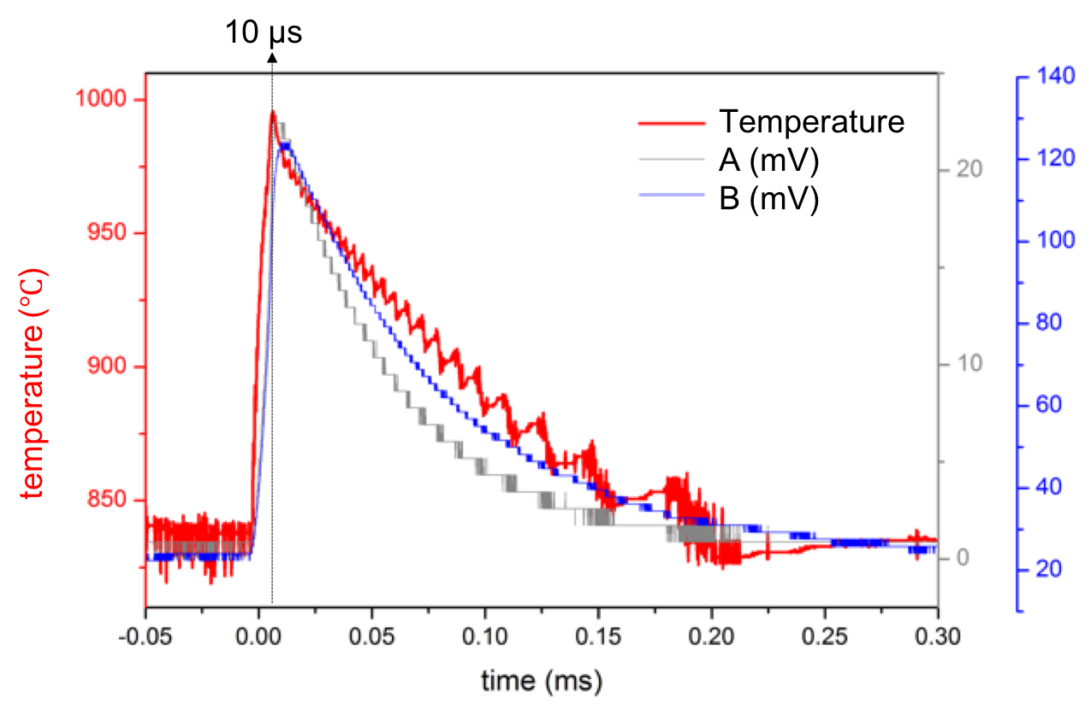

Figure S3 | Temperature changes during the period of the heating and cooling processes recorded by the thermometer. Under our system of laser-heated DAC for $10 μs$, the cooling rate was at 0.1 MK/s and the heating rate was at 0.1 GK/s.
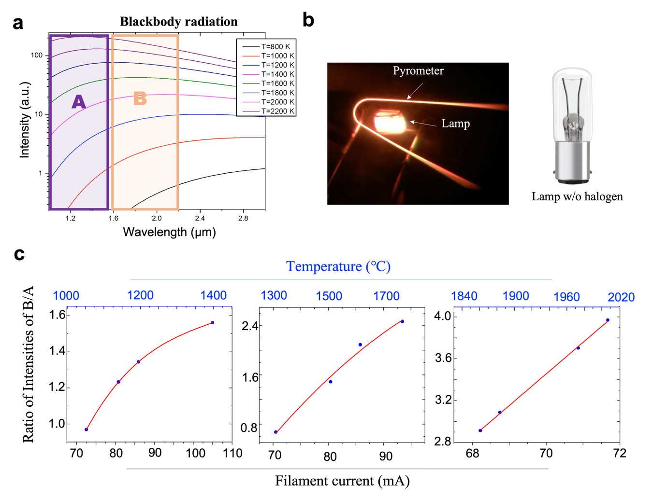

Figure S4 | Temperature calibration. a, The spectrum of blackbody radiation at different temperatures using the PhET Simulation [https://phet.colorado.edu]. Thermometry is based on the ratio of the intensities of two blackbody- radiation bands, A and B, changing from different temperatures. The range of A is at 0.9-1.45 µm and one of B is at 1.55-2.2 µm. b, The photo was taken when both lamps and blackbody pyrometer were working on. c, Three different temperature ranges were calibrated by carefully comparing the brightness between the lamp and the pyrometer. At a certain temperature, the two photodetectors recorded the intensities separately and then the ratio was converted.

Figure S5 | The photodetector (PDA10DT, Thorlabs) for the range of 0.9-1.45 µm was set on the highest gain, 70 dB, and tested against different bandwidths. The bandwidth of 1MHz, the same with the rise time up to 1µs, is the limit of our thermometry.

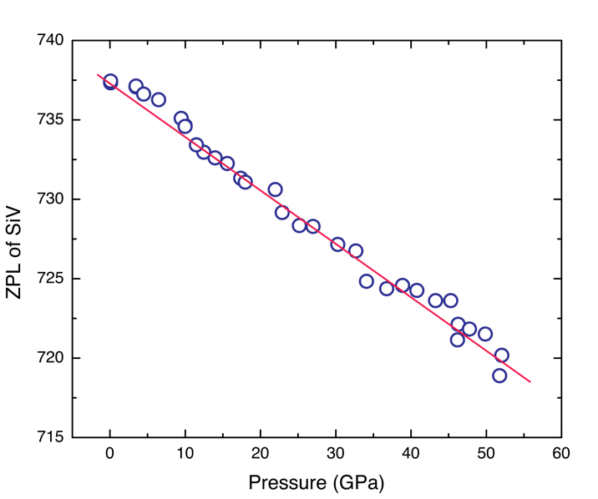

Figure S6 | With increasing pressure, the SiV peak broadened and blue-shifted. The slope is 0.36 nm GPa⁻¹ (0.837 meV GPa⁻¹).

Figure S7 | Low-magnification SEM image of as-synthesized diamond.

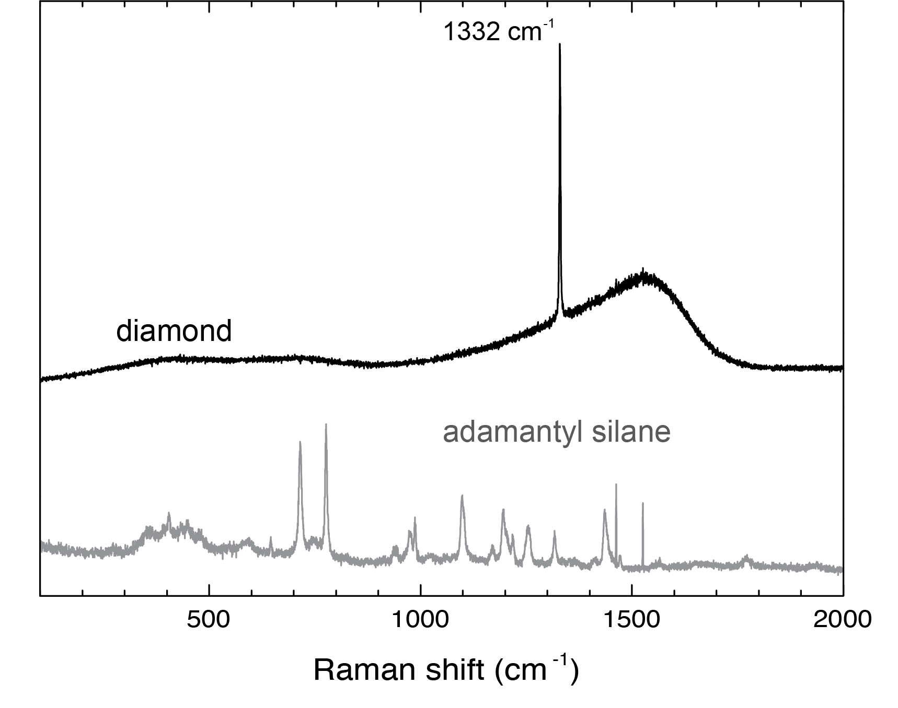
Figure S8 | The Raman spectra show AdaSi before (gray) and after (black) heating at high pressure in a DAC for one millisecond. After the high-pressure high-temperature treatment, the Raman spectrum at 1332 cm⁻¹ can be unambiguously distinguished as the diamond line.

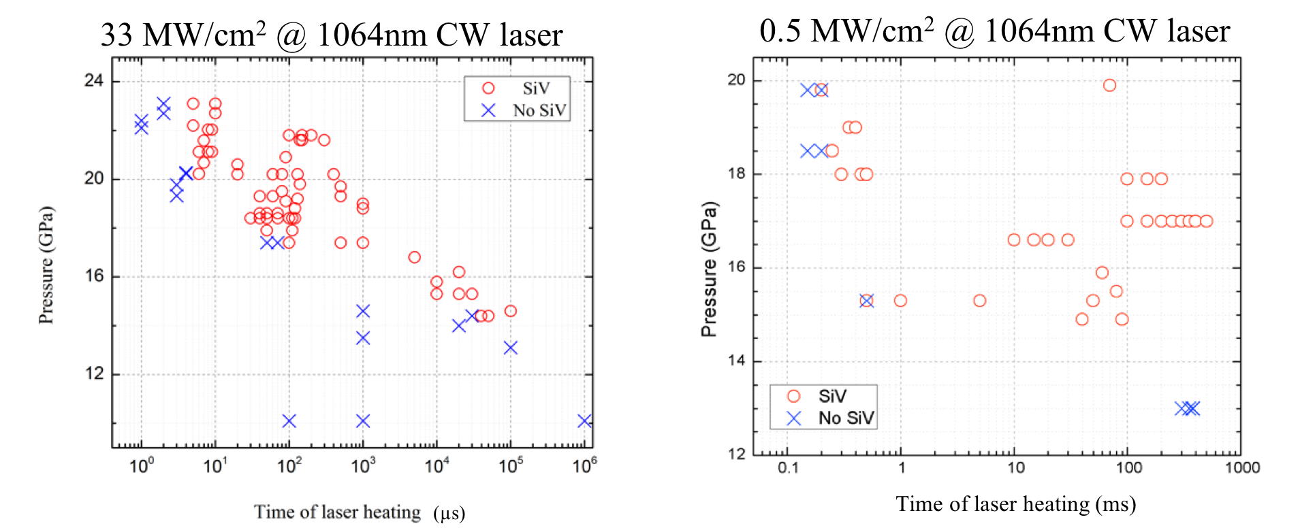
Figure S9 | The formation time of SiV center in diamond with two different laser energies of 33 and 0.5 MW/cm² inside of DAC. Both of them deliver the same magnitude of laser energy, about 0.1 kJ/cm².

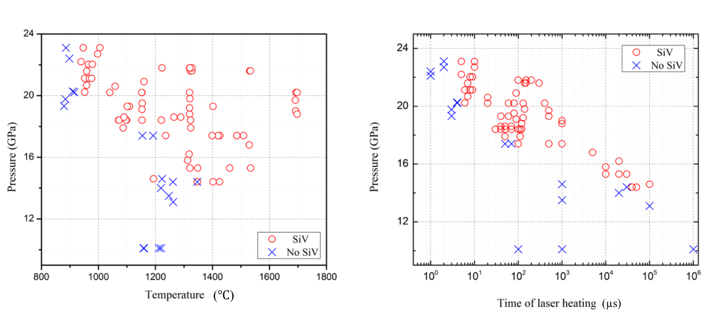
Figure S10 | The comparison of temperature and heating time is taken under the same experimental conditions via AOM-modulated CW laser of 0.26 MW/ cm² with DAC.

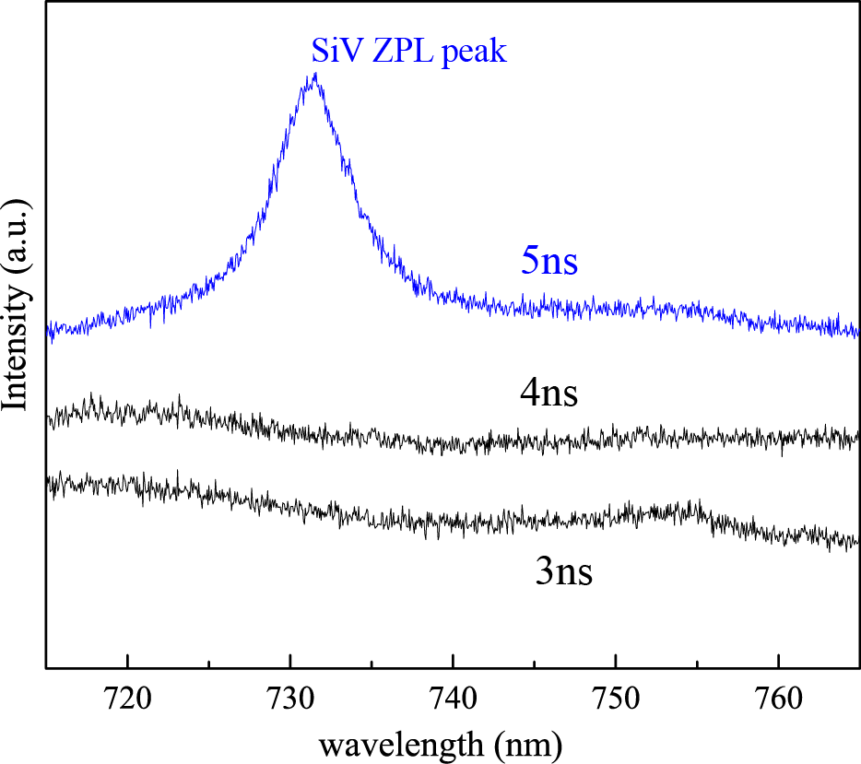

Figure S11 | A comparison between photoluminescence spectra at 3, 4, and 5 nanosecond pulse-width of nanosecond pulsed laser heated on DAC with the pressure of 18.4 GPa. The pulse energy of pulse-width at 5, 4, and 3 nanosecond is 25, 22, and 18 $μJ$, respectively.

Figure S12 | The original result of SiV photoluminescence measurement. Those two data were acquired by the pulsed annealing treatment with 1k Hz pulse repetition frequency, 10 µs pulse-width, at AOM-modulated CW laser of 260 kW/ cm².

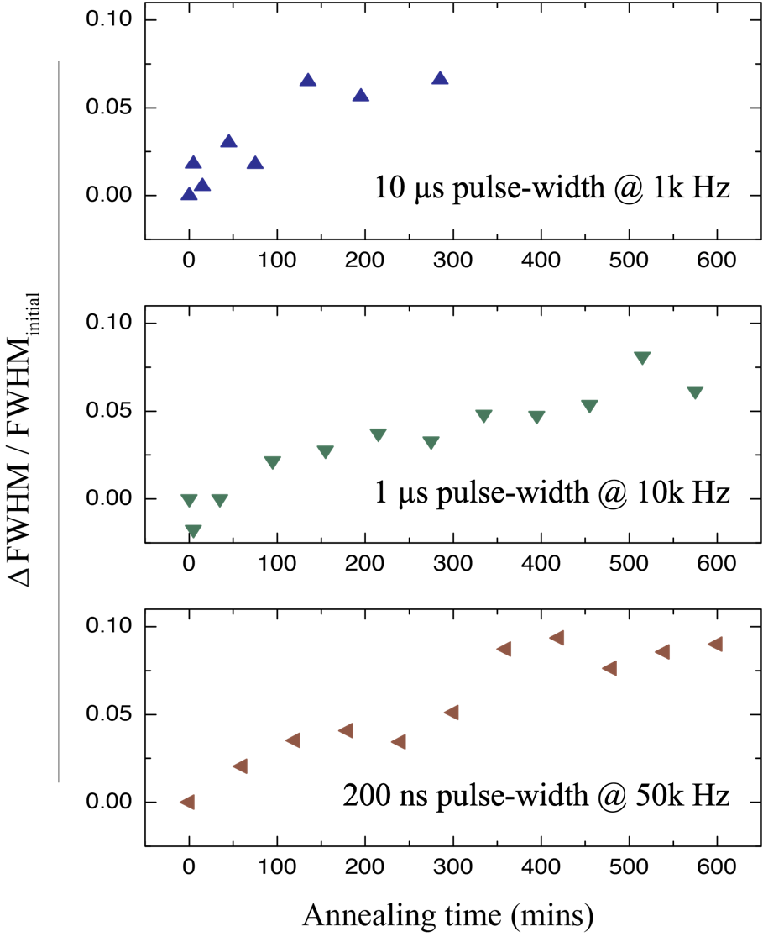

Figure S13 | The reduction of full-width at-half-maximum (FWHM) as the annealing time increased indicated an improvement of the diamond crystal quality under the 1k, 10k, and 50k Hz repetition frequency, 10, 1 $μs$, and 200 ns pulse-width at AOM-modulated CW laser of 260 kW/cm².

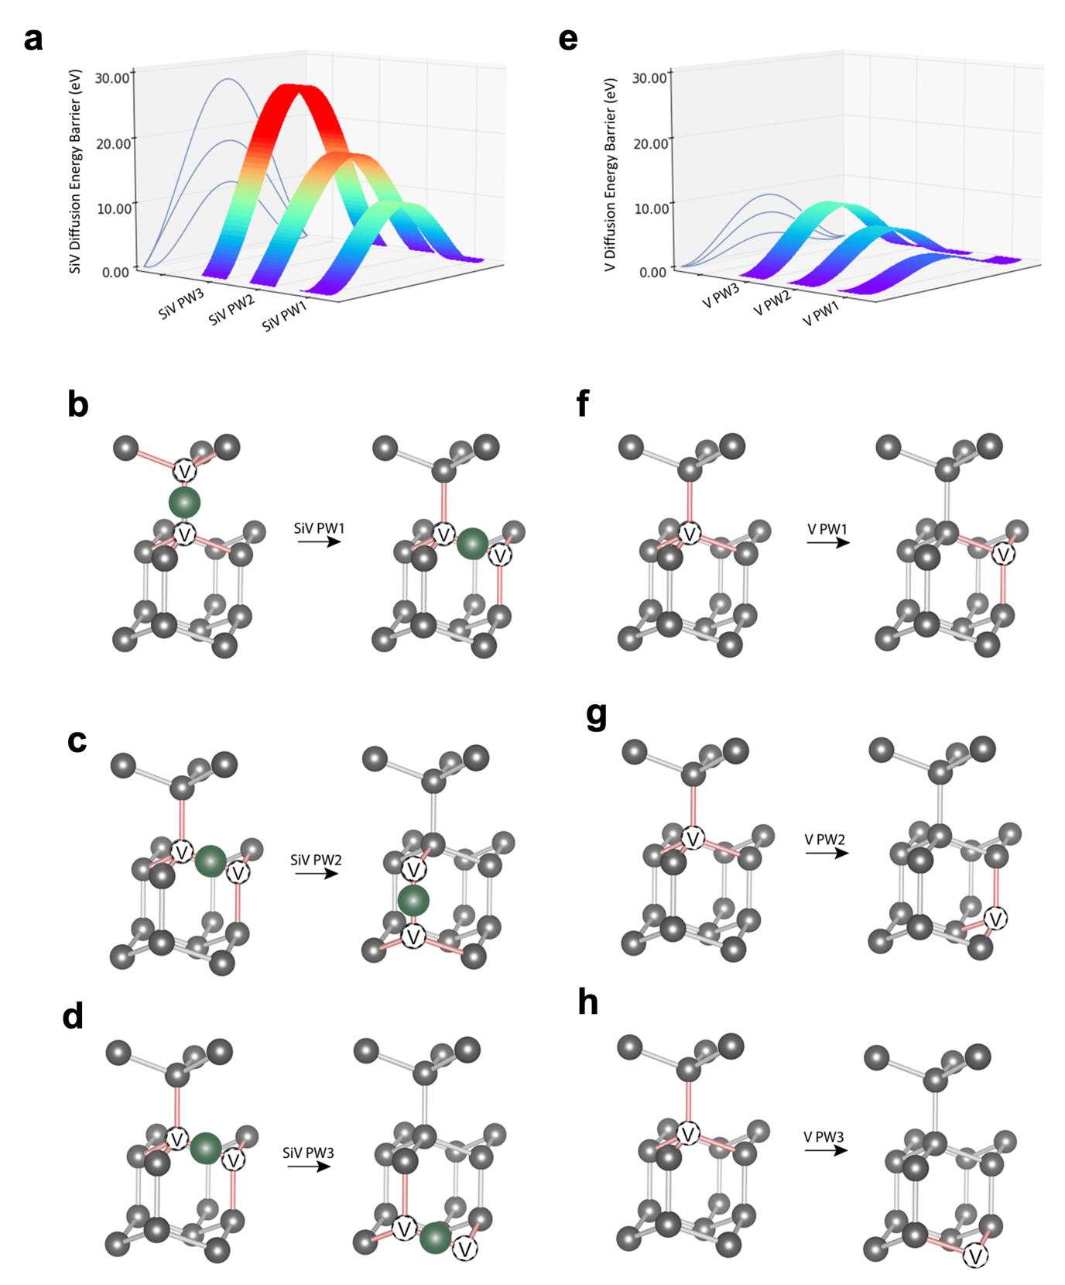

Figure S14 | Calculated energy barriers for different SiV and vacancy diffusion pathways. a, NEB calculated energy barriers for different pathways of SiV diffusion. b-d, Initial and final state configurations for SiV diffusion pathways. e, NEB calculated energy barriers for different pathways of vacancy diffusion. f-h, Initial and final state configurations for vacancy diffusion pathways.

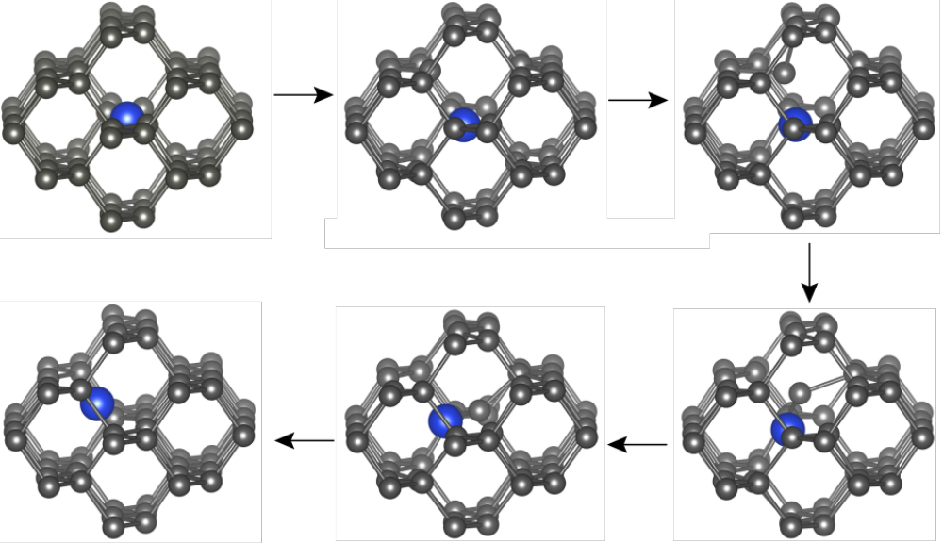
Figure S15 | Initial state, four intermediate transition states and final state configurations in Si-V diffusion pathway PW1. The upper left and lower left panels show the initial state and final state configurations respectively. The remaining panels show the intermediate transition state configurations. These states were calculated using nudged elastic band (NEB) method (with four intermediate states) as implemented in VASP.

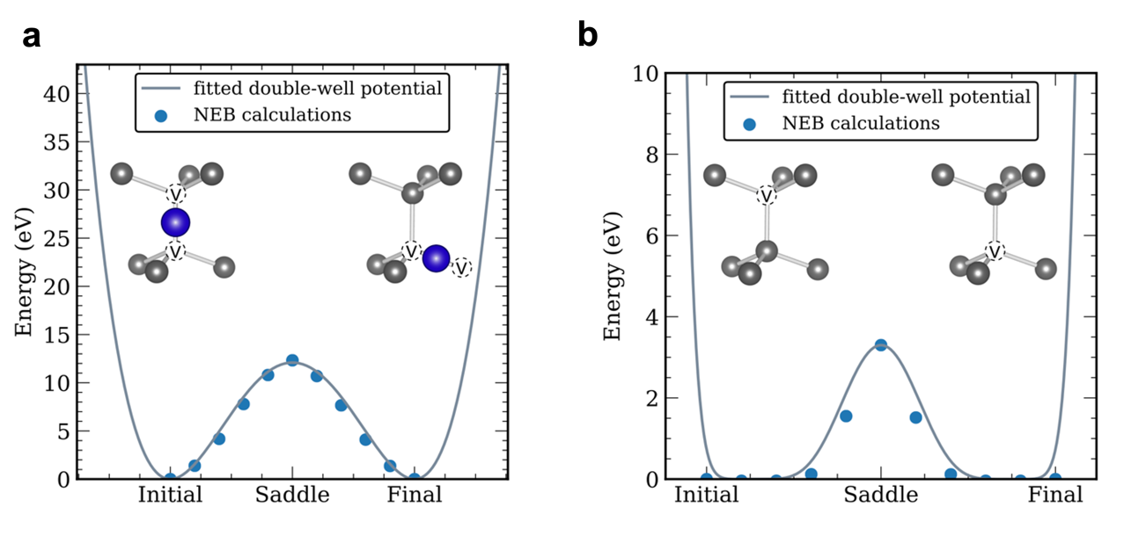
Figure S16 | NEB calculations of the energy barrier with 9 image states for a, SiV and b, vacancy nearest-neighbor diffusion pathways.

Table S1 | Experimental comparison of laser energy delivery to form SiV in diamond via laser-heated DAC.

Method | Laser power | Beam size (FWHM) | Pulse-width | Energy delivery
AOM-modulated  CW laser | 0.5 MW/cm² | 21.5 $μm$ | 200 $μs$ | 0.10 kJ/cm²
AOM-modulated  CW laser | 33 MW/cm² | 2.5 $μm$ | 5 $μs$ | 0.165 kJ/cm²
ns pulse laser | 25 $μJ$ | 5 $μm$ | 5 $ns$ | 0.176 kJ/cm²

