 | Beslin jeo currently working as assistant professor in ECE department, Hindustan University. He has more than 8 years of experience in teaching and research filed. He is an active member of ACM and his research interests are IoT, Antenna design, image processing, smart things. He is pursuing research in Hindustan University in the field of image processing in smart care things.
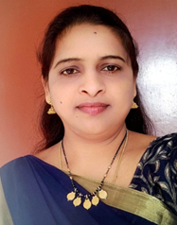 | Madhavi Latha Pandala, is working as an Assistant Professor in the Department of Information Technology, V R Siddhartha Engineering College,Vijayawada,Andhra Pradesh. She has more than fourteen years of experience in Teaching Engineering and Technology. She is pursuing her PhD in VIT,Bhopal.Her areas of interest is Data Mining, Data Science, Artificial Intelligence, Machine Learning and Deep Learning.Moreover, she has published more number of papers in International Journal and International Conference related to data mining and data science
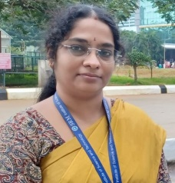 | N.Meenakshi Currently working as Assistant professor in the department of Computational intelligence, SRMIST, Chennai. she has completed his Ph.D, in Computer Science & Engineering in 2019 from Manonmaniam Sundaranar University (MSU) Tirunelveli. She has done his B.E, in ECE and M.E in Embedded from Anna University in the year 2006 and2009 respectively. Her research interests are networks, energy optimization.
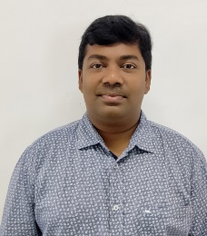 | V. Pandimurugan Currently working as Assistant professor in the department of networking and communications, SRMIST, Chennai. He has completed his Ph.D, in Computer Science & Engineering in 2019 from Manonmaniam Sundaranar University (MSU) Tirunelveli. He has done his B.E, in EEE and M.E in CSE from Anna University in the year 2005 and2008 respectively. has 11 years of teaching experience and has 22 publications in International Journals and Conferences. His research interests include Health Monitoring, Cyber Physical Systems and IoT. He is an active member of ACM and has authored the book titled-Principles of Communication, in the year 2012, published by Bharathi Publishers Chennai. He published one Scopus indexed book chapter and filed and published two international patents also one Indian patent to his credit.
 | Dr. Subash Chandra Bose Jaganathan is a Doctorate, Master of Engineering, Bachelor of Engineering all from Anna University, Chennai. He is working as an Electrical and Computer Science & Engineering more than 18 years in both the Industry and Teaching. He is Presently working as a Associate Professor Grade II in School of Computing Science and Engineering, VIT Bhopal University. He had worked and visited International countries like Thailand, King Saudi Arabia, North Macedonia. He had been acted as a Dean-Faculty of AITMIR,UIST,NM, He had been delivered the keynote address in Bangkok, Thailand and in the Technical University of Varna. His research interests include Medical Image Processing, machine learning, and intelligent systems. He is a recipient of different national and international awards such as ASDF overall “BEST COMPUTER SCIENCE FACULTY” Award by Association of Scientists, Developers and Faculties, Bangkok, Thailand on Dec 30, 2014

