S1a
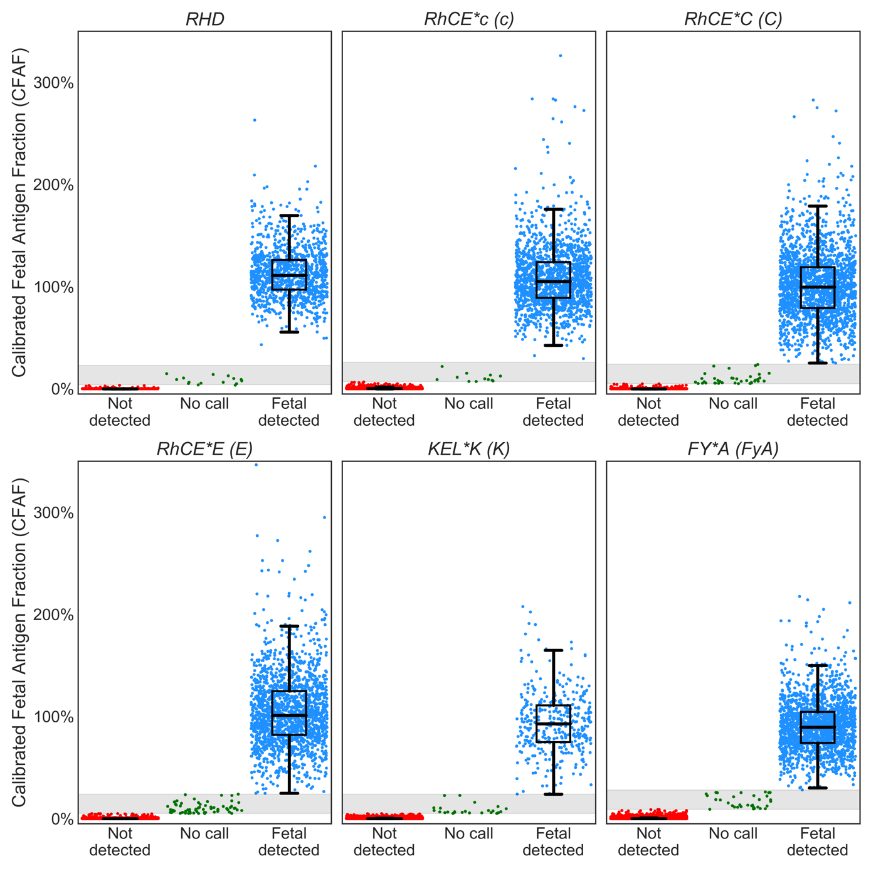

S1b
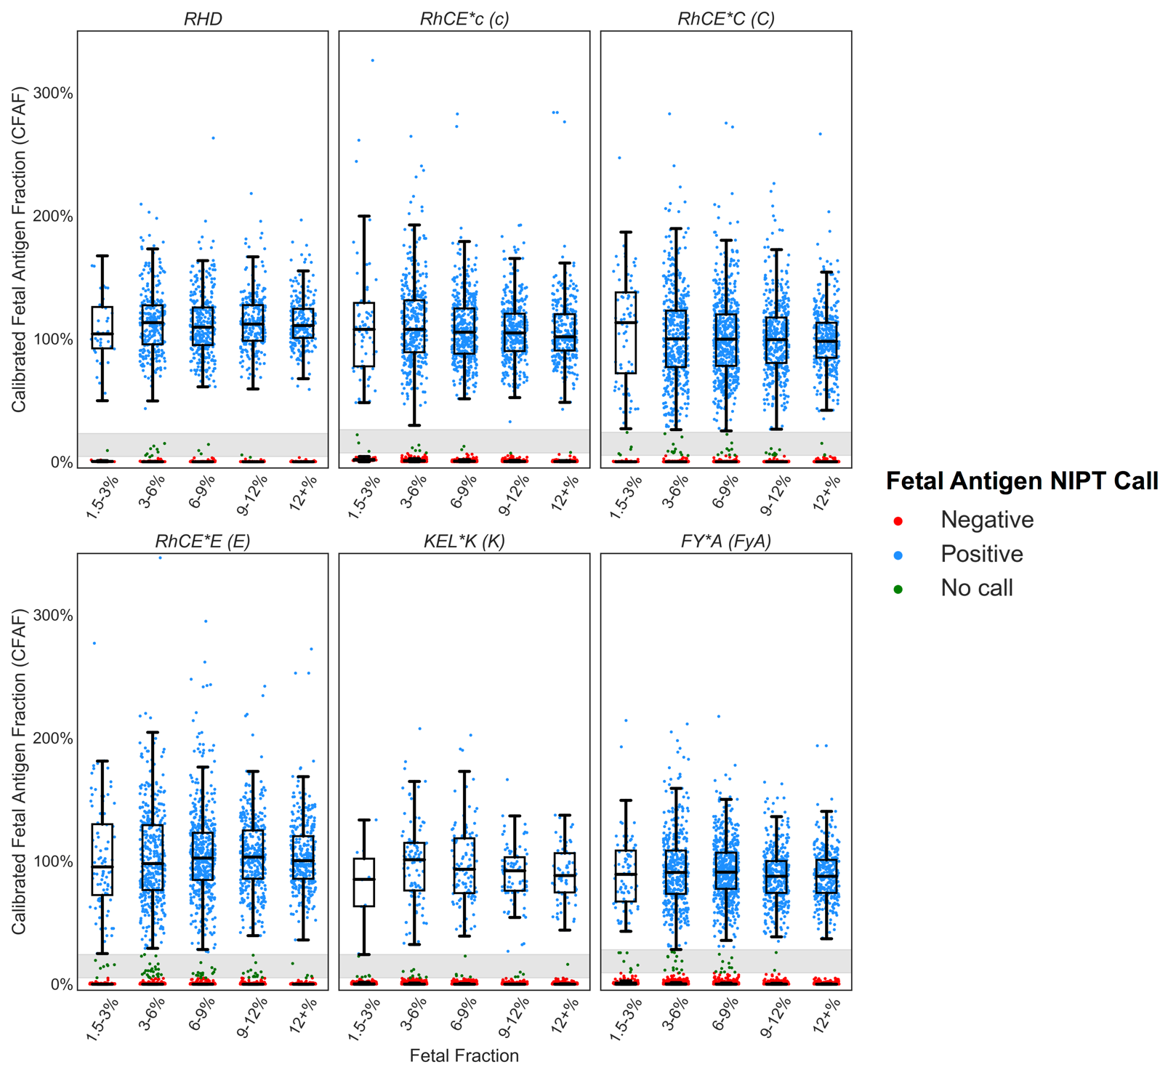

S1c
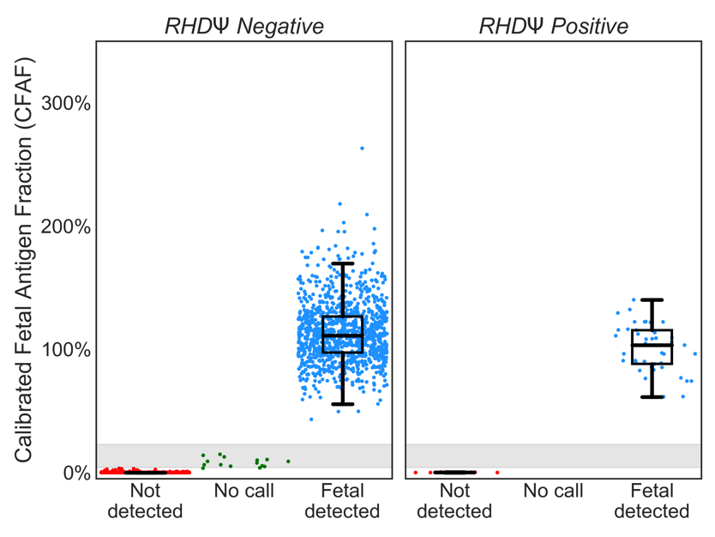

Figure S1a.b.c Calibrated fetal antigen fraction (CFAF)s and predicted fetal antigen status for clinical samples with individual data points. Antigen detected is indicated in blue, antigen not detected is indicated in red and no-call is indicated in green. a. Row 1: RhD, RHCE*C and RHCE*c, Row 2: RHCE*E, KEL*K and FY*A. b. The data in c. plotted by fetal fraction.
c. The fetal RhD prediction for the 510 without clinical samples where the RhDΨ variant was not detected (panel 1) and the clinical samples where RhDΨ variant was detected (panel 2). In qualitative RhD NIPT assays, samples with RhDΨ variant result in a no-call or inconclusive result.

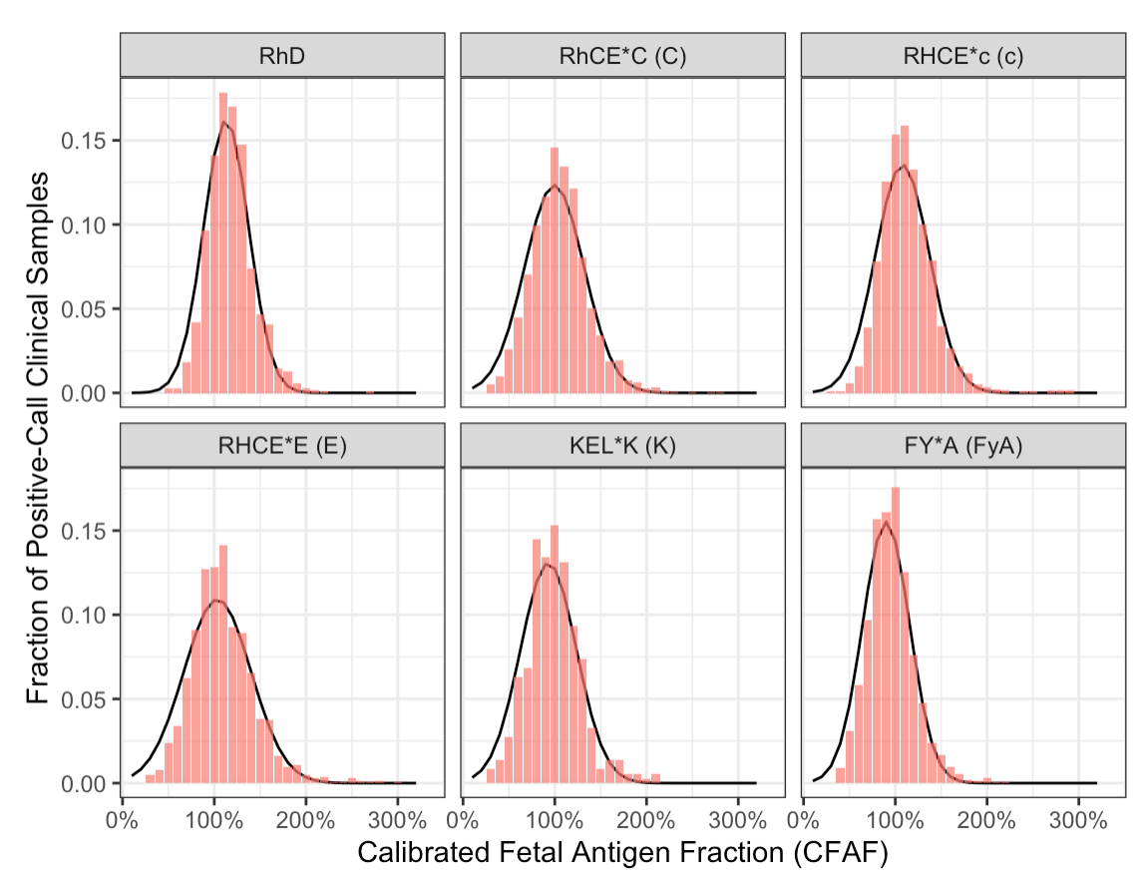
Figure S2. Truncated normal distribution fit to the NIPT CFAF values categorized as antigen detected from 15,939 plasma samples from pregnant individuals of unknown fetal antigen genotype and unknown pregnant person alloimmunization status who were negative (by genotype) for at least one of the RBC antigens.

