Synthesis and characterization of Related substances of Ampicillin – A β-Lactam Antibiotics
Chilamkurthi Suresh,*^{a, b} Dharmasoth Rama Devi,^{c} Keloth Basavaiah,^{b} Aaramadaka Sunil Kumar Reddy,ª K. V. V. Prasada rao,ª Guduri Anil Kumar,ª

S.No | Content | Page No
1 | ¹H NMR,¹³C NMR, HRMS & HPLC of Ampicillinyl-D-phenylglycine (2) | 2-5
2 | ¹H NMR,¹³C NMR, HRMS & HPLC of L-Ampicillin (3) | 6-9

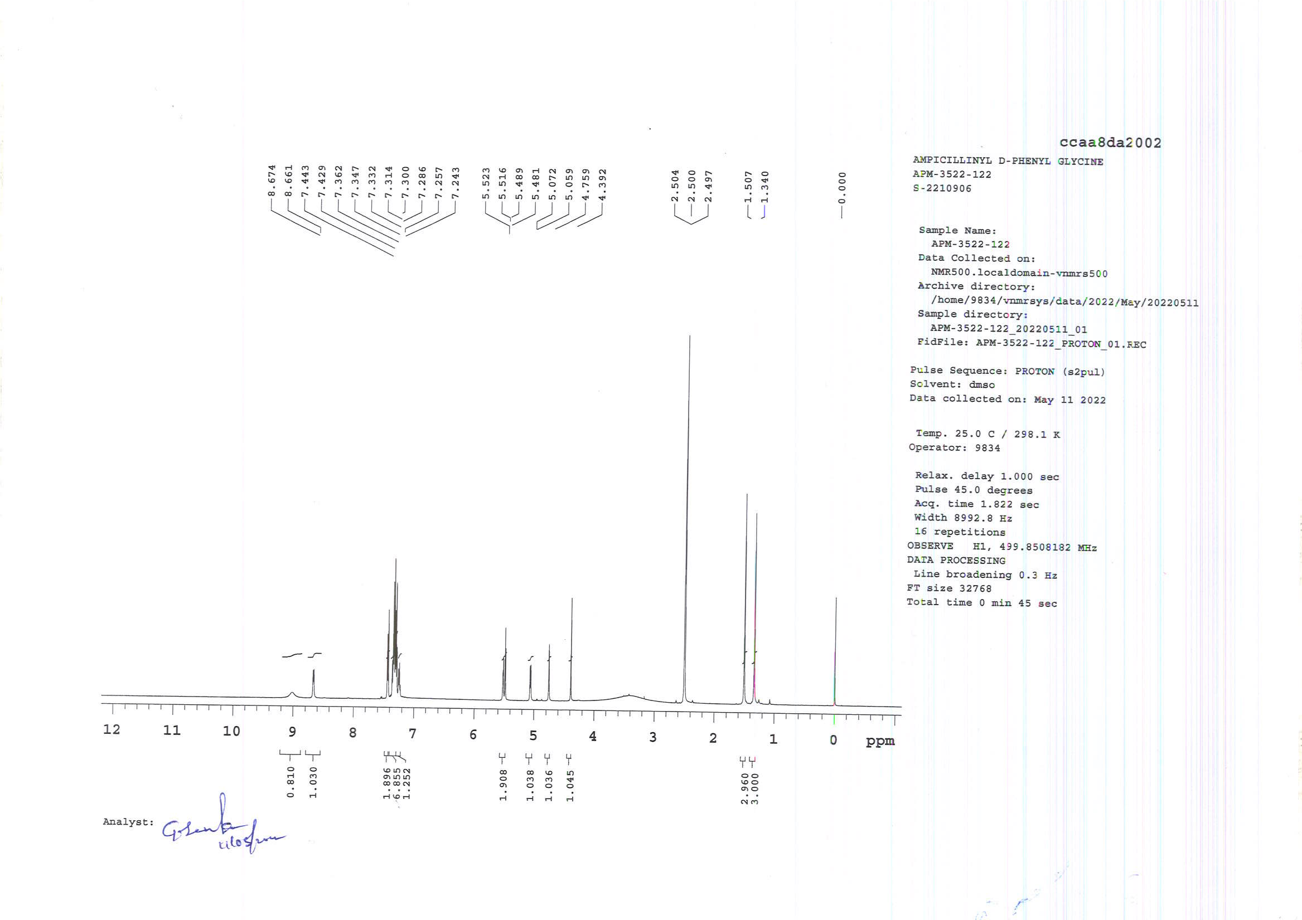
¹H NMR of Ampicillinyl-D-phenylglycine (2)
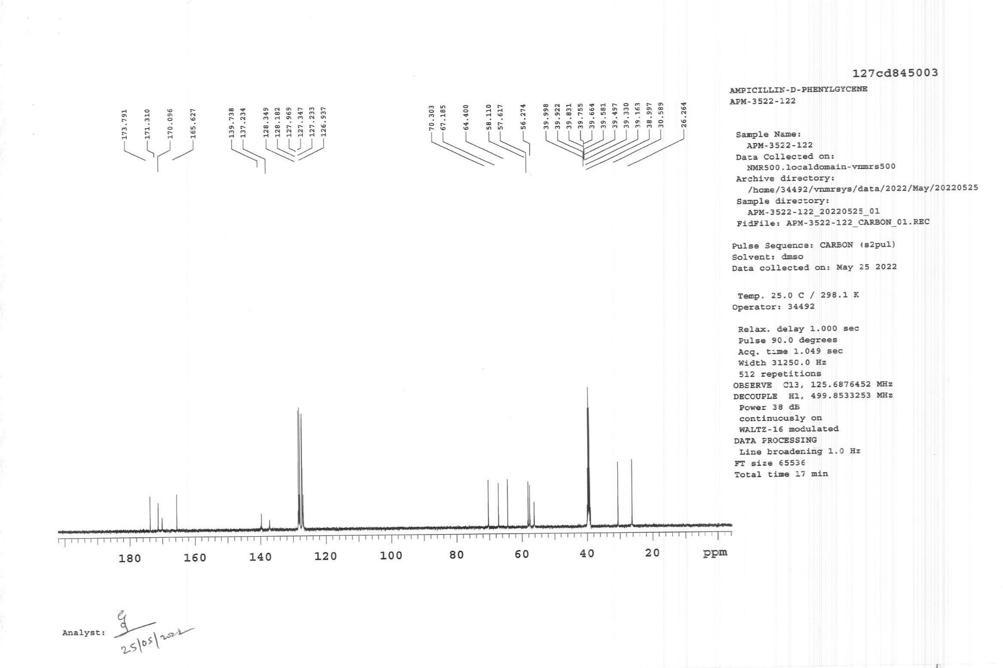
C¹³ NMR of Ampicillinyl-D-phenylglycine (2)
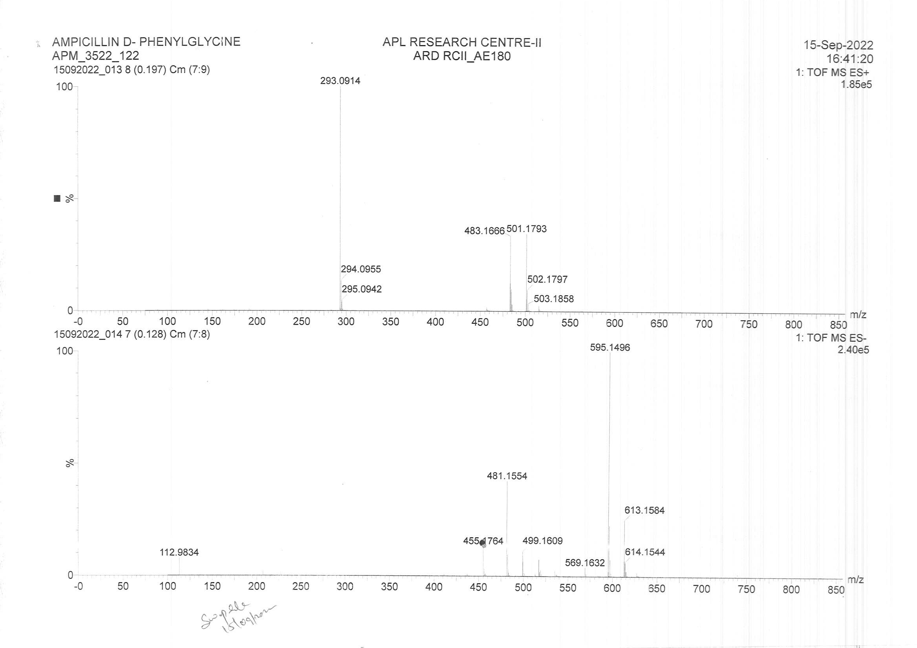
HRMS of Ampicillinyl-D-phenylglycine (2)

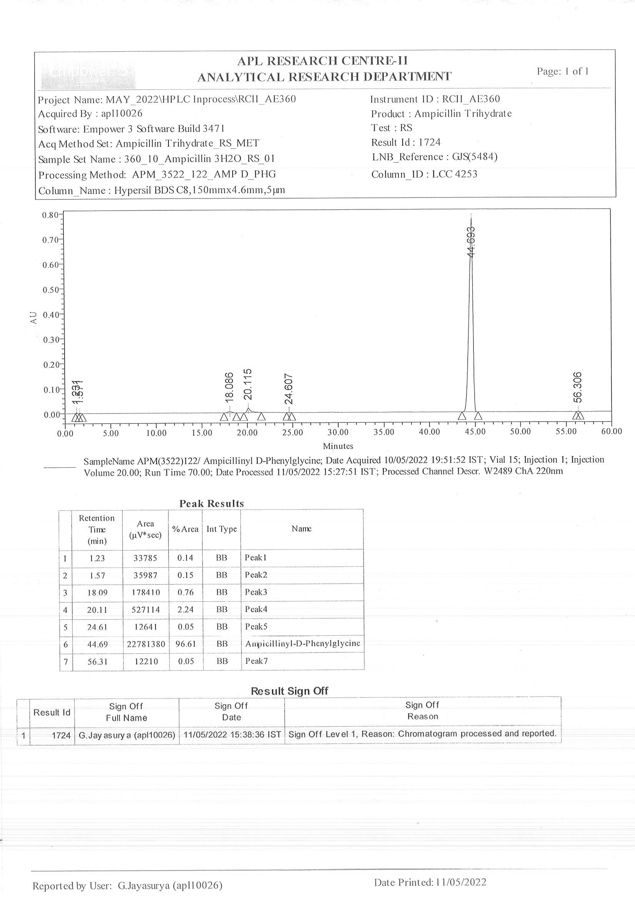
HPLC of Ampicillinyl-D-phenylglycine (2)
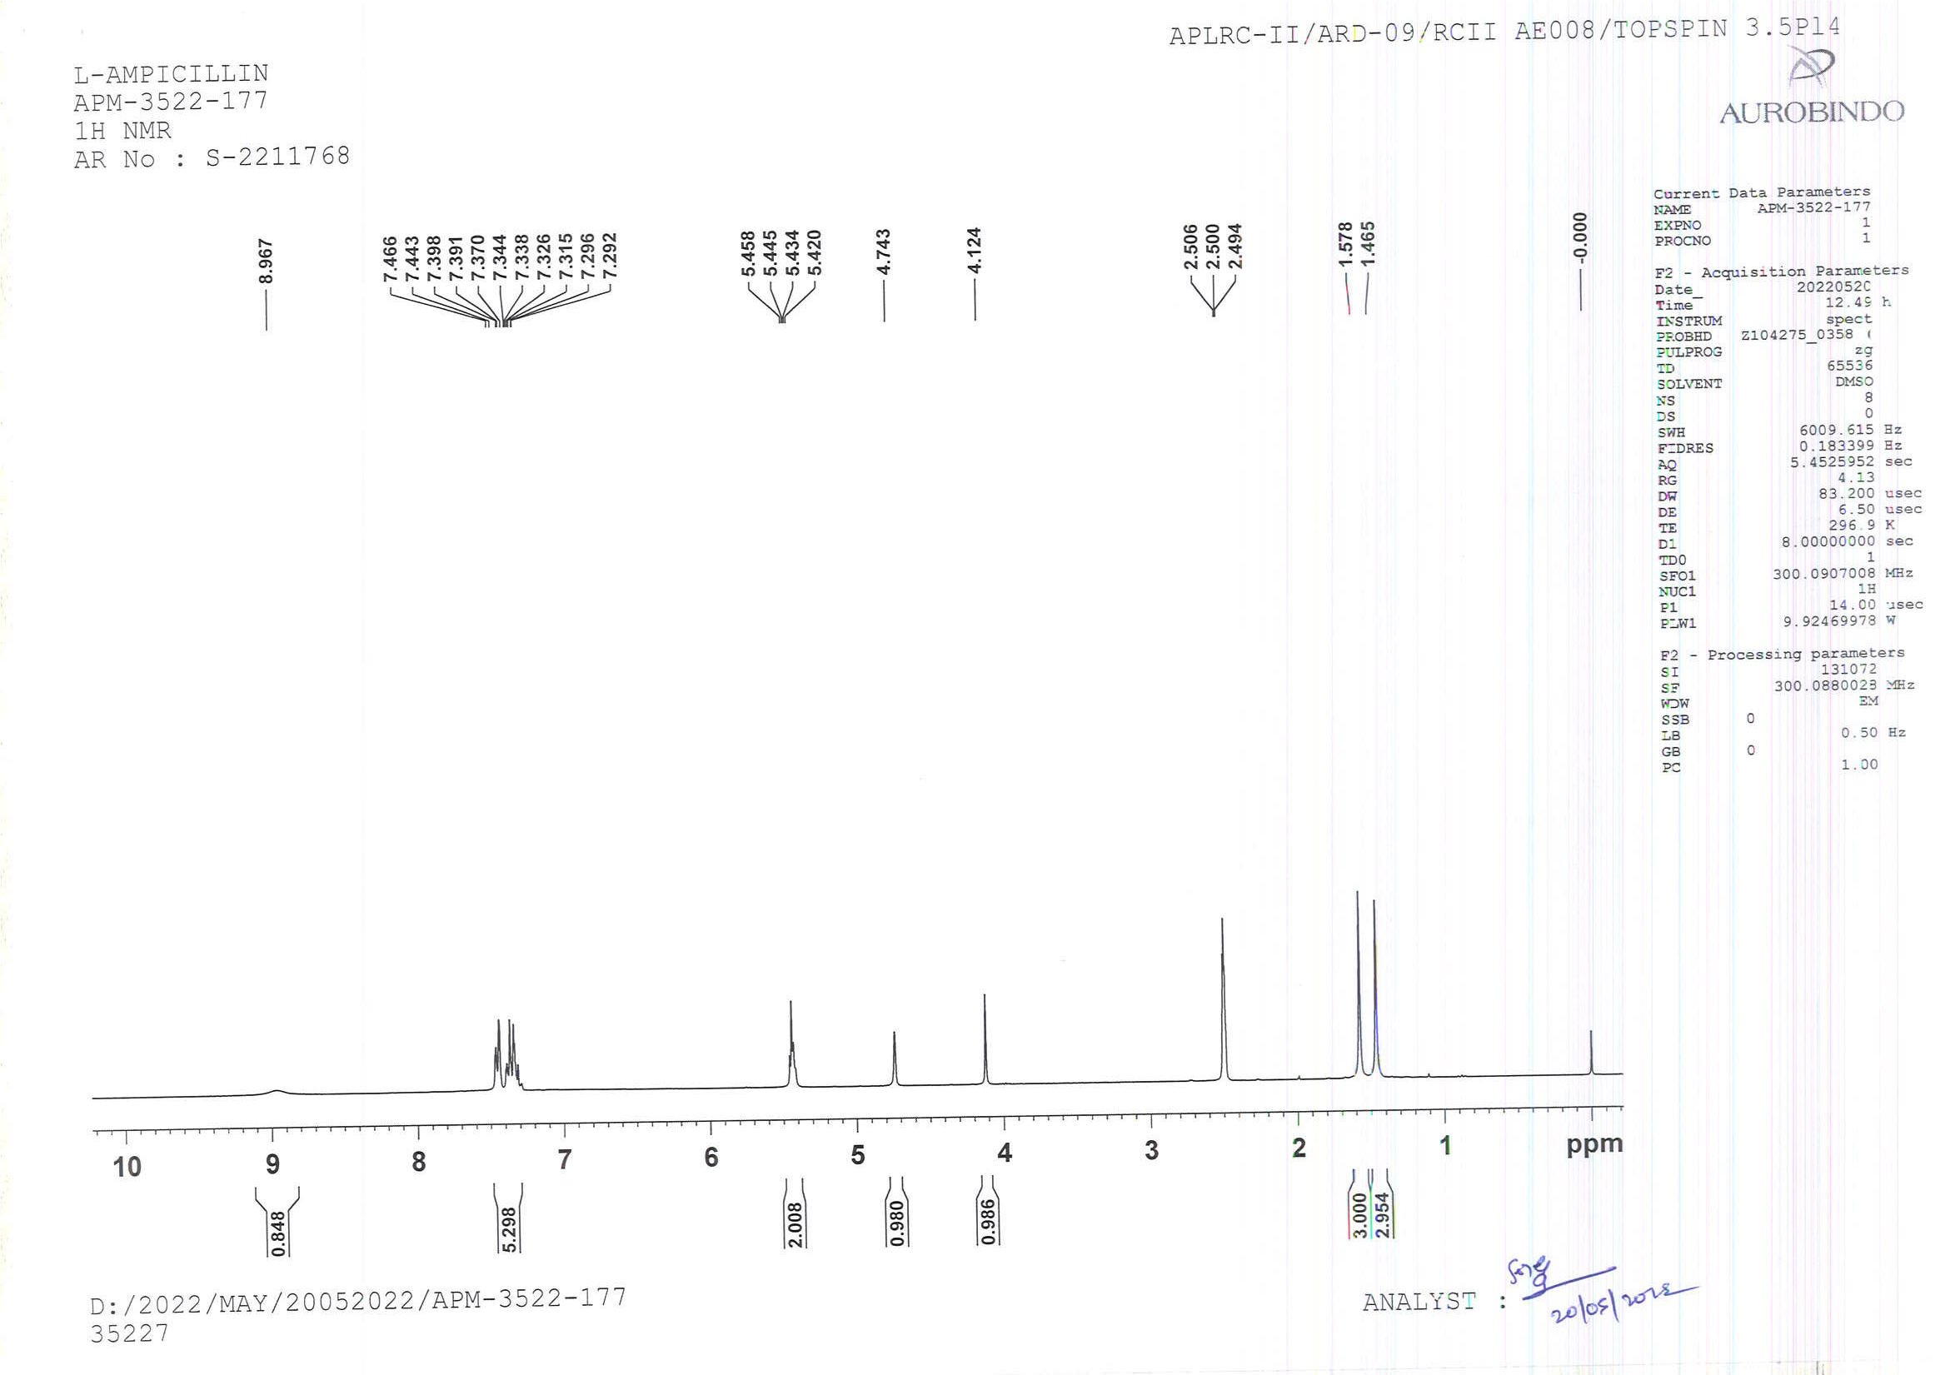
¹H NMR of L-Ampicillin (3)
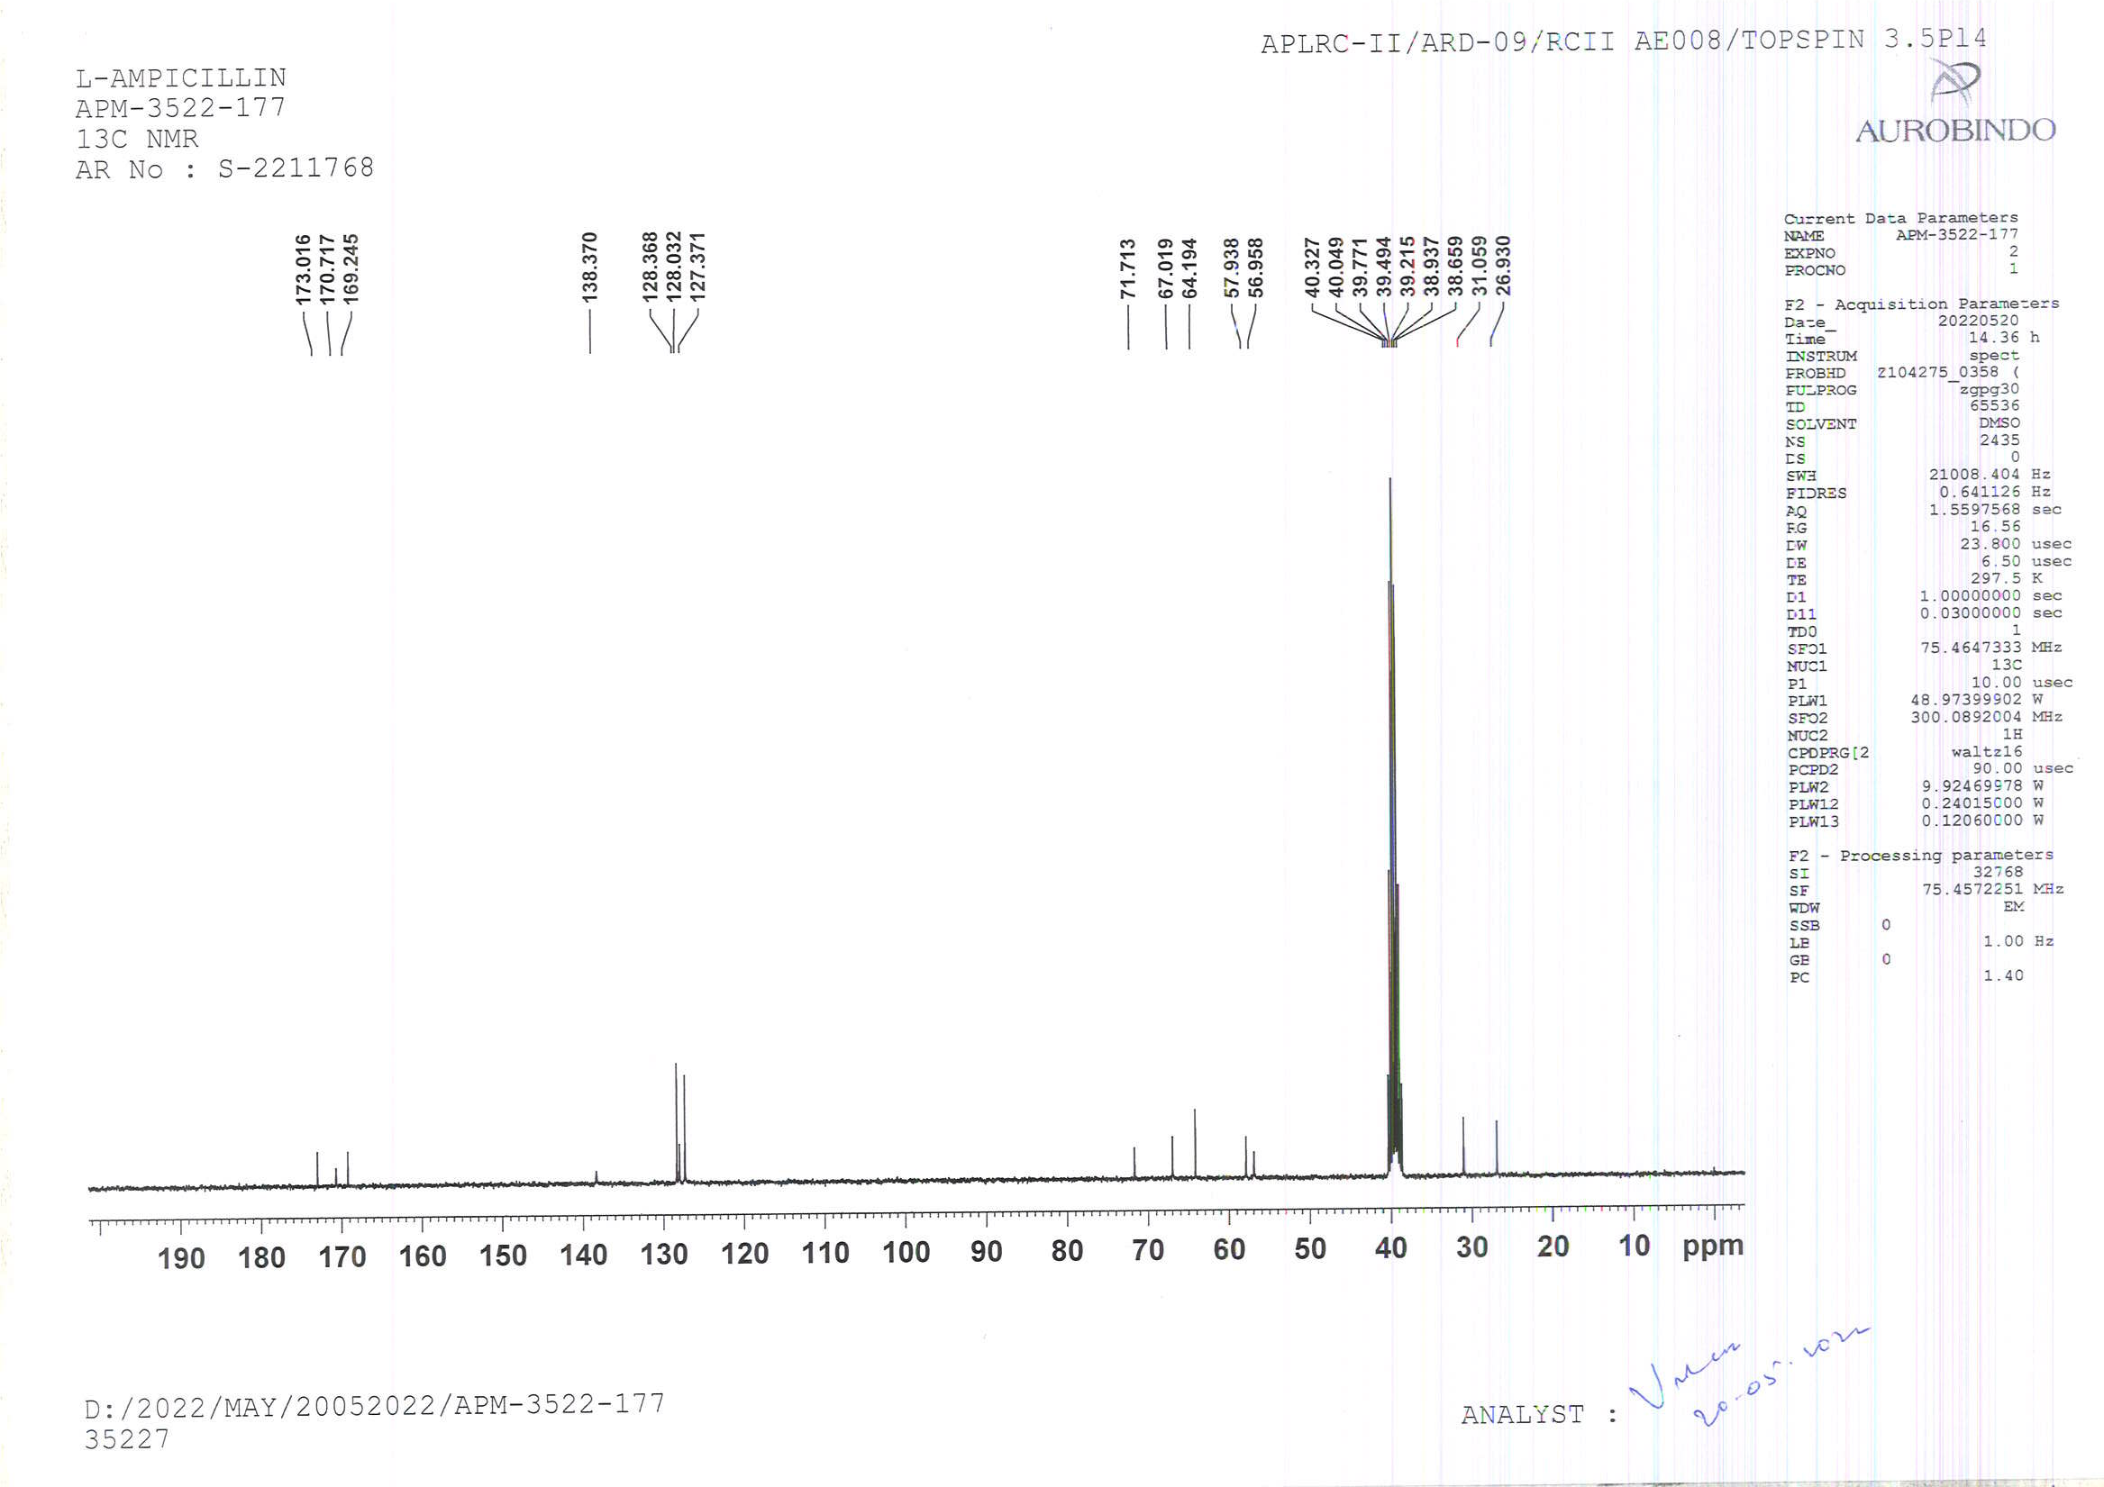
C¹³ NMR of L-Ampicillin (3)
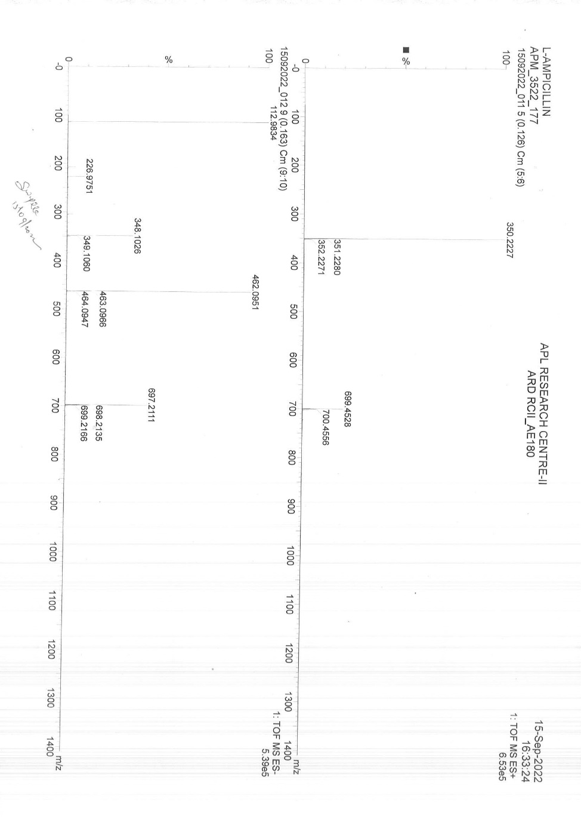
HRMS of L-Ampicillin (3)
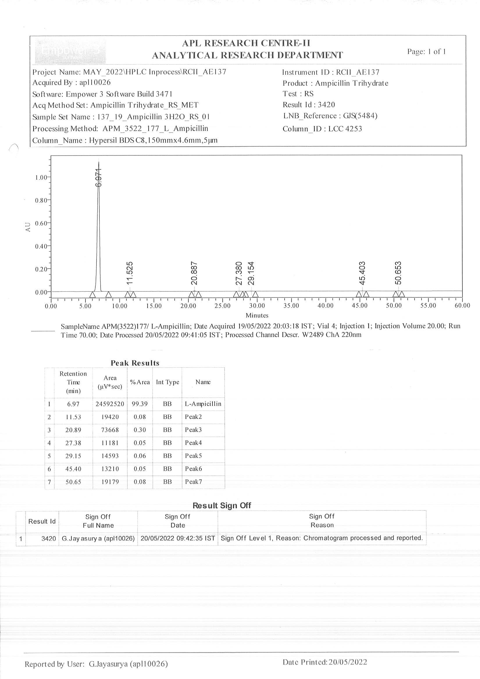

HPLC of L-Ampicillin (3)

