Table 1. The Progression of the Echocardiographic Data and the Examination Findings
 | On admission | After treatment | Post admission after 1 month
LAd(mm) | 48 | 43 | 42
LVEDd(mm) | 64 | 70 | 66
RAd(mm) | 47 | 38 | 38
RVEDd(mm) | 32 | 31 | 29
IVSTd(mm) | 10 | 9 | 11
PWTd(mm) | 10 | 9 | 10
EF(%) | 25 | 29 | 29
NT-pro BNP(pg/mL) | 2541 | 1474 | 1222
Chest X-ray | 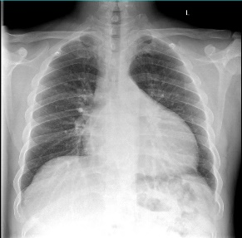 | (-) | 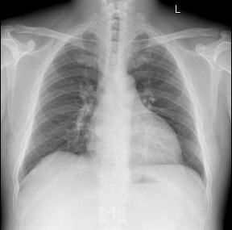
LAd: Left atrial diameter; LVEDd: Left ventricular end diastolic diameter; RAd: Right atrial diameter; RVEDd: Right ventricular end diastolic diameter; IVSTd: Interventricular septum thickness diameter; PWTd: Posterior left ventricular wall thickness diameter; EF: Ejection function; NT-proBNP: NT-pro brain natriuretic peptide

