Supplementary information
Terbium-Based Dual-Ligand Metal Organic Framework by Diffusion Method for Selective and Sensitive Detection of Danofloxacin in Aqueous Medium
Gurdeep Singh ª, Deepika ª,Sanjay Kumar ^{b}, Rajpal Verma ^{a,c}, Ashok Kumar Malik ^{a *}
ª Department of Chemistry, Punjabi University, Patiala-147002, Punjab, India
^{b} Department of Chemistry, Multani Mal Modi College, Patiala-147001, Punjab, India
^{c}Department of Chemistry, Dr. B. R. Ambedkar Govt. College Dabwali, Sirsa, Haryana, India
*Corresponding author: malik_chem2002@yahoo.co.uk (A.K.M.)

NAME | NOMENCLATURE | STRUCTURE | USE
Danofloxacin (DANO)  CAS No. 119478-55-6  Chemical Formula:  C₁₉H₂₀FN₃O₃  Mol. Wt. 357.37 | 7-[(1′s,4′s)-5′-Methyl-2′,5′ diazabicyclo[2.2.1]hept-2′-yl]-1-cyclopropyl-6-fluoro-1,4-dihydro-4-oxo-3- quinoline carboxylic acid |  | veterinary use
Ciprofloxacin (CIPRO)  CAS No. 86483-48-9  Chemical Formula:  C₁₇H₁₈FN₃O₃  Mol. Wt. 331.35 | 1-Cyclopropyl-6-fluoro-1,4-dihydro-4-oxo- 7-(1-piperazinyl)-3-quinoline carboxylic acid |  | Human and veterinary use
Norfloxacin (NOR)  CAS No. 70458-96-7  Chemical Formula:  C₁₆H₁₈FN₃O₃  Mol. Wt. 319.33 | 1-Ethyl-6-fluoro-1,4-dihydro-4-oxo-7-(1-  piperazinyl)-3quinoline carboxylic acid |  | Human and veterinary use
Levofloxacin (LEVO)  CAS No. 100986-85-4  Chemical Formula:  C₁₈H₂₀FN₃O₄  Mol. Wt. 361.37 | S-isomer of racemic ofloxacin |  | Human use
Ofloxacin (OFLO)  CAS No. 83380-47-6  Chemical Formula:  C₁₈H₂₀FN₃O₄  Mol. Wt. 361.37 | (±)-9-Fluoro-2,3-dihydro-3-methyl-10-(4 methyl-1-piperazinyl)-7-oxo-7 H-pyrido [1,2,3-de]-1,4-benzoxazine-6-carboxylic acid |  | Human and veterinary use
Table S1. Nomenclature, structure, and use of FQs.
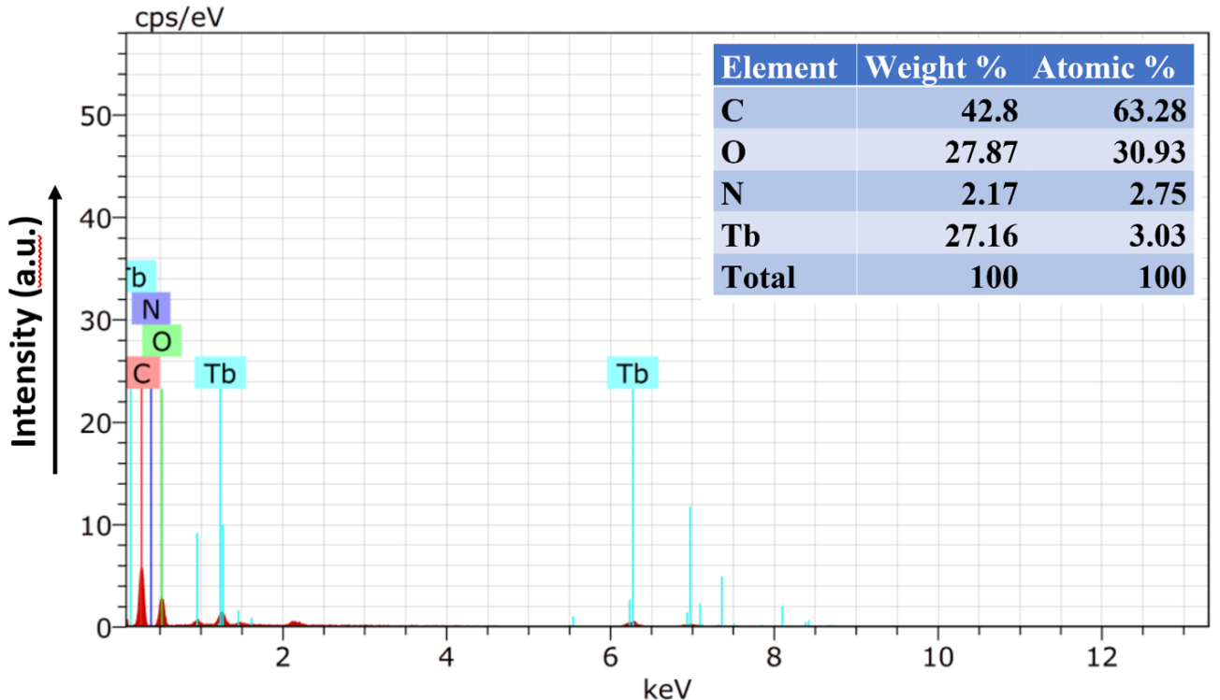
Figure S1. Energy-dispersive X-ray (EDX) spectra of TBP.

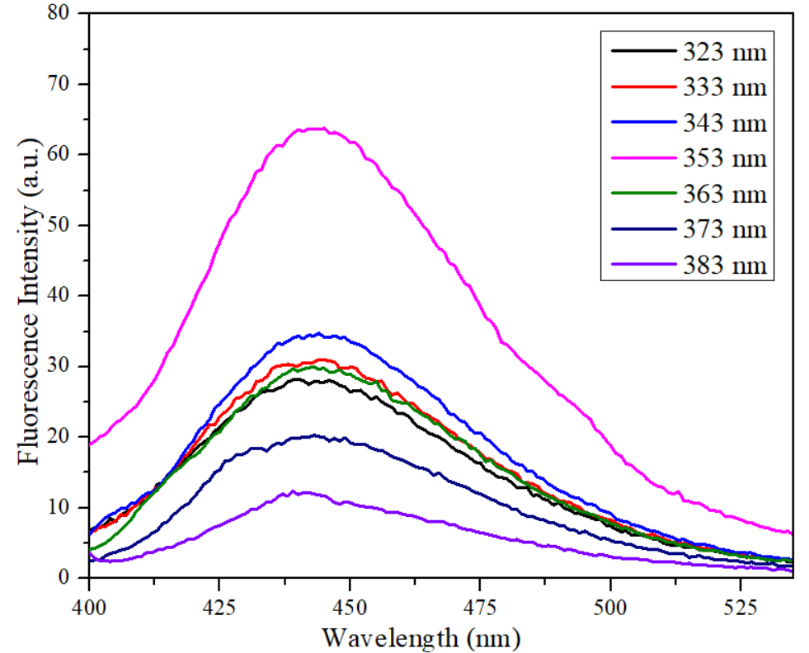
Figure S2. Fluorescence emission spectra (excitation wavelength (λ_{ex}) from 323 to 383 nm) of TBP in aqueous solution.

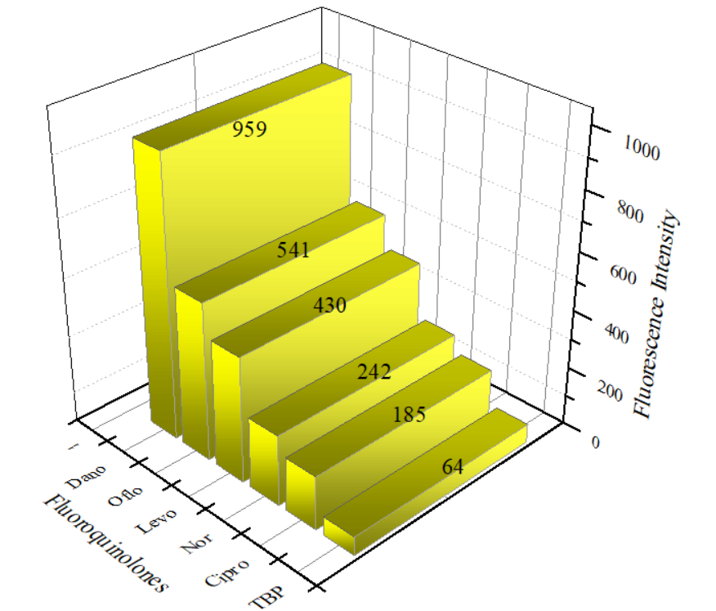

Figure S3. 3D bar graph of fluorescence spectra for TBP dispersed in an aqueous solution containing different FQs when excited at 353 nm.

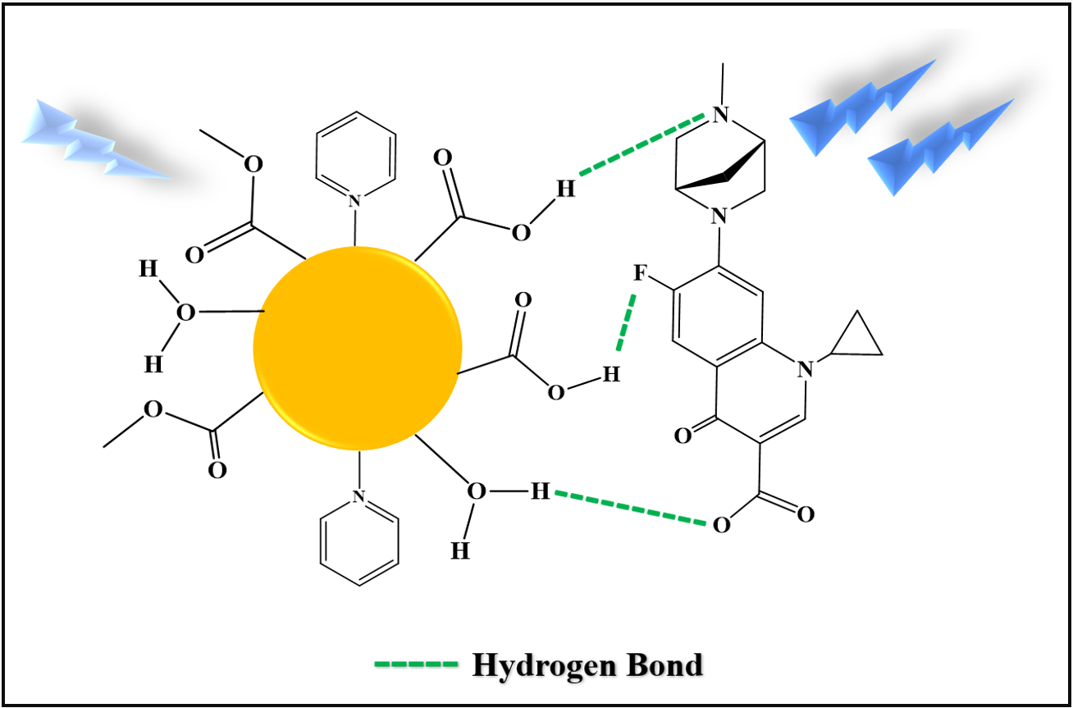
Figure S4. Schematic illustration of hydrogen bonding between TBP and DANO.
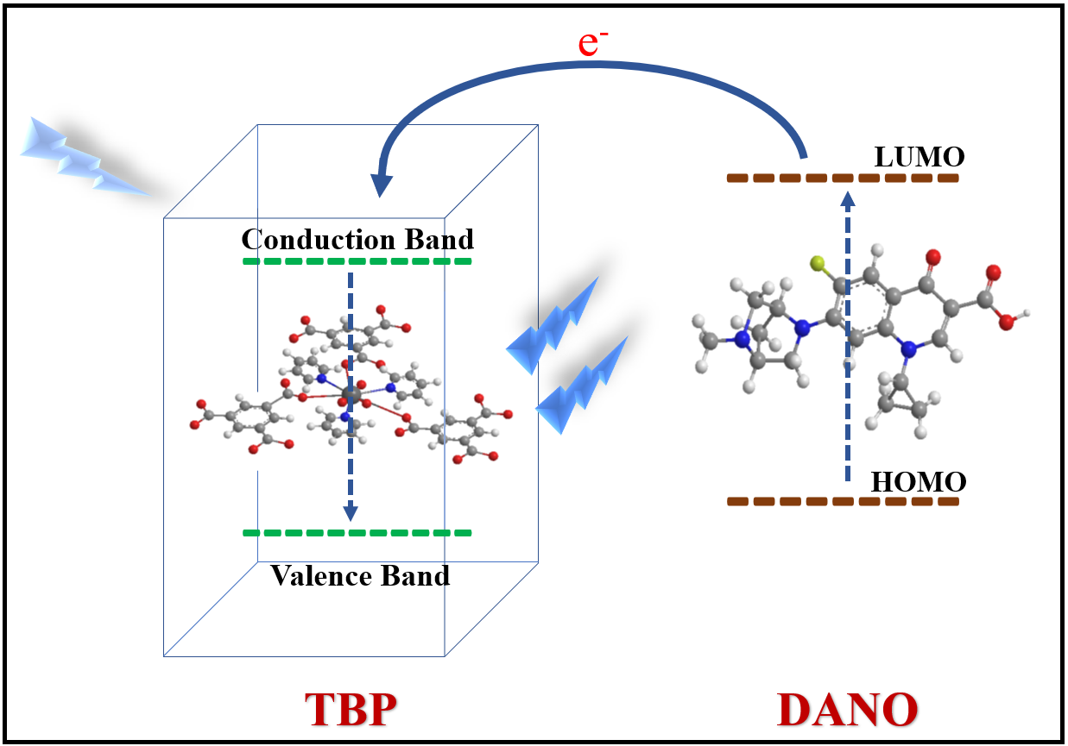
Figure S5. Schematic depiction of electron transfer between DANO and TBP (fluorescence turn-on mechanism)

