Supplementary Material

A novel model of anoikis-related gene for predicting prognosis and assessing immune status with hepatocellular carcinoma
Jiahe Hu^{1†}, Wenchao Fu^{2†}, Xiaoling Zhang^{1†}, Yuxin Zhou¹, Xuefeng Yu³, Haitao Xu⁴, Zhichang Ba⁵, Haoxin Zhang¹, Yanan Sun¹, Rongfang Wang¹, Xinlian Du¹, Ruishu Mou¹, Xuedong Li¹, Jiuxin Zhu^{6*}, Rui Xie^{1*}
* Correspondence: Rui Xie: rxie@hrbmu.edu.cn; Jiuxin Zhu: zhujiuxin@hrbmu.edu.cn

Supplementary Figures and Table Legends

Supplementary Figures

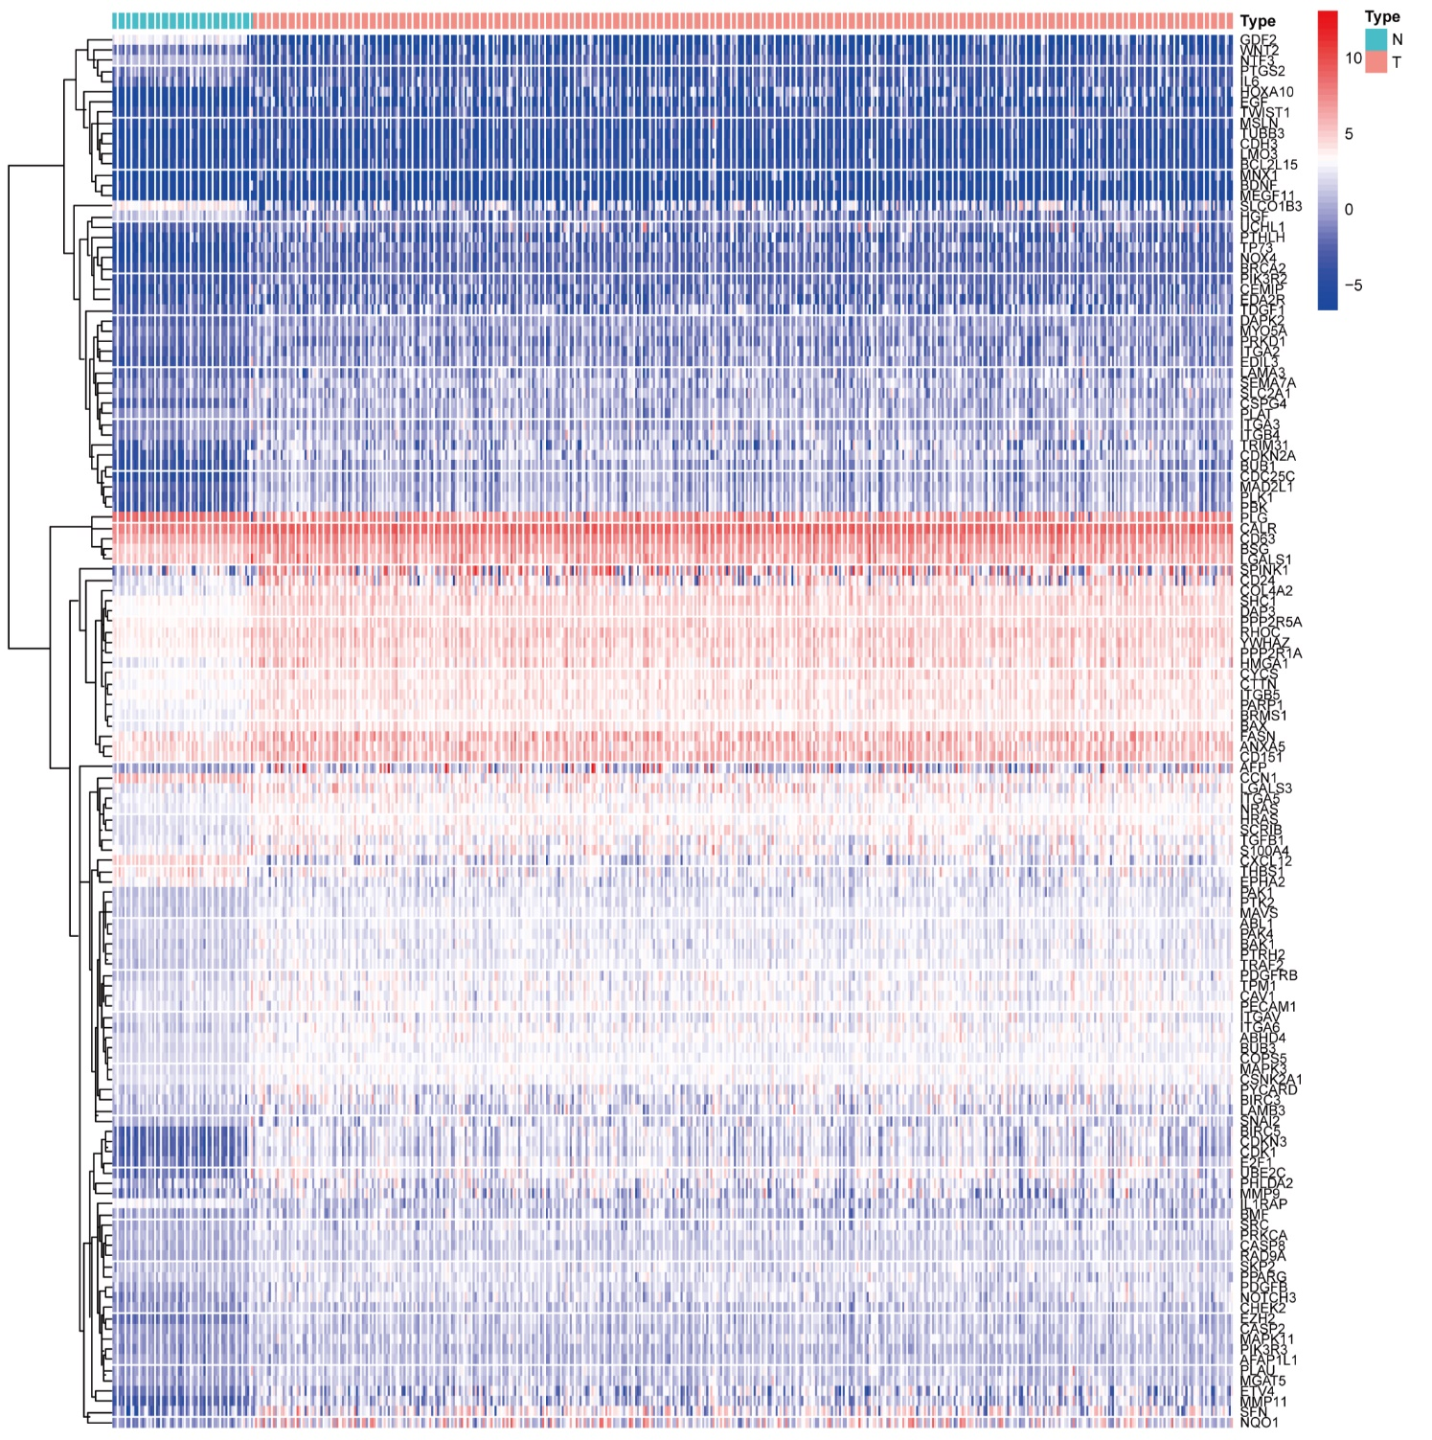
Figure S1. The heatmap of 134 anoikis-related DEGs by gene expression data of HCC samples and normal control in TCGA cohort.
Figure S2. The ROC curves of risk score and clinical characteristics in TCGA (A) and ICGC (C) cohorts. (B, D) Survival and mortality rates in high- and low-risk HCC patients in TCGA (B) and ICGC cohorts (D). (E, F) Spearman’s correlation analysis of anoikis-related genes and risk score in TCGA (E) and ICGC cohorts (F).
Figure S3. (A, C) PCA and (B, D) t-SNE plots analysis of patients in high- and low-risk groups. (E-J) Differences in risk score among different clinical characteristics subgroups. (H) stage (***P<0.001), (E) grade (***P<0.001), (F, I) age, (G, J) gender. TCGA cohort (A, B, E, F, G), ICGC cohort (C, D, H, I, J).
Figure S4. (A) Heatmap for risk score and immune activity. (B) Differences in TMB in high- and low-risk groups. (C) Estimate score of the expression profile in high-risk group and low risk group.

Supplementary Table Legends
Table S1: The 380 anoikis-related genes.
Table S2: The 216 chemotherapy drugs of FDA approved or on clinical trials.
Table S3: The 132 of 380 ANRGs were linked with survival.
Table S4: The 52 KEGG pathways obtained by GSEA analysis.
Table S5: The analysis of association between the prognostic genes expression and chemotherapy drug susceptibility.

