Supplementary material 2: Flux maps
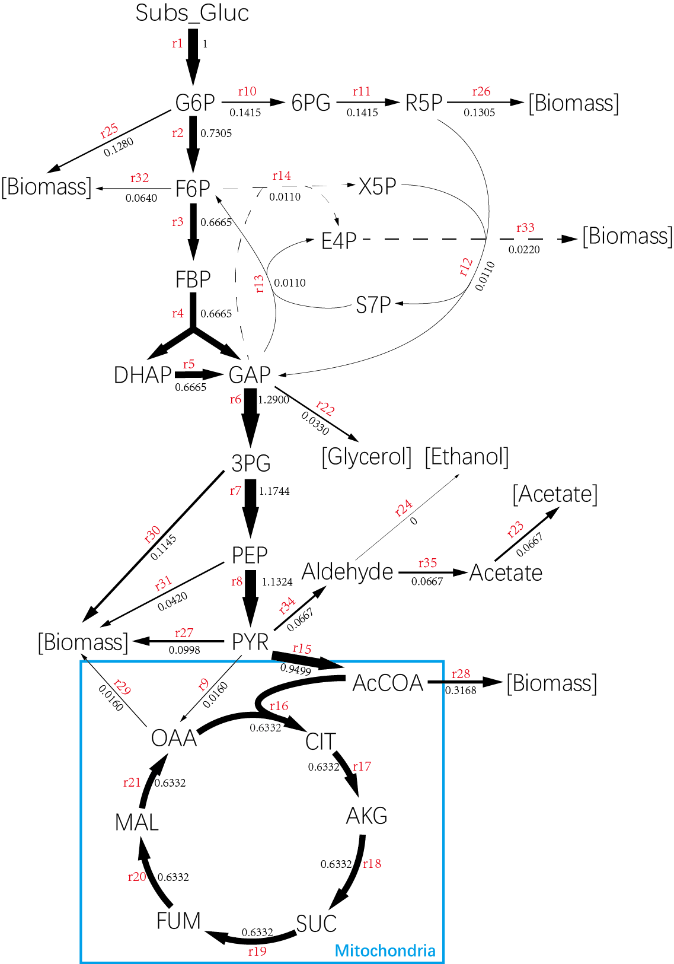

Figure 1: Flux distribution at dilution rate D=0.1211 h⁻¹. Flux values are given when glucose uptake rate set to 1.

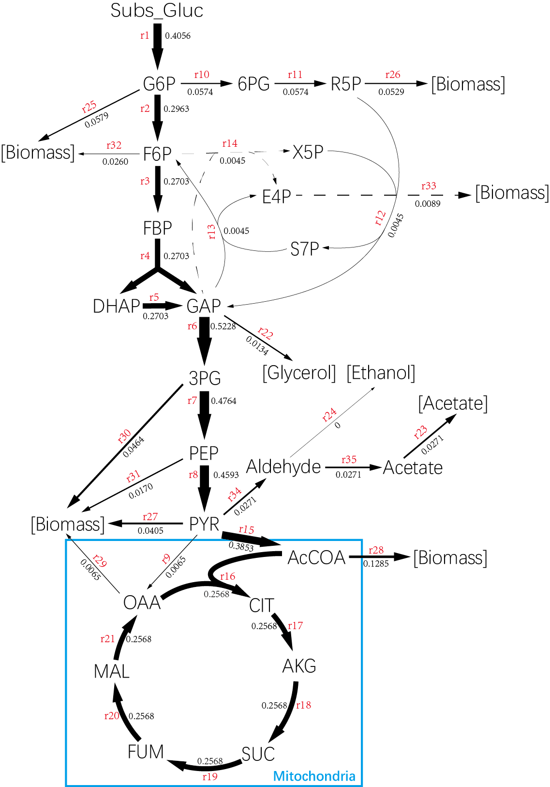

Figure 2: Flux distribution at dilution rate D=0.1211 h⁻¹. Flux values are given when glucose uptake rate set to true value.

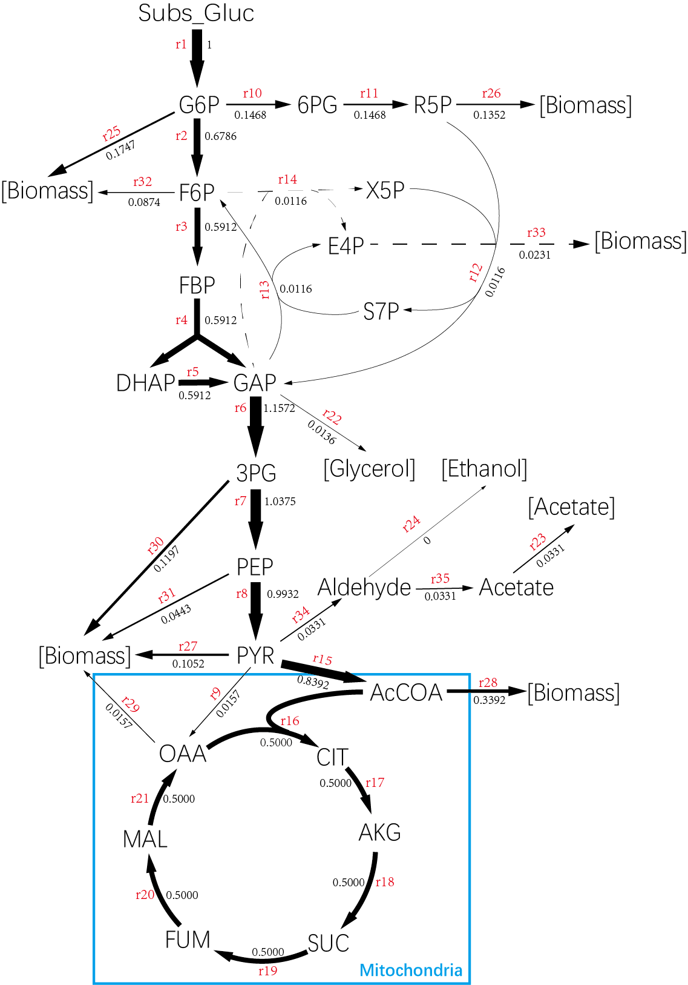

Figure 3: Flux distribution at dilution rate D=0.2188 h⁻¹. Flux values are given when glucose uptake rate set to 1.

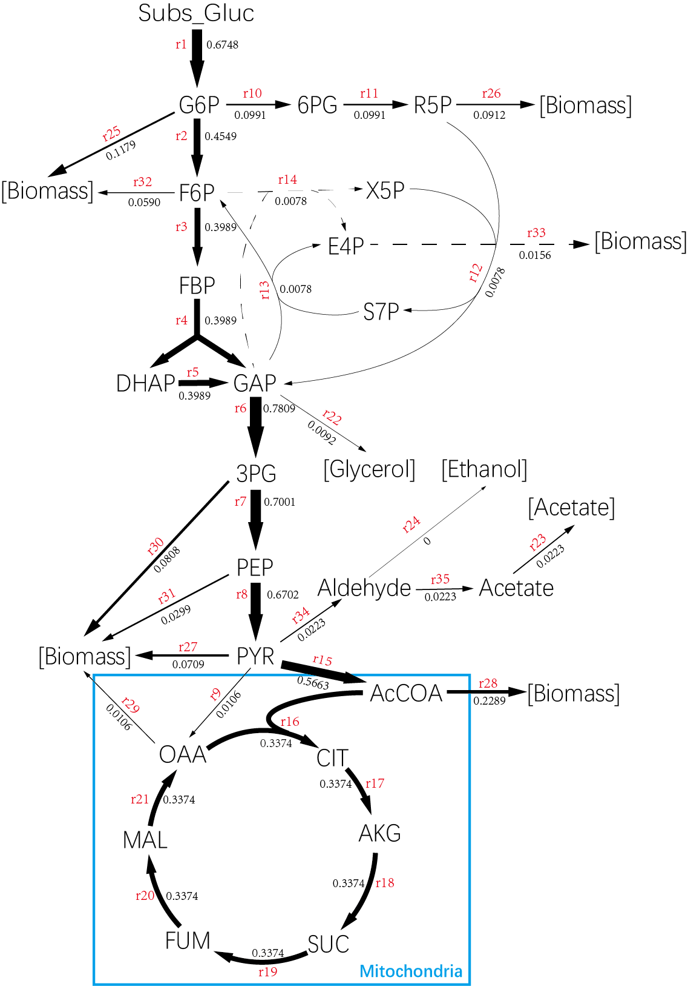

Figure 4: Flux distribution at dilution rate D=0.2188 h⁻¹. Flux values are given when glucose uptake rate set to true value.

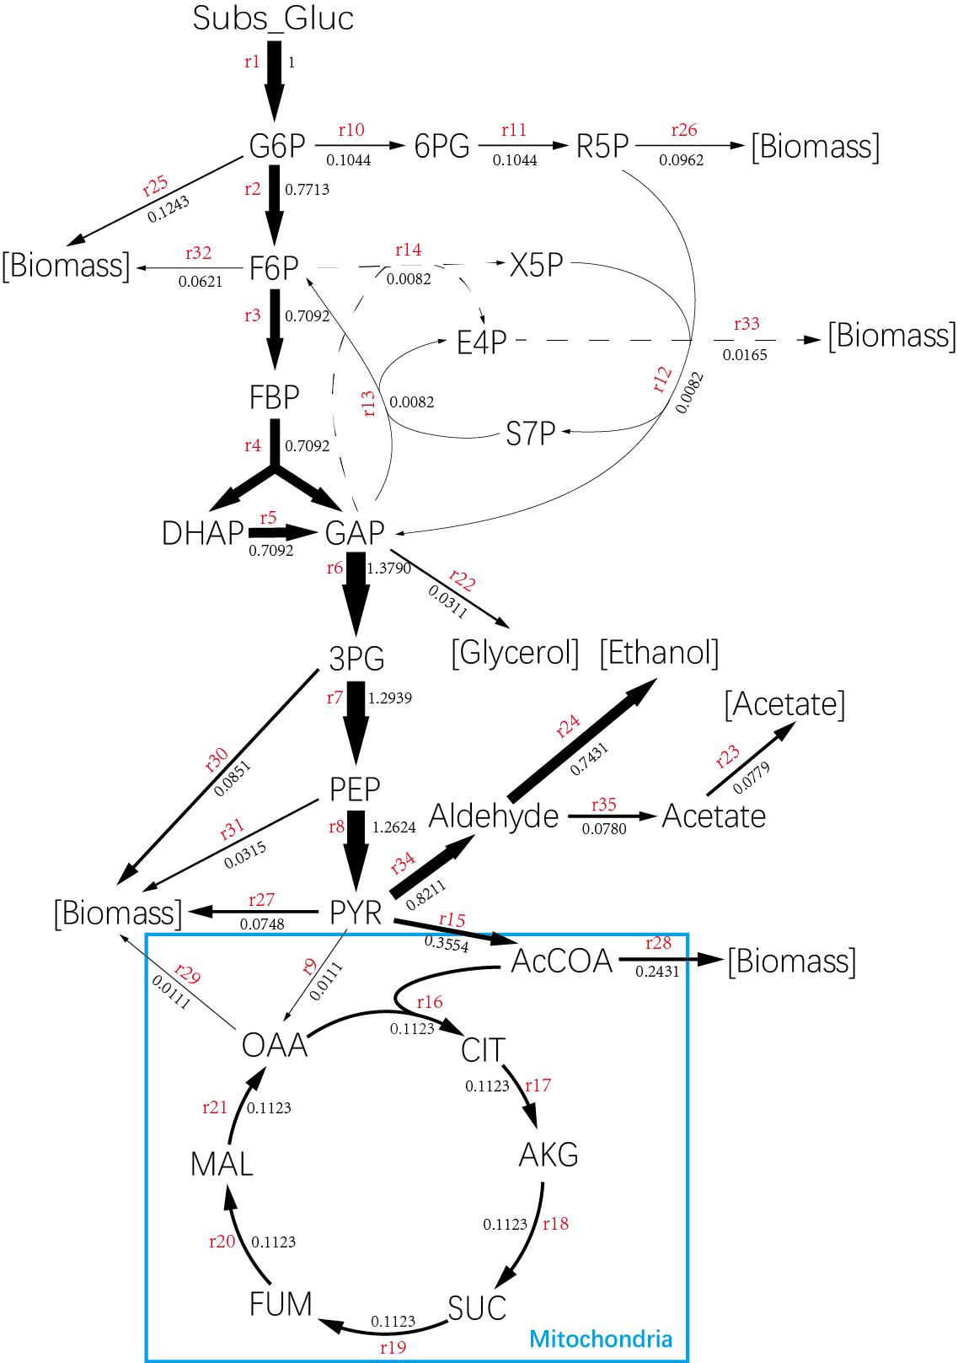

Figure 5: Flux distribution at dilution rate D=0.3235 h⁻¹. Flux values are given when glucose uptake rate set to 1.

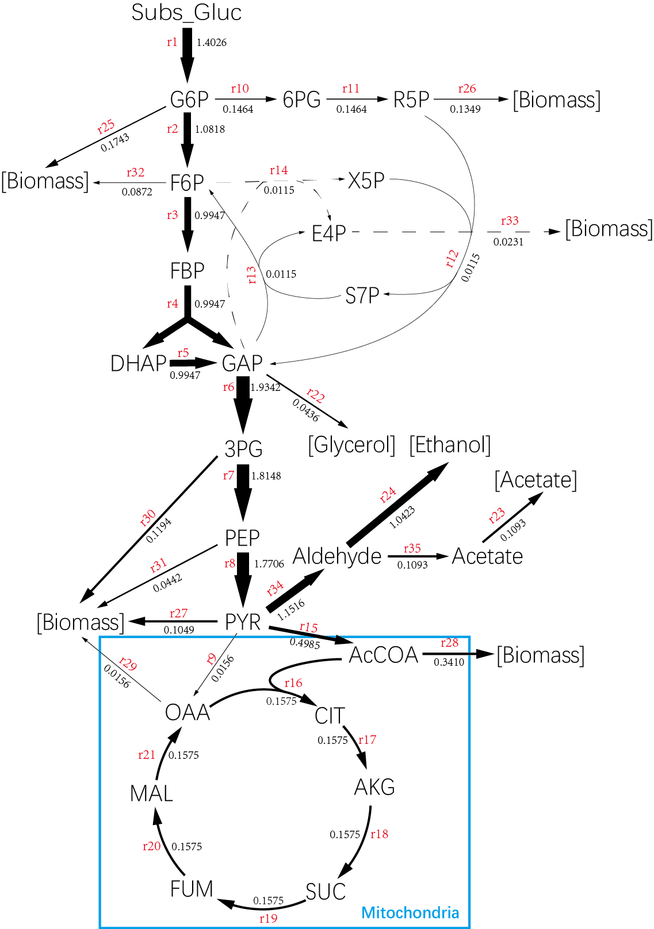

Figure 6: Flux distribution at dilution rate D=0.3235 h⁻¹. Flux values are given when glucose uptake rate set to true value.

