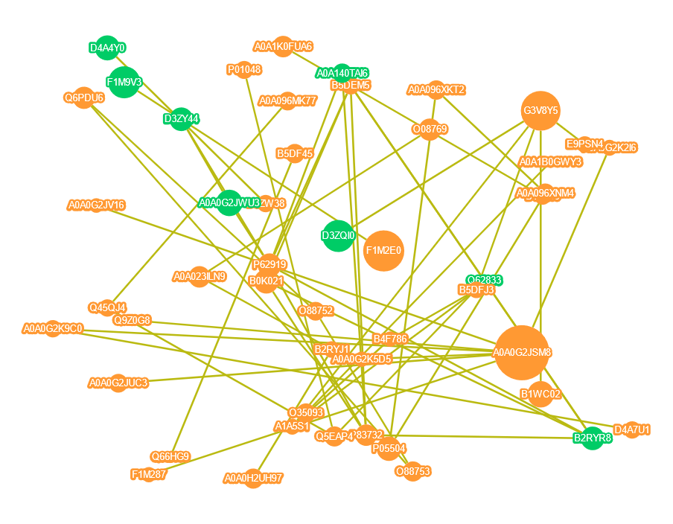
Supplement Figure 1 Interaction Analysis of Identified Proteins
Each node in the interaction network represents a protein, and the node size represents the number of proteins interacting with it. The larger the node is, the more proteins interacting with it. The color of the nodes indicates the expression level of the protein in the comparison pair, with red representing significantly high expression of the protein and green representing significantly low expression of the protein.

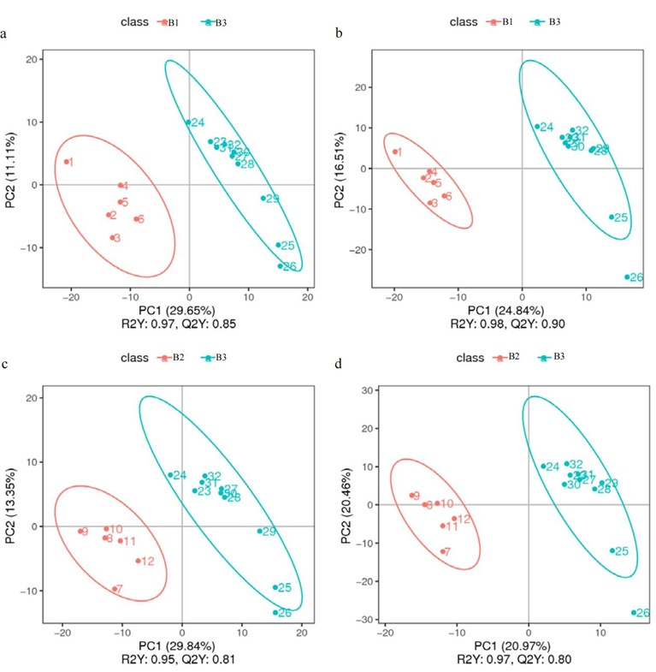
Supplement Figure 2 PLS-DA analysis between (a)B3 and B1 group (ESI- mode) (b) B3 and B1 group(ESI+ mode)(c) B3 and B2 group(ESI- mode)(d) B3 and B2 group(ESI+ mode)

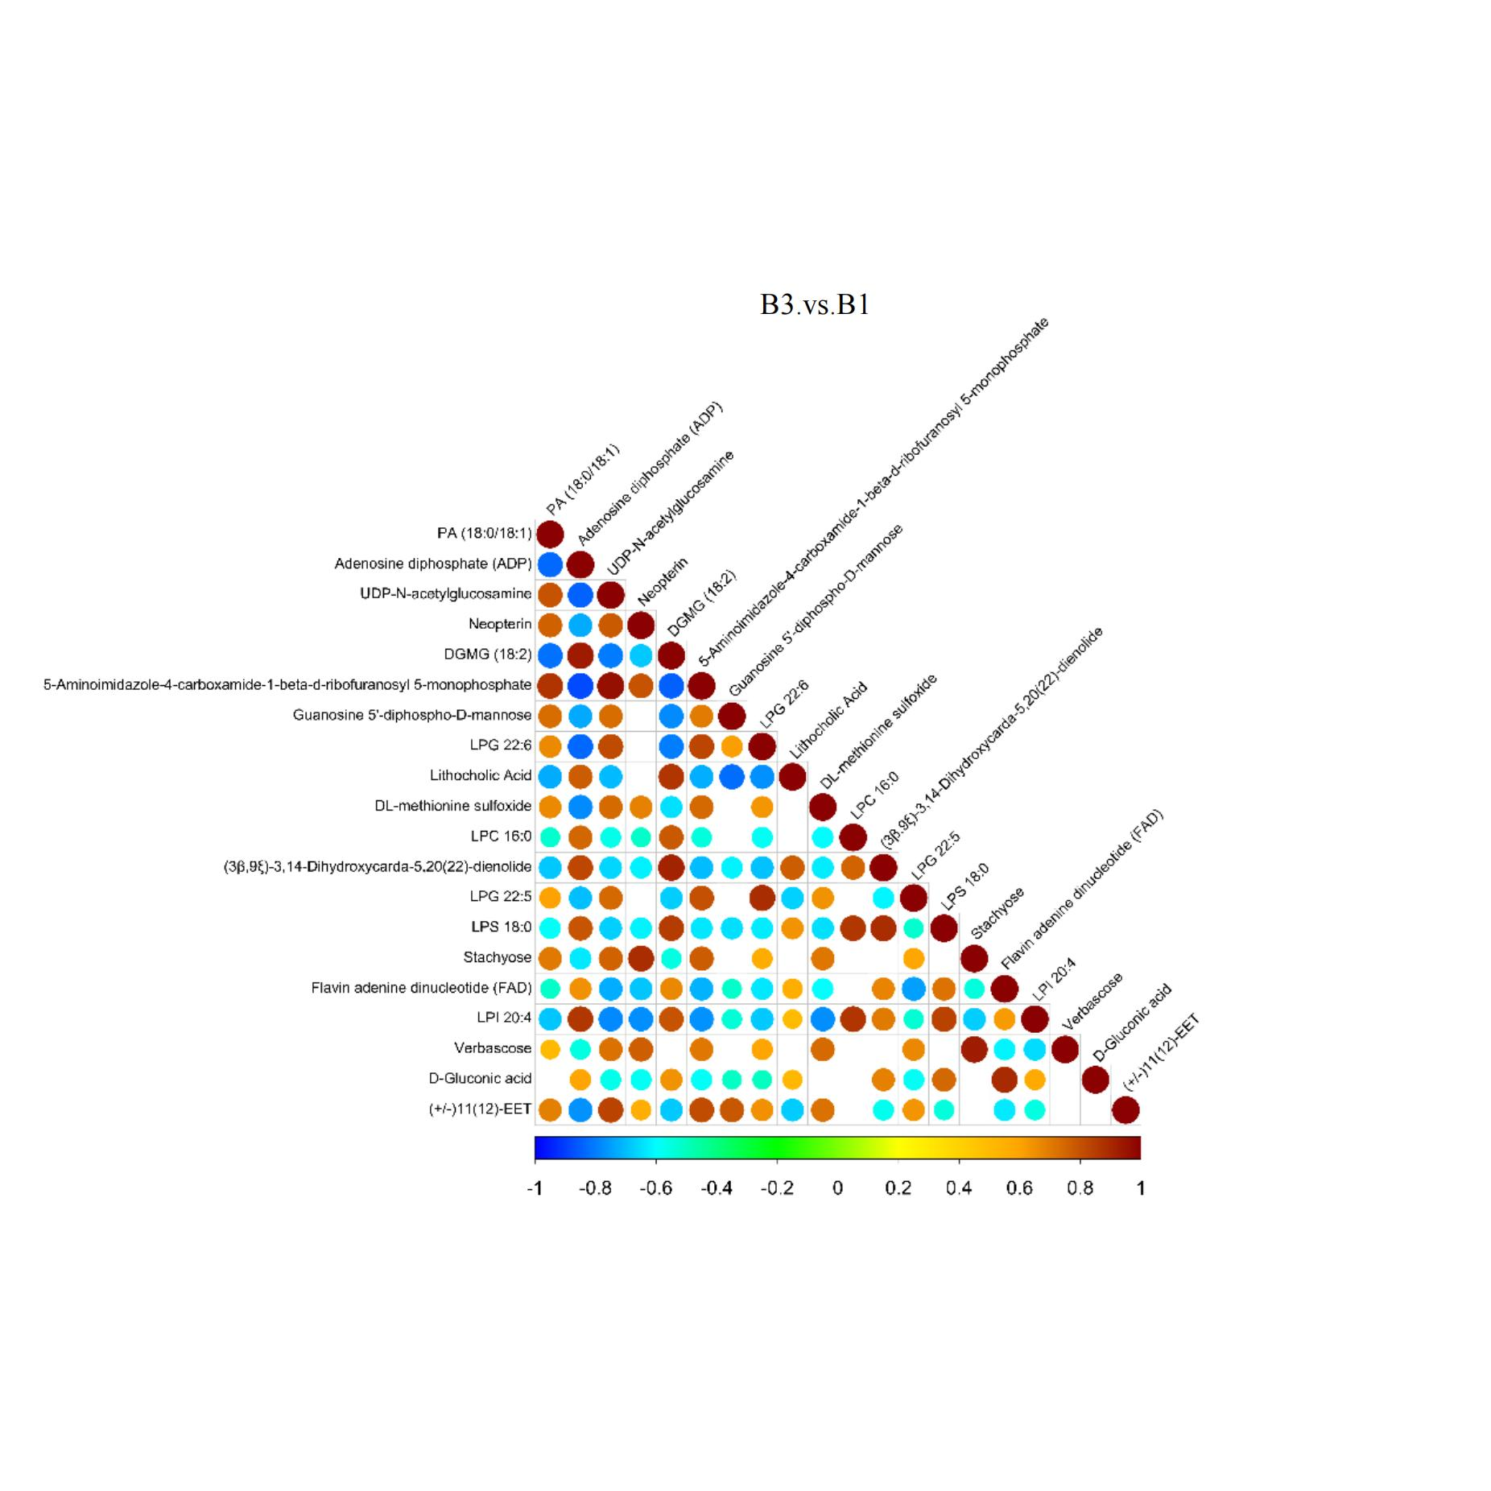
Supplement Figure 3A Differential Metabolite Correlation Analysis between B3 and B1(ESI- mode)

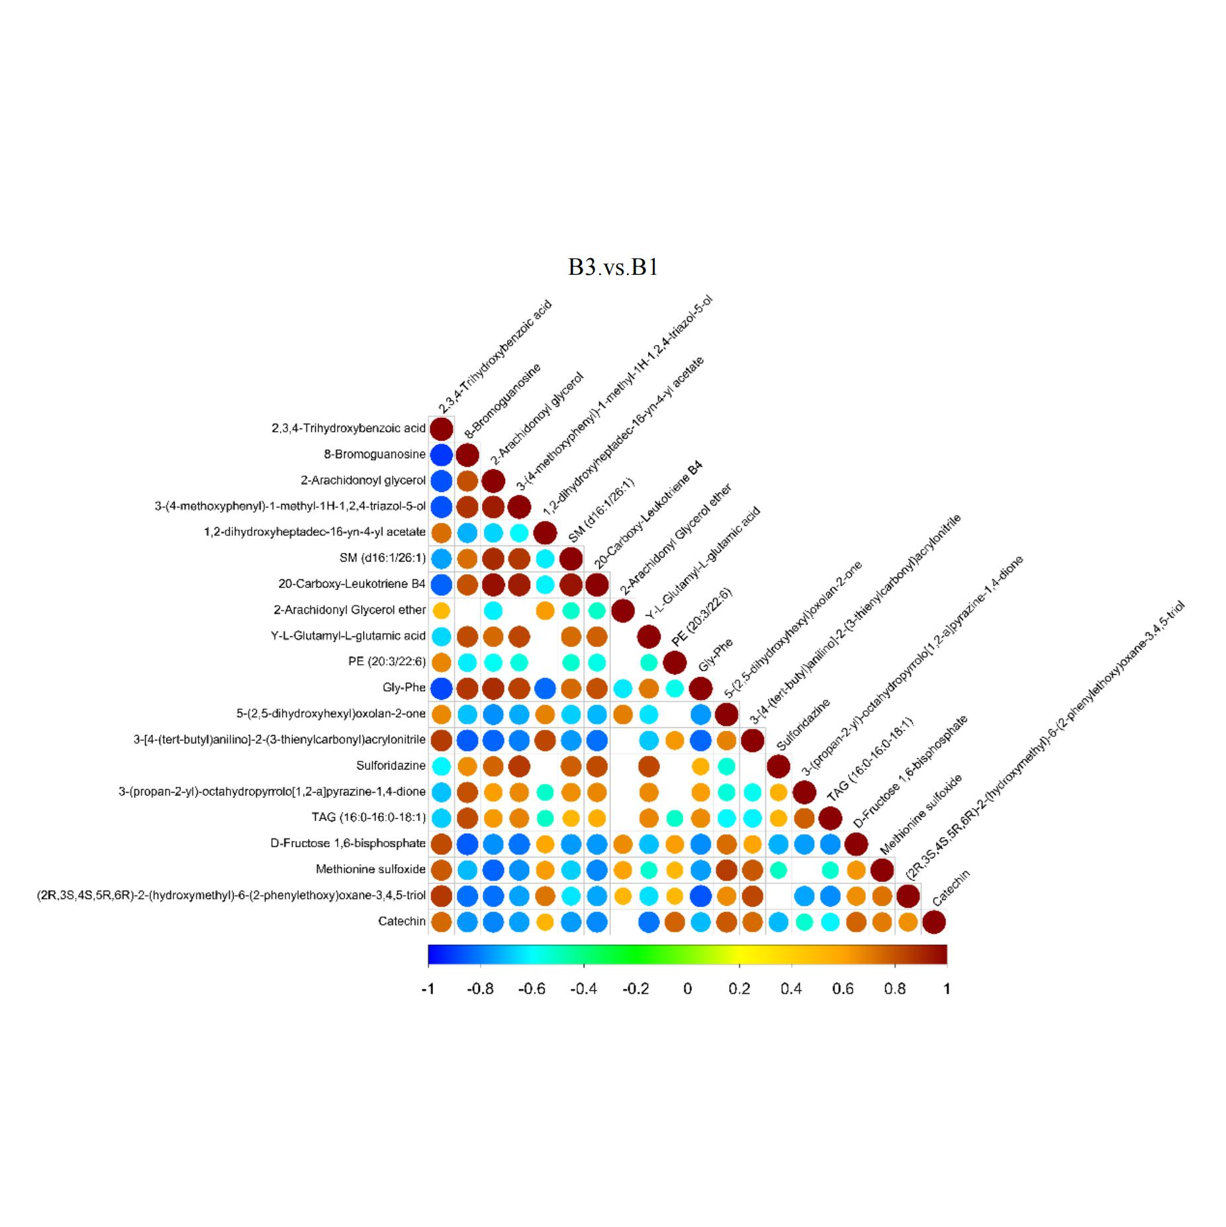
Supplement Figure 3B Differential Metabolite Correlation Analysis between B3 and B1(ESI+ mode)

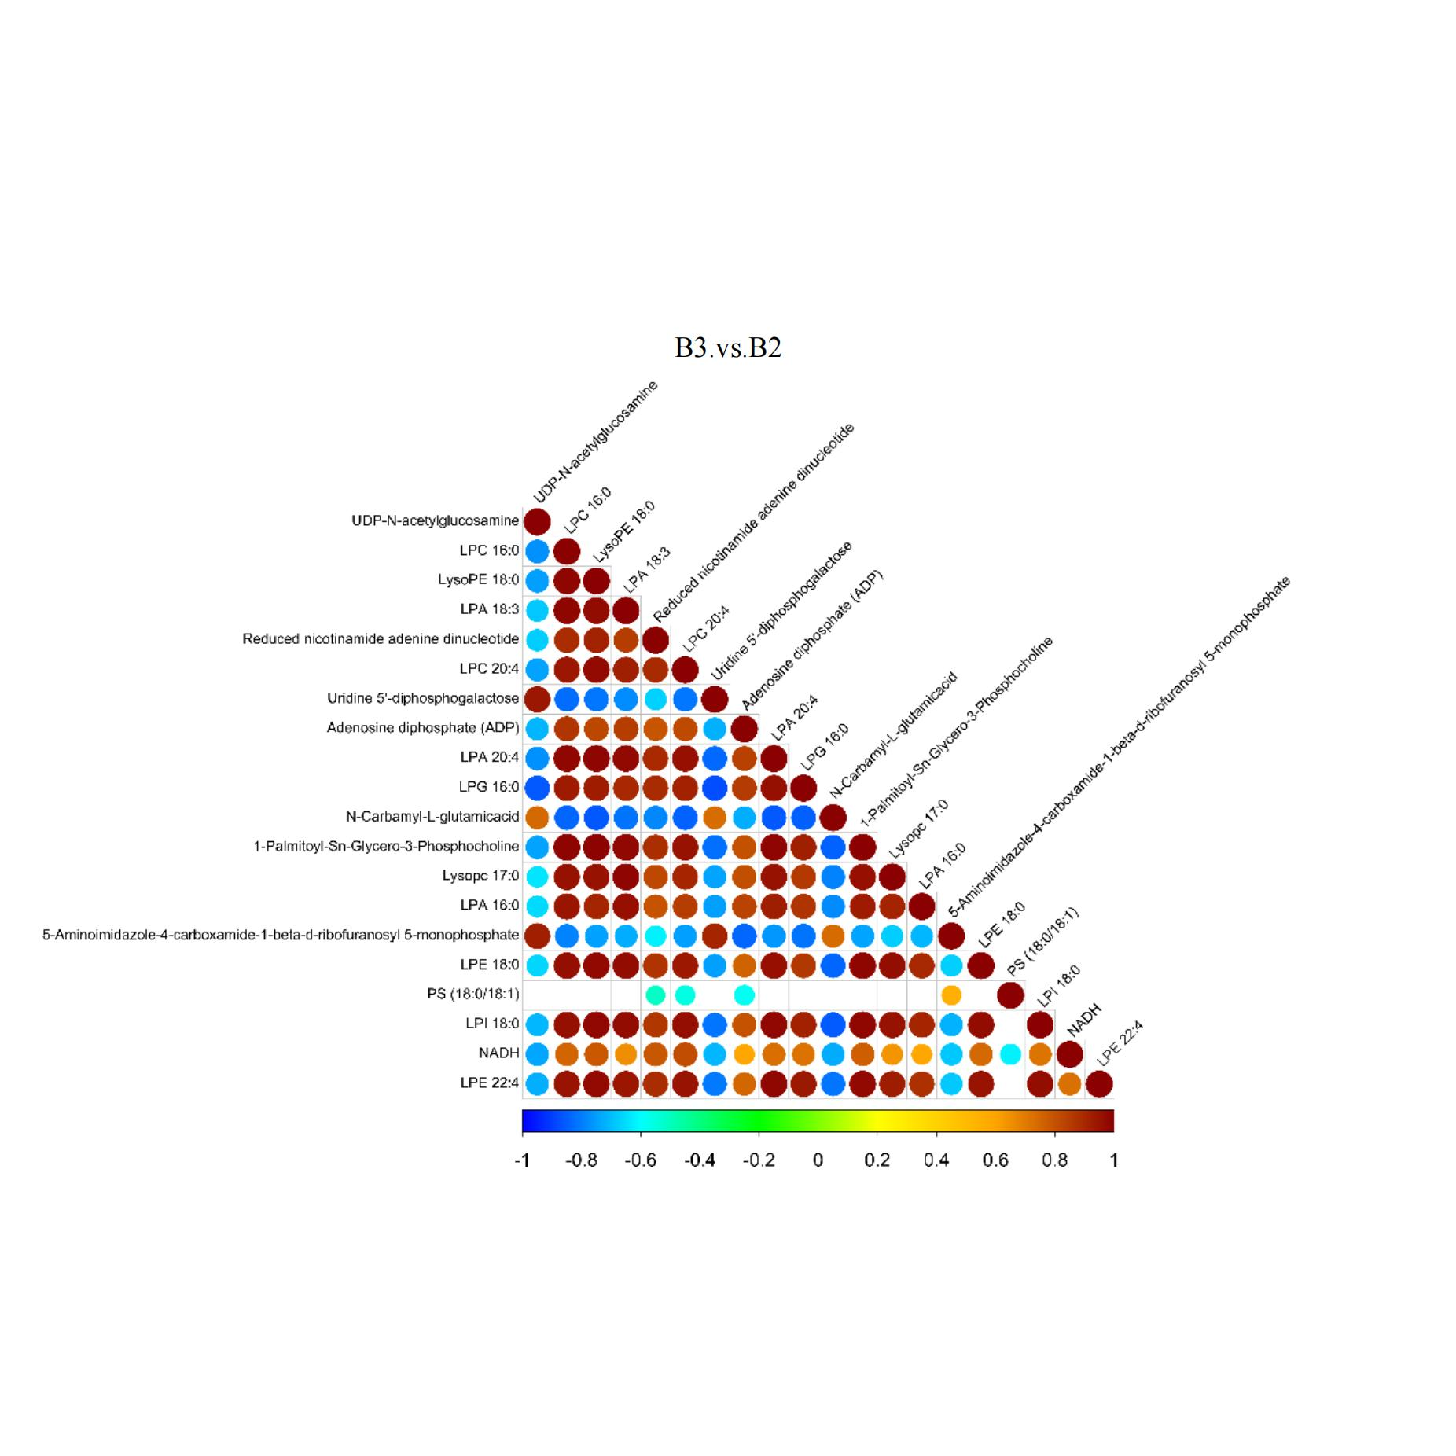
Supplement Figure 3C Differential Metabolite Correlation Analysis between B3 and B2(ESI- mode)

\

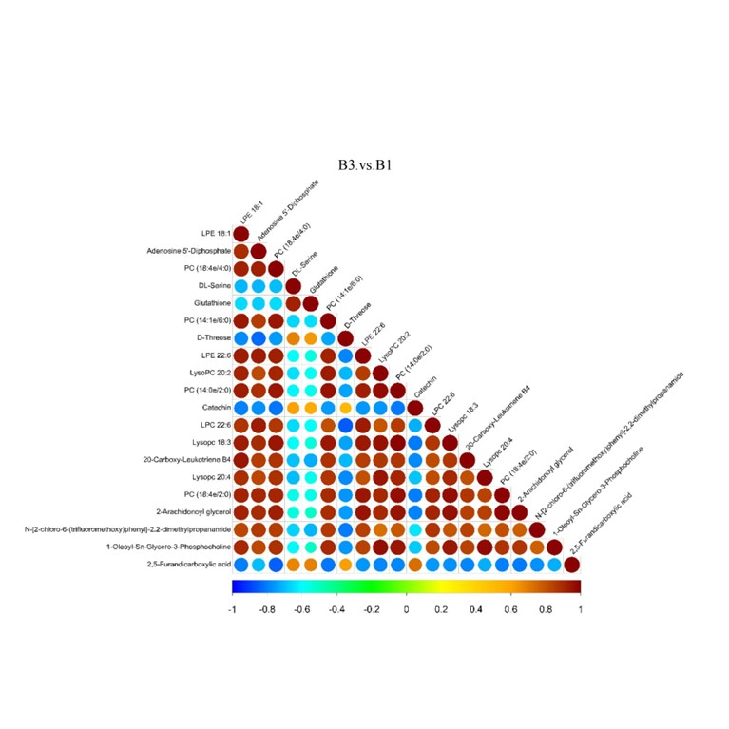
Supplement Figure 3D Differential Metabolite Correlation Analysis between B3 and B2(ESI+ mode)

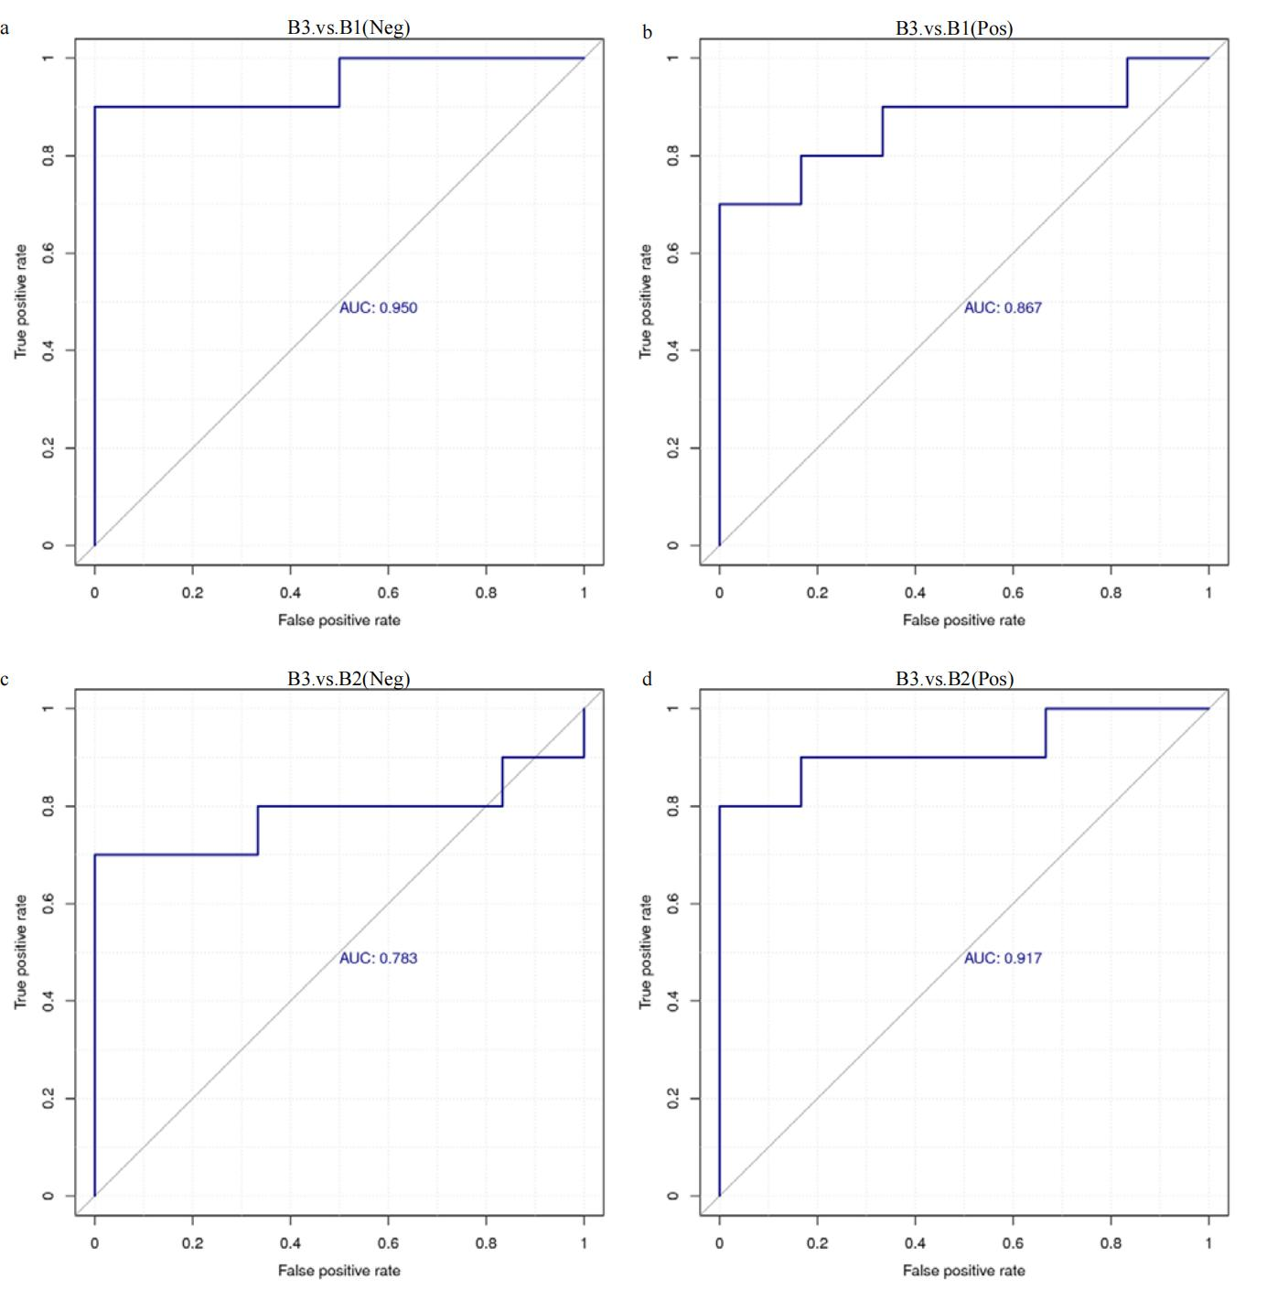
Supplement Figure 4 ROC CURVES OF quantitative values of DEMs between(a)B3 and B1(ESI-)(b)B3 and B1(ESI+)(c)B3 and B2(ESI-)(d) B3 and B2(ESI+)

