Supporting information

MOF-Derived Hybrid Arrays of Cobalt-Embedded Nitrogen-doped Carbon Nanotubes for Efficient Hydrogen Evolution Reaction

Ruijing Wang*, Lijuan Jiang, Qunlong Wang, Guang-Feng Wei, Xuefeng Wang*

Shanghai Key Lab of Chemical Assessment and Sustainability, School of Chemical Science and Engineering, Tongji University, Shanghai 200092, China

* Email: 18ruijing@tongji.edu.cn
xfwang@tongji.edu.cn

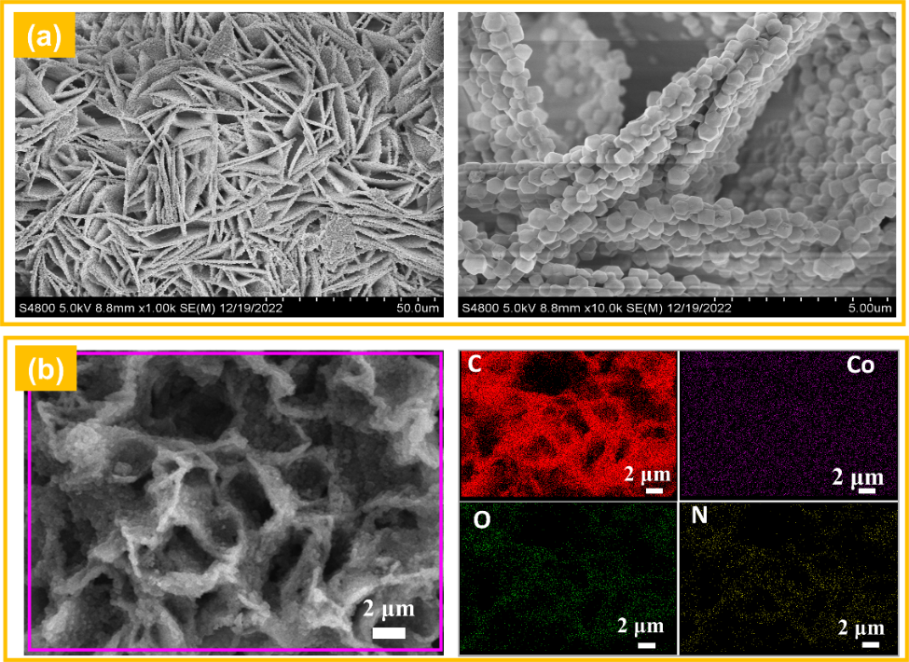
Fig. S1 a The SEM images of the ZIF-67/NF, b SEM-Mapping of Co-NCNT/NF.
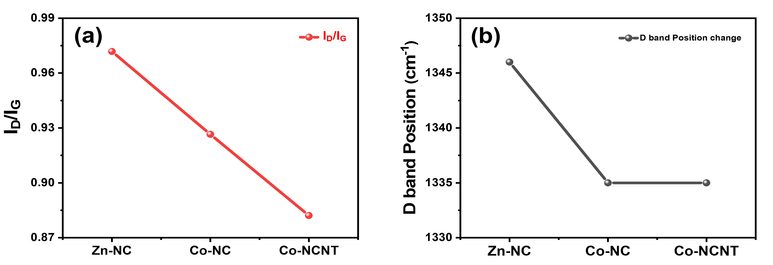
Fig. S2 The fitting data of Raman spectra of Zn-NC, Co-NC and Co-NCNT, a I_{D}/I_{G}, b D peak.
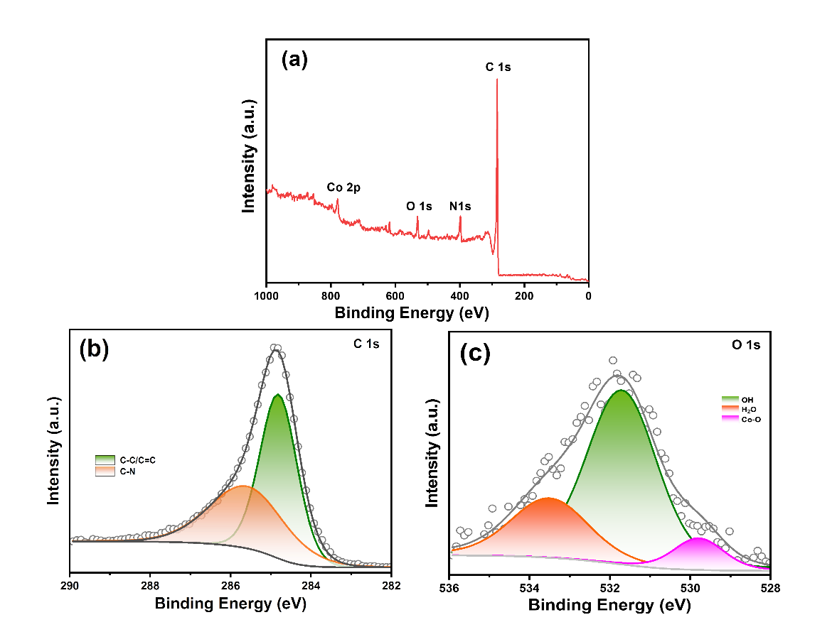
Fig. S3 The XPS spectra of Co-NCNT, a the full spectrum, b C 1s, c O1s.
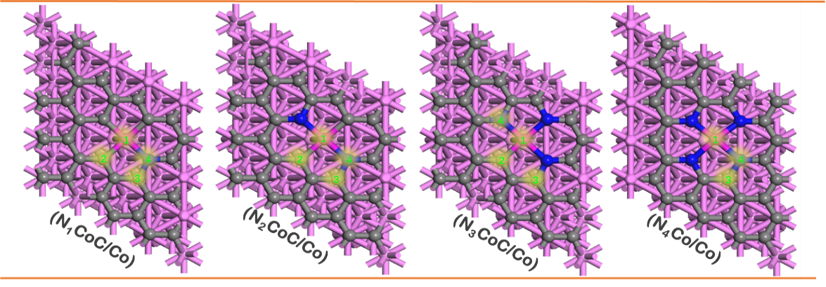
Fig. S4 The models of N_{x}CoC/Co with the different N coordination and the corresponding active sites labeled by the number (1 for Co site, 2 for Co-C site with the hydrogen adsorbing on C atom, 3 for Co-N-C site with the hydrogen adsorbing on C atom connected N atom, 4 for N site with the hydrogen adsorbing on N site connected by Co actom).
Table S1. The ΔG_{H*} of N_{x}CoC/Co on different sites.
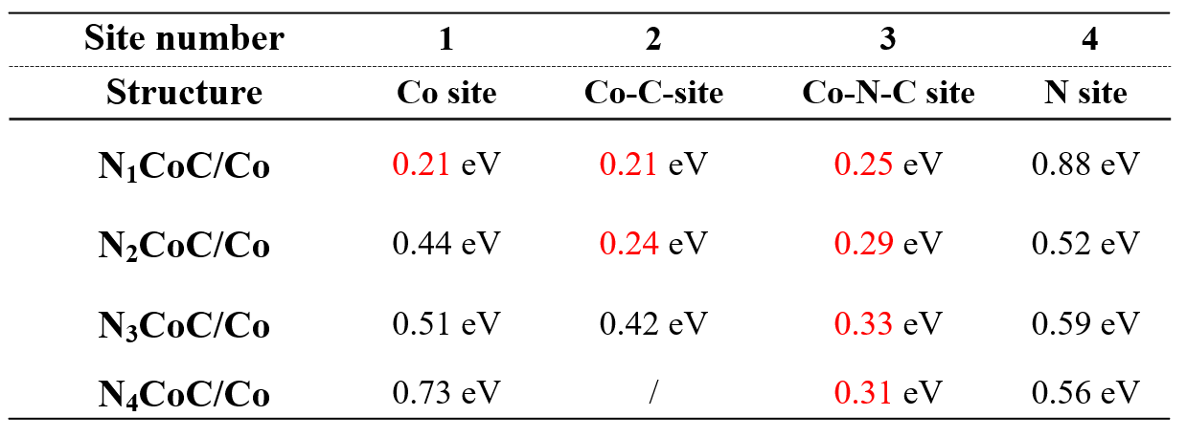
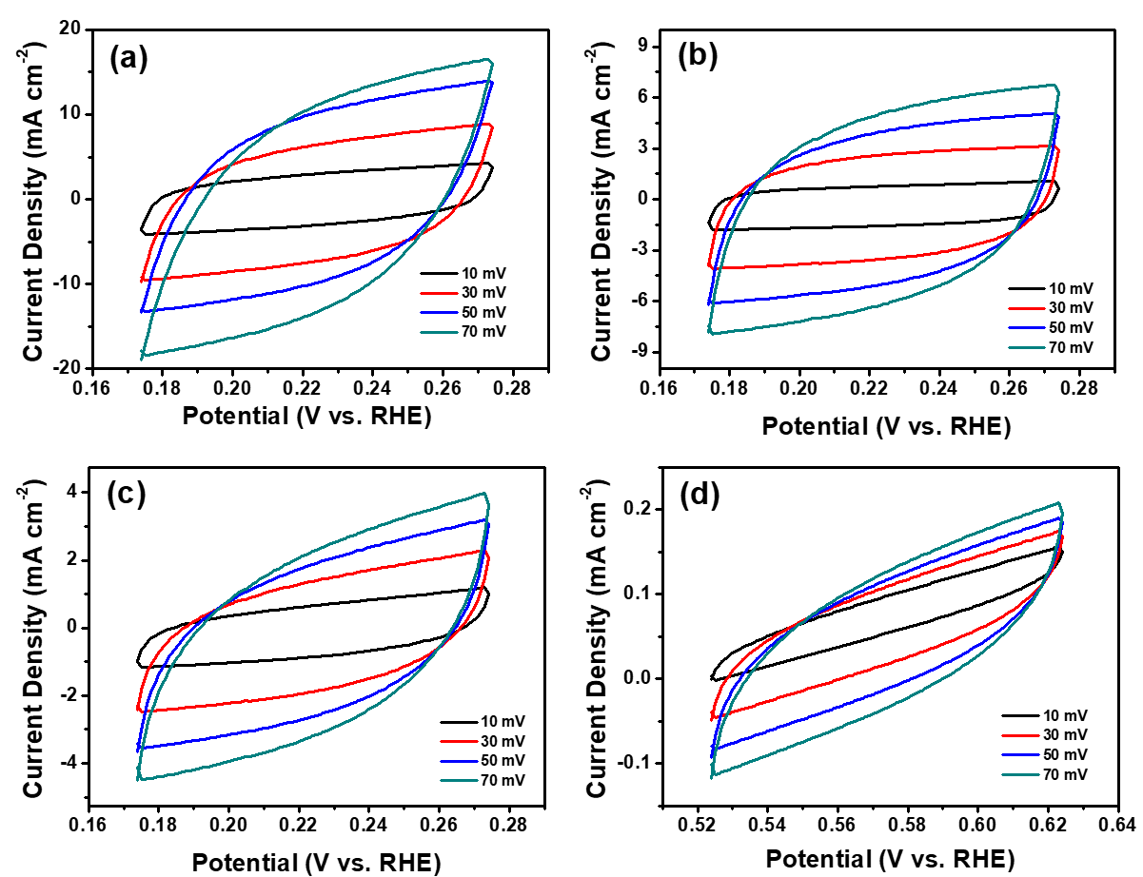
Fig. S5 a The CV curves of a Co-NCNT/NF, b Co-NC, c Zn-NC/NF, d NF at different scan rates.
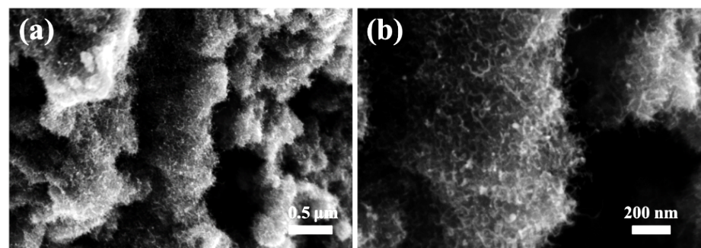
Fig. S6 The SEM images of the Co-NCNT/Ni after stability test.

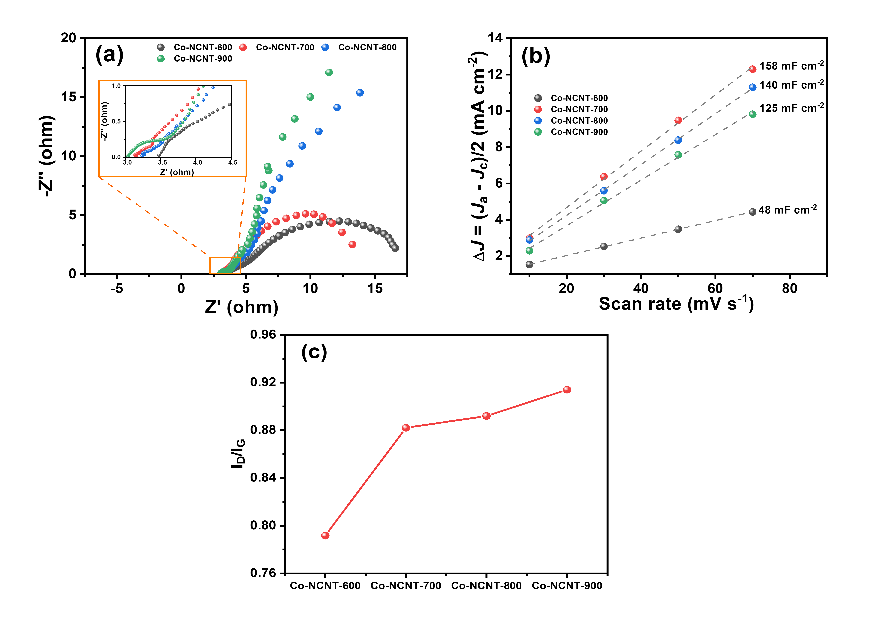
Fig. S7 a Nyquist plot, b C_{dl}, c the fitting Raman data of Co-NCNT/NF at different annealing temperatures.
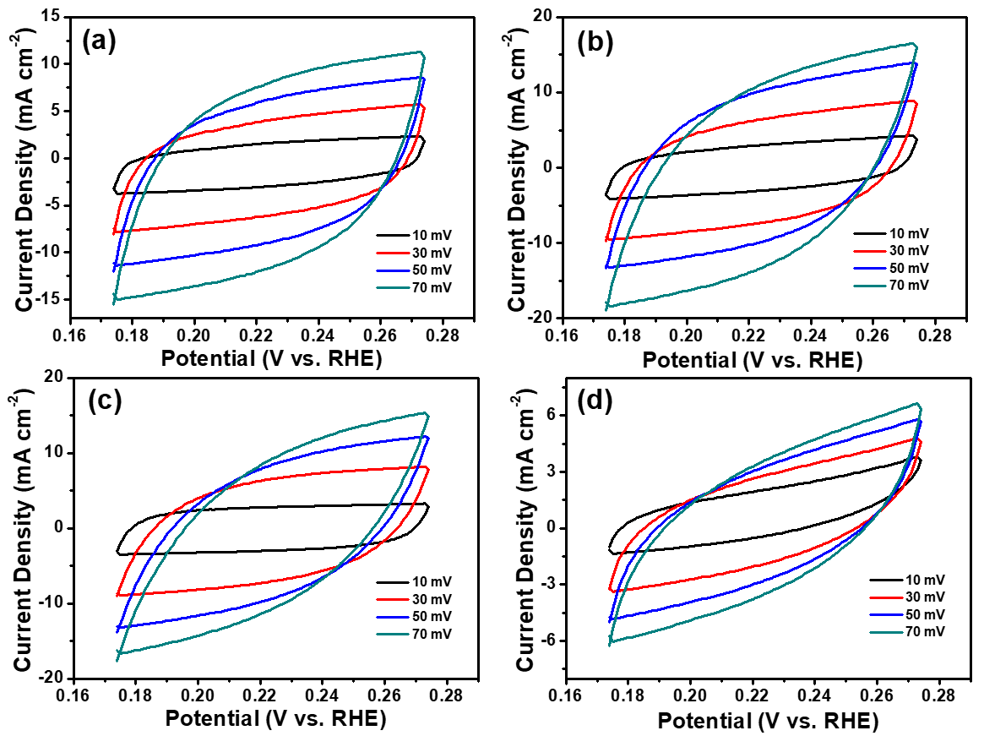
Fig. S8 The CV curves of Co-NCNT/NF at different annealing temperatures (a Co-NCNT-600; b Co-NCNT -700; c Co-NCNT -800; d Co-NCNT -900).
Table S2. Comparison of the HER activity of Co-NCNT Array with the reported Co-NC based electrocatalysts in 1 M KOH solution.
Catalysts | Current density (mA cm⁻²) | Corresponding overpotential (mV) | Refs.
Co@C/NC Composites | 10 | 175 | Energy Fuels 2022, 36, 1688-1696.
Ni-ZIF/NC | 10 | 163 | Journal of Colloid and Interface Science 604 (2021) 441–457
Co-MOF derived Carbon | 10 | 233 | Angew. Chem. Int. Ed. Engl. 2017, 56 (44), 13781-13785
Co-NPs/N-C-700 | 10 | 201 | Applied Catalysis B: Environmental 282 (2021) 119463
Co@NC/B-NCNTs | 10 | 182 | Electrochimica Acta 342 (2020) 136076
Co-NCNT arrays | 10 | 157 | This work

