Author’s Biography

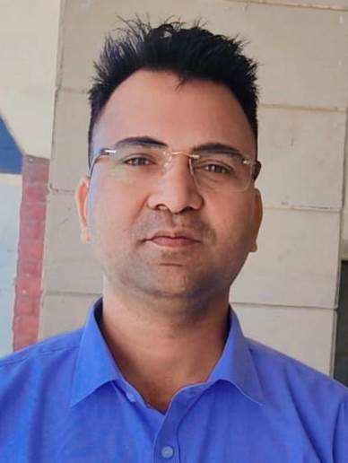
Dr. Akash Jaiman is working as an Associate Professor, Department of CSE, Poornima Institute of Engineering and Technology, Jaipur, India. His research area is IoT and AI.


Ms. Aniva Sharma, is working as an Assistant Professor, Department of Electrical Engineering, Poornima Institute of Engineering and Technology, Jaipur, India. Her research area is smart power grid and IoT.

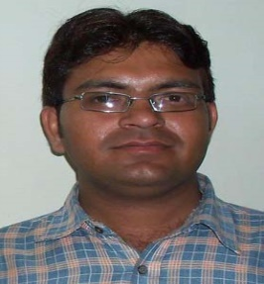
Mr. Vikas Jaiman, is working as an Assistant Professor, Department of Electronics and Communication Engineering, Compucom Institute of Technology and Management, Jaipur, India. His research area is embedded systems and renewable energy.

Mr. Naveen Porwal, is working as an Assistant Professor, Department of Mechanical Engineering, Poornima Institute of Engineering and Technology, Jaipur, India. His research area is smart mechanical systems.

