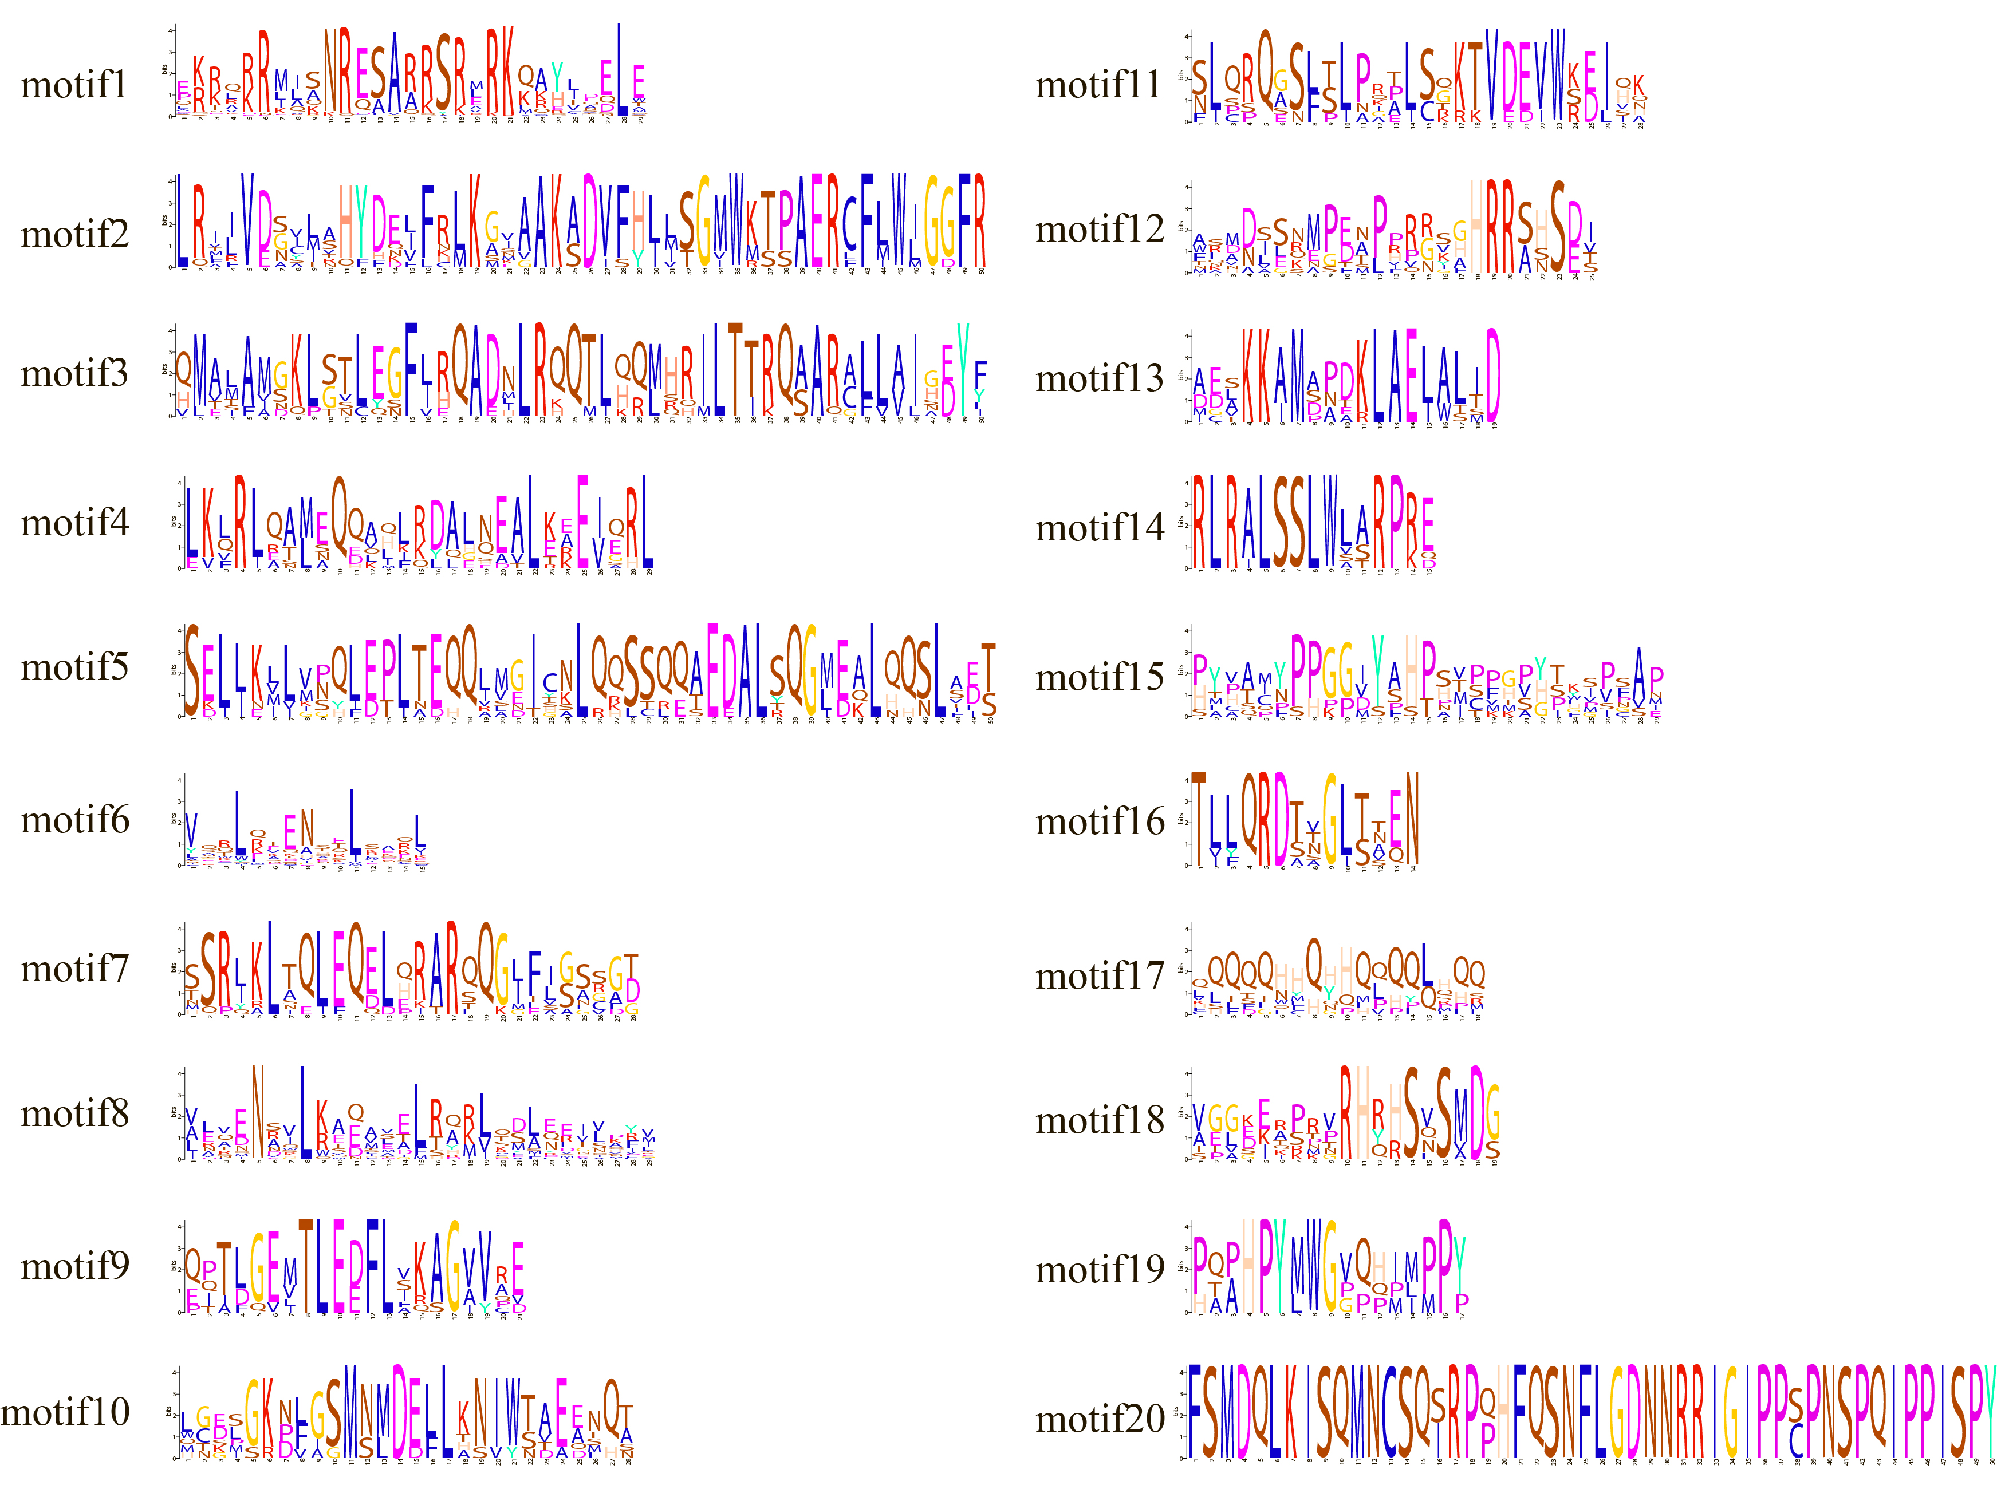
Fig. S1 20 motifs of BhbZIP genes. The height of the letters indicates the conserved amino acids, with different bases in different colors.

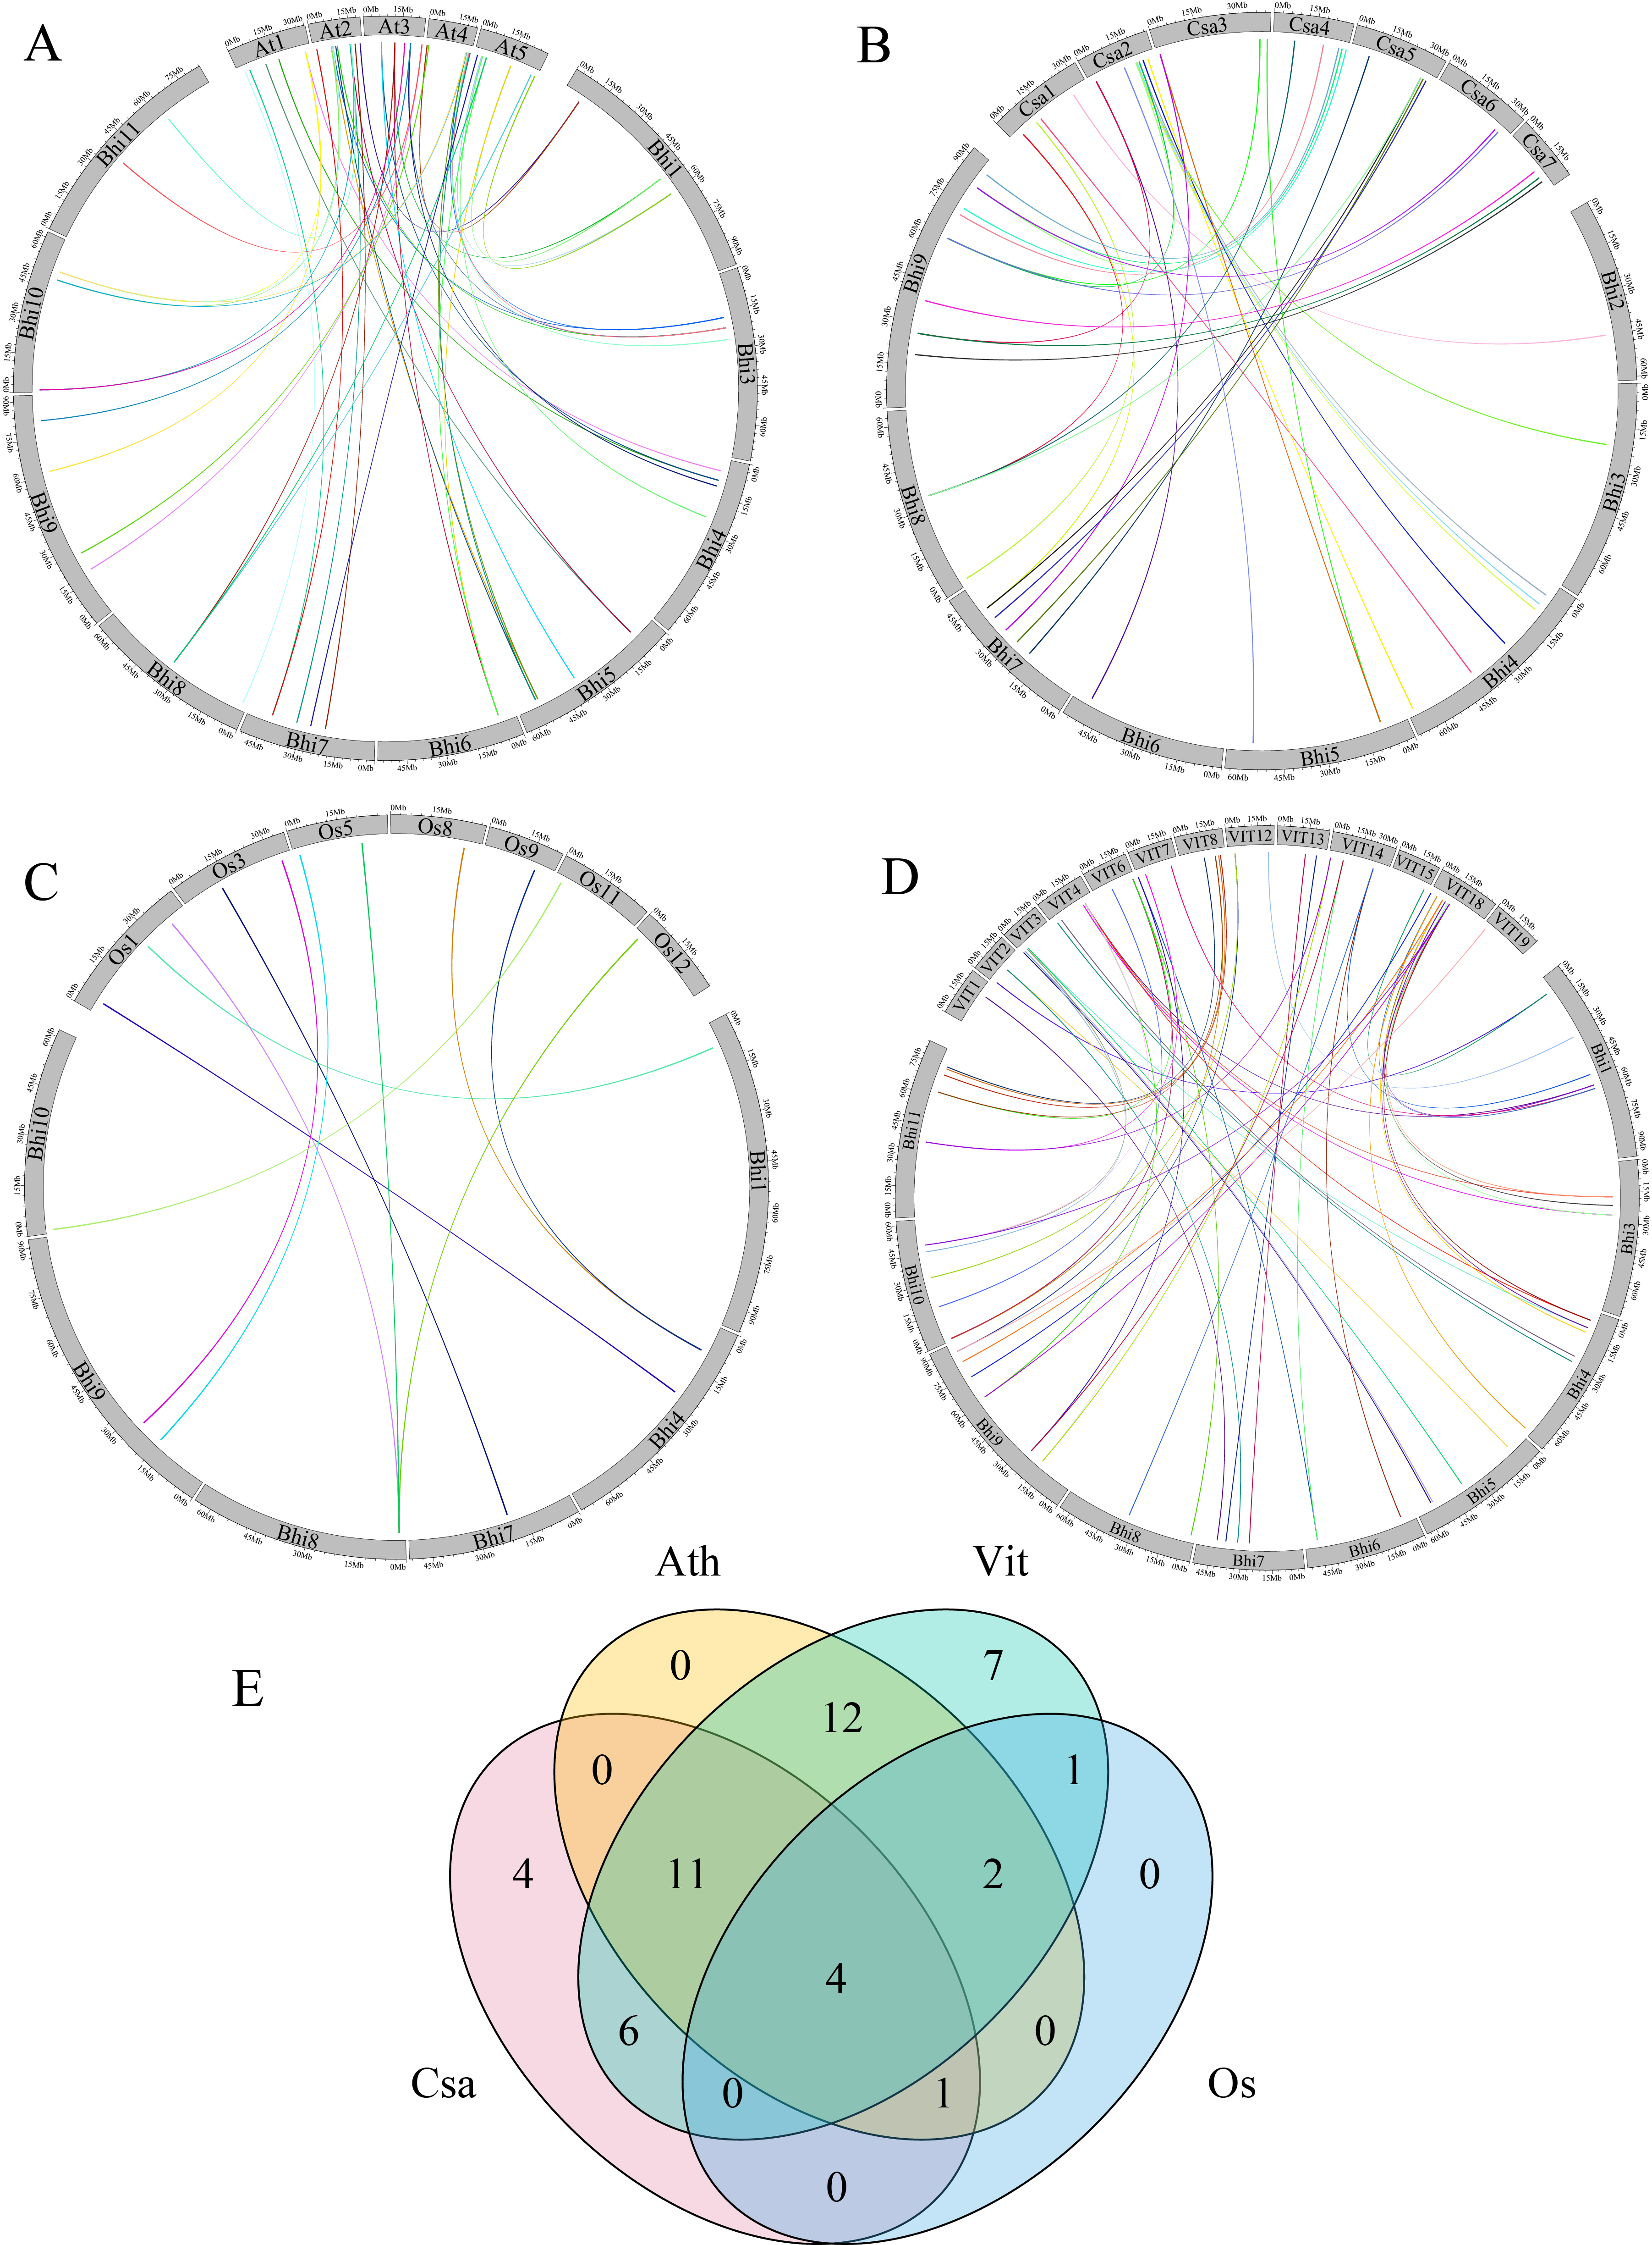
Fig. S2 Synteny analysis of the bZIP genes between wax gourd, and (A) Arabidopsis, (B) Cucumber, (C) Rice, (D) Grapes. The different colour lines indicated gene blocks in wax gourd that were orthologous to the other genomes, which delineate the collinear bZIP gene pairs. (E)The numbers of bZIP genes forming syntenic pairs between wax gourd and other four species which visualized using Venn plot.

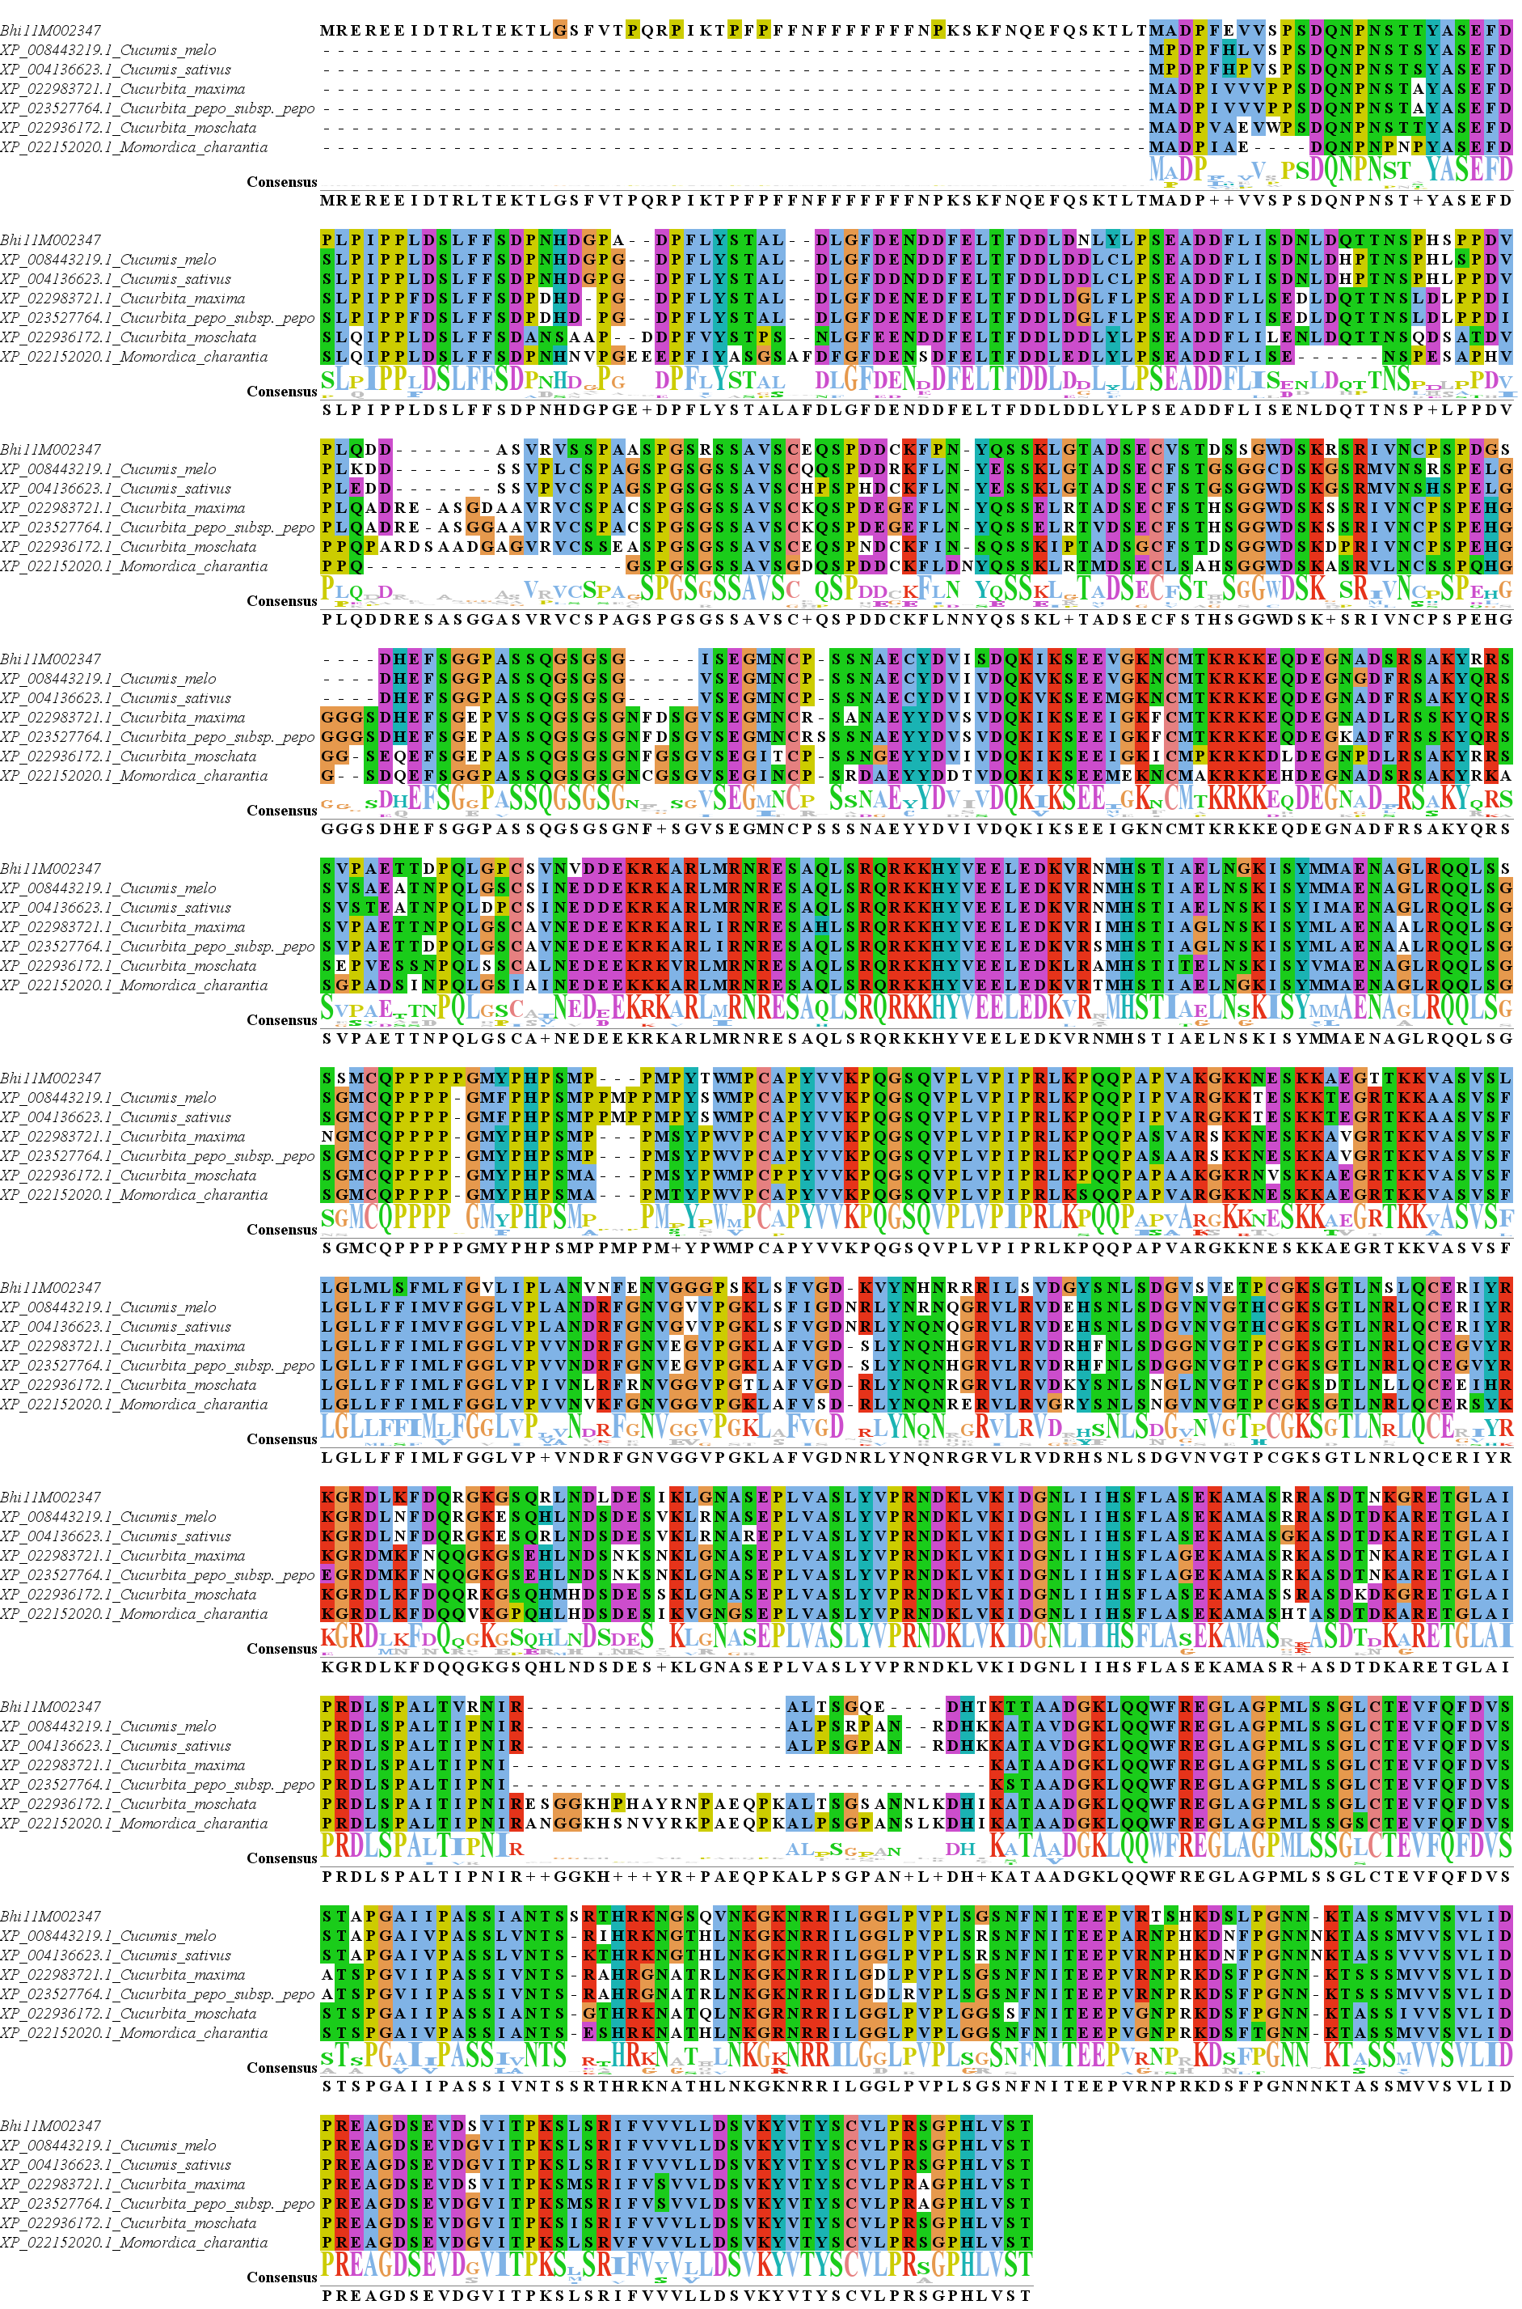
Fig. S3 Alignment of BhbZIP58 with other Cucurbitaceae homologous proteins. The letters at the bottom indicate the conservatism of the base and the overall height from the letter piles at each point shows the sequence conservation at that position.
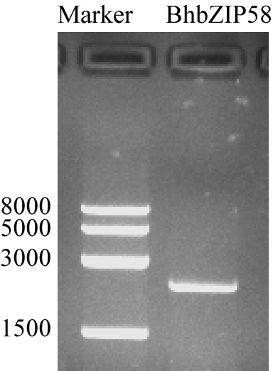
Fig. S4 Clone of BhbZIP58. Marker, Trans 8000bp DNA Marker. The picture of gel was cropped.

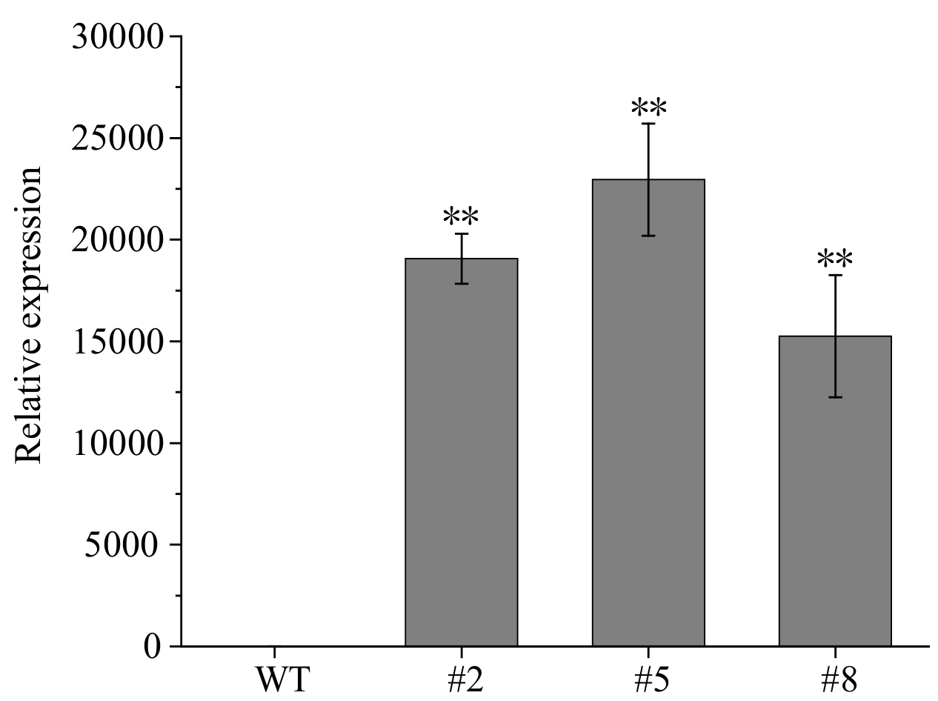
Fig. S5. Expression of BhbZIP58 in WT and 35S:BhbZIP58 seedlings. Values are means ± SDs (n = 3); **, p < 0.01 (Student’s t-test).

Table S1 Basic information of the bZIP genes identified in wax gourd
Gene name | GeneID | ChrID | Start：end | Length(aa) | PI | MW(KDa) | GRAVY
BhbZIP1 | Bhi01G000318 | chr1 | 7530748:7536413 | 417 | 9.05 | 44.31 | -0.705
BhbZIP2 | Bhi01G000868 | chr1 | 23273843:23291175 | 419 | 6.11 | 45.67 | -0.774
BhbZIP3 | Bhi01G000872 | chr1 | 23411561:23422206 | 413 | 6.44 | 45.46 | -0.785
BhbZIP4 | Bhi01G001186 | chr1 | 32661852:32668840 | 378 | 7.94 | 42.69 | -1.023
BhbZIP5 | Bhi01G001706 | chr1 | 53011531:53013251 | 163 | 6.15 | 19.12 | -1.022
BhbZIP6 | Bhi01G001873 | chr1 | 58550380:58551754 | 151 | 5.61 | 17.22 | -0.595
BhbZIP7 | Bhi01G001913 | chr1 | 60375671:60383941 | 323 | 7.11 | 36.88 | -0.588
BhbZIP8 | Bhi02G001384 | chr2 | 45029004:45036543 | 273 | 7.89 | 30.87 | -0.844
BhbZIP9 | Bhi03G000687 | chr3 | 17267714:17270928 | 140 | 5.11 | 16.18 | -0.895
BhbZIP10 | Bhi03G000814 | chr3 | 21508563:21510071 | 210 | 7.74 | 24.75 | -0.899
BhbZIP11 | Bhi03G000984 | chr3 | 26322523:26329349 | 364 | 6.49 | 38.42 | -0.919
BhbZIP12 | Bhi04G000003 | chr4 | 57745:65058 | 333 | 9.62 | 37.23 | -0.588
BhbZIP13 | Bhi04G000176 | chr4 | 4884614:4885915 | 136 | 6.11 | 15.71 | -0.633
BhbZIP14 | Bhi04G000330 | chr4 | 8835126:8839407 | 411 | 9.58 | 44.36 | -0.588
BhbZIP15 | Bhi04G000415 | chr4 | 11263231:11264074 | 176 | 7.06 | 20.64 | -0.45
BhbZIP16 | Bhi04G000795 | chr4 | 24471147:24473685 | 158 | 10.56 | 17.54 | -1.149
BhbZIP17 | Bhi04G000896 | chr4 | 27409625:27413653 | 327 | 6.33 | 36.02 | -0.677
BhbZIP18 | Bhi04G001290 | chr4 | 40810370:40816363 | 321 | 8.56 | 35.91 | -0.862
BhbZIP19 | Bhi04G001359 | chr4 | 43011626:43015983 | 322 | 9.48 | 35.53 | -0.706
BhbZIP20 | Bhi04G001371 | chr4 | 43255315:43257783 | 350 | 7.86 | 38.16 | -0.653
BhbZIP21 | Bhi04G001577 | chr4 | 50855951:50859846 | 467 | 5.92 | 51.6 | -0.382
BhbZIP22 | Bhi04G001617 | chr4 | 53721120:53721711 | 152 | 8.32 | 18.19 | -0.9
BhbZIP23 | Bhi04G002048 | chr4 | 67789639:67795009 | 400 | 6.69 | 45.87 | -0.528
BhbZIP24 | Bhi05G000290 | chr5 | 9230572:9238888 | 401 | 6.78 | 42.73 | -0.921
BhbZIP25 | Bhi05G000555 | chr5 | 22477177:22483880 | 269 | 6.49 | 30.21 | -0.751
BhbZIP26 | Bhi05G000928 | chr5 | 38558704:38563060 | 409 | 9.49 | 44.84 | -0.603
BhbZIP27 | Bhi05G001473 | chr5 | 55542151:55545169 | 272 | 5.87 | 29.85 | -0.664
BhbZIP28 | Bhi05G001531 | chr5 | 56537548:56541372 | 566 | 6 | 61.83 | -0.873
BhbZIP29 | Bhi05G001533 | chr5 | 56550412:56554943 | 576 | 6.84 | 63.44 | -0.941
BhbZIP30 | Bhi06G000246 | chr6 | 6798813:6800063 | 179 | 6.31 | 21.08 | -1.039
BhbZIP31 | Bhi06G001517 | chr6 | 49889635:49894255 | 434 | 6.35 | 46.7 | -0.691
BhbZIP32 | Bhi07G000420 | chr7 | 20197966:20204947 | 343 | 5.97 | 37.96 | -0.682
BhbZIP33 | Bhi07G000619 | chr7 | 26236299:26243837 | 286 | 8.87 | 31.91 | -0.651
BhbZIP34 | Bhi07G000824 | chr7 | 32032058:32039171 | 423 | 7.12 | 45.69 | -0.865
BhbZIP35 | Bhi07G001014 | chr7 | 37901498:37908733 | 331 | 8.92 | 37.23 | -0.561
BhbZIP36 | Bhi07G001174 | chr7 | 42289776:42291848 | 200 | 6.11 | 23.01 | -0.738
BhbZIP37 | Bhi08G000051 | chr8 | 2022959:2027458 | 395 | 7.76 | 44.68 | -0.484
BhbZIP38 | Bhi08G000880 | chr8 | 34406425:34407567 | 211 | 6.51 | 24.52 | -0.848
BhbZIP39 | Bhi09G000681 | chr9 | 18482223:18483529 | 140 | 8.09 | 16.45 | -0.698
BhbZIP40 | Bhi09G000917 | chr9 | 26060663:26084212 | 441 | 6.21 | 48.38 | -0.783
BhbZIP41 | Bhi09G001219 | chr9 | 37927622:37931189 | 350 | 6.81 | 38.54 | -0.796
BhbZIP42 | Bhi09G001870 | chr9 | 61450898:61452333 | 177 | 6.29 | 20.65 | -0.809
BhbZIP43 | Bhi09G002211 | chr9 | 70900539:70902105 | 203 | 9.45 | 23.28 | -0.743
BhbZIP44 | Bhi09G002310 | chr9 | 73484963:73488510 | 357 | 4.45 | 38.93 | -0.46
BhbZIP45 | Bhi09G002631 | chr9 | 82194776:82195425 | 153 | 9.62 | 18.25 | -0.831
BhbZIP46 | Bhi09G002846 | chr9 | 87934169:87937265 | 324 | 6.14 | 35.85 | -0.83
BhbZIP47 | Bhi10G000025 | chr10 | 983201:985428 | 345 | 7.62 | 39.2 | -0.744
BhbZIP48 | Bhi10G000031 | chr10 | 1156663:1165193 | 519 | 6.78 | 58.83 | -0.592
BhbZIP49 | Bhi10G000691 | chr10 | 17973917:17977572 | 391 | 6.86 | 41.91 | -0.638
BhbZIP50 | Bhi10G001078 | chr10 | 32950605:32953718 | 278 | 7.17 | 31.85 | -0.947
BhbZIP51 | Bhi10G001457 | chr10 | 46004337:46007733 | 273 | 6.26 | 29.84 | -0.729
BhbZIP52 | Bhi10G001591 | chr10 | 49402470:49404070 | 160 | 5.37 | 17.61 | -0.475
BhbZIP53 | Bhi11G001061 | chr11 | 37143787:37147045 | 142 | 9.42 | 15.89 | -0.508
BhbZIP54 | Bhi11G001648 | chr11 | 55713254:55717815 | 519 | 6.85 | 58.01 | -0.741
BhbZIP55 | Bhi11G001911 | chr11 | 62710703:62714289 | 442 | 8.64 | 47.37 | -0.587
BhbZIP56 | Bhi11G002213 | chr11 | 71682473:71691648 | 514 | 6.73 | 57.86 | -0.654
BhbZIP57 | Bhi11G002318 | chr11 | 74922564:74931505 | 468 | 8.41 | 51.65 | -0.55
BhbZIP58 | Bhi11G002347 | chr11 | 75954267:75960158 | 763 | 6.39 | 82.68 | -0.565
BhbZIP59 | Bhi12G000925 | chr12 | 31933500:31935616 | 147 | 5.75 | 17.22 | -0.839
BhbZIP60 | BhiUN613G6 | Contig613 | 139383:145977 | 387 | 8.77 | 42.51 | -0.791
BhbZIP61 | BhiUN916G5 | Contig916 | 105521:109140 | 421 | 6.86 | 47.52 | -0.747

Table S2 Secondary structure and subcellular localization of the 61 BhbZIP gene family members.
Gene name | Alpha helix | Extended trand | Beta turn | Random coil | Subcellular localization
BhbZIP1 | 26.14% | 4.32% | 2.40% | 67.15% | Nucleus.
BhbZIP2 | 33.41% | 4.06% | 1.43% | 61.10% | Nucleus.
BhbZIP3 | 36.56% | 4.84% | 1.94% | 56.66% | Nucleus.
BhbZIP4 | 35.98% | 2.91% | 0.53% | 60.58% | Nucleus.
BhbZIP5 | 51.53% | 3.07% | 1.84% | 43.56% | Nucleus.
BhbZIP6 | 60.26% | 2.65% | 3.97% | 33.11% | Nucleus.
BhbZIP7 | 57.59% | 7.43% | 2.79% | 32.20% | Nucleus.
BhbZIP8 | 36.63% | 4.40% | 2.20% | 56.78% | Nucleus.
BhbZIP9 | 72.86% | 2.86% | 5.00% | 19.29% | Nucleus.
BhbZIP10 | 40.48% | 5.71% | 2.86% | 50.95% | Nucleus.
BhbZIP11 | 25.27% | 4.67% | 1.65% | 68.41% | Nucleus.
BhbZIP12 | 66.37% | 6.61% | 1.50% | 25.53% | Nucleus.
BhbZIP13 | 71.32% | 2.21% | 1.47% | 25.00% | Nucleus.
BhbZIP14 | 31.87% | 9.73% | 1.70% | 56.69% | Nucleus.
BhbZIP15 | 67.61% | 2.84% | 1.14% | 28.41% | Nucleus.
BhbZIP16 | 52.53% | 0.63% | 0.63% | 46.20% | Nucleus.
BhbZIP17 | 37.61% | 6.73% | 2.75% | 52.91% | Nucleus.
BhbZIP18 | 33.02% | 5.92% | 1.56% | 59.50% | Nucleus.
BhbZIP19 | 41.30% | 5.59% | 1.55% | 51.55% | Nucleus.
BhbZIP20 | 37.71% | 6.29% | 2.57% | 53.43% | Nucleus.
BhbZIP21 | 50.75% | 10.71% | 2.57% | 35.97% | Nucleus.
BhbZIP22 | 66.45% | 6.58% | 1.32% | 25.66% | Nucleus.
BhbZIP23 | 59.00% | 8.00% | 2.75% | 30.25% | Nucleus.
BhbZIP24 | 20.20% | 5.24% | 0.50% | 74.06% | Nucleus.
BhbZIP25 | 47.58% | 2.60% | 1.12% | 48.70% | Nucleus.
BhbZIP26 | 31.30% | 9.29% | 1.22% | 58.19% | Nucleus.
BhbZIP27 | 27.94% | 11.40% | 1.47% | 59.19% | Nucleus.
BhbZIP28 | 28.98% | 4.95% | 1.06% | 65.02% | Nucleus.
BhbZIP29 | 30.21% | 3.82% | 1.56% | 64.41% | Nucleus.
BhbZIP30 | 53.63% | 3.91% | 0.00% | 42.46% | Nucleus.
BhbZIP31 | 37.79% | 2.53% | 0.92% | 58.76% | Nucleus.
BhbZIP32 | 34.99% | 4.96% | 1.17% | 58.89% | Nucleus.
BhbZIP33 | 43.01% | 2.80% | 1.05% | 53.15% | Nucleus.
BhbZIP34 | 24.35% | 5.44% | 0.47% | 69.74% | Nucleus.
BhbZIP35 | 68.88% | 3.93% | 1.51% | 25.68% | Nucleus.
BhbZIP36 | 56.50% | 3.00% | 0.00% | 40.50% | Nucleus.
BhbZIP37 | 57.47% | 3.80% | 2.28% | 36.46% | Nucleus.
BhbZIP38 | 48.82% | 9.48% | 3.32% | 38.39% | Nucleus.
BhbZIP39 | 67.86% | 2.14% | 2.86% | 27.14% | Nucleus.
BhbZIP40 | 33.11% | 2.72% | 0.68% | 63.49% | Nucleus.
BhbZIP41 | 35.14% | 7.14% | 2.29% | 55.43% | Nucleus.
BhbZIP42 | 63.28% | 9.04% | 2.82% | 24.86% | Nucleus.
BhbZIP43 | 41.87% | 11.82% | 0.49% | 45.81% | Nucleus.
BhbZIP44 | 46.22% | 8.40% | 3.08% | 42.30% | Nucleus.
BhbZIP45 | 64.71% | 7.84% | 0.00% | 27.45% | Nucleus.
BhbZIP46 | 36.11% | 2.16% | 2.47% | 59.26% | Nucleus.
BhbZIP47 | 44.35% | 2.90% | 0.87% | 51.88% | Nucleus.
BhbZIP48 | 46.44% | 7.32% | 3.08% | 43.16% | Nucleus.
BhbZIP49 | 30.43% | 4.35% | 1.53% | 63.68% | Nucleus.
BhbZIP50 | 37.41% | 4.68% | 2.52% | 55.40% | Nucleus.
BhbZIP51 | 28.94% | 9.16% | 4.03% | 57.88% | Nucleus.
BhbZIP52 | 65.00% | 1.88% | 1.25% | 31.87% | Nucleus.
BhbZIP53 | 66.20% | 3.52% | 1.41% | 28.87% | Nucleus.
BhbZIP54 | 33.33% | 4.24% | 0.77% | 61.66% | Nucleus.
BhbZIP55 | 32.35% | 4.75% | 1.81% | 61.09% | Nucleus.
BhbZIP56 | 49.42% | 6.61% | 1.95% | 42.02% | Nucleus.
BhbZIP57 | 52.78% | 7.05% | 1.50% | 38.68% | Nucleus.
BhbZIP58 | 17.56% | 11.80% | 1.83% | 68.81% | Nucleus.
BhbZIP59 | 62.59% | 3.40% | 1.36% | 32.65% | Nucleus.
BhbZIP60 | 43.41% | 1.81% | 1.29% | 53.49% | Nucleus.
BhbZIP61 | 33.49% | 6.41% | 1.43% | 58.67% | Nucleus.

Table S3 Protein–Protein Interaction of online STRING
Gene | Group | protein families | multiple sequences
Bhi01M001706 | S | NOG243340 | bZIP3
Bhi02M001384 | A | NOG243340 | AREB3
Bhi04M000330 | A | NOG243340 | ABF2
Bhi04M001290 | A | NOG243340 | AREB3
Bhi04M001359 | A | NOG243340 | AT5G44080
Bhi04M001617 | S | NOG243340 | bZIP3
Bhi05M000555 | A | NOG243340 | GBF4
Bhi05M000928 | A | NOG243340 | ABF3
Bhi06M000246 | S | NOG243340 | bZIP3
Bhi07M001174 | S | NOG243340 | bZIP42
Bhi09M002211 | A | NOG243340 | AREB3
Bhi12M000925 | S | NOG243340 | bZIP3
Bhi04M000003 | D | NOG06126 | AHBP-1B
Bhi07M001014 | D | NOG06127 | AHBP-1B
Bhi11M002318 | D | NOG06128 | AHBP-1B
Bhi01M000318 | G | NOG06792 | GBF3
Bhi03M000984 | G | NOG06792 | bZIP16
Bhi05M000290 | G | NOG06792 | bZIP68
Bhi07M000824 | G | NOG06792 | bZIP16
Bhi01M001186 | E | NOG01780 | AT1G58110
Bhi07M000619 | E | NOG01780 | AT5G04840
Bhi09M002846 | E | NOG01780 | BZIP34
Bhi10M001078 | E | NOG01780 | BZIP34
BhiUN916M5 | E | NOG01780 | AT1G58110
Bhi05M001531 | I | NOG258298 | AT4G38900
Bhi05M001533 | I | NOG258298 | AT4G38900
Bhi01M000868 | I | NOG05447 | AT1G06070
Bhi01M000872 | I | NOG05447 | AT1G06070
Bhi01M001913 | D | NOG03329 | TGA1
Bhi04M002048 | D | NOG03329 | TGA7
Bhi04M001577 | D | NOG259341 | PAN
Bhi07M000420 | I | NOG258070 | AT2G40620
Bhi10M000691 | I | NOG258070 | AT2G40620
Bhi08M000051 | D | NOG02544, KOG0167 | TGA9
Bhi10M000031 | D | NOG02544, KOG0167 | TGA9
Bhi06M001517 | C | NOG03282 | BZO2H3
BhiUN613M6 | C | NOG03282 | BZO2H3
Bhi05M001473 | F | NOG08178 | bZIP23
Bhi10M001457 | F | NOG08178 | bZIP23
Bhi11M002213 | D | NOG258315 | TGA10
Bhi04M001371 | I | NOG258335 | AT1G06070
Bhi09M001219 | I | NOG258335 | AT2G40620
Bhi01M001873 | S | NOG270019 | BZIP53
Bhi09M000681 | S | NOG270019 | BZIP53
Bhi09M001870 | S | NOG270019, NOG269807 | bZIP44
Bhi11M001061 | S | NOG270019 | BZIP53
Bhi03M000687 | S | NOG269807 | bZIP44
Bhi04M000176 | S | NOG269807 | bZIP2
Bhi10M001591 | S | NOG269807 | bZIP44
Bhi11M001911 | A | NOG257560 | ABI5
Bhi11M002347 | B | NOG39651, NOG01724 | BZIP17
Bhi10M000025 | A | NOG259163 | DPBF2
Bhi04M000896 | C | NOG07729 | BZIP9
Bhi04M000795 | H | KOG1414 | HY5
Bhi09M000917 | C | NOG10040 | BZO2H1
Bhi03M000814 | S | NOG262435 | bZIP6
Bhi04M000415 | S | NOG262435, NOG22462 | bZIP6
Bhi09M002310 | K | COG2801 | BZIP60
Bhi11M001648 | J | KOG0724, NOG08719 | AT1G19490
Bhi09M002631 | S | NOG270233 | bZIP6
Bhi08M000880 | S | NA | bZIP3

Table S4 Gene duplication type of the BhbZIP gene family
gene | duplication type | gene | duplication type
Bhi01M000318 | Dispersed | Bhi01M000868 | Proximal
Bhi01M001186 | Dispersed | Bhi01M000872 | Proximal
Bhi01M001873 | Dispersed | Bhi05M001531 | Proximal
Bhi01M001913 | Dispersed | Bhi05M001533 | Proximal
Bhi03M000984 | Dispersed | Bhi02M001384 | Transposed
Bhi04M000330 | Dispersed | Bhi04M000003 | Transposed
Bhi04M000896 | Dispersed | Bhi04M001290 | Transposed
Bhi04M001371 | Dispersed | Bhi04M001359 | Transposed
Bhi04M002048 | Dispersed | Bhi04M001577 | Transposed
Bhi05M000290 | Dispersed | Bhi04M001617 | Transposed
Bhi05M000928 | Dispersed | Bhi05M000555 | Transposed
Bhi06M000246 | Dispersed | Bhi07M000420 | Transposed
Bhi06M001517 | Dispersed | Bhi09M002211 | Transposed
Bhi07M000619 | Dispersed | Bhi11M001648 | Transposed
Bhi07M000824 | Dispersed | Bhi12M000925 | Transposed
Bhi07M001014 | Dispersed | Bhi01M001706 | WGD
Bhi07M001174 | Dispersed | Bhi03M000687 | WGD
Bhi08M000051 | Dispersed | Bhi03M000814 | WGD
Bhi09M000917 | Dispersed | Bhi04M000176 | WGD
Bhi09M001219 | Dispersed | Bhi04M000415 | WGD
Bhi09M002310 | Dispersed | Bhi04M000795 | WGD
Bhi09M002846 | Dispersed | Bhi05M001473 | WGD
Bhi10M000025 | Dispersed | Bhi08M000880 | WGD
Bhi10M000031 | Dispersed | Bhi09M000681 | WGD
Bhi10M000691 | Dispersed | Bhi09M001870 | WGD
Bhi10M001078 | Dispersed | Bhi09M002631 | WGD
Bhi11M001911 | Dispersed | Bhi10M001457 | WGD
Bhi11M002213 | Dispersed | Bhi10M001591 | WGD
Bhi11M002318 | Dispersed | Bhi11M001061 | WGD
Bhi11M002347 | Dispersed

Table S5 Selective pressure analysis of the BhbZIP gene family.
Sequence | Ka | Ks | Ka/Ks | P-Value (Fisher) | subgroup
Bhi10M001457-Bhi05M001473 | 0.162562 | 1.62428 | 0.100083 | 1.40E-83 | F
Bhi03M000687-Bhi04M000176 | 0.318781 | 3.33456 | 0.095599 | 0 | S
Bhi03M000687-Bhi09M001870 | 0.366946 | 3.49006 | 0.10514 | 0 | S
Bhi04M000176-Bhi09M001870 | 0.334118 | 3.08967 | 0.108141 | 0 | S
Bhi04M000415-Bhi09M002631 | 0.349425 | 1.84631 | 0.189255 | 3.34E-46 | S
Bhi03M000814-Bhi04M000415 | 0.486807 | 2.67982 | 0.181656 | 0 | S
Bhi03M000814-Bhi09M002631 | 0.789943 | 1.66863 | 0.473409 | 4.57E-20 | S
Bhi01M001706-Bhi08M000880 | 0.563839 | 2.65952 | 0.212008 | 0 | S
Bhi10M001591-Bhi04M000176 | 0.316717 | 3.57502 | 0.088592 | 0 | S
Bhi11M001061-Bhi09M000681 | 0.34871 | 2.07614 | 0.167961 | 0 | S
Bhi01M000868-Bhi01M000872 | 0.125671 | 0.540027 | 0.232711 | 1.88E-31 | I
Bhi05M001531-Bhi05M001533 | 0.065622 | 0.482551 | 0.135989 | 7.01E-53 | I

Table S6 Collinear bZIP gene pairs between species
gene-pair
Csa-Bhi
CsaV3_1G041950-Bhi02M001384 | CsaV3_1G014770-Bhi08M000051
CsaV3_2G025950-Bhi03M000814 | CsaV3_1G006310-Bhi08M000880
CsaV3_2G029010-Bhi04M000176 | CsaV3_4G009880-Bhi08M000880
CsaV3_2G026630-Bhi04M000330 | CsaV3_5G033640-Bhi08M000880
CsaV3_2G025950-Bhi04M000415 | CsaV3_7G029950-Bhi09M000681
CsaV3_2G031180-Bhi04M000896 | CsaV3_2G004160-Bhi09M000917
CsaV3_1G019640-Bhi04M001371 | CsaV3_7G027650-Bhi09M000917
CsaV3_2G033550-Bhi04M002048 | CsaV3_7G025120-Bhi09M001219
CsaV3_3G048810-Bhi05M000290 | CsaV3_2G029010-Bhi09M001870
CsaV3_3G001310-Bhi05M000290 | CsaV3_3G045480-Bhi09M001870
CsaV3_2G016100-Bhi05M001473 | CsaV3_6G046670-Bhi09M001870
CsaV3_2G004160-Bhi06M001517 | CsaV3_4G028620-Bhi09M002211
CsaV3_5G010910-Bhi07M000420 | CsaV3_4G037700-Bhi09M002310
CsaV3_5G035190-Bhi07M000619 | CsaV3_2G025950-Bhi09M002631
CsaV3_3G001310-Bhi07M000824 | CsaV3_4G035230-Bhi09M002631
CsaV3_5G036870-Bhi07M001014 | CsaV3_6G044300-Bhi09M002631
CsaV3_1G006310-Bhi07M001174 | CsaV3_4G033330-Bhi09M002846
CsaV3_5G033640-Bhi07M001174
Ath-Bhi
AT2G46270-Bhi01M000318 | AT5G38800-Bhi06M000246
AT4G01120-Bhi01M000318 | AT5G15830-Bhi06M000246
AT3G30530-Bhi01M001706 | AT2G40620-Bhi07M000420
AT5G38800-Bhi01M001706 | AT5G04840-Bhi07M000619
AT5G10030-Bhi01M001913 | AT2G35530-Bhi07M000824
AT5G65210-Bhi01M001913 | AT1G13600-Bhi07M001174
AT2G18160-Bhi03M000687 | AT2G04038-Bhi07M001174
AT4G34590-Bhi03M000687 | AT1G08320-Bhi08M000051
AT2G22850-Bhi03M000814 | AT3G30530-Bhi08M000880
AT3G49760-Bhi03M000814 | AT5G60830-Bhi08M000880
AT4G37730-Bhi03M000814 | AT5G15830-Bhi08M000880
AT4G36730-Bhi03M000984 | AT3G62420-Bhi09M000681
AT1G75390-Bhi04M000176 | AT4G02640-Bhi09M000917
AT1G45249-Bhi04M000330 | AT1G75390-Bhi09M001870
AT3G19290-Bhi04M000330 | AT3G49760-Bhi09M002631
AT3G49760-Bhi04M000415 | AT2G36270-Bhi10M000025
AT5G11260-Bhi04M000795 | AT3G44460-Bhi10M000025
AT1G32150-Bhi05M000290 | AT2G16770-Bhi10M001457
AT2G35530-Bhi05M000290 | AT4G35040-Bhi10M001457
AT3G19290-Bhi05M000928 | AT1G75390-Bhi10M001591
AT2G16770-Bhi05M001473 | AT2G18160-Bhi10M001591
AT4G35040-Bhi05M001473 | AT4G34590-Bhi10M001591
AT2G21230-Bhi05M001531 | AT3G62420-Bhi11M001061
AT4G38900-Bhi05M001531 | AT2G36270-Bhi11M001911
AT3G30530-Bhi06M000246
Vit-Bhi
VIT_02s0025g01020-Bhi01M000318 | VIT_13s0073g00430-Bhi07M000619
VIT_15s0046g01440-Bhi01M000318 | VIT_02s0012g02250-Bhi07M000824
VIT_12s0035g00620-Bhi01M001186 | VIT_13s0084g00660-Bhi07M001014
VIT_14s0083g00700-Bhi01M001706 | VIT_01s0010g00930-Bhi07M001174
VIT_04s0023g02430-Bhi01M001873 | VIT_06s0080g00360-Bhi08M000051
VIT_18s0001g13040-Bhi01M001873 | VIT_14s0083g00700-Bhi08M000880
VIT_07s0031g01320-Bhi01M001913 | VIT_07s0005g01450-Bhi09M000681
VIT_18s0001g04470-Bhi01M001913 | VIT_14s0060g01210-Bhi09M000681
VIT_04s0023g02430-Bhi03M000687 | VIT_07s0141g00170-Bhi09M000917
VIT_18s0001g13040-Bhi03M000687 | VIT_04s0023g02430-Bhi09M001870
VIT_18s0001g08710-Bhi03M000814 | VIT_18s0001g13040-Bhi09M001870
VIT_04s0023g01360-Bhi03M000984 | VIT_18s0122g00500-Bhi09M002310
VIT_18s0001g12120-Bhi03M000984 | VIT_18s0001g08710-Bhi09M002631
VIT_04s0023g02430-Bhi04M000176 | VIT_12s0028g02590-Bhi09M002846
VIT_18s0001g13040-Bhi04M000176 | VIT_19s0014g01780-Bhi09M002846
VIT_03s0063g00310-Bhi04M000330 | VIT_06s0080g00340-Bhi10M000025
VIT_18s0001g10450-Bhi04M000330 | VIT_08s0007g03420-Bhi10M000025
VIT_18s0001g08710-Bhi04M000415 | VIT_06s0080g00360-Bhi10M000031
VIT_04s0008g05210-Bhi04M000795 | VIT_06s0004g08070-Bhi10M000691
VIT_04s0008g02750-Bhi04M000896 | VIT_12s0028g02590-Bhi10M001078
VIT_18s0001g04470-Bhi04M002048 | VIT_03s0038g02420-Bhi10M001457
VIT_02s0012g02250-Bhi05M000290 | VIT_03s0038g04450-Bhi10M001591
VIT_03s0063g00310-Bhi05M000928 | VIT_04s0023g02430-Bhi10M001591
VIT_03s0038g02420-Bhi05M001473 | VIT_18s0001g13040-Bhi10M001591
VIT_03s0038g00860-Bhi05M001531 | VIT_07s0005g01450-Bhi11M001061
VIT_18s0001g13740-Bhi05M001531 | VIT_14s0060g01210-Bhi11M001061
VIT_01s0010g00930-Bhi06M000246 | VIT_08s0007g03420-Bhi11M001911
VIT_14s0083g00700-Bhi06M000246 | VIT_08s0007g06160-Bhi11M002213
VIT_07s0141g00170-Bhi06M001517 | VIT_08s0007g05170-Bhi11M002318
VIT_14s0030g02200-Bhi06M001517 | VIT_08s0040g00870-Bhi11M002347
Os-Bhi
Os01t0658900-Bhi01M000318 | Os12t0152900-Bhi08M000051
Os08t0472000-Bhi04M000330 | Os05t0443900-Bhi08M000051
Os09t0456200-Bhi04M000330 | Os05t0129300-Bhi09M000681
Os01t0174000-Bhi04M000795 | Os03t0796900-Bhi09M000917
Os03t0336200-Bhi07M000420 | Os11t0152700-Bhi10M000031
Os01t0859500-Bhi08M000051

Table S7 Primers used in this study.
Primer name |  | Primer sequence
BhbZIP58-qPCR | F | CCCAGAGAAGCTGGTGACAG
 | R | CTGAGCGGGGAAGAACACAT
Actin (Bhi10G001911) | F | ATGTTCACAACCACTGCCGA
 | R | GTCGAGCGCAACATAAGCAA
AtActin | F | TAACAGGGAGAAGATGACTCAGATCA
 | R | AAGATCAAGACGAAGGATAGCATGAG
BhbZIP58 gene clone | F1 | ATGGCCGACCCATTTGAGGTCG
 | R1 | GAAGGATGAGGATACATCCCAGGAGGAGG
 | F2 | AGGTCTAAGACAGCAGCTGAGTAGTAGT
 | R2 | TTAAGTAGACACGAGATGAGGACCTGAG
pSuper1300-BhiZIP58 | F | caaatcgactctagaaagcttATGGCCGACCCATTTGAGG
 | R | cctcgcccttgctcaccatggtaccAGTAGACACGAGATGAGGACCT
pYES2-BhbZIP58 | F | gccgccagtgtgctggaattcATGGCCGACCCATTTGAGG
 | R | ccctctagatgcatgctcgagTTAAGTAGACACGAGATGAGGACCTG
pBI121-BhbZIP58 | F | acgggggactctagaggatccATGGCCGACCCATTTGAGG
 | R | cgatcggggaaattcgagctcTTAAGTAGACACGAGATGAGGACCTG
pGBKT7-BD-BhbZIP58 | F | tcagaggaggacctgcatatgATGGCCGACCCATTTGAGG
 | R | tttcggcctccatggccatatgTTAAGTAGACACGAGATGAGGACCTG

