Additional Information:
Ground Water level, Rainfall and Land Use Land cover maps of 37 stations (mandals) of study area Visakhapatnam.
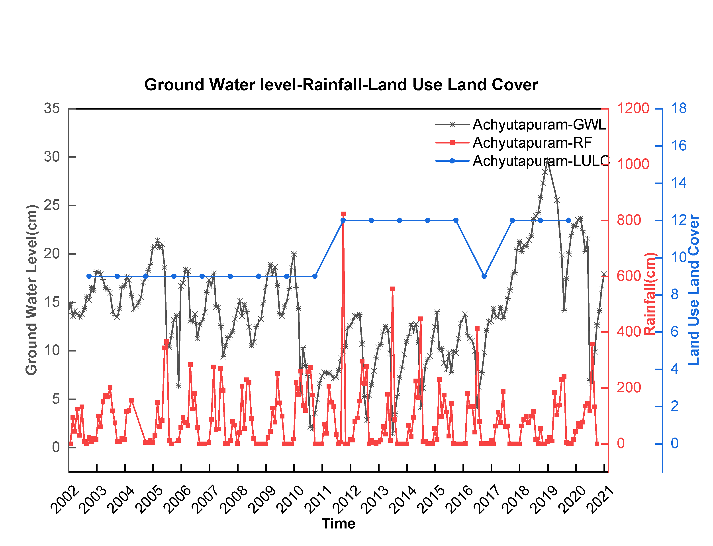

Fig 1: Ground Water Level(GWL), Rainfall(RF), Land Use Land Cover(LULC) data sets from Achyutapuram mandal of Visakhapatnam district, Andhra Pradesh, India.

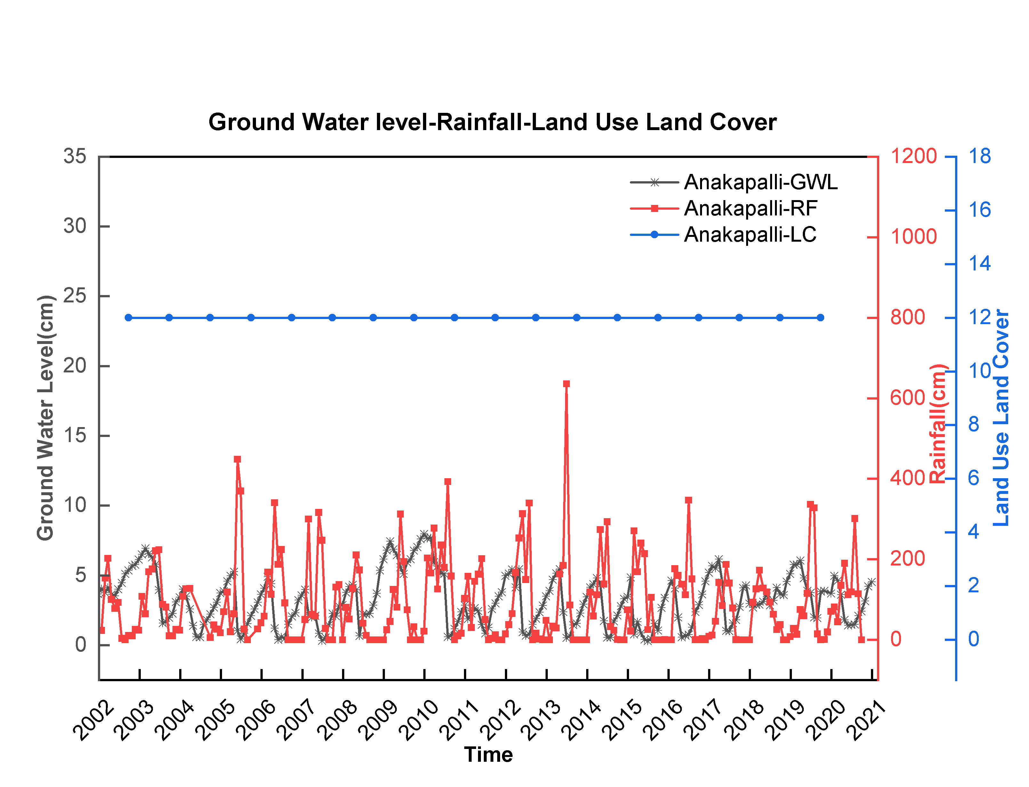
Fig 2: Ground Water Level(GWL), Rainfall(RF), Land Use Land Cover(LULC) data sets from Anakapalli mandal of Visakhapatnam district, Andhra Pradesh, India.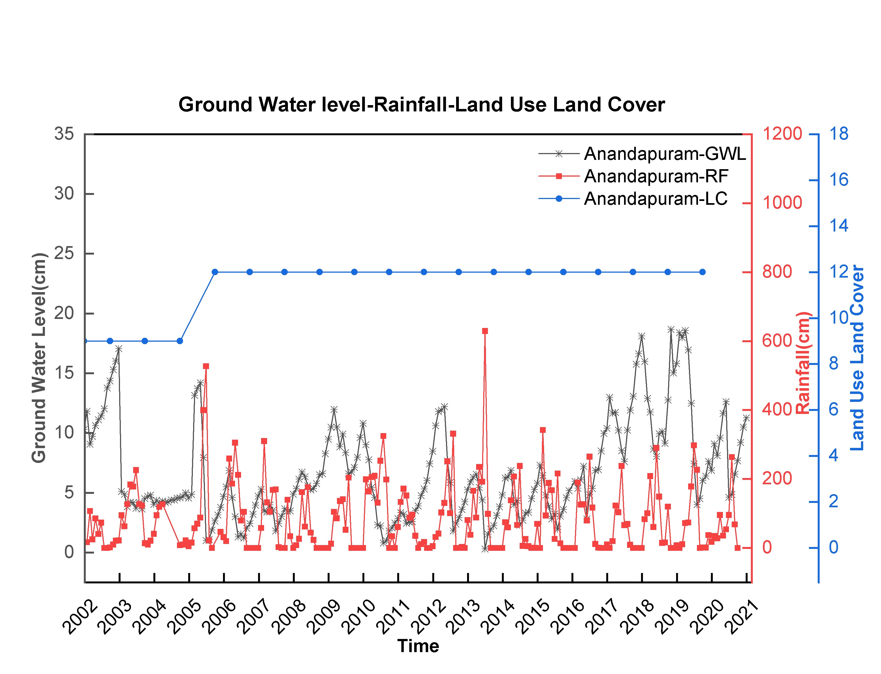
Fig 3: Ground Water Level(GWL), Rainfall(RF), Land Use Land Cover(LULC) data sets from Anandapuram mandal of Visakhapatnam district, Andhra Pradesh, India.
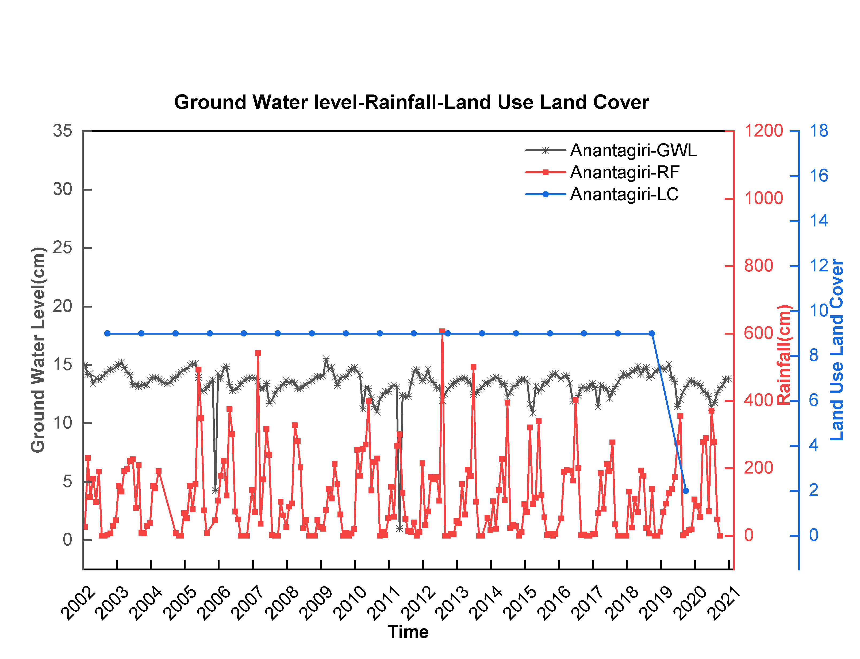
Fig 4: Ground Water Level(GWL), Rainfall(RF), Land Use Land Cover(LULC) data sets from Anantagiri mandal of Visakhapatnam district, Andhra Pradesh, India.
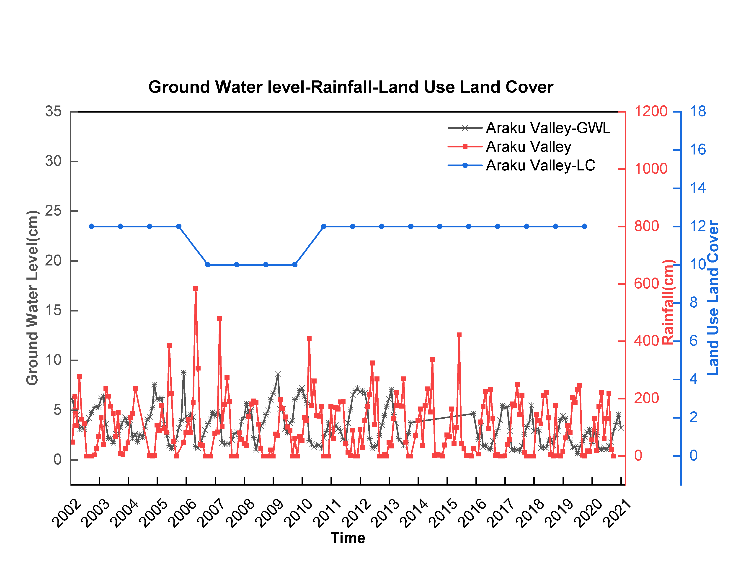
Fig 5: Ground Water Level(GWL), Rainfall(RF), Land Use Land Cover(LULC) data sets from Araku mandal of Visakhapatnam district, Andhra Pradesh, India.
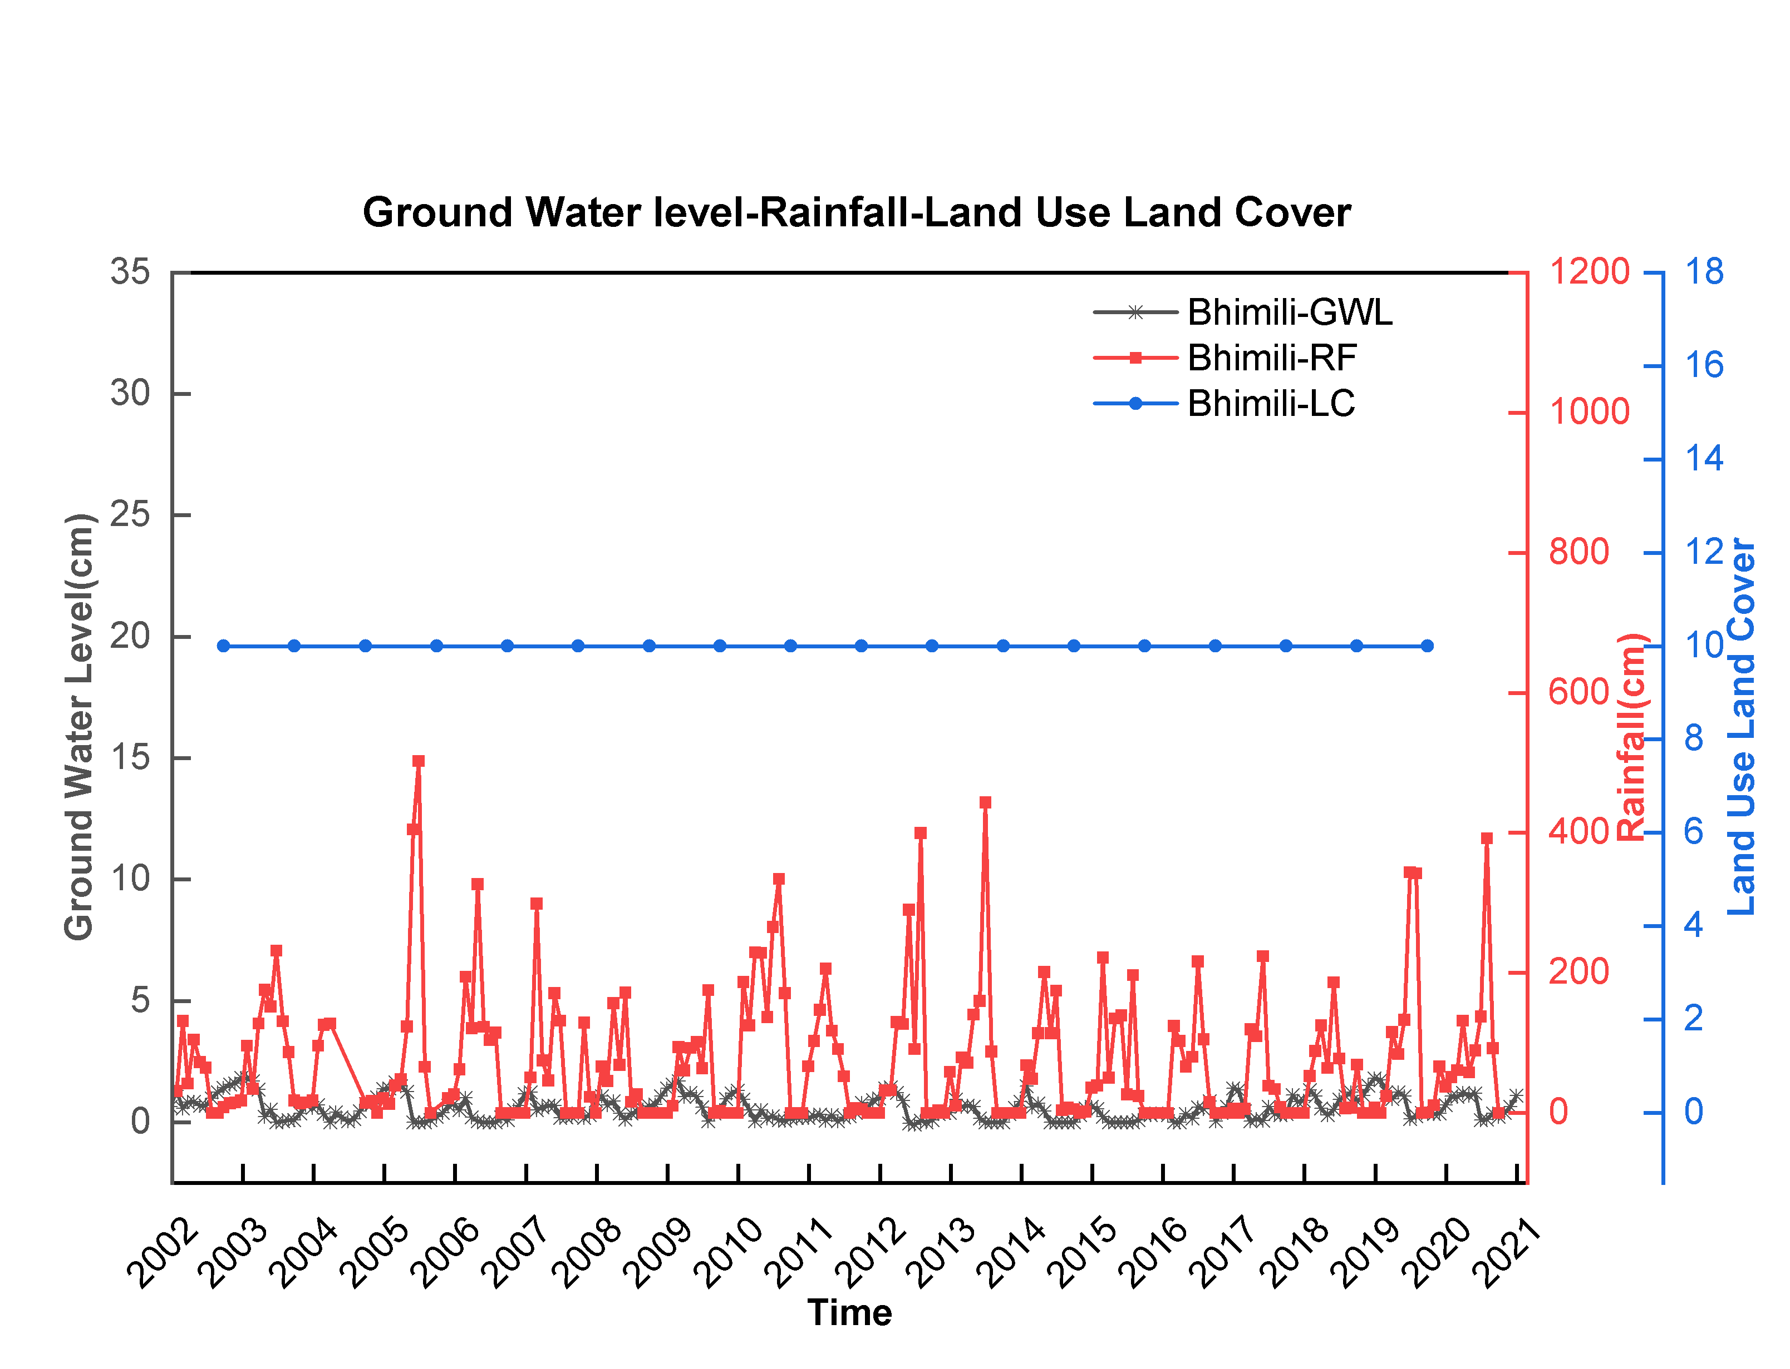
Fig 6: Ground Water Level(GWL), Rainfall(RF), Land Use Land Cover(LULC) data sets from Bhimili mandal of Visakhapatnam district, Andhra Pradesh, India.
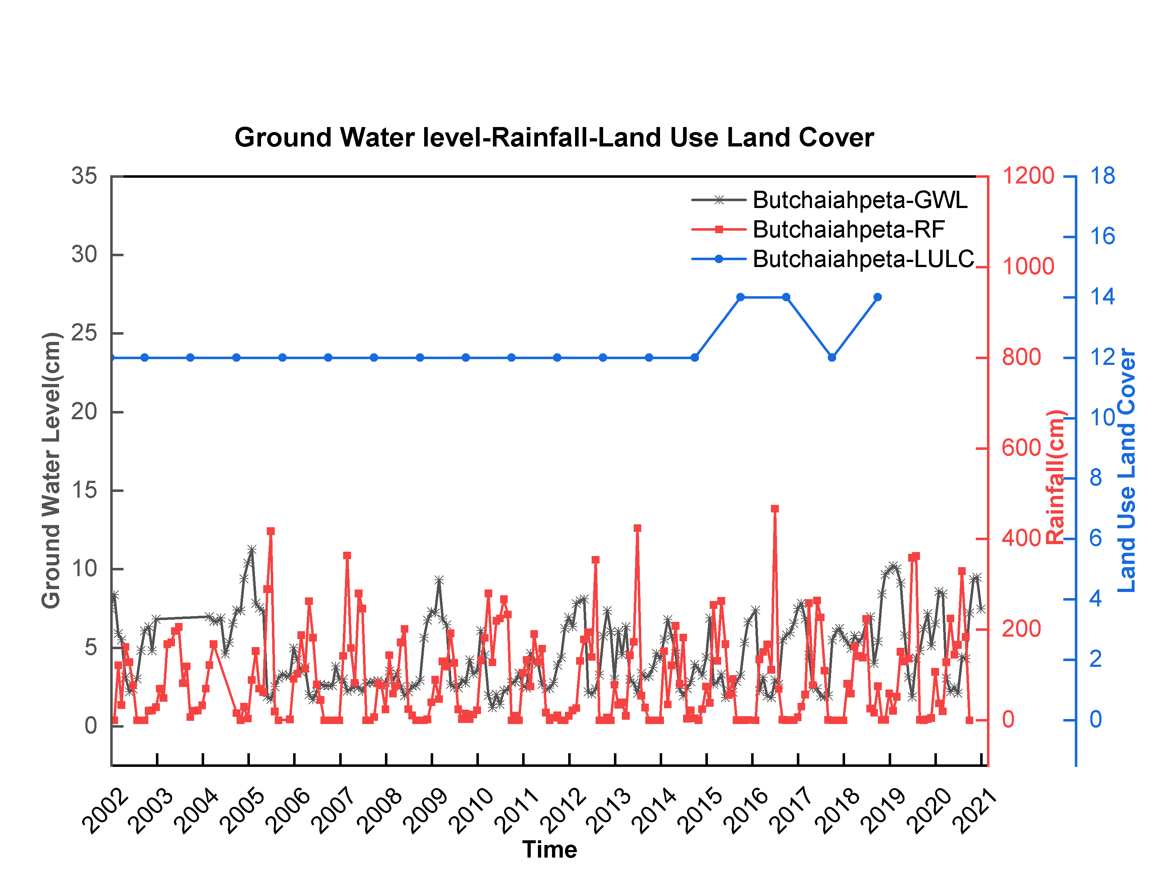
Fig 7: Ground Water Level(GWL), Rainfall(RF), Land Use Land Cover(LULC) data sets from Butchaiapeta mandal of Visakhapatnam district, Andhra Pradesh, India.
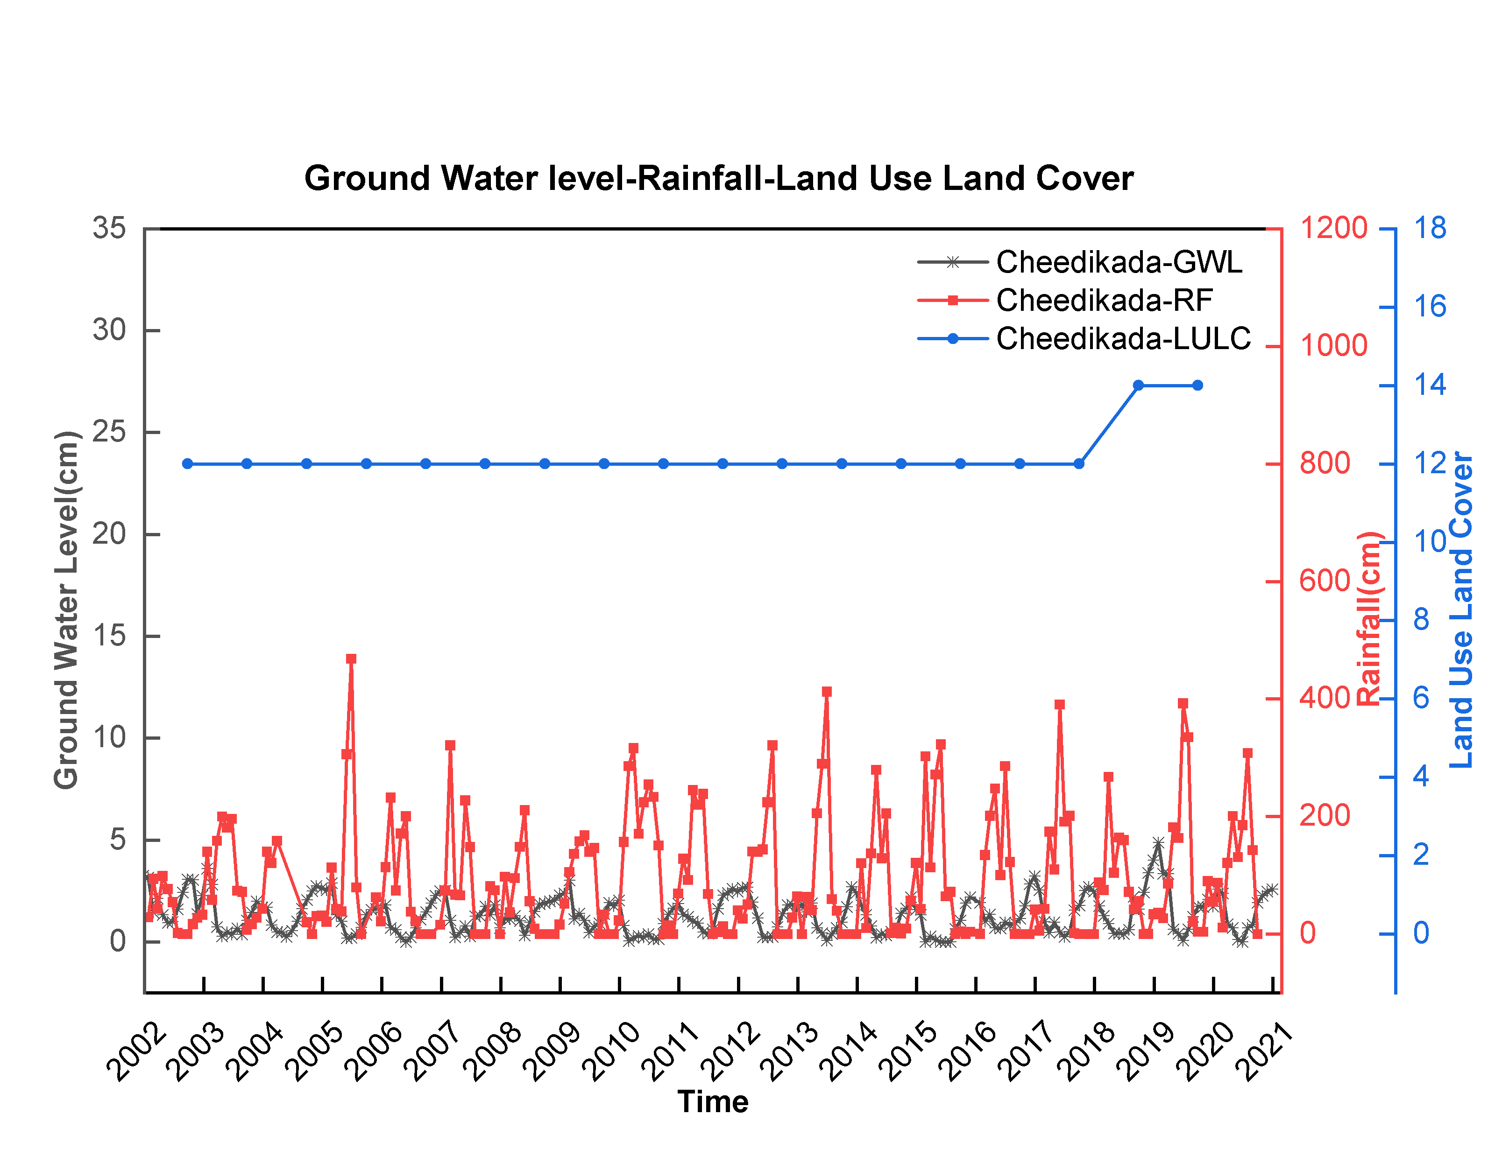
Fig 8: Ground Water Level(GWL), Rainfall(RF), Land Use Land Cover(LULC) data sets from Cheedikada mandal of Visakhapatnam district, Andhra Pradesh, India.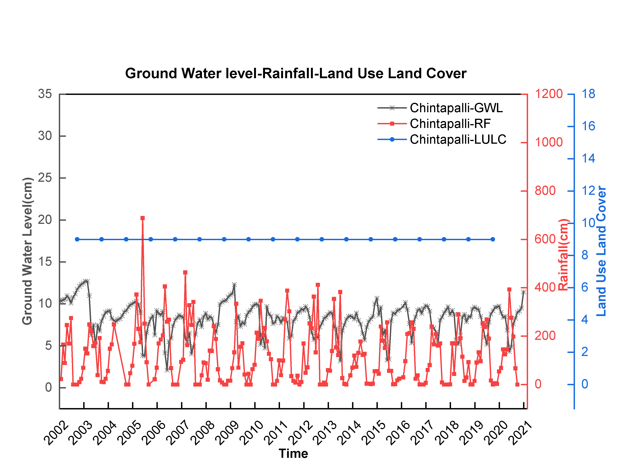
Fig 9: Ground Water Level(GWL), Rainfall(RF), Land Use Land Cover(LULC) data sets from Chintapalli mandal of Visakhapatnam district, Andhra Pradesh, India.
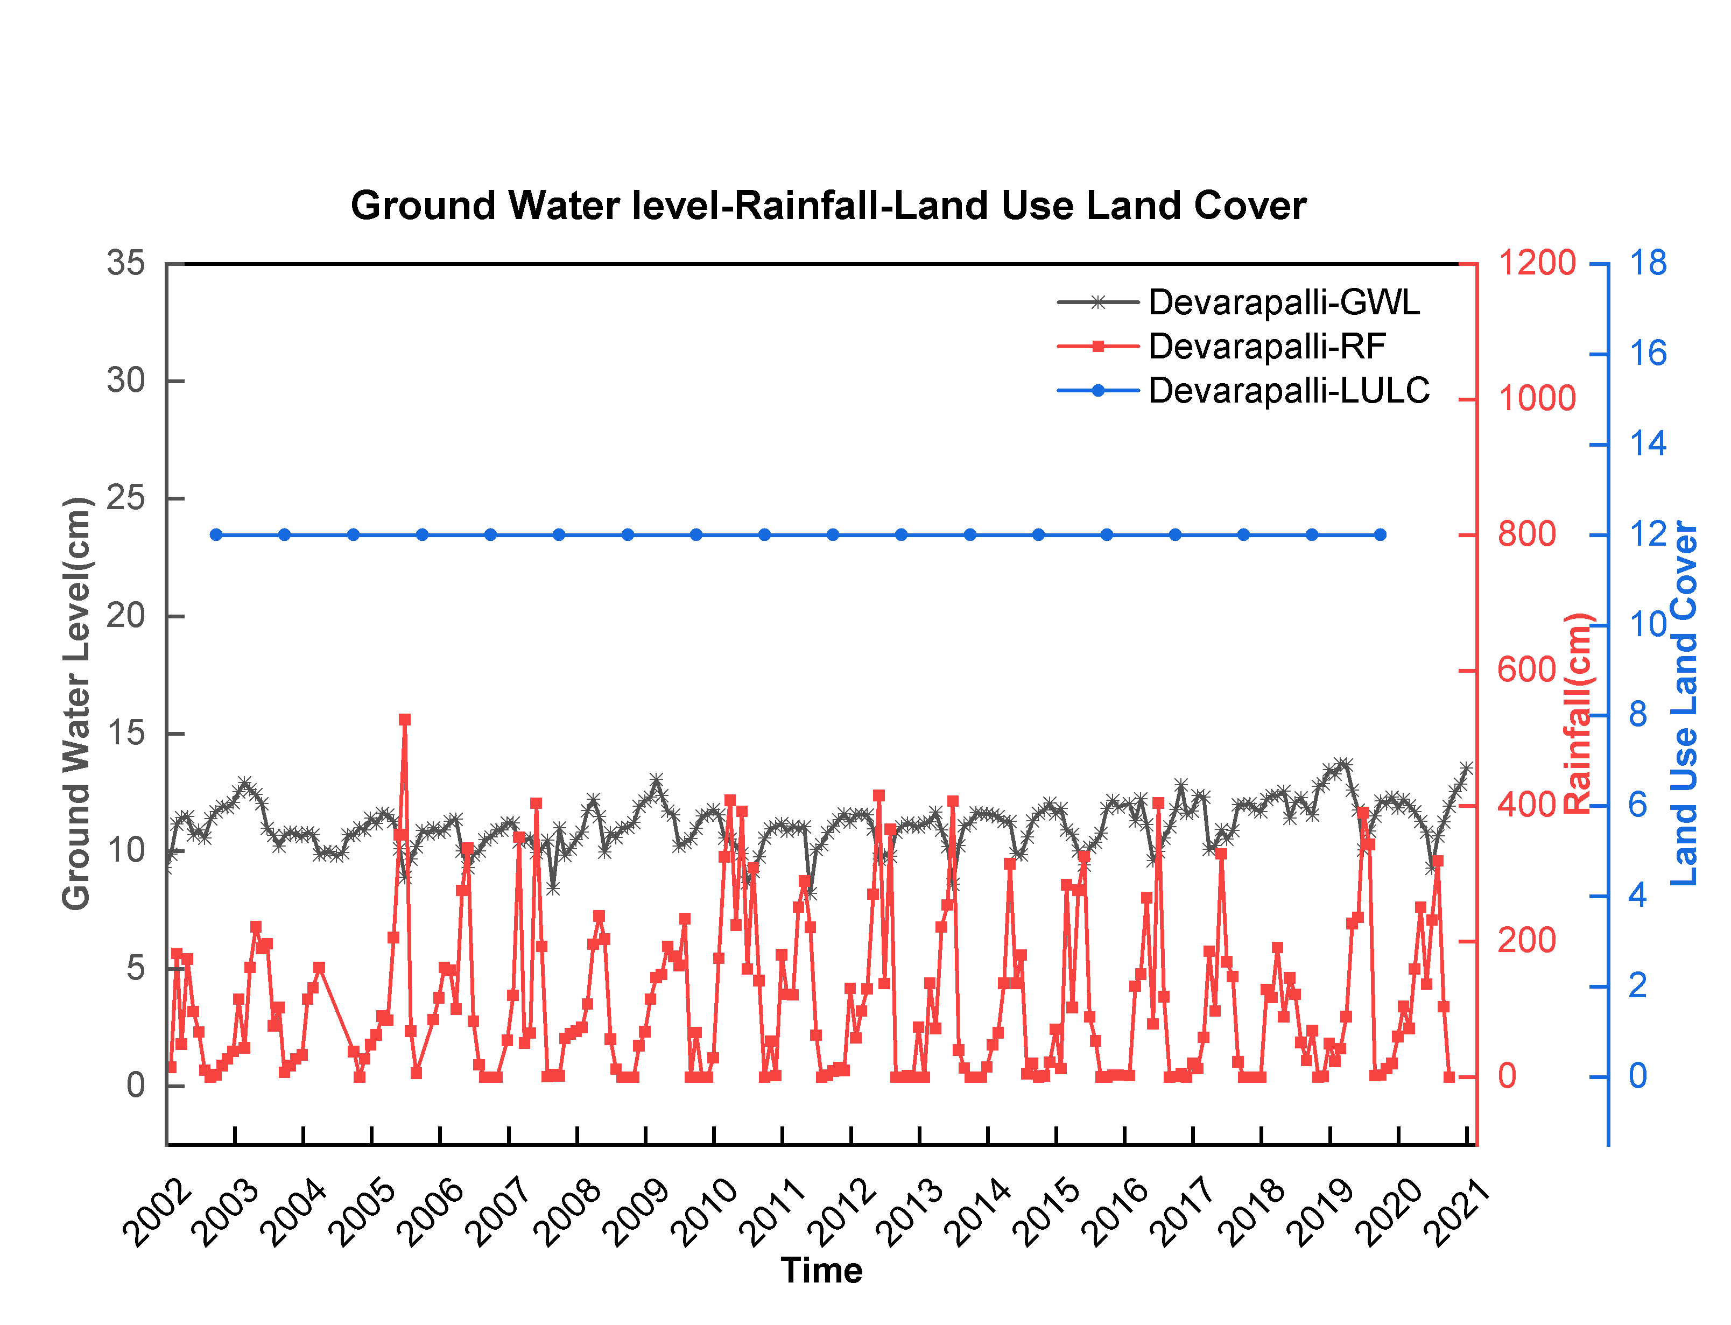
Fig 10: Ground Water Level(GWL), Rainfall(RF), Land Use Land Cover(LULC) data sets from Devarapalli mandal of Visakhapatnam district, Andhra Pradesh, India.
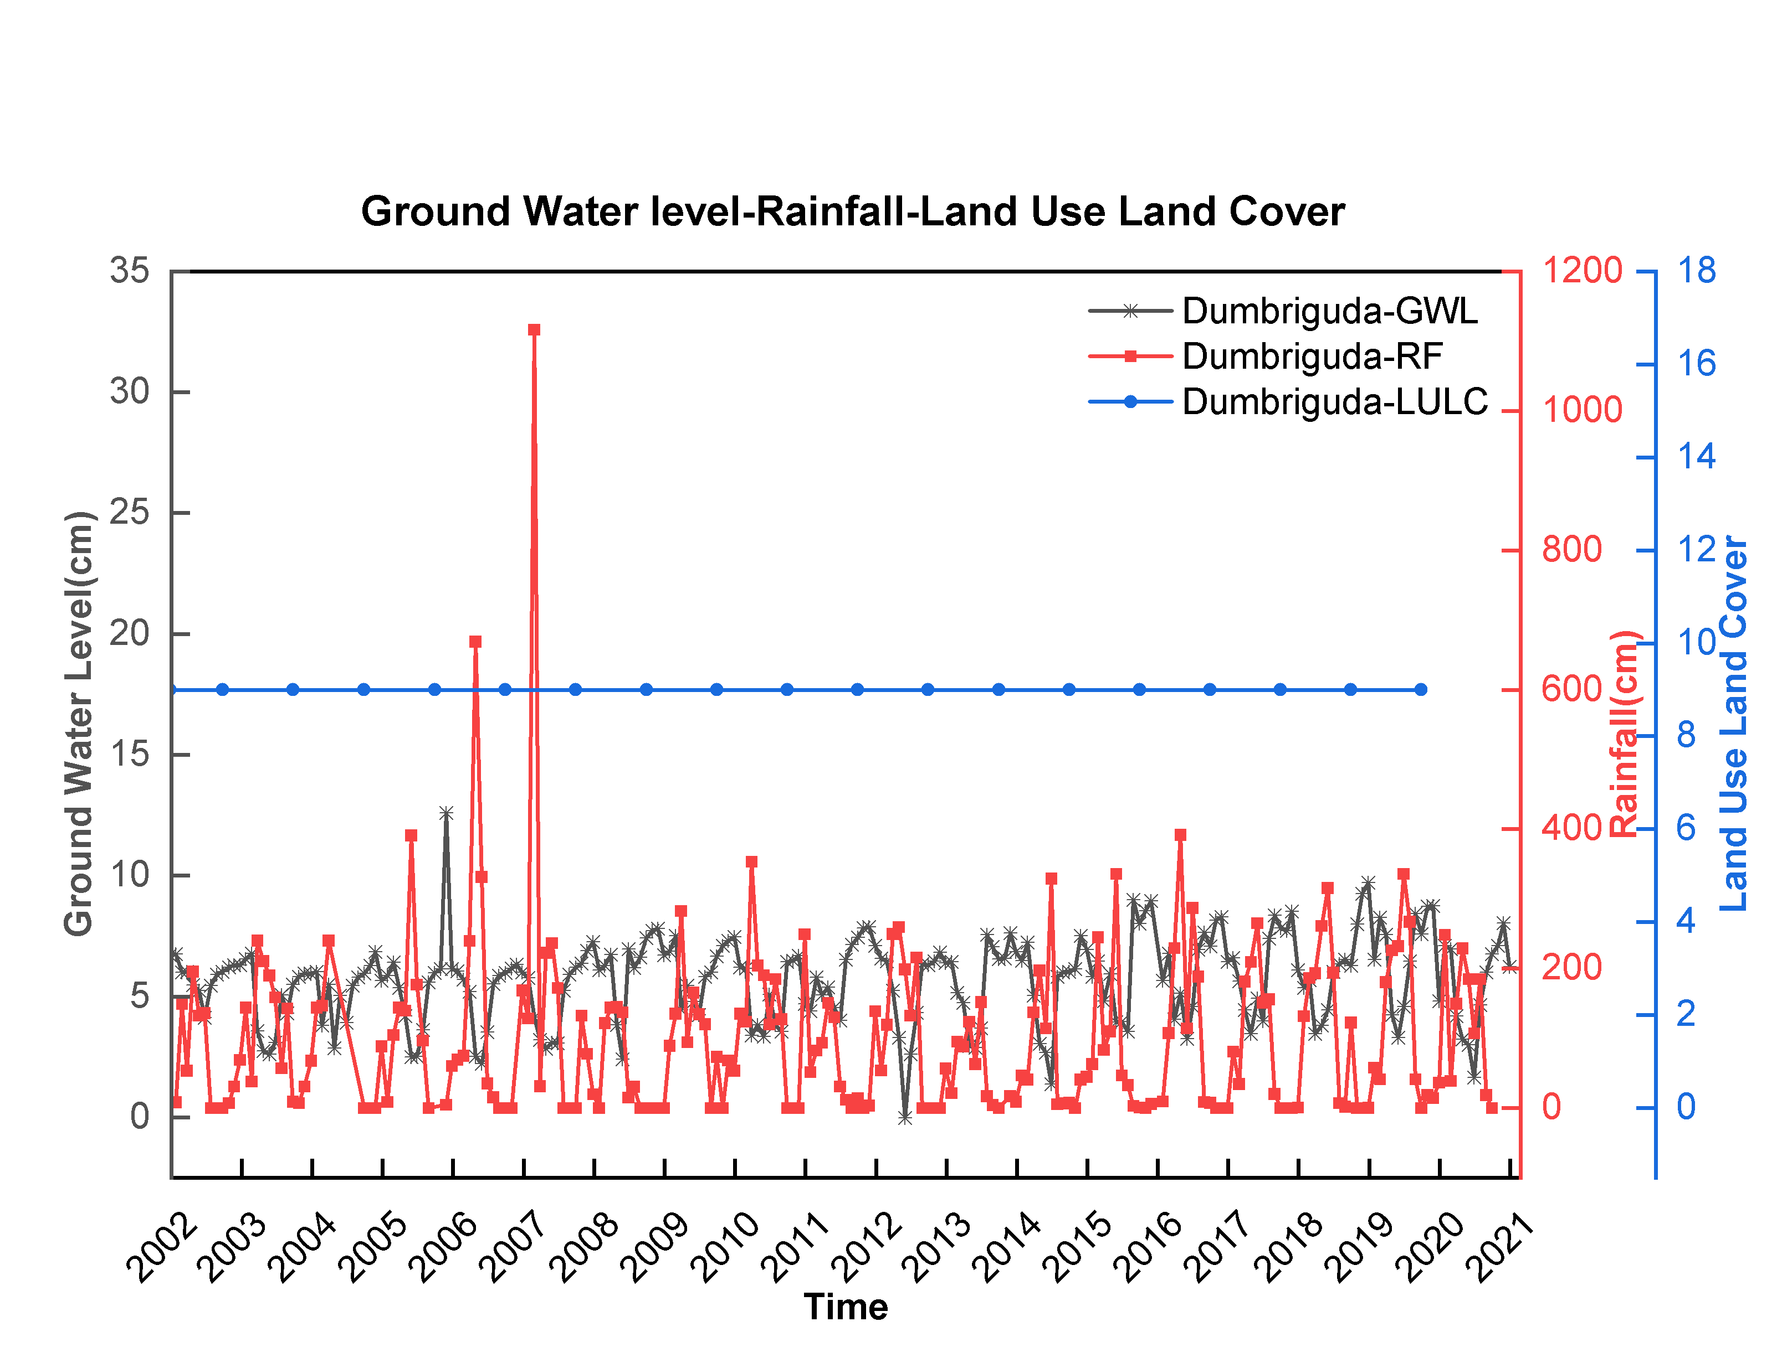
Fig 11: Ground Water Level(GWL), Rainfall(RF), Land Use Land Cover(LULC) data sets from Dumbriguda mandal of Visakhapatnam district, Andhra Pradesh, India.
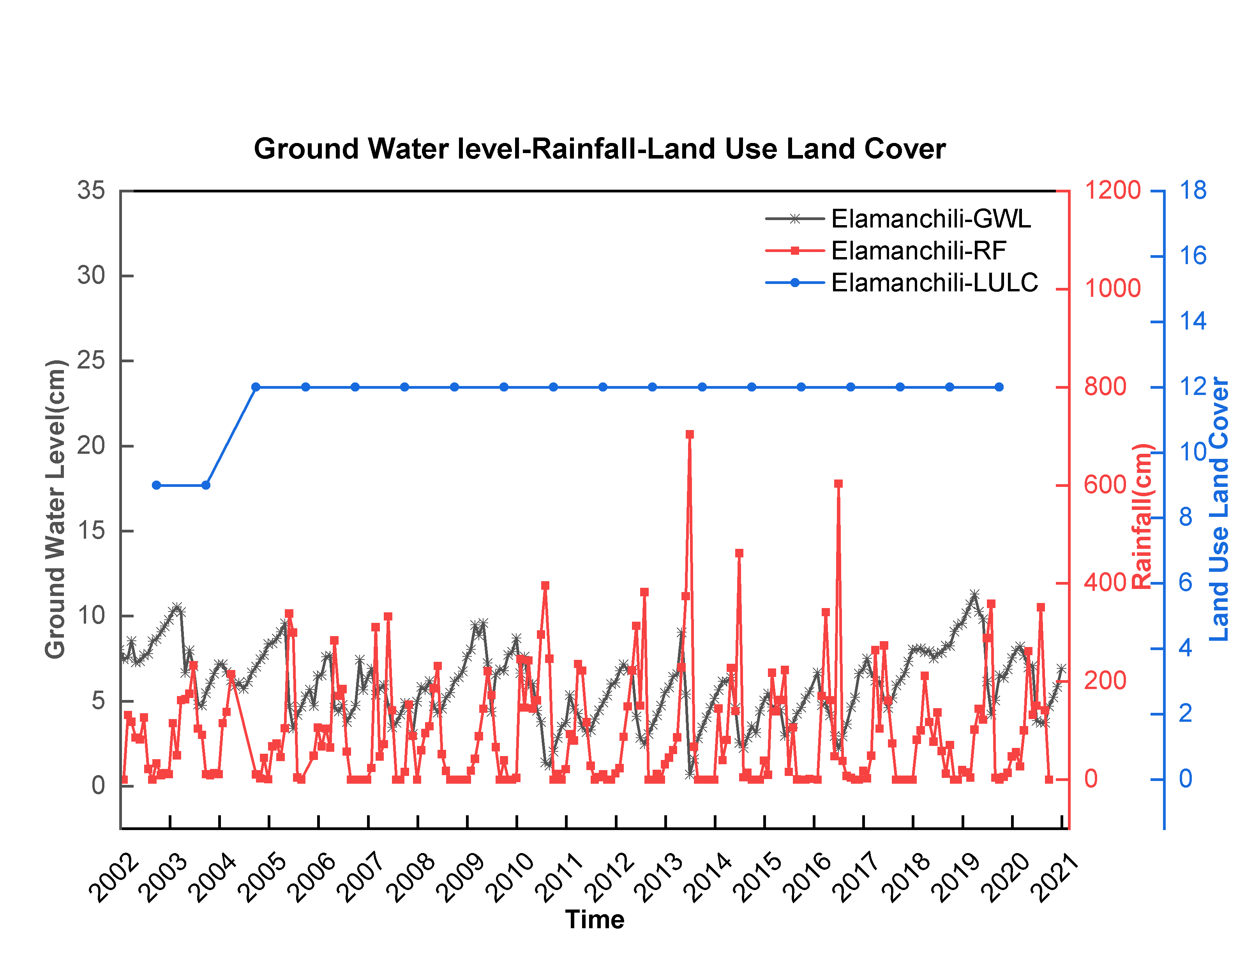
Fig 12: Ground Water Level(GWL), Rainfall(RF), Land Use Land Cover(LULC) data sets from Elamanchili mandal of Visakhapatnam district, Andhra Pradesh, India.
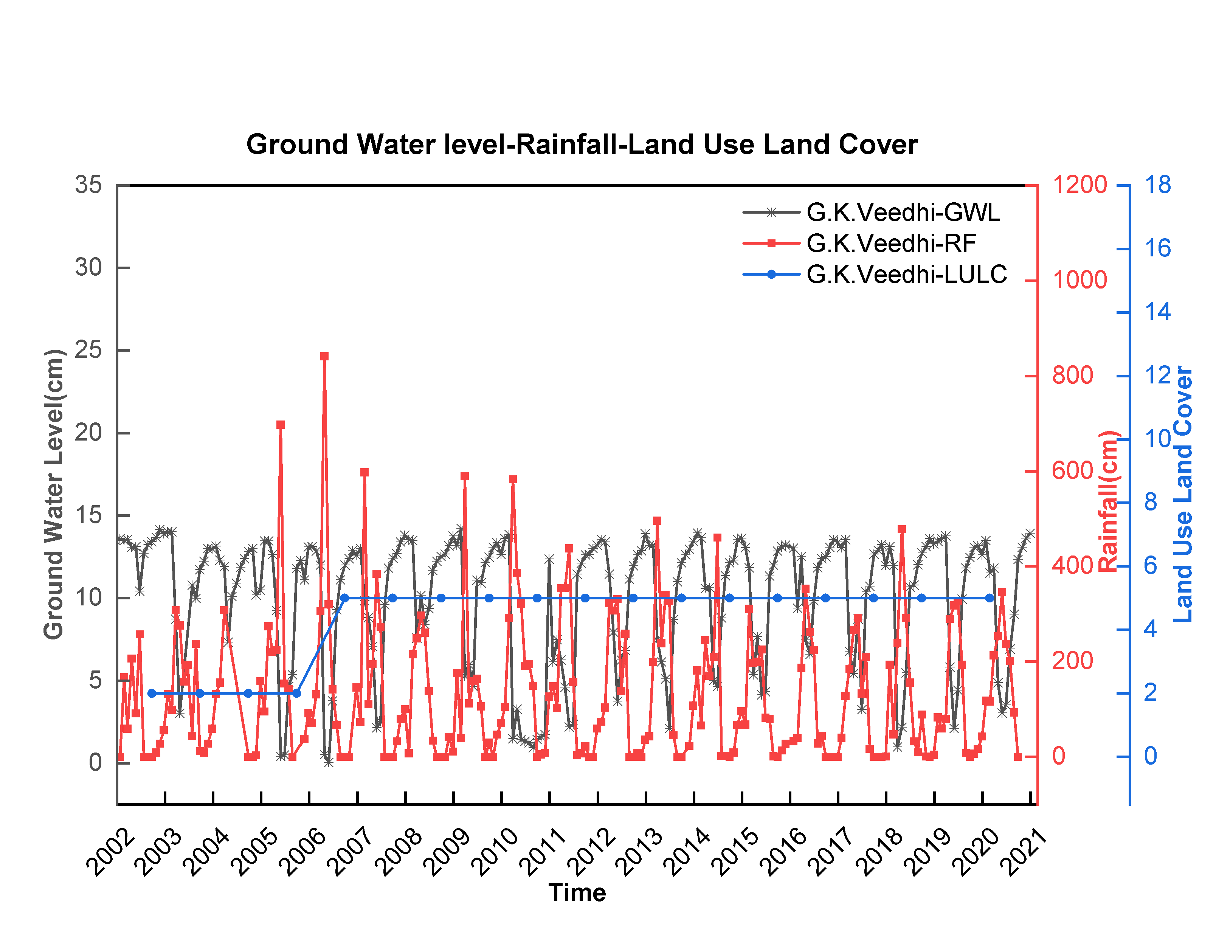
Fig 13: Ground Water Level(GWL), Rainfall(RF), Land Use Land Cover(LULC) data sets from G.K.Veedhi mandal of Visakhapatnam district, Andhra Pradesh, India.
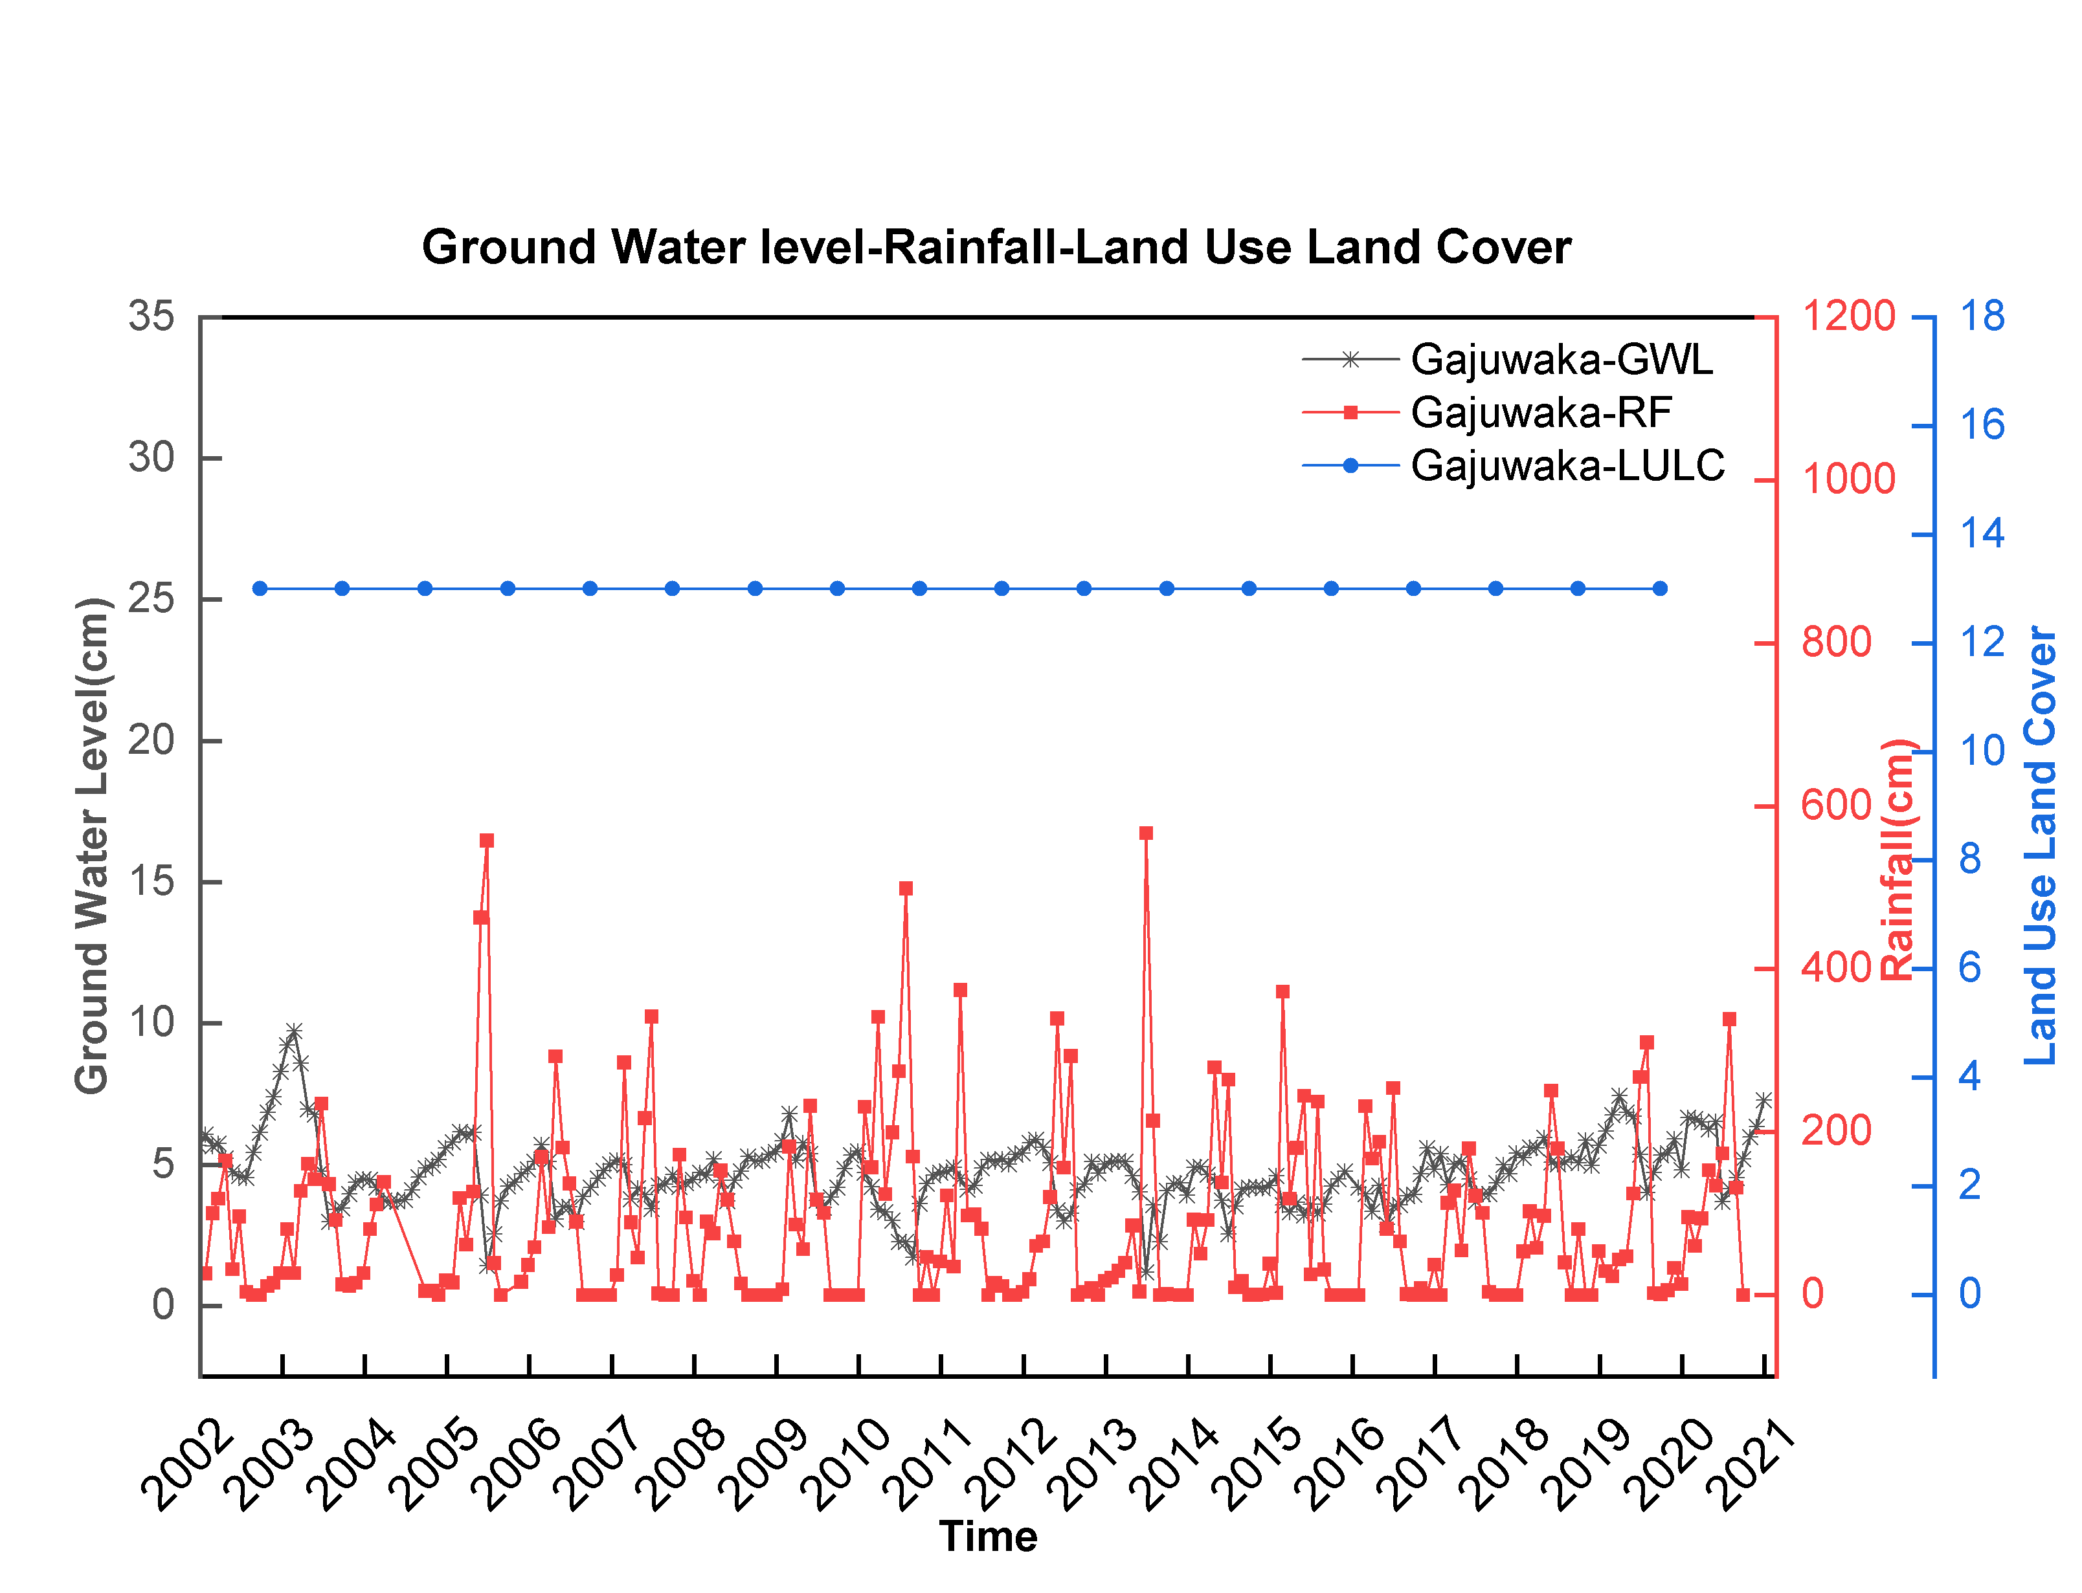
Fig 14: Ground Water Level(GWL), Rainfall(RF), Land Use Land Cover(LULC) data sets from Gajuwaka mandal of Visakhapatnam district, Andhra Pradesh, India.
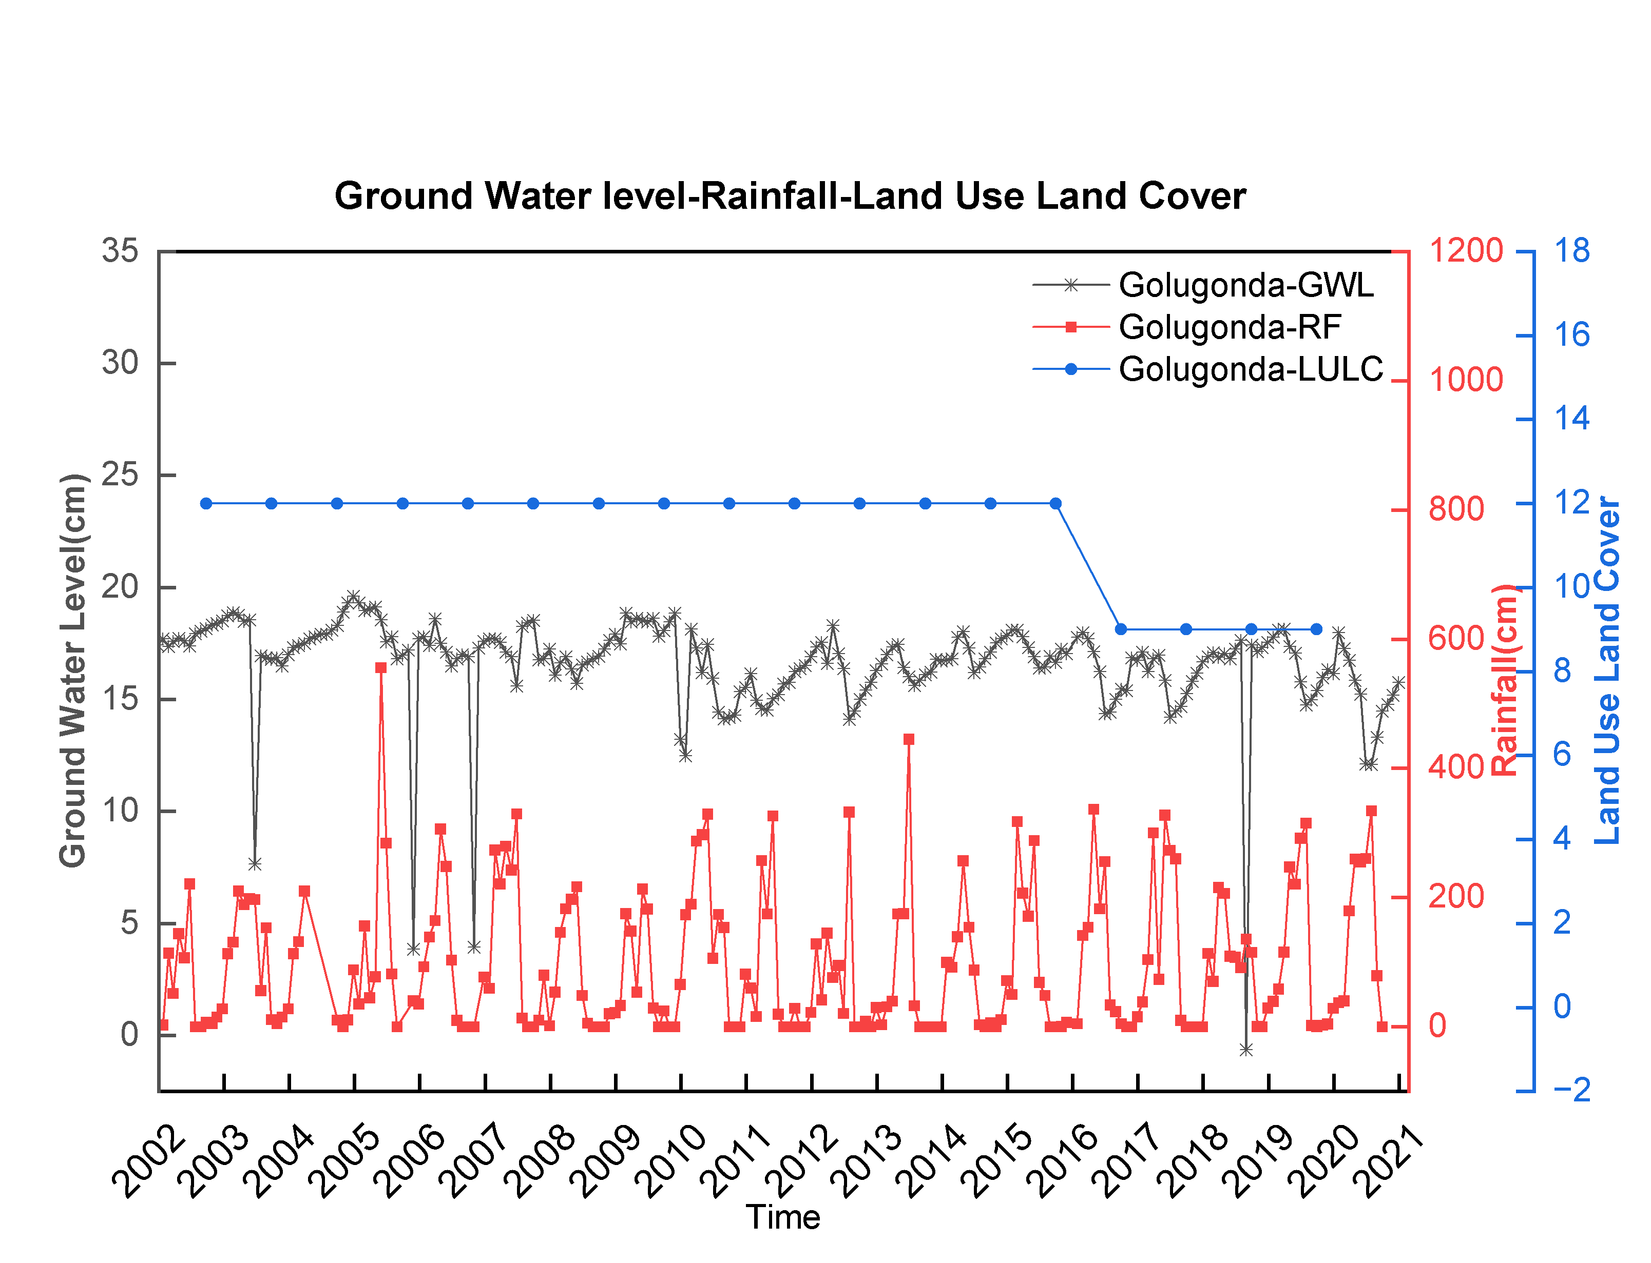
Fig 15: Ground Water Level(GWL), Rainfall(RF), Land Use Land Cover(LULC) data sets from Golugonda mandal of Visakhapatnam district, Andhra Pradesh, India.
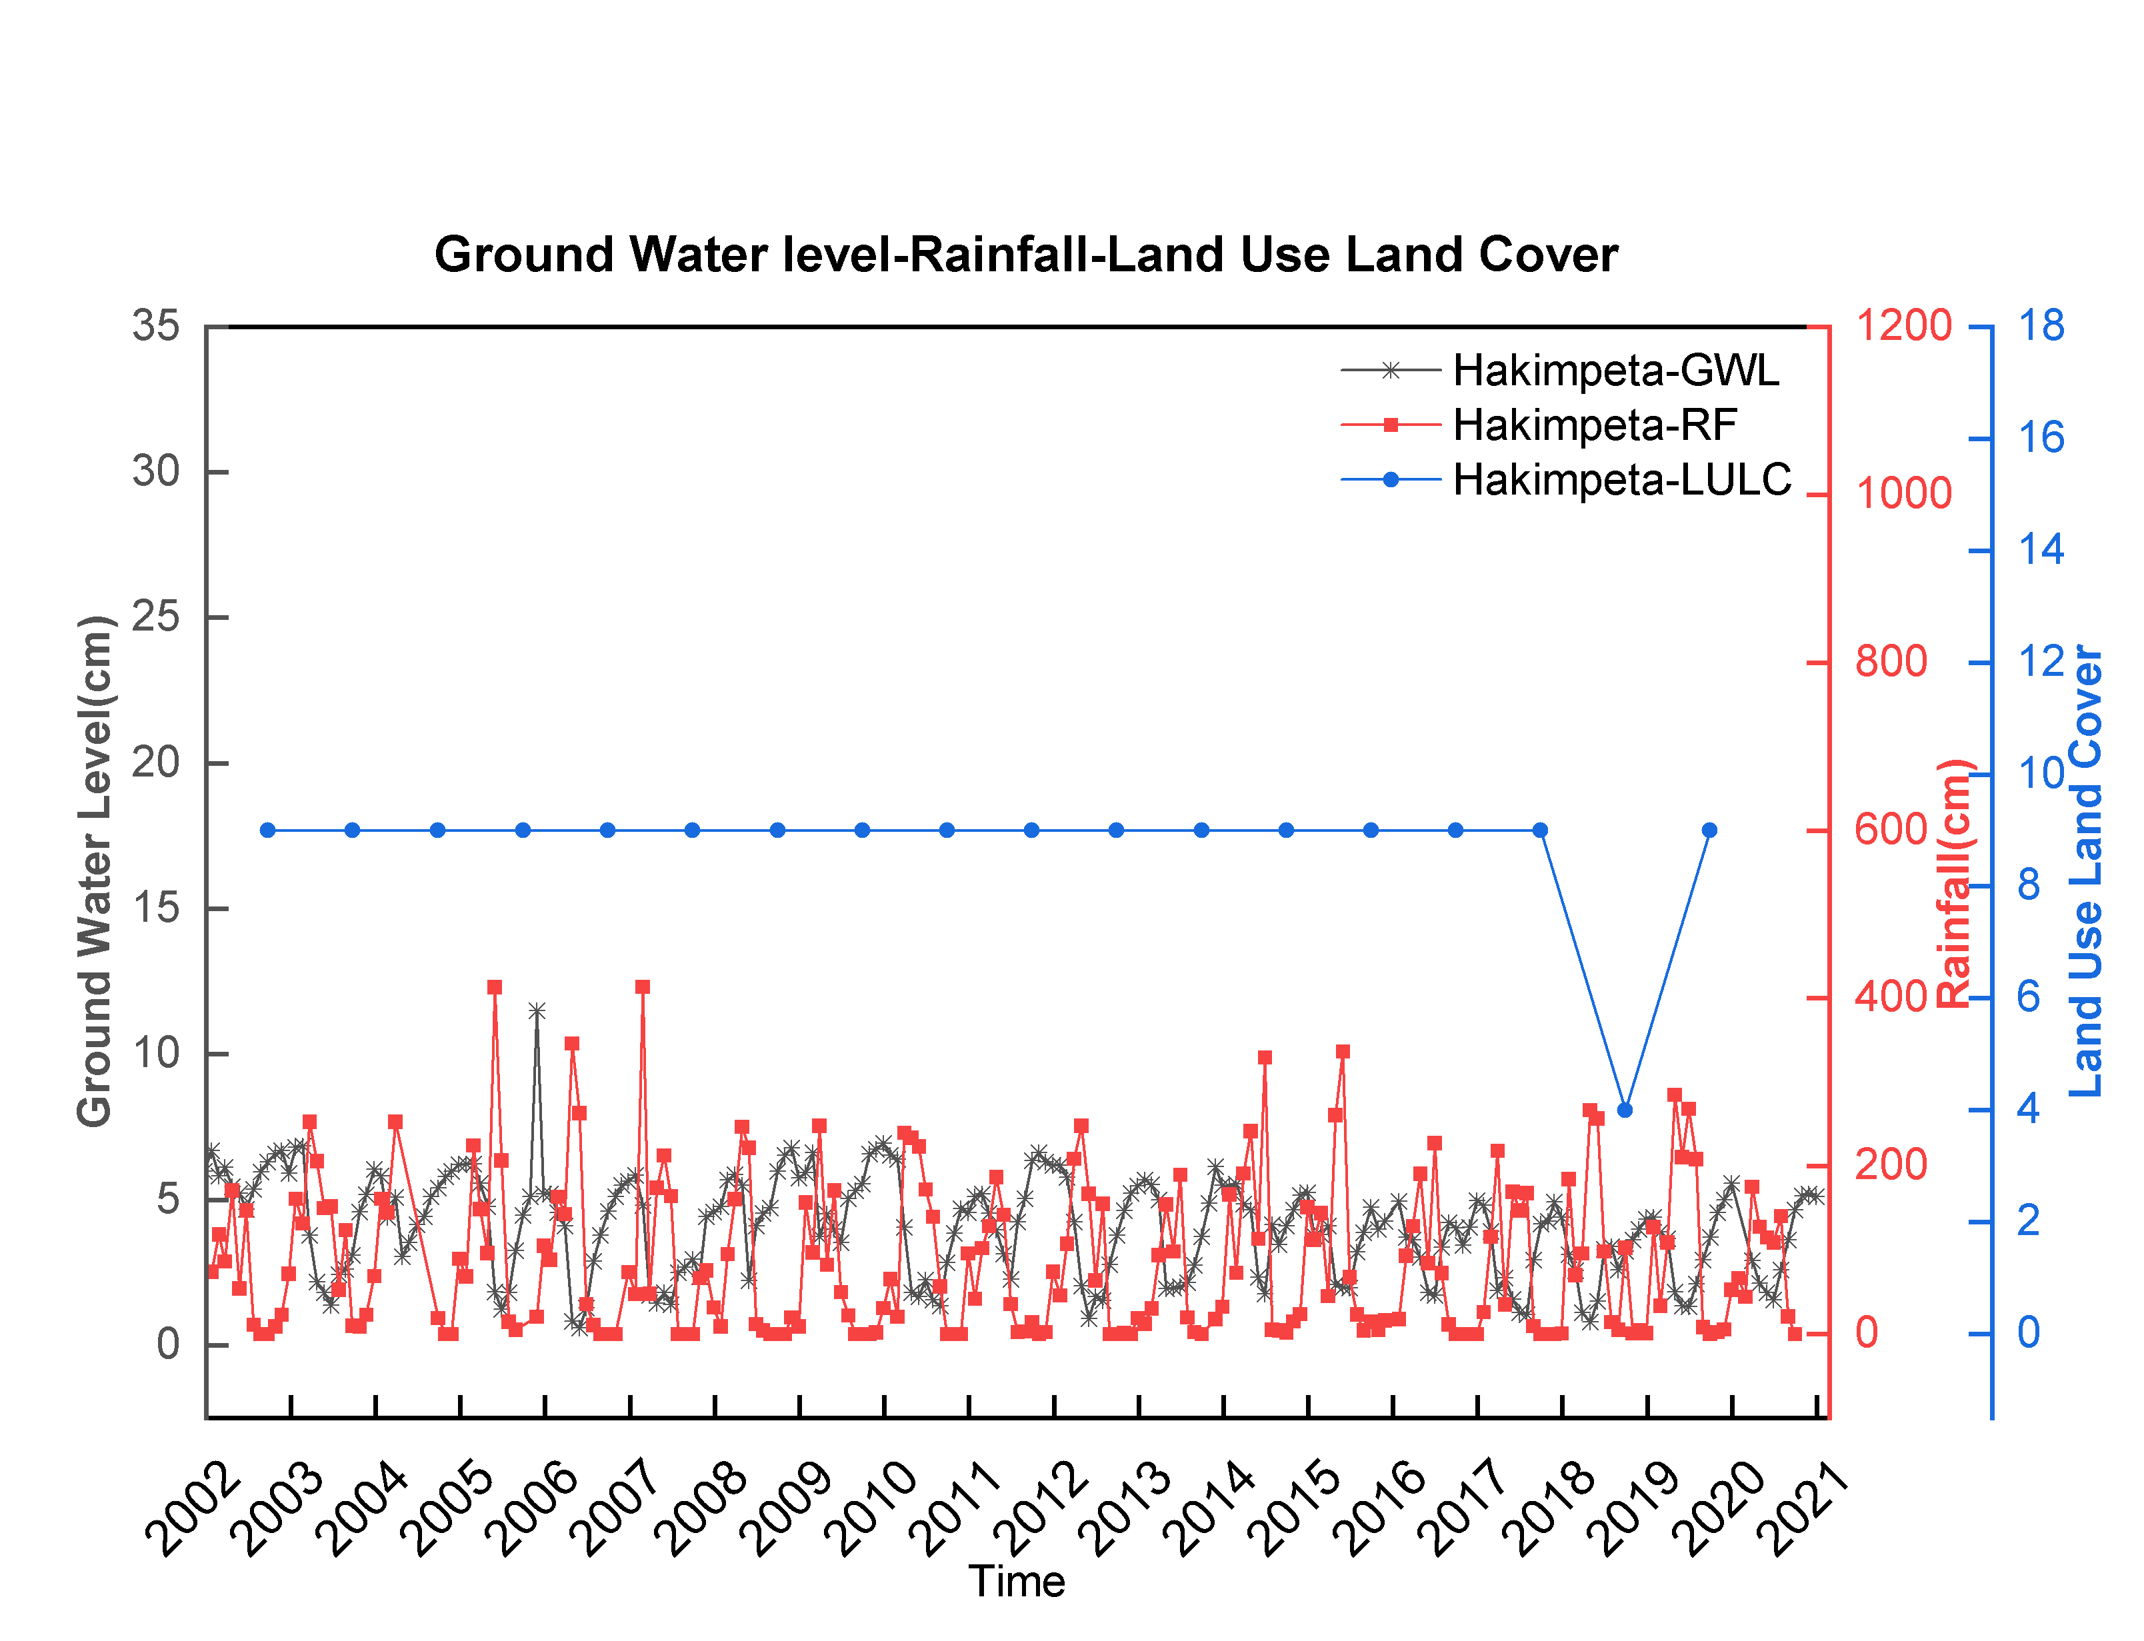
Fig 16: Ground Water Level(GWL), Rainfall(RF), Land Use Land Cover(LULC) data sets from Hakimpeta mandal of Visakhapatnam district, Andhra Pradesh, India.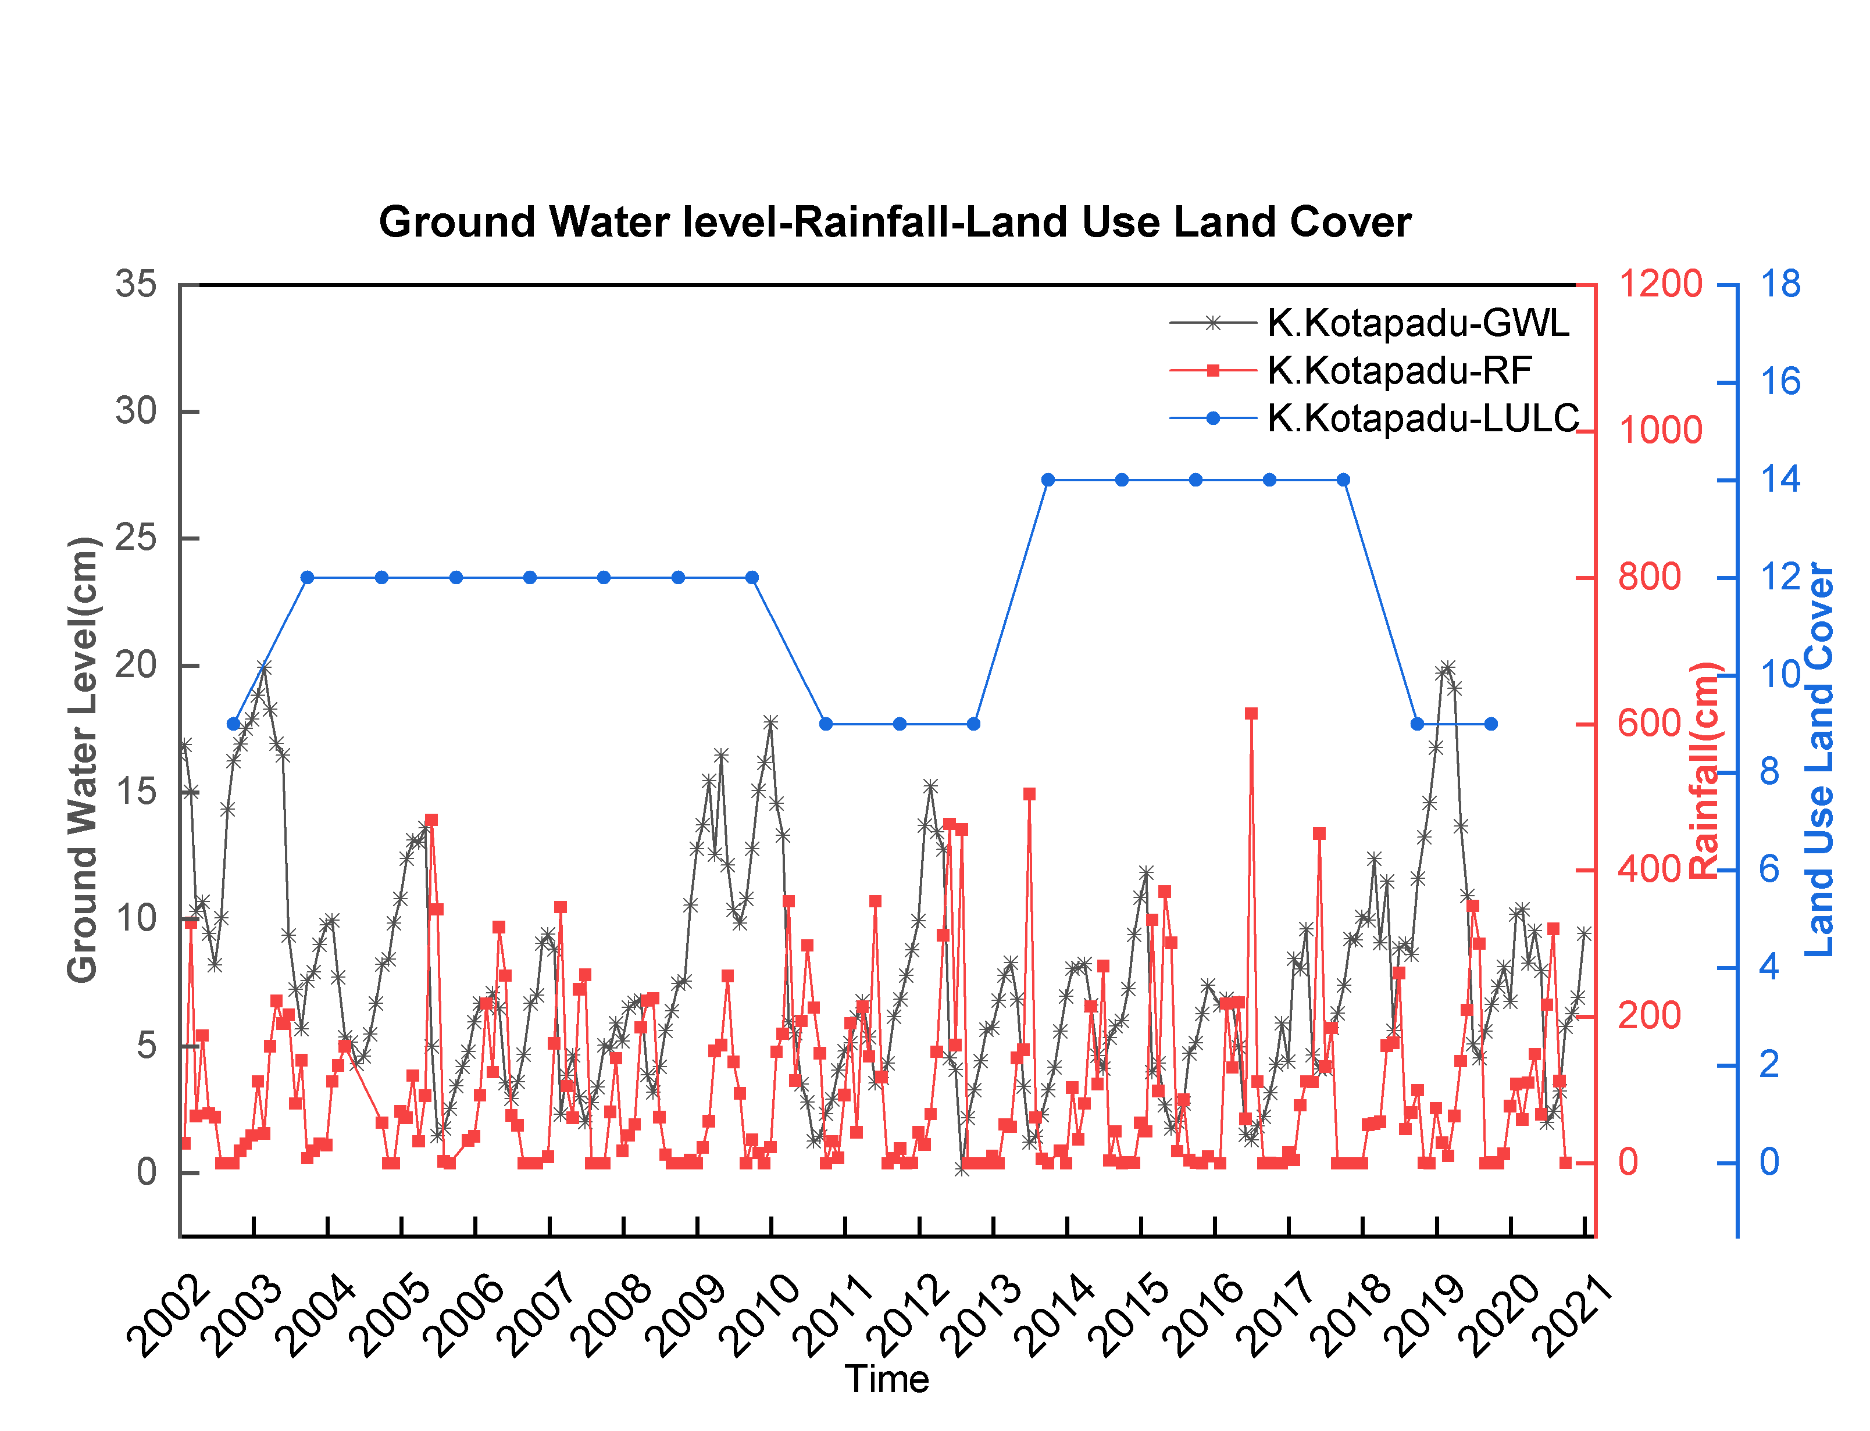
Fig 17: Ground Water Level(GWL), Rainfall(RF), Land Use Land Cover(LULC) data sets from K.Kotapadu mandal of Visakhapatnam district, Andhra Pradesh, India.
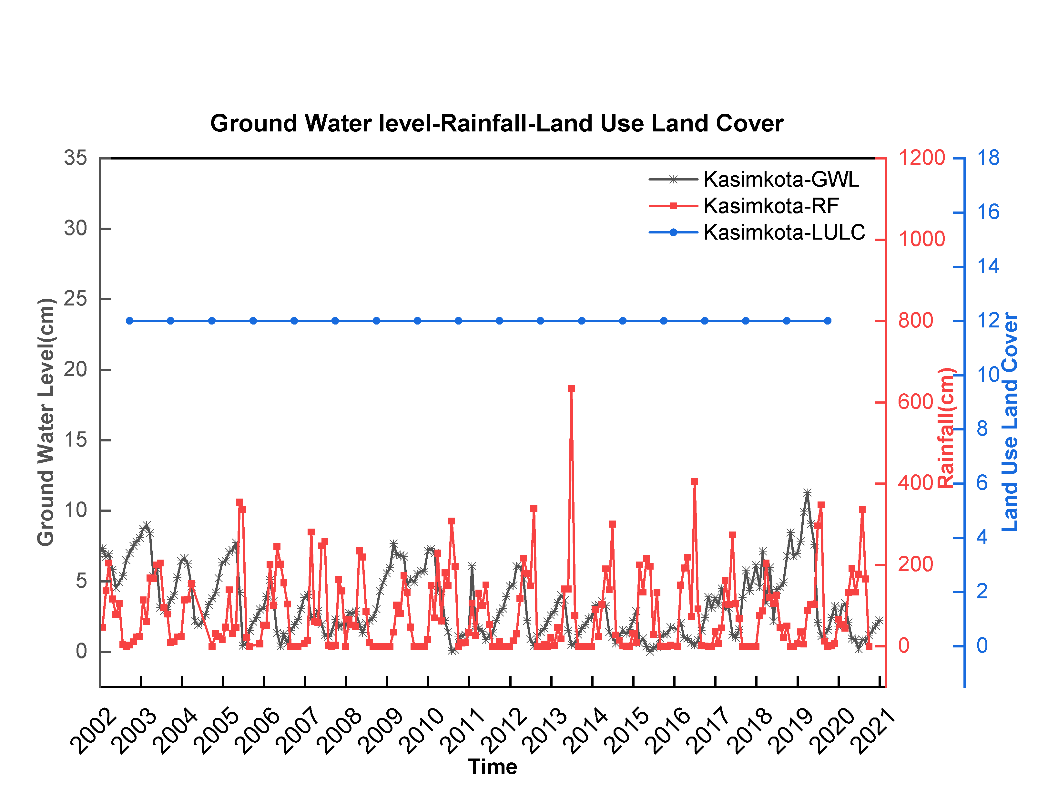
Fig 18: Ground Water Level(GWL), Rainfall(RF), Land Use Land Cover(LULC) data sets from Kasimkota mandal of Visakhapatnam district, Andhra Pradesh, India.
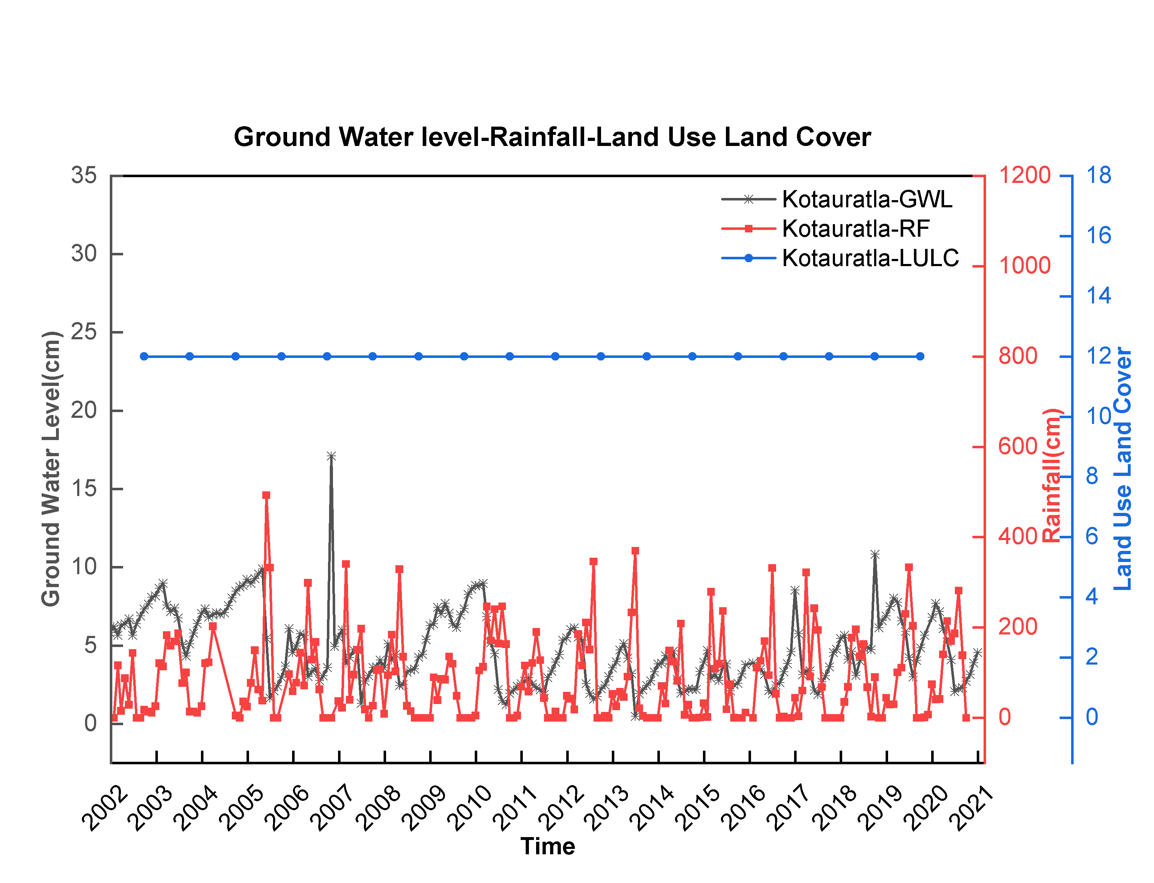
Fig 19: Ground Water Level(GWL), Rainfall(RF), Land Use Land Cover(LULC) data sets from Kotavuratla mandal of Visakhapatnam district, Andhra Pradesh, India.
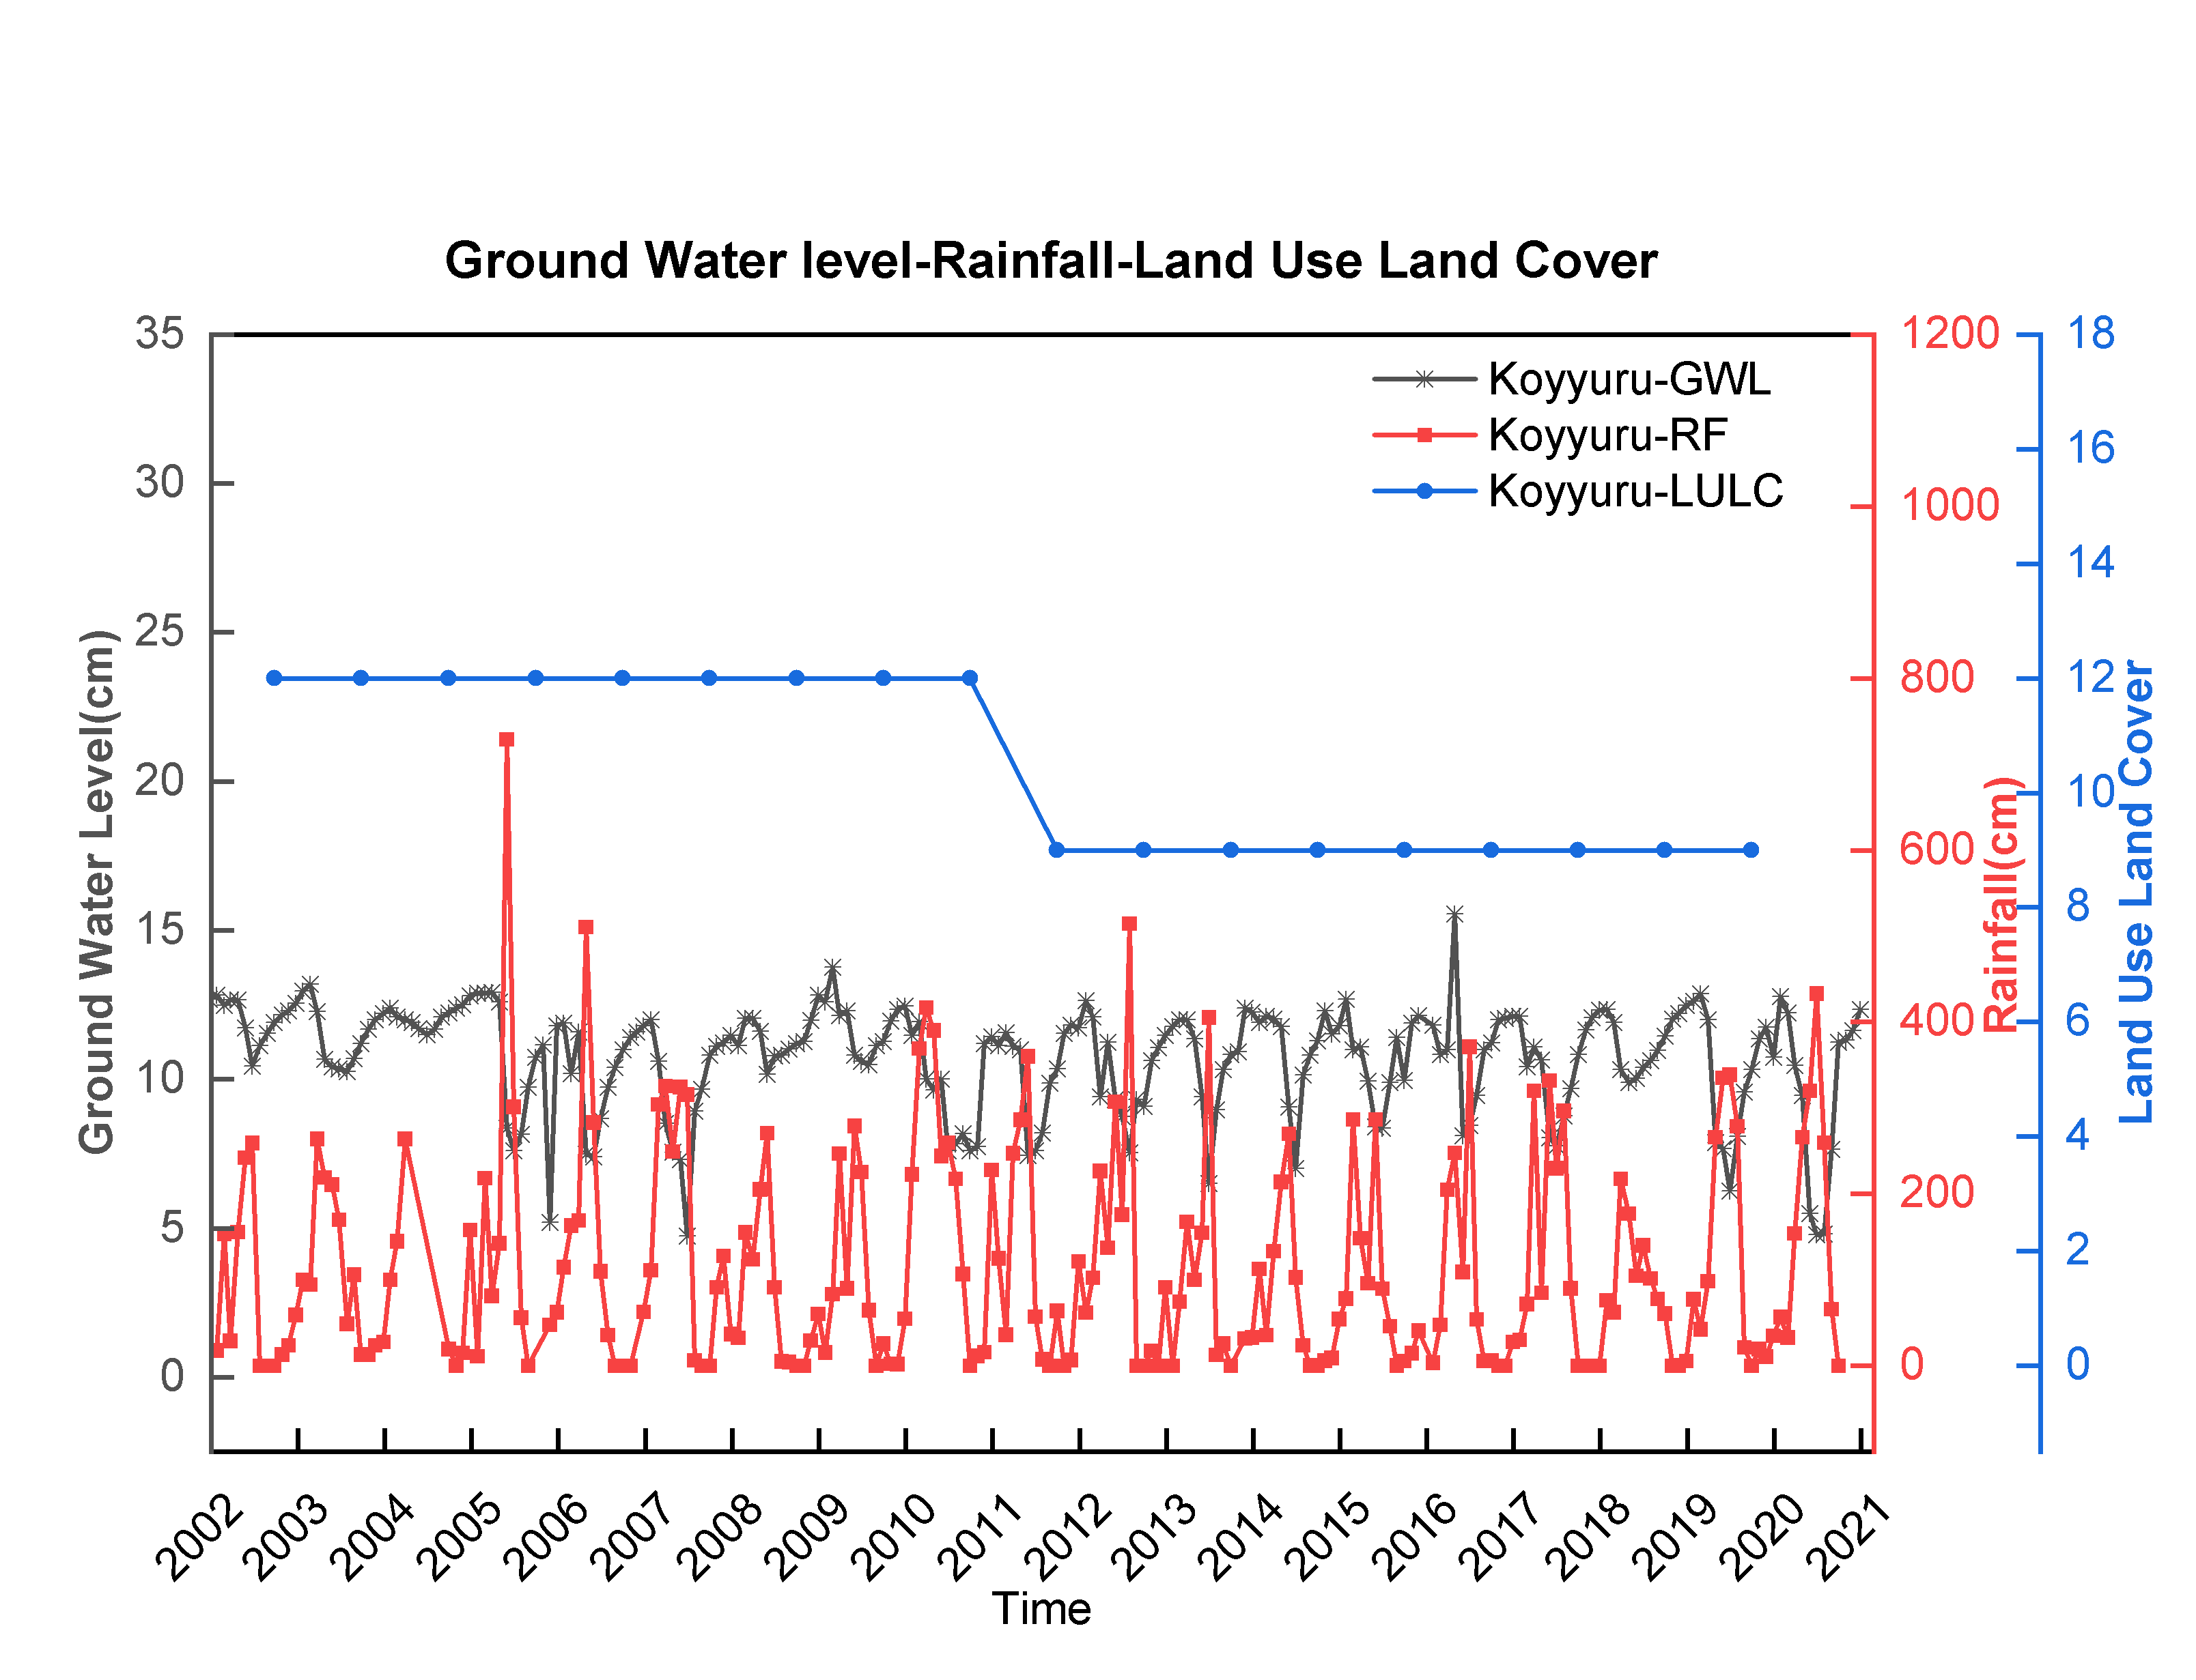
Fig 20: Ground Water Level(GWL), Rainfall(RF), Land Use Land Cover(LULC) data sets from Koyyuru mandal of Visakhapatnam district, Andhra Pradesh, India.
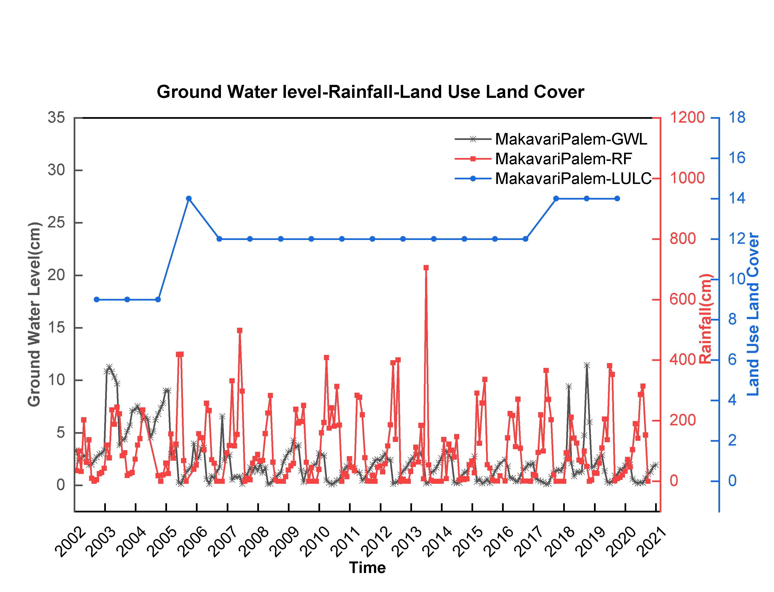
Fig 21: Ground Water Level(GWL), Rainfall(RF), Land Use Land Cover(LULC) data sets from Makavaripalem mandal of Visakhapatnam district, Andhra Pradesh, India.
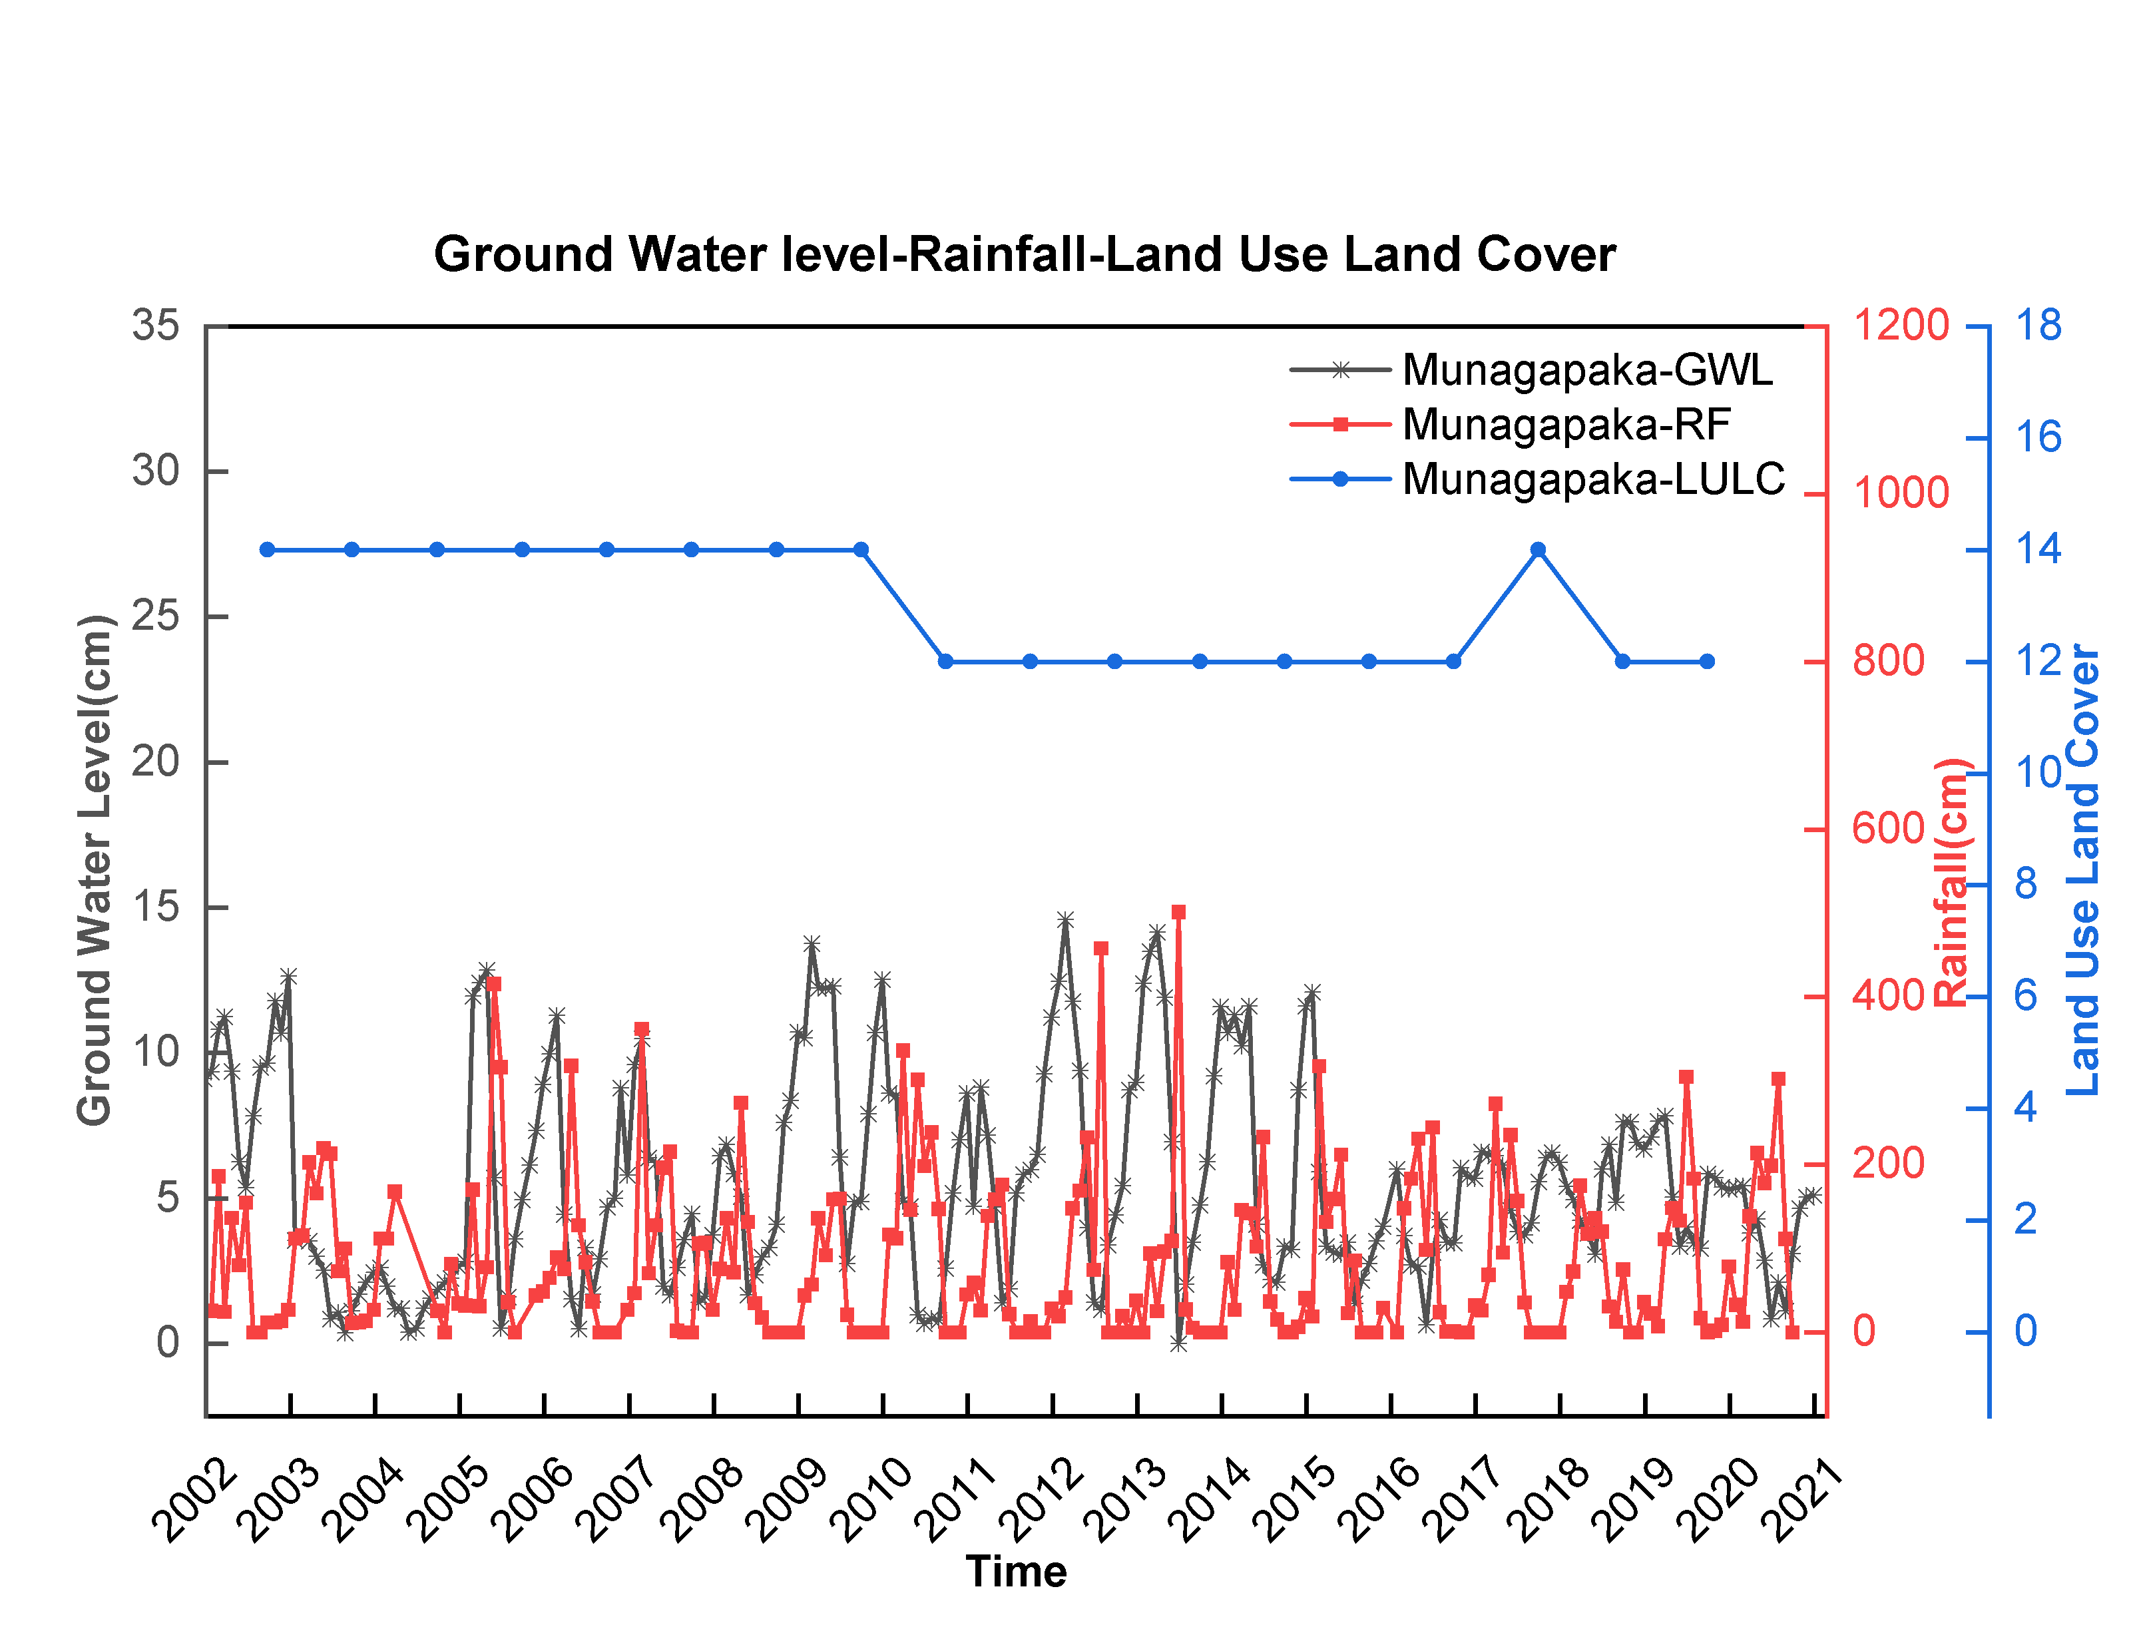
Fig 22: Ground Water Level(GWL), Rainfall(RF), Land Use Land Cover(LULC) data sets from Munagapaka mandal of Visakhapatnam district, Andhra Pradesh, India.
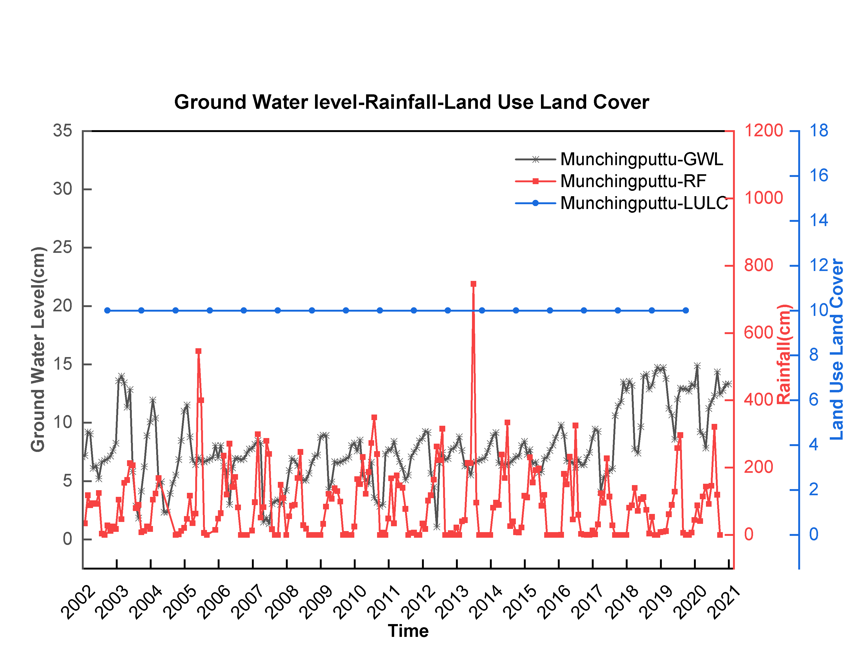
Fig 23: Ground Water Level(GWL), Rainfall(RF), Land Use Land Cover(LULC) data sets from Munchingputtu mandal of Visakhapatnam district, Andhra Pradesh, India.
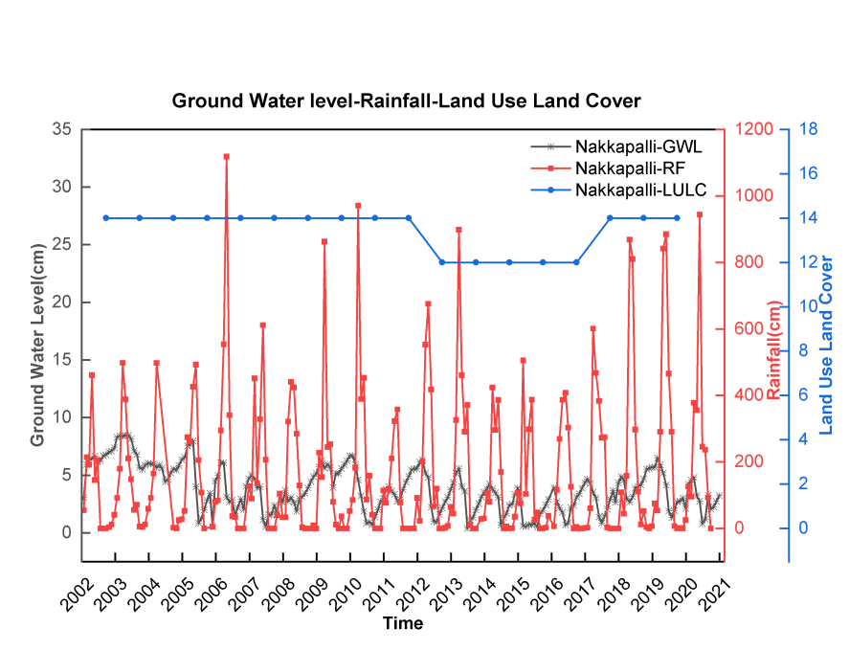
Fig 24: Ground Water Level(GWL), Rainfall(RF), Land Use Land Cover(LULC) data sets from Nakapalli mandal of Visakhapatnam district, Andhra Pradesh, India.
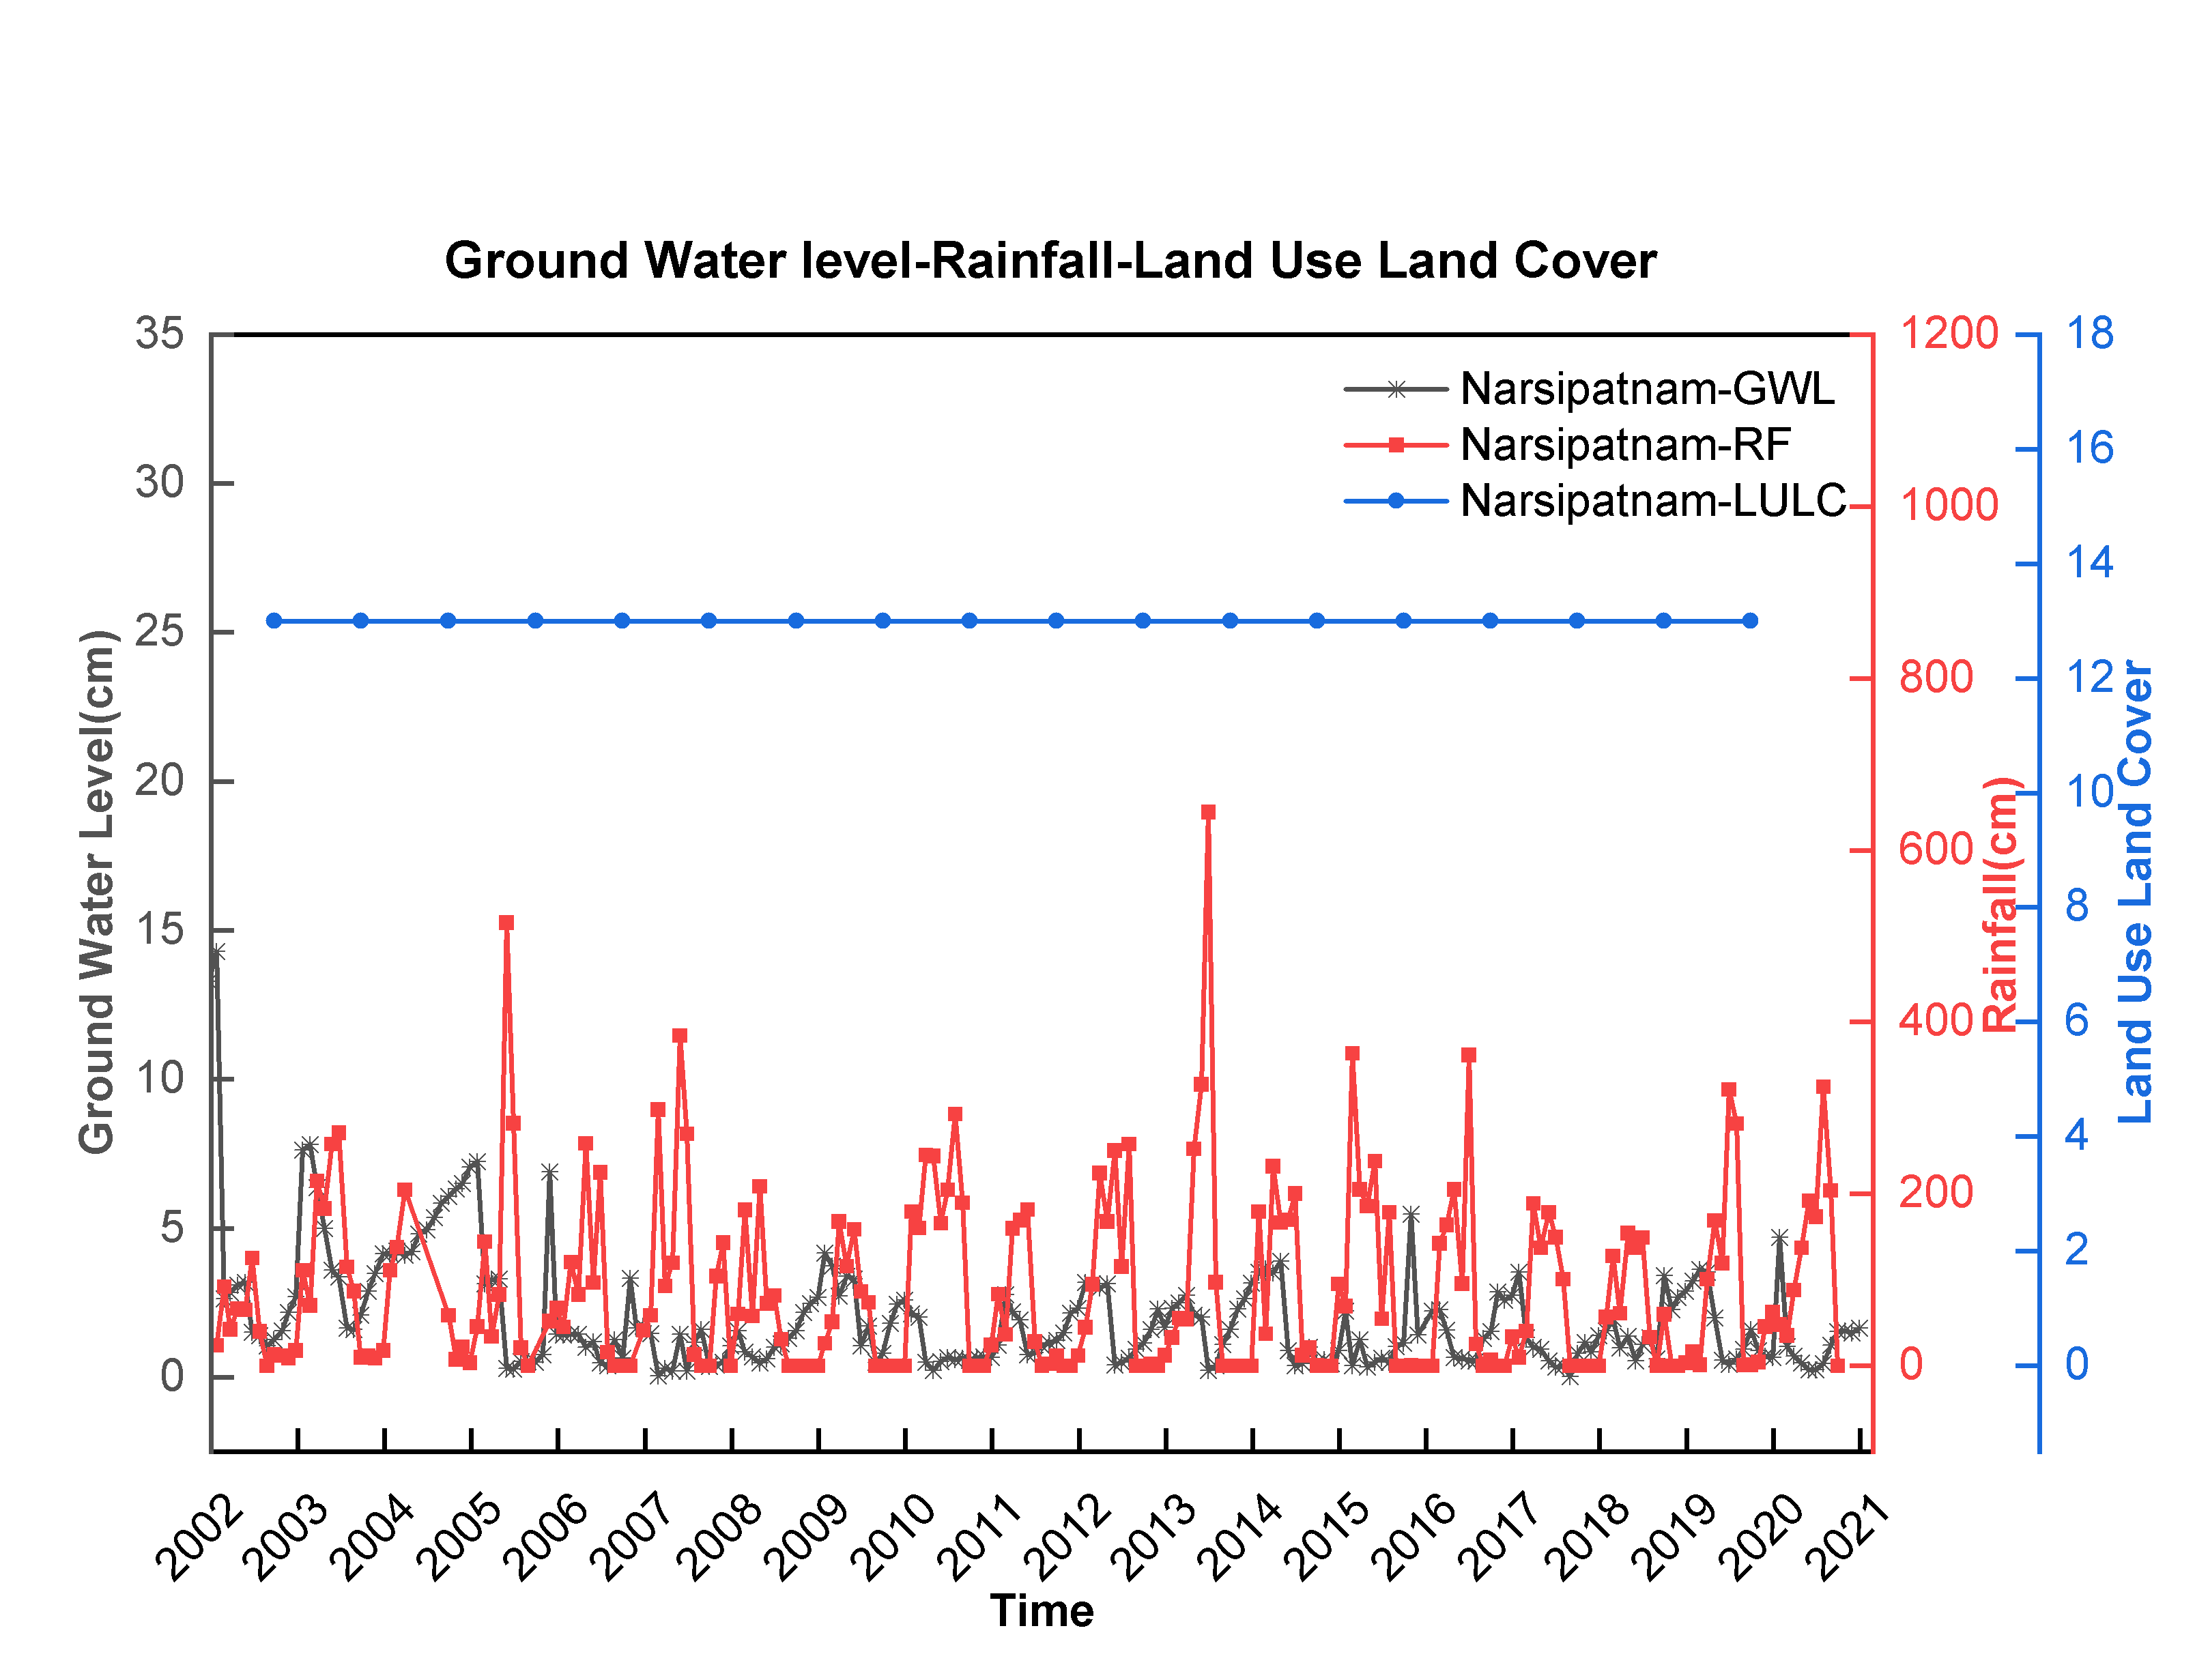
Fig 25: Ground Water Level(GWL), Rainfall(RF), Land Use Land Cover(LULC) data sets from Narsipatnam mandal of Visakhapatnam district, Andhra Pradesh, India.
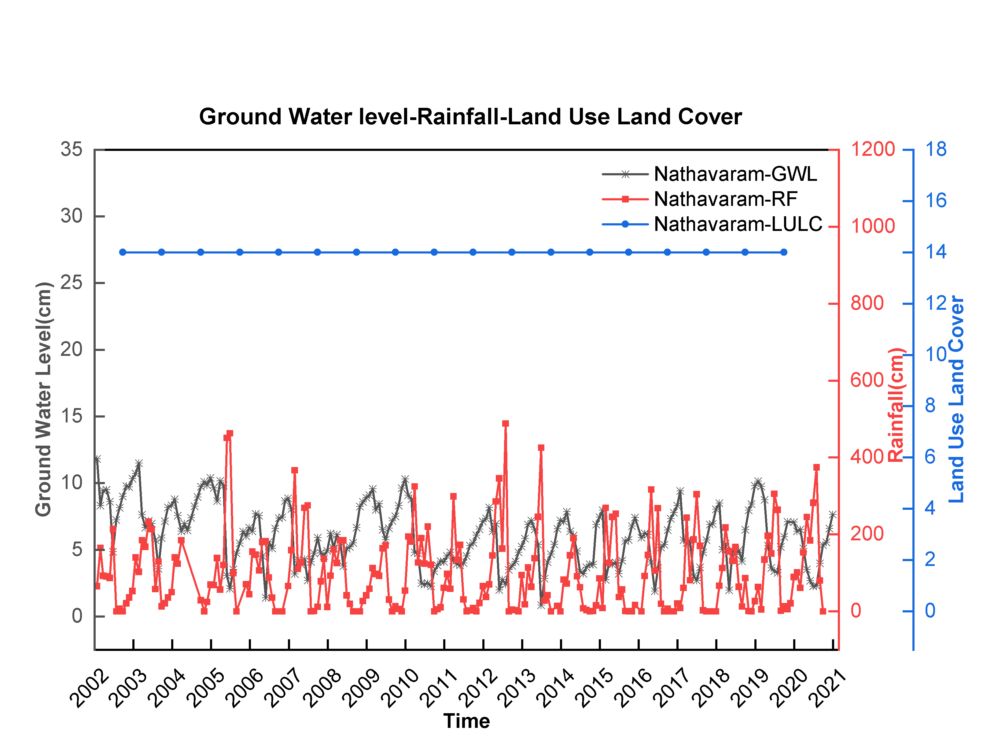
Fig 26: Ground Water Level(GWL), Rainfall(RF), Land Use Land Cover(LULC) data sets from Nathavaram mandal of Visakhapatnam district, Andhra Pradesh, India.
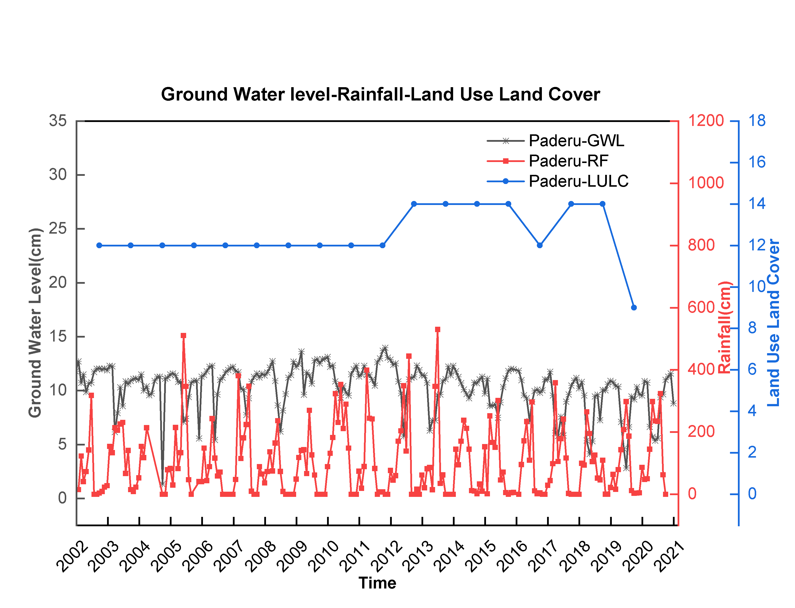
Fig 27: Ground Water Level(GWL), Rainfall(RF), Land Use Land Cover(LULC) data sets from Paderu mandal of Visakhapatnam district, Andhra Pradesh, India.
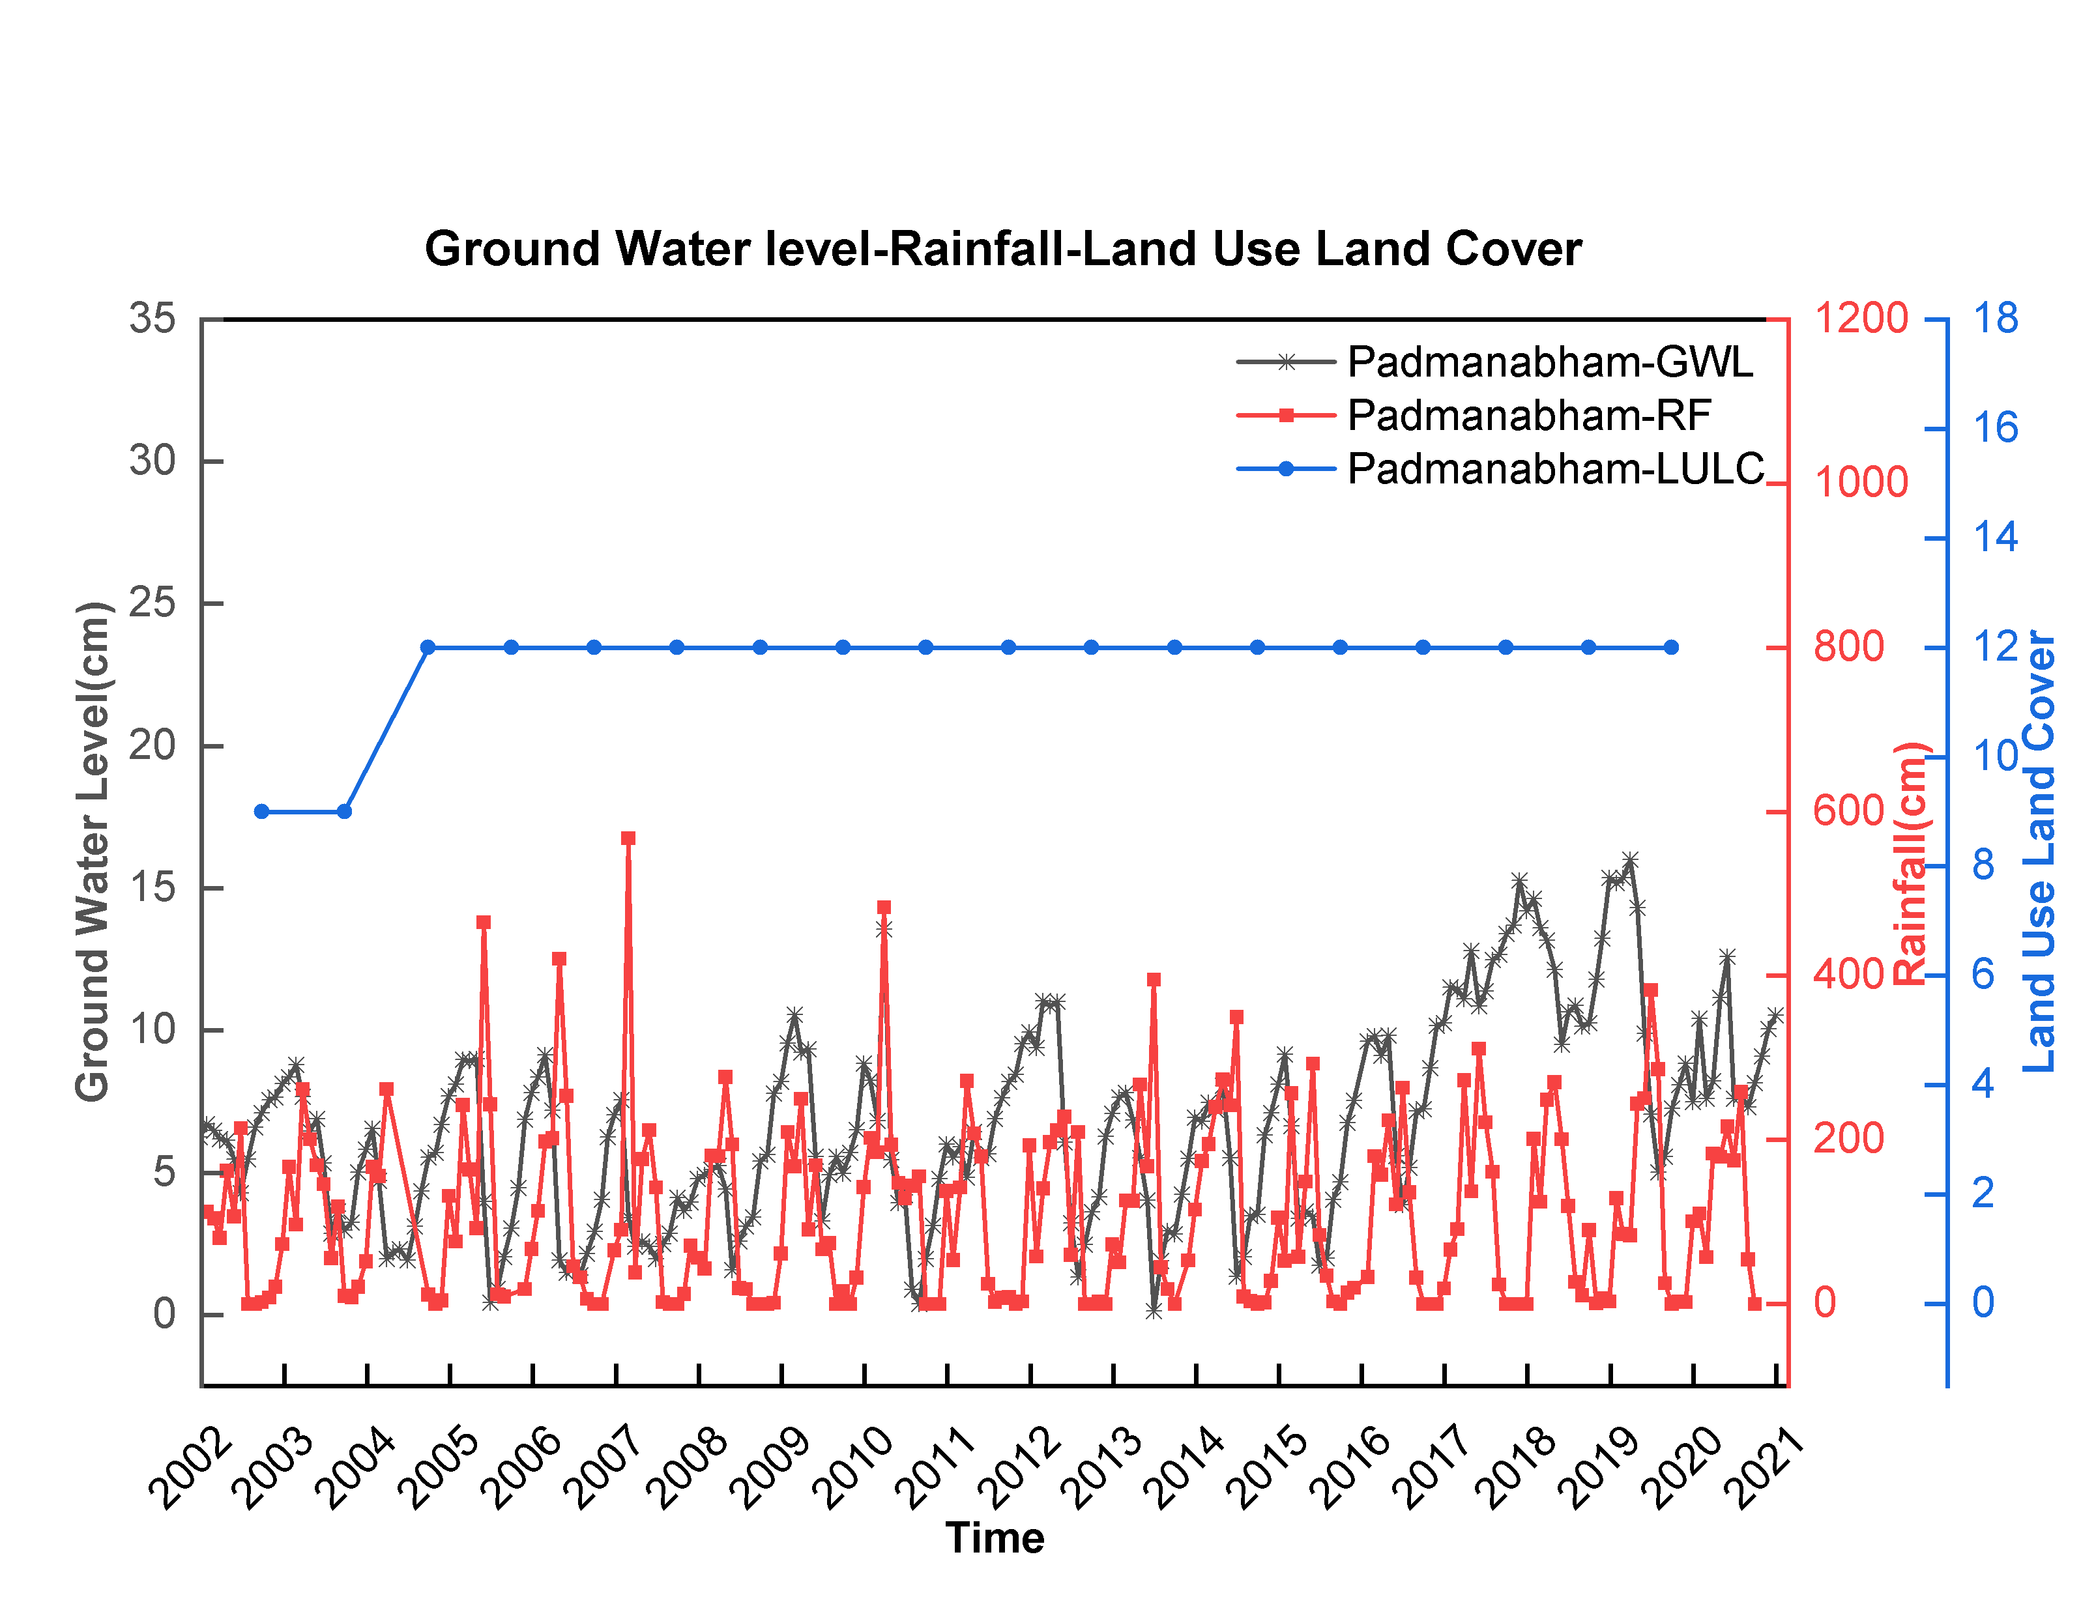
Fig 28: Ground Water Level(GWL), Rainfall(RF), Land Use Land Cover(LULC) data sets from Padmanabham mandal of Visakhapatnam district, Andhra Pradesh, India.
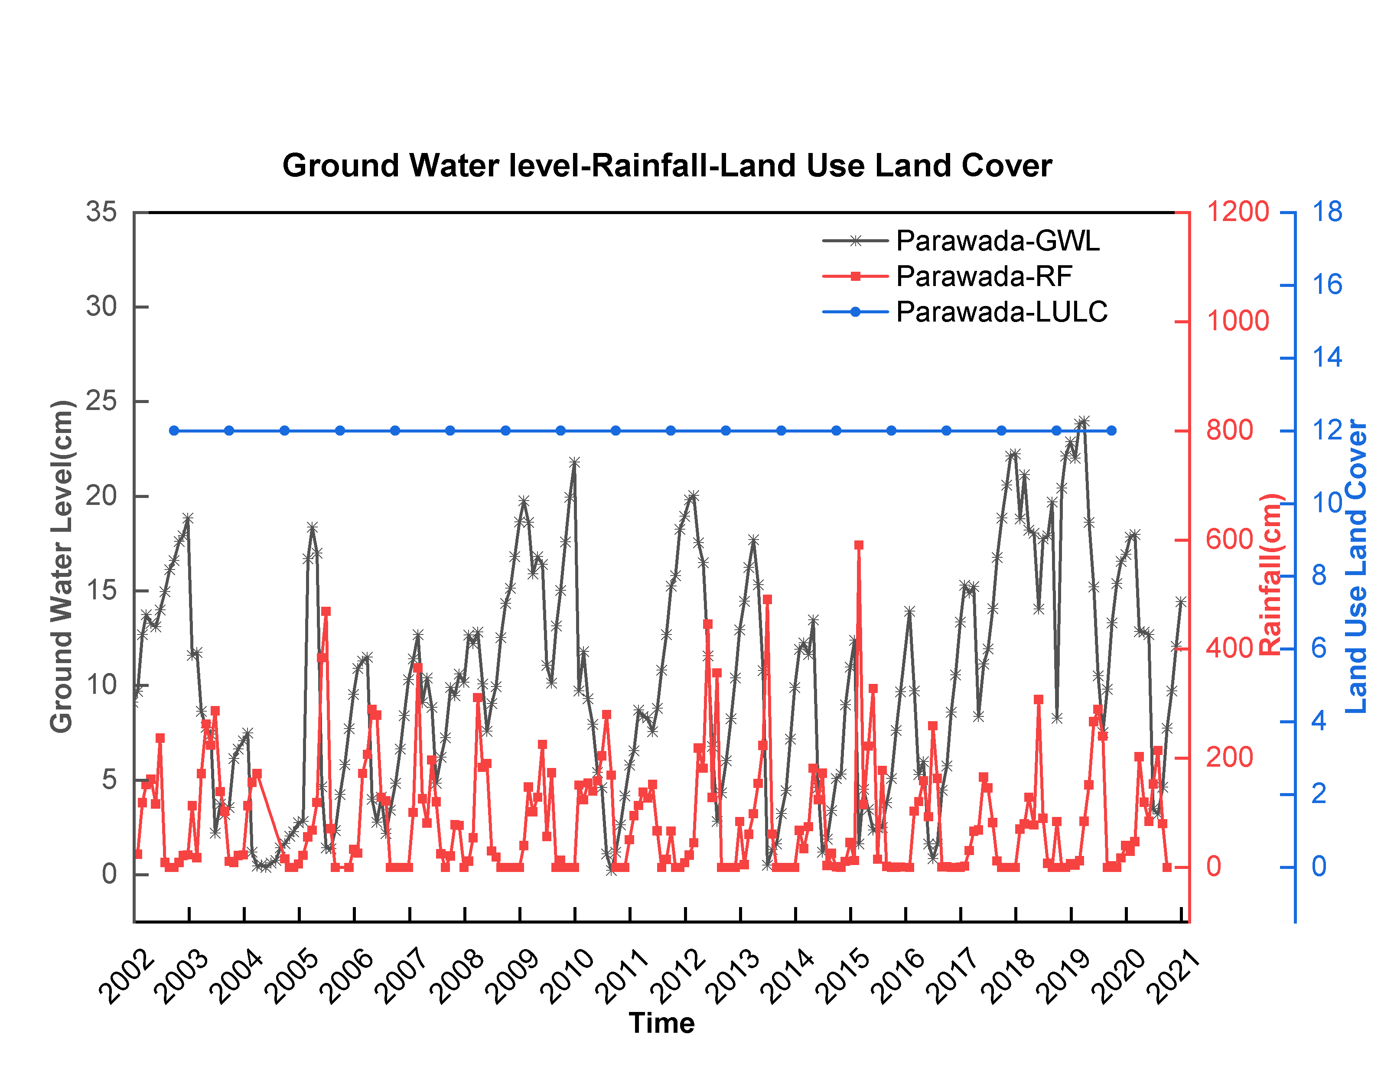
Fig 29: Ground Water Level(GWL), Rainfall(RF), Land Use Land Cover(LULC) data sets from Parawada mandal of Visakhapatnam district, Andhra Pradesh, India.
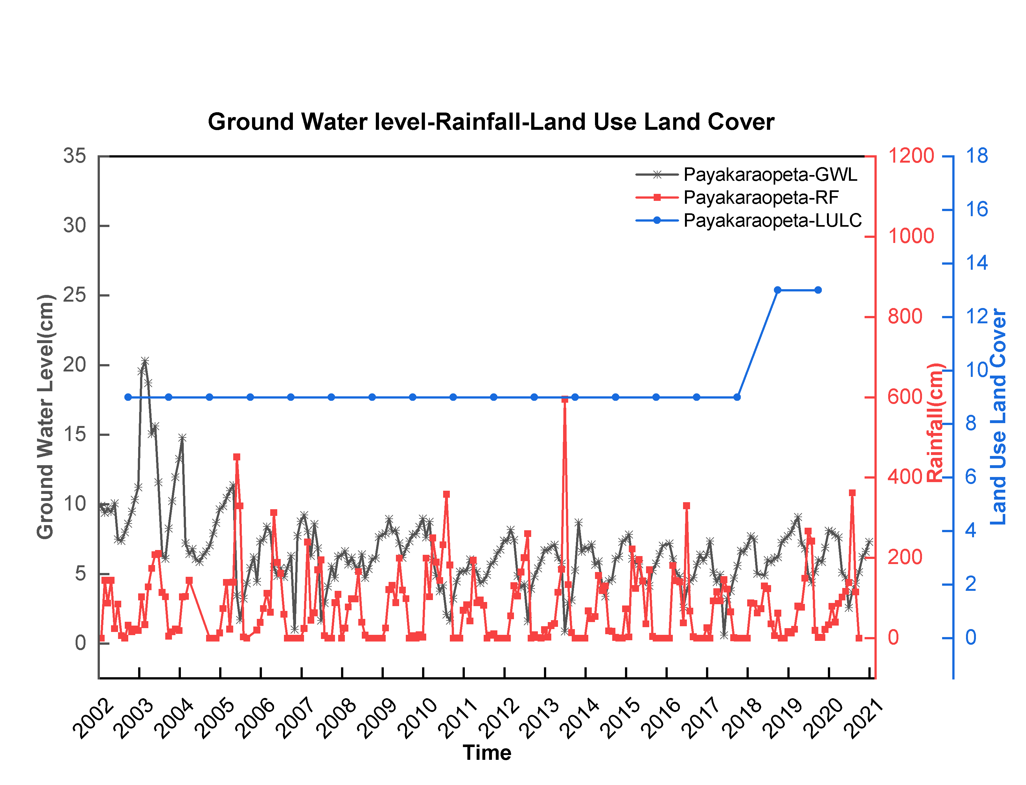
Fig 30: Ground Water Level(GWL), Rainfall(RF), Land Use Land Cover(LULC) data sets from Payakaraopeta mandal of Visakhapatnam district, Andhra Pradesh,India.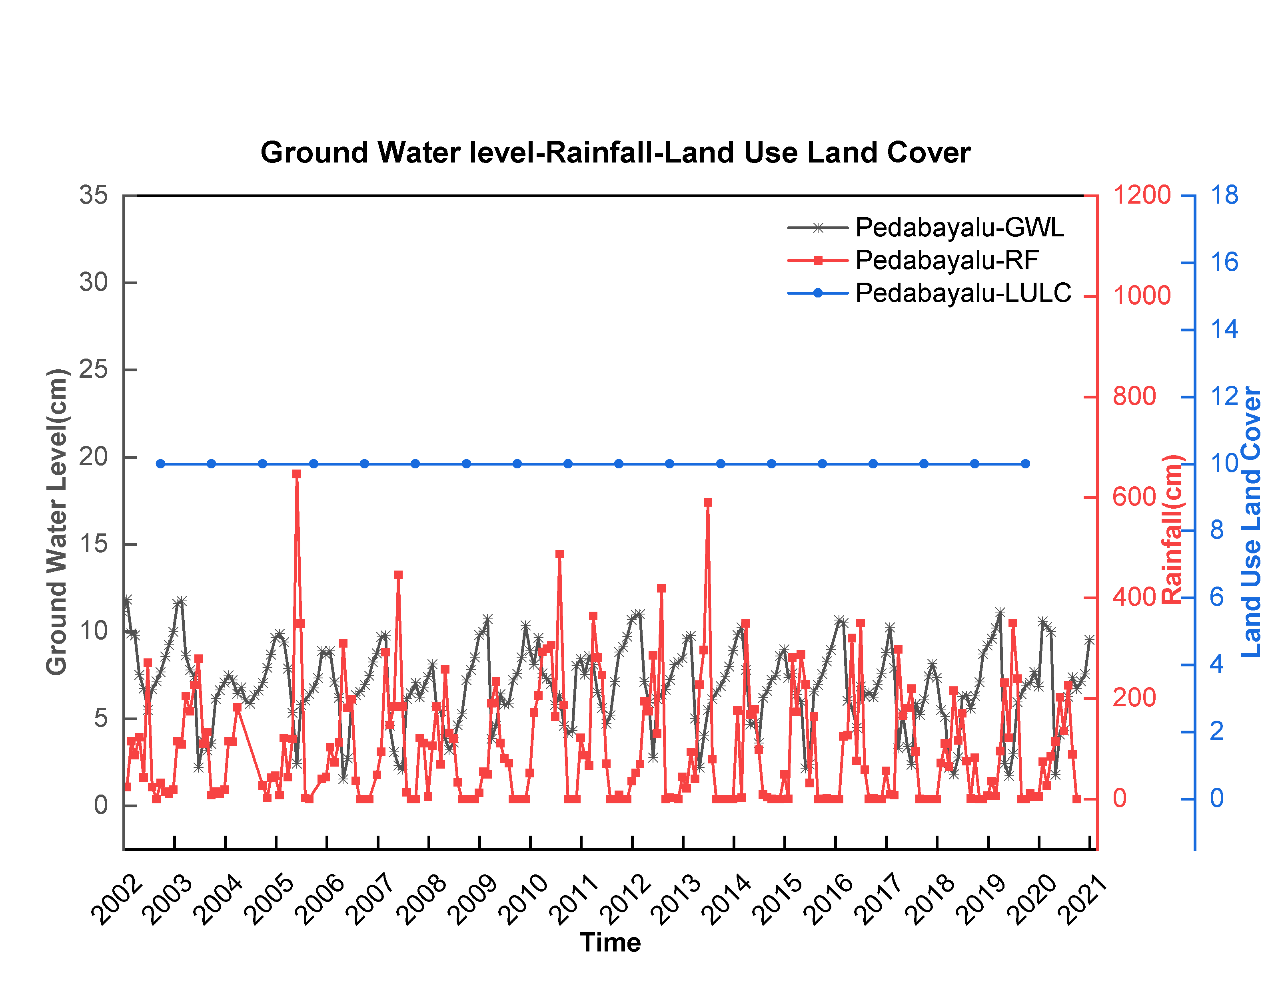
Fig 31: Ground Water Level(GWL), Rainfall(RF), Land Use Land Cover(LULC) data sets from Pedabayalu mandal of Visakhapatnam district, Andhra Pradesh, India.
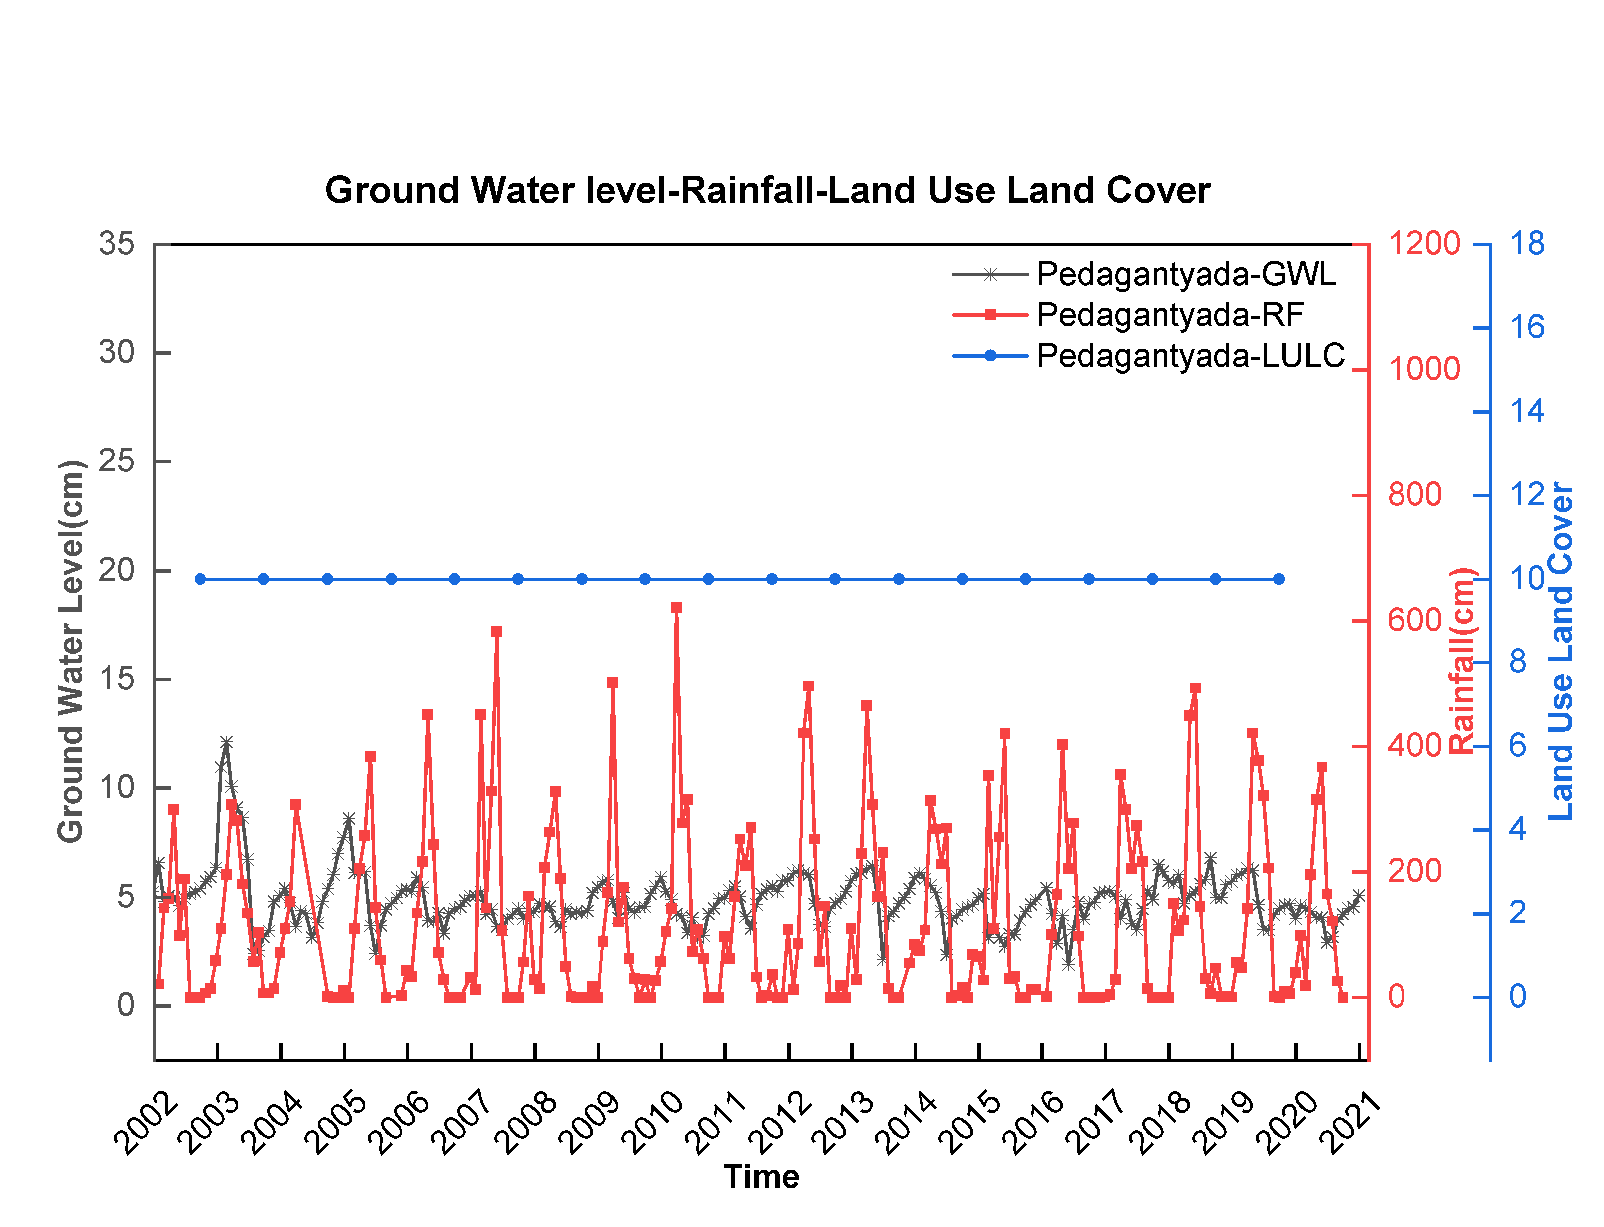
Fig 32: Ground Water Level(GWL), Rainfall(RF), Land Use Land Cover(LULC) data sets from Pedagantyada mandal of Visakhapatnam district, Andhra Pradesh, India.
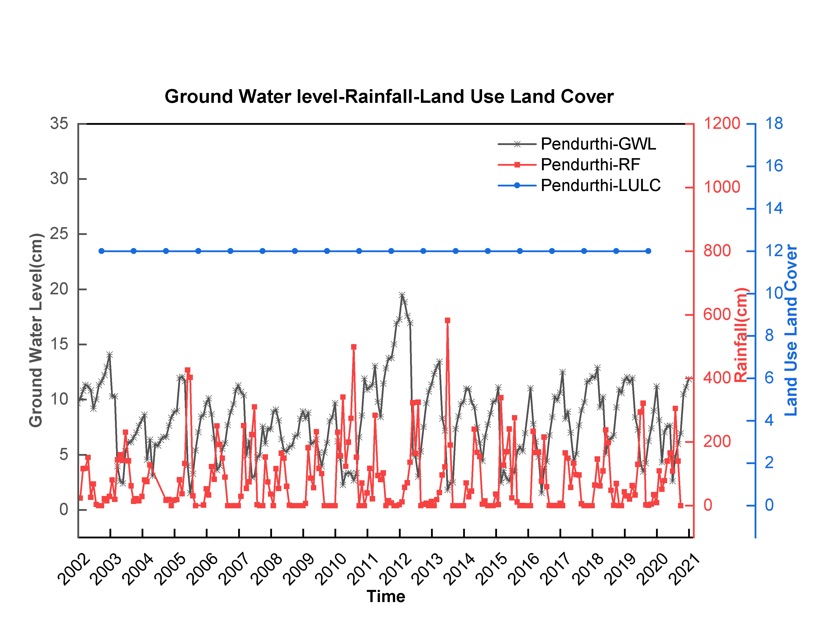
Fig 33: Ground Water Level(GWL), Rainfall(RF), Land Use Land Cover(LULC) data sets from Pendurthi mandal of Visakhapatnam district, Andhra Pradesh, India.
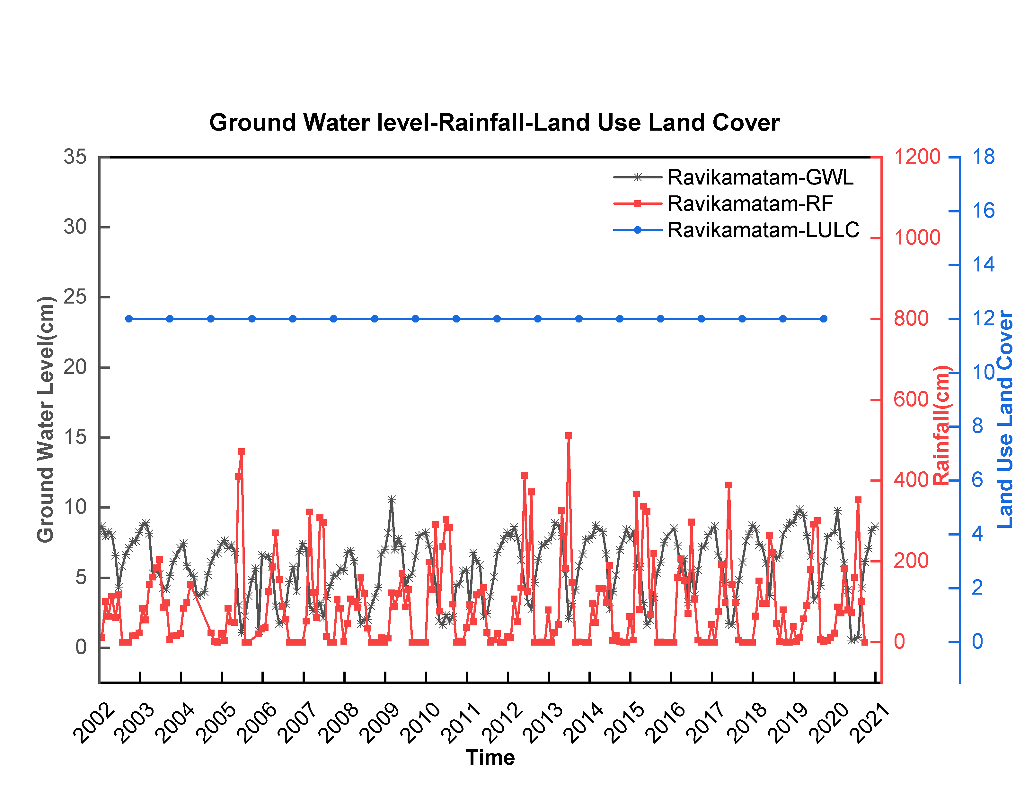
Fig 34: Ground Water Level(GWL), Rainfall(RF), Land Use Land Cover(LULC) data sets from Ravikamatam mandal of Visakhapatnam district, Andhra Pradesh, India.
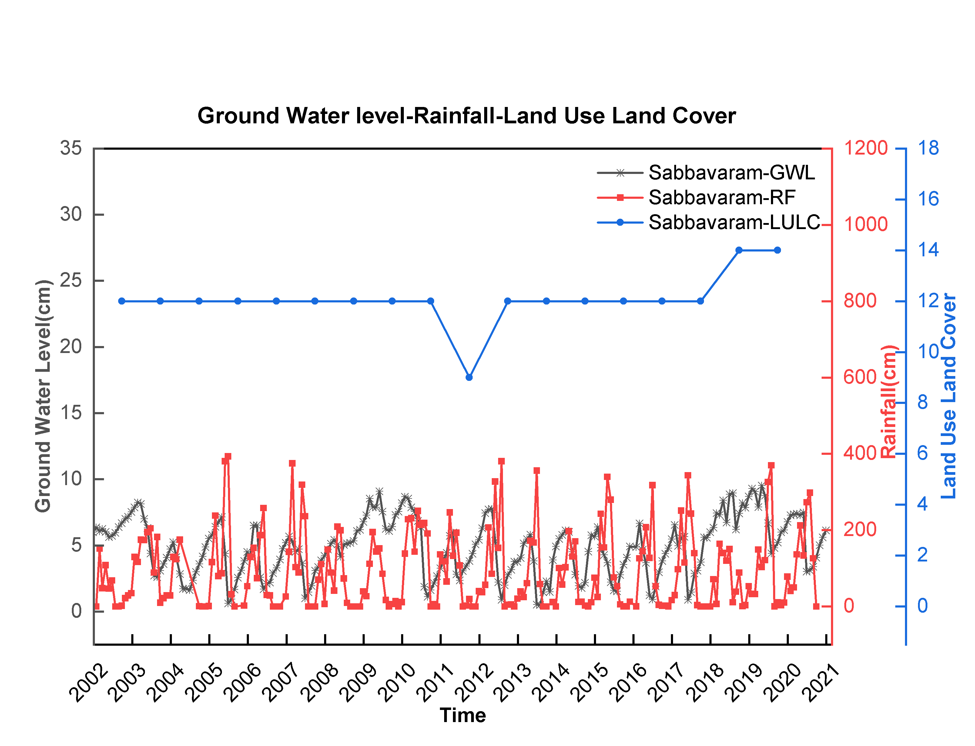
Fig 35: Ground Water Level(GWL), Rainfall(RF), Land Use Land Cover(LULC) data sets from Sabbavaram mandal of Visakhapatnam district, Andhra Pradesh, India.
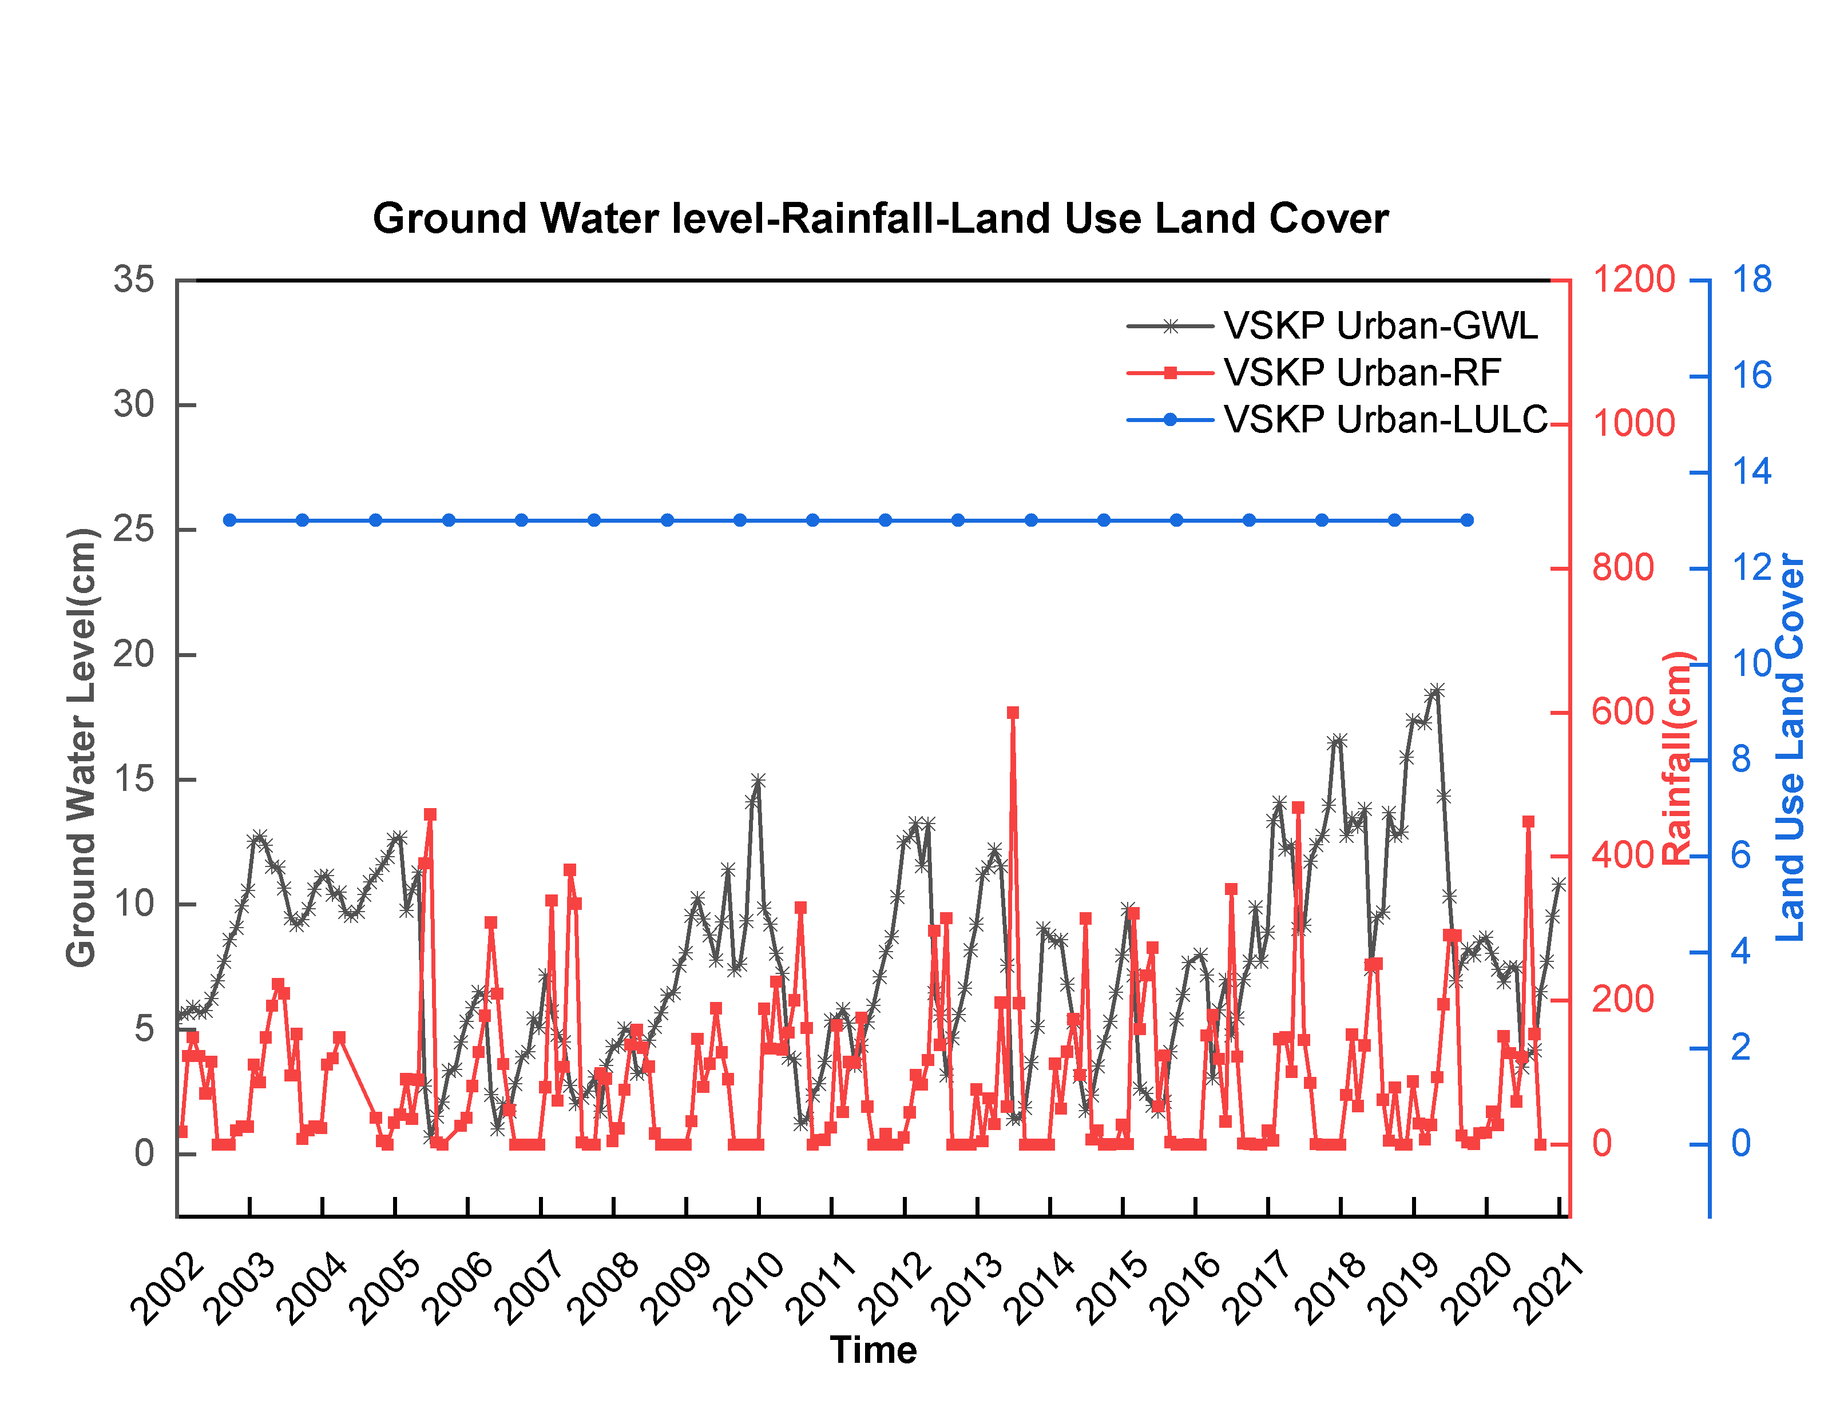
Fig 36: Ground Water Level(GWL), Rainfall(RF), Land Use Land Cover(LULC) data sets from Visakhapatnam Urban of Visakhapatnam district, Andhra Pradesh, India.
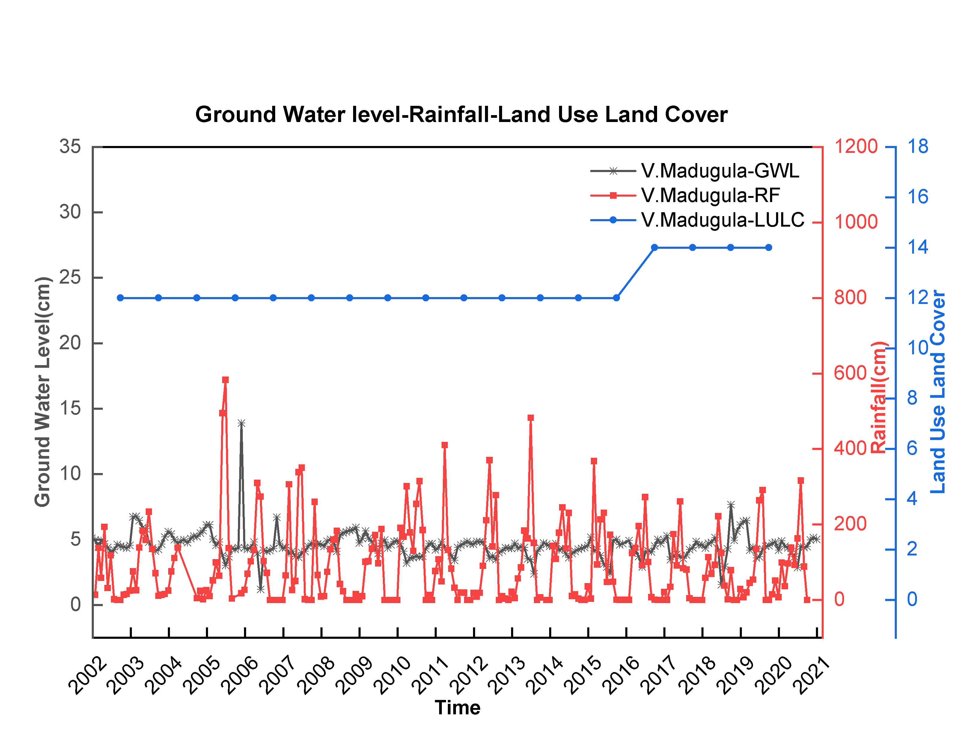
Fig 37: Ground Water Level(GWL), Rainfall(RF), Land Use Land Cover(LULC) data sets from V.Madugula mandal of Visakhapatnam district, Andhra Pradesh, India.

Testing the accuracy of the model with rainfall and temperature exogenic inputs
Case 1 – Rainfall and Temperature as an exogenic input: In addition to the rainfall that controls the Ground Water level, the temperature also influences evapotranspiration and thereby the Ground Water recharge. Therefore, here, we attempted to model the influence of the temperature by providing it as an exogenic input. The increasing temperature increases evapotranspiration, hence, the Ground Water recharge/ level is inversely proportional to the temperature. To incorporate this relationship, we considered the rainfall and temperature as inputs and Ground Water levels as output and evaluated the model accuracies using Bayesian regularisation with 5 hidden layers and 2 delays using the Nonlinear Autoregressive model with exogenic inputs (Figure A1).
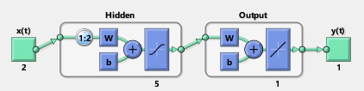

Figure A1: Nonlinear Input-Output Network model used in modeling Ground Water level changes with rainfall and temperature as exogenic inputs.
Figure A2: Regression analysis of the model shown in Figure A1.
Figure A3: Performance of the model shown in Figure A1.
As shown above the model with rainfall and temperature as exogenic inputs (Figure A1) can provide the best performance with nearly ~27% predictability. Thus it is clear that the dynamics of rainfall and temperature are not enough to predict the Ground Water level. Thus it is clear that the self-organized dynamic of Ground Water level data that is useful for the prediction is not from either rainfall or temperature. Further, if such self-organized dynamics present with either rainfall or temperature, then the model prediction might have close to that of the NAR model with Ground Water level as inputs, i.e., ~ 94% predictability.
Case 2 - Rainfall as input and Ground Water level as the target in the Nonlinear Input-Output model:
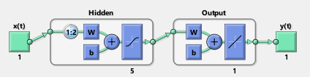
Figure A4: Nonlinear Input-Output Network model used in modeling Ground Water level changes with rainfall as exogenic input.
Figure A2: Regression fit during training, testing and both training and testing of the model shown in Figure A4.

Figure A6: Performance of the model shown in Figure A2.
As discussed, to check the sensitivity of the Ground Water levels to rainfall changes we tested the neural network nonlinear input-output model with rainfall as an input and Ground Water level as out. We have selected 5 hidden layers and 2 delay states to train the model. This model helps to judge whether the self-organized dynamics that helped for the prediction of the Ground Water levels data are from rainfall or not. As the prediction in this model is much poor compared to the NAR model, it is clear that the dynamics of the rainfall are not significant for improving the predictability of Ground Water level changes.
We have also tested the NARX model with rainfall and temperature data sets as exogenic inputs. Interestingly, the improvement in the model prediction is just 1% for the additional exogenic inputs compared to the simple NAR model. Here it may also be understood that the prediction accuracies from the dynamics of rainfall and temperature are present there in the dynamics of rainfall but their contribution is limited to less than 30% in any case.

