Supplementary information of
Global observational coverage of oil and gas methane sources with TROPOMI
Mozhou Gao^{1*}, Zhenyu Xing¹, Coleman Vollrath¹, Chris H. Hugenholtz¹, Thomas E. Barchyn¹
¹Centre for Smart Emissions Sensing Technologies, Department of Geography, University of Calgary, 2500 University Drive NW, Calgary, AB, T2N 1N4, Canada
*Correspondence to: Mozhou Gao (mozhou.gao@ucalgary.ca)

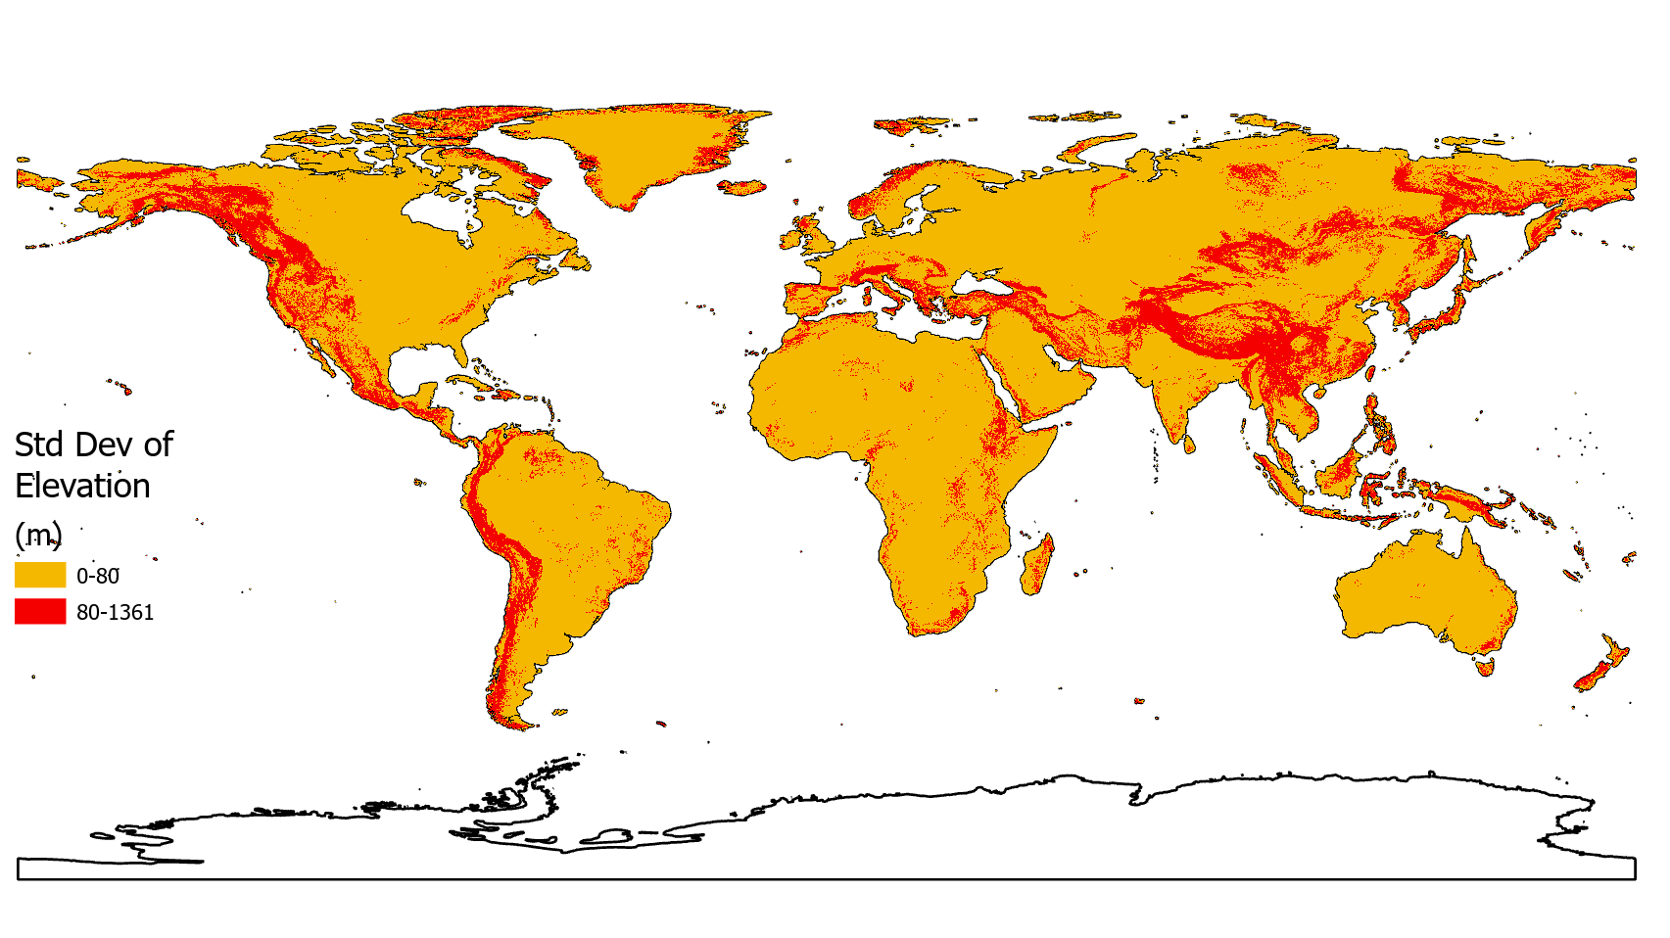
Figure S1. Map shows the region with the standard deviation of surface elevation greater than 80 m within a 5-km radius. The standard deviations were calculated by using Global Land One-kilometer Base Elevation dataset [1].

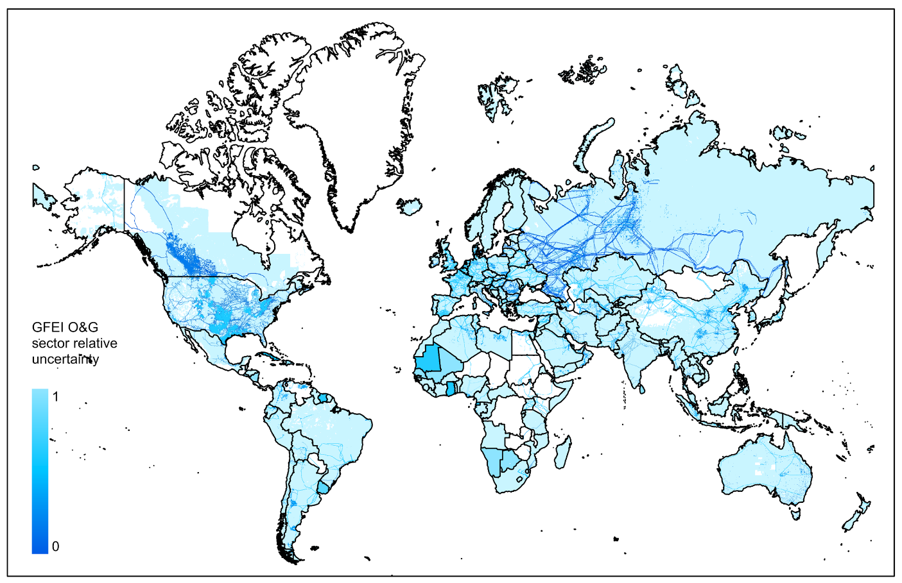
Figure S2. Relative uncertainty of Global Fuel Exploitation Inventory (GFEI) for O&G sectors [2]

Table S1. 3-year average TROPOMI observational coverages, 3-year average gap TROPOMI days, and 3-year average consecutive TROPOMI days for O&G sector grid cells of 160 countries.
Descriptions
CID: Unique ID for each country
TOC:3-year average annual TROPOMI observational coverage (%)
Gaps:3-year average gap TROPOMI days
Consecutives:3-year average consecutive TROPOMI days
GMP: whether a partner of Global Methane Pledge
CID | Country | TOC (%) | Gaps | Consecutives | GMP
0 | Afghanistan | 10 | 24 | 2 | N
1 | Albania | 0 | 365 | 0 | Y
2 | Algeria | 23 | 7 | 3 | N
3 | Angola | 7 | 25 | 2 | N
4 | Argentina | 13 | 12 | 2 | Y
5 | Armenia | 0 | 365 | 0 | Y
6 | Australia | 6 | 25 | 2 | N
7 | Austria | 5 | 28 | 1 | N
8 | Azerbaijan | 1 | 207 | 0 | N
9 | Bahrain | 0 | 365 | 0 | Y
10 | Bangladesh | 8 | 21 | 2 | N
11 | Belarus | 4 | 39 | 2 | N
12 | Belgium | 6 | 24 | 2 | Y
13 | Benin | 2 | 64 | 2 | Y
14 | Bolivia | 4 | 101 | 1 | N
15 | Bosnia | 0 | 238 | 0 | Y
16 | Brazil | 2 | 90 | 1 | Y
17 | Brunei Darussalam | 0 | 365 | 0 | N
18 | Bulgaria | 7 | 22 | 2 | Y
19 | Burkina Faso | 12 | 12 | 3 | Y
20 | Burundi | 0 | 192 | 0 | N
21 | Côte d'Ivoire | 1 | 111 | 1 | N
22 | Cambodia | 0 | 255 | 0 | N
23 | Cameroon | 1 | 186 | 1 | Y
24 | Canada | 4 | 31 | 2 | Y
25 | Canarias | 0 | 365 | 0 | N
26 | CAR | 1 | 199 | 1 | Y
27 | Chad | 12 | 13 | 3 | N
28 | Chile | 2 | 78 | 1 | Y
29 | China | 5 | 42 | 1 | N
30 | Colombia | 0 | 284 | 0 | Y
31 | Comoros | 0 | 365 | 0 | N
32 | Congo | 0 | 304 | 0 | N
33 | Congo DRC | 1 | 105 | 1 | N
34 | Costa Rica | 0 | 365 | 0 | Y
35 | Croatia | 10 | 13 | 2 | Y
36 | Cuba | 1 | 93 | 1 | Y
37 | Cyprus | 0 | 365 | 0 | Y
38 | Czech Republic | 4 | 33 | 2 | N
39 | Denmark | 2 | 56 | 1 | Y
40 | Djibouti | 8 | 30 | 2 | Y
41 | Dominican Republic | 0 | 294 | 0 | Y
42 | Ecuador | 0 | 284 | 0 | Y
43 | Egypt | 14 | 15 | 2 | N
44 | El Salvador | 0 | 365 | 0 | Y
45 | Equatorial Guinea | 0 | 365 | 0 | N
46 | Eritrea | 7 | 18 | 2 | N
47 | Estonia | 2 | 70 | 1 | Y
48 | Eswatini | 18 | 8 | 3 | N
49 | Ethiopia | 1 | 162 | 0 | Y
50 | Finland | 1 | 81 | 1 | Y
51 | France | 6 | 27 | 2 | Y
52 | Gabon | 0 | 365 | 0 | Y
53 | Gambia | 3 | 189 | 0 | Y
54 | Georgia | 0 | 365 | 0 | Y
55 | Germany | 5 | 26 | 2 | Y
56 | Ghana | 1 | 111 | 1 | Y
57 | Greece | 0 | 365 | 0 | Y
58 | Guatemala | 0 | 365 | 0 | Y
59 | Guinea | 5 | 27 | 2 | N
60 | Guinea Bissau | 16 | 9 | 3 | N
61 | Haiti | 0 | 365 | 0 | N
62 | Honduras | 0 | 365 | 0 | Y
63 | Hungary | 8 | 16 | 2 | N
64 | India | 12 | 15 | 3 | N
65 | Indonesia | 0 | 304 | 0 | Y
66 | Iran | 6 | 35 | 2 | N
67 | Iraq | 22 | 8 | 3 | Y
68 | Ireland | 1 | 75 | 1 | Y
69 | Israel | 9 | 30 | 2 | Y
70 | Italy | 5 | 34 | 1 | Y
71 | Jamaica | 0 | 365 | 0 | Y
72 | Japan | 1 | 90 | 0 | Y
73 | Jordan | 14 | 18 | 2 | Y
74 | Kazakhstan | 13 | 11 | 2 | N
75 | Kenya | 1 | 131 | 0 | N
76 | Kuwait | 37 | 4 | 3 | Y
77 | Kyrgyzstan | 0 | 365 | 0 | Y
78 | Laos | 2 | 50 | 2 | N
79 | Latvia | 4 | 30 | 2 | N
80 | Lebanon | 0 | 365 | 0 | N
81 | Lesotho | 12 | 11 | 2 | N
82 | Liberia | 2 | 103 | 2 | Y
83 | Libya | 22 | 7 | 3 | Y
84 | Liechtenstein | 0 | 243 | 0 | Y
85 | Lithuania | 4 | 32 | 2 | N
86 | Luxembourg | 6 | 21 | 2 | Y
87 | Madagascar | 5 | 26 | 2 | N
88 | Malawi | 5 | 22 | 2 | Y
89 | Malaysia | 0 | 365 | 0 | Y
90 | Mali | 9 | 19 | 2 | Y
91 | Mauritania | 3 | 191 | 0 | N
92 | Mexico | 5 | 27 | 2 | Y
93 | Moldova | 9 | 15 | 2 | N
94 | Mongolia | 5 | 26 | 2 | N
95 | Morocco | 15 | 14 | 2 | Y
96 | Mozambique | 4 | 36 | 2 | N
97 | Myanmar | 5 | 29 | 2 | N
98 | Namibia | 18 | 10 | 3 | N
99 | Netherlands | 5 | 30 | 2 | Y
100 | NewZealand | 0 | 271 | 0 | Y
101 | Nicaragua | 0 | 365 | 0 | N
102 | Niger | 11 | 18 | 2 | N
103 | Nigeria | 2 | 77 | 1 | Y
104 | North Korea | 2 | 71 | 1 | N
105 | North Macedonia | 5 | 30 | 2 | Y
106 | Norway | 0 | 365 | 0 | Y
107 | Oman | 5 | 35 | 2 | N
108 | Pakistan | 12 | 17 | 2 | Y
109 | Palau | 0 | 365 | 0 | Y
110 | Palestinian Territory | 8 | 19 | 2 | N
111 | Panama | 0 | 365 | 0 | Y
112 | Paraguay | 12 | 13 | 2 | N
113 | PEG | 0 | 365 | 0 | Y
114 | Peru | 0 | 365 | 0 | Y
115 | Philippines | 0 | 365 | 0 | Y
116 | Poland | 5 | 27 | 2 | N
117 | Portugal | 6 | 140 | 1 | Y
118 | Qatar | 3 | 50 | 1 | Y
119 | Romania | 5 | 28 | 2 | N
120 | Russian Federation | 4 | 37 | 2 | N
121 | Rwanda | 0 | 223 | 0 | Y
122 | San Marino | 0 | 365 | 0 | N
123 | Saudi Arabia | 21 | 8 | 3 | Y
124 | Senegal | 12 | 13 | 2 | Y
125 | Serbia | 7 | 24 | 2 | Y
126 | Sierra Leone | 3 | 39 | 2 | N
127 | Singapore | 0 | 365 | 0 | Y
128 | Slovakia | 3 | 46 | 1 | N
129 | Slovenia | 3 | 36 | 1 | Y
130 | Somalia | 6 | 34 | 2 | N
131 | South Africa | 12 | 13 | 2 | N
132 | South Korea | 3 | 31 | 1 | Y
133 | South Sudan | 6 | 19 | 2 | N
134 | Spain | 3 | 77 | 1 | Y
135 | SriLanka | 0 | 365 | 0 | N
136 | Sudan | 18 | 9 | 3 | N
137 | Suriname | 0 | 243 | 0 | Y
138 | Sweden | 1 | 284 | 0 | Y
139 | Switzerland | 1 | 162 | 0 | Y
140 | Syria | 28 | 6 | 3 | N
141 | Tajikistan | 0 | 365 | 0 | N
142 | Tanzania | 1 | 82 | 1 | N
143 | Thailand | 4 | 54 | 1 | N
144 | Togo | 3 | 46 | 1 | Y
145 | Tunisia | 12 | 11 | 2 | Y
146 | Turkey | 2 | 105 | 1 | N
147 | Turkmenistan | 20 | 9 | 3 | N
148 | UAE | 9 | 21 | 2 | Y
149 | Uganda | 0 | 148 | 0 | N
150 | Ukraine | 6 | 27 | 2 | Y
151 | United Kingdom | 2 | 53 | 1 | Y
152 | United States | 10 | 15 | 2 | Y
153 | Uruguay | 14 | 10 | 2 | Y
154 | Uzbekistan | 16 | 11 | 3 | Y
155 | Venezuela | 0 | 304 | 0 | N
156 | Vietnam | 1 | 182 | 1 | Y
157 | Yemen | 6 | 19 | 2 | N
158 | Zambia | 9 | 18 | 2 | Y
159 | Zimbabwe | 15 | 12 | 3 | N

Table S2. Current and planned satellite instruments for observing atmospheric CH₄
Satellite instruments | Launch time (or planned launch time) | Passive or active remote sensing | Orbit Type | Orbit altitude (km)
GOSAT | 2009 | passive | Sun-synchronous | 666
Landsat-8 | 2013 | passive | Sun-synchronous | 705
WorldView-3 | 2014 | passive | Sun-synchronous | 617
Sentinel-2 | 2015 | passive | Sun-synchronous | 786
GHGSats | 2016 | passive | Sun-synchronous | 512-550
TROPOMI | 2017 | passive | Sun-synchronous | 824
Gaofen3 | 2018 | passive | Sun-synchronous | 755
PRISMA | 2019 | passive | Sun-synchronous | 614
Ziyuan1 | 2019 | passive | Sun-synchronous | 785
EnMAP | 2022 | passive | Sun-synchronous | 653
EMIT | 2022 | passive | Sun-synchronous | 400
GOSAT-GW | 2023 | passive | Sun-synchronous | 667
MethaneSAT | 2023 | passive | Sun-synchronous | NA
MicroCarb | 2023 | passive | Sun-synchronous | 650
Carbon Mapper | 2023 | passive | Sun-synchronous | NA
Sentinel-2C | 2024 | passive | Sun-synchronous | NA
GeoCarb | 2025 | passive | Geostationary | 35786
CO2M | 2025 | passive | Sun-synchronous | NA
MERLIN | 2027 | active | Sun-synchronous | 500

References
1. Hastings, D. & Dunbar, P. K. Global Land One-kilometer Base Elevation (GLOBE) v.1. National Geophysical Data Center, NOAA (1999). https://www.ncei.noaa.gov/access/metadata/landing-page/bin/iso?id=gov.noaa.ngdc.mgg.dem:280 (Accessed 07 March 2023).
2. Scarpelli, T. R. et al. Global Inventory of Methane Emissions from Fuel Exploitation. Goddard Earth Sciences Data and Information Services Center (GES DISC) (2021). https://disc.gsfc.nasa.gov/datasets/GFEI_CH4_1/summary (Accessed 07 March 2023).

