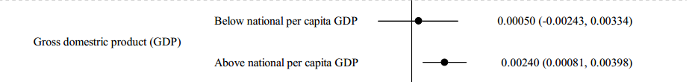

Figure S1. GDP-mediated temperature-uveitis relationship. The effect of variation in temperature on the number of uveitis cases when climate models contain an interaction-per capita GDP. The dots are point estimates of the effect of monthly temperature on monthly uveitis cases; the lines are 95% CI.

Table S1. Associations of uveitis onset with GDP per capita in subgroup
Type | β%-Effect size (95% CI) | P Value | β%-Effect size (95% CI) |  | P Value
Non-infectious uveitis | -1.92 (-2.61~-1.23) | <0.05 | -1.48 (-2.58~-0.39) |  | <0.05
Infectious uveitis | -0.24 (-3.67~2.97) | NS | -0.25 (-5.73~4.88) |  | NS
Uveitis alone | -1.30 (-2.11~-0.51) | <0.05 | -1.17 (-2.49~0.13) |  | NS
Uveitis with systemic diseases | -3.06 (-4.23~-1.86) | <0.05 | -1.96 (-3.84~-0.11) |  | <0.05
Idiopathic uveitis | -1.70 (-2.70~-0.74) | <0.05 | -1.10 (-2.69~0.46) |  | NS
Behçet’s disease | -7.58 (-10.09~-5.17) | <0.05 | -6.32 (-9.95~-2.83) |  | <0.05
Vogt-Koyanagi-Harada disease | -1.048 (-2.88~-0.74) | NS | -0.29 (-2.51~2.99) |  | NS
Overall | -1.85 (-2.52~-1.19) | <0.05 | -1.43 (-2.51~-0.37) |  | <0.05
 | no weights |  |  | population weights
CI= confidence intervals; NS=no significance

Table S2. per capita GDP-mediated 2.5–uveitis relationship
 | no climate controls |  | climate controls
 | β-Effect size (95% CI) | P Value | β-Effect size (95% CI) | P Value
below national per capita GDP | 0.011(0.0036~0.0185) | <0.01 | 0.0125(-0.0168~0.0417) | NS
above national per capita GDP | 0.0144(0.00819~0.0206) | <0.01 | 0.0124(0.0029~0.0220) | <0.01
CI= confidence intervals; NS=no significance

