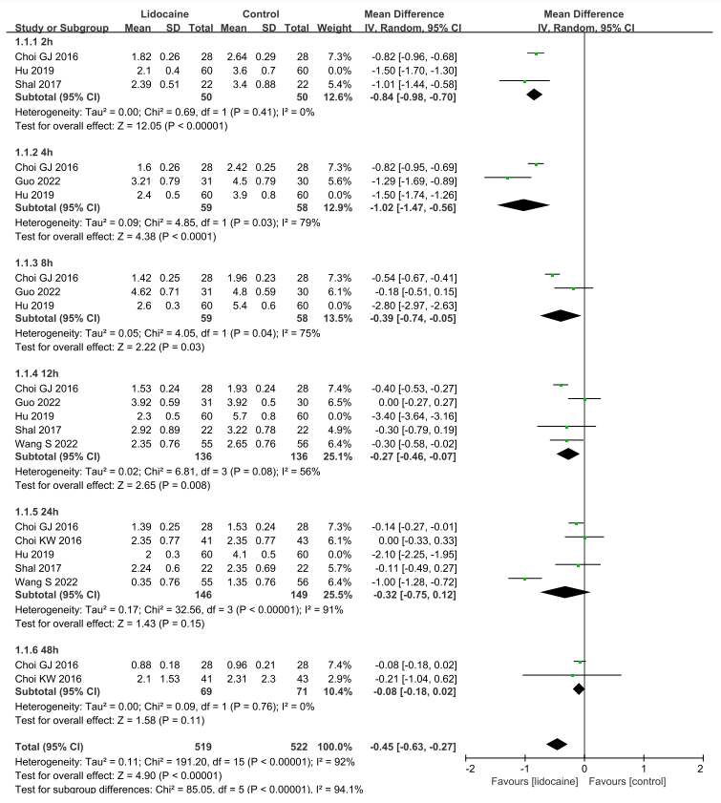

Supplementary Fig. 1. Forest plot of pain scores at 2h, 4h, 8h, 12h, 24h, and 48h after surgery, excluding Hu’s study which was deemed as the origin of heterogeneity after sensitivity analysis.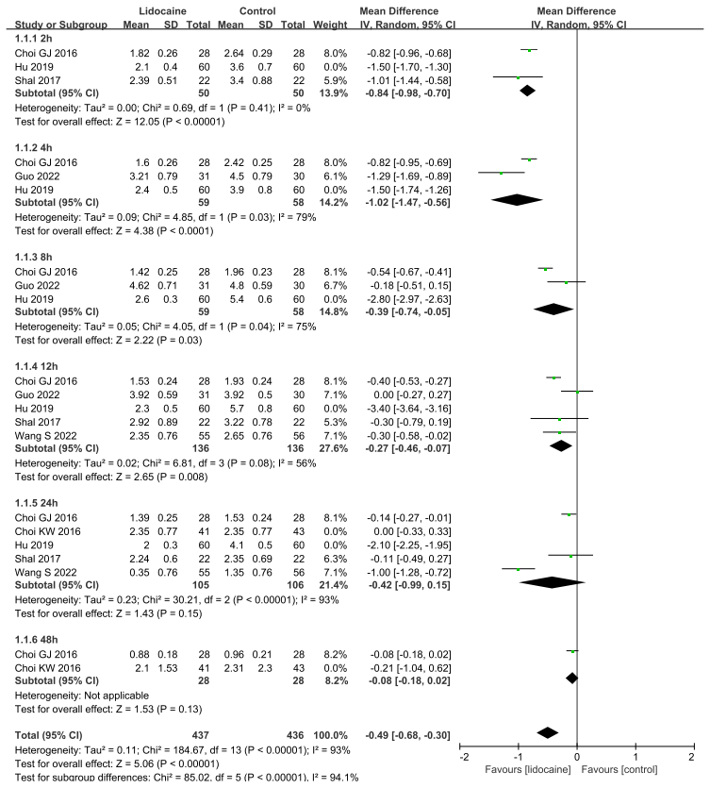

Supplementary Fig. 2. Forest plot of pain scores at 2h, 4h, 8h, 12h, 24h, and 48h after surgery, excluding Hu’s study and the study involving endoscopic surgery.
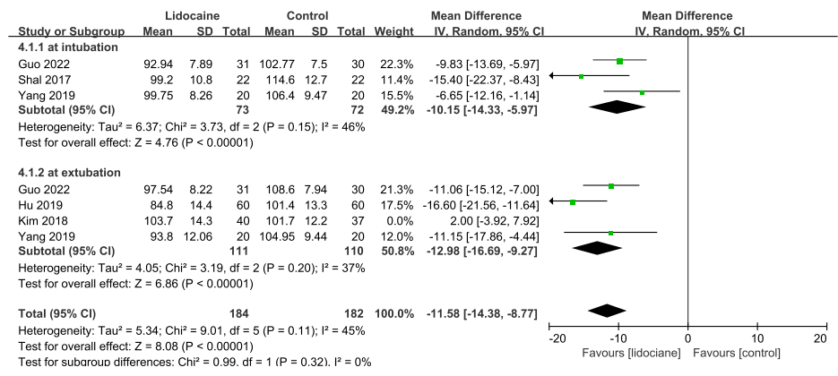

Supplementary Fig. 3a. Forest plot of MAP at intubation and extubation, excluding Kim’s study which was deemed as the origin of heterogeneity after sensitivity analysis.

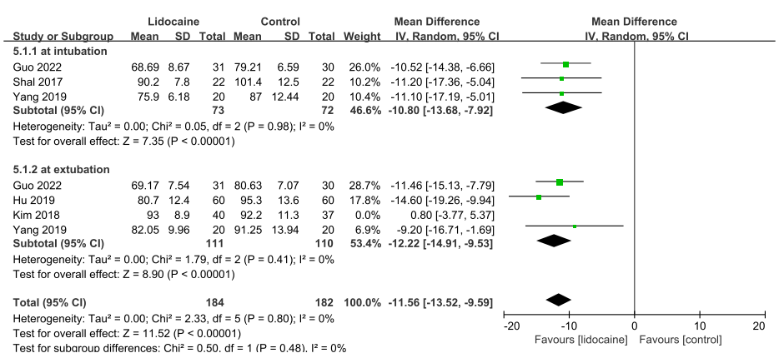
Supplementary Fig. 3b. Forest plot of HR at intubation and extubation, excluding Kim’s study which was deemed as the origin of heterogeneity after sensitivity analysis.

