Fig.S1: The ratio of lncRNA NR2F2-AS1 expression to miR-320b (a), BMI1 to miR-320b (b), and BMI1 to PTEN (c).

Table-S1: Demographic characteristic of individuals

Variable | Participants
Variable | n=40
Mean Age (±SD) (Min-Max) | 59.1 (± 12.51) (33 - 86)
No. of Age < 60 | 20 (50 %)
Mean Age< 60 (±SD) (Min-Max) | 49.4 (± 7.71) (33 - 59)
No. of Age ≥ 60 | 20 (50 %)
Mean Age≥ 60 (±SD) (Min-Max) | 68.9 (± 7.86) (61 - 86)
Gender
Female | 11 (27.5 %)
Male | 29 (72.5 %)
Metastasis status
No metastasis | 23 (57.5 %)
Metastasis | 17 (42.5 %)
Grouping in the base of Stage
Lower Stages (<T3a & M0) | 14 (35.0 %)
No Metastatic Higher Stages (≥T3 & M0) | 9 (22.5 %)
Metastatic Higher Stages (≥T3 & M+) | 17 (42.5 %)
Grade
G1 (well-differentiated) | 5 (12.5 %)
G2 (moderate differentiated) | 11 (27.5 %)
G3 (poorly differentiated) | 17 (42.5 %)
G4 (non-differentiated) | 7 (17.5 %)
Tumor Size
≤ 5 cm | 15 (37.5 %)
> 5 cm | 25 (62.5 %)
Alive after Sampling so far
Still alive | 13 (32.5 %)
Death | 27 (67.5%)

Table-S2: Real-time PCR primers..
Genes | Primer | Sequence (5'→3') | Tm (⁰C)
NR2F2-AS1 | F- | TCAGCCGGAAAACTACAAGCTC | 62
NR2F2-AS1 | R- | TCTTCGTGTAGCTGTTCCACC | 61
BMI1 | F- | GGTACTTCATTGATGCCACAACC | 63
BMI1 | R- | CTGGTCTTGTGAACTTGGACATC | 63
PTEN | F- | TGAGTTCCCTCAGCCGTTACCT | 64
PTEN | R- | GAGGTTTCCTCTGGTCCTGGTA | 64
miR-320b | F- | GCTGGGTTGAGAGGG | 60
miR-320b | R- | CGCTTCACGAATTTGCGTGT | 61
U6 | F- | AAG GAT GAC ACG CAA A | 61
U6 | R- | CGCTTCACGAATTTGCGTGT | 61
GAPDH | F- | GTCTCCTCTGACTTCAACAGCG | 62
GAPDH | R- | ACCACCCTGTTGCTGTAGCCAA | 62

Table-S3: Correlation analysis between studied genes
Spearman Correlation  between..... | r-value | 95% confidence interval | p-value
BMI & LncRNA NR2F2-AS1 | 0.7615 | 0.6468 to 0.8425 | <0.0001
BMI & miR-320b | -0.6893 | -0.7919 to -0.5488 | <0.0001
PTEN & LncRNA NR2F2-AS1 | -0.5435 | -0.6818 to -0.3676 | <0.0001
PTEN & miR-320b | 0.4792 | 0.2900 to 0.6323 | <0.0001
BMI & PTEN | -0.4569 | -0.6149 to -0.2637 | <0.0001
LncRNA NR2F2-AS1 & miR-320b | -0.7524 | -0.8362 to -0.6343 | <0.0001

Table-S4: Correlation analysis between studied genes and tumor size
Spearman Correlation  between..... | r-value | 95% confidence interval | p-value
Tumor Size & BMI | 0.2013 | -0.1176 to 0.4825 | 0.2130
Tumor Size & PTEN | -0.2037 | -0.4845 to 0.1151 | 0.2074
Tumor Size & LncRNA NR2F2-AS1 | 0.3152 | 0.004085 to 0.5707 | 0.0476
Tumor Size & miR-320b | -0.2283 | -0.5039 to 0.08961 | 0.1566

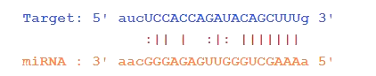
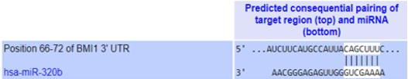
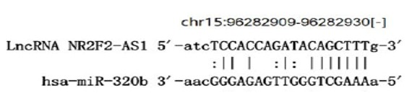
a)
b)
c)

Fig.S2: The prediction interaction of BMI1 gene and miR-320b in the base of (a) miRDB and (b) StarBase tools analysis. (c) The prediction of interaction of lncRNA NR2F2-AS1 and miR-320b in a base of analysis by Diana Tools (The links mentioned in the method).

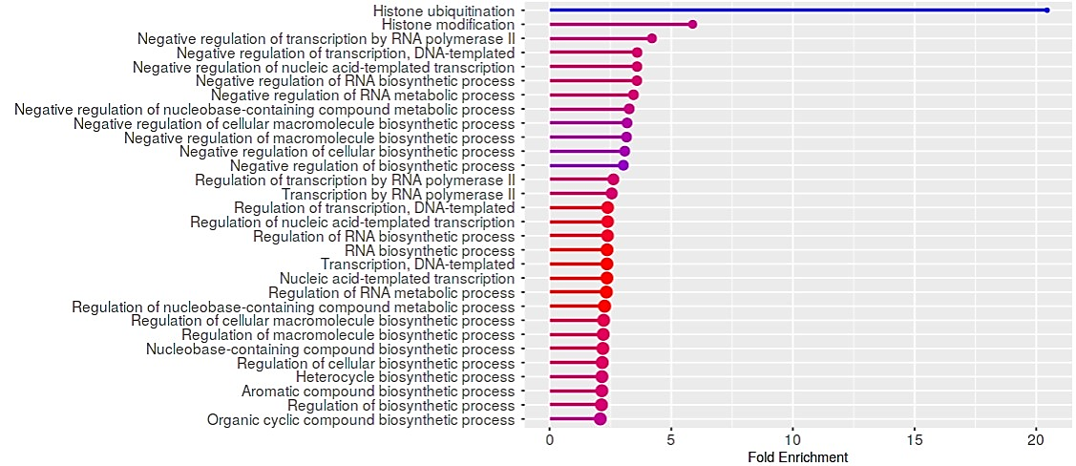
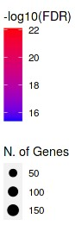
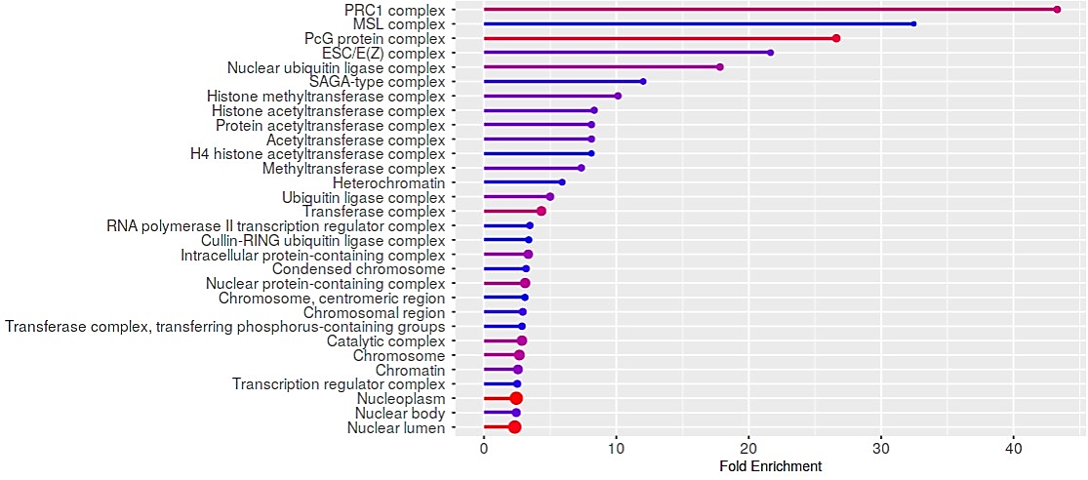
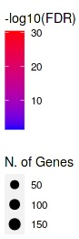
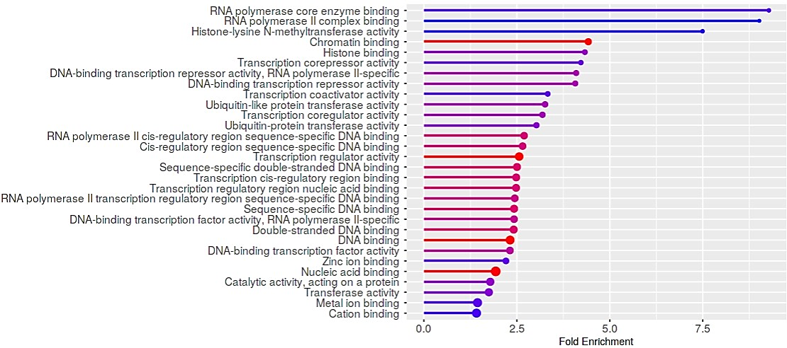
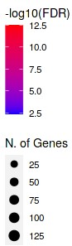
A) Biological Functions
B) Cellular Components
C) Molecular Functions

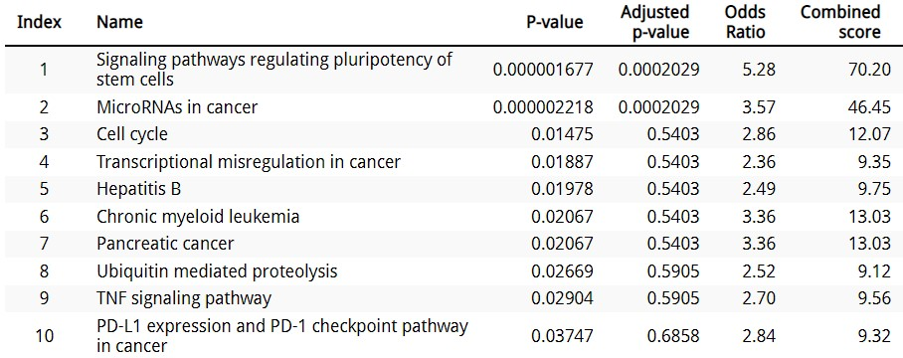
D) KEGG pathways

Fig.S3: GO enrichment assessment. Significantly enriched GO annotation of biological functions (A), Cellular components (B), and Molecular functions (C). Top 10 KEGG pathways enrichment analysis (D).

