Annexes:
Annex 1: Typology of mothers’ mistreatment in childbirth facilities based on Bohren's mistreatment typology (Bohren et al., 2015).
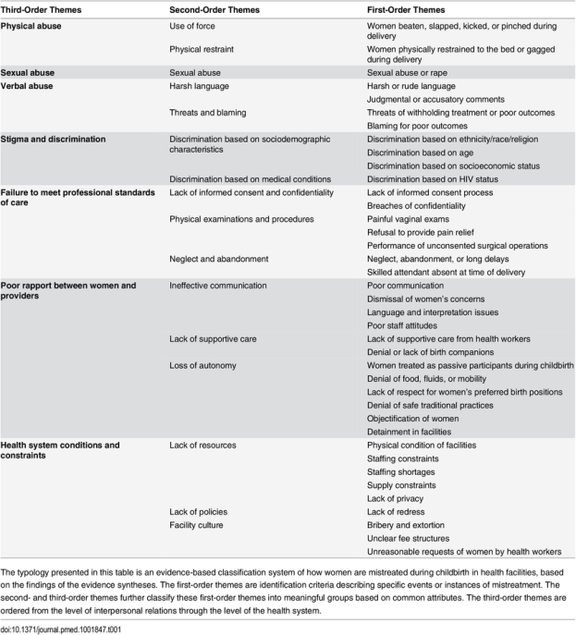

Annex 2: This study scales developments:
Abuse scale:
The physical abuse scale was developed based on experiencing any form of first-order themes including pinch, kick, slap, punch, beating with a tool, muzzle, tying mother to the hospital bed, forcefully holding mother on the bed, forcefully placing pressure on mother abdominal area before giving birth, or any other physical abuse mentioned by mothers. This scale was recorded to be a binary variable ( no physical abuse or at least experiencing one form of physical abuse), this scale has weak reliability, and Cronbach's alpha was 0.018.
The verbal abuse scale was developed based on experiencing any form of first-order themes including screaming, insulting, telling the mother off, ridiculing or making fun of the mother, commenting negatively on the mother's physical appearance, commenting negatively on the baby's appearance, commenting negatively on mother's sexual activity, threatening a mother with a medical procedure (such as a vaginal wound or a C-section, threatening the mother with physical violence, a threatening mother with having or her child having poor outcome, a threatening mother with withholding/stopping care for mother or her child, blaming mother, silence mother by (hush), or Other forms of abuse. This scale was recorded to be a binary variable ( no verbal abuse or at least experiencing one form of verbal abuse), this scale has accepted reliability, Cronbach's alpha was 0.585, but if deleted the items of “Did any of the hospital staff or workers comment negatively regarding your sexual activity?” it improved to 0.588, especially no any mother in our study has exposed to this theme of verbal abuse so we deleted it, also we deleted the items of “Did any of the hospital staff or hospital workers comment negatively on your child’s appearance (such as their outer appearance, gender, or other aspects of the child”, since its deletion improved the scale reliability. The recommended verbal scale contained only 12 items without above mentioned two themes since it has a better Cronbach's alpha of 0.592.
The stigma scale developed based on if health workers comment negatively about the mother’s ethnic origin, lineage, village/ clan, culture, religion, age, marital status, level of education, economic status, or HIV status. This scale was recorded to be a binary variable ( no stigma or at least experiencing one form of the above-mentioned stigma theme), this scale has weak reliability, with Cronbach's alpha -0.003.
Any abuse scale developed as a binary variable (yes/no) based if the mother experienced any themes of abuse mentioned above (physical, verbal, or stigma), this scale abuse Cronbach alpha: 0.197.
The typology of “Failure to meet a professional standard of care” has many themes, the first one is the negligence and abandonment scale which had constructed based on the following first-order themes:
1. Mother felt ignored by health workers
2. Mother felt neglected by health workers
3. Mother felt that her presence was an annoyance to health workers
4. Mother waited a long period before health staff acknowledged or prepared her in the hospital for labor
5. absence of health workers at the time of the child's arrival
The negligence and abandonment scale developed as a binary variable, ( no theme of negligence and abandonment or at least one form of negligence or abandonment, Cronbach's alpha with all above-mentioned theme 0.727, but It is 0.794 if the Items of “presence of health worker at the time of baby arrival” was deleted, so we used the modified scale which only contains the first 4 themes mentioned above.
Poor pain management developed as a binary variable, ( good pain management, or poor pain management which is represented by either being deprived of pain killer, ordering pain killer, or both.
The typology of poor rapport between mothers and health providers is measured by two second-order themes, the first is Lack of Supportive care which is measured by the presence of a birth companion at any stage of the labor process, by having a companion while staying in hospital or mother’s feeling that health workers emotionally supported. The second was the ineffective communication scale which developed as a dichotomous variable ( effective communication, not effective communication) it considers effective communication if the health workers kindly listened and respond to the mother's concerns and questions while she was in the childbirth setting, not effective if health workers didn't listen or didn’t respond to mother concern and questions, Cronbach's alpha for effective communication 0.896.
Annex 3: The prevalence of mistreatment during childbirth among Palestinian mothers.
Any physical abuse, verbal abuse, discrimination, or stigma was reported by 18.8% (140/745) of mothers, and it has a slightly higher prevalence in the Gaza strip (23%) (62/270) compared to the West Bank 16.4% (78/745). The most common form of abuse was verbal abuse which was reported by 16.4%(122 /745) of mothers (16.4%) with a slightly higher prevalence in the Gaza strip around 20% (53/270)than in the west bank (14.5%) 69/475). Physical abuse and Stigma or discrimination by 3.4% (25/745) and 0.7% (5/745) of mothers respectively, with a higher prevalence of physical abuse in the Gaza strip 5.2% (14/270). Regarding failure to meet the professional standard of care, 56.1% (415/740) of mothers had pain and ordered pain relief or has been deprived of pain relief while they were in the hospital. Also, 37.7% ( (281/745) of participant mothers had been neglected and abandoned by health care providers, it has a higher prevalence in the Gaza strip 47.4% (128/270) compared to the West Bank 32.3%(153/475). For the poor rapport between mothers and health providers, 22.4% (165/736) of mothers had been communicated ineffectively, and the prevalence of ineffective communication in the Gaza strip 34% (90/265) was double its prevalence in the West Bank 16% (75/471). 13.2% (98/744) of mothers hadn’t a companion during the childbirth process, the percentage was higher in the Gaza strip 22.2% (60/270) compared to the West Bank 8% (38/744). while 28.2% (210 /745) of mothers hadn’t received emotional support from employees. Regarding privacy, 4.7% (35/745) of mothers feel that their privacy wasn’t respected during checks, exams, and treatments, while 7% (52/743) of mothers reported a loss of privacy tools like curtains.
Annex 4: The Prevalence of mistreatment during the childbirth split by the West Bank and Gaza strip.
Mistreatment types | Total | The West bank # (%) | The Gaza strip # (%)
 | 745 | 475 | 270
Abuse
Any physical abuse, verbal abuse, stigma, or discrimination (Yes) | 140 (18.8%) | 78 (16.4%) | 62 (23%)
Physical abuse | 25 (3.4%) | 11 (2.3%) | 14 (5.2%)
verbal abuse (new scale) | 122 (16.4%) | 69 (14.5%) | 53 (19.6%)
Stigma or discrimination | 5 (0.7%) | 4 (0.8%) | 1(0.4%)
Failure to meet the professional standard of care
Poor pain management** | 415 (56.1%) | 291 (61.3%) | 124 (46.4%)
Negligence and abandonment scale (4 items only) | 281(37.7%) | 153 (32.2%) | 128 (47.4%)
The poor rapport between women and providers
Ineffective Communication ** | 165 (22.4%) | 75 (16%) | 90 (34%)
Time of birth companion presence(before, during, or post-childbirth)*
No companion at any stage | 99 (13.3% | 38 (8%) | 61 (22.2%)
Companion present at one of the above-mentioned stages | 82 (11%) | 58 (12.2%) | 24 (8.9%)
Companion present at two stages | 388 (52.2%) | 224 (47.2%) | 164 (60.7%)
Companion present at all stages | 175 (23.5%) | 154 (32.5%) | 21 (7.8%)
The mother is not supported emotionally by the employee | 210 (28.2%) | 118 (24.8%) | 92 (34.1%)
Health Facility culture, condition, and constraints
The mother felt that her privacy wasn’t respected during checks, exams, and treatments. | 35 (4.7%) | 23 (4.8%) | 12 (4.4%)
Lack of resources
loss of Privacy tools (Were curtains, dividers, or other measures used to provide the mother with privacy from other patients, family members, health workers, or employees)* | 52 (7%) | 35 (7.4%) | 17 (6.3%)
Key: *: one or two missed cases, **: 5-9 missed cases

