Supplementary file: Fingolimod in Cerebrovascular Stroke
Figures
Figure 1. Risk of Bias graph
Figure 2. Risk of Bias summary
Efficacy outcomes
Figure 3. Forest plot of NIHSS scores at days 7, 14, 30, and 90
Figure 4. Forest plot of MBI scores at days 7, 14, 30, and 90
Figure 5. Forest plot of mRS scores
Figure 6. Forest plot of CD4+ at day 1, 3 and 7
Figure 7. Forest plot of CD8+ at day 1, 3 and 7
Figure 8. Forest plot of CD19+ at day 1, 3 and 7
Figure 9. Forest plot of CD56+ at day 1, 3 and 7
Figure 10. Forest plot of Infarct volume change from 24 hours to day 7
Figure 11. Forest plot of rTI% perfusion ratio
Figure 12. Funnel plot of Forest plot of NIHSS scores at days 7, 14, 30, and 90
Figure 13. Funnel plot of MBI scores at days 7, 14, 30, and 90
Figure 14. Funnel plot of mRS scores
Figure 15. Funnel plot of CD4+ at day 1, 3 and 7
Figure 16. Funnel plot of CD8+ at day 1, 3 and 7
Figure 17. Funnel plot of CD19+ at day 1, 3 and 7
Figure 18. Funnel plot of CD56+ at day 1, 3 and 7
Figure 19. Funnel plot of Infarct volume change from 24 hours to day 7
Figure 20. Funnel plot of rTI% perfusion ratio
Safety outcomes
Figure 21. Forest plot of Symptomatic hemorrhage
Figure 22. Forest plot of Mortality rate
Figure 23. Forest plot of MI
Figure 24. Forest plot of Recurrent strokes
Figure 25. Forest plot of Cerebral hernia
Figure 26. Forest plot of Hemorrhage of GI
Figure 27. Forest plot of Fever
Figure 28. Forest plot of Lung infection
Figure 29. Forest plot of UTI
Figure 30. Forest plot of Herpes virus infection
Figure 31. Forest plot of Abnormal LFT
Figure 32. Forest plot of GI disorder
Figure 33. Forest plot of Leukopenia
Figure 34. Forest plot of Lymphopenia
Figure 35. Forest plot of Bradycardia
Figure 36. Forest plot of AV block
Figure 37. Forest plot of Macular edema
Figure 38. Funnel plot of Symptomatic hemorrhage
Figure 39. Funnel plot of Mortality rate
Figure 40. Funnel plot of MI
Figure 41. Funnel plot of Recurrent strokes
Figure 42. Funnel plot of Cerebral hernia
Figure 43. Funnel plot of Hemorrhage of GI
Figure 44. Funnel plot of Fever
Figure 45. Funnel plot of Lung infection
Figure 46. Funnel plot of UTI
Figure 47. Funnel plot of Herpes virus infection
Figure 48. Funnel plot of Abnormal LFT
Figure 49. Funnel plot of GI disorder
Figure 50. Funnel plot of Leukopenia
Figure 51. Funnel plot of Lymphopenia
Figure 52. Funnel plot of Bradycardia
Figure 53. Funnel plot of AV block
Figure 54. Funnel plot of Macular edema
Tables:
Table 1. Baseline Demographic and Characteristics of Patients
Table 2. Complications and Adverse Events

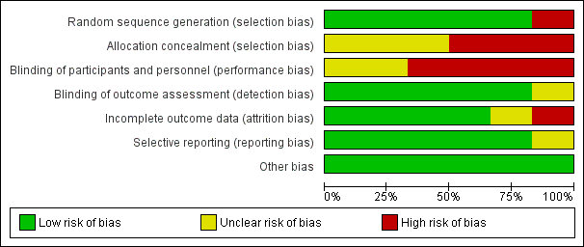
Figure 1. Risk of bias graph.

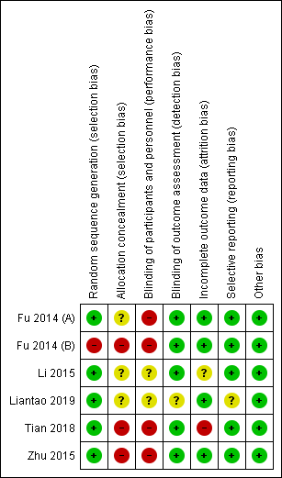
Figure 2. Risk of bias summary.
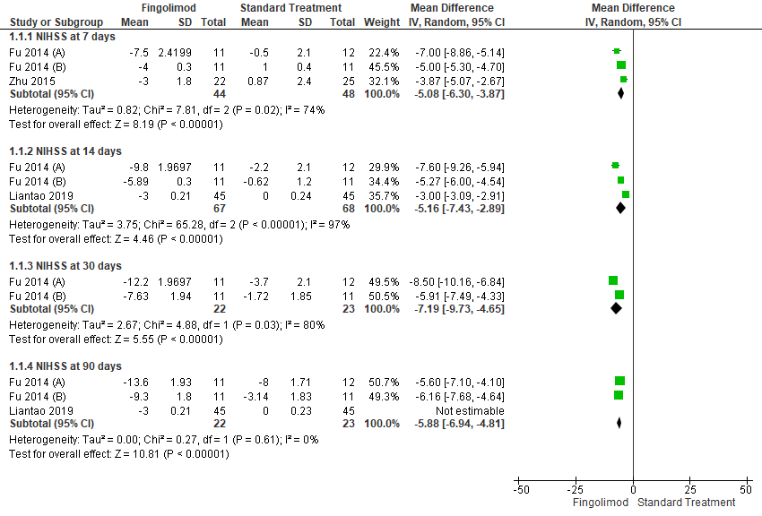
Figure 3. Forest plot of National Institutes of Health Stroke Scale scores at days 7, 14, 30, and 90 represented in mean difference and 95% confidence interval.

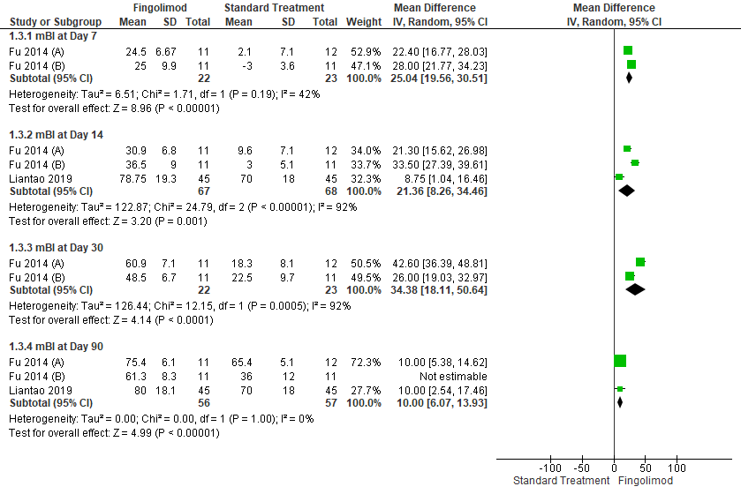
Figure 4. Forest plot of Modified Barthel Index scores at days 7, 14, 30, and 90 represented in mean difference and 95% confidence interval.

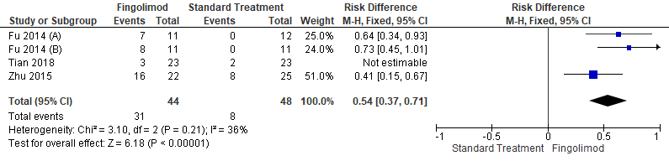
Figure 5. Forest plot of mRS scores represented in odds ratio and 95% confidence interval.

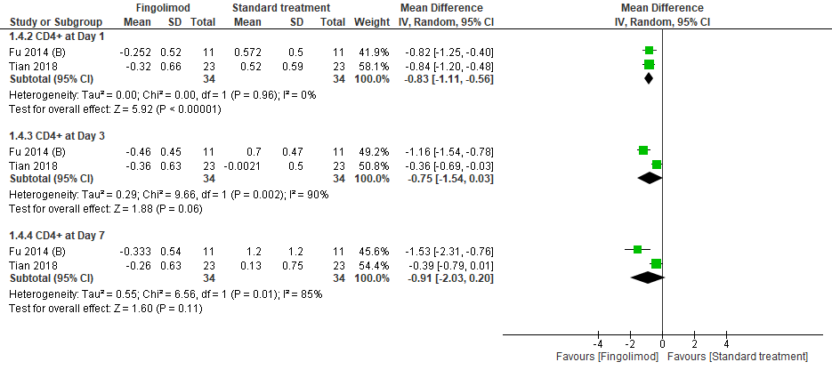
Figure 6. Forest plot of CD4+ at day 1, 3 and 7 represented in mean difference and 95% confidence interval.

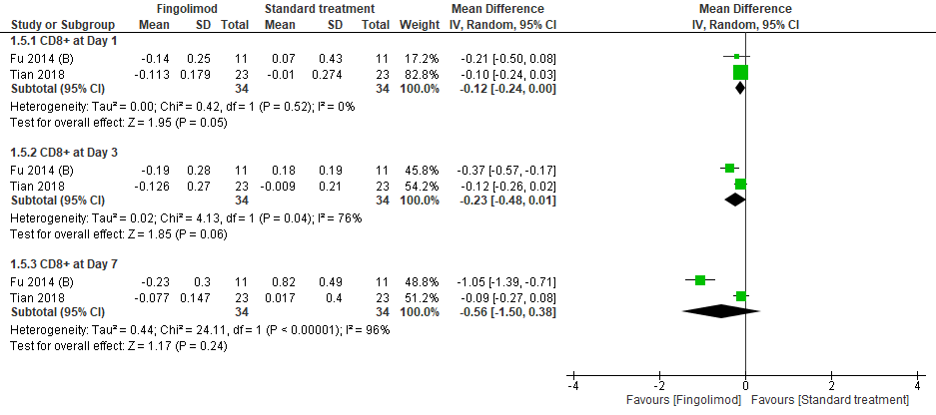
Figure 7. Forest plot of CD8+ at day 1, 3 and 7 represented in mean difference and 95% confidence interval.

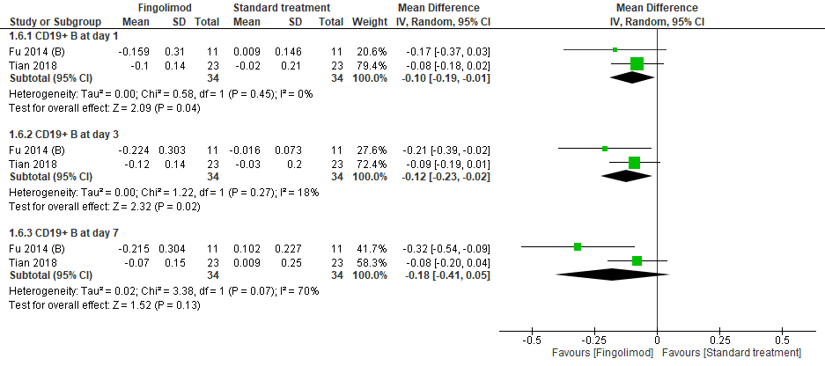
Figure 8. Forest plot of CD19+ at day 1, 3 and 7 represented in mean difference and 95% confidence interval.

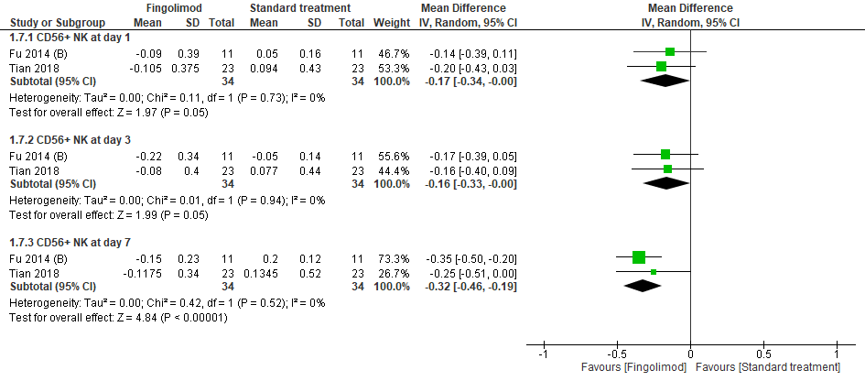
Figure 9. Forest plot of CD56+ at day 1, 3 and 7 represented in mean difference and 95% confidence interval.

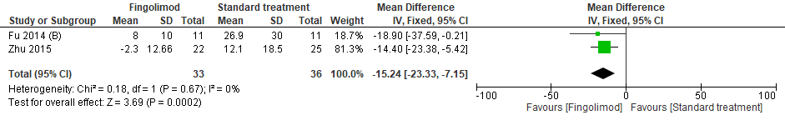
Figure 10. Forest plot of Infarct volume change from 24 hours to day 7 represented in mean difference and 95% confidence interval.

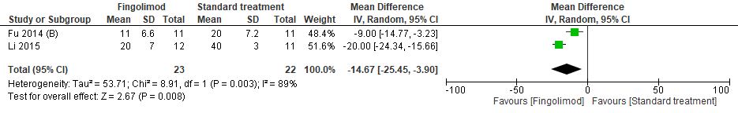
Figure 11. Forest plot of rTI% perfusion ratio represented in mean difference and 95% confidence interval.

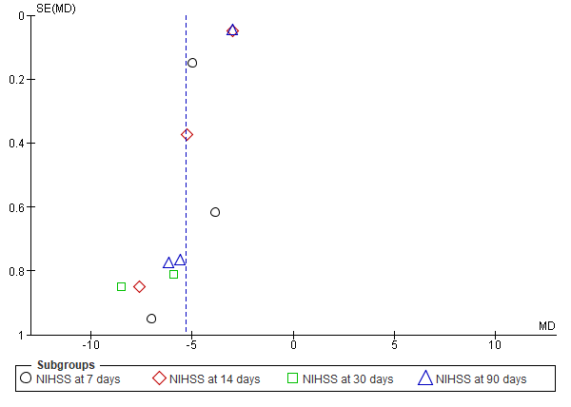
Figure 12. Funnel plot of Forest plot of National Institutes of Health Stroke Scale scores at days 7, 14, 30, and 90 showing Symmetry.

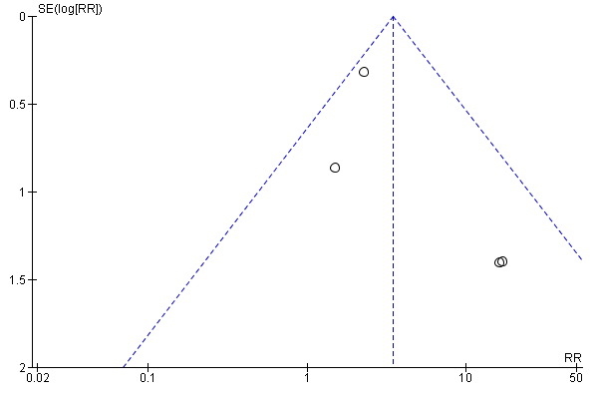
Figure 13. Funnel plot of Modified Barthel Index scores at days 7, 14, 30, and 90 showing Symmetry.

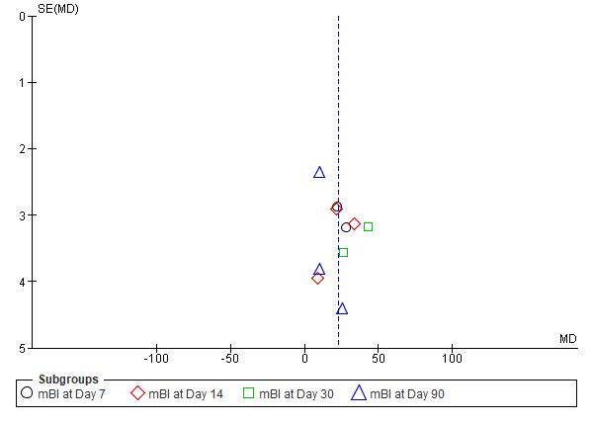
Figure 14. Funnel plot of mRS scores showing Symmetry.

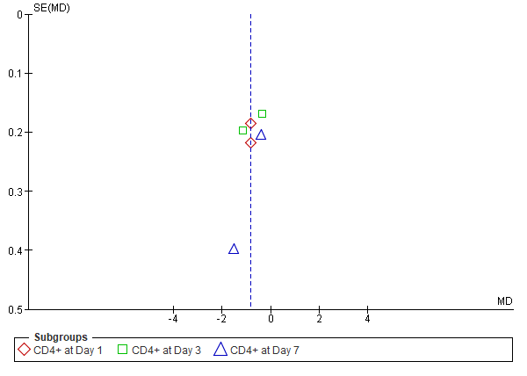
Figure 15. Funnel plot of CD4+ at day 1, 3 and 7 showing Symmetry.

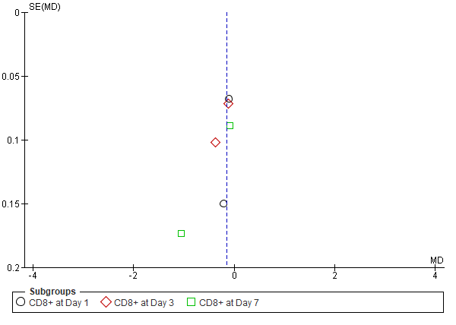
Figure 16. Funnel plot of CD8+ at day 1, 3 and 7 showing Symmetry.

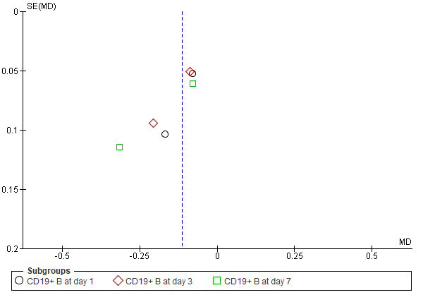
Figure 17. Funnel plot of CD19+ at day 1, 3 and 7 showing Symmetry.

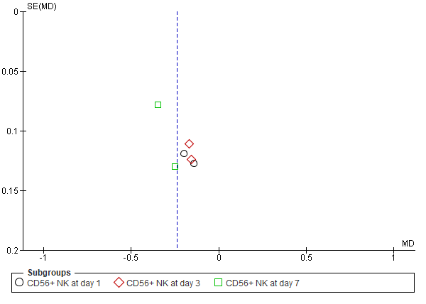
Figure 18. Funnel plot of CD56+ at day 1, 3 and 7 showing Symmetry.

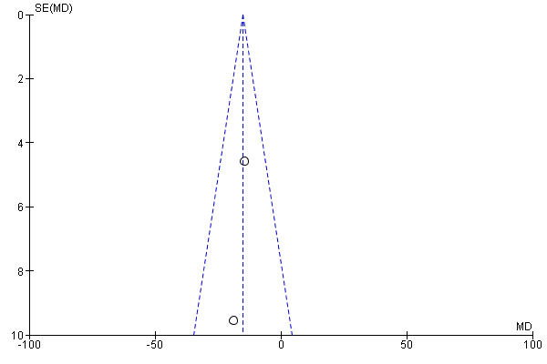
Figure 19. Funnel plot of Infarct volume change from 24 hours to day 7 showing Symmetry.

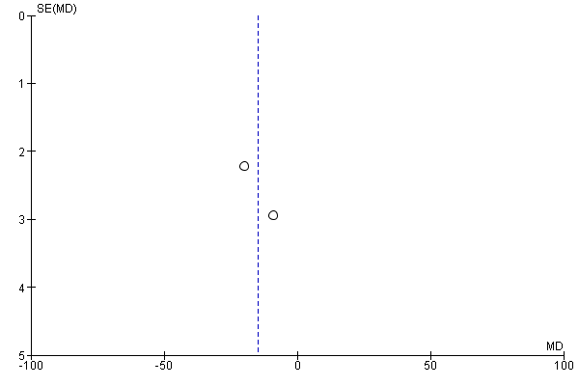
Figure 20. Funnel plot of rTI% perfusion ratio showing Symmetry.

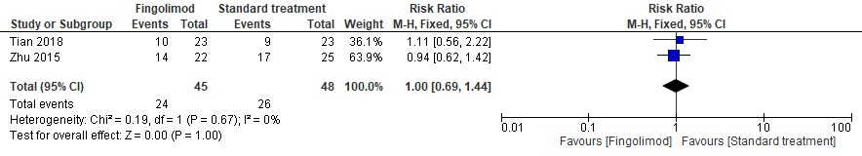
Figure 21. Forest plot of Symptomatic hemorrhage represented in risk ratio and 95% confidence interval.

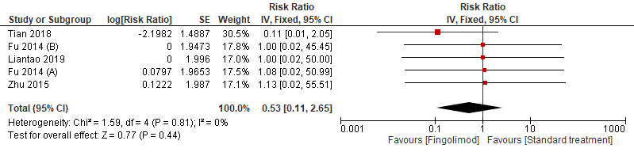
Figure 22. Forest plot of Mortality rate represented in risk ratio and 95% confidence interval.

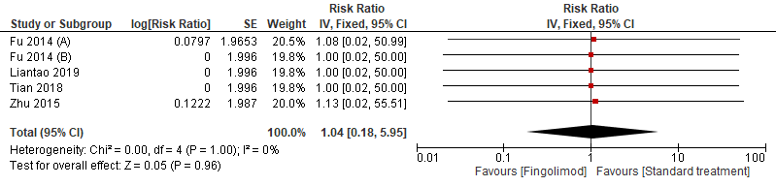
Figure 23. Forest plot of MI represented in risk ratio and 95% confidence interval.

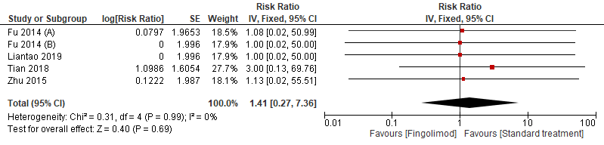
Figure 24. Forest plot of Recurrent strokes represented in risk ratio and 95% confidence interval.

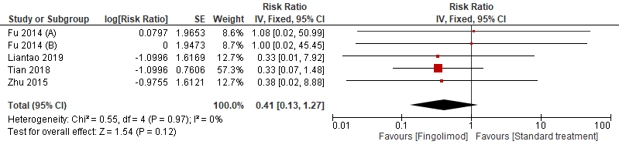
Figure 25. Forest plot of Cerebral hernia represented in risk ratio and 95% confidence interval.

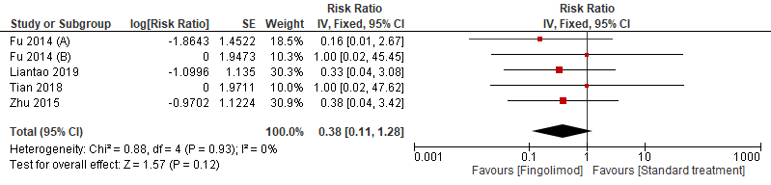
Figure 26. Forest plot of Hemorrhage of GI represented in risk ratio and 95% confidence interval.

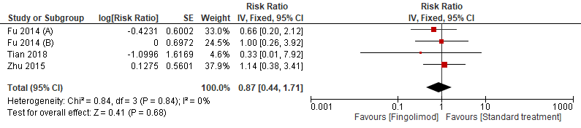
Figure 27. Forest plot of Fever represented in risk ratio and 95% confidence interval.

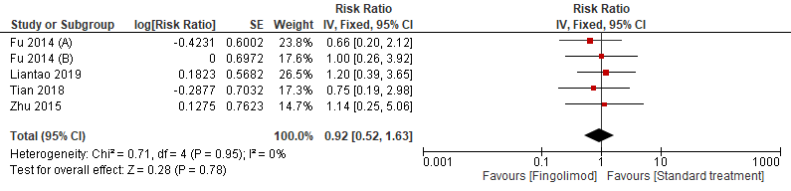
Figure 28. Forest plot of Lung infection represented in risk ratio and 95% confidence interval.

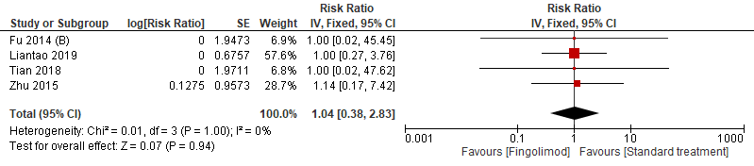
Figure 29. Forest plot of UTI represented in risk ratio and 95% confidence interval.

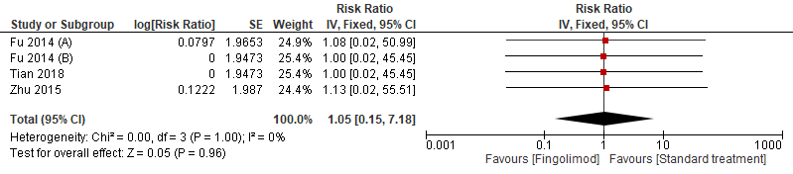
Figure 30. Forest plot of Herpes virus infection represented in risk ratio and 95% confidence interval.

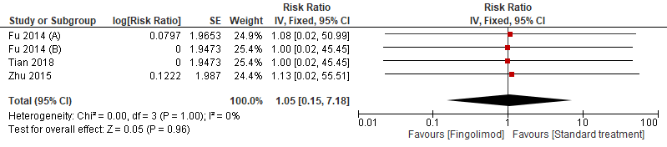
Figure 31. Forest plot of Abnormal LFT represented in risk ratio and 95% confidence interval.

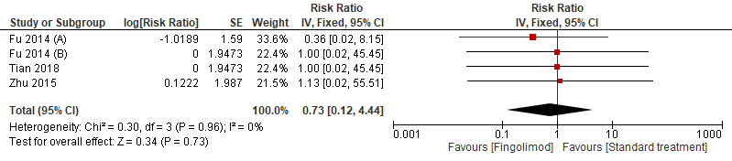
Figure 32. Forest plot of GI disorder represented in risk ratio and 95% confidence interval.

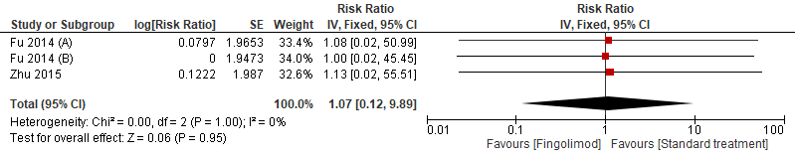
Figure 33. Forest plot of Leukopenia represented in risk ratio and 95% confidence interval.

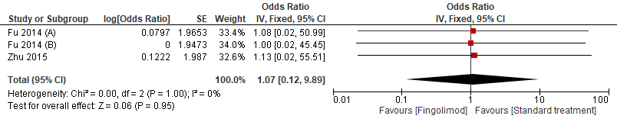
Figure 34. Forest plot of Lymphopenia represented in risk ratio and 95% confidence interval.

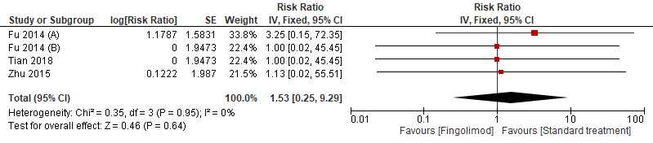
Figure 35. Forest plot of Bradycardia represented in risk ratio and 95% confidence interval.

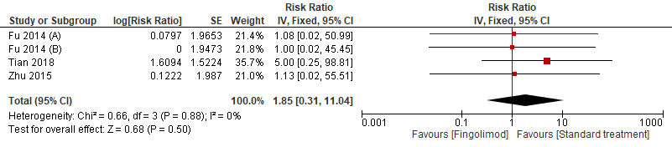
Figure 36. Forest plot of AV block represented in risk ratio and 95% confidence interval.

Figure 37. Forest plot of Macular edema represented in risk ratio and 95% confidence interval.

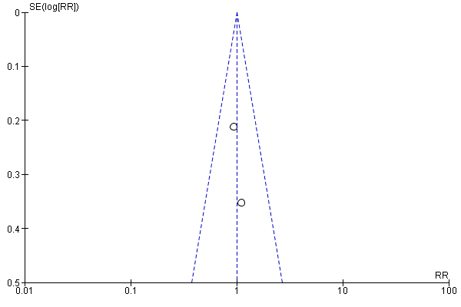
Figure 38. Funnel plot of Symptomatic hemorrhage showing Symmetry.

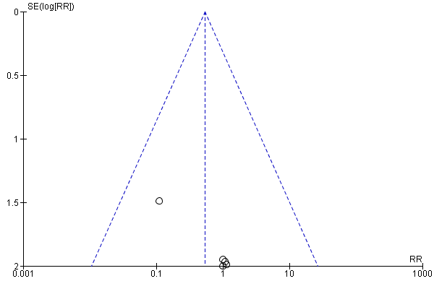
Figure 39. Funnel plot of Mortality rate showing Symmetry.

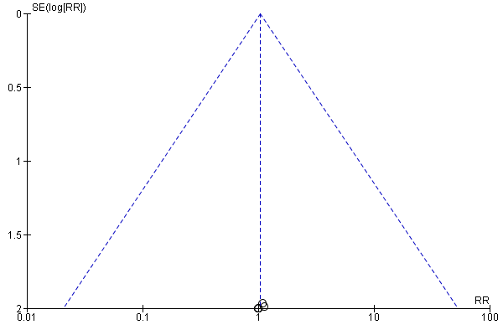
Figure 40. Funnel plot of MI showing Symmetry.

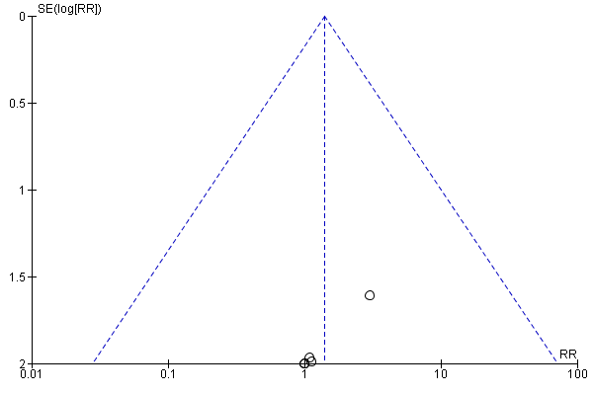
Figure 41. Funnel plot of Recurrent strokes showing Symmetry.

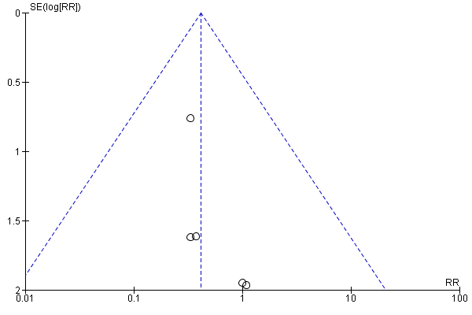
Figure 42. Funnel plot of Cerebral hernia showing Symmetry.

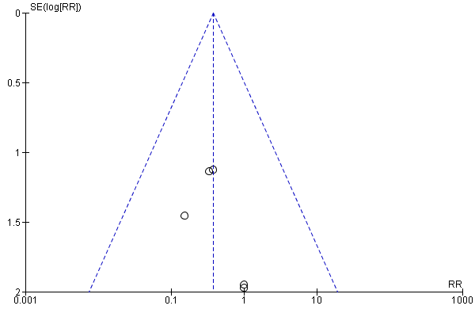
Figure 43. Funnel plot of Hemorrhage of GI showing Symmetry.

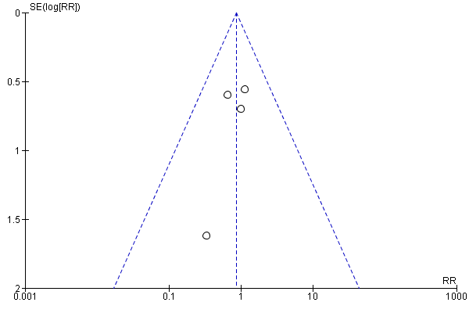
Figure 44. Funnel plot of Fever showing Symmetry.

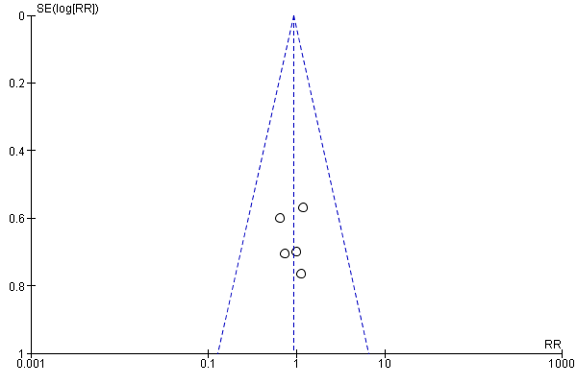
Figure 45. Funnel plot of Lung infection showing Symmetry.

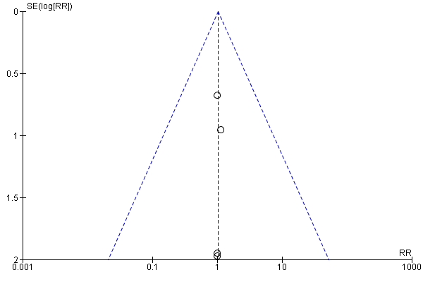
Figure 46. Funnel plot of UTI showing Symmetry.

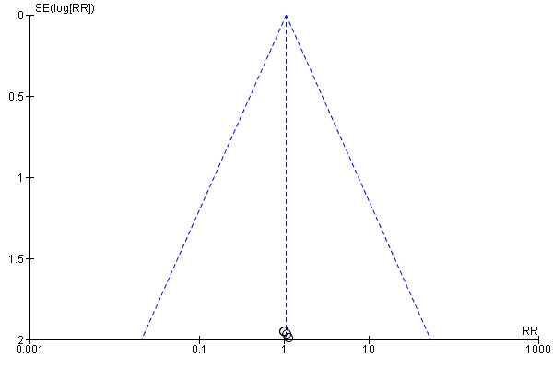
Figure 47. Funnel plot of Herpes virus infection showing Symmetry.

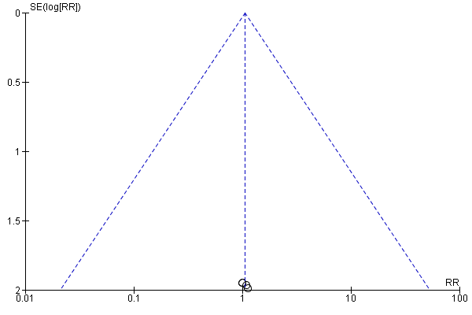
Figure 48. Funnel plot of Abnormal LFT showing Symmetry.

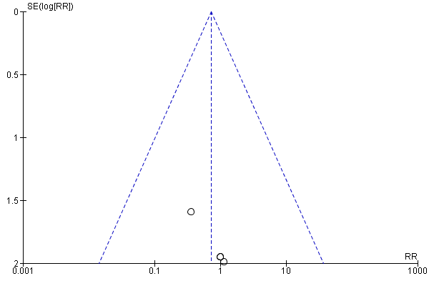
Figure 49. Funnel plot of GI disorder showing Symmetry.

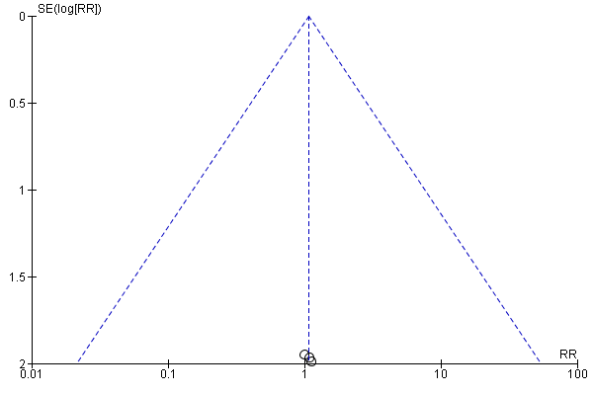
Figure 50. Funnel plot of Leukopenia showing Symmetry.

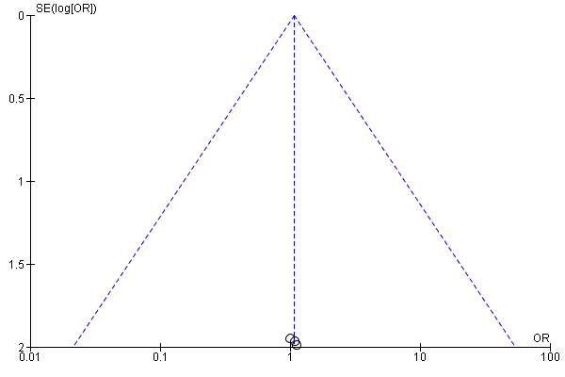
Figure 51. Funnel plot of Lymphopenia showing Symmetry.

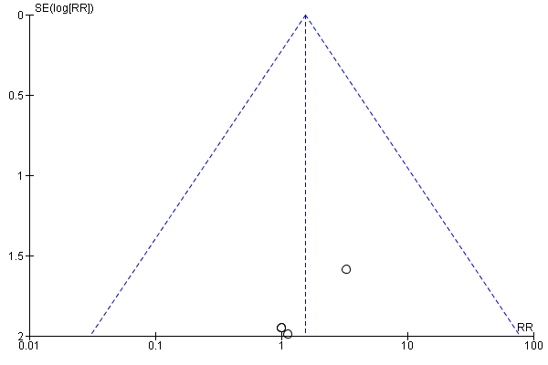
Figure 52. Funnel plot of Bradycardia showing Symmetry.

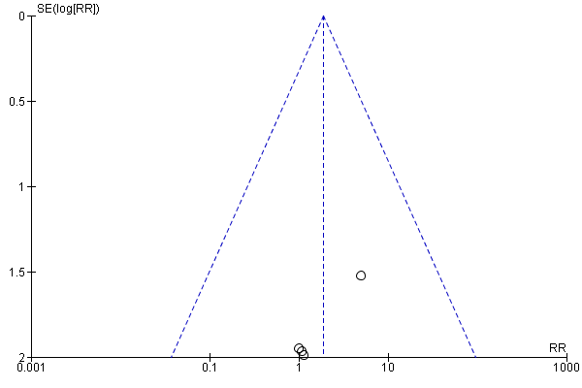
Figure 53. Funnel plot of AV block showing Symmetry.

Figure 54. Funnel plot of Macular edema showing Symmetry.

Table 1. Baseline Demographic and Characteristics of Patients.
 |  | Mean age, mean (SD), y | Male, n (%) | Hypertension n (%) | Smoking n (%) | Hyper-lipidemia n (%) | Diabetes mellitus n (%) | Arial fibrillation n (%) | Heart disease n (%) | NIHSS on admission mean (SD) | Anti-platelet agent  n (%) | Anti-coagulant agent  n (%) | Time to treatment, mean (SD), hours | Volume of infarct mean (SD), ml
Fu 2014 (A) | Fingolimod (11) | 60.7 (12.3) | 4 (36) | 11 (100) | NR | NR | 3 (27) | NR | NR | 15.6 (6.0) | 0 (0) | 0 (0) | 19.5 (19.5) | 16.7 (6.7)
Fu 2014 (A) | Control (12) | 58.2 (9.1) | 11 (91) | 12 (100) | NR | NR | 1 (8) | NR | NR | 13.0 (5.3) | 2 (18) | 0 (0) | 12.2 (13.1) | 15.4 (8.3)
Fu 2014 (B) | Fingolimod (11) | 62.3 (8.0) | 8 (73) | 6 (55) | 4 (36) | 3 (27) | 2 (18) | NR | 3 (27) | 11.0 (5.6) | NR | NR | 20 (15) | 61 (89)
Fu 2014 (B) | Control (11) | 54.7 (11.0) | 9 (82) | 9 (82) | 5 (45) | 4 (36) | 2 (18) | NR | 1 (9) | 9.0 (2.6) | NR | NR | 29 (21) | 60 (86)
Tian 2018 | Fingolimod (22) | 67 (6.8) | 9 (39) | 19 (83) | 9 (39) | 6 (26) | 5 (22) | 7 (30) | NR | 15 (4.6) | 5 (22) | 3 (13) | NR | 30 (10.6)
Tian 2018 | Control (25) | 65 (13.0) | 7 (30) | 13 (57) | 9 (39) | 6 (26) | 5 (22) | 6 (26) | NR | 11.5 (4) | 3 (13) | 1 (4) | NR | 25.25 (8.3)
Zhu 2015 | Fingolimod (23) | 60.0 (2.5) | 13 (59) | 11 (50) | 11 (50) | 8 (36) | 1 (5) | 8 (36) | NR | 13 (4.6) | 8 (36) | 1 (5) | 3.1 (0.2) | 23.0 (4.0)
Zhu 2015 | Control (23) | 59.0 (1.6) | 17 (68) | 13 (52) | 16 (64) | 12 (48) | 2 (8) | 2 (8) | NR | 12 (4) | 6 (24) | 1 (4) | 3 (0.2) | 20.0 (3.0)
Liantao 2015 | Fingolimod (45) | 63.31 (11.65) | 31 (68.8) | 26 (57.7) | NR | NR | 16 (35.3) | 6 (13.3) | NR | 6.75 (5.5) | NR | NR | NR | NR
Liantao 2015 | Control (45) | 65.46(11.7) | 26 (57.7) | 26 (57.7) | NR | NR | 10 (22.2) | 9 (20) | NR | 6 (5.2) | NR | NR | NR | NR
Note: Baseline data from Li 2014 study were reported in Fu 2014 (A) original trial. NR: Not reported.
Table 2. Complications and Adverse Events.
 | No. of studies | No. of participants | Risk ratio, 95% CI¶ | P Value
Mortality rate | 5 | 227 | 0.5 (0.11, 2.65) | .96
Myocardial infarction | 5 | 227 | 1.04 (0.18, 5.95) | .96
Recurrent strokes | 5 | 227 | 1.4 (0.27, 7.36) | .69
Cerebral hernia | 5 | 227 | 0.4 (0.13, 1.27) | .41
GIT† hemorrhage | 5 | 227 | 0.4 (0.11, 1.28) | .12
Fever (>38 °C) | 4 | 137 | 0.9 (0.44, 1.71) | .68
Lung infection | 5 | 227 | 0.9 (0.52, 1.63) | .78
Urinary tract infection | 4 | 205 | 1.04 (0.38, 2.83) | .94
Herpes virus infection | 4 | 137 | 1.05 (0.15, 7.18) | .96
Abnormal LFT* | 4 | 137 | 1.05 (0.15, 7.18) | .96
GIT† disorders | 4 | 137 | 0.7 (0.12, 4.44) | .73
Leukopenia | 3 | 91 | 1.07 (0.12, 9.89) | .95
Lymphopenia | 3 | 91 | 1.07 (0.12, 9.89) | .95
Bradycardia | 4 | 137 | 1.6 (0.25, 9.29) | .64
Atrioventricular block | 4 | 137 | 1.6 (0.31, 11.04) | .50
Macular edema | 4 | 137 | 1.05 (0.15, 7.18) | .96
Symptomatic hemorrhage at 24 hr | 2 | 93 | 1 (0.43, 2.31) | .1
¶CI: Confidence interval, *LFT: Liver function tests, † GIT: Gastrointestinal tract.

