Table 2. Visual Analysis of Elements of GOS in the Karebosi Field Complex

No | Landscape Elements | Current State of Landscape Elements | Deficiency | Comparative Landscape Elements
1 | 2 | 3 | 4 | 5
1 | Jogging Track | 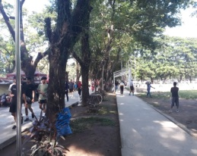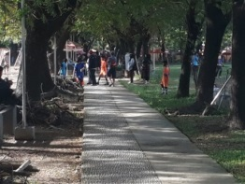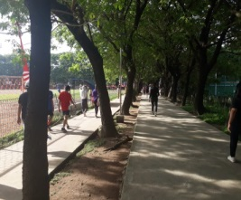 | - Unstructured and colorful paths  - Edge of the path that is not given lessons  - Surface is not smooth and flat  - There is no filling of grass and flowering plants between the paths  - The atmosphere looks arid | 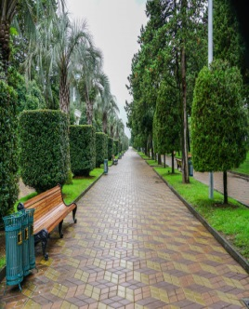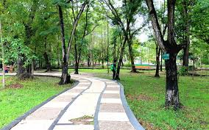
2 | Fence | 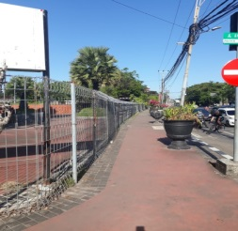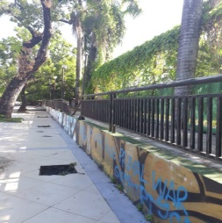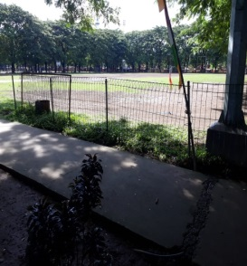 | - 1. The form of the fence that does not support the aesthetic value of GOS  - 2. Different forms of fences, there is no unity of form  - 3. Less maintenance  - 4. Some parts look dull and vandalism. | 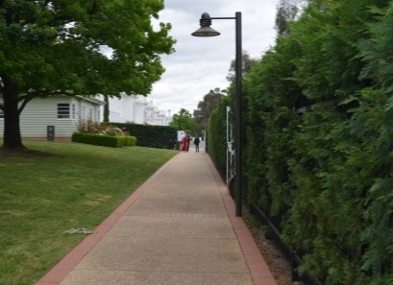  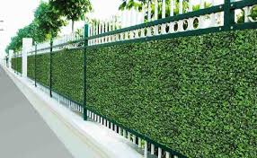
3 | Field Grass | 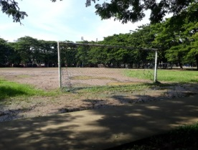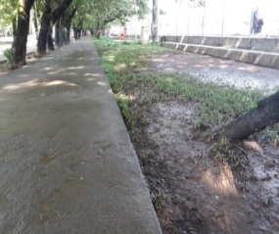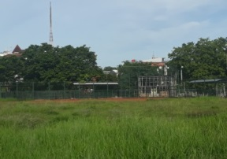 | - Field grass that does not grow and covers the entire surface well.  - There are several sloping sides that should be completed with sheet pile construction  - Looks untidy and will be muddy if it is inundated with water. | 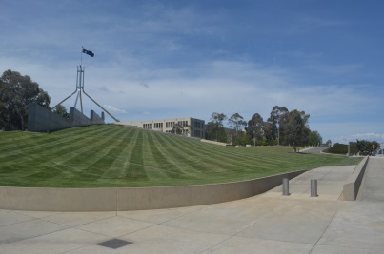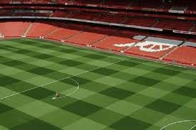
4 | Park bench | 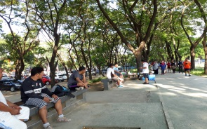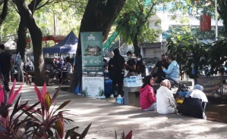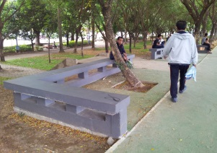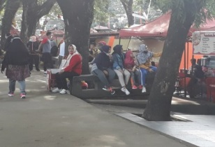 | - Seating looks made without paying attention to aspects of beauty and comfort  - Uneven placement in various angles of GOS. | 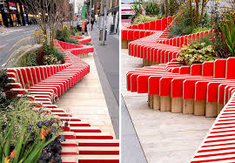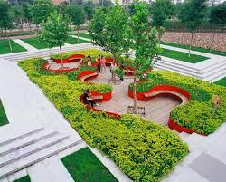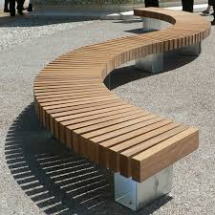
5 | There are no flowering plants, minimal variety of vegetation and uneven trash cans. | 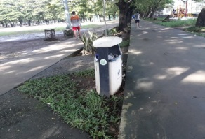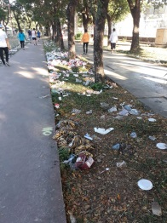 | - Areas that are not vegetated with flowering plants  - Areas between jogging paths that are not given flowering plants.  - Small trash cans, not by the amount  - Many visitors, and uneven at various angles of GOS  - As a consequence of the lack of trash cans, garbage is scattered, especially if there are activities that involve many people, such as leisure activities from certain community groups. | 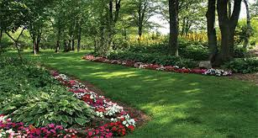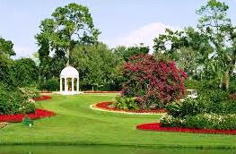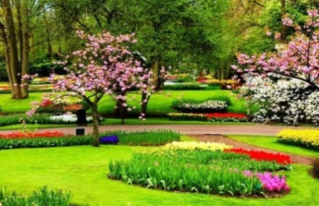
6 | Water Elements and Children's Game Rides | 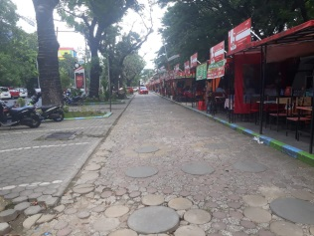  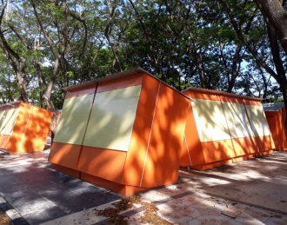 | - Food vendors' substations make this GOS even more unsightly.  - This area is quite adequate to be used for the placement of water elements and children's playgrounds. | 