Supporting information

MOF-derived Fe₂O₃/MoSe₂ Heterostructure for Promoted Electrocatalytic Nitrogen Fixation

Liming Huang^{1,2, ‡, *} · Leiming Tao^{2, ‡,*} · Kui Pang^{2,3} · Shuying He² · GuanHua Zhu² · LinHai Duan² · Chenglin Wen² · Changlin Yu² · Hongbing Ji^{1,*}

¹ School of Chemistry and Chemical Engineering, Guangxi University, Nanning, 530003, China
² Guangdong Provincial Key Laboratory of Petrochemical Equipment Fault Diagnosis, School of Science, Guangdong University of Petrochemical Technology, Maoming, Guangdong, 525000, China
³ Engineering Research Center for Nanomaterials, Henan University, Henan, 475001, China
‡ Liming Huang and Leiming Tao contributed equally to this work.

* Authors to whom correspondence should be addressed.
Electronic addresses: jihb@mail.sysu.edu.cn; leimingtao@foxmail.com.

Determination of NH₃
The concentration of generated ammonia was quantitatively determined by the indophenol blue method. Specifically, 2 ml of electrolyte solution was firstly taken from the cathode chamber, and then 2 ml of NaOH (1 M) mixed solution of salicylic acid (5 wt%) and sodium citrate (5 wt%), 1 ml of NaClO solution (0.05 M), 0.2 ml sodium nitroferricyanide (C₅FeN₆Na₂O·2H₂O) solution (1 wt%). After standing for 2 h in a dark light environment at room temperature, the absorbance of the solution at λ = 655 nm was measured with a UV-Vis spectrophotometer. Concentration-absorbance curves were calibrated using standard NH₄Cl solutions at different concentrations (0.1, 0.2, 0.3, 0.4, 0.5 and 0.8 μg/mL) in 0.1 M H₂SO₄. The fitted curve (y = 0.3958 x - 0.00636, R² = 0.997) shows a good linear relationship between absorbance values and NH₃ concentration.
The NH₃ yield was calculated by the following formula:
NH₃ Yield rate = (c_{NH3}×V) / (t×m)
The Faradaic efficiency was calculated as follows:
Faradaic efficiency = (3F × c_{NH3}× V) / 17Q
where c_{NH3} is the measured NH₃ concentration, V is the volume of electrolyte in the cathode compartment, t is the reduction reaction time (2 h), and m is the catalyst loading on the carbon cloth. F is Faraday's constant (96485 C mol⁻¹) and Q is the total charge passing through the electrode.

Determination of N₂H₄
The intermediate N₂H₄ during NRR was estimated by the method of Watt and Chrisp, first, by mixing dimethylaminobenzaldehyde (5.99 g), HCl (30 mL) and C₂H₅OH (300 mL) as a chromogenic reagent. Remove 5 mL of electrolyte and mix with the colour developer (5 mL) prepared above. After stirring at room temperature for 20 minutes, the absorbance of the resulting solution was measured at 455 nm, and the N₂H₄ yield was estimated from a standard curve.

Details of Density Functional Theory (DFT) Calculations
All the density functional theory (DFT) calculations were performed using the Vienna ab-initio simulation package (VASP). The description of the exchange correlation adopted the generalized gradient approximation (GGA) of the Perdew, Burke, and Ernzerhof form. The plane wave energy cutoff was set to 400 eV. The generalized gradient approximation (GGA) with the Perdew-Burke-Ernzerhof (PBE) exchange-correlation functional. The Brillouin zone was sampled at the Gamma point with the 2 × 2 × 1 k-point meshes for Fe₂O₃, MoSe₂ and Fe₂O₃/MoSe₂ surfaces. The energy and force criterion for convergence of the electron density was set at 10-5 eV and 0.03 eV/Å, respectively. The vacuum space along the z-direction was set to 15 Å to avoid interactions between adjacent images.
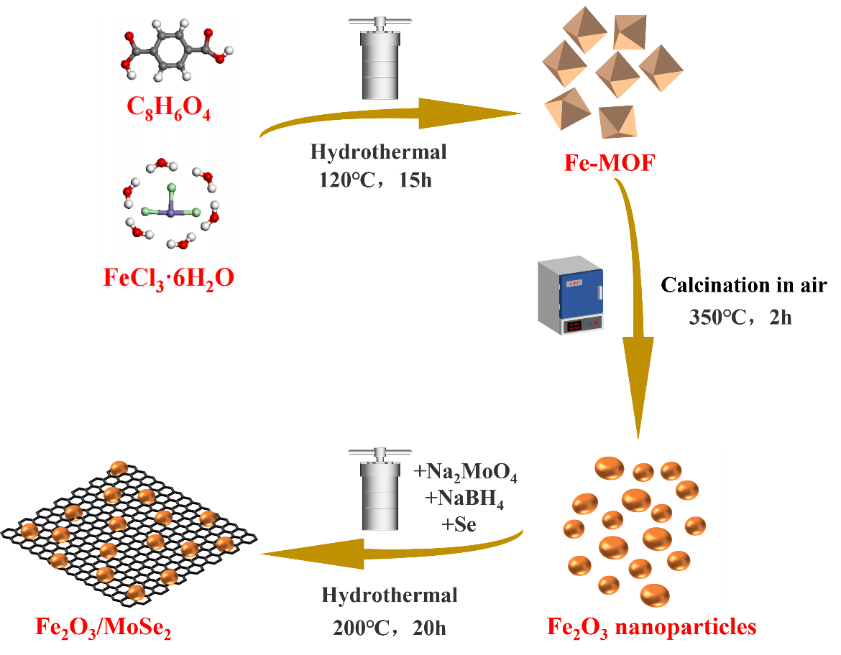
Figure S1. Synthesis process of Fe₂O₃/MoSe₂ heterostructure.

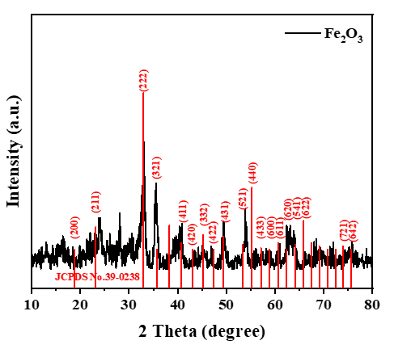
Figure S2. XRD pattern of as-synthesized Fe₂O₃.
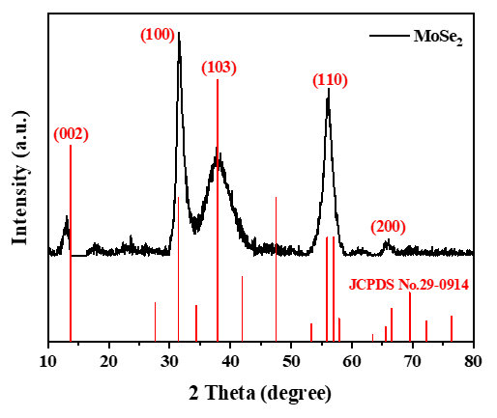
Figure S3. XRD pattern of as-synthesized MoSe₂.

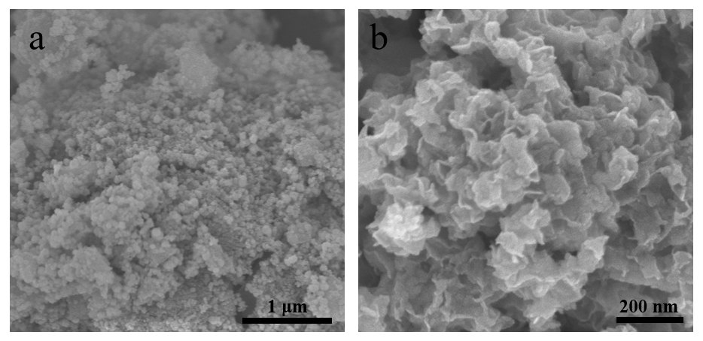
Figure S4. SEM images of (a) Fe₂O₃ and (b) MoSe₂.

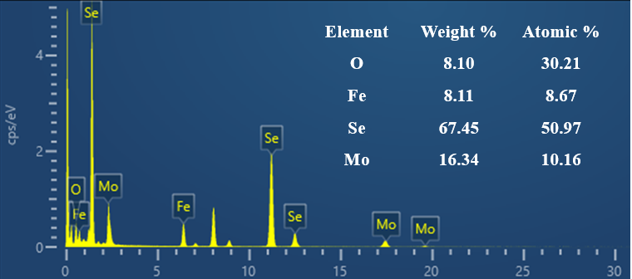
Figure S5. EDX spectra of Fe₂O₃/MoSe₂.

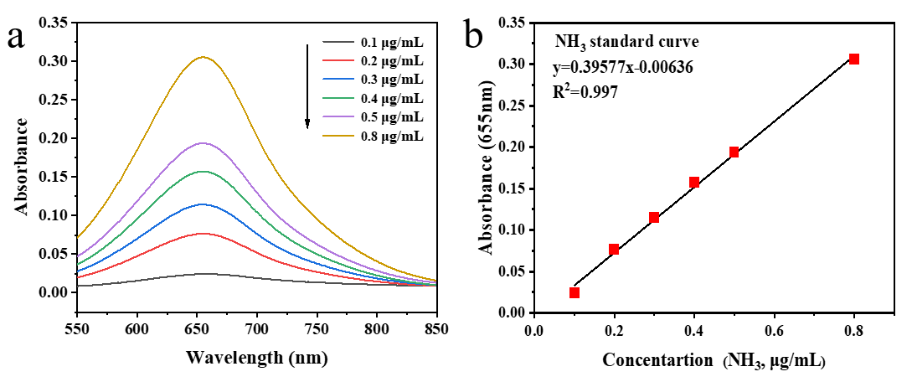
Figure S6. (a) UV-Vis absorption spectra of indophenol assays with NH₄Cl after incubated for 2 h at ambient conditions. (b) Calibration curve used for calculation of NH₃ concentrations.

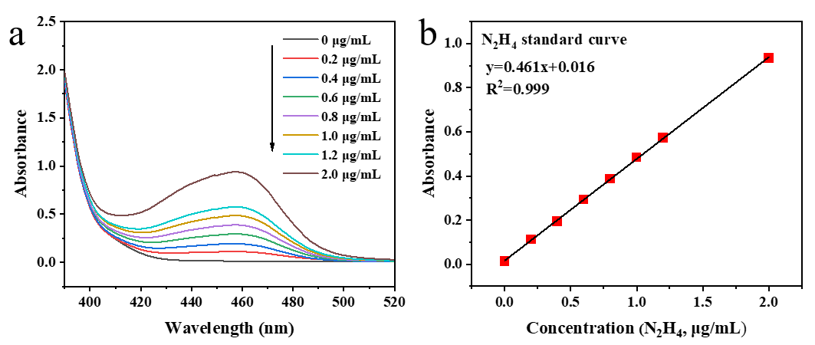
Figure S7. (a) UV-Vis absorption spectra of N₂H₄ assays after incubated for 20 min at ambient conditions. (b) Calibration curve used for calculation of N₂H₄ concentrations.

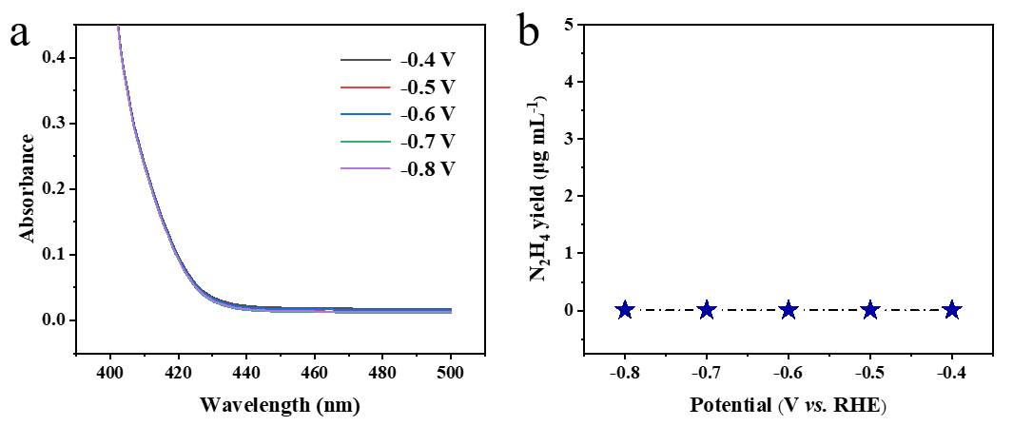
Figure S8. (a) UV-Vis spectra of the electrolytes (stained with the chemical indicator based on the method of Watt and Chrisp) after 2 h electrocatalysis on Fe₂O₃/MoSe₂ at various potentials, and (b) corresponding N₂H₄ concentrations in the electrolytes.

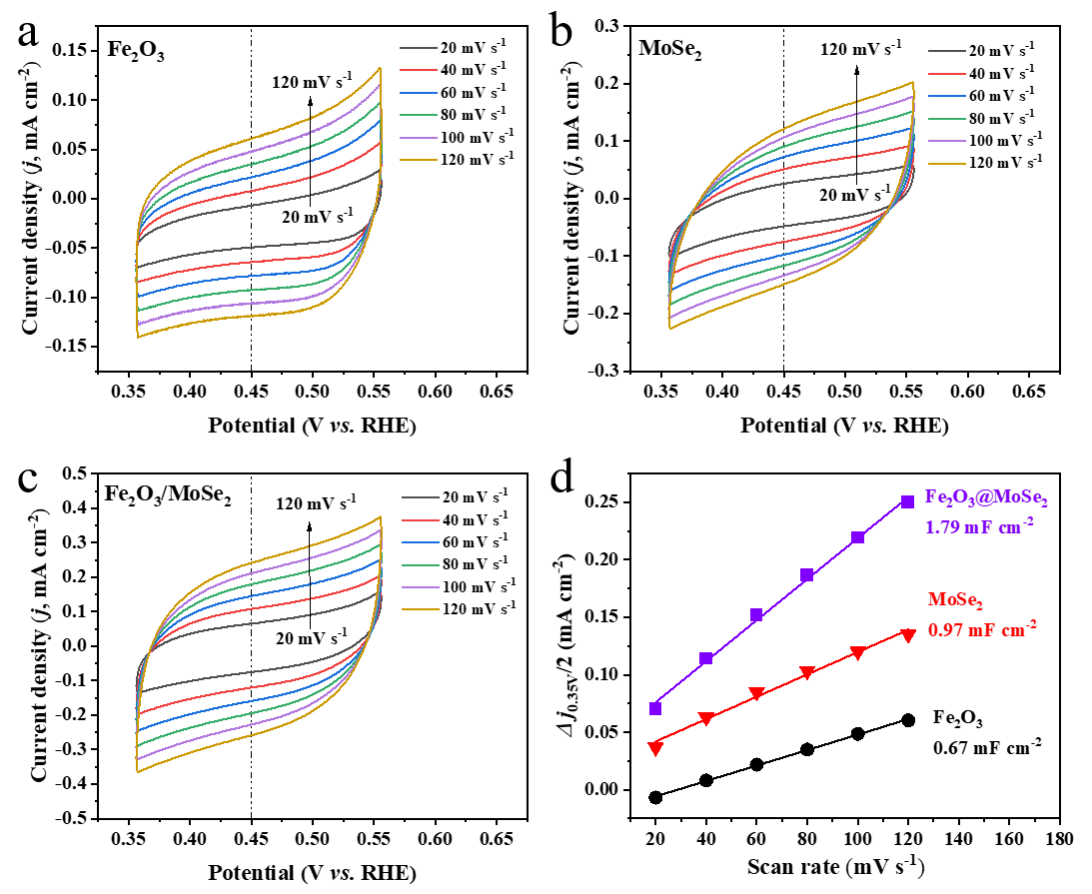
Figure S9. CV curves of (a) Fe₂O₃, (b) MoSe₂, and (c) Fe₂O₃/MoSe₂ at various scan rates, and corresponding (d) plots of current density differences (Δj/2) vs. scan rate at 0.45 V vs. RHE.

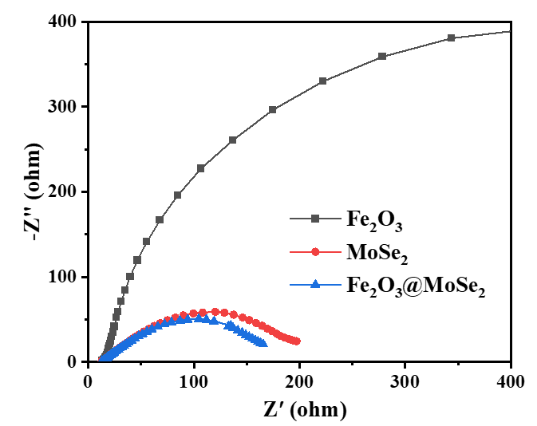
Figure S10. Electrochemical impendence spectra of Fe₂O₃, MoSe₂ and Fe₂O₃/MoSe₂.

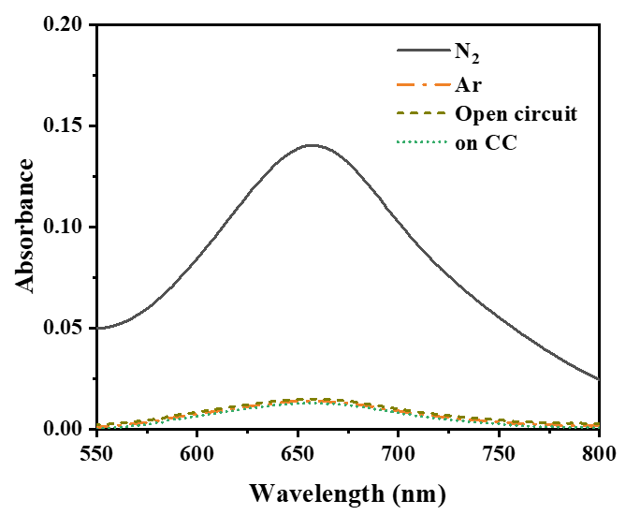
Figure S11. UV-Vis absorption spectra of working electrolytes after 2 h of electrolysis in N₂-saturated solution and Ar-saturated solutions on Fe₂O₃/MoSe₂ at -0.5 V, N₂-saturated solution on Fe₂O₃/MoSe₂ at open circuit, and N₂-saturated solution on pristine CC at -0.5 V.

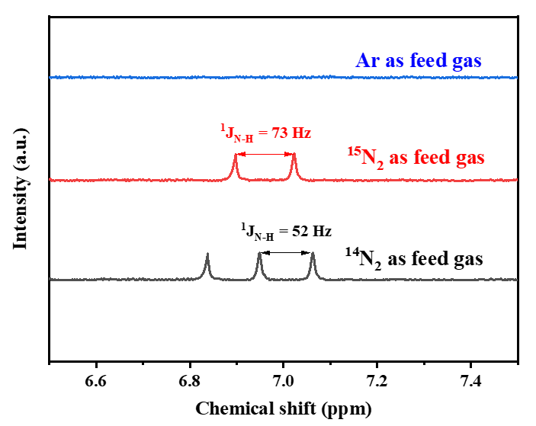
Figure S12. ¹H NMR measurements using ¹⁴N₂, ¹⁵N₂ and Ar as feed gases.
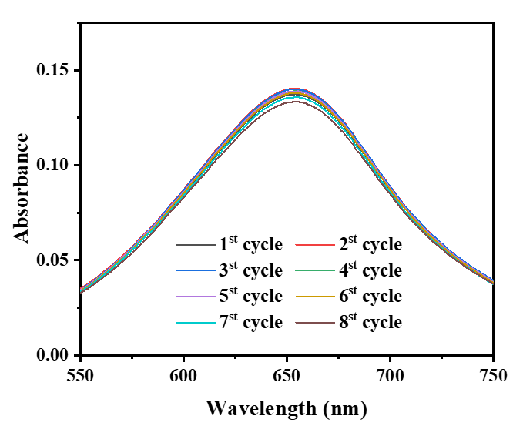
Figure S13. UV-Vis absorption spectra of working electrolytes on Fe₂O₃/MoSe₂ (each for 2 h of NRR electrolysis at -0.5 V) for seven cycles.

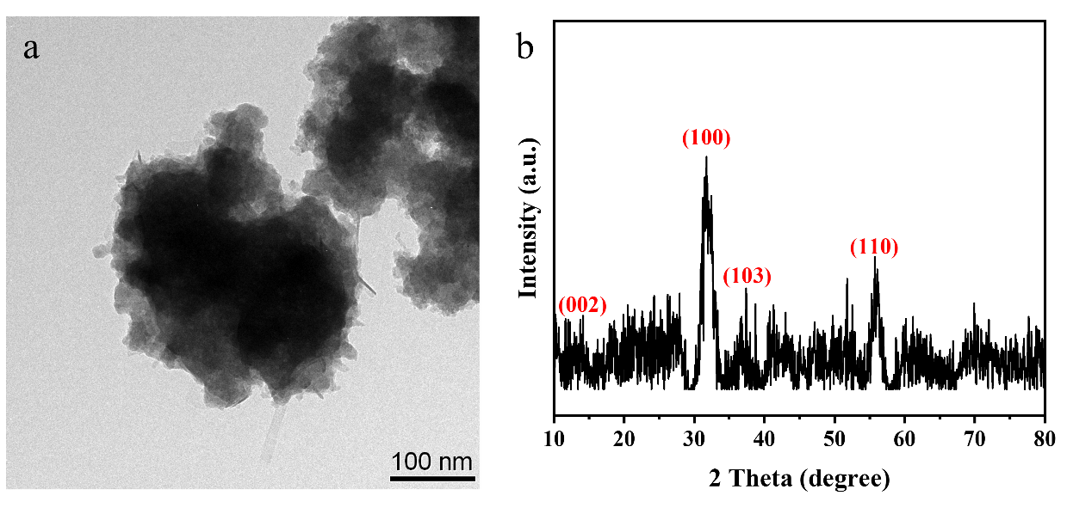
Figure S14. Morphologies and XRD pattern of Fe₂O₃/MoSe₂ after stability test.

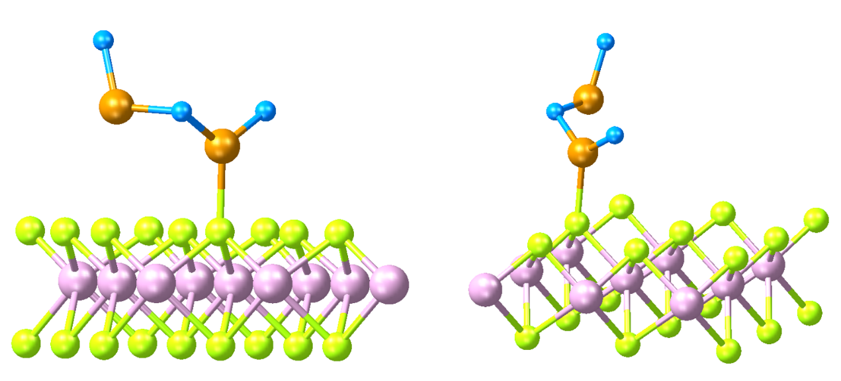
Figure S15. Optimized atomic configuration of Fe₂O₃/MoSe₂ (color notation: purple-Mo, green-Se, blue-O, yellow-Fe).

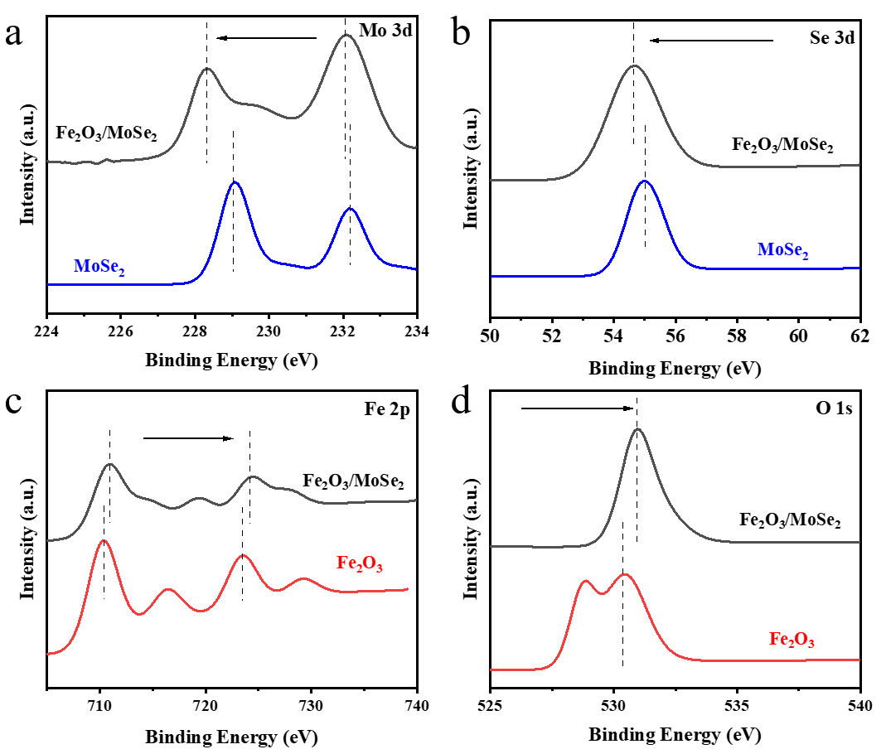
Figure S16. (a, b) High resolution XPS spectra of MoSe₂ and Fe₂O₃/MoSe₂: (a) Mo 3d, (b) Se 3d. (c, d) High resolution XPS spectra of Fe₂O₃ and Fe₂O₃/MoSe₂: (c) Fe 2p, (d) O 1s.

Table S1. The comparison of Fe₂O₃/MoSe₂ catalyst with the representative reported catalysts for electrochemical NRR in aqueous solutions.
Catalyst | Electrolyte | NH₃ yield rate (μgh⁻¹ mg_{mat}⁻¹) | Faraday Efficiency  (%) | Ref.
Fe₂O₃/MoSe₂ | 0.05 M H₂SO₄ | 55.52 | 9.6 | This work
Au_{SA}/np-MoSe₂ | 0.1 M Na₂SO₄ | 30.83 | 37.82 | [[1]]
Fe₂(MoO₄)₃ | 0.1 M Na₂SO₄ | 7.5 | 1.0 | [[2]]
Vo-MoO₂/C | 0.1M Na₂SO₄ | 9.75 | 3.24 | [[3]]
Cu_{2-x}S/MoS₂ | 0.1 M HCl | 22.1 | 6.06 | [[4]]
FeMoO₄ | 0.1M Na₂SO₄ | 17.51 | 10.5 | [[5]]
Fe SAs/MoS₂ | 0.1 M K₂SO₄ | 8.63 | 18.8 | [[6]]
Au-Fe₃O₄ | 0.1 M KOH | 21.42 | 10.54 | [[7]]
1T′-MoS₂/Ti₃C₂ | 0.1 M Na₂SO₄ | 31.96 | 30.75 | [[8]]
Nb₂O₅/C-800 | 0.1 M HCl | 29.1 | 11.5 | [[9]]
MoS₂/rGO | 0.5 M Li₂ClO₄ | 24.82 | 4.58 | [[10]]
V₄C₃T_{x} | 0.1 M KOH | 21.29 | 8.04 | [[11]]
CoS/S-MAs (Ti₃C₂T_{x} MXene) | 0.1 M Na₂SO₄ | 12.4 | 27.05 | [[12]]
Ru SAs/Ti₃C₂O | 0.1 M HCl | 27.56 | 23.3 | [[13]]

1. Chen D, Luo M, Ning S, Lan J, Peng W, Lu Y R, Chan T STan Y (2022) Single‐Atom Gold Isolated Onto Nanoporous MoSe₂ for Boosting Electrochemical Nitrogen Reduction. Small 18:2104043.
2. Chen C, Liu YYao Y (2020) Ammonia synthesis via electrochemical nitrogen reduction reaction on iron molybdate under ambient conditions. European Journal of Inorganic Chemistry 2020:3236-3241.
3. Du Y, He Z, Ma F, Jiang Y, Wan J, Wu GLiu Y (2021) Anionic Biopolymer assisted preparation of MoO₂@C Heterostructure nanoparticles with oxygen vacancies for ambient electrocatalytic ammonia synthesis. Inorganic Chemistry 60:4116-4123.
4. Jiang T, Li L, Li L, Liu Y, Zhang D, Zhang D, Li H, Mao BShi W (2021) Ultra-thin shelled Cu_{2-xS}/MoS₂ quantum dots for enhanced electrocatalytic nitrogen reduction. Chemical Engineering Journal 426:130650.
5. Wu J, Wang Z, Li S, Niu S, Zhang Y, Hu J, Zhao JXu P (2020) FeMoO₄ nanorods for efficient ambient electrochemical nitrogen reduction. Chemical Communications 56:6834-6837.
6. Su H, Chen L, Chen Y, Si R, Wu Y, Wu X, Geng Z, Zhang WZeng J (2020) Single atoms of iron on MoS₂ nanosheets for N₂ electroreduction into ammonia. Angewandte Chemie 132:20591-20596.
7. Zhang J, Ji Y, Wang P, Shao Q, Li YHuang X (2020) Adsorbing and activating N₂ on heterogeneous Au–Fe₃O₄ nanoparticles for N₂ fixation. Advanced Functional Materials 30:1906579.
8. Chen X, Zhang S, Qian X, Liang Z, Xue Y, Zhang X, Tian J, Han YShao M (2022) Enabling efficient electrocatalytic conversion of N₂ to NH₃ by Ti₃C₂ MXene loaded with semi-metallic 1T′-MoS₂ nanosheets. Applied Catalysis B: Environmental 310:121277.
9. Zhang M, Yin H, Jin F, Liu J, Ji X, Du A, Yang WLiu Z (2022) Vacancy engineering of oxidized Nb₂CT_{x} MXenes for a biased nitrogen fixation. Green Energy & Environment
10. Li Y, Li J, Huang J, Chen J, Kong Y, Yang B, Li Z, Lei L, Chai GWen Z (2021) Boosting electroreduction kinetics of nitrogen to ammonia via tuning electron distribution of single‐atomic iron sites. Angewandte Chemie 133:9160-9167.
11. Du C-F, Yang L, Tang K, Fang W, Zhao X, Liang Q, Liu X, Yu H, Qi WYan Q (2021) Ni nanoparticles/V₄C₃T_{x} MXene heterostructures for electrocatalytic nitrogen fixation. Materials Chemistry Frontiers 5:2338-2346.
12. Li Q, Song T, Wang Z, Wang X, Zhou X, Wang QYang Y (2021) A General Strategy toward Metal Sulfide Nanoparticles Confined in a Sulfur‐Doped Ti₃C₂T_{x} MXene 3D Porous Aerogel for Efficient Ambient N₂ Electroreduction. Small 17:2103305.
13. Chen G, Ding M, Zhang K, Shen Z, Wang Y, Ma J, Wang A, Li YXu H (2022) Single‐Atomic Ruthenium Active Sites on Ti₃C₂ MXene with Oxygen‐Terminated Surface Synchronize Enhanced Activity and Selectivity for Electrocatalytic Nitrogen Reduction to Ammonia. ChemSusChem 15:e202102352.

