Figure supplementary 2.The leave-one-out analysis about the effect of 25-hydroxy-vitamin D on basal cell carcinoma
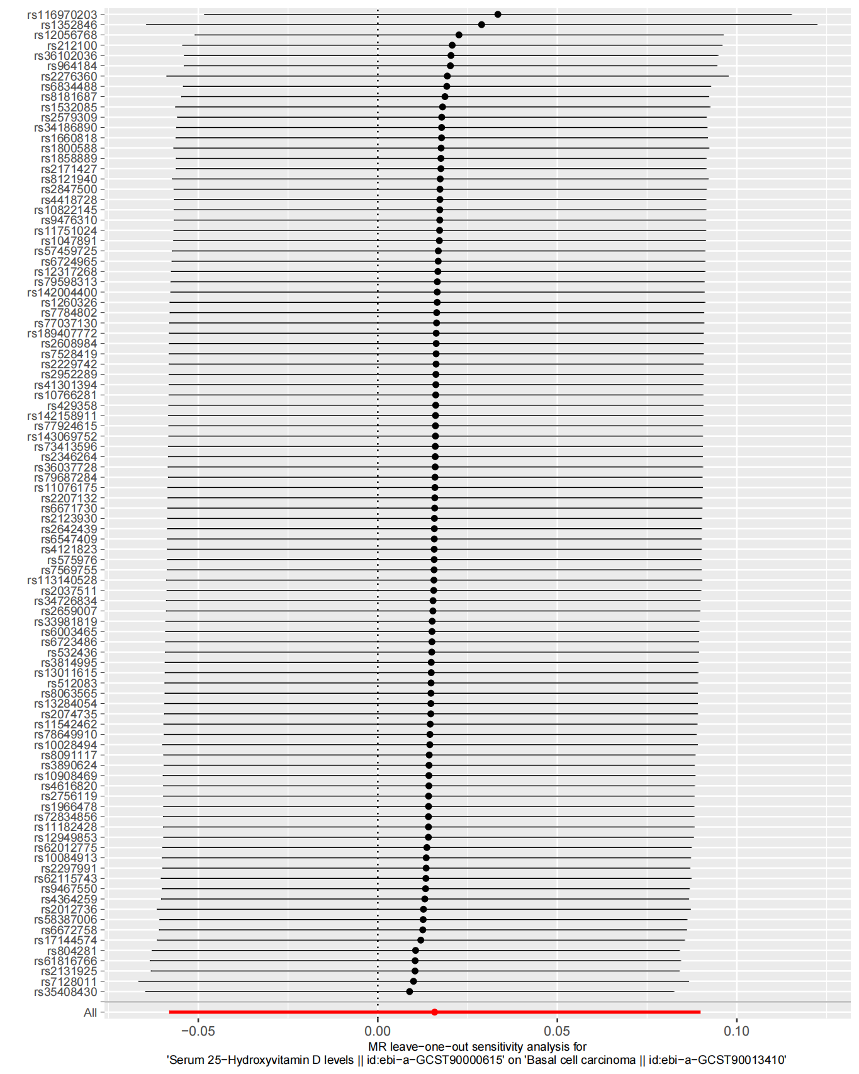
Abbreviations: MR—Mendelian randomization

