Figure supplementary 1. The leave-one-out analysis about the effect of body mass index on basal cell carcinoma
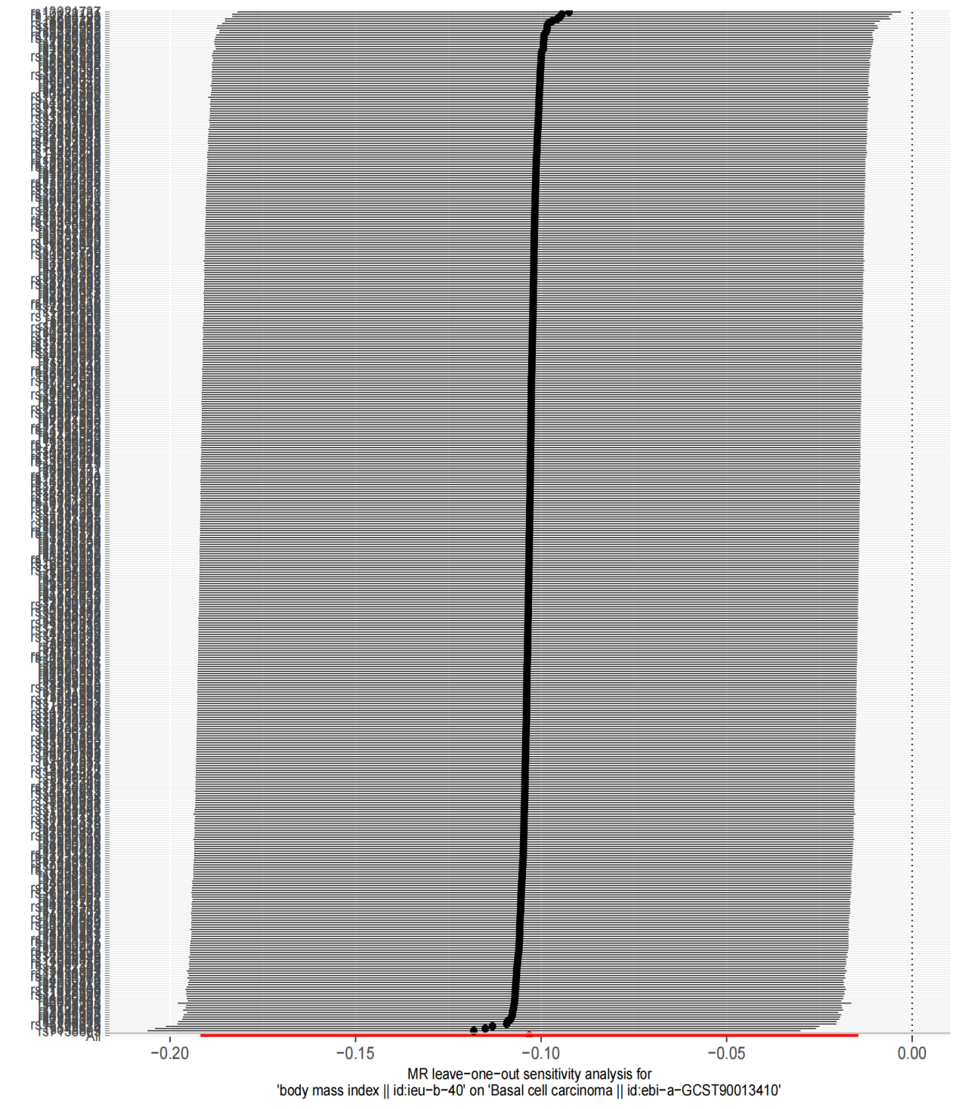
Abbreviations: MR—Mendelian randomization

